introduction to CAD-CAM Software

Ion Barbu, Cătălin Alexandru
Transilvania University, Brasov, Romania, ibarbu@unitbv.ro
Transilvania University, Brasov, Romania, calex@unitbv.ro

Abstract: The paper presents a lot of a NC program witch is a precise sequence of machine instructions. Each program consists of blocks of information that instruct the movements and sequence of events to machine a work-piece. These blocks include all necessary events, including activating the spindle, coolant, tool selection, and all axis movement required to cut the work-piece in a safe and productive manner. Every program is given a unique name for identification. Programs are stored in the CNC’s memory and accessed from the CNC’s Program Directory. You can create, delete, undelete, copy, and rename programs in the CNC’s Program Directory.
Keywords: computer, software, manufacturing, numerical control, technologies.

1. Historical perspective of CAM

CNC milling machines have of course been developed based on conventional milling machines, where the tool is moved through the material by operating a hand wheel for each of the available axes (X, Y, Z). The basis of adding NC (Numerical Control) is very simple: replace the hand wheel by a positioning motor and add some electronics (the N C controller) to control the position. Nowadays many conversion kits are available to perform such operation.
The first NC controllers w ere very simple no user-interface, just an option to re ad the tool positions to go to from a punched tape. Very soon new controllers were introduced, including a simple computer with a special-purpose key board and a display. T he operator now could enter the sequence of movements to make (the NC program) on the controller, which was called CNC (Computerized Numerical Control). In so me cases a tape puncher / reader still was available for external storage.
Next step was of course to use a PC for external storage, communicating with the CNC controller via a serial cable. This allowed the operator to conveniently sit at his desk to enter a new NC program, while at the same time the CNC machine was executing a previous job. Do note that for most desktop machines the situation is a bit different, as here a PC is used for the CNC controller (much cheaper than a special purpose control computer).

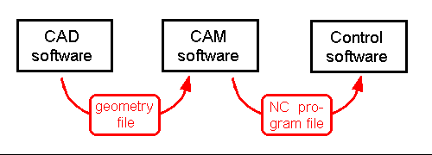

Fig. 1: The path of CAD-CAM files.

In the situation just described the operator enters the complete NC program on the computer, using a plain editor like Notepad or a special purpose NC editor. Each movement has to be separately entered, like "G0X10Y20Z30" for "Machine in a straight line from the current position to position (10,20,30)". This is of course very labor intensive, and this is where CAM software comes in to 'automatically' generate NC program files.

2. The position of CAD-CAM Software in the process

In order to manufacture a part, nowadays typically three different software programs are used (see the illustration above):
- First the CAD software to make the design of the part
- Next de CAM software to calculate the tool-paths based on the design, compensating for the cutter's geometry, adding feed-rate an d spindle commands, etc.
- Third the control software to read the tool-paths and let the machine actually move along these paths.
This subdivision of tasks by three different programs is the same for both 2D and 3D applications. The Control software comes with the milling machine, while in contrast the CAD and the CAM software have to be bought separately. In case an NC controller with built in special purpose computer is used, the Control software is integrated. In case of a PC the Control software has to be installed, still it "belongs" to the machine as the machine cannot function without the Control software. Do note that many low-cost CNC machines are delivered with MS Dos based Control software, as the real-time control needed for machining is difficult to program under Windows.
A typical computer programs: CAD (Computer Aided Design) software, for example CATIA, PROENGINEER, EUCLID; MBS (Multi Body Systems) software, for example ADAMS, DYMES, SD-EXACT, PLEXUS; FEA (Finite Element Analysis) software, for example NASTRAN, PATRAN, NISA, COSMOS, ANSYS. The CAD software is used for creating the geometric model of the mechanical system (i.e. solid model). This model contains information about the mass and the inertia properties of the rigid parts. At the same time, the CAD environment provides the ability to perform simple motion studies and to easily transfer geometry between CAD system and CAM software. The part's geometry can be exported from CAD environment to CAM environment using standard format file, for example IGES (Initial Graphics Exchange Standard) or STEP (Standad for the Exchange of Product Model Data). To import the geometry of the rigid parts, the CAM software reads the CAD file and converts the geometry into a set of CAM geometric elements.
Communication between the three programs is done using files. From CAD to CAM the design is transferred using a file format for geometry data exchange. For instance file types like IGES, STL and STEP for 3D, DXF for both 2D and 3D(figure 2), and Postscript and HPGL for 2D applications. These are standard formats that in most (!) cases can be used without any special configuring needed. Much more can be said about these file types. Perhaps an idea for a next article of the month I won't add any explanations here.

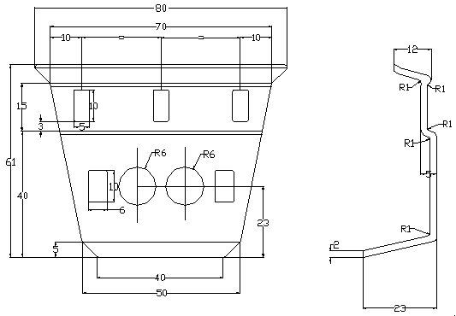 | 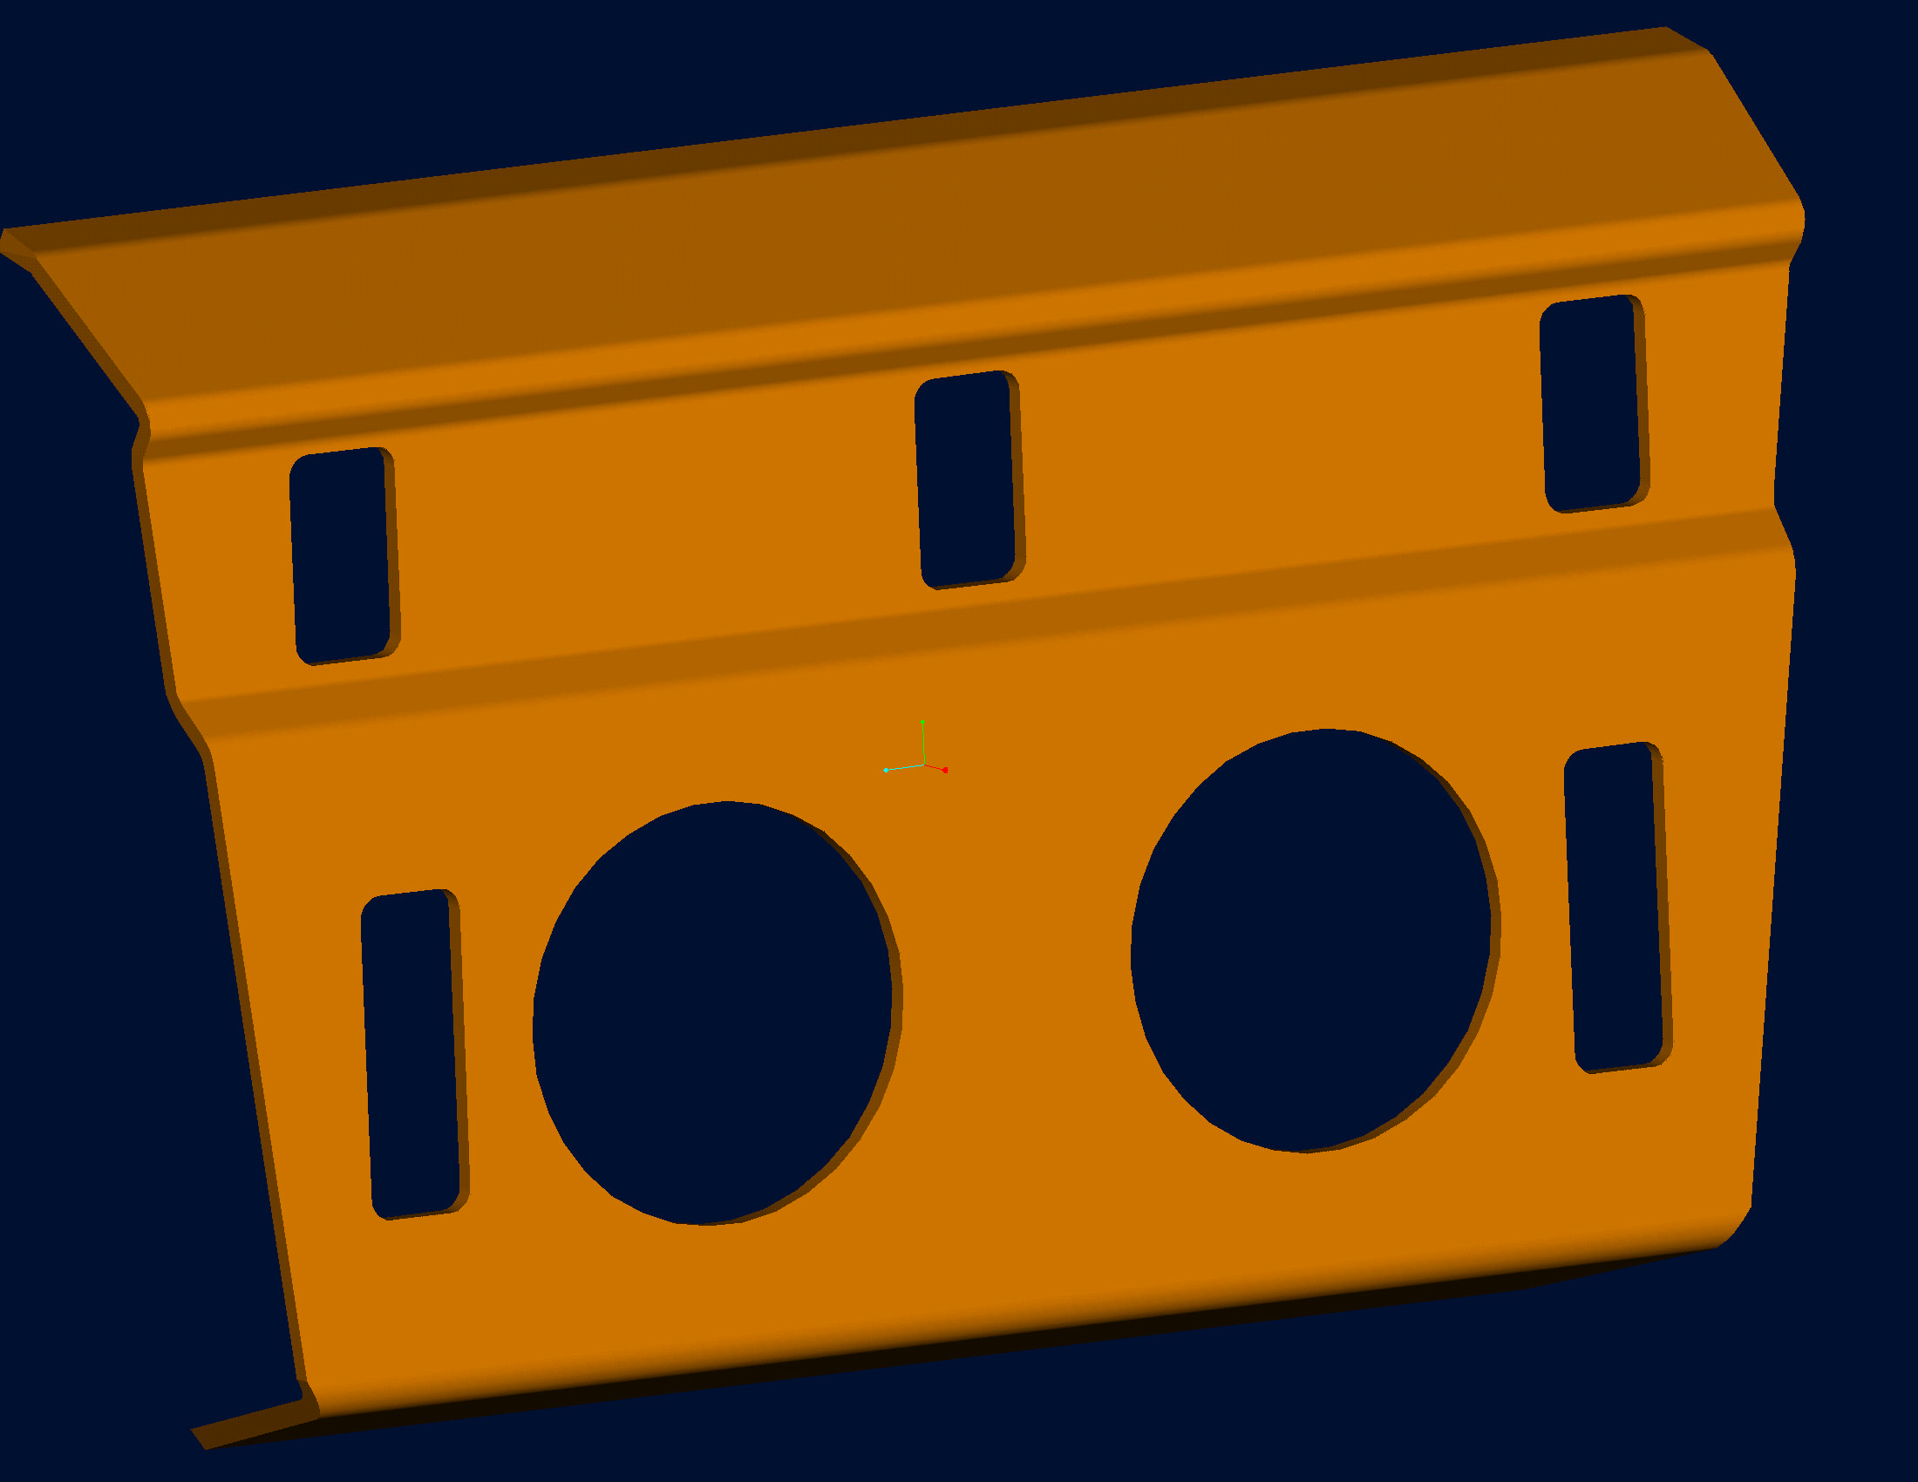
2D –“dxf” model file | 3D – “prt” model file
Fig.2: The 2D and 3D view from the model
Communication from CAD to Control software is done using NC program files, for which many formats do exist. In most cases the format will be a (minor) variation on the ISO / DIN G-code format. G-code is supposed to be a standard, however in practice each manufacturer chooses a bit different implementation. In other cases a proprietary format is used. So for this communication the CAM software has to fine tune its output in order to meet the requirements of the NC controller used. This fine tuning is done by the Postprocessor.
The Postprocessor is the part of the CAM software that translates the tool-path data into the correct file format when saving (in fact an export filter). This functionality is the same as used in the (Windows) device driver that comes with any printer, to translate the word processor's output to the format required by that printer. In many current CAM systems the postprocessor can be configured by the user, making it easy to connect to any new machine. This in contrast to the older CAM packages where the user has to pay(much) money to the supplier to order a new postprocessor.
I some specific situations one of the three programs just described (CAD-CAM-Control) may be omitted. For instance some machines can be used with out control software (like the small Roland models, where a plain "print" command is sufficient to start the machine). Or in some setups a plot file (or even a 2D DXF file) from the CAD system can be immediately sent to the control software, skipping the CAM step. Still it makes sense to distinguish the three basic steps, for a clear picture of the process involved.

3. Types of CAM software

Many different CAM software packages are available, showing large differences in price. It is a very difficult job to get a clear view about each system s capabilities and it's price/performance ratio. The CAM software model is shows in figure 3. In follow figure can be view the some steps with PowerMill software for simulate a manufacturing for a existing CAD model can be made using anything design computer software.

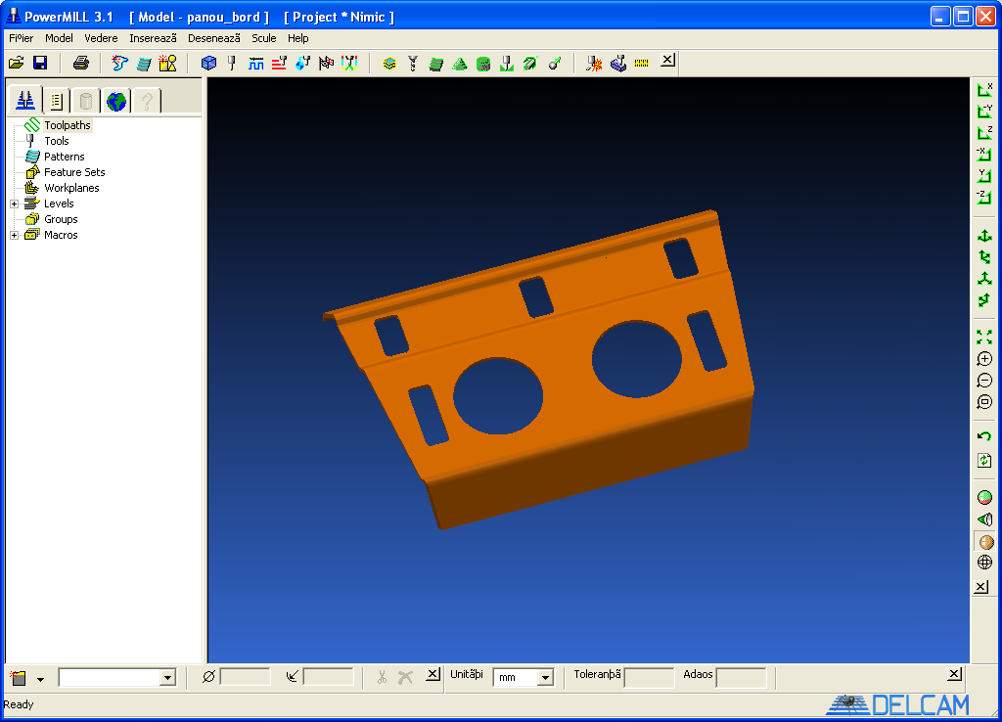 | 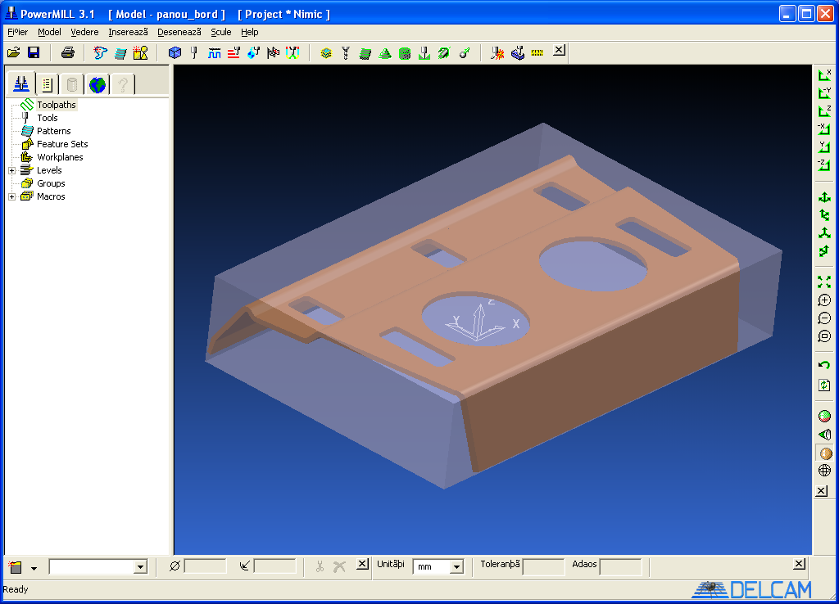 |  | Step I: Import CAD model
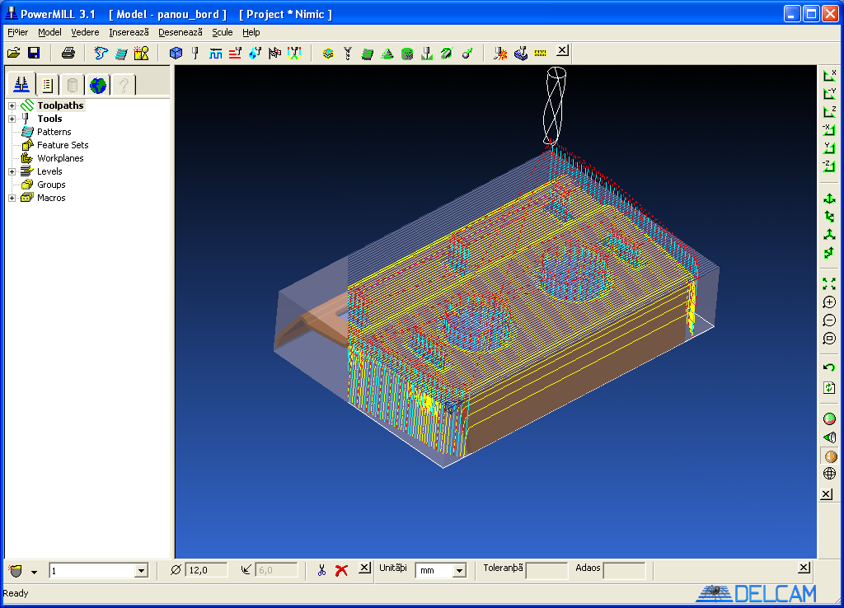 | 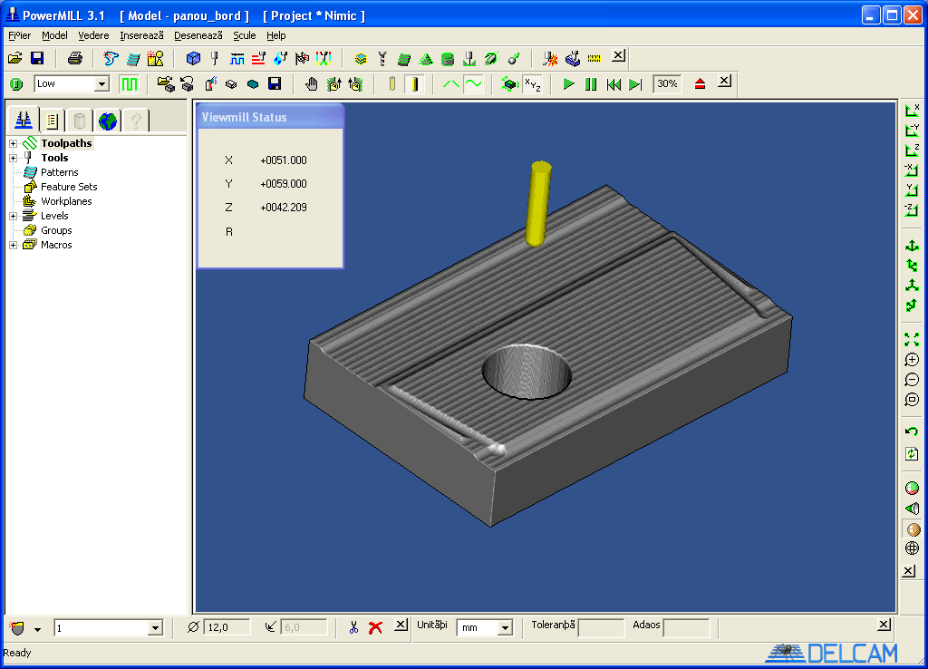 |  | Step II: Generate the tool-path
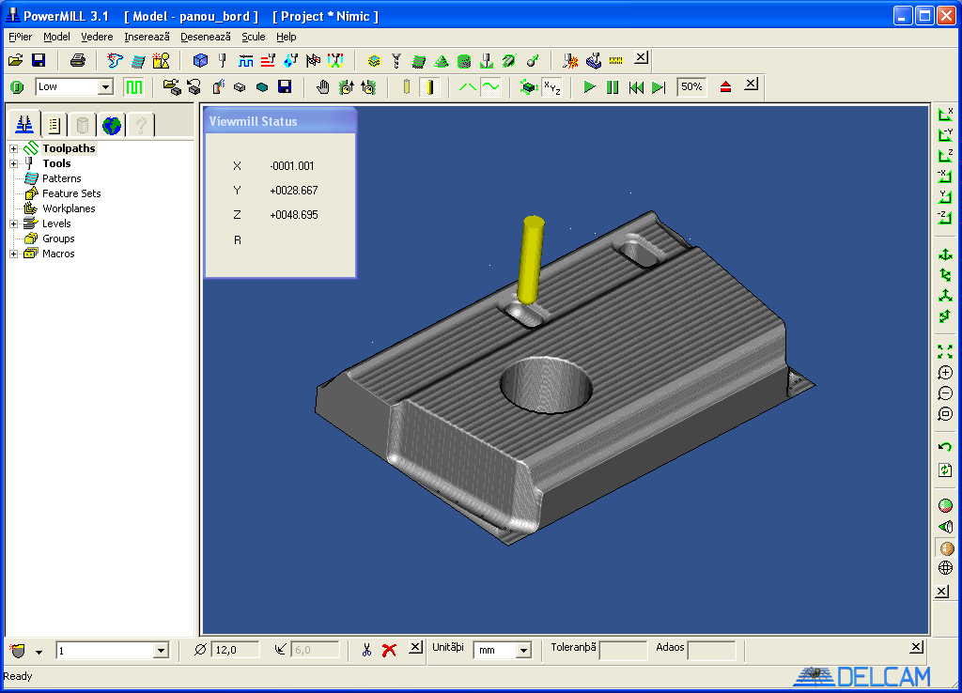 | 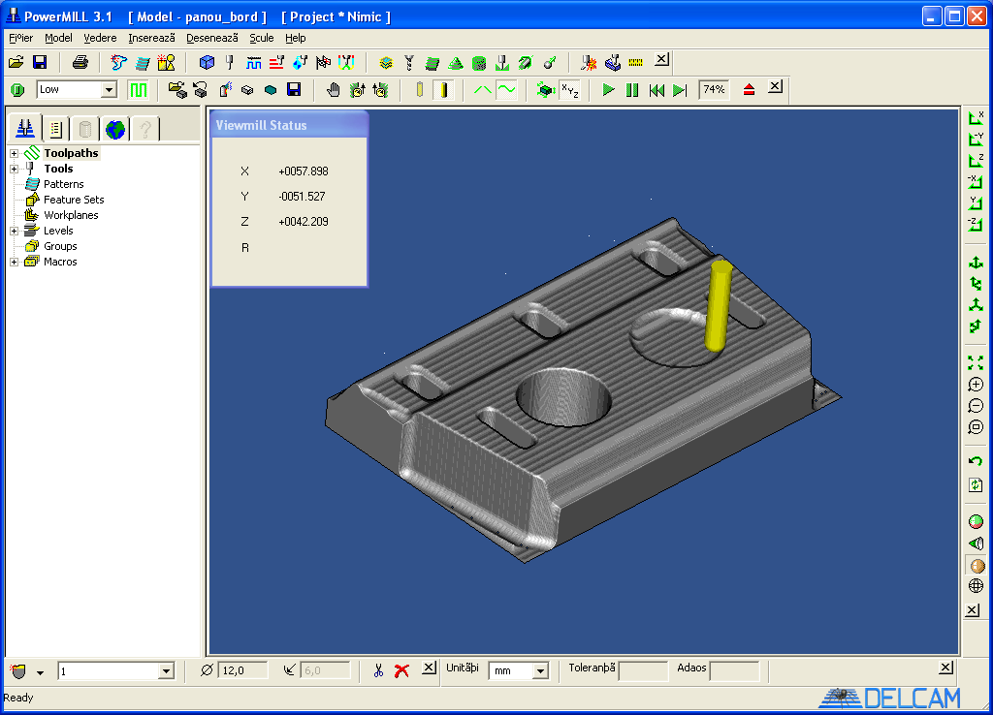 |  | Step III:  Simulate the manufacturing
Fig.3: Import model CAD with “igs” extension and simulate manufacturing using PowerMill software

A clear difference is present between CAM software for 2D and for 3D applications. With 2D is me ant that the CAM system imports a 2 D drawing file and calculates a tool-path with all movements taking place on a constant Z-level. Obviously several tool-paths on different Z-levels can be combined to create a 3D result, which is called 2.5 D machining (note that more definitions of the notion 2 .5D do exist). In that ca se to user has to enter the correct Z -level to be used for each tool-path. A 3D CAM system in contrast imports a full 3D CAD model and calculates tool-paths to create a 3D result. Note that in this case also tool-paths on constant Z-level may be used (waterline machining), however these are automatically generated. Many CAM pack ages do offer both 2D and 3 D, however still have their clearly recognizable foundation in one of both fields.
A second distinction is between simple an d high -end CAM software. The high-end stuff is meant for professional toolmakers, who know about all possible milling parameters, want to be able to control any parameter for an optimum result, and are willing to pay for that. These extra high-end parameters do include options like:
- support for a fourth axis, or for full 5 axis machining
- optimization for High Speed machining (constant tool load)
- special sequences for approaching and leaving the geometry (lead-ins)
- automatic step-over calculation
- a wide choice of machining strategies, like parallel, spiral, radial, pencil tracing, flat surface recognition, offset machining, plunge milling and automatic smoothing of almost vertical surfaces.
- automatic detection and removal of rest material
- management of under cuts
- rendered machining simulations.
The more simple programs offer less options, and are thus both cheaper an d easier to use and testing.

4. conclusion

The word "NC Program" can be used in two senses, which can be quite confusing when communicating about C AM. In this article it is used for the 'File that contains all tool-path information', exported by the CAM system and imported by the Control software. As the word "Program" in most case s means Software, sometimes the word "NC program" is used for a 'Program to calculate NC data', so for the CAM software. Be aware of possible confusions.
The capabilities of your machine must of course match the requirements of the CAM software. One requirement should be checked, as some older CNC machines do not offer this: 3D line interpolation. This means the possibility to travel from point A to point B in a straight line in full 3D. This is not easy, as all three axes will have to keep up a different speed. Some machines are only capable of straight lines involving 2 axes (2D line interpolation). A second important machine capability is on-line machining: the capability to handle large NC program files directly from the computer's hard disk.
This involves some handshaking between the PC and the controller, as in most cases the data transfer will be faster than the actual machining. No big deal: any simple printer can do so. However be aware that many CNC machines cannot: the y have been designed for NC programs that are completely entered by hand, so consider a 100 Kb NC program file as very large. For CAM this is not large: it is easy to create 10 Mb NC program s, or even larger.
Those older machines require the complete NC program file to be transferred before the machining can start, limiting the file size to the (say) 256 Kb of available internal memory. The option of on-line machining is also called drip-feed, or DNC (for Direct Numerical Control).

REFERENCES

- Barbu, I., Barbu D.M. „Tehnologii CNC în mecanica fină şi mecatronică”. The VI-th International Conference on Precision Mechanics and Mechatronics COMEFIM 6, Braşov, România, 2002, vol. 2, pag. 293, ISSN 1220-6830;
- Alexandru C., Barbu I. „Functional design of the windshield wiper mechanisms using virtual models”. International conference on the theory of machines and mechanisms–CEACM Conference on Computational Mechanics, Liberec, Czech Republic, 2004, pag.23.

