VIRTUAL TRACK FOR SIMULATING A FULL-VEHICLE
DIGITAL MODEL

Cătălin Alexandru
University “Transilvania”, Braşov, ROMANIA, calex@unitbv.ro

Abstract: In this paper, we attempt to carry out the dynamic analysis of a motor vehicle, using the virtual prototype developed with the MBS software ADAMS of MSC Software. The dynamic model takes into consideration the geometric restrictions as well as the nonlinear characteristics of the elastic and damping elements. The virtual prototype includes the front and the rear suspension subsystems, the steering subsystem, and the car body subsystem. Two double-wishbone mechanisms are used for the suspension of the front wheels. The steering subsystem contains a central pitman arm that rotates to impart motion to the left and right tie-rods. The rear rigid axle is guided by a three-links mechanism, which is a dependent suspension model. The experiment designed is one frequently carried by the automotive manufacturers, namely passing over bumps, considering a virtual track.
Keywords: virtual prototype, suspension, steering, dynamics.

1. INTRODUCTION

The revolutionary evolutions in the field of motor vehicles imposed the development and utilization of high technologies both for manufacturing and design. The simulation techniques allow the engineers to conceive and equip virtual prototypes, which permit a large-scale evaluation of the system behavior.
In this paper, we attempt to carry out the dynamic analysis of a motor vehicle, using the virtual prototype developed with the MBS software ADAMS of MSC, which is licensed to “Transilvania” University of Brasov in the frame of the Center Product Design for Sustainable Development. The dynamic model takes into consideration the geometric restrictions as well as the nonlinear characteristics of the elastic and damping elements. The virtual prototype includes the front and the rear suspension subsystems, the steering subsystem, and the car body subsystem. Two double-wishbone mechanisms are used for the suspension of the front wheels. The steering subsystem contains a central pitman arm that rotates to impart motion to the left and right tie-rods. The rear rigid axle is guided by a three-links mechanism, which is a dependent suspension model. The above-presented subsystems were created in ADAMS/View as separate models in the same database. In addition, a new model was created in order to successively add the subsystems in a single model (the full-vehicle model, in fact the virtual prototype of the vehicle).
The experiment designed is one frequently carried by the automotive manufacturers, namely passing over bumps, the road profile including a lot of bumps. The connection between wheels - tires and road (ground) is made using contact forces. These allow modeling how adjacent bodies interact with one another when they collide during the simulation. The specific ADAMS/Solver module has a geometry engine that is responsible for detecting contact between geometries, locating the points of contact, and calculating the common normal at the contact points. Once the contact kinematics is known, contact forces, which are a function of the contact kinematics, are applied to the intersecting bodies.
On the virtual prototype, a lot of measurements have been made having in view to evaluate the dynamic behavior of the vehicle. The results allow evaluating and optimizing the dynamic behavior of the virtual prototype, by making easy virtual measurements in any point and / or area of the guiding system, and for any parameter (displacement, velocity, acceleration, force and so on). This is not always possible in the real cases due to the lack of space for transducers placement, lack of appropriate transducers or high temperature. In this way, we can quickly exploring multiple design variations, testing and refining until optimizing guiding system, without going through expensive physical prototype building and testing. This technique allows realizing the projected reductions in cycle times while maintaining and increasing the vehicle performance, safety, and reliability.

2. ASPECTS REGARDING THE VIRTUAL PROTOTYPING PROCESS

Two decades ago, in automotive engineering, the concept of transferring of the drawings in the computer was introduced. At the same time, major improvements were developed, enabling engineers to move from creating simple, two-dimensional drawings, to modeling three-dimensional solids. The traditional CAD/CAM/CAE technologies are orientated on the concept referred to as “art-to-part”, which is directed toward the design, development and manufacturing of higher quality parts. Three-dimensional solid modelers have been used to design the form of the components. Finite element programs performed detailed meshing and analysis of structural, thermal and vibratory characteristics of individual parts. At the same time, specialized software aimed at improving manufacturability of parts. However, optimal component design does not always leads to optimal system design. The interaction of form, fit, function and assembly of all parts in a mechanism is a major contributor to overall product quality. The only way to increase quality, and reduce time and cost, consists now of functional virtual prototyping applied to system level [7, 8].
On the basis of advanced computer programs, engineers have the possibility to build models of not just parts but entire system, and then to simulate their behaviour and optimize the design before building an expensive hardware prototype. A lot of scientific papers reveal a growing interest on analysis methods for “multi-body” systems that allow the self-formulating algorithms, having in view to develop powerful modelling and simulation programs, which facilitate building and simulating a computer (virtual) model of any mechanical system [2, 6, 9, 10, 11]. These types of programs were lanced in commercial versions even in the 1970’s but in the last decade a new type of studies were defined through their use: Virtual Prototyping. This technology consists mainly in conceiving a detailed model and using it in a virtual experiment, in a similar way with the real case. Virtual Prototyping is a software-based engineering process that enables modelling the mechanism, simulating the motion under real operating conditions and, finally, optimizing its behaviour. An important advantage of this kind of analysis - simulation consists in the possibility of make virtual measurements in any point and area of the mechanism and for any parameter.
Virtual prototyping allows the full operation of the product to be considered and evaluated early enough in the design process to allow for function to truly drive form and fit. It also allows multi-function optimization to be realized, such that a true balance can be obtained between competing functional requirements involving performance, safety, durability, cost, comfort, etc. These two benefits were largely impractical in traditional development cycles involving extensive reliance on hardware prototypes. In addition to these benefits, functional virtual prototyping has proven effective in facilitating tighter and more successful relationships between manufacturers and their lead suppliers. Virtual Prototyping brings several advantages: it reduces the time and cost of the new product development; it reduces the product cycles; it reduces the number of expensive physical prototypes and experiment with more design alternatives.
Generally, the virtual prototyping platform includes CAD, MBS and FEA programs [4, 5]. The CAD environment is used to create the geometric model, which contains information about the mass and the inertia properties of the rigid bodies. The solid model can be exported to the MBS environment using standard format file, such as IGES, STEP DXF or DWG files. The MBS software, which allows analyzing and simulating the mechanism, reads the CAD file and converts the geometry into a set of MBS geometric elements. The FEA software is used for modeling flexible bodies in mechanism and provides the ability to transfer loads from MBS to FEA and to bring component flexibility from FEA back into MBS. Integrating flexible bodies into virtual model allows capturing inertial and compliance effects during handling and comfort simulations, study deformations of the flexible components, and predict loads with greater accuracy, therefore achieving more realistic results. The flexible body characteristics are defined in a finite element modeling output file (MNF).
The main component of the virtual prototyping platform is the “multibody system” software (MBS). The steps to create a virtual model with MBS software mirror the same steps to build a physical prototype [12, 13, 14]. The virtual prototypes are created of both the new product concept and any target products which may already exist in the market. The geometry and mass properties of the bodies are obtained from component solid models. The structural, thermal and vibratory characteristics result from component finite element models or experimental tests. Testing of hardware prototypes has traditionally involved both lab tests and field tests in various configurations, which are very expensive. With virtual prototyping, it is enough to create virtual equivalents of the lab tests and the field tests, for example virtual test tracks in automotive simulation, and this cut time and cost. However, the physical testing is used at various stages to revalidate the model after significant refinement. To validate the virtual prototype, the physical and virtual models are tested identically (the same procedures). The results are compared, and design sensitivity analyses are performed on the virtual model to identify design parameters that have great influence on the performance results that do not correspond. Refining the virtual prototype may involves to replace the rigid components with flexible counterparts, to add frictions, and to represent automatic control systems. The optimization is made with the following steps: parameterize the model, defining the design variables, defining the objective design functions, performing design studies to identify the main design variables, and optimizing the model on the basis of the main design variables.

3. FULL-VEHICLE VIRTUAL PROTOTYPE

In the last years, the virtual prototyping has become very important in a lot of applications in the field of automotive design and development, such as [13, 15]: suspension design; vehicle dynamics; engine design; powertrain engineering; body hardware engineering; noise, vibration, harshness, and ride; tire-roadway interaction; driver behavior; controls design; safety systems; road surface wear; vehicle durability. The confluence of the modern technologies (digital mock-up, virtual prototyping, virtual factory simulation, product data management) is enabling the realization of the functional digital car such that we can evaluate and optimize total vehicle performance on a computer [1, 3, 8]. It is now possible to combine accurate mathematical model representations of chassis subsystems, engine and driveline subsystems, and body subsystems to create a full virtual vehicle, which allows simulating the performance in a virtual test lab environment or on a virtual test track and replicate real-world behavior. The virtual vehicle can be integrated with hardware-in-the-loop simulations to investigate the real-time performance with real subsystems such as TCS or ABS [8].
In these terms, in the present paper, we attempt to carry out the virtual prototype of the guiding – suspension system of a motor vehicle, using the virtual prototyping environment ADAMS (Automatic Dynamic Analysis of Mechanical Systems) of MSC Software, which is licensed to Transilvania” University of Brasov in the frame of the Centre Product Design for Sustainable Development. ADAMS is a powerful computer program for virtual prototyping of the mechanical systems, and includes a specific module to analyze the vehicle subsystems such as suspension, steering, car body, power train, brake, or anti-roll bar. The vehicle can be tested under various road conditions in the computer, performing every manoeuvre normally run on a test track to accurately predict handling characteristics such as body roll, ride quality including vibration and bumps, safety and performance parameters of the vehicle. The full-vehicle virtual prototype developed in this paper contains the front and rear suspension subsystems, the steering subsystem, and the car body (chassis) subsystem.
Two double-wishbone mechanisms are used for the suspension of the front wheel (fig. 1). The suspension linkage uses two lateral control arms to hold the wheel carrier and control its movements. The lower and upper wishbones connect to the car body mount part using compliant joints - bushing elements. Spherical joints constrain the wheels carriers (upright parts) to the upper and lower control arms. A spherical joint also connects the tie rod to the. Tie rods attach to the steering mount part through spherical joints. Revolute joints connect the wheel carriers to the rims. The spring & damper elements are disposed between the car body part and the lower control arms. The upper - lower struts of the dampers (used to model the damper mass) are connected through cylindrical joints, and to the adjacent parts (car body, and lower control arms, respectively) through spherical joints. The suspension includes also bumpers and rebound elements, which are disposed inside the dampers.
The rear rigid axle is guided by a three-links mechanism (fig. 2), with two lower binary links and one upper triangular link double-connected to car body, which is a dependent suspension model. The wheels are mounted at either end of a rigid beam so the movement of one wheel is transmitted to the opposite wheel causing them to steer and camber together. Bushing elements (compliant joints) connect the guiding links to the solid axle, respectively to the car body part. Revolute joints connect the axle spindle to the rims. The translational springs & dampers are concentrically disposed between car body and axle, and the bumpers and rebound elements are disposed inside the dampers. The upper - lower struts of the dampers are connected through cylindrical joints, and to the adjacent parts (car body - axle) through spherical joints.

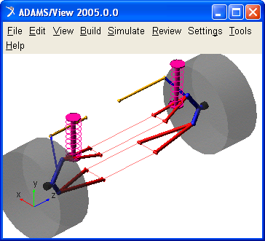  Figure 1: The front suspension subsystem | 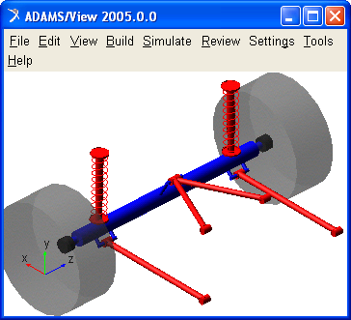  Figure 2: The rear suspension subsystem

The steering subsystem (fig. 3) contains a central pitman arm that rotates to impart motion to the left and right tierods from the suspension system in order to steer the wheels. The steering wheel rotates the intermediate shaft and the steering input shaft. The three shafts are connected using Hooke joints. The location point of the Hooke joint represents the connection point of the two parts, and two shaft axes leading to the cross bars identify the axes about which the two parts are permitted to rotate with respect to each other. The worm steering gear transmits motion from the steering input shaft to the pitman arm. The steering wheel shaft, the input shaft and the pitman arm are connected to the car body through revolute joints.
The car body – chassis subsystem (fig. 4) represents the base frame of the vehicle. Shell elements create the chassis graphic. A single rigid part models the chassis. The graphics was made using CAD software (CATIA), the solid model being imported in MBS software using the STEP format file. The mass - inertia properties of the car body have been calculated by multiplying the volume of the STEP geometry by the material density defined in the MBS software.

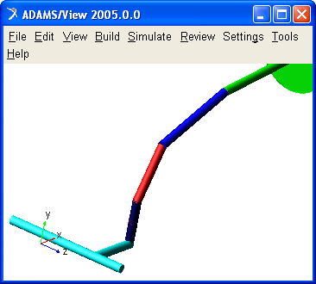  Figure 3: The steering subsystem | 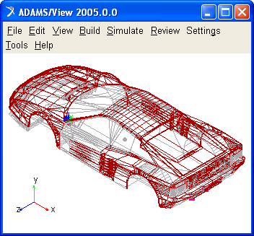  Figure 4: The car body subsystem

The above-presented subsystems were created in ADAMS/View as separate models in the same database. In addition, a new model was created in order to successively add the subsystems in a single model, using “Merge two models” command from “Tools” menu. In this way, the virtual prototype of the vehicle, shown in figure 5, was obtained. The model has 72 degrees of freedom (i.e. independent generalized coordinates), as follows [4]: 15 active degrees of mobility (vertical displacements of the wheels - 4, steering rotation of the front wheels - 1, car body oscillations - 6, rotations of the wheels around the wheel spindle - 4), 45 elastic restricted motions in bushings, excepting the necessary spherical rotations, and 15 passive degrees of mobility - proper rotations (upper and lower struts of the dampers - 8, steering tierods - 2, rear lower links - 2), respectively.

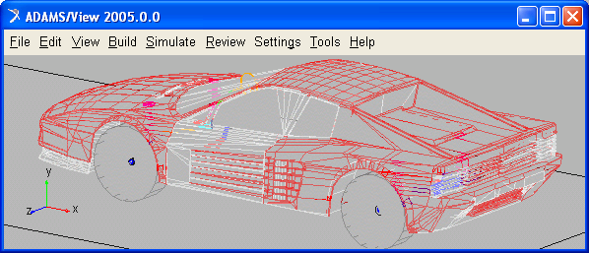

Figure 5: The full-vehicle virtual prototype

The virtual prototype is simulated in passing over bumps dynamic regime, the road profile (fig. 6) including few bumps of 50 mm amplitude. The connection between wheels - tires and road (ground) is made using contact forces. These allow modeling how adjacent bodies interact with one another when they collide during the simulation. ADAMS models the contact as a unilateral constraint, that is, as a force that has zero value when no penetration exists between the specified geometries, and a force that has a positive value when penetration exists between two geometries. The specific ADAMS/Solver module has a geometry engine (namely, RAPID) that is responsible for detecting contact between geometries, locating the points of contact, and calculating the common normal at the contact points. Once the contact kinematics is known, contact forces, which are a function of the contact kinematics, are applied to the intersecting bodies.
To model the contact forces, the following data are necessary: I / J Solid – the geometries for wheels and road; Normal Force – the normal contact force is based on an impact using the IMPACT type function that models the collision; Stiffness - the tire stiffness that is to be used to calculate the normal force for the impact model; Force Exponent – a real variable that specifies the exponent of the force deformation characteristic (for a stiffening tire characteristic, e > 1.0, and for a softening tire characteristic, 0 < e < 1.0); Damping - the damping properties of the contacting material; Penetration Depth – the boundary penetration at which ADAMS applies full damping.

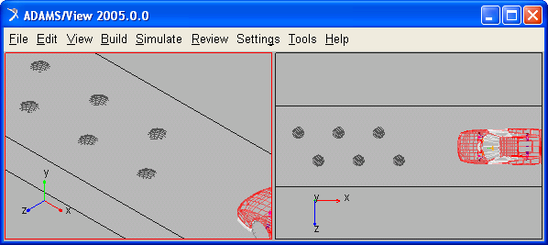

Figure 6: The virtual track

4. RESULTS AND CONCLUSIONS

Analyzing - simulating the virtual prototype, a lot of measures that define the dynamic behaviour of the vehicle can be obtained. The vehicle starts from the static equilibrium position, having the acceleration a = 6500 mm/s²; when the left front wheel begin to pass over the first bump, the vehicle has the velocity v = 20 km/h. The simulation was achieved for a time interval long enough to catch all relevant motions during the virtual experiment. For example, in the diagrams shown in figure 7, the vertical displacement, the vertical acceleration, the roll angle and the pitch angle of the car body are presented (the measure unit are: mm, second, degree).
Such results allow evaluating and optimizing the dynamic behavior of the virtual prototype, making easy virtual measurements in any point and / or area of the guiding system, and for any parameter (displacement, velocity, acceleration, force and so on). This is not always possible in the real cases due to the lack of space for transducers placement, lack of appropriate transducers or high temperature. In this way, we can quickly exploring multiple design variations, testing and refining until optimizing guiding system, without going through expensive physical prototype building and testing. Virtual prototyping-based design tools allow to more quickly assessing form, fit, function, and manufacturability of suspension – steering systems throughout concept design, concept refinement, detailed design, release, and production. Virtual prototyping allows realizing the projected reductions in cycle times while maintaining and increasing the vehicle performance, safety, and reliability.
The result of virtual prototyping is that we are much better equipped to manage the risks inherent in the product development cycle. Traditionally, the amount of information concerning the actual performance of a new photovoltaic tracking system was fairly low throughout the tracker development process until the prototype and assembly stage. Then, behavioural information increased, and risk could be reduced through effective design changes.
Unfortunately, late cycle changes are very expensive and error prone. With virtual prototyping, behavioural performance predictions are obtained much earlier in the design cycle, thereby allowing more effective and cost efficient design changes and reducing overall risk substantially.
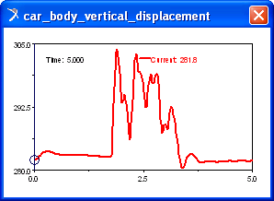 | 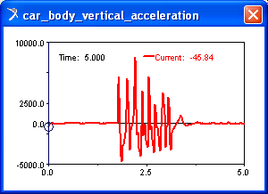
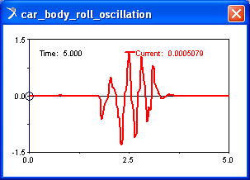 | 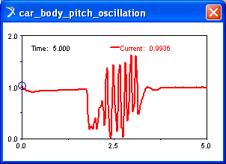
Figure 7: Dynamic characteristics

REFERENCES

- Alexandru C., Alexandru P., Visa I.: Virtual prototyping of the guiding – suspension system of the rear axle of passenger cars using MBS software, Proceedings of European Automotive Congress - EAEC, Barcelona, Spain, p. 144-151, 1999.
- Alexandru C.: Simulation of the mechanical systems (in Romanian), Lux Libris Publisher, Brasov, 2000.
- Alexandru C., Alexandru P.: The virtual prototype of an off - road vehicle, Proceedings of the 17th International Conference ESV, Amsterdam, p. 250, 2001.
- Alexandru C., Pozna C.: Dynamics of mechanical systems using virtual prototyping (in Romanian), Transilvania University Publisher, 2003.
- Alexandru C., Visa I.: Aspects regarding the analysis and simulation of the mechanisms using functional virtual prototypes, Proceedings of the International Conference MTM, Cluj-Napoca, vol. 1, p. 3-8, 2004.
- Haug E.J.: Computer aided kinematics and dynamics of mechanical systems, Allyn and Bacon, Massachusetts, USA, 1989.
- Haug E. J., Choi K. K., Kuhl J. G., Vargo J. D.: Virtual prototyping simulation for design of mechanical systems, Transaction of ASME, no. 117, p. 63-70, 1995.
- Ryan R.: Functional virtual prototyping - realization of the digital car, Mechanical Dynamics Inc., Michigan, 2002.
- Schiehlen W. O.: Advanced multibody systems dynamics, Kluwer Academic, 1993.
- Shabana A.: Dynamics of multibody systems, John Wiley & Sons, New York, 1988.
- Visa I.: Mechanical systems modelling as multibody systems in product design, Proceedings of PRASIC’02 International Symposium, Transilvania University of Brasov, vol. lV, p. 255-263, 2002.
- *** DYMES - User manual, EMRC, Michigan, 1995.
- *** Getting started using ADAMS/Car, MSC Software, 2005.
- *** Getting started using ADAMS/View, MSC Software, 2005.
- *** http://www.mscsoftware.com.

