Aspects of large displacement bending of thin regtangular plates

Vasile Ciofoaia¹, Ionel Rusu¹
¹ Transilvania University of Brasov, Romania, ciofoaiav@unitbv.ro

Abstract: An analysis for the cylindrical behavior of rectangular plates is presented. The governing nonlinear differential plates Kármán equations are solved in conjunction with boundary conditions for two joint edges by use of the analytical solution. The solution is used at load – deflection relations. The numerical results are compared to the analytical results.
Keywords: large displacement, rectangular plate, von Kármán equation

1. INTRODUCTION

In the design of modern plate structures, the classical theory for small deflection is no longer valid. In structural analysis, the bending of the rectangular plate with large displacement as shown in Fig 1 is often of interest. The behavior of elastic plate when subjected to large deflection is governed by two-coupled nonlinear partial differential equations originally derived by von Kármán in 1910[1, 2, 4, 5, 6, 8]. The coupling of the von Kármán equations leads to considerable computational difficulties [1, 2, 5] to obtain solutions for even the simplest conditions of loading and support and subsequently, approximate techniques such the finite difference, the finite elements, the asymptotic expansions and the perturbations procedures have been employed. In the paper [9], the bending of circular plate with large displacement is presented. A solution of the von Kármán-type differential governing the postbuckling behavior of a simply supported unsymmetric angle-ply rectangular plates has been formulated by Chia and Prabhakara [3]. In the note [8] the method of solution given in [3] is extended to the large deflection analysis of simply supported unsymmetric angle-ply rectangular plates subjected to the uniform edge moments. The present work is an attempt to describe the large deflection of the pin connected of the two parallel edges of a rectangular plate subjected to uniform loading. The equations are solved for this plate and the data are verified with the finite element method.

2. StATEMENT OF PROBLEM

Let us consider the bending of a rectangular thin plate of thickness h and edge lengths 2a (large) and 2b (fig.1). The material is considered to be isotropic. The median surface of the plate is reported to a Cartesian coordinate system x, y, z: the axis x and y are contained in the plane of the median surface and the z axis is perpendicular on it. The plate is articulated on the margins that are parallel to axis x. The loading of the plate is uniformly distributed p = ct. The deflections are considered to be of the same order of magnitude as the plate thickness. In this case the cylindrical bending of the plate is described. From the equations [4] it follows that:
, (1)
The equation system (1) has two unknown variables v and w and is of the order six , y = ± b, and has three conditions. In the case of articulations places on the lateral margins:
la y = ± b, w = 0, , v = 0, (2) the position of the plate Δ is described as:

, (3)  Since the lateral margins having the articulations cannot come closer to each other:  , (4)  The relation (4) can also be written in the following form: v(±b)=0.  In the relations (1),  and . (5)  The first equation (1) can be written in the form: | 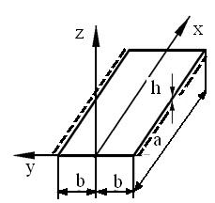  Figure 1 The rectangular thin plate

, where: , (6)
in which C is the integration constant.
The left part of the relation represents the axial forces:
,
when the positioning aids supported do not allow for the stretching of the plate.
Noting:
(N_{y} > 0) . (7)
The second equation from the system (1) can be written:

. (8)

The solution for the differential equation (8) with constant coefficients is:
$w=C_{1}+C_{2}y+C_{3}λy+C_{4}\text{ch}λy−\frac{{\text{py}}^{2}}{2{Dλ}^{2}}$. (9)
From the contour conditions (2) it follows that the integration constants are:
, C₂ = C₃ = 0, . (10)
By using them in the expression (10) it follows the following form for the displacement expression:
. (11)
In this expression the unknown variable is λ. In order to determine its value, the closeness condition for the margins is employed. (4) Δ = 0 or . From the condition (4) taking into account (3), and the second relation ε_{x} = 0 (the length of the plate is large) and the relation it follows that:
$$Δ=\int_{−b}^{b}{\frac{\text{dv}}{\text{dy}}\text{dy}}=\int{\left[\frac{D}{B}λ^{2}−\frac{1}{2}{\left(\frac{\text{dw}}{\text{dy}}\right)}^{2}\right]\text{dy}=2\frac{D}{B}{bλ}^{2}−\frac{q}{D^{2}λ^{7}}\left(2,5\text{th}λb−2,5λb+0\text{.}5λb⋅{\text{th}}^{2}λb+\frac{1}{3}λ^{3}b^{3}\right)=0}$$
By using the adimensional variables:
, , , , , (12)
it follows the equation for the determination of the parameter μ and the expression of the adimensional displacement ρ.
, , (13)
The relations (13) represent the two equations F₁ (μ, P) = 0, F₂(ς, μ, P) = 0. The first equation is transcendental and cannot be solved analytically. From the graphical representation of the first equation μ can be determined in rapport to P, and then it follows that ς = ς(P). Thus, the five integration constants C₁, C₂, C₃, C₄ and N_{y} = C can be determined. The sixth integration constant can be obtained by integrating the equation and by obeying one of the conditions v(±b)=0. All these constants in the plate theory, as a rule, do not matter. We only know that the displacement can be determined from (5) and it has the following form:
One can observe that by meeting the criterion Δ = 0 as described by the formula Δ = v(b) – v(-b) = 0 the constant C₅ disappears and the connection between μ and P can be ascertained.
The plate tension can be determined according to the relation:
. (14)
By inserting the adimensional stress
, (15)
it follows that
. (16)
On the plate faces ( z = ± h/2 ) the stress (16) has extreme values
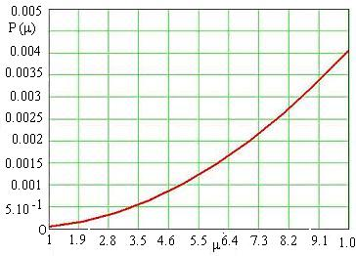  Figure 2 The relation P = P(μ) | 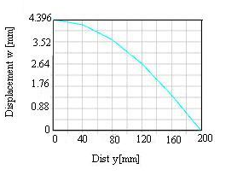  Figure 3 Transversal displacement
The extreme value of the tension is found on the median surface:
, . (17)
where and represent the adimensional membrane tension, the adimensinal bending tension respectively.
In this paper we present the analytical and numerical results for a rectangular plate with a width h = 5 mm, length 2b = 400 mm subjected to a uniformly distributed force of 0,1 MPa. Thus it was established analytical values for the μ and the displacement w (11). Figure 2 represents P = P(μ). The last relation of (12) is used to determine P and from figure 2 is determined μ. This value of μ is insert in the relation (11) for determining the displacement w or the last equation (13) for adimensional displacement. Figure 3 presents the variation of the transversal displacement on half of the plate. The numerical results are determined by using ANSYS. The maximal displacement is 4,3 mm and the maximal tension can be obtained for the symmetry axis of the plate having a value of 209,7 MPa . This value of the maximal tension are graphically presented in Figure 4. Agreement between the analytical and numerical methods is good.
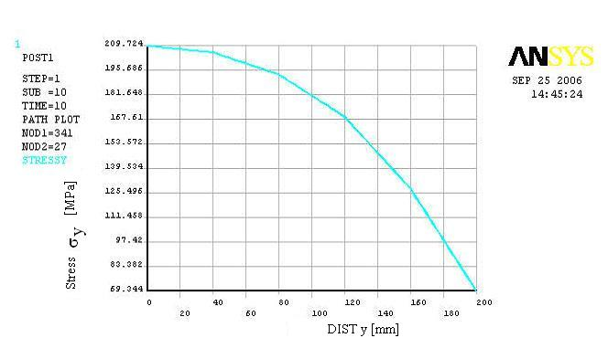
Figure 4 Stress σ_{y} versus the width

3. CONCLUSION

The present paper determines the solution for the behaviour of the rectangular plate with large displacements in the case of two parallel articulated clamped edges. The analytical results have been compared with those determined numerically for the articulations fixed plate on the margins. The results confirmed a satisfactory correspondence between the two results that were obtained. The analytical model can be used to determine the transversal displacement values.

REFERENCES

[1] | Beschea, A., Rezistenta materialelor,Editura Didactica si Pedagogica. Bucuresti, 1971.
[2] | Berbente, C., Berbente, I., Bare si placi cu deplasari mari. Editura Tehnica, Bucuresti, 1997.
[3] | Chia, C.T., Prabhakara, M.R., Postbucking behavior of unsymmetrically layered anisotropic rectangular plates. Transactions of the ASME, Journal of Applied Mechanics,vol.96, pp155- 162.
[4] | Ciofoaia, V., Rusu, I., Asupra comportarii placilor circulare cu deplasari mari. Buletinul Universitati Petrol-Gaze Ploiesti, vol.LVII, Seria Tehnica nr.4/2005, ISSN 1221-9371, p.171-176.
[5] | Григоренко Я., М., Мукоед А., П., Решение нелинейны хзадач теории оболочек. Киев, Вища школа. Головное изд-во, 1983.
[6] | Martian, I.,Placi plane cu deformatii mari de diferite contururi. Rezumatul tezei de doctorat, Cluj-Napoca, 1988.
[7] | Mazilu, P., Topa, N., IeremiaM., Teoria si calculul placilor ortotrope. Editura Tehnica Bucuresti, 1983.
[8] | Prabhakara, M.K., Finite deflections of unsymmetric angle-ply anisotropic rectangular plate under edge moments. Transactions of the ASME, Journal of Applied Mechanics, March 1977, pp171-172.
[9] | Timoshenko, S.P., Woinowsky, K., Teoria placilor plane si curbe. Editura Tehnica, Bucuresti, 1968.

