Aspects concerning Experimental
Measurements of the Mechanical Systems

Ion Barbu
University “Transilvania”, Brasov, Romania, ibarbu@unitbv.ro

Abstract: The limit of stability are reached when the resultant force of all the forces acting on a vehicle reaches the boundary of the stability plane, providing that the wheels have not started to slide along the contact surface. The stability plane for a vehicle with a pivoting axle is described by an inclined triangle: the apex of the triangle is the (front) axle pivot point; the triangle base being a line connecting the ground contact points of the wheels on the non-pivoting axle (rear wheels).
Key words: tractor, modeling, CAD, simulate, stability.

1. Introduction

Determining the stability of agricultural tractors has been a concern of tractor designers and researchers for many years. Studies have been conducted to determine the factors influencing the directional stability of a tractor on a slope. Analyses have been performed describing the tipping phenomenon of tractors under static conditions. Dynamic studies relating the inertia properties and energy levels during rollover have been done
The present study establishes stability limits for tractor-implement systems on slopes. Furthermore, safe operating regions in terms of heading angles ψ and slope angles ϕ are proposed. Conditions under which stability is lost were determined and design parameters which affect stability were identified. The values of these parameters which maximize safe operating regions on slopes were determined. These analyses were conducted through computer simulation.

2. Static stability theory

The static lateral stability criteria for the agriculture tractor or other vehicle configurations were determined using classic rollover theory, developed by Coombes (1968) and other workers in the late 1960's. The limit of stability is reached when the resultant force of all the forces acting on a vehicle reaches the boundary of the stability plane, providing that the wheels have not started to slide along the contact surface. The stability plane for a vehicle with a pivoting axle is described by an inclined triangle: the apex of the triangle is the (front) axle pivot point; the triangle base being a line connecting the ground contact points of the wheels on the non-pivoting axle (rear wheels). The sides of the triangle join the ends of the base line to the (front) axle pivot point. A typical inclined triangular plane is shown in the schematic figures 1.

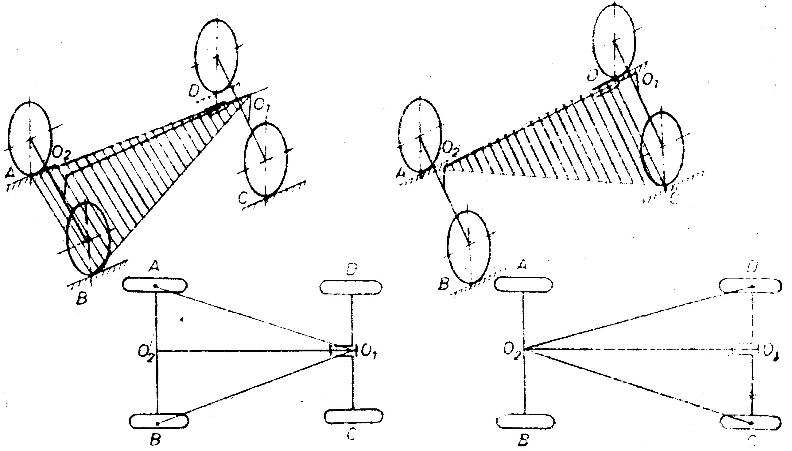
Fig. 1. The sides of the triangle join the ends of the base line to the (front) axle pivot point

Figures 2 show the side views of a A 533 DTOE agriculture tractors which is about to roll-over laterally. The vehicle body will rotate about points of support at the rear wheel contact E and front axle pivot pin B. At instability the support force at the third corner of the stability plane, i.e. the rear wheel contact D, will be reduced to zero. The resultant force, G_{t} (due to the vehicle weight) is about to pass outside the stability plane intersecting the boundary line EB at point S. Considering rotation about line EB for equilibrium at the point of instability and taking moments about S, the following equation may be derived:

Fig.2. Vehicle lateral stability – front and side view

, (1)
by geometry $\frac{y}{12⋅t}=\frac{c}{l_{p}}=\frac{z}{h_{p}}$, (2)
Therefore , (3)

Referring to equation (3), to increase vehicle lateral stability:
- increase t - widen vehicle wheel track;
- decrease h - lower vehicle centre of gravity;
- increase hp - raise front axle pivot point.
The major factors influencing stability are also shown diagrammatically in figure 3. The slope angle (β), at which lateral roll-over of a pivoted-axle vehicle commences, defines the first of two stages of instability. At this angle all weight comes off the upper wheel on the non-pivoting axle. However, as the vehicle body continues to roll around line EB, a point will occur, on most vehicles, when the travel limit of the pivoting axle is reached. At this point roll will occur about a line joining the base of the lower front and rear tires (points E and C in figures 2). This is the point or angle γ, that depicts the second stage of stability. For simple 4-wheel rigid frame vehicles, only the second stage instability angle applies, due to the absence of a front axle pivot. Referring to figures 2, it can be deduced that the second stage instability slope angle γ (not shown) is given by Equation (4):
, (4)
Fig. 3. Vehicle parameters affecting lateral stability.
3. Dynamic stability modeling

A variety of dynamical computer-based simulation models were developed to investigate vehicle stability. These simulation models were based on 3-dimensional (3D) CAD models of a A 533 DTOE tractor.
Virtual prototyping is a software based engineering process that enables modelling mechanical system, simulating its motion under real operating conditions and, finally, optimizing the form, fit, function, and manufacturing characteristics, long before building the first hardware (physical) prototype, and in a fraction of the cost of traditional hardware prototype processes. In addition to virtual prototyping, which investigates product function and operating performance, digital mock-up is to quickly assess form and fit of entire assemblies of three-dimensional solid models comprising a product.

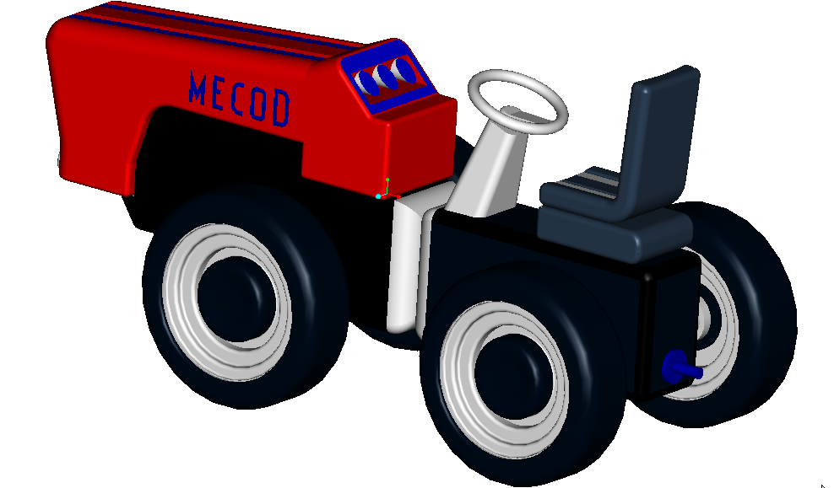 | 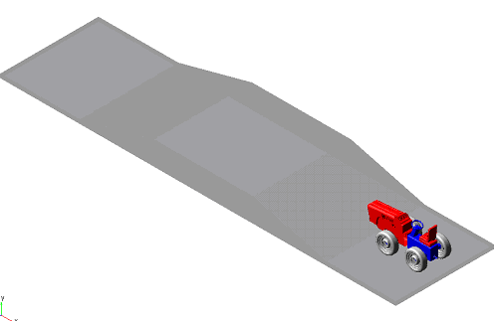
Fig. 4. Virtual prototype of the agriculture tractor A533 DTOE | Fig. 5. The virtual prototype on the road
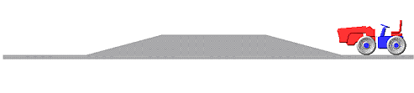
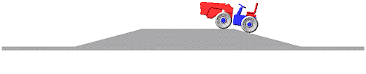
Fig.6. Aspects to dynamic simulation

The CAD software have used for creating the geometric model of the mechanical system. This model contains information about the mass and the inertia properties of the rigid parts. At the same time, the CAD environment provides the ability to perform simple motion studies and to easy transfer geometry between CAD system and virtual prototype software. The part's geometry can be exported from CAD environment to MBS environment using standard format file, for example IGES (Initial Graphics Exchange Standard) or STEP (Standard for the Exchange of Product Model Data). To import the geometry of the rigid parts, the MBS software reads the CAD file and converts the geometry into a set of MBS geometric elements.
Virtual prototyping platform provides the ability to transfer loads from virtual prototyping to FEA and to bring component flexibility from FEA back into virtual prototyping. Integrating flexible body into model allows capturing inertial and compliance effects during handling and comfort simulations, study deformations of the flexible components, and predict loads with greater accuracy, therefore achieving more realistic results.
it The steps to create a virtual (software) model mirror the same steps to build a physical (hardware) model, as shown in figure 4.
One of the most important axioms for successful functional virtual prototyping is to simulate as you test. Testing of hardware prototypes has traditionally involved both lab tests and field tests in various configurations, which are very expensive. With virtual prototyping, is enough to create virtual equivalents of the lab tests and the field tests, for example virtual test tracks in automotive simulation.
The virtual prototypes are analyzed in passing over bumps dynamic regime, simulating the experimental test on stand. The wheels are in contact with the road, which execute rotation motion relative to the ground using rotate joints. The inputs applied to the wheels enface the models a motion of movement with steady speed. The road is in ramp shape and is followed the measurement horizontal and vertical forces from the level to each wheel. The results appear in the following figure with the two cases when the model ascends to the ramp and descent to the slope.

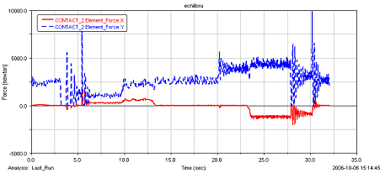

REFERENCES

1. Barbu Ion, Marius Luculescu., Stability of Agricultural Tractors on Slopes Using Virtual Prototyping, Al III-lea Simpozion International “Mecatronica, Microtehnologii, Materiale Noi”, Targoviste, nov. 2005;

