TESTING THE MECHANICAL SYSTEMS BY USING VIRTUAL PROTOTYPING ENVIRONMENT

Cătălin Alexandru
University “Transilvania”, Braşov, ROMANIA, calex@unitbv.ro

Abstract : The traditional CAD/CAM/CAE techniques focused on a concept referred to as art to part. Optimal part design rarely leads to optimal system design; the interaction of form, fit, function, and assembly of all parts in a product is a major contributor to overall product quality. The big opportunity to increase quality and reduce time and cost has shifted to the system level. Virtual prototyping-based design practices allow product designers, engineers, and analysts to more quickly assess form, fit, function, and manufacturability of new products throughout concept design, concept refinement, detailed design, release, and production. In this paper, a lot of aspects regarding the usage of virtual prototyping tools in designing & testing the mechanical systems are presented, as follows: the components of the virtual prototyping platform, the connections between them in a prototyping scheme, and the virtual prototyping phases, respectively. Finally, the virtual prototype of a complex mechanical system is developed.
Keywords: virtual prototype, multibody system, digital mock-up, simulation.

1. INTRODUCTION

Frequently used in mechanical systems engineering in the last decades, the classic CAD/CAM/CAE technologies were orientated on the concept “art-to-part” that is directed toward the design, development and manufacturing of the system’s components [6]. Three-dimensional solid modelers were used to design the form of the components. Finite element programs performed detailed meshing and analysis of structural, thermal and vibratory characteristics of individual parts. At the same time, specialized software aimed at improving manufacturability of components. However, optimal component design does not always leads to optimal system design. The interaction of form, fit, function and assembly of all parts in a mechanical system is a major contributor to overall product quality. The only way to increase quality, and reduce time and cost, consists now of virtual prototyping applied to system level.
The modern design process of the mechanical systems involves conceptual design, functional design, testing and optimization [9]. The conceptual design has as central objective to establish the best product concept (in the given conditions, by performing an efficient management of information picked by the science, technology, economy, market, culture, legislation, policy etc.), using specific design tools, such as multi-criteria analysis and morphologic analysis. The multi-criteria evaluation is for obtaining the most efficient and feasible product, performing the following steps: establishing the variants and the evaluation criteria; determining the contribution for each criterion; applying the contribution notes for each variant; establishing the optimal variants by using the consequences matrix. The morphologic analysis is made for choosing the solution by taking into consideration the requirements list, which contains aspects regarding the material, form, color, mounting place etc. For describing the solutions, there are used combinatory procedures, which generate the specific morphologic table.
The functional design involves identifying, modeling and evaluating the operational performances of the mechanical systems, and the deviations from the imposed characteristics, with other words the mode in which the mechanisms responses to the design requirements. The present-day researches in the field of kinematics and dynamics of mechanical systems are focusing upon several topics such as the development of new formalism for the description of the mechanical systems, the improvement of classical methods with new mathematical theories, the development of new analysis programs, and the improvement of the numerical integration methods.
Determining the real behaviour of the mechanical systems is a priority in the design stage since the emergence of the computer graphic simulation. Important publications reveal a growing interest on analysis methods for multi-body systems that may facilitate the self-formulating algorithms, having as main goal the reducing of the processing time in order to make possible real-time simulation [3, 7, 8]. These methods were used to develop powerful modelling and simulation environments - MBS programs, which allow building and simulating a computer model of any mechanical system that has moving parts. The mechanical device is treated with the MBS method as a constrained, multibody, spatial mechanical system, in which body elements are connected through mechanical joints and force elements. The main difference of mechanical system dynamics from the conventional structural system dynamics is the presence of a high degree of geometric nonlinearity associated with large rotational kinematics. Governing equations for conventional structural dynamics are linear differential equations, while those equations for mechanical system dynamics are nonlinear differential equations that are coupled with nonlinear algebraic equations of kinematic constraints.

2. THE VIRTUAL PROTOTYPING PROCESS

In the last decade, a new type of studies was defined through the utilization of the MBS software: virtual prototyping. This technology is a software based engineering process that enables modeling mechanical system, simulating its motion under real operating conditions and, finally, optimizing the form, fit, function, and manufacturing characteristics, long before building the first hardware (physical) prototype, and in a fraction of the cost of traditional hardware prototype processes. In addition to virtual prototyping, which investigates product function and operating performance, digital mock-up is to quickly assess form and fit of entire assemblies of three-dimensional solid models comprising a product [4, 6].
The steps to create a virtual (software) model mirror the same steps to build a physical (hardware) model, as follow: build - modeling parts, constrain the parts, create forces; test - measure characteristics, perform simulation, review animation; validate - import test data, superimpose test data; refine - add friction, define flexible parts, define control; optimize - add parametrics, define design variables, define objective functions, perform design studies, and perform optimization studies.
During the build phase, virtual prototypes are created of both the new product concept and any target products which may already exist in the market. The geometry and mass properties of the bodies are obtained from component solid models. The structural, thermal and vibratory characteristics result from component finite element models or experimental tests.
One of the most important axioms for successful functional virtual prototyping is to simulate as you test. Testing of hardware prototypes has traditionally involved both lab tests and field tests in various configurations, which are very expensive. With virtual prototyping, it is enough to create virtual equivalents of the lab tests and the field tests, for example virtual test tracks in automotive simulation or virtual landing strips for aircrafts.
To validate the virtual prototype, the physical and virtual models are tested identically, using the same testing and instrumentation procedures. The results are compared, and design sensitivity analyses are performed on the virtual model to identify design parameters that have great influence on the performance results that do not correspond. Afterwards, a lot of changes on the main design variables are realized in order to obtain an acceptable correlation between the virtual and hardware models.
Refining the virtual prototype involves the fidelity of the model. By replacing the rigid components with flexible counterparts, adding frictions, and representing the automatic systems that control the operating performance of the mechanical system, respectively, can make the improvement of the virtual prototype.
The optimization of the virtual prototype is made with the following steps: parameterizing the model; defining the design variables; defining the objective function for optimization; performing design study and design of experiments; optimizing the model on the basis of the main design variables. Parameterizing the model simplifies changes to model because it helps to automatically size, relocate and orient bodies. Design variables allow creating independent parameters and tie modeling objects to them. Design study describes the ability to select a design variable, sweep that variable through a range of values and then simulate the motion behavior of the various designs in order to understand the sensitivity of the overall system to these design variations. Design optimization represents the capability to obtain the optimal configuration of the mechanical system.

3. THE VIRTUAL PROTOTYPING PLATFORM

A typical virtual prototyping platform includes four types of computer programs (fig. 1): CAD (Computer Aided Design), for example CATIA, PROENGINEER, SOLIDWORKS; MBS (Multi Body Systems), for example ADAMS, DYMES, SD-EXACT, PLEXUS; FEA (Finite Element Analysis), for example NASTRAN/PATRAN, NISA, COSMOS, ANSYS; Command & Control, for example MATLAB, EASY5, MATRIX. In addition, a modern virtual prototyping platform includes specific software for product data management (PDM); this technique is the glue that enables the main components of the virtual prototyping platform to be successful by making all of the up-to-date component data readily available and manageable [6].
The MBS software is the main component of the virtual prototyping platform, and it allows analyzing, optimizing, and simulating the mechanical system under “real” operating conditions. The CAD software is used for creating the geometric model of the mechanical system (i.e. solid model). This model contains information about the mass and the inertia properties of the rigid parts. At the same time, the CAD environment provides the ability to perform simple motion studies and to easily transfer geometry to the virtual prototyping software.

The geometry can be exported from the CAD environment to the MBS environment using standard format file, for example IGES (Initial Graphics Exchange Standard) or STEP (Standad for the Exchange of Product Model Data). To import the geometry of the rigid parts, the MBS software reads the CAD file and converts the geometry into a set of MBS geometric elements.  The FEA software is used for modeling flexible bodies in mechanical systems. Virtual prototyping provides the ability to transfer loads from MBS to FEA and to bring component flexibility from FEA back into MBS. Integrating flexible body into model allows capturing inertial and compliance effects during handling and comfort simulations, study deformations of the flexible components, and predict loads with greater accuracy, therefore achieving more realistic results. The flexible body characteristics are defined in a finite element modeling output file (MNF - Modal Neutral File). | 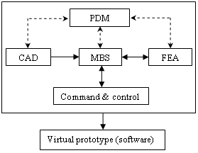  Figure 1: The virtual prototyping platform

In the typical design process of a mechanical system with controls, the mechanical designer and the controls designer work from the same concept, but use different sets of software tools. The result is that each designer produces a model for the same problem. Each design is then subject to verification and testing, and the first time the two designs are brought together is during physical prototype testing. If a problem occurs during the interaction between the controls design and the mechanical design, the engineers must refine the control design and/or the mechanical design, and then go through the entire verification process.
Integrating the control system in the mechanical model (concurrent engineering), the two designers can share the same mechanical model (fig. 2); they can also verify from one database the combined effects of a control system on a nonlinear, non-rigid model. The physical testing process is greatly simplified, and the risk of the control law being poorly matched to the real system is eliminated [5]. Inside the virtual prototyping platform, the command & control software directly exchanges information (import – export) with the MBS software; the output from the MBS model is input for the control system and vice-versa.
In the concurrent engineering philosophy, the simulation algorithm of the mechanical system, involves the following steps: regarding the MBS software - designing the mechanical model (including bodies, joints, elastic and damping elements, external forces and torques); analyzing the dynamic model, identifying the inputs and outputs, which complete a closed loop between the MBS model and the control application, exporting the obtained model; regarding the control application - importing the mechanical model block, explaining the mechatronic system trajectory in the task space and defining the input block diagram, designing the control system block diagram, designing the controller and the interface electric circuits, simulating the mechatronic system. This simulation process creates a closed loop in which the control inputs from the control application affect the MBS simulation, and the MBS outputs affect the control input levels. | 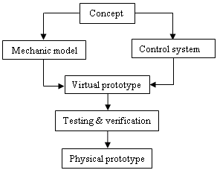  Figure 2: The concurrent engineering model

4. APPLICATION

In the last years, the virtual prototyping has become very important in a lot of applications in the field of automotive design and development, such as [1]: suspension design; vehicle dynamics; engine design; powertrain engineering; body hardware engineering; noise, vibration, harshness, and ride; tire-roadway interaction; driver behavior; controls design; safety systems; road surface wear; vehicle durability. Regarding the body hardware engineering, the virtual prototyping is frequently used in door, trunk, and hood latch design, trunk and hood hinge linkage design, seat mechanism design, window mechanism design, windshield wiper simulation and so on. The confluence of the modern technologies, such as digital mock-up and virtual prototyping, is enabling the realization of the functional digital car such that we can evaluate and optimize total vehicle performance on a computer. It is now possible to combine accurate mathematical model representations of chassis subsystems, engine and driveline subsystems, and body subsystems to create a full virtual vehicle, which allows simulating the performance in a virtual test lab environment or on a virtual test track and replicate real-world behavior. The virtual vehicle can be integrated with hardware-in-the-loop simulations to investigate the real-time performance with real subsystems such as TCS or ABS [6].
To demonstrate the virtual prototyping capabilities, in the present paper the virtual prototype of a windshield wiper system is developed, by integrating in the digital prototyping platform the following licensed software: CAD - CATIA, MBS - ADAMS, FEA - NASTRAN/PATRAN, Control - MATLAB, PDM – SMARTEAM. The windshield wiper mechanisms are vehicle-specific systems in which the wiping motion is transferred from the wiper motor to the pivot-shaft assemblies via linkages. A compact wiper system consists of the following components: wiper motor with thermo-switch, wiper gearing, motor crank, steel baseplate, crank linkage, and pivot-shaft assembly with oscillating crank [11]. The design algorithm of the windshield wiper systems was presented in [2], by taking into consideration three mechanical models:
a. the kinematic model – contains the rigid parts from the wiper mechanism, connected through geometric constraints (joints), and the geometric parameters that define the mechanism; the input is made using a kinematic restriction, applied in the joint between motor crank and body’s baseplate, which controls the angular position / velocity of the motor crank;
b. the inverse dynamic model – includes the kinematic model and, in addition, the external & internal loading (the friction forces between the wiper blade and windshield, and the mass characteristics); this model is used to determine the turning moment applied to the motor crank;
c. the dynamic model – includes the inverse dynamic model, but the input is made through the above-determined torque; the aim is to evaluate the “real” behavior of the wiper system (virtual prototype).
As example, a tandem pattern double-lever wiper system, corresponding to a domestic passenger car, is considered. The wiper mechanism contains two four-bar spatial linkages (fig. 3): ABCD – the command mechanism, from the wiper motor crank to the left wiper arm, and DC’FE – the connection mechanism, which transmits the revolute motion to the right wiper arm. The 3D-solid model was made using CAD software; the geometry was transferred to ADAMS using the STEP file format. The flexible wiper lamellas were modeled with FEA software; the transfer to ADAMS was made using the MNF file format. The motor crank (1) and the left & right wiper arms (3, 5) are connected to the grounded part (i.e. car body) using revolute joints A, D, and E. The crank linkages (2, 4) are connected to the motor crank, respectively to the wiper arms, using spherical joints B, F and cylindrical joints C, C’, respectively. The wiper system has one degree of mobility, DOM = 6⋅n - Σr_{g} = = 30 - 29 = 1, where “n” represents the mobile parts (bodies) and “Σr_{g}” is the number of geometric constraints. In the kinematic and inverse dynamic models, the input is made using a motion generator, ϕ₁(t) / ω₁(t). For the dynamic model, the kinematic constraint is replaced by the motor torque applied to the input crank.
The friction forces that act on the wiper lamellas depend on the friction coefficient between rubber and windshield, and the normal force generated by the spring mounted between arm and oscillating crank. The direction of the friction force depends on the sign of wiper arm’s velocity, which is modelled in ADAMS by the SIGN function (using Function Builder) [10]. This function transfers the sign of one expression representing a numerical value to the magnitude of another expression representing a numerical value, as follows: SIGN(a1, a2) = ABS(a1) if a2≥0, SIGN(a1, a2) = -ABS(a1) if a2<0. In our case, “a1” represents the friction force’s magnitude, and “a2” is the angular velocity of the wiper arm.
In order to obtain the torque that move the motor crank, a control system is developed using ADAMS/Controls and MATLAB. ADAMS/Control is a plug-in to ADAMS/View that allows integrating motion simulation and controlling system design in the virtual model. ADAMS/Controls allows connecting the ADAMS model to block diagrams that are developed with control applications.
To drive the wiper mechanism, a DC motor is used, so that the objective is to control the angular velocity of the motor crank, which is perturbed with the crank turning moment. This torque is obtained having in view the mechanical model of the wiper mechanism, on which act the external forces (i.e. the external environment).
The input to the windshield wiper model is the angular velocity of the motor crank. The output, which will be transmitted to the controller, is the crank turning moment. ADAMS/Controls and MATLAB communicate by passing state variables back and forth. Therefore, it is necessary to define the model’s input and output variables, and the functions that those inputs and outputs reference, with a set of ADAMS state variables.
For the input state variable, representing the angular velocity of the motor crank, the run-time function is 0.0 during each step of the simulation, because the velocity will get its value from the control application. The run-time function for the input variable is VARVAL(angular_velocity), where VARVAL (Variable Value) is an ADAMS function that returns the value of the given variable [10]. For the output state variable, representing the crank turning moment, the run-time function returns the sum of torques on body (motor crank) at location (a marker placed in the joint between motor crank and chassis).

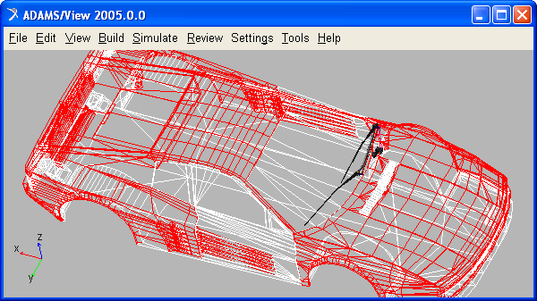

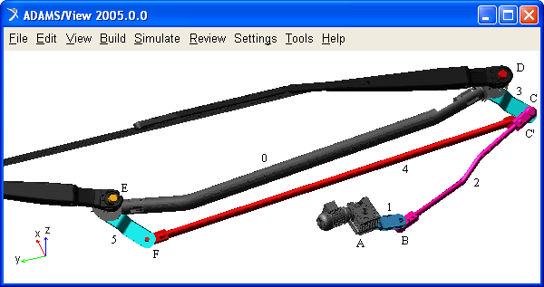

Figure 3: The virtual prototype of the windshield wiper system

The next step is for exporting the ADAMS plant files for the control application. The Plant Input refers the input state variable (angular_velocity), and the Plant Output refers the output state variable (control_torque). ADAMS/Controls save the input and output information in an “*.m” file (specific for MATLAB); it also generates a command file (*.cmd) and a dataset file (*.adm), which will be used during the simulation process.
With these files, the control system block is created in MATLAB/Simulink, in order to complete the link between the controls and mechanical systems. ADAMS/Controls and MATLAB communicate by passing state variables back and forth. ADAMS accepts the control inputs from MATLAB and integrates the mechanical model in response to them. At the same time, ADAMS provides the control torque information for MATLAB to integrate the Simulink model.
Analyzing - simulating the virtual prototype, a lot of measures that define the dynamic behavior of the windshield wiper system have been obtained. The simulation was achieved for a time interval long enough to catch all relevant motions during the virtual experiment, considering four complete rotations of the motor crank, and then the system is stopped in the parking position. For example, in the diagrams shown in figure 4, there are presented the time-history variations for the angular velocity of the motor crank and the crank turning moment (in Newton, meter, and second).
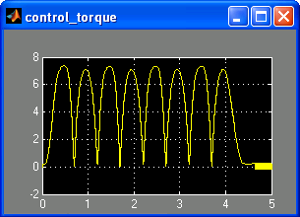 | 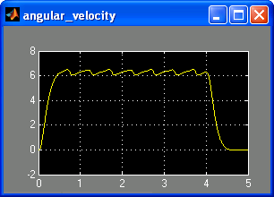
Figure 4: Specific results for the controlled virtual prototype

5. CONCLUSIONS

Such results allow evaluating and optimizing the dynamic behavior of the mechanical system, making easy virtual measurements in any point and / or area of the mechanism, and for any parameter (displacement, velocity, acceleration, force and so on). This is not always possible in the real cases due to the lack of space for transducers placement, lack of appropriate transducers or high temperature. In this way, we can quickly exploring multiple design variations, testing and refining until optimizing mechanical system, without going through expensive physical prototype building and testing. Virtual prototyping-based design tools allow to more quickly assessing form, fit, function, and manufacturability of suspension – steering systems throughout concept design, concept refinement, detailed design, release, and production. Virtual prototyping allows realizing the projected reductions in cycle times while maintaining and increasing the vehicle performance, safety, and reliability.
The result of virtual prototyping is that we are much better equipped to manage the risks inherent in the product development cycle. Traditionally, the amount of information concerning the actual performance of a new photovoltaic tracking system was fairly low throughout the tracker development process until the prototype and assembly stage. Then, behavioral information increased, and risk could be reduced through effective design changes. Unfortunately, late cycle changes are very expensive and error prone. With virtual prototyping, behavioral performance predictions are obtained much earlier in the design cycle, thereby allowing more effective and cost efficient design changes and reducing overall risk substantially

ACKNOWLEDGEMENT

The Romanian Ministry of Education financially supported the publishing of this paper in the frame of the CNCSIS research grant - code 1321 / 2006.

REFERENCES

- Alexandru C., Pozna C.: Dynamics of mechanical systems using virtual prototyping (in Romanian), Transilvania University Publisher, 2003.
- Alexandru C.: Design algorithm of the windshield wiper mechanisms of the passenger vehicles, Proceedings of the 10-th International Research/Expert Conference “Trends in the Development of Machinery and Associated Technology” TMT 2006, Barcelona-Lloret de Mar, Spain, p. 757-760, 2006.
- Haug E. J.: Computer aided kinematics and dynamics of mechanical systems, Allyn and Bacon, 1989.
- Haug E. J., Choi K. K., Kuhl J. G., Vargo J. D.: Virtual prototyping simulation for design of mechanical systems, Transaction of ASME, no. 117, p. 63-70, 1995.
- Pozna C.: Automated systems theory (in Romanian), MatrixRom Publisher, Bucuresti, 2003.
- Ryan R.: Functional virtual prototyping, Mechanical Dynamics Inc., Michigan, 2002.
- Schiehlen W. O.: Advanced multibody systems dynamics, Kluwer Academic, 1993.
- Shabana A.: Dynamics of multibody systems, John Wiley & Sons, 1988.
- Visa I.: Mechanical systems modelling as multibody systems in product design, Proceedings of the PRASIC’02 International Symposium, Transilvania University of Brasov, vol. lV, p. 255-263, 2002.
- *** Getting started using ADAMS/View & Controls, MSC Software, 2005.
- *** Wiper systems for commercial vehicles, Robert Bosch GmbH, 1997.

