NUMERICAL ESTIMATION OF LOAD CAPACITY OF THIN MICROFILTER-PLATES

Ádám Kovács
Budapest University of Technology and Economics, Budapest, HUNGARY, adamo@mm.bme.hu

Abstract: Load capacity, i.e. maximum bursting pressure of square-form, very thin perforated silicon-nitride microfilter-plate has been estimated with the help of finite element simulations. Large deflection analysis has been performed to determine a mathematical relationship between maximum normal stress arisen at the boundary and the normal stress at the middle point. For the latter stress a verified analytical estimate can also be given. Numerical simulations show that the number of perforations and the width of closed frame have no effect on the load capacity, if the perforation rate is constant and the number of perforations is not too small.
Keywords: perforated thin plate, MEMS, load-capacity

1. INTRODUCTION

Perforated thin plates are often used in various engineering applications. Some classical examples in the macroscale are material or fluid screens, heat exchangers and acoustic devices. They are also applied in micro-electromechanical systems (MEMS) for filtering purposes. The microfilter-plate is made from perforated or porous silicon-nitride (SiN) because of its high temperature and chemical stability as well as good mechanical properties (linear elasticity in a wide loading range and large fracture strength). Performance of filters highly depends on the perforation rate, being defined as the perforated area over total area of the plate. In order to obtain better filtration the perforation rate should be as high as possible [1] which diminishes the strength, and consequently, the load capacity of the plate. This load capacity is equivalent by the critical (bursting) pressure p_{crit}, that causes failure of the plate. Adequate methods should be used in the design to estimate the critical pressure. In microfiltration the side-length of plates are some order greater than the thickness (), therefore classical thin plate theories can not be applied effectively to perform strength analysis. A challenging mechanical problem is the treatment of the very large deflection of the membrane due to even small pressure. Exact solution for this problem is not known.
Van Rijn et al. [2] worked out an analytical approximation for the maximum deflection and maximum load by combining a fixed-edge beam problem with a simply-supported thin plate. Unfortunately, the estimates do not fit well to the results of experiments. Gaspar et al. [3] investigated multilayer thin-film membranes as a strip and gave an analytical formula for the deflection function only. Yang and Paul [4] reported a semi-analytical method applied for long plates, where the maximum stresses were determined with finite element simulation. In this paper we show a simple method to predict p_{crit} analytically from the normal stress at the middle point of the plate using stress coefficients obtained from numerical simulations. The effect of the number of perforations at constant perforation rate as well as the width of closed frame of the plate on the critical pressure is also investigated.

2. MECHANICAL MODELING

The structure under consideration was realized by low pressure chemical vapor deposition (LPCVD), a well-known process in MEMS technology. Low stress silicon-nitride layers were used as free-standing plate material. Perforations and backside were etched for bulk micromachining process (Fig. 1). In order to increase mechanical stability of the plate an additional not perforated (closed) frame was used at the rim.

Elastic modulus E and tensile strength σ_{B} for SiN_{x} materials show a great variety in the literature [5,6]. In order to determine the elastic modulus E experiments have been carried out. only the maximum deflection of the plate and the bursting pressure could be measured. Since
Figure 1: Schematic view of the structure

The simplified model of the structure is shown in Figure 2. Constant manufacturing parameters are the height (), the bottom width () and the inclination angle (°) of the wafer. Variable dimensions are the length L, the thickness h of the plate and the width of the closed (unperforated) free frame. Experiments have shown [7] that the variation of these quantities have essential effect on the mechanical response of the plate.

The external loading of the plate is a steady-state and homogenous pressure. Strength analysis is needed to determine the stresses in the plate. The thick wafer has been assumed to be perfectly rigid with respect to the very thin plate and therefore the edges of the plate were kept to be fixed.

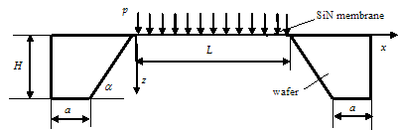

Figure 2: Simplified model of the structure

Because of the simple geometry analytical estimates based on the von Kármán plate theory using Ritz-method can be given for the deflection and the normal stress at the middle point of the fully closed plate [8] as follows:
, (1)

, (2)
where p is the applied pressure and E is Young’s modulus.
Since the material is a brittle ceramic, the Navier (greatest normal stress) criterion is used to predict failure:
, (3)
where is the fracture strength of the material. Because of the very large fraction L/h bending stresses vanish from the stress distribution except of the very narrow band at the rim, where the plate is almost fixed. The maximum principal stress arises probably within this band. Since Ritz-method is based on trial displacement functions, it is not suitable to predict within an acceptable tolerance. In order to calculate it finite element simulations were performed. The symmetries of the plate allow to mesh only one quarter of the plate as it is seen in Fig. 3.

Some thousands of linear thin shell elements were used to mesh the quarter-plate and a nonlinear finite element procedure using total Lagrange description was performed to calculate the stress distribution in the plate. What the load capacity concerns, only the maximum principal stress and - for verification purposes – the normal stress at the middle point of the plate is interesting.
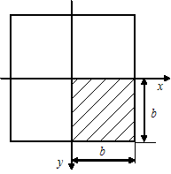

Figure 3: Simplified model of the structure

Since these stresses are obviously proportional each to other, the following formula is assumed to describe the relation between the stress expressed in Eq. (2) and :
, (4)
where C_{σ} is a calibration parameter, defined as the rate of the normal stresses in the midpoint of the plate calculated by finite elements and by Eq. (2) and determined as result of the numerical simulation. The load capacity is then estimated by expressing from Eq. (4), substituted into Eq. (2) and combining with Eq. (4). Finally, we obtain the following formula for p_{crit}:
. (4)
In the case of perforated plate Eq. (5) is used with the material parameters E_{p} and σ_{Bp}. Based upon numerical simulations the following empirical formulae are recommanded [9]:
, (5)
, (6)
where P is the perforation rate (area of perforations/total area of the plate) and constants e and f are determined by the numerical simulations. It is worth to note that Eq. (1) is suitable to evaluate Young’s modulus, if the deflection w₀ is measured.

3. NUMERICAL SIMULATION

In order to show the applicability of the above method and to investigate of the effect of some topological parameters of the perforated plate on the results a physically realized closed structure with the geometrical and material parameters shown in Table 1 was analyzed.

Table 1: Geometrical and material parameters of perforated plate
Parameter name | Symbol [unit] | Value
Length | L [µm] | 1700
Thickness | h [µm] | 263
Young’s modulus | E [GPa] | 220
Poisson ratio | ν [−] | 0.25

3.1. Effect of perforation topology

In the finite element model of the quarter-plate linear triangular SHELL4 elements were used. The numerical simulations were performed with the commercial finite element package COSMOS/M v2.6. First the width of closed frame (cf. Fig. 1) was changed within 10...350 µm. The pressure was kept to be constant: p = 400 mbar. Figure 4 shows the comparison of the dimensionless maximum deflection () and normal stress () in the midpoint and the maximum principal stress () of a perforated plate with perforation rate P = 0.1923. In all cases the values in the denominator correspond to the fully closed (unperforated) plate.
Figure 4: Effect of closed frame width on the mechanical response

As it is seen maximum both deflection and stresses change within a very narrow band and therefore this effect can be neglected. Second, the effect of the number of perforations (N) at constant perforation rate was analyzed. The same perforation rate was used with N = 4, 64, 256 and 1024 holes. Figure 5 shows the finite element meshes respected to the four cases investigated.

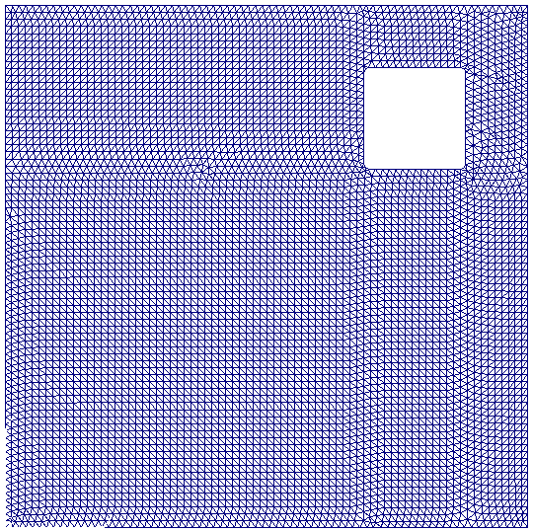 | 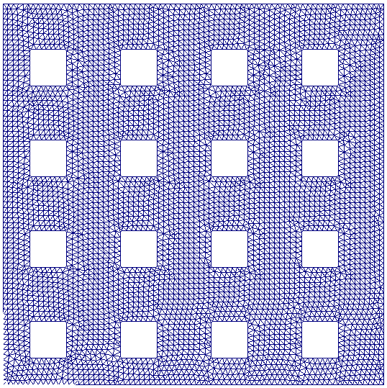
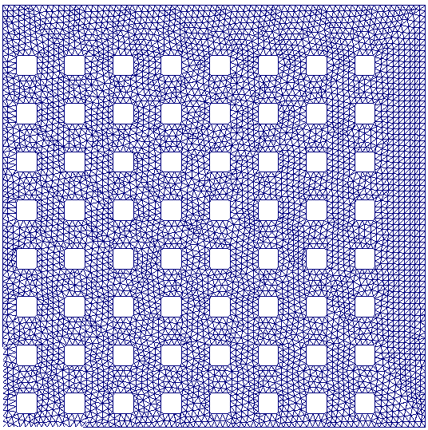 | 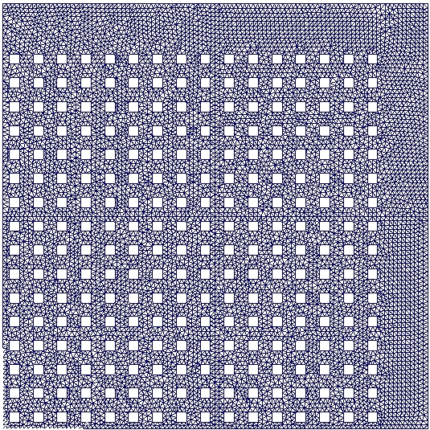

Figure 5: Finite element meshes of perforated quarter-plate

As a reference Fig. 6 shows the variation of the maximum principal stress along the half symmetry axis. Figure 7 shows the same stress distribution in the case of N = 64. The presence of holes modifies the stress distribution, because local maxima occur about at the line of the edges of holes, however, maximum principal stress arise at the same place, i.e. at the edge of the plate. This maximum is clearly greater than the maximum in the unperforated plate.
Figure 6: Stress distribution along the half symmetry axis in unperforated plate

Figure 7: Stress distribution along the half symmetry axis in perforated plate (N = 64)

Finally Fig. 8 shows the effect of the number of holes on the maximum principal stress. The figure contains a dimensionless stress, as was divided by the applied pressure p. Although the stress shows a slight variation as N is changing, the difference between the two limit cases is less than 5%. It seems that the number of holes plays no role in the value of the load-capacity.
Figure 8: Effect of hole numbers on the maximum principal stress

3.2. Calculation of load-capacity

An example for the application of the method presented in Chapter 2 is now shown. Experiments were made by Van Rijn et al. [2], therefore the dimensions differ from those in Table 1. Figure 9 shows the inverse of the critical pressure as function of plate length for the unperforated and perforated cases. Squares and plus signs correspond to measured values, while continuous and dashed lines refer to the estimated values.

Figure 9: Measured and predicted load-capacity
Finite elements simulations resulted in the following powers in Eqs. (5), (6): e = 1.2, f = 2.0. As it is seen in Fig. 9 a good correlation between experimental and theoretical values was obtained, which proves the applicability of the above method.

4. CONCLUSION

The theoretical prediction of load capacity of perforated thin plates requires numerical simulations in order to find appropriate mathematical relation between the maximum principal stress and the normal stress arisen in the midpoint of the plate. Once this relationship has been established, the load capacity can be estimated from measured or simulated mechanical response of an unperforated plate. The topology of perforations seems to play no role in the mechanical response.

ACKNOWLEDGMENTS

This work has been financially supported by the National Scientific Research Fund (OTKA) under contract no. T49848, which is highly appreciated. The author would like to thank A. Kovács (IAR HS Furtwangen, Germany) for the experimental realization of the structure.

REFERENCES

- Van Rijn, C.J.M.: Nano and Micro Engineered Membrane Technology, Elsevier, 2004.
- Van Rijn, C.J.M., Van der Wekken, M., Nijdam, W., Elwenspook, M.: Deflection and maximum load of microfiltration membrane sieves made with silicon micromachining. J. of Microelectromechanical Systems, Vol. 6, No. 1, pp. 48-54, 1997.
- Gaspar, J., Ruther, P., Paul, O.: Mechanical characterization of thin-film multilayer membranes. Mikrosystemtechnik Kongress, 10-12 Oktober 2005, VDE Verlag, pp. 109-112, 2005.
- Yang, J.L., Paul, O. Fracture properties of LPCVD silicon nitride thin films from the load-deflection of long membranes, Proc. of Transducers'01, Munich, Germany, June 10-14, pp. 1394-1397, 2001.
- Yi, T., Kim, C-J.: Measurement of mechanical properties for MEMS materials. Meas. Sci. Technol., Vol. 10, pp. 706-716, 1999.
- Sharpe Jr., W.N.: Tensile testing at the micrometer scale. Experimental Mechanics, Vol. 43, No. 3, pp. 228-237, 2003.
- Kovacs, A., Kovacs, A., Pogany, M., Mescheder, U.: Realization and mechanical investigation of perforated and porous membranes for filter applications. Proc. of Eurosensors XX, Gothenburg, Sweden, September 17-2006, to appear.
- Ugural, A.C.: Stresses in Plates and Shells, McGraw-Hill, Boston, 1999.
- Kovács, Á., Kovács, A., Mescheder, U.: Estimation of elasticity modulus and fracture strength of very thin perforated SiN membranes with finite element simulations. Computational Materials Science, submitted.

