THE ELECTRICAL CONDUCTIVITY OF SOIL MEASUREMENT WITH THE VIRTUAL INSTRUMENTATION

B. Braun¹,C, Turcu¹, C. Drugă¹
¹ “TRANSILVANIA” University of Brasov, ROMANIA e-mail: braun@unitbv.ro, cturcu2000@yahoo.com, druga@unitbv.ro

Abstract: The paper followed the soil electrical conductivity study, in order to obtain the tracing map of the soil conductivity, usable for the farming management. This kind of maps permits to stand out the different electrical conductivity areas, this soil property, finally, having connection with the agricultural productivity. The measuring methods could be simplified using a virtual instrument who permits the introducing in soil of an electric voltage, via two external electrodes, and also the voltage variation reading through the two internal electrodes, in line with the first two external electrodes.
Keywords: farming, virtual instrument, electrodes, conductivity

1. INTRODUCTION

The variability of the agricultural grounds characterization and its consequences about the production, resources use and efficiency reducing are possible in farming of precision. Due to the technical realizations in plants growing, production monitoring, geographical information systems (GIS,), global positioning (GPS) and tele-detection.
The precision farming involves a systematical approach of the invoked factures biological, ecological and socio-political factures (Singh and Thornton, 1992) and it has as characteristic elements the spatial and temporal factors. It appears like an farming inputs reducing necessity, due to the economical, loyal, environment protection pressure and also about the farming system control.
Systematically, the precision farming includes all the other researching and interpretation methods of the experimental results, starting from remarks, experiments, statistical and spatial analysis, systematical approach, processes modeling and simulation, to top spatial technologies use.
Precision farming has as issue the soil resources, water and chemical inputs using optimization, on specific local bases and it has as goals:
- increased and quality production obtaining, constant in space and time;
- economical profits optimization;
- integral environment protection;
- farming systems durability increase.
The research made in precision farming area demonstrated the connection between the physic-chemical soil properties and its electrical conductivity.
In fact the soil electric conductivity is provided in the water layer who fills the pores between the soil particles.
The electric conductivity is influenced by a lot of soil properties (McNeil,1992): porosity, water continence, salinity level, changing ion capacity, temperature.
In precision farming, the mobile sensors were used for the first time as a method for the soil electric conductivity standing out, in order to obtain some non-direct measurements of any researched soil properties.
Indifferently what the method was used for the data storage referring to the soil electric conductivity, there are passed through an analog – digital converter to a PC, who records the date, associated with the given location by a global positioning differential system (GPS).

2. EXPERIMETAL EQUIPMENT

For the laboratory studies, but also on the ground it was necessary a variable voltage source, with both AC / DC alimentation.
The signal generator was realized in order to permit the measuring mode influence study about the obtained results, standing out three blocks: the oscillator, the final amplifier and the connection board.

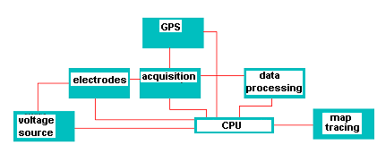
Figure 1: Bloc scheme of the used equipment

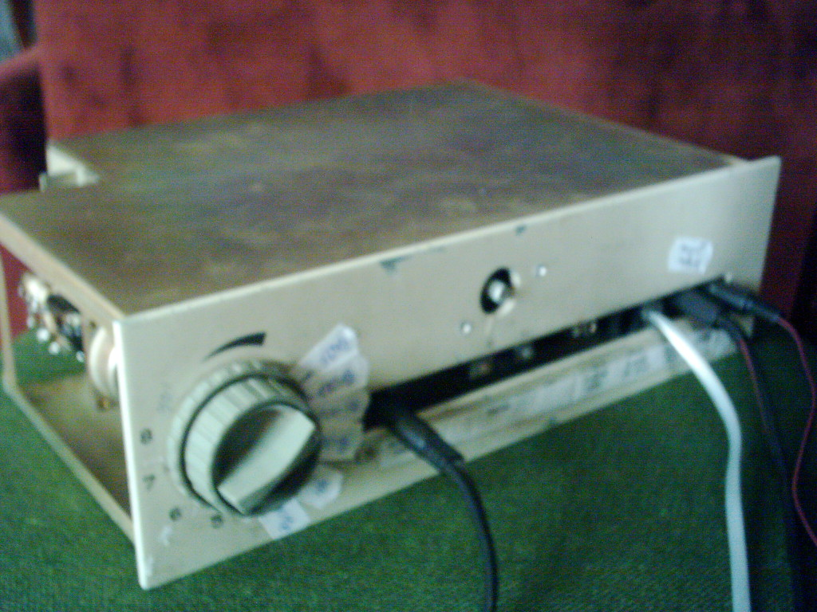

Figure 2: Signal generator

The oscillator having the electric scheme, presented in the figure 3, can generate a sinusoidal or rectangular signal.
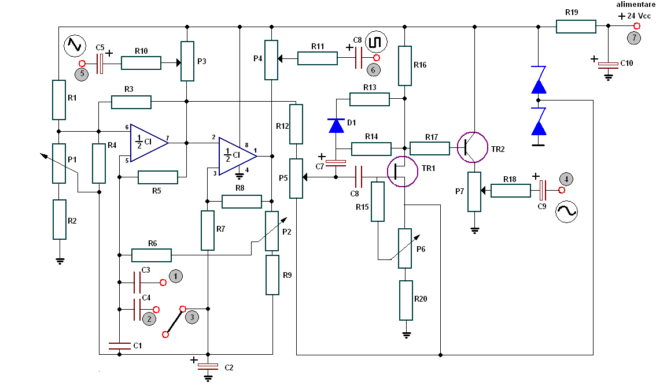

Figure 3: Signal generator oscillator

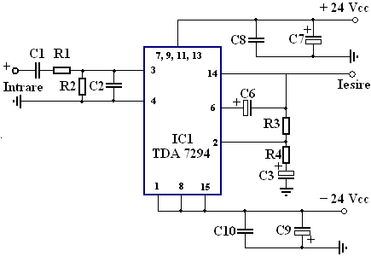
Figure 4: The final amplifier

As measuring principle of the soil resistivity, it was proposed the four electrodes method. The current which intensity is known, is introduced in soil, via two electrodes, 1 and 4. Measuring the voltage level produced by this current between the 2 and 3 electrodes, the soil electric resistivity is determined.
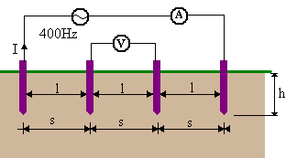

Figure 6: The four electrodes method

For the 4 electrodes introduced in soil we have the following equation:

$V=\frac{ρ}{4π}\left(\frac{1}{s}+\frac{2}{\sqrt{s^{2}+4h^{2}}}−\frac{2}{\sqrt{4s^{2}+4h^{2}}}\right)=\frac{ρ}{2⋅π⋅s}$, if h <<s (1)

So the offered resistance between the electrodes 2 and 3 is:

$R=\frac{V}{I}=\frac{ρ}{2⋅π⋅s}$ (2)
where $ρ=2⋅π⋅s⋅R$ [Ω m] is the soil resistivity and $σ=\frac{1}{ρ}$ is the soil conductivity [Sm⁻¹].
The equipment for the electric conductivity measurement of the soil was made for high deep determinations. For the equipment supplying it was used an UPS and a transformer, the input voltage being 24 V (AC).
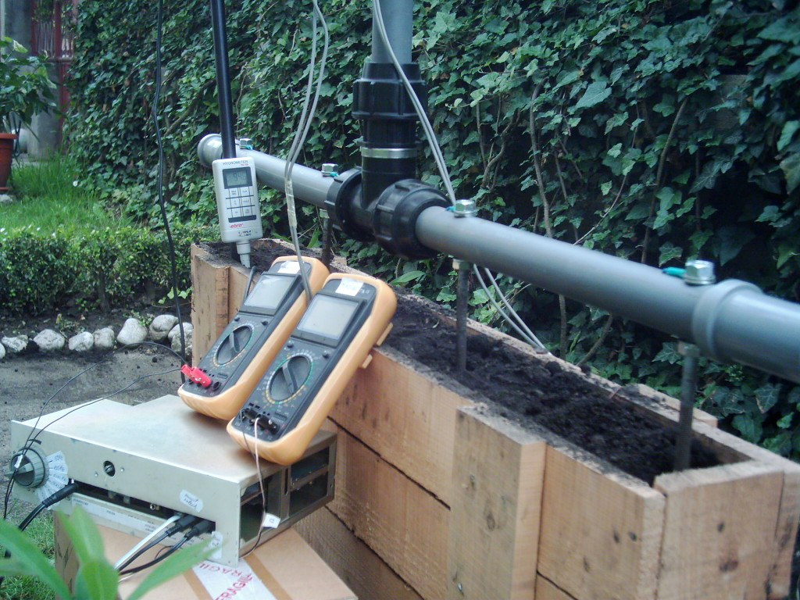
Figure 7: The static equipment for the electric soil conductivity measuring
- THE VIRTUAL INSTRUMENT FOR THE AIDED BY COMPUTER MEASURING

In laboratory conditions it was made a virtual instrument for the for the electric conductivity values displaying. For this reason, it was used Lab VIEW 7.1 programming software, produced by National Instruments. The main concept of Lab VIEW is the virtual instrument, who, in this case, accesses the LabJack device, being an easy to use interface between the PC and the physical environment.
The virtual instrument issue is for the 1 and 4 electrodes supplying, with a continuous voltage, having values between 0 and 5 V, selectable by the user, accessing the control tensiune de alimentare. At a simple program running, the acquisition board generates to the AO₀ analog input, the voltage being indicated by user. This signal is applied to the electrodes 1 and 4, on which is measured the electric current intensity, who is measured using the analog input AI₁, having the 1 SE channel selected. The voltage level on 2 and 3 electrodes can be readed to the AI₀ analog input, with 0 SE active channel selected.
The program contains a virtual switcher for the following reading validation could be executed by the user asking.
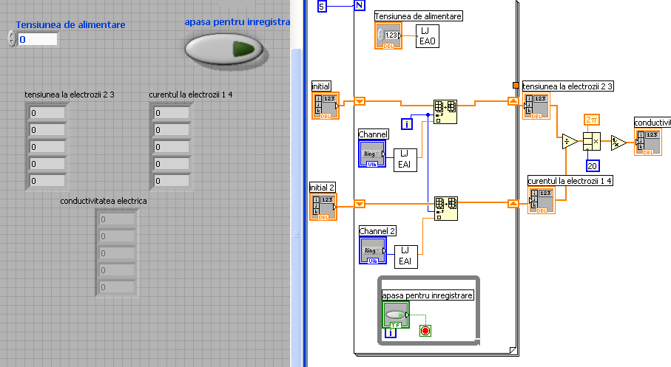

Figure 8: The panel and diagram windows of the used virtual instrument

3. CONCLUSION

The realized study follows, finally, using this method, the directly measuring to the soil area of the conductivity , in order to obtain of a 3D chart from each it can result all the soil properties. Once the chart was obtained, it will be possible to draw a conclusion regarding the necessary water and chemical substances assurance, for the soil fertilizing.

REFERENCES

[1] Ursuţiu, D Iniţiere în LabVIEW. Programarea grafică în Fizică şi Electronică, Editura Lux Libris, 2001;

[2] Cottet, F.; Ciobanu, O. Bazele programării în LabVIEW, Editura MATRIX ROM, Bucureşti, 1998;

[3] Sava, T. Clubul utilizatorilor LabVIEW – Tutorial, http://www.labsmn.pub.ro

