VIRTUAL INSTRUMENT FOR THE TEMPERATURE MEASUREMENT

B. Braun¹, C. Drugă¹, C. Turcu¹, M. Cismaru¹
¹ “TRANSILVANIA” University of Brasov, ROMANIA, e-mail braun@unitbv.ro, druga@unitbv.ro, cturcu2000@yahoo.com, cismaru@unitbv.ro

Abstract:.The paper presents a method for the fluid temperature measurement .It was token as an example the measurement of the water temperature , who was introduced into a thermometric trough, with a Pt 100 thermo-resistance. The method invokes two steps: The first one consisted in the resistance measurement with the water temperature increase, at regular time intervals. The other step to simulate aided by computer the temperature evolution depending by the resistance and also, simultaneously with the temperature evolution in time simulation. LabVIEW 7.1 was the software used in order to create a virtual instrument for the simulation. It permitted to display the corresponding temperature values depending by the resistance variation and also the graphic representation for the temperature with resistance variation, simultaneously with the graphic representation for the time evolution in time
Keywords : thermo-resistance, temperature, virtual instrument, simulation

1. INTRODUCTION

The thermo-resistive transducers functioning is based on the property of (semi)conductive materials (in this case, the Platinum) to modify their electrical resistance with the temperature variation. Generally, the metals resistivity increase with their temperature increase. The (semi)conductive metals have a positive temperature coefficient; in case of electrolytes of the semiconductors and isolated materials , it decrease with the temperature increase, having a negative temperature coefficient.
The electric resistance is a depending by temperature function, R = R(θ), who can be expressed in Taylor series around a reference temperature, θ₀.

$R=R_{0}⋅[1+α⋅(θ−θ_{0})+β⋅(θ−θ_{0})^{2}+γ⋅(θ−θ_{0})^{3}+\text{.}\text{.}\text{.}]$ (1)

and if θ₀ = 0°C, the following equation is obtained:

$R=R_{0}⋅(1+α⋅θ+β⋅θ^{2}+γ⋅θ^{3}+\text{.}\text{.}\text{.})$ (2)

The α, β, γ,… coefficients have constant values for any temperature intervals.

Table 1: Thermo-resistive characteristics of some materials
Material | Temperature interval |  | Resistivity at 0°C  (R₀) [Ω m] | Report value R₁₀₀/R₀ | Temperature coefficients
Material | min | max | Resistivity at 0°C  (R₀) [Ω m] | Report value R₁₀₀/R₀ | α | β | γ
 |  |  |  |  | [1/°C] | [1/°C] | [1/°C]
Platinum | -190 | 630 | 0.0983 10⁻⁶ | 1.391 | 3.83 10⁻³ | -0.58 10⁻⁶ | -3.14 10⁻¹²
Nickel | -100 | 300 | 0.0638 10⁻⁶ | 1.617 | 5.43 10⁻³ | 7.85 10⁻⁶
Copper | -30 | 150 | 0.0178 10⁻⁸ | 1.426 | 4.2 10⁻³ | --

For a restricted temperature interval, the temperature coefficient α is considered as a constant, so the transducer resistance is given by the following equation:
$R=R_{0}⋅(1+α⋅θ)$ . (3)
where the temperature coefficient α =3,85 10⁻³ 1/ degree.

Table 2 The nominal characteristics of Pt 100
Nominal characteristic | Measuring unit | Value
Resistivity | Ω m | 0,0983
Electric resistance at 0° (R₀) | Ω | 100
Electric resistance at 100° (R₁₀₀) | Ω | 139.1
R₁₀₀/ R₀ report | -- | 1.391
The average temperature coefficient for the (0÷100°C ) | 1/°C | 3.91-10⁻³
Using temperature interval | °C | -200 ÷ +630

2. THE EXPERIMENTAL INSTALATION

The experimental equipment is composed by a thermometric through, for oil or water, type TB 101, a thermo-resistance Pt 100, a thermo-plunger and a digital multi-meter

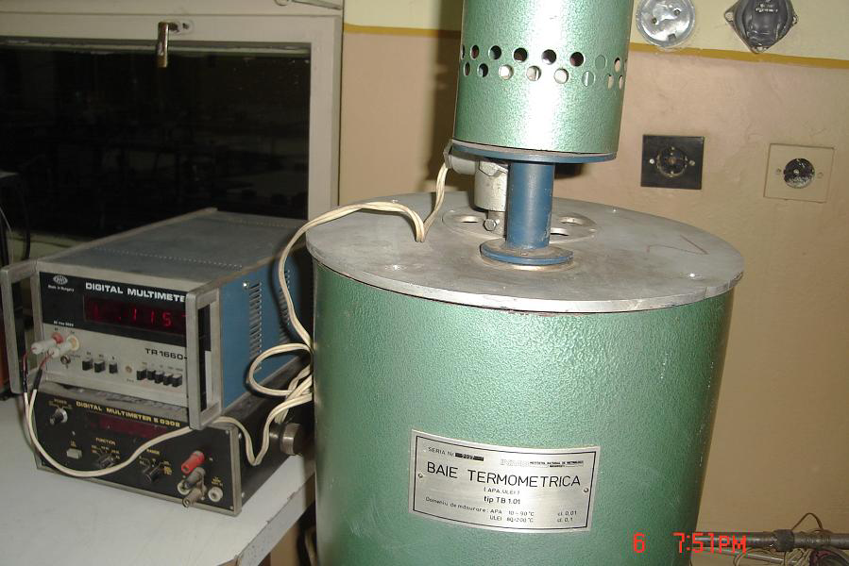
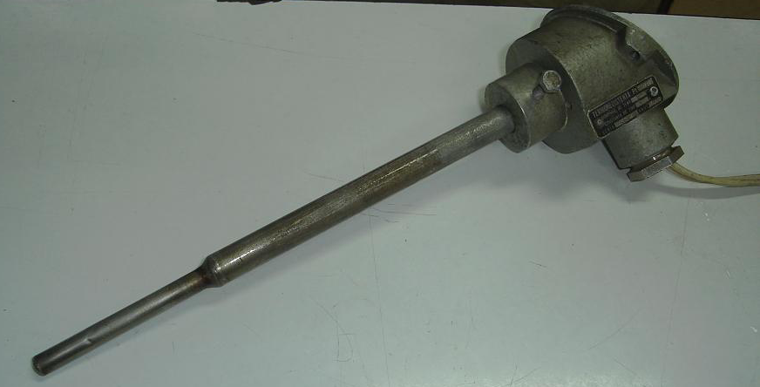

b)

a)

Figure 1: The used experimental equipment: a) the thermometric through coupled to the multi-meter,
b) the thermo-resistance

3. THE RESISTANCES MEASURING

For the beginning it was introduced about 4 l of water into the thermometric through, who was warmed up until the its boiling limit, while, at regular time intervals (each minute) with the multi-meter it was measured the resistance . The following results were obtained:

Table 3 : The obtained resistance values during the water warming up, at regular
moments
Measuring regular moments [minutes] | Measured resistance (R) [Ω]
0 | 107
1 | 107.25
2 | 107.75
3 | 108.75
4 | 110
5 | 111.5
6 | 113.5
7 | 116
8 | 119
9 | 122
10 | 125.5
11 | 129.5
12 | 133.5
13 | 138
14 | 139

4. THE TEMPERATURE EVOLUTION SIMULATION

In the Lab VIEW 7.1 software was made the simulation of the evolution T[°C] – R[Ω] and T[°C] - τ[min].First of all it was created the programming for the virtual instrument.

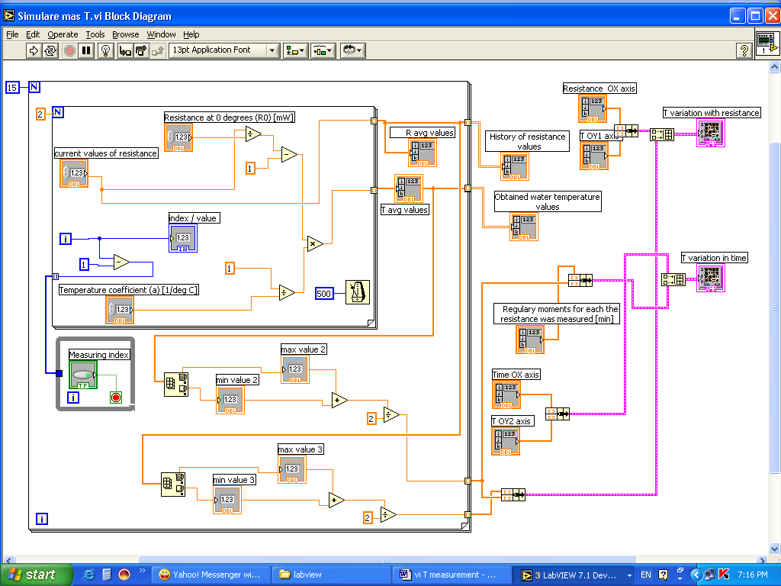

Figure 2: The diagram programming for the simulation virtual instrument

Corresponding to the specified values in the Table 3, by simulating were obtained in the panel the variation temperature values. It can be observed that the temperature – resistance variation is linear and the in time temperature evolution in non-linear.
Figure 3 shows the panel of the virtual instrument of the application.

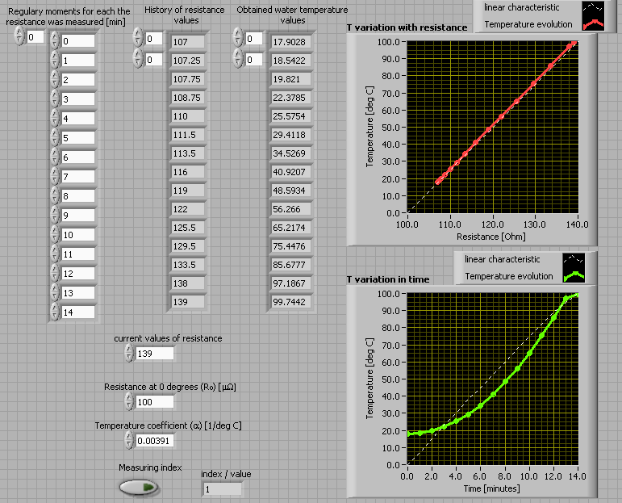

Figure 3 The panel of the phenomena simulation

5. CONCLUSION

The presented application can be successfully used for didactic goals , for the laboratory work sessions for different domains, like: Electrical measuring of the non – electric systems , Metrology, Sensors and transducers.
It is a good example for the simulation, via virtual instrumentation, of frequently laboratory phenomena.

REFERENCES

[1] Iordache, P: Măsurarea electrică a mărimilor neelectrice – curs, Univ. „TRANSILVANIA Brasov, 1992

[2] Roşca, I., Iordache, P, Cristea, L: Îndrumar de metrologie, Univ. „TRANSILVANIA Brasov, 1996

[3] Ursuţiu, D: Iniţiere în LabVIEW, Ed. LUX LIBRIS, Brasov, 2001.

