modular reorganisation of the automatic system for the micro-bearings dimensional inspection

Cristea LUCIANA¹, Baritz MIHAELA,ROSCA ILEANA²
^{1,2} Department of Fine Mechanics and Mechatronics TRANSILVANIA University of Brasov
500036, Brasov, 29 Eroilor Bd., Romania, lcristea@unitbv.ro

Abstract: The national programme “Engineering and nanosciences” paves the way for a field of applied and basic research, characterized by varied technical applications. The new production has to undertake a continuous quality improvement due to its major economic involvement; the consequence consists in high performances in the quality assurance. The new idea of product quality assurance as well as the control effectiveness lay down the necessity of a strong interaction and integration among different branches of engineering. The structure effectiveness for processing and control is worldwide a top concern. The results presented in here illustrate some possibilities of reorganisation, structural optimisation and functioning in case of quality increase in the micro-bearing with promoting and developing the use of micro-systems of high precision for the special bearing production.
Key words: Dimensional inspection, micro-bearings, automatization, modular structure, micro-systems.

1. Theoretical aspects

Miniature bearings and micro-bearings are of great utility in constructing measuring instruments and, in general, in constructing Microsystems.
Miniature bearings have to answer the general conditions of bearings, as well as the special ones, which depend upon the conditions of practice specific to the Microsystems whom they belong to. Their dimensional properties are comprised between 0.5 and 30 mm, with working up accuracy of 1…2µm. One of the important factors in designing, using and developing Microsystems or miniature bearings as system components, consists in quality.
In producing miniature bearings, the accomplishment of a complete inspection, of high precision and productivity, stands for an essential characteristic, for an indispensable factor of the scientific management of the production process, as well as of the maintaining and raising the quality of the products to a proper level.
The new idea of products’ quality insurance as well the control effectiveness lay down the necessity of a strong interaction and integration among different branches of engineering.
The quality of Microsystems is measured by the precision of their geometrical parameters and, in order to enhance them, testing and controlling Microsystems of high performance are required.
As an integrated field, the automatic inspection devices include the classic mechanic engineering, electronics and computer field in designing, control and evaluation for these systems.
The bearing industry achieved in our country special results in the automatic inspection devices field. The currently used automatic drive systems are manufactured for concrete service and are equipped with elementary components.
The control methods used for miniature bearings have to secure the accomplishment of the special conditions required by the characteristics of the measuring (some slight measuring errors, narrow measuring field, diminished tolerance zone).
Taking into account these characteristics, as far as the miniature bearings industry is concerned, we recommend so-called classical methods (with contact), as well as methods with no contact (optical). The micro-objects may not be handled so easily as a tool of regular size. In order to accomplish these operations we need adequate gripping elements, such as micro pliers, and gripping nozzles.
The flexibility of the control devices is achieved through the “modular structure” concept.
The application of this concept makes possible the standardisation and merging of the complex, multiparametric control devices structure.
The performed analysis allowed the transition to a reorganisation of all constituent subassemblies of the automatic system in order to modulate and insure a better flexibility and a higher estimation of the results based on the achieving of a control PC-endowed system, with developing plates and performed acquisition systems.

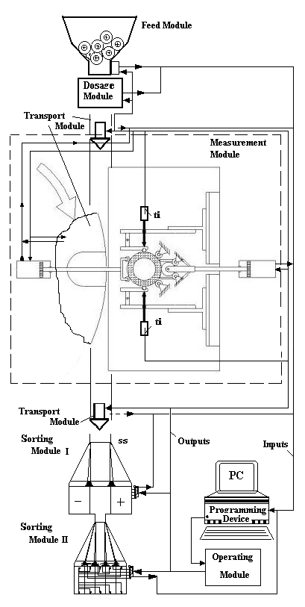

Fig. 1 The block chart of automatic dimensional control system.

2. EXPERIMENTAL RESULTS

Through the modulating of the component subassemblies and the using of microelectronic systems with the world wide highest performances for control and drive and based on a detailed analysis of the automate control systems, we consider as necessary the improvement of the control devices for micro-bearings and redesign modular and flexible micro- dimensional control systems. Figure 1 presents the block chart of this dimensional control automatic system. All modular devices are defined in order to execute the inspection operations in correlation with all parts in group.
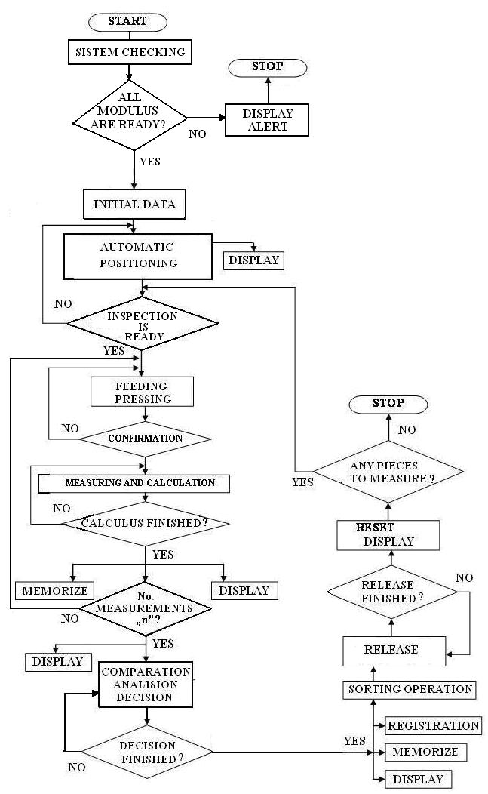

Fig 2. Logical diagram for dimensional inspection.

The performed researches aimed at an original method of grouping the parts based on the relation between dimensional micro-inspection process characteristics and modular design of all micro-control equipments with a high universality and flexibility degree.
In designing the process, we emphasize that the modular control station could be organized as follows: All modularly and flexibly organized devices; Modular device designed in the most propitious way for each families of parts; Measuring and automation checked by an electric computer controlled device; High accuracy of operating; Interchangeable modulus; Different measuring and control transducers and sensors to be used; High productivity and efficiency.
The control station could be organised as follows:
- The achieving of many measuring types to make possible the mounting of various control heads ( the out of roundness measuring of the inner and external diameter of the conic and radial bearings; the taper measuring of the conic bearing race; the quality of the bearing race surface measuring; the mounting height measuring of the conic bearings; the measuring of the radial and conic bearing rings).
- The use of different measuring transducers; capacity transducer; transducer with electric contact; electro-pneumatic feeler; optic transducer.
- Makes possible the control head positioning, depending on the measuring variant, using an electric computer controlled device, which is built up of a step by step motor and a rack.
The computer processes all the information, testing the analysed system and setting the working parameters to obtain an optimised mechanical system.
The control system developed for the automatic control device, took in account the followings:
- The configuration of an automatic device of some mechanic devices such as the: supplying, dosage, sorting, etc, depending on the needs.
- The control of a larger product range from the same category or a similar one.
- The control according to one parameter or multiparametric, arranging the pieces in classes.
The design of improved control systems for the control automatic device has taken into account the following issues: the configuration of an automatic device with a certain number of mechanic modules - for supplying, distribution, sorting, etc, depending on the user’s needs; it makes possible the checking of a larger product range from the same class or similar ones; it makes possible the checking according to one single parameter or a multi-parameter one, with many sorting possibilities of the codes, such as, the classification and the sorting in n dimensional classes according to the control criteria.
Special attention is dedicated to the analyses of dimensional control technology and product characteristics in order to segment the parts into homogenous groups of products with similarly technological characteristics based on concept of group technology.
By correlating the influential factors of parts assortment and measuring and control equipments, suitable for computer implementing, the results necessary for a modular designing are obtained.
The analyses that have been carried out allowed a reorganisation of automatic dimensional control systems by modulating the component subassemblies and using microelectronic systems with the worldwide highest performances for control.
This system is based on client – server concept. By means of the user’s interface, the client (user) gives inputs of de information system. The user has the possibility to input data concerning his/her own application (part, measuring and process characteristics). After that, the main menu of the system works with data bases of parts, measuring and automation process, modular device projects and gives the process results for the most propitious dimensional control structure.
Figure 2 shows the logical diagram of the interactive work inspection. This new method was tested in the bearing and assembling component production.

3. CONCLUSIONS

Dimensional inspection in series manufacture imposes the use of the measuring and sorting automations. Through the research carried out we have intended a particularly modern approach of the automated inspection systems, vouched for miniature bearing, by means of choosing a unitary, modular design, of the highest degree of universality.
The main purpose of this research is to generate optimised automatic inspection systems for more mechanical efficiency. This system is reorganized to meet the international trends in achieving the automatic control systems.

References

- Balachandra R.: Modular Design and Technological Innovation, The Information Storage Industry Centre, Report 2002-02, Univ. Of California 2002.
- Luciana CRISTEA, Angela REPANOVICI, Ciprian OLTEANU, Ioan CURTU, Dimensional inspection Microsystems for miniature bearings, Revista Mecatronica nr. 3/2004, ISSN 1583-7653, 2004, pag 36-39.
- Luciana CRISTEA - Considerations regarding the improvement of thrust bearings automatic dimensional inspection, Acta Technica Napocensis, Series: Applied mathematics and mechanics, 49 Vol-III/2006 ISSN1221-5872.,2006, pag. 737-740,
- Wolfgang Osten Optical Measurements Systems for Industrial Inspection IV ISBN:0819458562, Publisher: Society of Photo Optical , 2005

