THE ANALYSIS OF THE BARE AND GEAR WINDSHIELD WIPERS MECHANISMS, USING MULTIBODY SYSTEM METHOD

Adrian-Constantin BUTA¹, Petre ALEXANDRU²
Transilvania University of Braşov, Dept. of the Product Design and Robotics
e-mail: ¹acbuta@unitbv.ro, ²alex.p@unitbv.ro

Abstract: The paper presents an analysis of the windshield wipers mechanisms, with Multi-Body System method. This method can be easy apply to all the types of the mechanisms, indifferent by structure [1, 2], configuration or complexities – linkage windshield wiper mechanism, linkage and grooved roller windshield wiper mechanism or bar and gear windshield wiper mechanism.
Keywords: mechanism, wiper, windshield, gear, Multi-Body System.

1. INTRODUCTION

The diversity and the complexity of the windshield wiper mechanisms are very large, from linkage windshield wiper mechanisms (with evident advantages – the simple construction, secure functionality to many work speeds, the high reliability), to windshield wiper mechanisms with linkage and grooved roller or the bare and gear windshield wipers.
The paper is a continuation of the precedent papers „The analysis of a linkage windshield wiper mechanism using the Multi-Body System method” and „The analysis of a windshield wiper mechanism with linkage and grooved roller, using the Multi-Body System method”.
The objective of the present paper is to analysis with Multi-Body System method, the bare and gear windshield wiper mechanism use by Mercedes Benz Elegance [4]. Beside with other analysis methods, modeling the windshield wipers mechanisms with Multi-Body Systems result a small number of the geometrical and kinematical restriction equations.

2. THE GEOMETRICAL DETERMINATION

The bare and gear windshield wiper mechanism will modeling MBS with minimal number of body [3] and result the six body (one fixed, the ground, and five mobile), like figure 1.
Each body has one specific reference system. For the fix body „0” (fig. 2) the reference system XOY is parallel with the passenger car reference axis and the body is definite by $A\left(0,0\right)$, $F\left(X_{F},Y_{F}\right)$ and $R_{F}$.
The input body „1” is definite in the reference system $X_{1}0_{1}Y_{1}$ by $A_{1}(X_{A_{1}}^{(1)}=0,Y_{A_{1}}^{(1)}=0)$, $B_{1}(X_{B_{1}}^{(1)},Y_{B_{1}}^{(1)}=0)$ and its the position angle $ϕ_{1}$ (fig. 3). The figure 4 present the output body „2” who is definite in the reference system $X_{2}0_{2}Y_{2}$ by $L_{2}(X_{L_{2}}^{(2)}=0,Y_{L_{2}}^{(2)}=0)$, $M_{2}(X_{M_{2}}^{(2)},Y_{M_{2}}^{(2)}=0)$, $M_{2}^{'}(X_{M_{2}^{'}}^{(2)},Y_{M_{2}^{'}}^{(2)}=0)$ and its the position angle (who need calculate) $ϕ_{2}$.
The complex bodies „3” „4” and „5” are definite in its reference systems $X_{3}0_{3}Y_{3}$, $X_{4}0_{4}Y_{4}$ respective $X_{5}0_{5}Y_{5}$, the points $B_{3}(X_{B_{3}}^{(3)}=0,Y_{B_{3}}^{(3)}=0)$, $C_{3}(X_{C_{3}}^{(3)},Y_{C_{3}}^{(3)}=0)$, $D_{3}(X_{D_{3}}^{(3)},Y_{D_{3}}^{(3)}=0)$, $F_{4}(X_{F_{4}}^{(4)}=0,Y_{F_{4}}^{(4)}=0)$, $E_{4}(X_{E_{4}}^{(4)},Y_{E_{4}}^{(4)}=0)$, $G_{4}(X_{G_{4}}^{(4)},Y_{G_{4}}^{(4)}=0)$, $H_{4}(X_{H_{4}}^{(4)}=0,Y_{H_{4}}^{(4)})$, $J_{4}(X_{J_{4}}^{(4)}=0,Y_{J_{4}}^{(4)})$, $M_{4}(X_{M_{4}}^{(4)}=0,Y_{M_{4}}^{(4)})$, $M_{4}^{'}(X_{M_{4}^{'}}^{(4)}=0,Y_{M_{4}^{'}}^{(4)})$, $J_{5}(X_{J_{5}}^{(5)}=0,Y_{J_{5}}^{(5)}=0)$,
$K_{5}(X_{K_{5}}^{(5)},Y_{K_{5}}^{(5)}=0)$, $H_{5}(X_{H_{5}}^{(5)},Y_{H_{5}}^{(5)})$, $R_{J}$ and its the position angles (who need calculate) $ϕ_{3}$, $ϕ_{4}$, respective $ϕ_{5}$, according to the figure 5.

Figure 1: The bare and gear windshield wiper mechanism

Figure 2: The fix body „0”

Figure 3: The input body „1” Figure 4: The output body „2”

Figure 5: The complex bodies „3”, „4” and „5”

The next table presented the geometrical restrictions between bodies.

Table 1: The geometrical restrictions
body | restriction type | joint(s) name | equation’s number
0 – 1 | R | A | 2
0 – 4 | R | F | 2
0 – 4 | CC | H | 1
1 – 3 | R | B | 2
2 – 4 | T | MM’ | 2
2 – 5 | RR | LK | 1
3 – 4 | RR | CE | 1
3 – 4 | RR | DG | 1
4 – 5 | R | J | 2
 |  | TOTAL | 14

In this way obtain 14 equations of the geometrical restrictions, where in the global system $\text{XOY}$ the point „P” coordinates are $X_{P}=X_{0_{i}}+X_{P_{i}}^{(i)}\text{cos}ϕ_{i}−Y_{P_{i}}^{(i)}\text{sin}ϕ_{i}$ and $Y_{P}=Y_{0_{i}}+X_{P_{i}}^{(i)}\text{sin}ϕ_{i}+Y_{P_{i}}^{(i)}\text{cos}ϕ_{i}$, plus the equation of the kinematic restriction (function on time), that is a determinate system of 15 equations with 15 unknowns.

The functions of the geometrical restrictions are:
F₁: $X_{A_{1}}=X_{A}⇒X_{0_{1}}+X_{A_{1}}^{(1)}\text{cos}ϕ_{1}−Y_{A_{1}}^{(1)}\text{sin}ϕ_{1}=X_{A}$ (1)
F₂: $Y_{A_{1}}=Y_{A}⇒Y_{0_{1}}+X_{A_{1}}^{(1)}\text{sin}ϕ_{1}+Y_{A_{1}}^{(1)}\text{cos}ϕ_{1}=Y_{A}$ (2)
F₃: $X_{F_{4}}=X_{F}⇒X_{0_{4}}+X_{F_{4}}^{(4)}\text{cos}ϕ_{4}−Y_{F_{4}}^{(4)}\text{sin}ϕ_{4}=X_{F}$ (3)
F₄: $Y_{F_{4}}=Y_{F}⇒Y_{0_{4}}+X_{F_{4}}^{(4)}\text{sin}ϕ_{4}+Y_{F_{4}}^{(4)}\text{cos}ϕ_{4}=Y_{F}$ (4)
F₅: $\frac{ω_{5}−ω_{4}}{ω_{0}−ω_{4}}=\frac{R_{F}}{R_{J}}⇒\frac{ω_{5}}{ω_{4}}=1−\frac{R_{F}}{R_{J}}⇒ϕ_{5}=−ϕ_{4}\left(\frac{R_{F}}{R_{J}}−1\right)$ (5)
F₆: $X_{B_{1}}=X_{B_{3}}⇒X_{0_{1}}+X_{B_{1}}^{(1)}\text{cos}ϕ_{1}−Y_{B_{1}}^{(1)}\text{sin}ϕ_{1}=X_{0_{3}}+X_{B_{3}}^{(3)}\text{cos}ϕ_{3}−Y_{B_{3}}^{(3)}\text{sin}ϕ_{3}$ (6)
F₇: $Y_{B_{1}}=Y_{B_{3}}⇒Y_{0_{1}}+X_{B_{1}}^{(1)}\text{sin}ϕ_{1}+Y_{B_{1}}^{(1)}\text{cos}ϕ_{1}=Y_{0_{3}}+X_{B_{3}}^{(3)}\text{sin}ϕ_{3}+Y_{B_{3}}^{(3)}\text{cos}ϕ_{3}$ (7)
F₈: $(X_{M_{2}}−X_{M_{4}})(Y_{M_{2}}−Y_{M_{2}^{'}})−(X_{M_{2}}−X_{M_{2}^{'}})(Y_{M_{2}}−Y_{M_{4}})=0⇒$
$(X_{0_{2}}+X_{M_{2}}^{(2)}\text{cos}ϕ_{2}−Y_{M_{2}}^{(2)}\text{sin}ϕ_{2}−X_{0_{4}}−X_{M_{4}}^{(4)}\text{cos}ϕ_{4}+Y_{M_{4}}^{(4)}\text{sin}ϕ_{4})(Y_{0_{2}}+X_{M_{2}}^{(2)}\text{sin}ϕ_{2}+Y_{M_{2}}^{(2)}\text{cos}ϕ_{2}−$$−Y_{0_{2}}−X_{M_{2}^{'}}^{(2)}\text{sin}ϕ_{2}−Y_{M_{2}^{'}}^{(2)}\text{cos}ϕ_{2})−(X_{0_{2}}+X_{M_{2}}^{(2)}\text{cos}ϕ_{2}−Y_{M_{2}}^{(2)}\text{sin}ϕ_{2}−X_{0_{2}}−X_{M_{2}^{'}}^{(2)}\text{cos}ϕ_{2}+$
$+Y_{M_{2}^{'}}^{(2)}\text{sin}ϕ_{2})(Y_{0_{2}}+X_{M_{2}}^{(2)}\text{sin}ϕ_{2}+Y_{M_{2}}^{(2)}\text{cos}ϕ_{2}−Y_{0_{4}}−X_{M_{4}}^{(4)}\text{sin}ϕ_{4}−Y_{M_{4}}^{(4)}\text{cos}ϕ_{4})=0$ (8)
F₉: $(X_{M_{2}}−X_{M_{4}^{'}})(Y_{M_{2}}−Y_{M_{2}^{'}})−(X_{M_{2}}−X_{M_{2}^{'}})(Y_{M_{2}}−Y_{M_{4}^{'}})=0⇒$
$(X_{0_{2}}+X_{M_{2}}^{(2)}\text{cos}ϕ_{2}−Y_{M_{2}}^{(2)}\text{sin}ϕ_{2}−X_{0_{4}}−X_{M_{4}^{'}}^{(4)}\text{cos}ϕ_{4}+Y_{M_{4}^{'}}^{(4)}\text{sin}ϕ_{4})(Y_{0_{2}}+X_{M_{2}}^{(2)}\text{sin}ϕ_{2}+Y_{M_{2}}^{(2)}\text{cos}ϕ_{2}−$$−Y_{0_{2}}−X_{M_{2}^{'}}^{(2)}\text{sin}ϕ_{2}−Y_{M_{2}^{'}}^{(2)}\text{cos}ϕ_{2})−(X_{0_{2}}+X_{M_{2}}^{(2)}\text{cos}ϕ_{2}−Y_{M_{2}}^{(2)}\text{sin}ϕ_{2}−X_{0_{2}}−X_{M_{2}^{'}}^{(2)}\text{cos}ϕ_{2}+$
$+Y_{M_{2}^{'}}^{(2)}\text{sin}ϕ_{2})(Y_{0_{2}}+X_{M_{2}}^{(2)}\text{sin}ϕ_{2}+Y_{M_{2}}^{(2)}\text{cos}ϕ_{2}−Y_{0_{4}}−X_{M_{4}^{'}}^{(4)}\text{sin}ϕ_{4}−Y_{M_{4}^{'}}^{(4)}\text{cos}ϕ_{4})=0$ (9)
F₁₀: $(X_{L_{2}}−X_{K_{5}})^{2}+(Y_{L_{2}}−Y_{K_{5}})^{2}=l_{\text{LK}}^{2}⇒$
$$[(X_{0_{2}}+X_{L_{2}}^{(2)}\text{cos}ϕ_{2}−Y_{L_{2}}^{(2)}\text{sin}ϕ_{2})−(X_{0_{5}}+X_{K_{5}}^{(5)}\text{cos}ϕ_{5}−Y_{K_{5}}^{(5)}\text{sin}ϕ_{5})]^{2}+$$
$+[(Y_{0_{2}}+Y_{L_{2}}^{(2)}\text{sin}ϕ_{2}+Y_{L_{2}}^{(2)}\text{cos}ϕ_{2})−(Y_{0_{5}}+X_{K_{5}}^{(5)}\text{sin}ϕ_{5}+Y_{K_{5}}^{(5)}\text{cos}ϕ_{5})]^{2}=l_{\text{LK}}^{2}$ (10)
F₁₁: $(X_{C_{3}}−X_{E_{4}})^{2}+(Y_{C_{3}}−Y_{E_{4}})^{2}=l_{\text{CE}}^{2}⇒$
$$[(X_{0_{3}}+X_{C_{3}}^{(3)}\text{cos}ϕ_{3}−Y_{C_{3}}^{(3)}\text{sin}ϕ_{3})−(X_{0_{4}}+X_{E_{4}}^{(4)}\text{cos}ϕ_{4}−Y_{E_{4}}^{(4)}\text{sin}ϕ_{4})]^{2}+$$
$+[(Y_{0_{3}}+Y_{C_{3}}^{(3)}\text{sin}ϕ_{3}+Y_{C_{3}}^{(3)}\text{cos}ϕ_{3})−(Y_{0_{4}}+X_{E_{4}}^{(4)}\text{sin}ϕ_{4}+Y_{E_{4}}^{(4)}\text{cos}ϕ_{4})]^{2}=l_{\text{CE}}^{2}$ (11)
F₁₂: $(X_{D_{3}}−X_{G_{4}})^{2}+(Y_{D_{3}}−Y_{G_{4}})^{2}=l_{\text{DG}}^{2}⇒$
$$[(X_{0_{3}}+X_{D_{3}}^{(3)}\text{cos}ϕ_{3}−Y_{D_{3}}^{(3)}\text{sin}ϕ_{3})−(X_{0_{4}}+X_{G_{4}}^{(4)}\text{cos}ϕ_{4}−Y_{G_{4}}^{(4)}\text{sin}ϕ_{4})]^{2}+$$
$+[(Y_{0_{3}}+Y_{D_{3}}^{(3)}\text{sin}ϕ_{3}+Y_{D_{3}}^{(3)}\text{cos}ϕ_{3})−(Y_{0_{4}}+X_{G_{4}}^{(4)}\text{sin}ϕ_{4}+Y_{G_{4}}^{(4)}\text{cos}ϕ_{4})]^{2}=l_{\text{DG}}^{2}$ (12)
F₁₃: $X_{J_{5}}=X_{J_{4}}⇒X_{0_{5}}+X_{J_{5}}^{(5)}\text{cos}ϕ_{5}−Y_{J_{5}}^{(5)}\text{sin}ϕ_{5}=X_{0_{4}}+X_{J_{4}}^{(4)}\text{cos}ϕ_{4}−Y_{J_{4}}^{(4)}\text{sin}ϕ_{4}$ (13)
F₁₄: $Y_{J_{5}}=Y_{J_{4}}⇒Y_{0_{5}}+X_{J_{5}}^{(5)}\text{sin}ϕ_{5}+Y_{J_{5}}^{(5)}\text{cos}ϕ_{5}=Y_{0_{4}}+X_{J_{4}}^{(4)}\text{sin}ϕ_{4}+Y_{J_{4}}^{(4)}\text{cos}ϕ_{4}$ (14)
and the kinematic function:
F₁₅: $ϕ_{1}=f(t)$ (15)

3. RESULTS

The numerical values for geometrical parameters are:
$X_{A}$ = 0 [mm]; $Y_{A}$ = 0 [mm]; $X_{F}$ = -276 [mm]; $Y_{F}$ = 40 [mm]; $R_{F}$ = 56 [mm]; $l_{\text{AB}}$ = 42 [mm]; $l_{\text{BC}}$ = 228 [mm]; $l_{\text{BD}}$ = 322 [mm]; $l_{\text{CD}}$ = 94 [mm]; $l_{\text{CE}}$ = 93 [mm]; $l_{\text{DG}}$ = 93 [mm]; $l_{\text{EF}}$ = 36 [mm]; $l_{\text{FG}}$ = 36 [mm]; $l_{\text{FJ}}$ = 45 [mm]; $R_{J}$ = 11 [mm]; $l_{\text{JK}}$ = 35 [mm]; $l_{\text{KL}}$ = 80 [mm]; $l_{\text{LM}}$ = 90 [mm]; $l_{\text{LM}'}$ = 40 [mm].
The diagrams of the unknown angles for a complete rotation of the input body with the kinematic function $ϕ_{1}=6,\text{28}⋅t$ are presented in the next section.

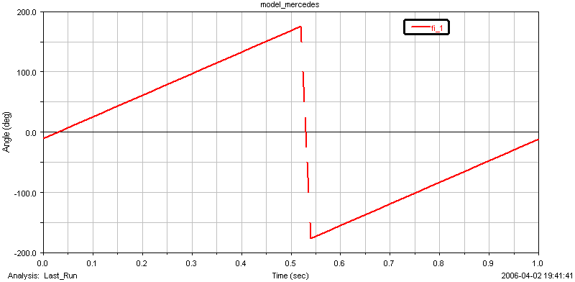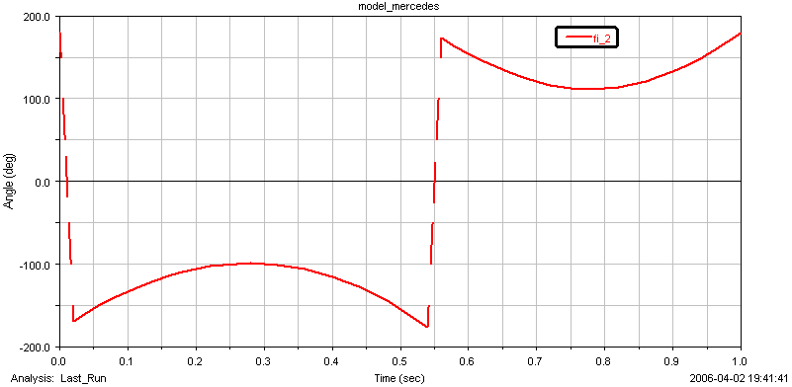
Figure 7: The angle φ₁ Figure 8: The angle φ₂

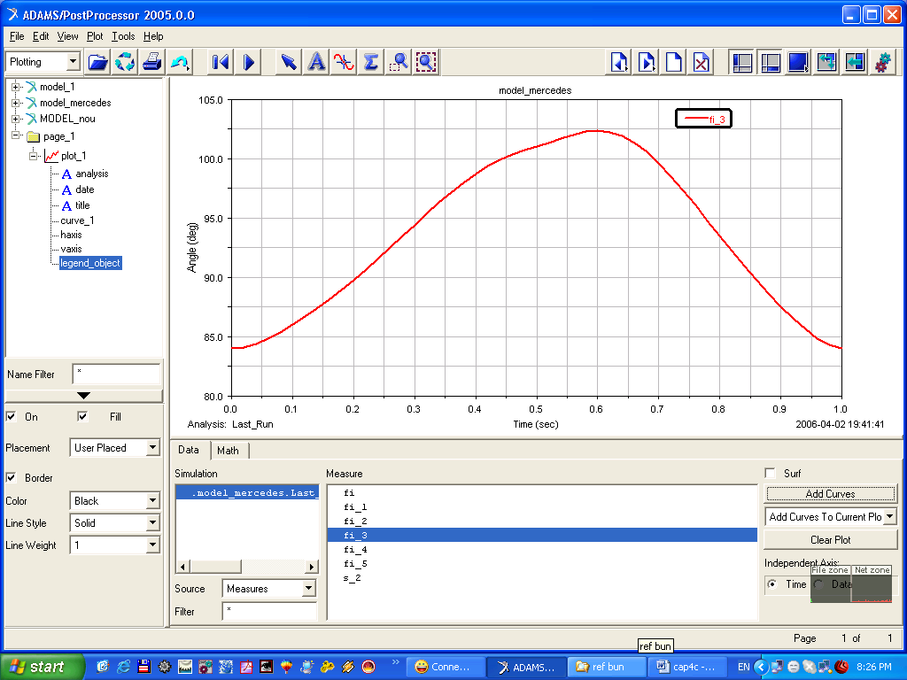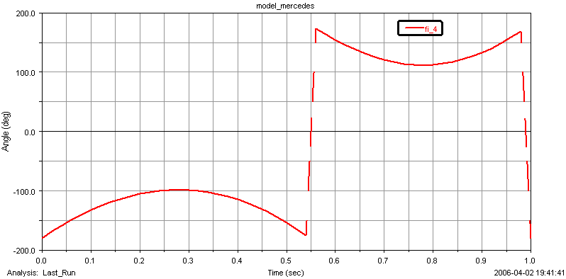
Figure 9: The angle φ₃ Figure 10: The angle φ₄

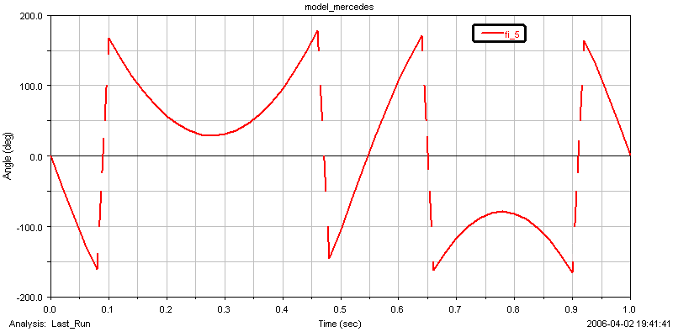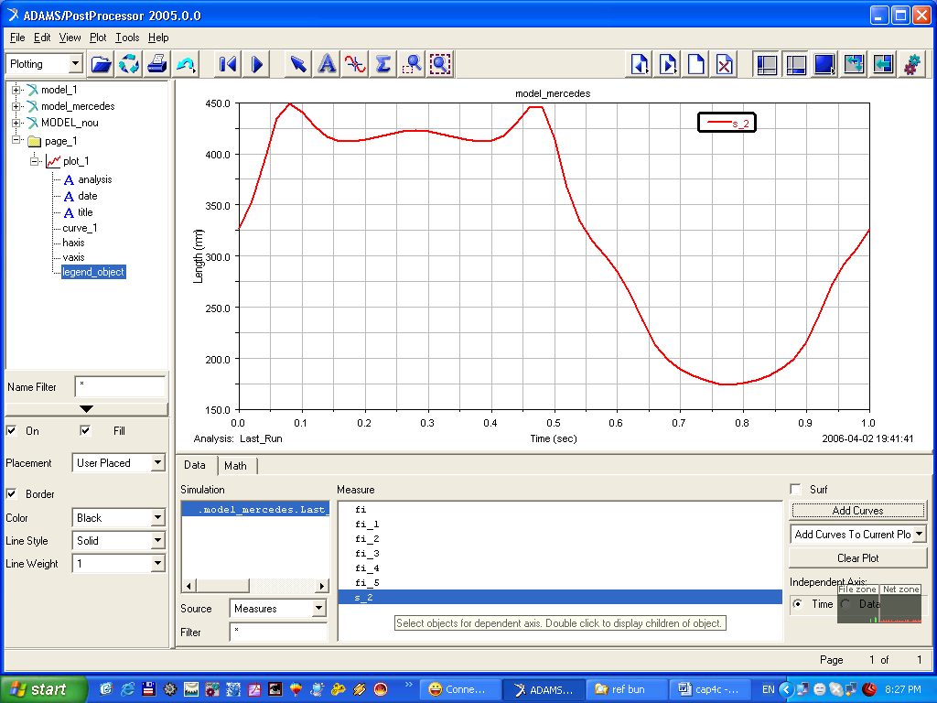
Figure 11: The angle φ₅ Figure 12: The distance s₂

The wiper lamella (the output body) executes a translation movement on the car windshield (vs. A point) and the graphic of this is presented in figure 12.

The velocity and the acceleration functions are obtained from successive derivation of the position equations system.

4. CONCLUSIONS

The MultiBody System method is easy to apply for all types of mechanisms, indifferent of the components stucturation, configurations or complexity. Among the multiple advantages that the usage of MBS software offers in analysis, simulation and optimization of mechanical systems there are: efficient and fast design, the possibility of modeling any type of mechanism (mechanical system), the flexibility of the model, the estimation of the dynamic behavior through the easy modification of a geometric and / or elastic characteristics of the mechanism, considering the fact that experimental testing presume the implementation of expensive physical prototypes, often superficial.

5. REFERENCES

- Buta A.C., Alexandru C.: The structural systematization of the windscreen wipers mechanisms, IMT Oradea – 2005, (abstract book), vol. IV, pp. 188b, Oradea, 2005;
- Buta A.C., Alexandru P.: The analysis of the windshield wipers mechanisms, with MultiBody System, IMT Oradea – 2006, (abstract book), vol. V, pp. 95, Oradea, 2006;
- Vişa I., Alexandru P., Talabă D., Alexandru C.: Proiectarea funcţională a mecanismelor – metode clasice şi moderne, Editura Lux Libris Braşov, 2004;
- www.tiriacauto.ro/mercedes.

