THE ELASTIC STABILITY OF A BEAM WITH TWO PRISMATIC COAXIAL REGIONS THROUGH THE DIAGRAMS AND CONSTRAINED CONDITIONS

Gabriela Al. Ivan¹
¹Universitatea ”Transilvania” din Braşov, România, eliane@unitbv.ro

Abstract: The graphic solutions in the stability equation solving at the straight beam with two embedded / free ends, with two prismatic coaxial regions and loaded with two compressive forces are investigated.
Thus for to establish the critical through derivation buckling load value is defined and is used the “conventional” slenderness coefficient; at the same time are analyzed the constrained conditions so validity in Euler's relation using is preserves.
Keywords: propped beam, stability equation, constrained conditions.

1. Introduction

The static stability problem by axial centric compression of the straight beam with constant or variable cross section regarded the theme of many theoretical and experimental studies.
The solving of this, by view point of the machine tools and industrial buildings applications, didn't find a final determination.

2. The propped beam with two coaxial regions and two compressive forces

In this paper is investigated the straight beam with one fixed and another free ends (the propped beam) with two coaxial prismatic regions, which are loaded with two certain compressive forces P₁ and P₂, so in Fig.1.
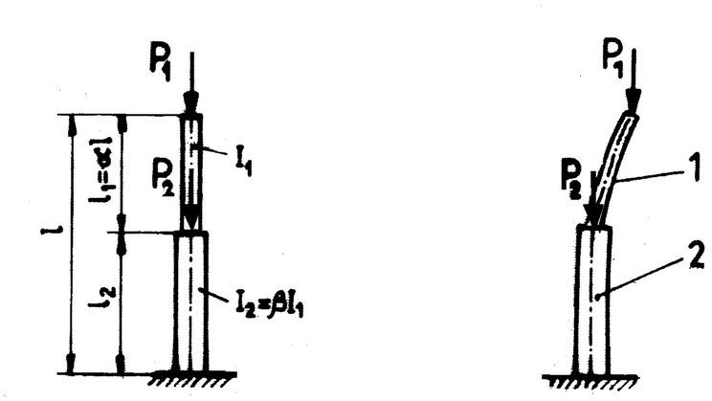
Figure 1: Straight beam with two coaxial regions:
a) initial state b) deformed state

For this case it writes the stability equation, known from the technical literature [1, 3, 4, 5, 7]:
${\text{tgk}}_{1}l_{1}⋅{\text{tgk}}_{2}l_{2}=\frac{k_{2}I_{2}}{k_{1}I_{1}}$ (1)
with coefficients:
$k_{1}=\sqrt{\frac{P_{1}}{{\text{EI}}_{1}}}$, $k_{2}=\sqrt{\frac{\left(P_{1}+P_{2}\right)}{{\text{EI}}_{2}}}$ (2)
which are expected constants, while l₁ and I₁ or l₂ and I₂ are length (l₁ = αl) and the superior axial inertia moment (I₁ = A₁$i_{1}^{2}$), respective the length
l₂ = (1 – α)_{l} (3)
and the axial inertia moment
I₂ = βI₁ = A₂$i_{2}^{2}$ (4)
of the inferior region beam. Between the two constant forces applied at beam, P₁ and P₂, there is the relation:
P₂ = ηP₁ (5)
Concomitantly between the two coefficients, from equation (1) is possible to write relations:
k₂ = ζk₁, where is noted
ζ = $\sqrt{\frac{\left(1+η\right)}{β}}$ (6)
Introducing the dimensionless value
“u” = k₁l (7)
the stability equation (1) becomes:
$\text{tg}αu⋅\text{tg}\left(\text{1-}α\right)ξ\text{u }=\text{ξβ}$ (8)

3. The stability equation solving by various PARAMETERS α, β and η

For the certain particular values of the geometrical (α and β) and the loading (η) parameters, from equation (8) it retains the smallest positive solution “u” and then by the substitution of this value into the relations (2), (5) and (7) results the values of the critical load buckling through derivation :
$P_{1,\text{cr}}=\frac{u^{2}\text{EI}}{l^{2}}$and (P₁ + P₂)_{cr} = (1 + η)P_{1,cr} (9)
For to have the certainty determination of the minimum positive solution and for the reduction of testing (when doesn't use the numerical computation methods) in the paper, Fig.2, Fig.3, are shows:
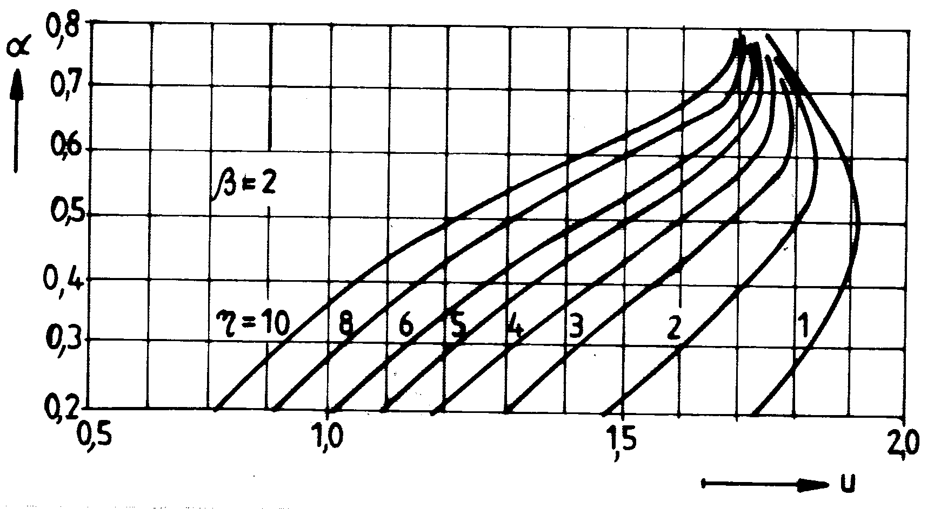
Figure 2: Graphical solving of the stability equation for beam with β = 2, $β=\frac{I_{2}}{I_{1}}$
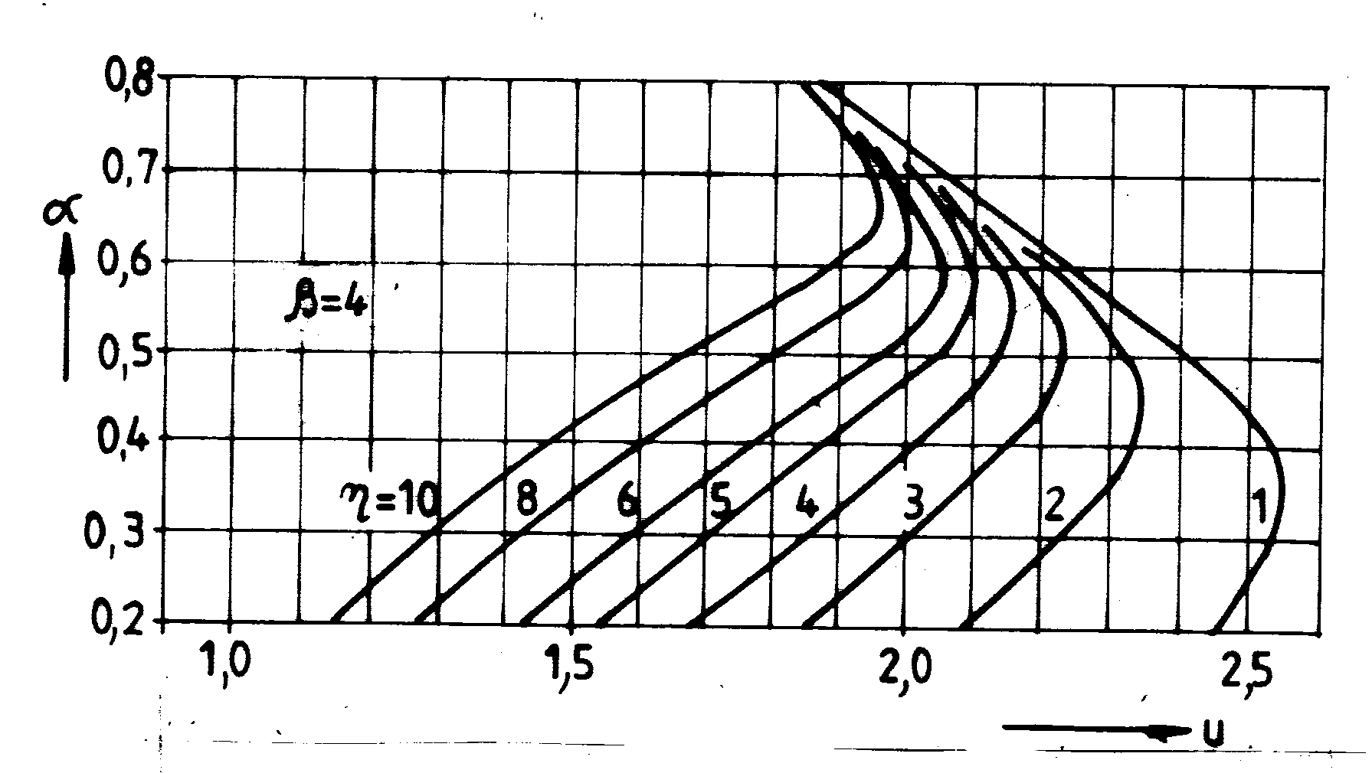
Figure 3: Graphical solving of the stability equation for beam with β = 4

the graphical resolution of the stability equation for an usual values of α, β and η parameters, Fig.4, and Fig.5.
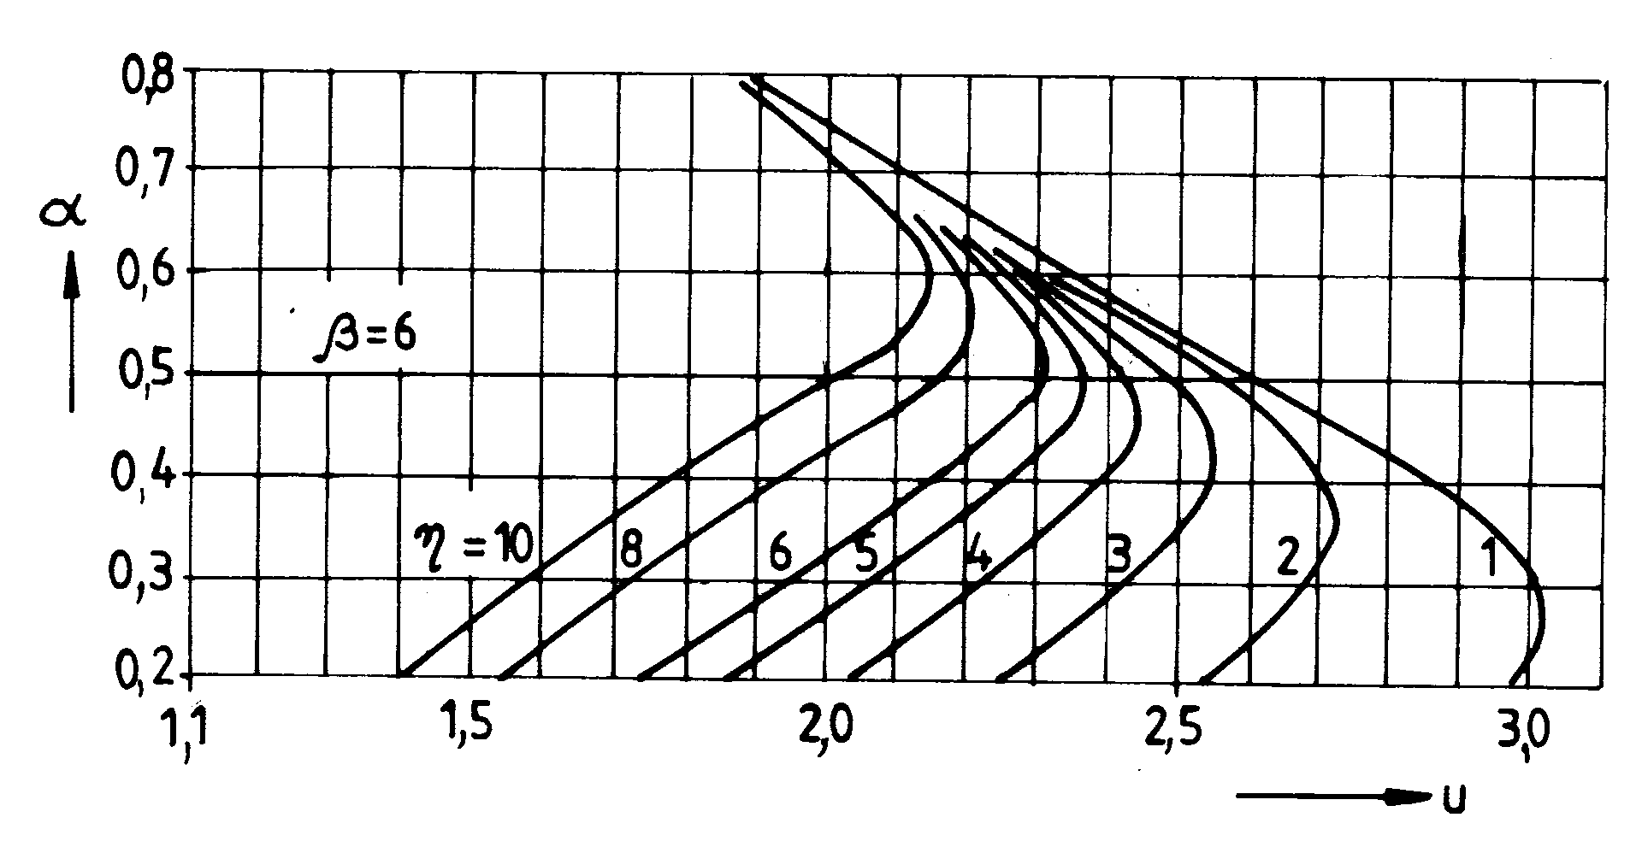
Figure 4: Graphical solving of the stability equation for beam with β = 6
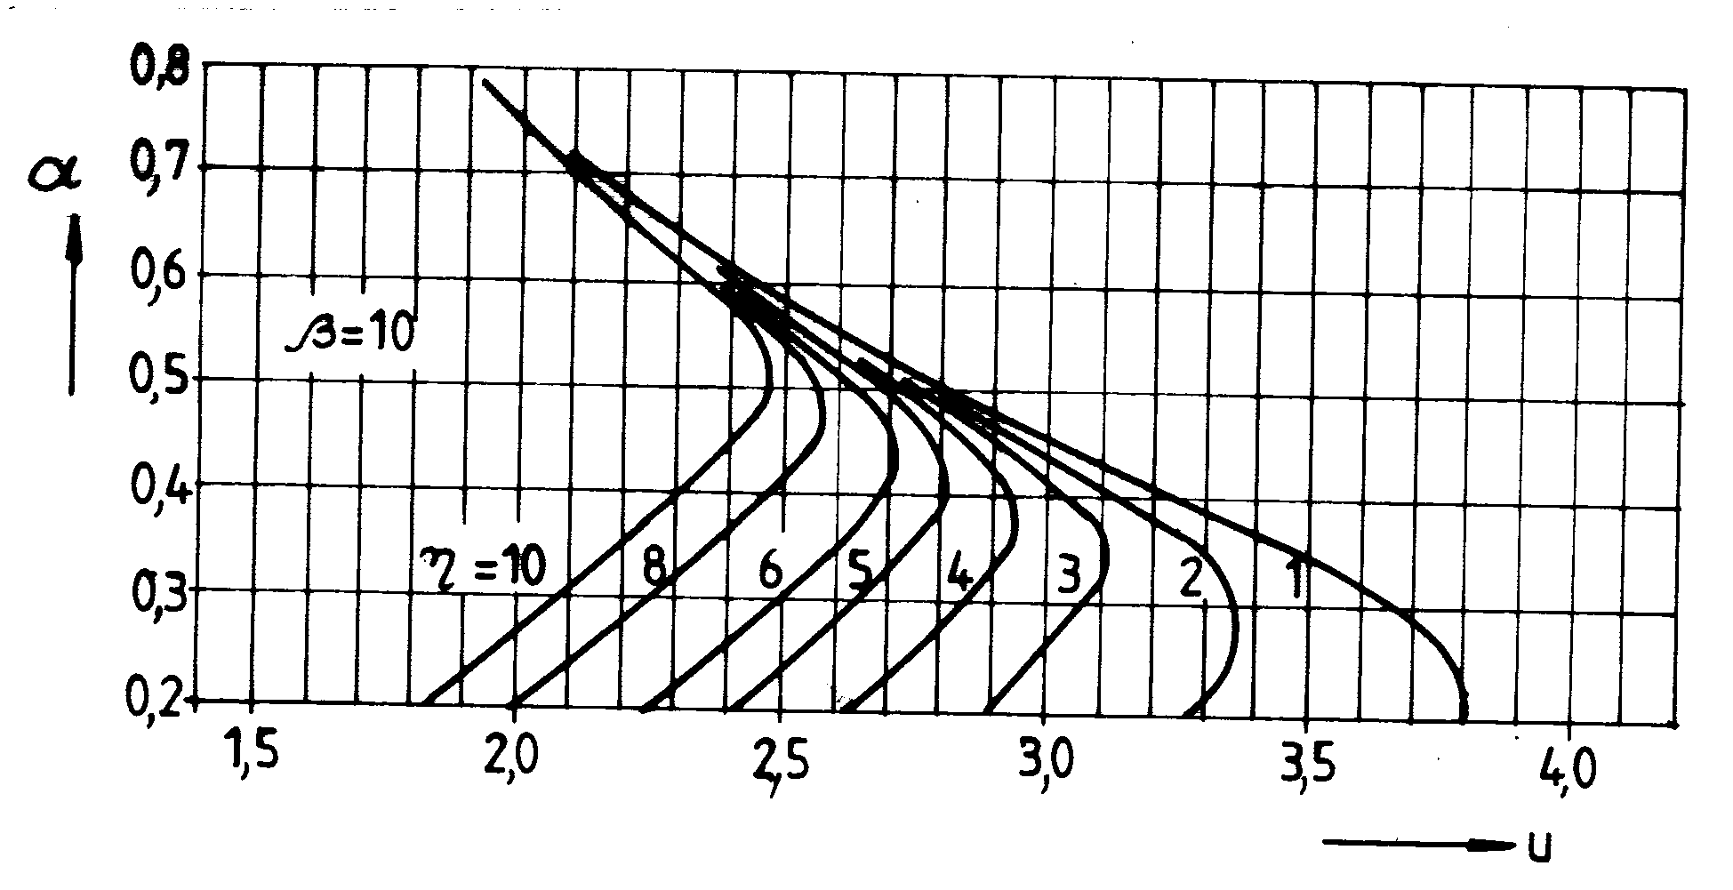
Figure 5: Graphical solving of the stability equation for beam with β = 10

4. The constrained conditions in Euler's relation using

The stability equation determines the real solutions only if k₁ and k₂ preserves constant values at the reaching of the critical buckling value, P_{cr}; with another words, the normal stresses (in two regions of the beam) must don't surpass the material proportionality limit, σ_{p} , which usually it takes equal with the elasticity limit, σ_{el}. So it imposes conditions:
$σ_{1,\text{cr}}=\frac{P_{1,\text{cr}}}{A_{1}}≤σ_{\text{el}}$, $σ_{2,\text{cr}}=\frac{{\left(P_{1}+P_{2}\right)}_{\text{cr}}}{A_{2}}≤σ_{\text{el}}$ (10)
The first from the previous conditions may be written as:
$λ_{1}≥λ_{\text{01}}=2u\sqrt{\frac{E}{σ_{\text{el}}}}$ (11)
in which the quantity λ₁ =$\frac{2l}{i_{1}}$, equal with the beam buckling length – the radius of inertia ratio is denominated the “conventional” slenderness coefficient for the superior region beam, respectively λ₀₁ is the slenderness coefficient which lower delimits the elastic domain of this region.
Adequate, the second constrained conditions becomes:
$λ_{2}≥λ_{\text{02}}={\text{ξλ}}_{\text{01}}$ (12)
where the quantity
$λ_{2}=\frac{2l}{i_{2}}=λ_{1}\sqrt{\frac{A_{2}}{{βA}_{1}}}$ (13)
represents the “conventional” slenderness coefficient of the lower region beam.

5. Particular cases

a) For α = 0, the beam has constant cross section, the both forces are applied at the superior end, from the relation (8) results:
tgζu = ∞, with the solution
u =$\frac{π}{2ξ}$ (14)
which substituted in the relations (11) and (12) recovers at the known analytical [1, 3, 5] expression:
$λ_{0}\sqrt{\frac{σ_{\text{el}}}{E}}=π$ (15)
b) For α = 1, the stability equation becomes:
tgα = ∞, with the solution, u =$\frac{π}{2}$, thus so the function $λ_{\text{01}}\sqrt{\frac{σ_{\text{el}}}{E}}$is equal with π, the well known value from technical [2, 4, 6, 7] literature.

c) For the case η = 0, the beam has two regions, but it is loaded only with the force P₁, thus the relation (8) may be write:
$\text{tg}αu⋅\text{tg}\frac{\left(1−α\right)}{\sqrt{β}}u$=$\sqrt{β}$ (16)
in this last particular case, if it admits that A₂ ≥ A₁, only the constraint condition (11) is enough to be performed [1, 4, 5] as the validity Euler's equation to be maintain.

Conclusions

In this paper for different constructive and loading versions (cases) of the propped compressed beams, the graphical representations, it gets the general solution for the Euler's equation and its validity.
At the calculations performance about the critical buckling load, the fulfillment of the constrained conditions (11) and (12) is compulsory.
The ignorance of these conditions may constitute one of the frequent discrepancies causes between the theoretical values about the “ideal” beam and experimental values, so what it announces into many technical papers or books [1, 2, 4, 7].

References

[1] Alămoreanu, E., Buzdugan, Gh., Iliescu, N., Minca, I., Sandu, M.,: Îndrumar de calcul în ingineria mecanică, Editura Tehnică, Bucureşti, 1996.
[2] Gheorghiu, Al.: Concepţii moderne în calculul structurilor, Editura Tehnică, Bucureşti, 1985.
[3] Ivan, G.E.: Influenţa prinderii cu elemente elastice a barei asupra valorii forţei critice de flambaj, Proceedings CDM 2001, A III-a Conferinţă de Dinamica maşinilor, Braşov, 2001.
[4] Mateescu, D., Appeltauer, I.,Cuteanu, I.: Stabilitatea la compresiune a structurilor din bare de oţel, Editura Academiei Române, Bucureşti, 1980.
[5] Timoshenko, S.P., Gere, J.: Teoria stabilităţii elastice, Editura Tehnică, Bucureşti, 1967.
[6] Teodorescu, P.P.: Sisteme mecanice, Editura Tehnică, Bucureşti, 2004.
[7] Voinea, R.P., s.a.: Introducere în mecanica solidului cu aplicaţii în inginerie, Editura Academiei Române, Bucureşti, 1989.

