EXPERIMENTAL METHODS FOR DETERMINATION THE ELASTICS TENSIONS

Ioan Enescu
“Transilvania”University Brasov , ROMANIA, enescu@unitbv.ro

Abstracts: This methods permits the study of spatial model by the similary force to them who are apliceted of the real pieces and heatinng them to a critical temperature of the optic material from what is made the model,and by X-rays.
Key words: tensometry,

1.THE STUDIE ON THE PROIECTION OF THE DEVICE OF TENSOMETRY ADAPTED TO THE X-RAYS INSTALATION

For the determination of tensions in the bodings and the rues of bearings by the X-rays it is projected a hydraulic disparities ,with than ,we are pressure the balls of bearings exact to the edge of the rues bearings (figure 1).

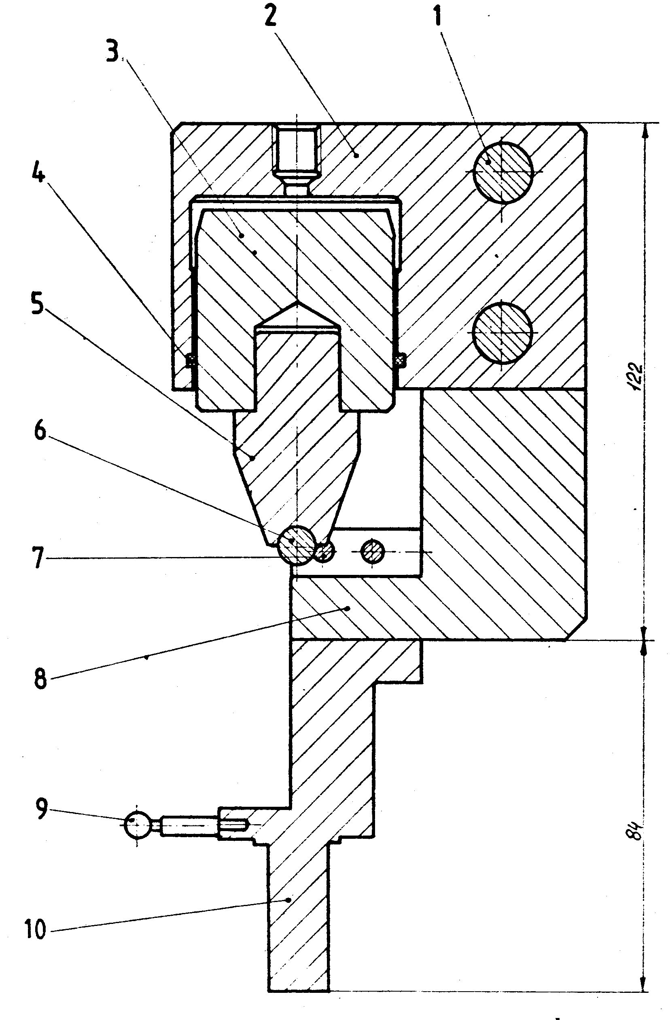

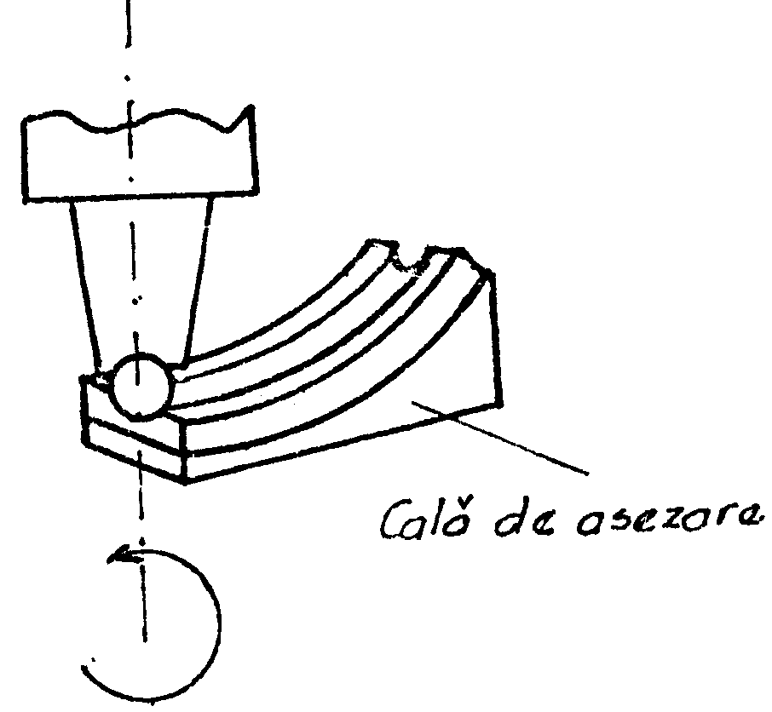
Place way

Figure 2

Figure 1: Device of tensometry

All this system is mounted from the goniometric installation with X-rays .The pressing load for the ball it is realized with a hydrostatic press for the calibration manometers (Figure.2).
The force it is calculated by the produce of the surface of the piston and the indicate pressure of the standard manometer of the hydraulic pomp.
`Thedispositive (Figure1) iscomposed by a superior corp with cylindre (2) into is a piston (3) executabled by a unoxidable steel and is rectificabled from the thigheness of the surface.

2.1 The analyses of the deformations structures by the X-rays method

By the analyses the former of the line profile of X-rays diffraction on can obtained the structural information than :
- The median dimension of the crystals
- The median square deformations of the structures (the tensions and the deformations determinate by the treatments
- The probability of defects the crystalline structures (%)
This information can be determinate by two methods:
1). Sherrer method – where with the width of the line profile is determinate B_{hld} of the line profile is determinate with the relation:
D_{s}=0.8λ/β_{hld} cosθ (1)

Where
- λ- The length of the wavelength
- θ- The center of weight of the experimental profile
2). Fourier method –where the D_{elf} (effective deformations),the distribution curve after P(l) dimension, the square in median deviation A of the structure <ε_{m}(L=D_{elf})> are obtained by the analyses of the Fourier coefficients F(L) of the line profile:
F(L)=1-L/D_{elf}-C² <ε²(L)>L²+C²<ε²(L)>L³/D_{elf} (2)

where : C²=2π²h²_{o}/a²
F (L)=a₀+a₁L+a₂L² (3)

A₀=1, a₁=(1/D_{elf}+C²k), a₂=C²k/D_{elf} (4)

ε²- the coefficient of deformations for structure
The curve of distribution of the crystals is make by :
F (L)= d² A²(L)/dL²D_{elf} (5)

and
D=$\int_{L_{\text{min}}}^{L_{\text{max}}}{\text{LP}(L)}$ (6)

2. 2 Results.

The experimental specters of diffraction was processed by XPLINE calculus, use an experimental use of the line profile of line diffraction. The use to the line profile of the line diffraction is make a goniometric of X-rays for crystalline dust type HZG-3 assembled to a TUR_M61 installation.
The determination is was make for a deformed and undeforme bearing structure, following the application a same force (540 Kgf, 900Kgf, 1800Kgf, 2700Kgf) with a dispositive realized at the Faculty of Physic of University Babes-Boyai Cluj-Napoca.
The results are presented in table 1.

Table 1
Kgf | D [R] | <e²> | %
undeformable | 314 | 2,34 | 2,33
540 | 252 | 5,15 | 2,66
900 | 262 | 11,27 | 3,65
1800 | 265 | 12,82 | 3,82
2700 | 272 | 13,60 | 4,41

3. THE ANALYSIS OF THE CONTACT PROBLEMS FOR STRUCTURED OF ROLLINGS BEARINGS ELEMENTS

3.1.Contents

Some (optical) matherials present the proprety to fixed about to cooling at the ambient temperature of the loaded model , the state of tensions in model at the critical temperature of dip.
In this situation on can cut plane bands without that the state of tensions table modified. The plate on can sudie to the polariscop. The rezult are the izoclines and the izocromates (the directions and the difference of principales tensions in the plane of the plate.
By the standardizy the material of the models we can determine the photoelastic constant and we can determinet the difference of principal tensions ($σ_{1}−σ_{2}$ ).
For the cast of bearings inners we are proiect and realize the demontable metal (figure.3) , where we are found simultaneous in the same inners.

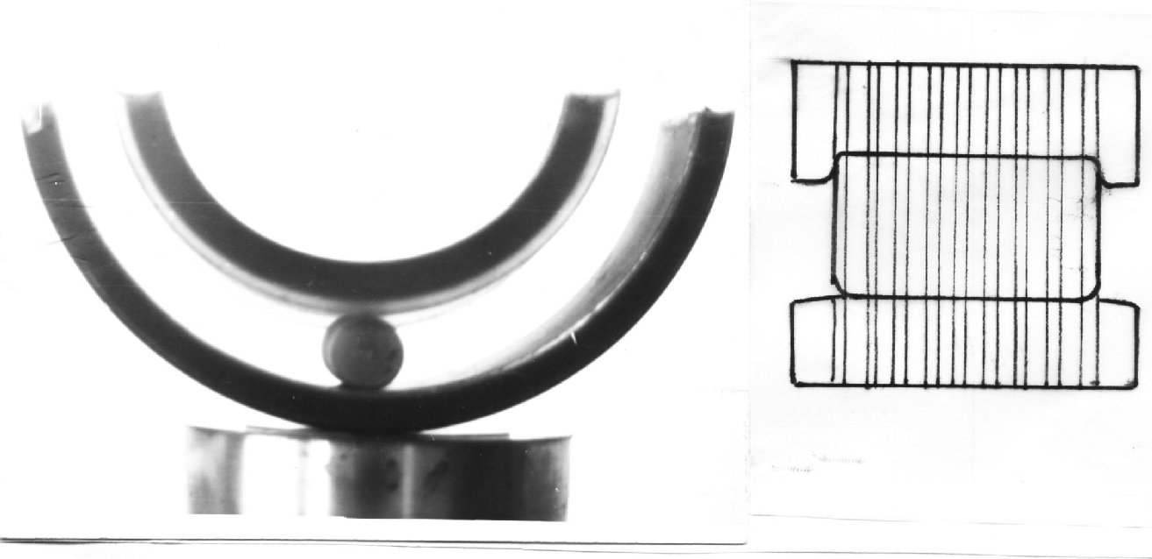

Figure 3

3.2 The solicitation of the models

For the solicitation of the models we used the elements of metals interior cylindre, where loads are applied .Between thise elements we are make optic materials for the inners and the ruler corp (figure.4) and the whole ensamble we are introduce in a drying closet whith the posibility to regulate and to maintain a constant temperature.
The drying closet was heating at 100⁰ C temperature and it was maintained this uniforme in models, after this it let to a slow coaling.
About coaling we cut the bands necessary to the study by device for cut provided with a diamant disk (Minosecar 2 type).

3.2.The standardize of the materials

For the standardize the material of the models where we are cast for each change plate white 6 mm. thickness and after this we are made the disk with the 50 mm.The disk we are solicited diametral to the compression in the same conditions of temperature so as the model.
After air cooling ,the disk are studied in the circlar polariscope and are studied by compresion, the k ordin of the izocromates are found in the centre of the disk.

If the study the models is made at the beginning in the white light. We can determine the izocromates from zero ordin, that is black colours from beginings and after we count the izocromates.
The numbers from orders of izocromates reprezent this number. Theoretical the difference of main (principal) tensions in the centre of the disk is make by the relation:
$(σ_{1}−σ_{2})=\frac{8P}{πDδ}$ (7)

where :
P - is the force of compression with who solicited the disk
D - the diametrer of disk
δ - the thicknesss of the disk
The difference of main tensions is determined by the order of the izocromates utilize the relation:
$σ_{1}−σ_{2}={kσ}_{0}$ (8)
where :
k- the order of izocromate
σ₀- the constant photoelastic of the disk
Arom (1) and (2) equation result :
$σ=\frac{8P}{πDδk}$ (9)

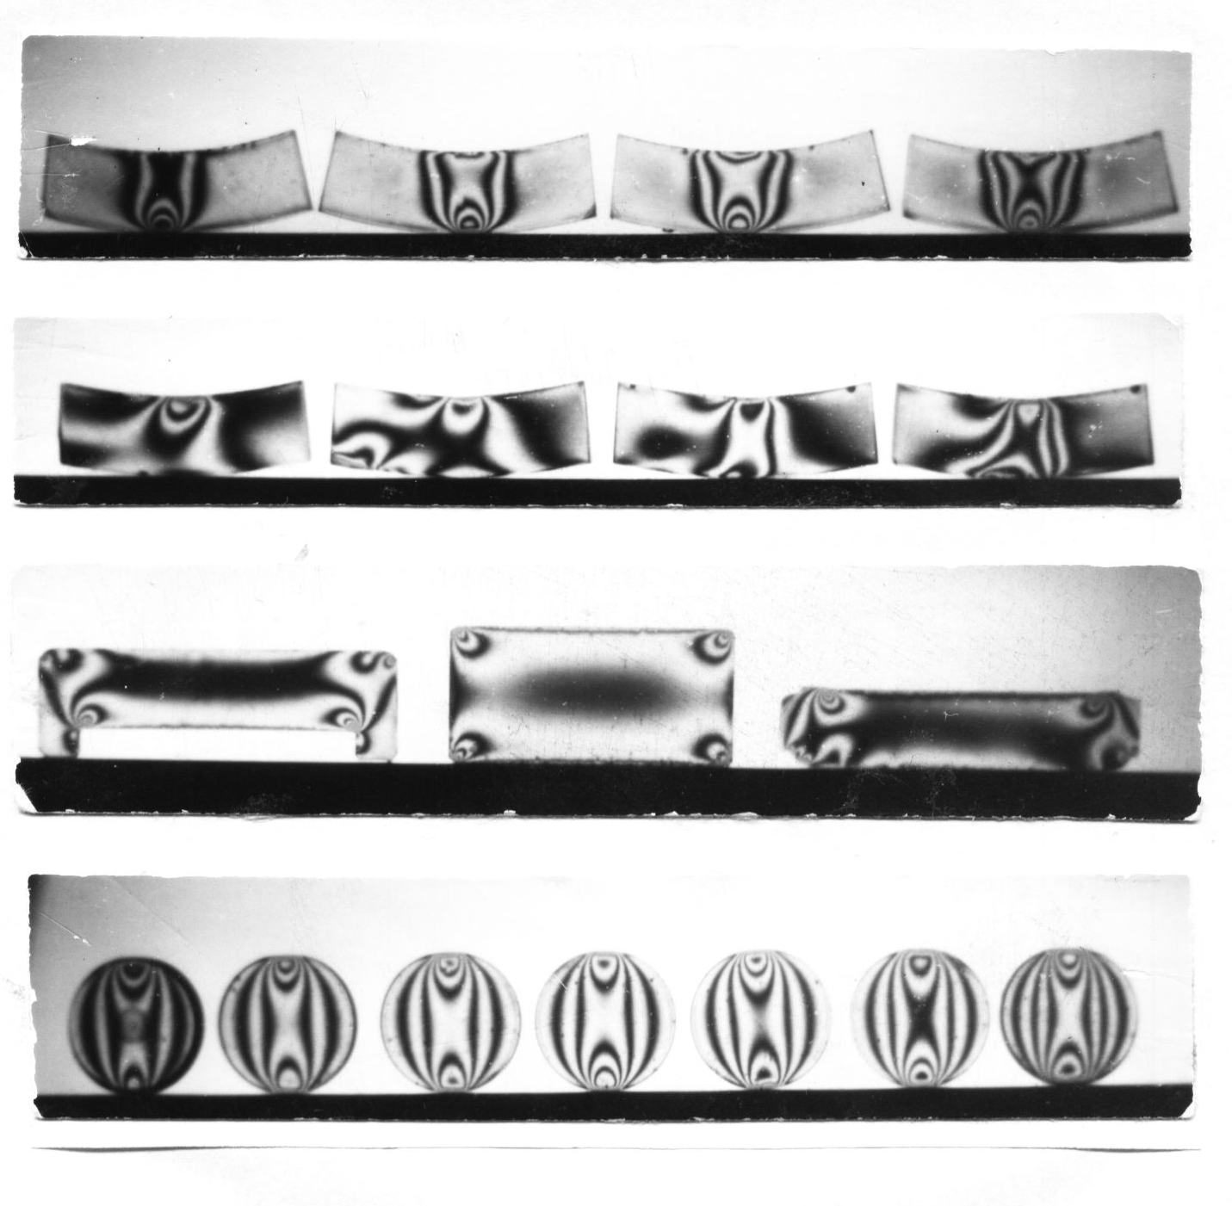

Figure 4

The constant σ⁻₀ corespund to a model by ,δ thichness and for determinet the constant δ₀ of material we multiply σ₀ by δ .

$δ_{0}=\frac{8P}{π\text{Dk}}$ (10)
In function by thickness δ_{I} of bands we can determinet the constantes σ_{0I} who are make for the calculation of the tension in bands.In (figure.3) are presented the izocromates in a disk for the standardize.

REFERENCES

[1] I.Enescu, Aspecte ale mecanicii contactului la rulmenţi, Editura Lux Libris Braşov, 1999 pag.71-75.
[2] I. Păstrăv, Gh.Ceptureanu, I. Enescu, Stării de tensiuni şi deformaţii în contactele dintre căile de rulare şi corpurile de rulare ale rulmenţilor, Contract C.I.R.O.A., Braşov nr.27/1989 .
[3] Crisan V., Cherebetiu T., Ceptureanu Gh.,Enescu I. Contract nr.24/1089 C.C.S.I.T.R.O.A.-Universitatea Transilvania Brasov
[4] Enescu I., Ceptureanu Gh., Enescu D. Rulmenti Editura Universitatii Transilvania Brasov.

