STRUCTURAL MODELLING BY MBS METHOD APPLIED TO LINKAGES USED TO AILERON AIRCRAFT CONTROL

Marius GHITESCU
Department of Product Design and Robotics
TRANSILVANIA University of Brasov Bv. Eroilor 29, Brasov Romania Email motanmotan34@yahoo.com

Abstract: The aim of the paper is structural modelling of linkages used in airplane flaps control, on bases of the Multibody System method (MBS). In virtual prototyping of the aircraft , these linkages have to be modeled by a minimum number of bodies (MBS min). In the paper an appropiate algorithm is descriebed and also applied for concrete mechanical systems. This will be the bases for dynamic modelling of these subsystems as parts of the whole product (airplane).
Keywords: mechanical systems, multibody systems, structural modeling, kinematic analysis, aircraft, Flaps

1. INTRODUCTION

Generally control surfaces of an aircraft include : ailerons , rudder , elevator , tabs and flaps[6].
(see figure1). Movement of this surfaces generate roll, pitch and yaw. During the fly flaps move between “cruise posision” and “landing position” by intermediate of mechanical transmissions.
In design process of an aircraft one of the main step is virtual prototyping.
In virtual prototyping of the aircraft, mechanical systems are considered as Multibody Systems (MBS). They have to be modelled as MBS with minimum number of bodies (MBS min) to favorise obtaining real time simulation of aircraft.
The aim of this paper is structural and kinematic modelling of linkages used for actioning of aileron , as multibody systems. On bases of MBS, kinematic and dynamic models could be obtained (see Part02).
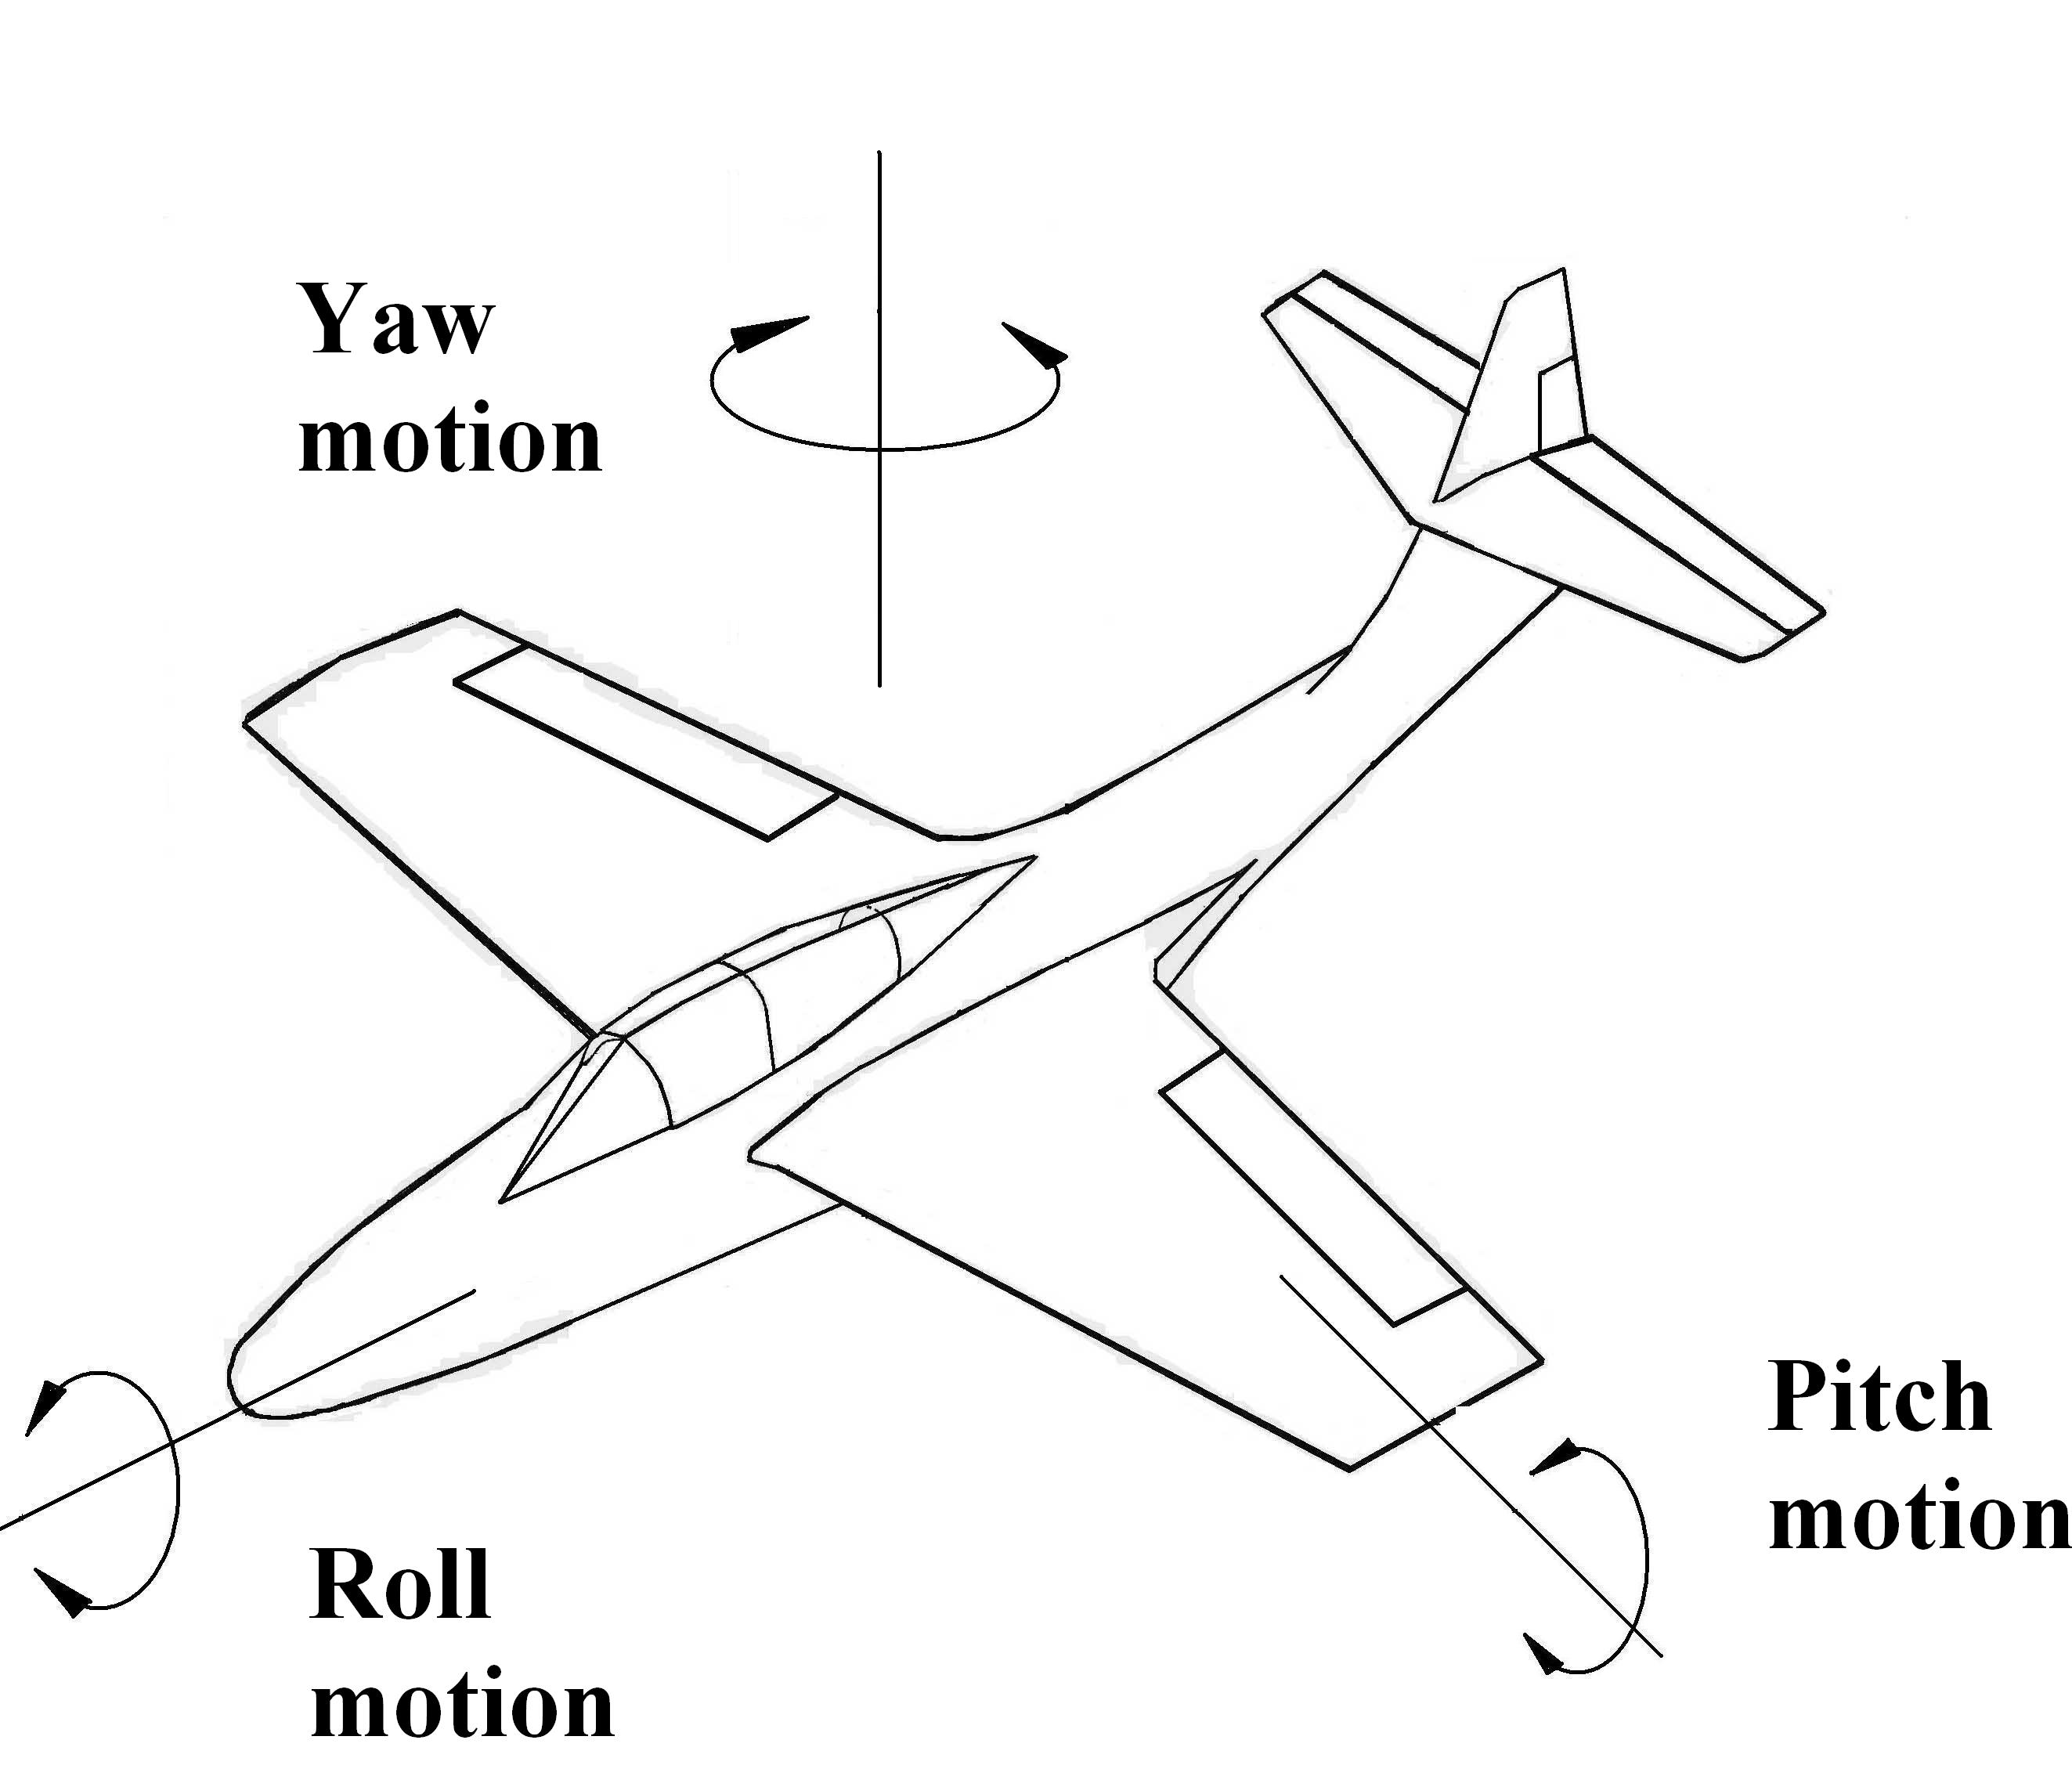
Aileron
Elevator
Rudder

Fig 1

2. THEORETICAL CONSIDERATION

According to MBS theory , a mechanical system is considered as a collection of bodies linked between them by geometrical and driving constraints[4,9].
The body is an entity which in the dynamic model will have mass and moment of inertia, and also could take over the external forces.
Motion of a rigid body in space can be described by six generalized coordinates - S_{x} , S_{y} , S_{z} = translation, φ_{z} ,φ_{y} ,φ_{z} = rotation (x,y,z are the orthogonal axes) Planar motion has S_{x} , S_{y} , φ_{z}
Global Reference Frame GRF is a coordinate system represented three orthogonal axes fixed in time. This coordinate system is rigidly connected to fixed body [4,9].
Body Reference Frame BRF is a coordinate system formed by three orthogonal axes connected to each mobile body component to the MBS system[4,9].

In a linkage having “n” elements number of bodies n_{b} is :

n_{b} n
(1)
Generally:
n_{b min} n_{b} n

n_{b min} representing the minimum number of bodies for modeling a concrete linkage[11]
The geometrical constraint imposes restrictions in bodies relative motion. Number of restriction is
r =1 and r = 2 in the case of planar systems (S =3), respectiv r = 1…5 in the case of three dimensional systems (S = 6).
The restrictions are imposed by joints or composite joint [4,9]. In planar systems they are: rotation R
(r =2), translation T (r =2), rotation-rotation RR (r =1), rotation –translation RT (r =1)curve –curve CC (r = 1) [4,9,11].
Driving constraints corespond to the mobility M of the system Of course M 1 .Between number of bodies n_{b} number of geometrical constraints (Σr) in a concrete space S , and mobility M there is the relation [11]
(2)
M = S (n_{b} - 1) – Σ r

The algorithm for MBS modelling with minimum number of bodies has the following steps:
- Identifying the bodies , in order:
- fixed body,
- input body (bodies),
- output body (bodies),
- bodies with more than two connection,
- bodies with applied forces,
- other bodies (if necessary).
- Identifying geometrical constraints:
- type ,
- location,
- number of restriction.

3. STRUCTURAL ANALYSIS OF CONCRETE LINKAGE

In the paper , one linkage used for aileron control is analized.
The bases of this linkage is wing structure , that represent for the linkage – fixed body. The output body is the ailerons. The input motion is generated by pilot from control lever by intermediate of mechanical / hydraulic actuators.
The linkage from fig 2 is modeled as MBS min having 6 bodies, five geometrical constraints type R and four geometrical constraints type SS. The input body is body 2 and the output bodies are the ailerons 4 and 6. Mobility
M =1.
Figure 3 represent structural scheme at this aileron mechanism.

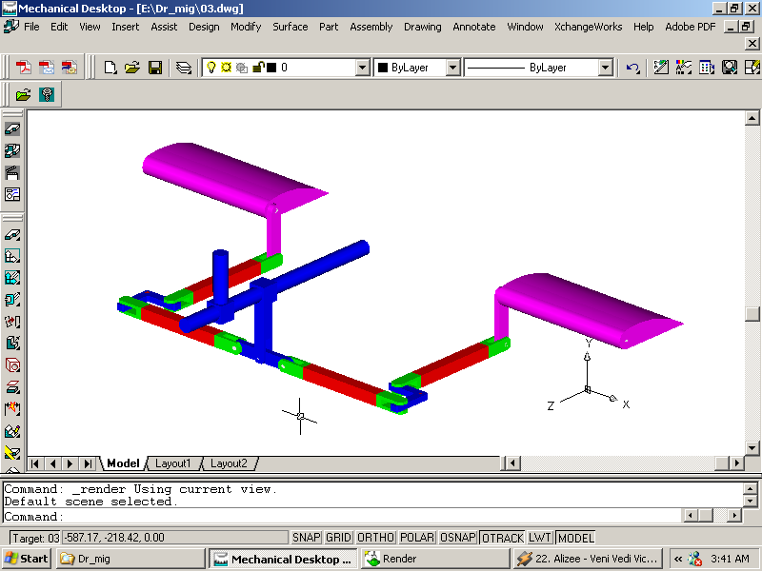

Fig 2

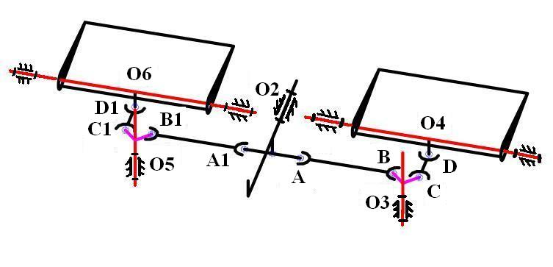
4
2
6
5
3

Fig 3

Table 1: aileron control (see fig 3)
Body i  Body j | gc | Location | Number of  M = S (n_{b} - 1) – Σ r  Σ r = 29  n_{b} = 6 si S = 6  M = 1  constraints
1-2 | R | O2 | 5
1-3 | R | O3 | 5
1-4 | R | O4 | 5
1-5 | R | O5 | 5
1-6 | R | O6 | 5
2-3 | SS | AB | 1
2-4 | - | - | -
2-5 | SS | A1B1 | 1
2-6 | - | - | -
3-4 | SS | CD | 1
3-5 | - | - | -
3-6 | - | - | -
4-5 | - | - | -
4-6 | - | - | -
5-6 | SS | C1D1 | 1

$${\left(X_{A}−X_{B}\right)}^{2}+{\left(Y_{A}−Y_{B}\right)}^{2}+{\left(Z_{A}−Z_{B}\right)}^{2}={\text{AB}}^{2}$$
(3)
$$\begin{aligned}\left[X_{A} | \right]\left[Y_{A} | \right] \\ \end{aligned}$$
$X_{A^{(2)}}$,$Y_{A^{(2)}}$, $Z_{A^{(2)}}$ are local coordinates (coordinates of points into BRF). O2X2Y2Z2 represente BRF for body2.

Rotation matrix is:
$$M_{\text{21}}=\left[\begin{matrix}\text{cos}ϕ2 & −\text{sin}ϕ2 \\ \text{sin}ϕ2 & \text{cos}ϕ2\end{matrix}\right]$$
(4)
Global coordinates for O2 point are:
$X_{O2}$=$Y_{O2}$=$Y_{O2}$= 0

For B point:
$$\begin{aligned}\left[X_{B} | \right]\left[Y_{B} | \right] \\ \end{aligned}$$
Where
(5)
$X_{B^{(3)}}$=$Z_{B^{(3)}}$=0
Then:
$\begin{aligned}\left[X_{A} | \right]\left[Y_{A} | \right] \\ \end{aligned}$ si $\begin{aligned}\left[X_{B} | \right]\left[Y_{B} | \right] \\ \end{aligned}$
We know:
$X_{O2}$,$Y_{O2}$,$Z_{O2}$ $X_{O3}$,$Y_{O3}$,$Z_{O3}$, $X_{A^{(2)}}$,$Y_{A^{(2)}}$,$Z_{A^{(2)}}$,$X_{B^{(3)}}$,$Y_{B^{(3)}}$,$Z_{B^{(3)}}$

Generally rotation matrix is:
$$M_{i}=\begin{aligned}\left[\text{cos}(X_{i},X)\text{cos}(Y_{i},X)\text{cos}(Z_{i},X) | \right]\left[\text{cos}(X_{i},Y) \text{cos}(Y_{i},Y) \text{cos}(Z_{i},Y) | \right] \\ \end{aligned}$$
(6)
For body “2”
$M_{\text{21}}$= $M_{β}$ and $M_{β}=\begin{aligned}\left[\text{cos}β 0 \text{sin}β | \right]\left[0 1 0 | \right] \\ \end{aligned}$
(7)
Result:
$\begin{aligned}\left[X_{A} | \right]\left[Y_{A} | \right] \\ \end{aligned}$ si $\begin{aligned}\left[X_{B} | \right]\left[Y_{B} | \right] \\ \end{aligned}$
Where:
$$M_{α}=\begin{aligned}\left[\text{cos}α −\text{sin}α 0 | \right]\left[\text{sin}α \text{cos}α 0 | \right] \\ \end{aligned}$$
(8)
Result:
$$\begin{aligned}\begin{aligned}\left\{X_{A}=X_{A^{(2)}}\text{cos}β+Z_{A^{(2)}}\text{sin}β | \right.\left\{Y_{A}=Y_{A^{(2)}} | \right.\end{aligned} \\ \end{aligned}$$
(9)
For B point:
$$\begin{aligned}\left[X_{B} | \right]\left[Y_{B} | \right] \\ \end{aligned}$$
(10)

Result:
$$\begin{aligned}\begin{aligned}\left\{X_{B}=X_{O3}−Y_{B^{(3)}}\text{sin}α | \right.\left\{Y_{B} = Y_{O3}+Y_{B^{(3)}}\text{cos}α | \right.\end{aligned} \\ \end{aligned}$$
(11)
Final relation go to:
$$\begin{aligned}{\left(X_{A^{(2)}}\text{cos}β+Z_{A^{(2)}}\text{sin}β−X_{O3}+Y_{B^{(3)}}\text{sin}α\right)}^{2}+{\left(Y_{A^{(2)}}−Y_{O3}+Y_{B^{(3)}}\text{cos}α\right)}^{2}+ \\ +{\left(−X_{A^{(2)}}\text{sin}β + Z_{A^{(2)}}\text{cos}β−Z_{O3}\right)}^{2}={\text{AB}}^{2}\end{aligned}$$
(12)

Between bodies “2” and “5” we have restriction A1B1 type SS:
(13)
$${\left(X_{A1}−X_{B1}\right)}^{2}+{\left(Y_{A1}−Y_{B1}\right)}^{2}+{\left(Z_{A1}−Z_{B1}\right)}^{2}=A1B1^{2}$$

Where:
$\begin{aligned}\left[X_{A1} | \right]\left[Y_{A1} | \right] \\ \end{aligned}$ si $\begin{aligned}\left[X_{B1} | \right]\left[Y_{B1} | \right] \\ \end{aligned}$
(14)
And:
$M_{\text{21}}=Mβ$ , $M_{\text{51}}=Mα$

$M_{β}=\begin{aligned}\left[\text{cos}β 0 \text{sin}β | \right]\left[0 1 0 | \right] \\ \end{aligned}$ and $M_{α}=\begin{aligned}\left[\text{cos}α −\text{sin}α 0 | \right]\left[\text{sin}α \text{cos}α 0 | \right] \\ \end{aligned}$
Result:

$\begin{aligned}\begin{aligned}\left\{X_{A1}=X_{{A1}^{(2)}}\text{cos}β+Z_{{A1}^{(2)}}\text{sin}β | \right.\left\{Y_{A1}=Y_{{A1}^{(2)}} | \right.\end{aligned} \\ \end{aligned}$ si $\begin{aligned}\begin{aligned}\left\{X_{B1}=X_{O5}−Y_{{B1}^{(5)}}\text{sin}α | \right.\left\{Y_{B1} = Y_{O5}+Y_{{B1}^{(5)}}\text{cos}α | \right.\end{aligned} \\ \end{aligned}$
(15)
Then previous relation go to:

$$\begin{aligned}{\left(X_{{A1}^{(2)}}\text{cos}β+Z_{{A1}^{(2)}}\text{sin}β−X_{O5}+Y_{{B1}^{(5)}}\text{sin}α\right)}^{2}+{\left(Y_{{A1}^{(2)}}−Y_{O5}+Y_{{B1}^{(5)}}\text{cos}α\right)}^{2}+ \\ +{\left(−X_{{A1}^{(2)}}\text{sin}β + Z_{{A1}^{(2)}}\text{cos}β−Z_{O5}\right)}^{2}=A1B1^{2}\end{aligned}$$
(16)

Between bodies “3” and “4” we have geometrical constraint CD type SS:
${\left(X_{C}−X_{D}\right)}^{2}+{\left(Y_{C}−Y_{D}\right)}^{2}+{\left(Z_{C}−Z_{D}\right)}^{2}={\text{CD}}^{2}$ and $\begin{aligned}\left[X_{C} | \right]\left[Y_{C} | \right] \\ \end{aligned}$
(17)
Where:
$Y_{C^{(3)}}=Z_{C^{(3)}}=0$ and $M_{\text{31}}$=$M_{α}=\begin{aligned}\left[\text{cos}α −\text{sin}α 0 | \right]\left[\text{sin}α \text{cos}α 0 | \right] \\ \end{aligned}$
(18)

For D point:
$\begin{aligned}\left[X_{D} | \right]\left[Y_{D} | \right] \\ \end{aligned}$ and $M_{\text{41}}$ = $Mγ=\begin{aligned}\left[\text{ 1 }0 0 | \right]\left[0 \text{cos}γ −\text{sin}γ | \right] \\ \end{aligned}$
(19)
Final result:

$$(X_{O3}+X_{C^{(3)}}\text{cos}α−X_{O4})^{2}+(Y_{O3}+X_{C^{(3)}}\text{sin}α−Y_{O4}+Z_{D^{(4)}}\text{sin}γ)^{2}+(Z_{O3}−X_{O4}−Z_{D^{(4)}}\text{cos}γ)^{2}={\text{CD}}^{2}$$
C1D1 is geometrical constraint type SS:
(20)
$${\left(X_{C1}−X_{D1}\right)}^{2}+{\left(Y_{C1}−Y_{D1}\right)}^{2}+{\left(Z_{C1}−Z_{D1}\right)}^{2}=C1D1^{2}$$
Result:
$\begin{aligned}\left[X_{C\text{ 1}} | \right]\left[Y_{C1} | \right] \\ \end{aligned}$ and $\begin{aligned}\left[X_{D1} | \right]\left[Y_{D1} | \right] \\ \end{aligned}$
(21)
$M_{\text{51}}$=$M_{α}=\begin{aligned}\left[\text{cos}α −\text{sin}α 0 | \right]\left[\text{sin}α \text{cos}α 0 | \right] \\ \end{aligned}$ and $M_{\text{61}}$ = $Mγ=\begin{aligned}\left[\text{ 1 }0 0 | \right]\left[0 \text{cos}γ −\text{sin}γ | \right] \\ \end{aligned}$
Restriction ecuation for C1D1 result:

$$(X_{O5}−Y_{{C1}^{(5)}}\text{sin}α−X_{O6})^{2}+(Y_{O5}+Y_{{C1}^{(5)}}\text{cos}α−Y_{O6}+Z_{{D1}^{(6)}}\text{sin}γ)^{2}+(Z_{O5}−Z_{O6}−Z_{{D1}^{(6)}}\text{cos}γ)^{2}=C1D1^{2}$$
Kinematic constraints is: γ = f (t)
(22)
R E F E R E N C E S

[1] Brine, Gerald, T. Flap System For Short Takeoff and Landing Aircraft , United States Patent US4784355,1988
[2] Frans Willem de Haan., Cornelis Adrianus.,Aircraft fitted with wing trailing edge flaps actuated by six-bar mechanisms, In: UK Patent Aplication GB 2079688 A, 1982
[3] Hans Juergen Steinhauer,Walter Martens, Flap Drive SystemFor Airfoils, US4763862, 1988
[4] Haug, J.E., Computer Aided Kinematics and Dynamics of Mechanical Systems , Allyn and Bacon,U.S.A., 1989
[5] Klose, A, J., Airplane Aileron System, In: United States Patent US2369832
[6] Lawrence,Y,Lam., Michael,Lam.,Aileron For Fixed Wing Aircraft, In: United States Patent US6554229B1,2003
[7] Lee, Norman. Aircraft Flap System, United States Patent US3785594 , 1972
[8] Peter K.C. Rudolph , Flap Assembly For Aircraft Wing ,U.S.4381093,1983.
[9] Shabana, A., Dynamics Of Multibody Systems, A Wiley Interscience Publication, 1989
[10] Stephenson, M, F., Wash, Issaquah., Wing Flap Mechanism, In: United States Patent US4605187, 1986
[11] Visa,I., Alexandru,P., Alexandru,C.,Talaba,D., Proiectarea functionala a mecanismelor ,Metode clasice si moderne, Editura Lux Libris ,Brasov 1998
[12] Visa,I., Antonya,Cs.,Structural synthesis of planar linkages as multibody systems, Proceedings of the Eighth IFToMM International Symposium on Theory of Machines and Mechanisms Bucharest,Romania Syrom,2001
[13] Visa,I.,Mechanical Systems Modeling as Multibody Systems in Product Design, Brasov,Romania,PRASIC 2002
[14] Wang, Timothy., Variable camber leading edge flap, United States Patent US4189120 , 1980
[15] Westburg,P.W.,Aircraft flap supporting and operating mechanism. United States Patent US3013748
[16] Deladi , S. , Deladi , L . , Voicu , C. – Indrumar de laborator – Instalatii de comanda si
conducere a aeronavelor Universitatea Transilvania din Brasov 2001
[17] Deladi , S. , Deladi , L . , Deliu , Gh. – Mecanica aeronavelor Indrumar de proiect –
Universitatea Transilvania din Brasov 2001

