ACTUATION SYSTEMS OF TACTILE DISPLAYS

Dan MÂNDRU¹, Ion LUNGU², Nour CRIŞAN
Technical University of Cluj-Napoca, Cluj-Napoca, ROMANIA,
e-mail: Dan.Mandru@mmfm.utcluj.ro ¹, lungu_ion@yahoo.com²

Abstract: The tactile displays are used to interpret information concerning the shape and surface of some objects, stimulating receptors within the tegument tissue. The stimuli generated by the tactile displays (vibrations, thermal parameter, pressure distribution and electric stimulation) that excite the skin receptors are analyzed. The actuation systems of the tactile displays composed of a matrix of independently controllable pins which can move orthogonally to the surface of the skin are presented. The actuation systems of the pins in the structure of Braille Displays, based on shape memory alloy wires, respectively on the electromagnets, developed by the authors, are presented.
Keywords: tactile, display, Braille, actuator

1. INTRODUCTION

The tactile displays are man-machine interfaces that help a human subject to interpret information concerning the shape, texture, roughness and temperature of some objects. According to this definition, a tactile display has the role to stimulate receptors within the tegument tissue, for generating the contact sensation. Also, this term is used for naming the systems that offer tactile feedback from the interaction with virtual objects (haptic feedback) or in teleoperation applications. In certain situations, the tactile display is interpreted as a surface capable of changing shape on the background of control from a computer, [1], [2].
The importance of sensorial and communicational functions results from the fact that the human organism is an open biosystem, in a permanent exchange of energy and information with the environment. The human being receives information from the environment: 1% by taste, 1.5% by tactile sense, 3.5% by smell, 11% by hear and 83% by sight (Fig. 1), [3]
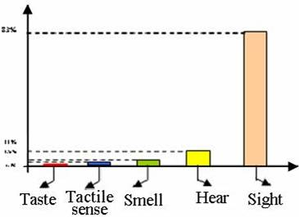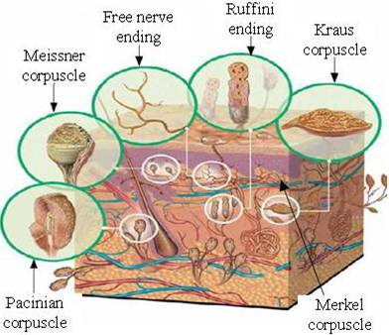
Figure 1: The importance of human senses Figure 2: The skin and its receptors

The skin - the largest receptor surface - gives us the possibility to perceive environmental impressions as touch (pressure), texture, temperature, pain. The skin contains four types of mechanoreceptors (Fig.2): the Meissner corpuscles respond to velocity, slip and local shape, the Pacinian corpuscles are dedicated to vibration, slip and acceleration, Merkel’s disks have an optimal response for local shape and pressure and the Ruffini corpuscles sense skin stretch and local force. Meissner and Merkel endings lie close to the skin surface and have high spatial resolution. Pacinian corpuscles and Ruffini endings are embedded deep in the skin and hence their receptive fields are much broader. In addition, there are free endings with a high threshold which respond to painful and potentially harmful stimuli, [4]. Considering the nature of skin receptors, it results that the stimulus generated by the tactile displays must be categorized as follows:
- vibrations - offer information concerning the surface’s texture, flow, impact and punctual contact (the domain of frequency of vibration varies from few Hz, to few hundred Hz);
- distribution of pressure and reproduction of shapes at low scale (this situation needs a pin network, closely positioned one to each other, which can be in contact with finger tip, individually, so that they can approximate a desired shape);
- sensation of a thermic parameter (it represents a new domain, thermic perception can be based on a combination of some parameters like: temperature, thermic conductivity, etc.);
- other modalities: electric stimulation, devices with electro-rheological fluids for converting the information concerning compliance and others.
Humans respond to sensory information with a certain latency (for the fastest reflexes, the latency is 20-30 ms and much longer times for voluntary responses).

2. ANALYSIS OF THE TACTILE DISPLAYS’ ACTUATION SYSTEMS

To address the future requirements of mechatronic systems, novel actuation systems are being developed based on the actuators with special properties, like softness, lightness and safety, [5]. The amount of work that actuators perform and their energetic efficiency depend drastically on the method of actuation. The actuation effect is achievable by three different means: field interaction, mechanical interaction and limited strains. In order to actuate the pins in the structure of the tactile displays, following features must be satisfied: miniaturization, small size and simple design, good controllability, rapid actuation potential, low power consumption.
Wagner et al. developed a 6x6 pins tactile display using commercial servomotors. This low cost and simple solution offers high bandwidth, large vertical displacement, and firm static response, [6]. The servomotors are available in different sizes and provide a good position accuracy but the rotary motion must be transformed in linear by rocker arms or combinations of screws and nuts. The stepper motors ar often used, [7] for macro tactile displays (e.g. 16x16 pins on an area 175x175 mm, diameter of pin: 5 mm; spacing between pins:10 mm; high of pin 0-6 mm). In [8], a tactile display composed on four independent voice-coil actuators that are arranged in the form of human‘s hand is described. It serves to reconstruct the roughness of a material rubbed by a tactile sensor. Another type of electromagnetic actuators are solenoids which are able to create direct by linear motion. Because of the highly non-linear magnetic coil characteristic of solenoids it is difficult to implement a position control.
Pneumatic actuators use the pressure or flow of the air to drive pins or inflate air chambers. The benefit of pneumatic actuators is that the compressor which generates the pressure can be placed at peripheral locations. Therefore they can provide a good power density by using simple components. Disadvantages are the non-linearities and thus difficulties in control of either pressure or flow, [9]. Miniaturized actuators (e.g. electrostatic) are implemented to control the microvalves for pneumatic refreshable displays.
The conventional actuators, used in commercial products are not suitable for high-resolution graphic tactile displays. The shape memory alloy actuators were found as the most promising candidates for these applications.
Also, the piezoelectric technology is mature, well understood but its major limitation is a small strain. The stacked or bimorph actuators are currently used.
Liu et al. describes in [10] a single cell tactile display based on magneto-rheological (MR) fluid. The MR fluids exhibit rapid, reversible and significant changes in their rheological properties while subjected to an external magnetic field (they are in liquid state without external stimuli and behave as solid gels in magnetic field). The sensed surface profiles changed in synchronization with the magnetic field. Taylor at al., [11] developed a tactile array based on electro rheologic fluids (which under normal conditions behaves as a liquid but on the application of an electric field, is transform to a plastic state in milliseconds). Differential actuating systems were developed for selective stimulation of the skin receptors: superficial stimulation by air pressure and shallow and deep stimulation by vibration, producing more realistic feeling of touching a texture, [12].
In figure 3 some examples of tactile displays are presented, according with [6] - [16]. In figure 3a is put on view an alternative with four pins in oscillatory movement, each of the four pins being tied from the base by a spherical articulation and being put on move by two d.c. servomotors. The pins apply a cutting force over the fingers which they come in contact. Examples 3 b-f are characterized by the vertical movement of the pins with different options of mini/microactuators. The actuating system in figure 3b is based on chemical actuators with dielectric polymers. When a tension is applied, they narrow and grow their surface. When the tension is no longer applied, the polymer resizes to its initial shape and surface. For realizing a considerable movement of the pin, more stacks of dielectric material and electrodes are required. The solutions in figures 3c, d, e and f are useful for actuating pins based on memory-shape alloy, with active elements, wire-typed, the resizing being ensured by the elastic elements. These actuators offer the optimum conditions for miniaturizing. The alternative in figure 3d consists of eight modules, each of them with two pins. The pin’s movement in figure 3e is produced by activating a wire with shape memory alloy, whose stroke is amplified within an articulated element. The display in figure 3f contains 10 pins linearly disposed. A mouse with tactile display is presented in figure 3 g. In figure 3 h there is a display for reading in the Braille alphabet. It consists of 20-80 cells which are disposed in a circle; three of them are active, being situated near de access window. Each cell has eight pins, disposed on two columns, each column containing four pins actuated by the electromagnets.

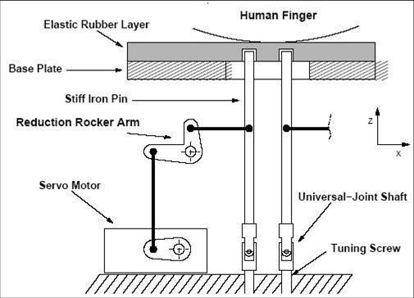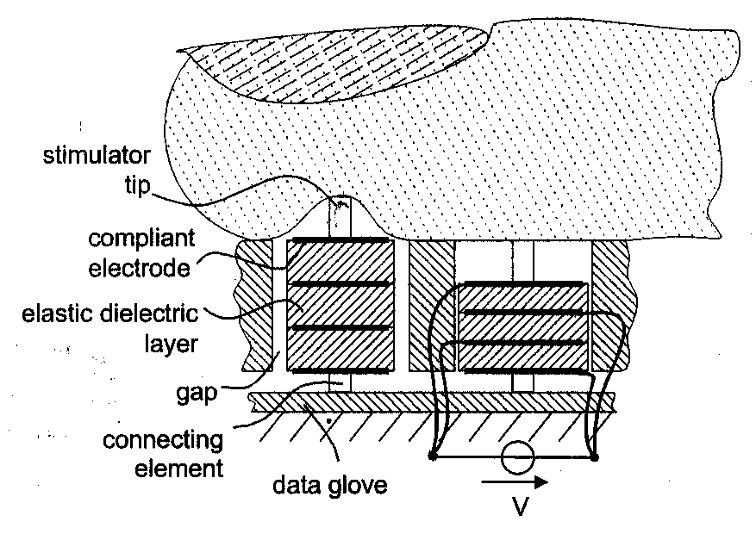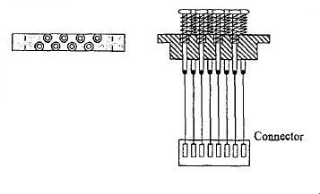
a b c d
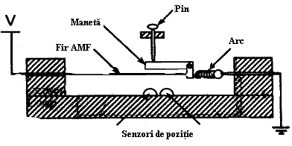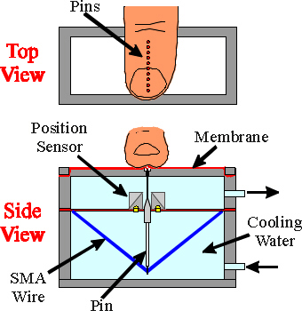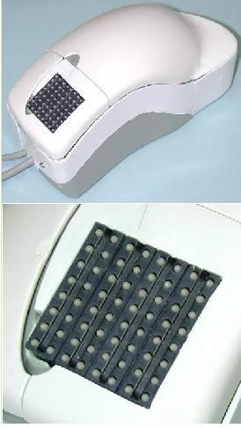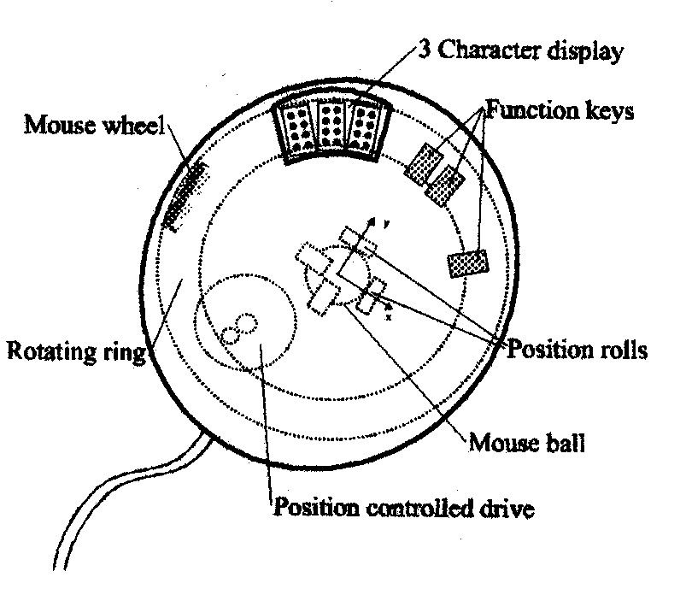
e f g h
i j 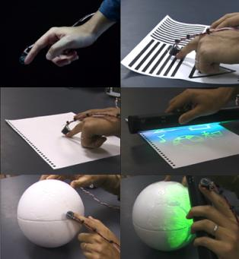 k 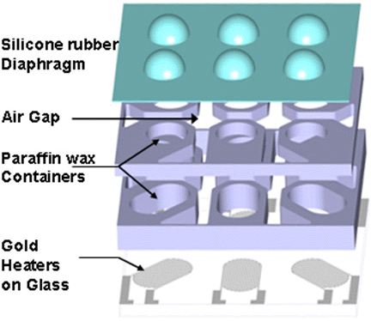l

Figure 3: Examples of tactile displays

The most important functional parameters, specific to the tactile displays and their actuating systems are: normal pressure applied on finger tips (vertical force carried by the actuator), amplitude of vertical movement, the frequency of excitation, the power density, possibility of miniaturization (the pin diameter, the distance between the centers of two consecutive elements), the number of pins, possibility of independent action of the actuators, possibility of integrated production, costs, stability, a.s.o.
Table 1 shows a summary of the performances of various actuating systems of the tactile displays.

Table 1: The performances of the actuating systems
Actuators | Frequency |  |  | Comments
Actuators | <10 | 50 | 250 | Comments
D.C. motors  stepper motors | x | x | o | Low cost, simple solution but difficult to miniaturize
Electrostatic | x | x | x | Small forces, high voltage
Piezoelectric | x | x | x | Practical to implement, amplification of the actuators’ stroke is needed
Shape memory alloy  actuators | x | o | o | Low frequencies, high forces; high resolution display
Electro Active Polymers | x | x | x | High voltage, high deformations
Electro rheological fluids | x | o | o | Variation of viscosity, high voltage
Pneumatic | x | x | o | Simply construction, good power density
Electrical stimulation | x | x | x | Low power, invasive excitation

3. THE DEVELOPED SYSTEMS

The functional and constructive parameters of the first developed tactile display are: pin diameter: 1.5mm, center-to-center spacing of the pins: 2.5mm, force at each pin: 2N, vertical displacement of the pins: 1.5 mm. We selected SMA wires as actuators because of their very high force-to-volume and force-to-weight ratios. Electrical current heats the SMA wires, which undergo a phase transformation and shorten, thus pushing the pins up.
a b c

Figure 4: Different solutions to actuate the pins by SMA wire actuators

In figure 4, some actuating possibilities by SMA wires are given. The mechanical design of one element of the tactile display that we have chosen is shown in figure 4c. Based on the input data and on the SMA wire actuators design methodology, presented in [5], we determined the necessary length and diameter of the wire, the elastic force of the biasing spring. We adopt the distance between the ends of the wire (Fig. 5a): AB = 50 mm and the high of the pin: DC = 25 mm. It results the length of the wire at low temperature, in the martensite phase: l = 71 mm. For a shape memory effect about 3 %, results the length of the contracted wire at high temperatures, in the austenite phase: l’ = 68.8 mm. These lengths assure the imposed pin displacement.

a b c
Figure 5: The calculus schemes

The force exerted by a pin, F_{pin} is (Fig. 5c):
${F_{\text{pin}}=F_{f}⋅\text{sin \{}α}^{'}$, (1)
where F_{f} is the force developed by the wire when it “remembers” its the initial length. This active force can be calculated as follows:
$F_{f}=σ_{R}⋅A=σ_{R}⋅\frac{π⋅d^{2}}{4}$ (2)
where σ_{R} is the reccomended recovery strain (for FLEXINOL , σ_{R} =200 N/mm² ), [17].
The restoring or relaxation force F_{relax} which extends the cooled wire is:
$F_{\text{relax}}=σ_{\text{relax}}⋅\frac{π⋅d^{2}}{4}$; (3)
where σ_{relax} = 35 N/mm² represents the relaxation strain.
The necessary force to be developed by the bias spring is (Fig. 5c):
${F_{a}=F_{\text{relax}}⋅\text{sin \{}α}^{'}$; (4)
Based on the force F_{a} we established the diameter d, the average diameter D, the number of active coils n and the spring rate c for the restoring (relaxation) spring.
The values of the forces, for different wire diameters, are presented in Table 2.

Table 2: The forces for different wire diameters.
Diameter of the wire [mm] | F_{f}  [N] | F_{pin}  [N] | F_{relax}  [N] | F_{a}  [N]
0,05 | 0,39 | 0,26 | 0.068 | 0.045
0,1 | 1,57 | 1,05 | 0.27 | 0.18
0,15 | 3,53 | 2,36 | 0.61 | 0.40
0,25 | 9,81 | 6,57 | 0.71 | 1.14

The tactile system in our prototype consists of a line of four individually actuated pins that are raised against the finger pad. The 3D model without the SMA wires is given in figure 6.
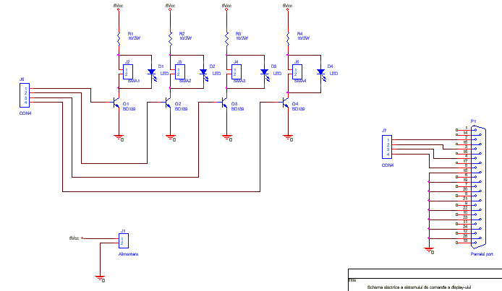

Figure 6: The 3D model of the developed prototype Figure 7: The electronic scheme of the prototype

For the developed prototype, the actuation system of SMA wires is realized through parallel port of a P.C. Electrical schematics uses as command elements four transistors BD139 which were chosen according with power consumption required by the wires. Because the maximum current for activation is 400mA (recommended for 0,15 mm wire diameter) were used four limiting elements of 10Ω at an active power of 2W. The command in the base of transistors is realized by using the 2, 3, 4, 5 pins of the parallel port connector DB25 pins; those pins belongs to data register 378h. (fig. 7). The source of the program for the developed prototype was written in LabView. In the figure 8 is presented a snapshot picture of the program source.

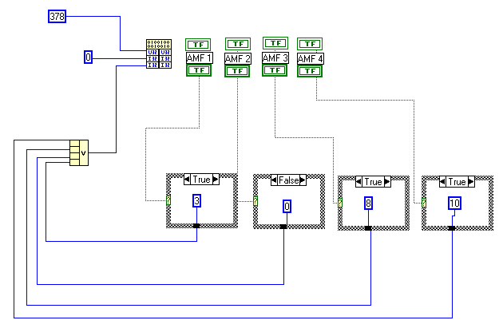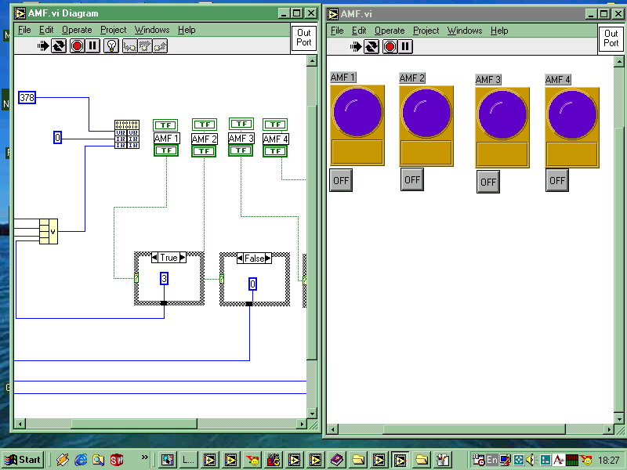
a b

Figure 8: The program and interface for the command of the prototype

Braille is a medium which allows a non-sighted person to read text by touch, is also a method for writing tactile text. The Braille code is physically presented as raised dots, usually arranged in cells of 6 or 8 dots. A Braille display is a tactile device consisting of several cells, each cell has 6 or 8 pins controlled electronically to move up and down to display characters as they appear on the display of the source system - usually a computer or Braille note taker.. Advanced Braille code features 8 dot Braille, but most probably will use only the 6 dot code. Dots 7 and 8, if present. can be used to show the position of the cursor in the text or for European 8 dot Braille. They can also be used for advanced maths work and for computer coding. In order to design an interactive system for learning the Braille alphabet by children with disabilities of sight and the dactilemes used in the International Sign Language by children with disabilities of view and speech, a new system is under construction, [18]. It contains a Braille display with 6 pins actuated by solenoids, (Figure 9).

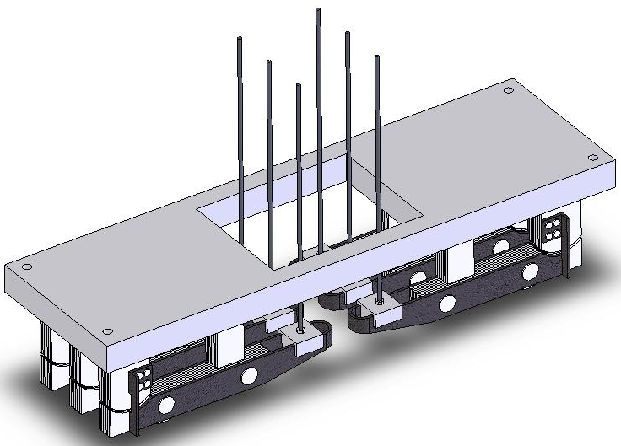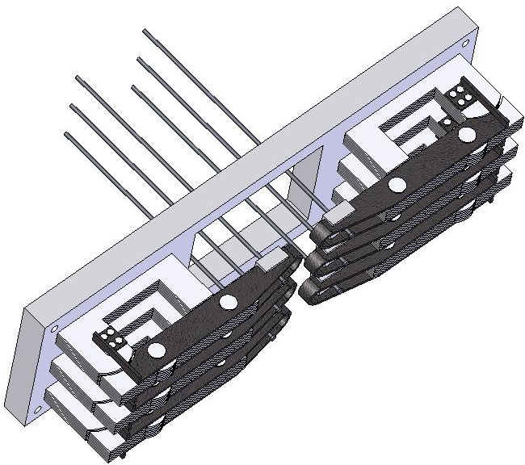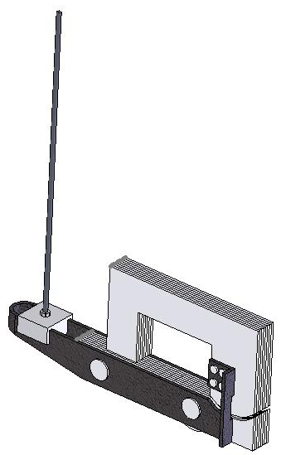

Figure 9: The Braille cell with solenoid actuators

4. CONCLUSION

The different applications of tactile displays are: sensory substitution, 3D surface generation, Braille systems, teleoperation and telepresence, games. According with the application, specific actuating systems were implemented. The most used technology is electromagnetic actuation. In the case of electric motors, the interfaces are bulky. For commercial Braille systems, the piezoactuators are recommended due to the high bandwidth and generated forces. The technology based on shape memory alloys is widely used in high resolution tactile display. Its advantages are: simplicity, compactness, clean and silent operation, high power/weight ratio. The drawback of this technology is the low bandwidth.
A prototype of a tactile display, consisting in tactile pins that reproduce sensations related to normal contact forces, has been developed. The actuators are based on shape memory alloy wires. First tests show encouraging results. Future approach will be made on the appropriate packaging and interconnection technology. The second prototype is based on electromagnetic actuation and is implemented in a device for learning the Braille alphabet.
REFERENCES

[1] Mândru, D., Crisan, R., Buiga, S.: Research concerning the development of a Tactile Display, Buletinul Stiintific al Universitatii de Nord, Baia-Mare, seria C, volumul XVIII, pag. 195-200, 2004.
[2] http://robotics.eecs.berkeley.edu/~gmoy/tactiledisplay/main.html
[3] Mândru, D.: Ingineria protezarii si reabilitarii, Editura Casa Cartii de Stiinta, Cluj-Napoca, 2001.
[4] Wood, D.: Tactile Displays:Present and Future, Displays 18 (1998), pp. 125-128, 1998.
[5] Mândru, D., et al.: Actionari in Mecanica Fina si Mecatronica, Ed. Alma Mater, Cluj-Napoca, 2004
[6] Wagner, C., et al.: A tactile Shape Display Using RC Servomotors, Proc. of the 10th Symp. on Haptic Interfaces HAPTIC’02, 2002.
[7] Kawai, Y.: Interactive Tactile Display System, 2004, available at: www.staff.aist.go.jp/y.kawai/paper
[8] Tanimichi, K., et al.: Sensing distant objects by tele-aptic interface, Proc. of the 2003 IEEE Int. Conf. on Advanced Inteligent Mechatronics, pp. 412-416, 2003
[9] Fritschi, M.: Design of a Tactile Shear Force Prototype Display, 2003, available at: http://www.tuch-hapsys.org
[10] Liu, Y., et al.: Single cell magnetorheological fluid based tactile display, Displays 26, pp.29-35, 2005.
[11] Taylor, P.M. et al.: Advances in an electrorheological fluid based tactile array, Displays 18(1998), pp. 135.
[12] Asamura, N., et al.: Selectively Stimulating Skin Receptors for Tactile Displays, IEEE Computer Graphics and Applications, December 1998, pp. 32-37, 1998
[13] Brenner, W., Micro-Actuation Principles for Hight Resolution Graphic Tactile Displays, 2000, available at: www.rm.mce.uec.ac.jp\study-shumj\TactilDisplay\.
[14] Wagner, C., et al.: A tactile Shape Display Using RC Servomotors, Proc. of the 10th Symp. on Haptic Interfaces HAPTIC’02, 2002.
[15] Howe, R.D., Shape Memory Alloy Actuator Contoller Design for Tactile Displays, Proc. of the 34th IEEE Conf. on Decision and Control, New Orleans, 1995, pag. 1-5.
[16] Ando, H., SmartFinger: Nail-Mounted Tactile Display, 2003, disponibil la: www.star.t.u-tokyo.ac.jp \project\smartfinger.
[17] Gilbertson, R.G., Muscle Wires. Mondo-tronics Inc., San Anselmo, 1994
[18] Mândru, D., et al.: Interactive System for Learning the Braille Alphabet and the Fingerspelling Signs, Annals of the Univ. Oradea, Fascicle of Manag. and Technological Eng., vol. V(XV), pp. 631-638, 2006

