KINEMATIC-DYNAMICAL OPTIMIZATION OF THE FOUR LINKS SUSPENSION MECHANISM FROM CAR BODY’S ROLL MOTION CRITERION

Petre Alexandru¹, Gabriel Andreica²
Transilvania University, Brasov, ROMANIA, e-mail: alex.p@unitbv.ro

Abstract: Considering four variants of the four links mechanisms used in passengers cars suspensions, on the basis of Matlab and ADAMS-View softwares, a series of kinematical and dynamical analyses are realised with the target of making evident the influence of the roll center position and roll centroides forms on the parameters of the automobile frame roll motion. There are seeked: roll motion centroids, roll angle, roll angle velocity, roll angle acceleration, lateral displacement of the center of gravity of the automobile’s frame.
Keywords: mechanism, suspension, roll, kinematics, dynamics .

1. THE ROLL CENTRE AND THE ROLL MOTION CENTROIDES

The roll motion of the automobile’s frame around an approximate longitudinal axis is an important part of the automobile’s dynamic and comfort. This movement is greatly defined by the geometrical and elastic characteristics of the suspension.
Defining the roll centre (C_{r}) as the point in the longitudinal plane of the frame’s rotation relative to the ground (I_{co}), in the case of the usual suspension with four links mechanism the rolling motion centre is at the intersection of the I₂₀I_{2c} line with the longitudinal plane (the theorem of the collinearity of three relative rotation centres – fig.1).

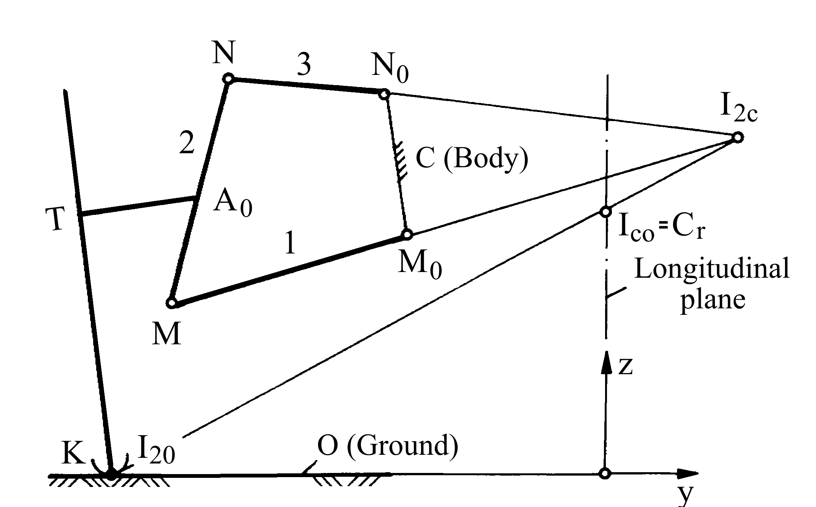
Figure 1

In the case that the horizontal position of the roll center needs to be drawn or if there is an unequal vertical movement of the wheels, the lines I_{s20}I_{s2c} from the right wheel won’t meet again in the longitudinal-vertical plane, so that the roll centre C_{r} will describe a mobile centroide (m) and a fixed one (f) (fig. 2).
The spatial variant of a four link suspension mechanism has the arm’s axis at the automobile’s frame joints inclined relatively to the longitudinal axis x with the angles ψ₀₁/ψ₀₃ in horizontal plane and /or ν₀₁/ν₀₃ in longitudinal plane, so that the application of the collinearity theorem involves complications; in this case is recommended to appeal to the velocities vectors method for localizing the roll centre: the roll centre I_{co}≡C_{r} is at the intersection of the perpendiculars brought to the velocity vector of the point K in the vertical transversal plane yOz.

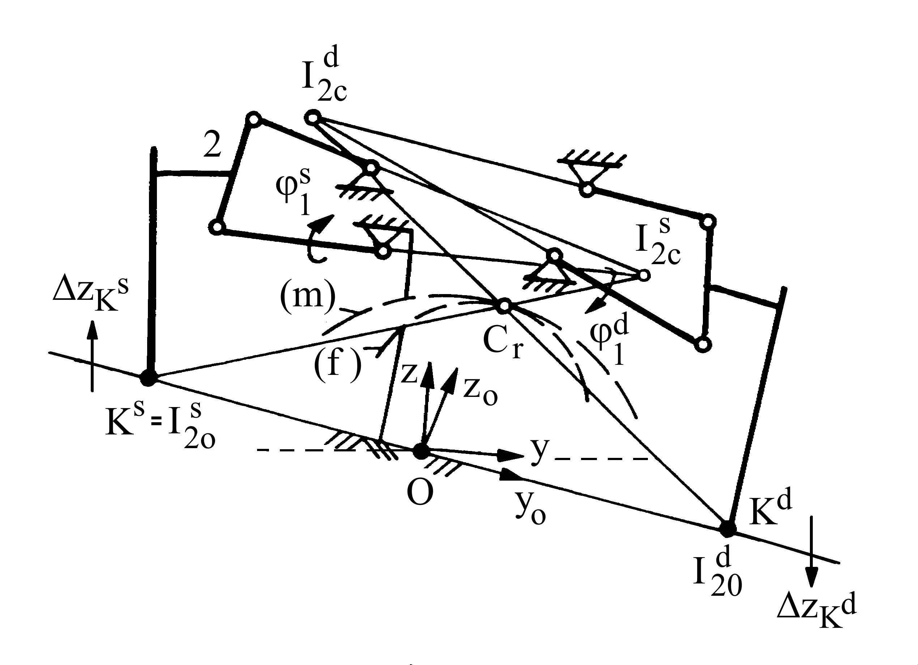
Figure 2

For the general case of a planar mechanism and for the two wheels unequal motion, the roll center position is derived as in figure 3.

Figure 3

The method implies finding out the coordinates of the point K (y_{k1} z_{k1}) from the kinematic analyses of the mechanism, according to which the height of the rolling motion’s centre in comparison to the ground will be:

$\frac{v_{\text{ky}}}{v_{\text{kz}}}=\frac{{\text{dy}}_{k}{dϕ}_{1}}{{\text{dz}}_{k}{dϕ}_{1}}=\frac{{\text{dy}}_{k}}{{\text{dz}}_{k}},⇒h_{C_{r}}=y_{k}\frac{{\text{dy}}_{k}}{{\text{dz}}_{k}}\text{.}$ (1)

The velocity vectors method presents a general applicability, being necessary only to know the movement of the points K of the tyre contact patch with the ground, which can be performed through the “in house” programme as well as through MBS commercial programmes (for eg. ADAMS Car).
For the kinematic analyses of the four links suspension mechanism and the drawing the roll centroides, the authors have conceived programmes written in Matlab, based on the analyses with the MBS method. For the roll motion simulation it has been used the principle of inversion of the movement, through fixing the automobile’s frame and inclining the road path (the car’s wheels are moving vertically in opposite directions).
For an easier comparison of the different mechanisms under the aspect of the roll centroides, it has been considered that the vertical movements of the two wheels are equal and in opposite directions (the vertical movement of the wheels were considered as being variable independent). The mobile centroide is expressed through the centre’s coordinates in the frame’s system xyz, and the fixed centroide in the ground’s system x₀y₀z₀ (x₀≡x). The programme writes and solves the nonlinear systems of the restriction equations, the calculations of the centroides and the graphical representation of the mechanism, with kinematic parameters which define the wheel functionality*. In figure 4 is given the example of simulation of the mechanism, the kinematic functions regarding the variations of the track and the camber angle and the centroides for two vehicle loading cases (nominal and maximum).
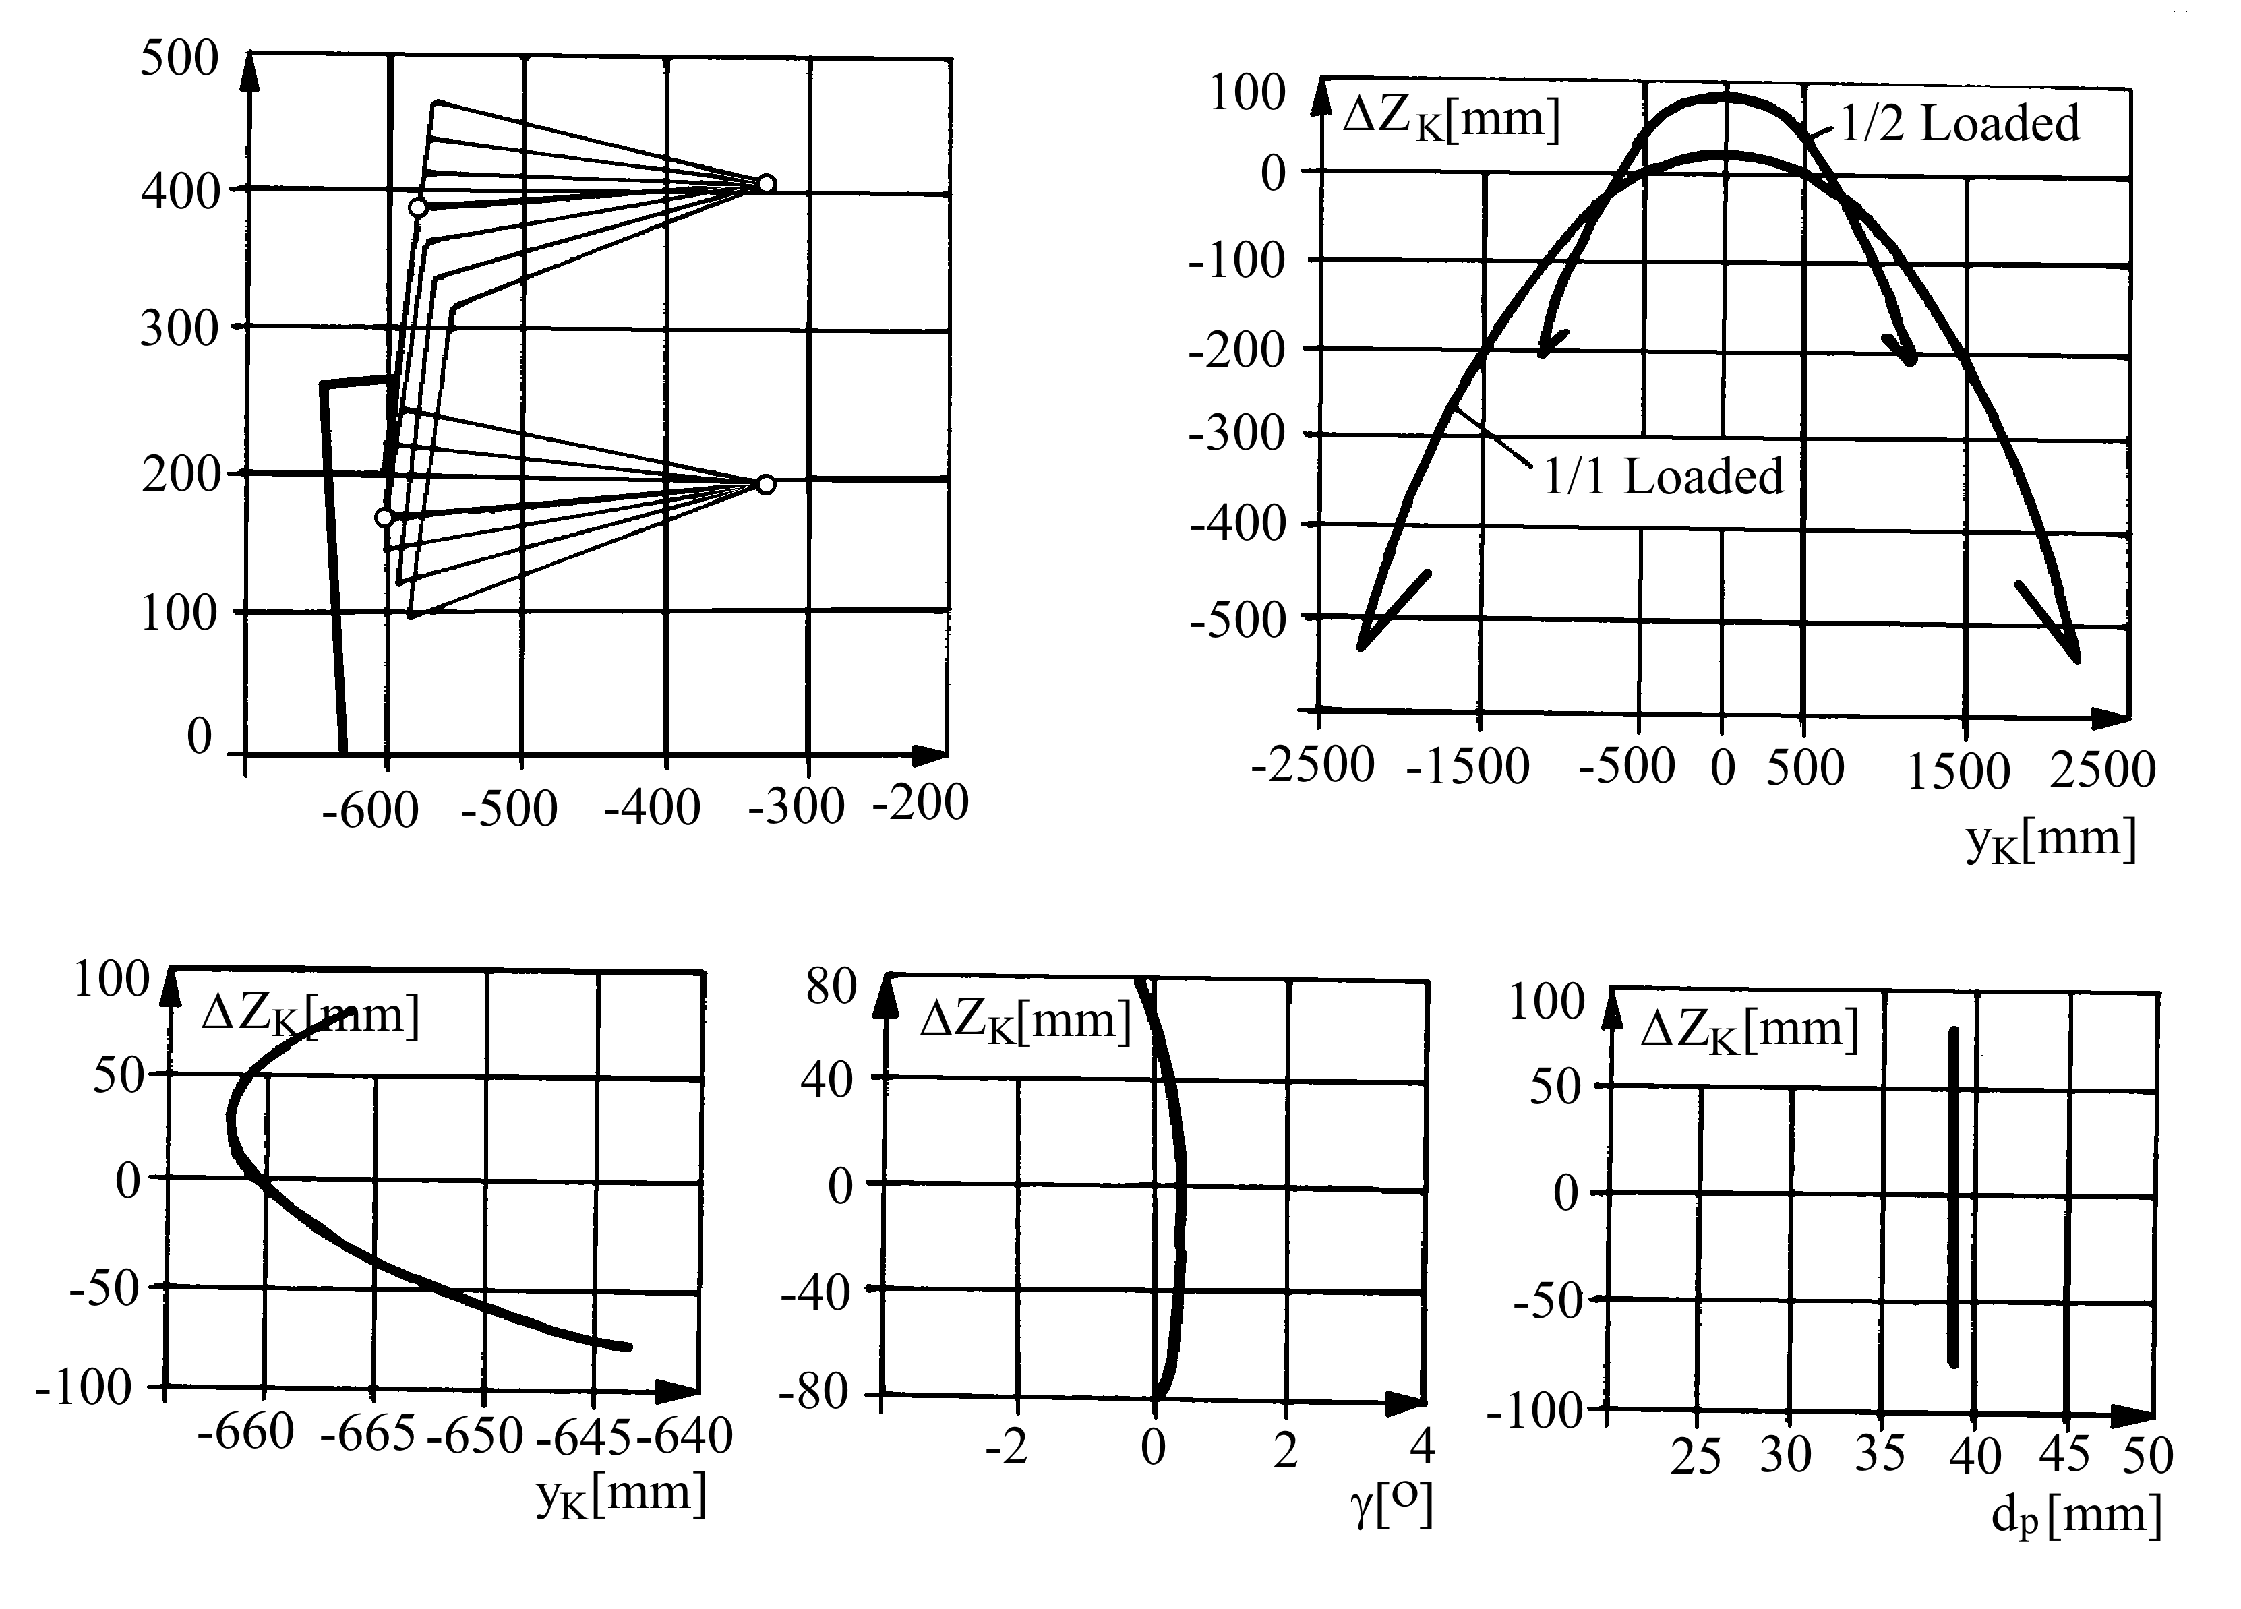
Figure 4

2. OPTIMISATION ELEMENTS REGARDING THE ROLL MOTION KINEMATIC CENTROIDES

It is being imposed the explanation that in the speciality literature is not given a general and complete optimisation method of the suspension mechanism starting from the rolling movement criteria, due to the highly personalised character of the optimisation of a complex system such as the suspension system. Also the world wide known softwares for analysing and simulating passengers cars do not give an specialised algorithm for the design – optimisation of the suspension mechanism starting from the position of the roll center, this aspect being considered an output parameter or one that has to be modified according to several criterias.
For pointing out the roll centers position criteria, four representative variants of four links suspension mechanism are considered, which are represented in the initial positions in figure 5.

a. | b. | c. | d.
Figure 5

In order to compare the results, the four variants have been defined by the same values of the following geometrical parameters: bars length, wheel radius and track, but with different values of bars inclination angles and different distances between the articulation points of the upper and lower bars to the car body (poins M0, N0). Also, for this analisys, it was considered that the kinematical parameters that define the degree of perfection of the wheel bump and rebound motion (camber angle variation and track variation) are not of the interest.
In figure 6 are presented the four centroides obtained after runing the Matlab written programme, in variant a) with the initial parallel arms, the roll centre being the most far off from the symmetry axis of the automobile, in variant c) the centroide is under the ground level, and in variant d)the centroide is at the highest position from the ground, variant b) having an intermediate roll center height.
The centroide dispersion indicates the possibility of correlating the geometry of the mechanisms with an answer regarding the angle and the moment of the roll motion.

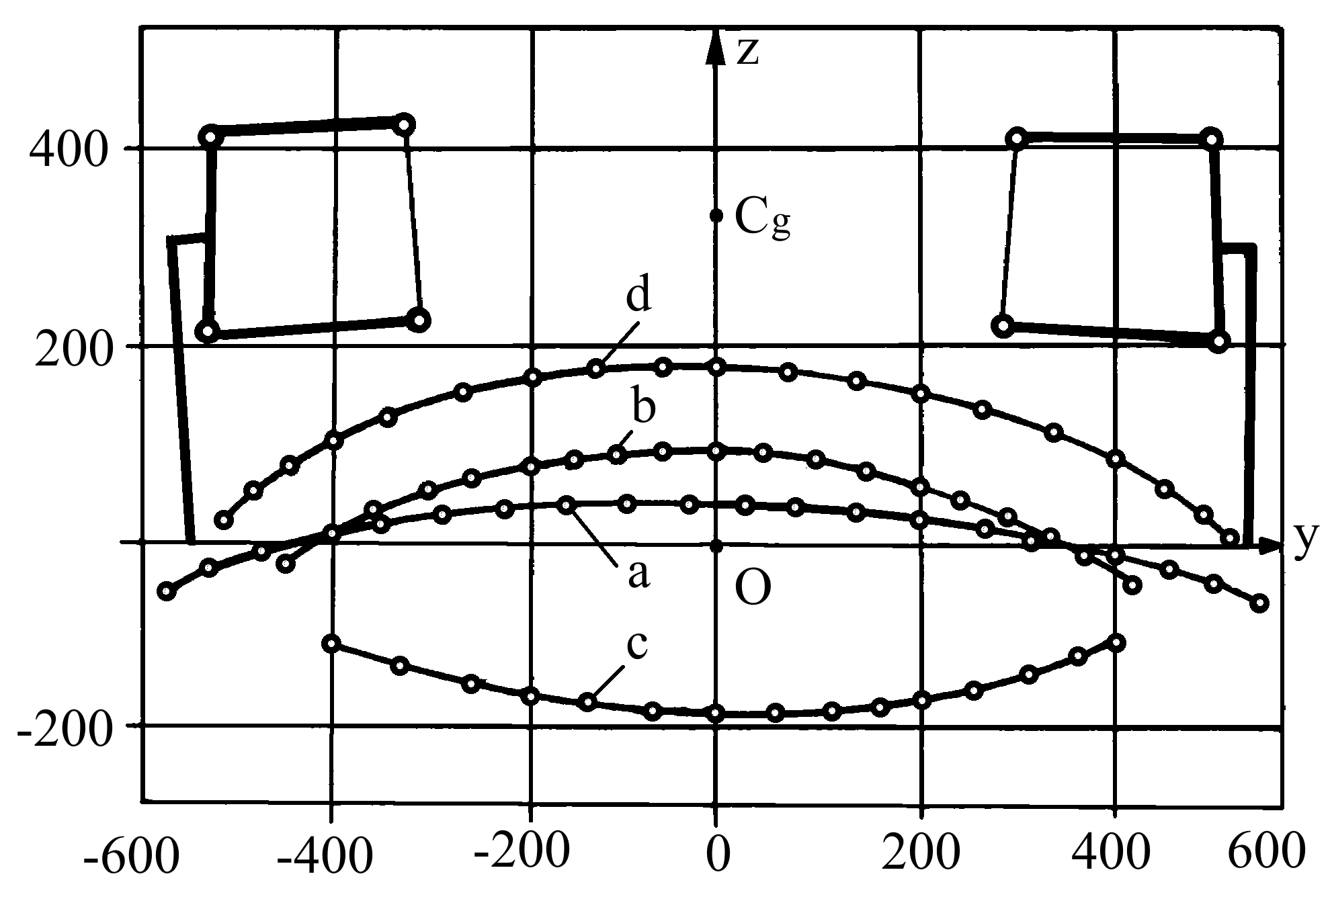
Figure 6

3. OPTIMISATION ELEMENTS REGARDING THE DYNAMIC BEHAVIOURS IN THE ROLLING MOTION

The dynamic model constructed in ADAMS/View (fig. 7) has completed the kinematic model with the tyres (2_{s,d}), springs – dampers forces (4_{s,d}) and the anti-roll bar (5), considering the stiffness coefficients of tires (only vertical), springs and anti-roll bar k_{p}, k_{a} and k_{b} and the damping coefficients c_{a} and c_{p}.

Figure 7

Because the rolling motion is determined mainly by the lateral forces, it is important not only the position of the roll centre C_{r}, but also the position of the centre of gravity C_{g}, it’s height from the ground h_{g}, the car body mass m_{c} and its inertia moment J_{x}.
The simulations have been performed using as input parameters the values of the lateral force (which is in this case was of the type impulse F=1700N, simulating a cornering maneouver), observing as the outputs the following parameters: the roll angle ϕ_{r}, the roll angular velocity ω_{r}, the roll angular acceleration ε_{r}, the lateral movement of the gravity centre S_{y}. It was kept in sight that the lateral force should have a maximum value that would not imply the action of the suspension bump and rebound stops, which would introduce an incontinuity and a variable rigidity.
The dynamic analyses have aimed pointing out the influence of roll center position’s and the kinematic centroides form of the representative four links mecanisms variants given in fig. 5-6 over the vehicle parameters which characterise the rolling motion ( ϕ_{r}, ω_{r}, ε_{r}, S_{y} ). In order to do this the geometrical values of all variants were kept the same as at the kinematical analysis. Were modified only the aplication points of the spring-damper forces, so that the initial configuration of the mechanism (car body position relative to ground) do not change during the static equilibrium.
The results of the simulations are given in fig. 7, 8, 9 and 10 representing respectively: the angle ϕ_{r}, the velocity ω_{r}, the acceleration ε_{r} and the lateral movement S_{y} for the automobile equipped with every representative types of suspension quadrilateral.
Figure 8

Figure 9

Figure 10

It is being observed that at type c) – with the centroide under the plane of the rolling path – the values ϕ_{r}, ω_{r} and ε_{r} are the biggest, the rolling motion angle reaching 19,5°, which shows a overturn beginning . The types b) and d) give the best values ϕ_{r}, of 8,4°, respectively 8,7°.
The rolling motion angular velocity and acceleration maxims, which characterise the comfort, are also quite different from the four types, the difference being over 10 gr/s for roll angular
velocities and over 150 gr/s for the roll angular accelerations. The same results can be observed to the lateral desplacement of the car body’s center of gravity, where S_{y} has the biggest value (210 mm, and the beginig of a lateral slide) when roll center is under the ground level (variant c).

Figure 11

All these elements give us an image of the implications of roll center position in vehicle’s stability and passenger confort and the way to improuve the vehicle’s characteristics by means of the suspension mechanism and the roll center criteria.

4. CONCLUSIONS

The paper presents some optimization aspects regarding the relation between the suspension mechanism and car body roll motion, both kinematic and dynamical. The use of the Matlab authors written software allows a complete MBS kinematic analysis of the four links suspension mechanism along with the roll centroides drawing. By entering a range of values for the geometrical parameters of the mechanism, the roll center position ca be determined in each case, and the use it in further dynamical analysis for a variety of roll centroids shapes and positions.
In this paper, starting from the roll center height criteria, four mechanisms were chosed so that length of the bars, wheel radius and vehicle track remained constant. Their simplified dynamical models were analyzed with ADAMS/View under a lateral force, showing important differences between each one.
As the fact that in real application the wheels suspension good functionality depends on the minimum variation of the wheel caber angle and of the vehicle track, this parameter should be considered as the restrictions. Regarding the dynamical optimization it is necessary to point out the complexity of a real wheels suspension mechanism where the joints and the tyres lateral stiffness, along with the spring’s stiffness and damping play a great role in the roll center position. For dynamical models the cornering maneuvers (understeer and oversteer), ride comfort and overturning safety are parameters of a critical importance that acts as restrictions and imposed condition.
Therefore a further detailed optimization study, starting from the roll center position criteria, should take in account all these kinematic and dinamic condition, using an full vehicle dynamical model built analyzed with a specialized MBS software like ADAMS/Car. Because of the complexity and the number of variables, the purpose of the study is, in this case, to find a global optimum solution that meats all the required conditions.

REFERENCES

- Alexandru, P., Vişa, I., Souca, N.: Comportarea funcţională şi optimizarea modelelor structural-cinematice a mecanismelor de ghidare a roţii şi punţilor autoturismelor, Fazele I, II, III, ICSITA Piteşti, 1981-1985
- Alexandru, C.: Simularea pe calculator a sistemelor mecanice articulate, Editura Lux Libris, Braşov, 2000
- Andreica, G.E: Optimizarea mecanismelor de ghidare a roţilor/punţilor autoturismelor pentru controlul mişcării de ruliu, Braşov, 2004
- Fenton, J.: Handbook of Automotive Powertrains and Chassis Design, Professional Engineering Publishing, London, UK, 1998
- Ghinea, M, Fireţeanu, V.: Matlab, calcul numeric şi aplicaţii, Editura Teora, Bucureţti 2001
- Mangeron, D., Irimiciuc, N.: Mecanica rigidelor cu aplicaţii în inginerie, Vol. 1, 2, 3, Eitura Tehnică, Bucureşti, 1980
- Reimpell, J.: Fahrwertechnik, vol. 1,2,3, Voge-Verlag, Wurzburg, 1970
- *** Using ADAMS. MDI, SUA, 1999
- *** Matlab User’s Guide, The MathWorks Inc., SUA, 1995.

* In this paper is not presented the mathematical basis of the programme

