MATLAB GRAPHICAL USER INTERFACE FOR PATIENT DATABASES

Marius C. LUCULESCU¹
¹ “Transilvania” University of Braşov, Romania, lucmar@unitbv.ro

Abstract: The paper presents a Graphical User Interface (GUI) developed in MATLAB for patient databases. The database has a certain structure containing information regarding the name and personal data of the patient, the diagnostic name and its image file, the image source, a history of the disease, clinical features, treatment, observations and so on. User can browse, append, modify and delete records, can select and view the image file corresponding to the diagnostic and can export the information to a diagnostic database. All of these options are very useful for generating and updating patient databases. This GUI is integrated in a Computer Aided Diagnostic (CAD) system for macular diseases.
Keywords: Patient, database, image, diagnostic, MATLAB.

1. INTRODUCTION

The objective of this paper is to present why a patient database is a very powerful tool for organizing patient care data to improve patient care and strengthen communication of data among health care providers and to present how such a database can be implemented in Matlab.
The patient database is even more powerful when used in a system that retrieves applicable medical knowledge to support clinical decision making [1].

2. PATIENT DATABASES

The main role of the database records is to support the delivery of medical care to a particular patient. The databases are parts of systems that encompass data entry and presentation, storage, and access to the clinical decision maker - usually a physician or nurse. The data can be entered by keyboard, dictation and transcription, voice recognition and interpretation, light pen, touch screen, handheld computerized notepad (perhaps wireless) with gesture and character recognition and grouping capabilities, and other means. Entry may also be by direct instrumentation from electronic patient monitors and bedside terminals, nursing stations, analysis by other computer systems such as laboratory autoanalyzers and magnetic resonance imagers, or another provider’s.
The database may be stored centrally or it may be stored in many places (distributed) for retrieval at the request of an authorized user through a database management system.
A record in the patient database is a collection of data about a patient’s health care in electronic form. Records have to contain personal patient information and also past and current information about his diagnostics, status, treatments and so on, information that can be accessed by the health care givers. The patient data should be acquired as part of the normal process of health care delivery, by the providers of care and their institutions, to improve data accuracy and timeliness of decision support.
Data contained in records can be represented by text, tables, graphs, sound, images, full-motion video, and signals. If some information cannot be incorporated directly in the database, a link may point to the location of additional patient data (for example path to the image files).
The patient database can also be an instrument for building a clinical data repository that is useful for collecting information about which medical treatments are effective in the practice of medicine in the community and for improving population-based health care.
Databases can be used in a Clinical Decision Support System (CDSS) [1] - computer software designed to aid clinical decision making - to provide the physician with medical knowledge that is pertinent to the care of the patient. Diagnostic suggestions, testing prompts, therapeutic protocols, practice guidelines, alerts of potential drug-drug and drug-food reactions, treatment suggestions, and other decision support services can be obtained through the interaction of the database with a CDSS.
Existing knowledge about potential diagnoses and treatments, practice guidelines, and complicating factors pertinent to the patient’s diagnosis and care is needed at the time treatment decisions are made. Information can be stored in a “knowledge server,” being acquired from different sources. The patient database is such a source that can provide the knowledge server with proper context, i.e., specific data and information about the patient’s identification and condition
Databases can have great value for developing research, medical knowledge, and quality assurance information that would otherwise require an inordinate amount of manual resources to obtain in their absence.
A database may hold and exchange radiological and pathological images of the patient taken or scanned in digital form. The advantage is that digital images may be transferred long distances without a reduction in quality of appearance. This allows patients to receive proficient medical advice even when they and their local family practitioner are far from their consulting physicians.

3. MATLAB GRAPHICAL USER INTERFACE FOR PATIENT DATABASES

The database module we will describe here is a part of a Computer Aided Diagnostic System for macular diseases. The patient database we have developed in Matlab has a certain structure that is verified at the opening moment. The MAT-file containing the database is valid only if it stores a variable called ’Patients’ and the variable has eleven fields called 'Patient_Name', 'Patient_ID', 'Sex', 'Varsta', 'Domeniu', 'Diag_date', 'Den_fisimag', 'Den_diag', 'Diag_history', 'Treatment' and 'Observ' exactly in that order. In Figure 1 all these fields can be observed.

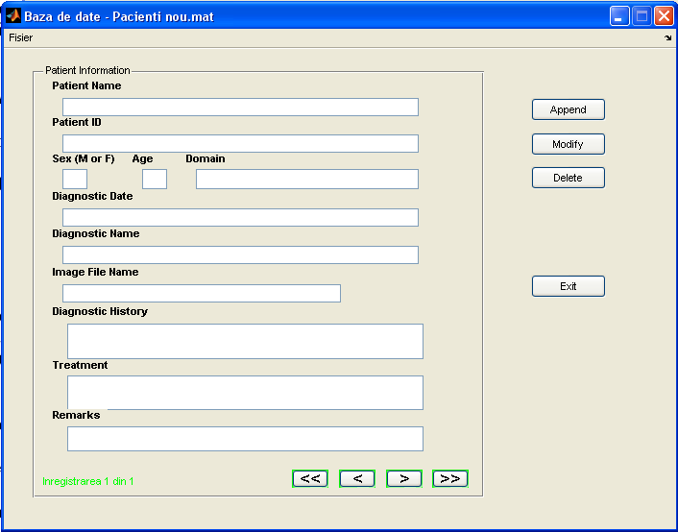

Figure 1: Structure of a patient database record

Patient’s record contains the following information: name of the patient, patient’s ID which is used for uniquely identify of the same person, if it is male or female, patient age, working domain, the date when the record was added or diagnostic date, name and full path of the image file, what the diagnostic is about, a history of patient status or past diagnostics, the treatment recommended for him and some special remarks.

Because of the size of the database, we considered that it is more useful to store in the MAT file only the path and the name of the diagnostic image file. All the image files can be stored in a separate folder on the hard-disk for example. It is an advantage because these images can be viewed, analyzed or transferred independently of the database itself, instead of embedding them in the database.
All the information has to be entered using keyboard and mouse.
The Graphical User Interface (GUI) allows to append, to modify and to delete records. Appending option let user to fill the text fields for a new record. The diagnostic image file can be search in a storage device using the Browse option. If it is found, the full path and name are copied in the input text control and the diagnostic image is displayed in a frame (Figure 2). After filling the fields, record can be saved.
Software also allows to modify information in a certain record and save the changes, and to delete records from the database.
The content of the records can be displayed from the first one to the last. For doing this, the graphical interface includes special push buttons for jumping at the first record, at the last record, at the next record or at the previous one.
The total number of diagnostics and the number of the current diagnostic is displayed on the screen.

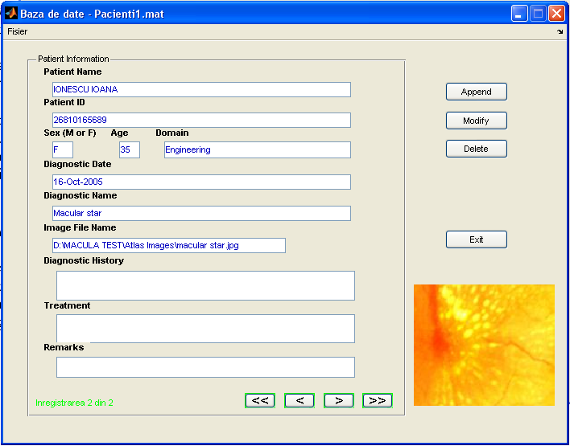

Figure 2: Information included in a patient database record

Although Matlab has a special toolbox for databases, for our application we will use a simpler mode to implement the patient evidence. This is a first step, because the next step will integrate this information in a relational database.
This software was developed entirely in Matlab [2]. A set of options will allow generating reports regarding the evolution of a disease for a certain patient, regarding a set of images for a certain diagnostic. It will be also possible to search in the database for a certain patient using his ID or his name, or to search for a certain diagnostic. Statistical information can be obtained also from the database records.
4. CONCLUSION

Records of the database can be browsed, viewing the evolution of patient diseases with associated text and images. All editing operations are allowed. It is possible to append new records, to modify the existing records and to delete records. Information from this database can be exported to a diagnostic database and can also be used to train a neural network for improving recognition performances.
Data have additional value beyond supporting the care of specific patients. For example, subsets of individual patient care data can be used for research purposes, quality assurance purposes, developing and assessing patient care treatment paths (planned sequences of medical services to be implemented after the diagnoses and treatment choices have been made), assessments of treatment strategies across a range of choices, and assessments of medical technologies in use.

REFERENCES

- ***: The Biomedical Engineering HandBook, Second Edition, Ed. Joseph D. Bronzino, Boca Raton: CRC Press LLC, 2000
- Marchand P, Holland T.: Graphics and GUIs with MATLAB - Third Edition, CRC Press, 2003

