POWER TRANSMISSION ON ELECTRIC CARS PART 1

Marian VASII ¹ , Maria Luminita SCUTARU²
¹„Transilvania” University of Brasov, Romania vasiimarian@yahoo.com
²„Transilvania” University of Brasov, Romania lscutaru@unitbv.ro

Abstract The electric gear-boxes have a continue variation of conduction ratio and are composed from electric generator and one or more electric engines. The mechanical power produced by the engine with internal burning is transform in electric energy by the electric generator and this will be transform again in mechanical energy by the one or more electric engines. When the electric motor are in the wheels of the car is not required the transmission of cars namely main transmission and differential because in this case is an electric transmission. If the motion from the electric motor is transmited to wheels by mechanical transmission will be speak about the electromechanical transmission.
Keywords : electric cars ; transmission ; electric generator

1. INTRODUCTION

The electric transmission present some advantage :
- assure it a variation continuously of transmission ratio
- between certain limit assures the automatic accommodation of the car to conditions of road
- is the most quick and precise way of control
- assure the engine and transmission durability because of the smooth variations regims of upload and the absence of rigid connection among motor and transmission
- the electric motor in wheels permits the placement of the engine with internal burning in any place inside the car
- feature of traction for electric motors of continuous current is very favorably for cars
Among the disadvantage is remembered:
- assure a low efficiency than the mechanical transmissions
- weight and big gauge; the specifies weight of all the elements in a electromechanical transmission represent 68….136 N/Kw, against the specifies weight of the mechanical elements replaced which is about 7…40 N/Kw
- are much expensive
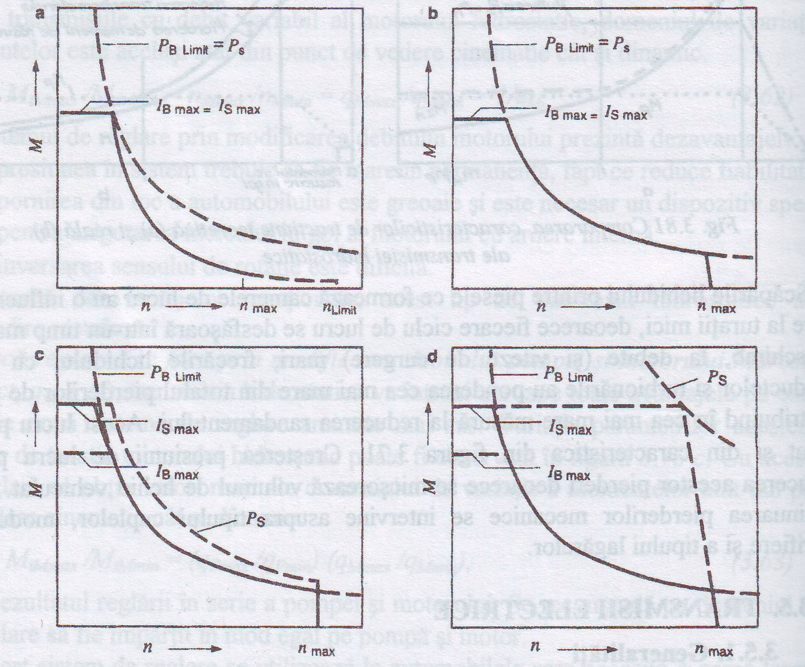

Fig 1 Features of couple limits for different electric motors
a-continuous current with series excitation, b-continuous current with paralel excitation, c- asynchronous, d-synchronous with permanent excitation, Ibmax, Ismax – maximum current for battery respectively control, Pb limit- maximum batteries, P_{s} – the power of the control uni

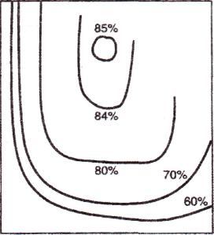

Fig 2 Curve of izorandament for electric motor of direct current with parallel excitation

Characteristic of traction of direct current motor with parallel excitation is very favorable and this feature is very much spred among the cars which utilize the electric motor for traction . For illustrate the way wich efficiensy depends on revolution and the torque value in figure 2 is prezented the curve of izorandament of electric motor of direct current with parallel excitation.

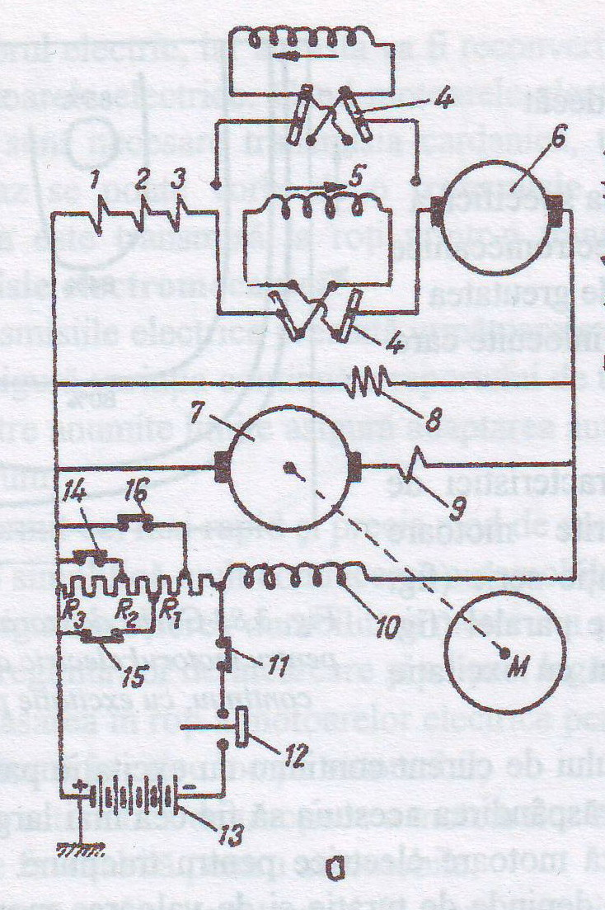
Fig 3 Transmission scheme of a car with a single traction engine

Electric scheme of a electromechanical transmission with a single electrical engine is show in the figure 3.
The engine with internal burning M is powering the generator 7, having the winding-up of excitation 10 connected in parallel .A loop of excitation winding-up is connected in series. A part of excitation winding-up cant be shortcircuit by relays 14,15 and 16. With the help of the switch 12 commanded by acceleration pedal of the engine with intenal burning in the circuit of excitationis is put the storage batteries 13. The electric motor of traction 6 has excitation winding-up 5 connected in series .The electromagnetic fluxes sense from excitation winding-up 5 and therefore the sense of rotation of indus can be modify with the help of inversor 4, manually commanded.
Variation in large limit of funtion regims of the electric motor causes an unimportant modification of generator revolution and implicit of motor revolution with internal burning . To usual scheme the revolution modification and torque with 500...600% produces a varition a generator revolution of only 5... 10%. This absence of adaptability of the power of road condition causes the increase of fuel . For to remove this trouble , in electric scheme they entered the relays 14,15 and 16 commanded by coil 1,2 and 3 connected in series with excitation coil of the electric motor from that is establish a dependency between generator excitation and curent amperage from the winding-up of the electric motor excitation.

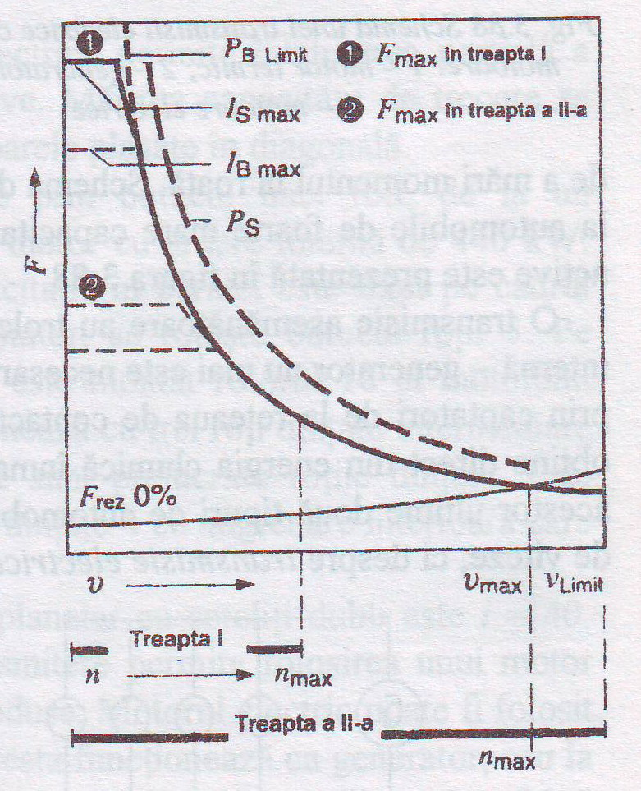
Fig. 4 Characteristic of traction of a car with electromechanical transmission in two stages: F_{nz} – total resistant to go forward; Ibmax ,Ismax. – the maximum currents for battery respectively controller,; PBlimit the maximum power of battery ; P_{s} ~the pqwer of the controller

In the figure 4 is presented characteristic of traction of one vehicule with electromechanical transmission in two stage .The gear-boxes in two stage allows a better adaptation of car transmission on road condition . In first gear this ensurea the maximum value of tractiune force, and in second gear the maximum of speed.

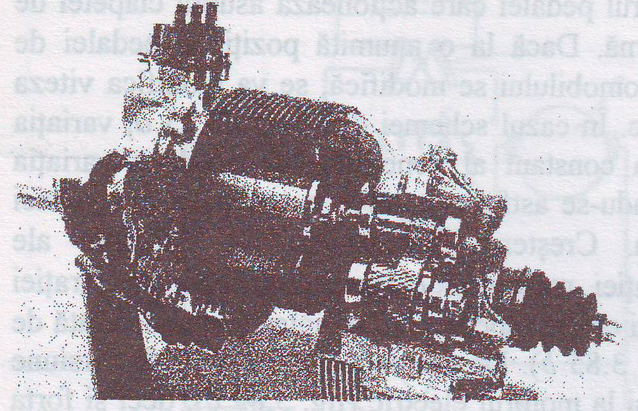

Fig. 5 Constructiv solution of electromechanical with one electrical enginer (Toyota E-com)

More electrical engine
On electrical cars the electrical power is maid directly from the chemichal energy storegy in the battery .In caz of this type of cars is not needed to talk about a gear-boxesbut about a electrical transmission.
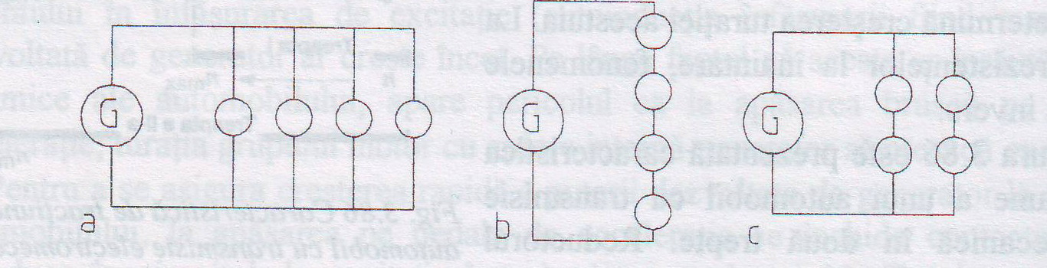
Fig. 6 Possibility of connect electrical engine: a - series; b -parallel; c - both

In the figure 6 is shown the possibility of connect electrical engine (represented through circle) to electric circuit of generator G in case of the vehicle with four wlheels drive.

CONCLUSION

The cars with electrical transmission is better from different point of view , from the point of view of building is very easy but is very expensive for now but in the future the price could be smaller from the point of view of smoke is very environmentally friendly.

BIBLIOGRAPHY

[1] Ambrosi,G. Orofino,L. Driveline vibration simulation in a four-wheel drive vehicle. In: 925088 XXIV FISITA Congress, part 2, p. 105-115, Londra, 1992.
[2] Baines,N.C. PantingJ.R. Etemad,M.R. Besant C.B. A gas turbine-electric vehicle concept. In: 925080 XXIV FISITA Congress, part 2, p. 27-32, Londra, 1992.
[3] Baker,A. Torotrak Transmission. In: Automotive Engineer Volume 21 Number 3 June/July 1996, p.46, 47.
Baselga,S. Miravete,A. Pellicer.E. Alba,J. Cdlculo de la cadena de transmision y de las prestaciones del automovil. C.P.S. de la Universidad de Zaragoza, 1995.
[4] Brusaglino,G. Vittone.O. Traction system for electric vehicles. In: 925081 XXIV FISITA Congress, part 2, p. 33-46, Londra, 1992.
[5] Burger,A. Gierer,G. Haupt,J. VolkelJ. Das neue Fiinfgang-Automatik-getriebe fur die neue BMW 3er Baureihe. In: ATZ und MTZ, 1998, p. 134-140.
[6] Chi§u,E. Calianu, D. Velicu,D. Moldovean,Gh. Uber die Synthese der stufenlosen Kraftfahrzeugschalt-getriebe. In: CONAT Vol.11, p.323-329, Bra§ov, 1993.
[7] Ciolan,Gh. Preda,I. Salajan,C. Vulpe,V. Studiu privind solicitdrile transmisiei unui autoturism ARO-10 in regim tranzitoriu. In: Buletinul ESFA, vol.Ill, p.85-88, Bucure§ti, 1995.
[8] CiolaiijGL Preda,I. Dogariu,M^ Determindri experimental ale solicitdrilor unor organe ale transmisiei. In: Buletinul CONAT, vol.IV, p.325-330, Brasov, 1996.
[9] Coanda,S. PredaJ. Ciolan,Gh. Multiplexing sistem for cars. In: 6st EAEC (European Automobile Engineers Cooperation) European Congress "Lightweight and Small Cars - The Answer to Future Needs" Proceedings, volume II, p.999-1002, Cernobbio, 1997.

