KINEMATICS, DYNAMICS AND MECHANICAL EFFICIENCY
OF A CARDAN JOINT
WITHMANUFACTURING TOLERANCES - Part I

E. Pennestr`ı, L. Vita, P.P. Valentini
Dip. di IngegneriaMeccanica, Universit`a di Roma “Tor Vergata”, Roma, ITALY, pennestri@mec.uniroma2.it

Abstract: A Cardan joint with manufacturing errors is usually modeled as an RCCC linkage. This first part, after a brief review of dual numbers, summarizes the main equation for the kinematic and static analysis of an RCCC linkage.
Keywords: Mechanical transmissions, Cardan joint, Dual numbers.

1. INTRODUCTION

Cardan joints are common devices for transmitting the motion between misaligned intersecting axes. Although mainly applied in automotive applications, their capability of easy mounting, of resisting high loads and commercial availability makes them also an attractive solution, as a substitute of spherical pairs, in parallel robots.
At the book level, the most relevant sources of informations on the Cardan joint are the monograph authored by F. Duditza [1] and the handbook edited by E.R. Wagner [2]. The book of Duditza, originally published in 1966 and translated in many languages, contains the description of different mathematical models for kinematic, dynamic, vibrational and stress analysis of polycardan mechanisms.
Although the structure of the Cardan joint has been known for centuries, only in modern times a complete dynamic analysis has been presented in a series of papers authored by F. Freudenstein and his coworkers [3,4,5,9].
Purpose of this paper is to report the main equations for kinematic, static, dynamic and mechanical efficiency analysis of a Cardan joint subjected to manufacturing tolerances.
The paper is splitted in two parts. The first part deals with kinematics and statics of the Cardan joint. The second part discuss dynamic analysis and mechanical efficiency analysis. For completeness, the first part includes also a brief explanation of dual numbers algebra.
The modeling of manufacturing errors in Cardan joints is introduced by considering a kinematically equivalent RCCC mechanism. In the first part of the paper a kinematic and static analysis of the RCCC mechanism by means of the dual numbers algebra is preliminarly carried out. Then, the effects of friction are included. For this purpose, the following hypotheses are herein adopted:
- Coulomb friction;
- absence of stiction;
- negligible inertia forces;
- absence of backlash in the kinematic pairs;
- rigid bodies.

2. NOMENCLATURE

- ai : minimum distance between z_{i} and z_{i+1} axes;
- F_{ix}, F_{iy}, F_{iz} joint forces cartesian components at the i^{th} joint;
- F_{ix}, F_{iy}, F_{iz} joint forces at the i^{th} joint;
- x_{i}y_{i}z_{i}: moving cartesian system attached to the i^{th} body, as in the Denavit-Hartenberg convention;
- $\left[J_{C\left(i\right)}^{\left(i_{k}\right)}\right]$ Matrix of inertia of body i expressed in $C−x_{i_{k}}y_{i_{k}}z_{i_{k}}$ reference components.

Figure 1: Denavit-Hartenberg parameters

- s_{i} : relative linear displacement of the links measured according to the Denavit-Hartenberg convention (see Figure 1);
- αi angle between z_{i} and z_{i+1} axes;
- ε dual unity (ε² = 0);
- ω_{i}: angular velocity of the i^{th} body, measured in the cartesian system o−x_{i}y_{i}z_{i};
- θ_{i}: relative angular displacement of the links measured according to the Denavit-Hartenberg convention (see Figure 1);
- the^denote dual quantities;
- Dots denote differentiation w.r.t. time.

3. BBRIEF REVIEW OF DUAL NUMBER ALGEBRA

Dual numbers have been introduced by W. Clifford in 1873. A classical work dedicated to dual numbers has been authored by E. Study [6]. Modern reference works are due to R. Beyer [7], F.M Dimentberg [8] and I.S. Fischer [9]. One of the first applications of dual numbers to kinematic analysis of spatial mechanisms has been presented by F.M Dimentberg (1952) and J. Denavit [10] (1953).
A dual number$\hat{a}$ is defined by the sum
(1)
where by definition $ε≠0$ and $ε^{2}=0$. The real numbers a e a₀ are, respectively, the real and dual components. In pure dual number a = 0.
The parameter p of a dual number is the ratio $p=\frac{a}{a_{0}}$ .

3.1 Algebra of dual numbers

For the dual numbers the basic algebraic operations are defined as follows:
Sum and subtraction
(2)
Product
(3)
Division
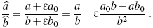 (4)
From this expression is clear that the division by a pure dual number is not defined.
An ordinary function of dual argument is decomposed into a real and dual part by the formula
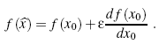 (5)
A dual angle is defined by the expression
(6)
where, with reference to two skew lines, θ is the minimum angle between the lines and s the minimum distance.
Table 3.1 summarizes the definition of most common functions of dual numbers.

Table 1: Definition of noteworthy dual functions

All trigonometric identities, such as remain valid.
The dual function of a dual variable is defined as follows
(7)
where f (x,x0) e f₀ (x,x0) are real functions of real variables x and x₀. In order $\hat{y}$ be analytic, the functions f and f₀ must satisfy the conditions

3.2 Dual vectors

Over the ring D of the dual numbers a three dimensional dual vector space is defined. Two vectors $\vec{F}$ and $\vec{M}$ of a dual vector
(8)
have both origin at the origin of the Cartesian coordinate system. Dual vector are conventionally denoted with capital letters (e.g.$\hat{F}$).

3.3 Software tools

There are different software choices to implement formulas using directly the dual formalism. The language Ch¹, developed by H. Cheng [13] is the best tool for numerical computations involving dual numbers. C and Fortran 90 users may take advantage of the type procedures written by I.S. Fischer [9] and E.D. Fasse [12]. Maple V worksheets with procedures for the algebraic handling of dual quantitis in symbolic form are reported in the thesis of G. Alba Perez [14].

4. Kinematic analysis of the RCCC linkage

4.1 Position analysis

Let us denote with
(9)
the dual numbers which define, respectively, the relative position between adjacent links and the geometry of the i^{th} link.
With reference to Figure 1, the transform matrix from coordinate system o_{i+1} −x_{i+1}y_{i+1}z_{i+1} to o_{i} −x_{i}y_{i}z_{i}, in terms of such numbers is given by²
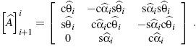 (10)
The closure condition for the RCCC mechanism shown in Figure 2 is expressed by the matrix product
(11)
where [I] is the identity matrix. The above equation can be rewritten in the form
Carrying out the matrix products and equating the elements on the same rows and columns one obtains [9]:
(12)
where
(13)
and
(14)
(15)

Thus, the dual angles${\hat{θ}}_{2}, {\hat{θ}}_{3} \text{and} {\hat{θ}}_{4}$, and are computed as follows:
(16)
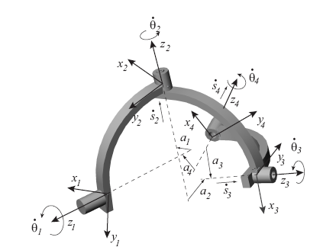
Figure 2: The RCCC kinematically equivalent linkage
4.2 Velocity analysis of RCCC mechanism

Let
(17)
(i = 1,2,3,4) be the dual relatve speeds in reference joints.
In terms of dual vectors, such velocities are expressed as
(18a)

(18b)
The absolute dual speed of body 2, referred to point C₂ and with components expressed in coordinate system o₂−x₂y₂z₂ is obtained as the sum of two dual relative velocity vectors
(19)
Similarly, the absolute dual speed of link 2, referred to point C3 and expressed in coordinate system 3, is
(20)
Between such velocities the following relation hold
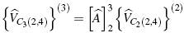 (21)
From (21), taking into account (18), (19), (20), follows the system
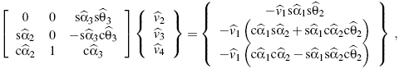 (22)
whose solution is
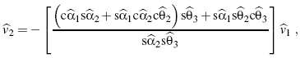 (23)
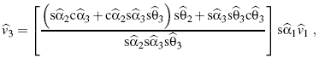 (24)
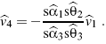 (25)

Static analysis of the RCCC linkage

Let us denote with the dual numbers
${\vec{F}}_{\text{xj}}=F_{\text{xj}}+{εM}_{\text{xj}}$ , (26)
${\vec{F}}_{\text{yj}}=F_{\text{yj}}+{εM}_{\text{yj}}$, (27)
${\vec{F}}_{\text{zj}}=F_{\text{zj}}+{εM}_{\text{zj}}$, (28)
for j = 1,2,3,4, the joint forces.
Imposing the static equilibrium of the links one obtains
(29)
(30)
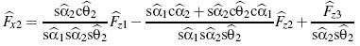 (31)
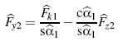 (32)
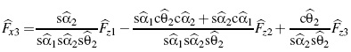 (33)
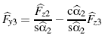 (34)
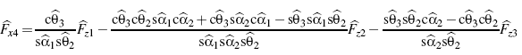 (35)
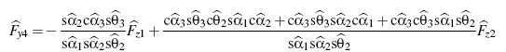 (36)
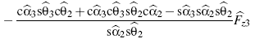

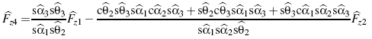 (37)
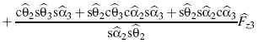

In the frictionless RCCC linkage the following equalities hold: Fz2 = Fz3 = Fz4 = 0, Mz2 = Mz3=0.

REFERENCES

[1] Duditza, F., Transmissions par Cardan, Editions Eyrolles, Paris, 1971.
[2] Wagner, E.R., Universal Joint and Driveshaft Design Manual, SAE AE-7, 1979.
[3] Fischer, I., Freudenstein, F., Internal Force and Moment Transmission in a Cardan Joint with Manufacturing
Tolerances, ASME Journal of Mechanisms, Transmissions and Automation in Design, vol.106, December 1984,
pp.301-311.
[4] Chen, C.K., Freudenstein, F., Dynamic Analysis of a Universal Joint with Manufacturing Tolerances, ASME
Journal of Mechanisms, Transmissions and Automation in Design, vol.108, December 1986, pp.524-532.
[5] Freudenstein, F., Macey, J.P., The Inertia Torques of the Hooke Joint, Proc. Of the 21st Biennial ASME Mech- anisms Conference, Chicago, September 16-19, 1990, DE-Vol.24, pp.407-413.
[6] Study, E., Geometrie der Dynamen, B.G. Teubner, Leipzig, 1903.
[7] Beyer, R., Technische Raumkinematik, Springer Verlag, Berlin, 1963.
[8] Dimentberg, F.M., The Screw Calculus and Its Applications in Mechanics, U.S. Department of Commerce, NTIS, AD-680 993, April 1968.
[9] Fischer, I.S., Dual-Number Methods in Kinematics, Statics and Dynamics, CRC Press, Boca Raton, 1998.
[10] Denavit, J., Displacement Analysis of Mechanisms Based on 2 ﾗ 2 Matrices of Dual Numbers, VDI-Berichte, vol.29, 1958, pp.81-88.
[11] Keler, M.L., Kinematics and Statics Including Friction in Single-Loop Mechanisms by Screw Calculus and
Dual Vectors, ASME Journal of Engineering for Industry, May 1973, pp.471-480.
[12] Fasse, D.,E., Some Applications of Screw Theory to Lumped Parameter Modeling of Visco-Elastic Coupled
Rigid Bodies, Proceedings of the Symposium Commemorating the Legacy Works and Life of Sir Robert Stawell Ball, University of Cambridge, Trinity College, July, 9-11, 2000.
[13] Cheng, H.H., Extending C and FORTRAN for Design Automation, ASME Journal of Mechanical Design,
vol.117, Sep.1995, pp.390-395.
[14] Alba Perez, G., Analysis and Design of Bennett Linkages, MS Thesis, University of California, Irvine, 1999.
[15] Pennestr`ı, E., Vita, L., Mechanical Efficiency of Cardan Joint with Manufacturing Tolerances, Proc. of the
RAAD03 International Workshop, Cassino (Italy), 2003, Paper n.053RAAD03

