KINEMATICS, DYNAMICS AND MECHANICAL EFFICIENCY
OF A CARDAN JOINT
WITHMANUFACTURING TOLERANCES - Part II

E. Pennestr`ı, L. Vita, P.P. Valentini
Dip. di IngegneriaMeccanica, Universit`a di Roma “Tor Vergata”, Roma, ITALY, pennestri@mec.uniroma2.it

Abstract: This second part of the paper summarizes the methodology for dynamic and mechanical efficiency analysis of a Cardan joint. The numerical results have been also experimentally validated.
Keywords: Mechanical transmissions, Cardan joint, Dual numbers, mechanical efficiency.

1. INTRODUCTION

Although the kinematics of the Cardan joint seems extensively studied, the contributions on models for internal forces analysis are scarce. The first studies on the dynamics of the Cardan joint appear around 1930-1940 and may have been prompted by the numerous joint failures observed in the drivelines of automobiles. These studies hinted the presence of rocking torques or secondary couples, with direction orthogonal both to input and output shafts, as causes of the failures.
To the best of our knowledge, the most detailed approach to the dynamic analysis of Cardan joints is due to F. Freudenstein and his coworkers (e.g. [1, 2]. In a series of papers, making use of dual vectors, the equations of motion have beed deduced in symbolic form. The main steps of their deductions are herein outlined.
Regarding mechanical efficiency of Cardan joints, likely the first scientific contribution is due to Morecki [3]. Such a model, based on a simplified static analysis and including the losses in the yoke bearings only, has been verified by E. Pennestr`ı et al. with a different analytical approach and refined by including also the losses in the fixed bearings [5, 6]. The results have been plotted in a design chart which allows to compute the efficiency as a function of the angle between input-output shaft axes .
The influence on energy losses of angular speed, input and output shafts angular misalignement, have been investigated by E. Pennestr`ı et al. [7]. The numerical results have been also experimentally validated [10]. In this second part the main findings of the different investigations mentioned will be summarized and discussed.

2. NOMENCLATURE

The nomenclature introduced in the first part of this paper must also be considered.
- a_{i} : minimum distance between z_{i} and z_{i}+1 axes;
- D: distance between the bearings of the cross;
- d_{i}: diameter of shaft i;
- f : friction coefficient;
- x_{i}y_{i}z_{i}: moving cartesian system attached to the i^{th} body, as in the Denavit-Hartenberg convention;
- 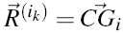vector expressed in C−;
-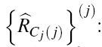 Dual reaction forces acting on link j, evaluated in C_{j}, and expressed in the reference of the joint j;
- ε dual unity (ε² = 0);
- η mechanical efficiency of the Cardan jojnt;
- ω_{i}: angular velocity of the i^{th} body, measured in the cartesian system o−x_{i}y_{i}z_{i};
- θ₁ : Input angle;
- 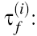: frictional torque at the i^{th} revolute joint;
- the ^ denote dual quantities;
- Dots denote differentiation w.r.t. time;
- ~: Denote the skew matrix of a vector.

DYNAMIC ANALYSIS OF THE RCCC LINKAGE

In terms of dual algebra the momentum of the ith rigid body w.r.t. a point C and expressed in the joint reference
frame i_{k} is:
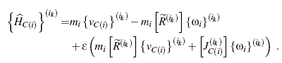 (1)
According to the Newton - Euler equation, differentiating Eqn.(1) w.r.t. time, one obtains the dual expression of the resultant of external loads (forces and moments) at point C acting on the rigid body
(2)
The joint reference frame i_{k} is not an inertial frame and its motion is defined by means of the dual velocity .
Thus Eqn.(2) is changed into
(3)
where 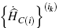 is the time derivative of expression (1).
Considering the RCCC linkage, the equilibrium equations of the moving links in terms of dual algebra are
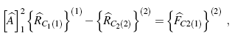 (4a)
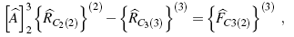 (4b)
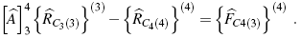 (4c)
Using Eqns.(4) in Eqn.(3) one obtains the following system of linear equations (with j = 2,3,4)
, (5)
where the unknowns are the dual vectors of the reaction forces at the joint. Considering the system under investigation,
the expressions of the dual momentum of each moving link can be obtained [4, 7].

3. THE FRICTIONAL FORCES AT THE KINEMATIC PAIRS

In the ideal Cardan joint, the resultant of the reaction force at the kinematic pairs is zero and there is not any displacement along the joint axes. This is not necessarily true in presence of manufacturing errors. Considering that in a revolute joint the velocity along the z axis is zero , the effects of friction on the reaction force component along the same axis (F_{iz}) are herein neglected. However, these can be taken into account when detailed informations on the geometry of the revolute joint are available.

3.1 Revolute Pairs

The frictional forces at the ith revolute joint arise from two sources: a) reaction forces F_{xi}, F_{yi} and F_{zi}; b) reaction moments M_{xi} and M_{yi}.
The resistant action about the z axis, arising from the reaction moments M_{xi} and M_{yi}, can be modeled [?, 9, 6] according to the scheme presented in Fig.1.
In particular, for our purposes, the torque M_{ix} is substituted by two parallel and opposite forces F acting normally to the revolute joint axis. Because of the presence of friction, these forces generate the frictional torque
(6)
where d_{i} is the diameter of the journal bearing, L_{i} the distance between bearing supports¹ and f the friction coefficient.
Similarly, the torque M_{yi} generate the frictional torque 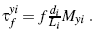

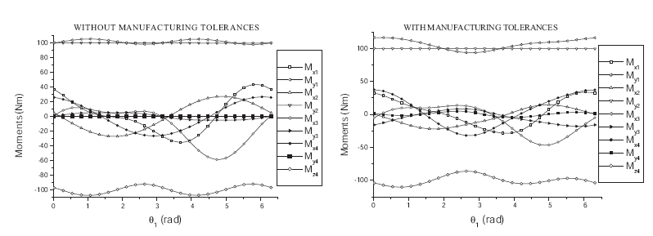

Figure 2: Comparison between torques at the kinematic pairs in joints without (left) and with (right) manufacturing tolerances
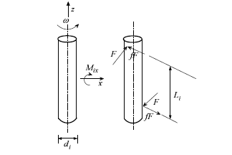
Therefore the friction reaction torque component
along the z axis is computed as follow
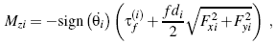 (7)
where 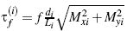. It is clear that the presence of friction alters the equilibrium of the links.

Cylindric Pairs
In the frictionless cylindric pair M_{zi} = 0 and F_{zi} = 0. When friction is considered, the values of M_{zi} and F_{zi} must be computed.
Figure 1: Modeling of friction in revolute pairs

However, the computation of M_{zi} is carried out with the same model adopted for the revolute pair
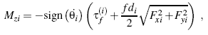, (8)

¹For a single support bearing, L_{i} represents the length of the bearing.
F_{zi} is defined in the same manner but making these substitutions
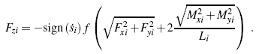. (9)
The presence of friction in the kinematic pairs modifies the equilibrium condition between links. In Fig.2 are compared the moments at the kinematic pairs with and without the mounting errors. The manufacturing tolerances are set to αi = 0.5 mm and αi = 10−3 rad (i = 1,2,3,4).

4. NUMERICAL EXAMPLES

The goal of this paper is to investigate the effects of manufacturing errors on the dynamic behavior of the Cardan
joint. In particular the instantaneous efficiency has been evaluated in several work conditions. The expression of the instantaneous efficiency is
, (10)
where P_{lost} is the sum of power losses due to the frictional forces at each kinematic pair and P_{in} = ω₁T₁ is the input power due to the driving torque T₁. The power loss in each joint is defined as the product of the frictional force (9) and relative velocity along the axis of the cylindric pair, and of the frictional torque (8) and the relative angular velocity
In the numerical examples herein reported the following nominal parameters have been assumed:
- coefficient of dynamic friction f = 0.005;
- lengths and diameters of the links L_{i}=50 mm, d_{i}=40 mm, (i = 1,2,3);

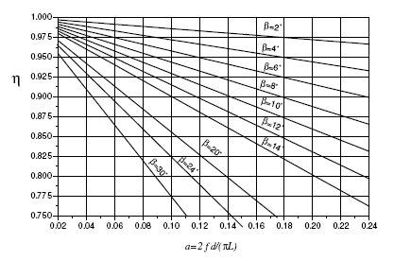

Figure 3: Average efficiency in a Cardan joint without manufacturing tolerances under static conditions.[3, 5]

- masses of the links m₁=1.890 kg, m₂=1.57 kg, m₃=3.130 kg (the other inertial features are summarized in Tab.1);
- input torque T₁ = 100 Nm.

Table 1: INERTIAL FEATURES IN S.I. UNITS

The average efficiency η_{m} of a Cardan joint, according to the model described in [6] can be obtained using the chart of Figure 3, where a = 2 f d_{i}/ (pL_{i}) is an adimensional parameter introduced by A. Morecki [3]. In the mentioned model, the Cardan joint has no manufacturing tolerances and the energy losses are computed including all the four revolute joints.

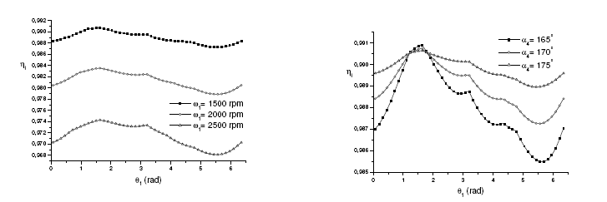

Figure 4: Influence of the angular speed on the efficiency.

Figure 5: Influence of the angular speed on the efficiency and angular misalignement between input and output shafts

The present analysis investigates the influence on the efficiency of the following parameters:
- Rotation speed.
- Angular configuration of the output shaft.
- Presence of manufacturing tolerances, estimated in the following values of axes offsets a1 =a2 =a3 =a4 =0.5 mm and angular error on α_{j}=0.001 rad ( j = 1,2,3,4).
Figure 6 shows the comparison between instantaneous efficiency loss (1−η) with and without manufacturing tolerances. The influence on the mechanical efficiency of rotation speed and of the angular displacement between input and output shafts has been also investigated. The results of this analysis are shown in Figure 4 and Figure 5. Finally the mechanical efficiency of a Cardan joint with manufacturing tolerances or mounting errors has been computed. The angular velocity has been kept constant, ω₁=1500 rpm, and the nominal parameters affected by errors have been changed into a1 = a2 = a3 = a4 = 0.5 mm and a1 = a2 = a3 = 90.006°, a4 = 150.006°. Figure 7 shows the results of this investigation.

5. EXPERIMENTAL ANALYSIS

The mechanical efficiency model previously presented has been experimentally validated [10].
The test rig used, shown in Figure 8, was equipped with the following instruments:
- an adjustable steel table;
- two torque/speed transducers (modelMagtrol TMB 210 with max torque: 100.00 Nm; max speed: 4000 r.p.m.;torque sensitivity 100mV/Nm; speed sensitivity: 60 pulses per rev.);
- one brushless motor (two poles; peak torque: 110 Nm) with a control panel and control software;
- one electromagnetic brake (model Merobel SA FRAT 650; max torque 65 Nm; min torque 0.63 Nm) with a radial fan and a DGT 200 MC digital controller;
- one personal computer with an a/d converter and a National Instrument multichannel acquiring system.

Figure 6: Instantaneous efficiency loss in a Cardan joint
Figure 7: Influence of manufacturing errors on mechanical efficiency

6. CONCLUSIONS

Two formulations for computing themechanical efficiency of a Cardan joint with manufacturing tolerances or mounting errors have been presented. The first formulation is based on quasi static working conditions. The results obtained coincide with those obtained by F. Duditza [3] for the standard Cardan joint, but with a different approach. Our methodology can take into account skewness between the axes of the joints. The second formulation, also based on dual numbers, includes the effects of inertia forces. Thus the effects on energy losses due to:
- increment of the rotation speed;
- angular errors between axes;
- manufacturing tolerances;
have been quantitatively analyzed. It can be observed that increasing the rotation speed from 1500 rpm to 2500 rpm the efficiency loss is about 1.8%, while the efficiency loss due to manufacturing tolerances is about 0.15%. This situation could be explained considering that the reaction forces at the kinematic pairs are scarcely affected by mounting errors, as shown in Fig.2. The model for computing the mechanical efficiency under dynamic conditions have been also experimentally validated [10]. Also within the framework of dual numbers, paper [11,?] discuss the effects of joint tolerances on the kinematics of spatial linkages.

Figure 8: Experimental test rig for the mechanical efficiency analysis of mechanical joints

REFERENCES
[1] Chen, C.K., Freudenstein, F., Dynamic Analysis of a Universal Joint with Manufacturing Tolerances, ASME Journal of Mechanisms, Transmissions and Automation in Design, vol.108, December 1986, pp.524-532.
[2] Freudenstein, F., Macey, J.P., The Inertia Torques of the Hooke Joint, Proc. Of the 21st Biennial ASME Mech- anisms Conference, Chicago, September 16-19, 1990, DE-Vol.24, pp.407-413.
[3] Duditza, F., Transmissions par Cardan, Editions Eyrolles, Paris, 1971.
[4] Fischer, I.S., Dual-Number Methods in Kinematics, Statics and Dynamics, CRC Press, Boca Raton, 1998.
[5] Pennestr`ı, E., Vita, L., Mechanical Efficiency of Cardan Joint with Manufacturing Tolerances, Proc. of the RAAD03 International Workshop, Cassino (Italy), 2003, Paper n.053RAAD03
[6] Biancolini,M.E, Brutti, C., Pennestr`ı, E., Valentini, P.P., Dynamic,Mechanical Efficiency and Fatigue Analysis of the Double Cardan Homokinetic Joint, International Journal of Vehicle Design, vol.32, n.3/4, September 2003, pp.231-249
[7] Cavacece, M., Pennestr`ı, E., Valentini, P.P., Vita, L., Mechanical Efficiency of a Cardan Joint, Proc. of ASME DETC’04, Salt Lake City (USA), 2004, Paper DETC2004/MECH-57317
[8] Keler, M.L., Kinematics and Statics Including Friction in Single-Loop Mechanisms by Screw Calculus and Dual Vectors, ASME Journal of Engineering for Industry, May 1973, pp.471-480.
[9] Dhanaraj, C., Sharan, A.M., Efficient Modeling of Rigid Link Body Dynamic Problems with Friction, Mecha- nism and Machine Theory, vol.30, 1995, pp.749-764.
[10] Cavacece, M., Stefanelli, R., Valentini, P.P., Vita, L., A Multibody Dynamic Model of a Cardan Joint with Experimental Validation, MULTIBODY DYNAMICS 2005 Thematic Conference, Madrid, Spain, 21-24 June 2005
[11] Cecchini, E., Pennestr`ı, E., Stefanelli, R., Vita, L., A Dual Number Approach to the Kinematic Analysis of
Spatial Linkageswith Dimensional and Geometric Tolerances, Proc. of ASME DETC’04, Salt Lake City (USA), 2004, Paper DETC2004/MECH-57324
[12] Pezzuti, E., Stefanelli, R., Valentini, P.P., Vita, L., Computer Aided Simulation and Testing of Spatial Linkages with Joint Mechanical Errors, International Journal For Numerical Methods in Engineering, vol. 65, pp. 1735- 1748, 2006

