FINITE ELEMENT MODEL OF AN ACTIVE ELEMENT OF A DIE

Radostina PETROVA¹, Veselin Raichev²
¹Faculty of Engineering and Pedagogy – Sliven, Technical University, Sofia, BULGARIA,
e-mail: rpetrova123@abv.bg
²Faculty of Engineering and Pedagogy – Sliven, Technical University, Sofia, BULGARIA,
e-mail: vesraichev@yahoo.com

Abstract: A methodology, using Finite Element method, for studying the stresses and the eivenvalue buckling force in a typical active element of a die is created. Nonlinear static analysis and eigenvalue (linear) buckling analysis are performed. The Finite Element model is created by software ANSYS. It regards the type of the supporting head of the active element, the exact position of the sleeve (or its absence) and the yielding of the perforated plate iron, i.e. the thickness of the iron sheet. All results (numerical tables or graphs) can be saved in preferred file formats.
Keywords: active element of a die, nonlinear static analysis, eigenvalue buckling analysis, Finite Element model, software ANSYS

- 1. INTRODUCTION

For successful design of a die a special attention is paid to the calculation of the active element, especially to the maximal stresses and the value of the buckling force.
The presented work is among the first steps in fulfilling a project for classifying and systematizing sets of different types of active elements, according to the realized support. The proposed methodology for examining the distribution of the stresses (especially the position and the value of the maximal stress) in the active element of the die and in the plate iron, is compared with some experimental results, obtained by Fuji Prescale Film method ([3]).
The authors demonstrate the main steps and principles of the methodology for a die with two centrally situated leading columns and a cylindrical active element with a cone supporting head.
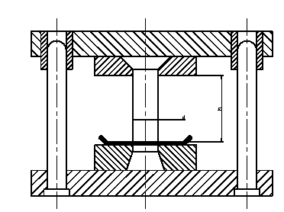

Figure 1: Scheme of a die with two centrally situated leading columns and an active element with cone supporting head
2. DESCRIPTION OF A MODEL FOR STUDYING THE BEHAVIOUR OF PLATE IRON AND AN ACTINE ELEMENT OF A DIE

2.1. Description of the Mechanical Model
For realizing experiments and studying the distribution of the stresses and the buckling force in an active element of a die, a die with the following modules is constructed (fig. 1):
- - a module with two centrally situated leading columns and a sleeve;
- - a set of active elements, which consists of a fixed supporting plate and an active element with cone supported head;
- - a set of matrixes - a monolithic matrix with a cylindrical working zone and cone zone for decreasing the friction and the forces of pushing out of the cut form.
The change in the perforating force in the designed die form, during the process of perforation, is a function of the changes in the thickness of the cut form. The increasing of the perforating force, due to blunt cutting edges of the matrix and the active element, is not regarded in the experiments. During the perforation of the plate iron, the force for pushing the cut forms out of the working cylindrical zone of the matrix is assumed to be constant. This force is calculated using standard methods for calculating the perforating force – P=10% of the force for perforating a plate iron with the maximal possible thickness.
The buckling behavior of the active element can be influenced in two totally different ways: by changing the used set of matrix and an active element, while the height and the diameter of the active element remain constant or by reduction of the height of the active element by polishing when the starting height equals the maximal theoretically admissible.
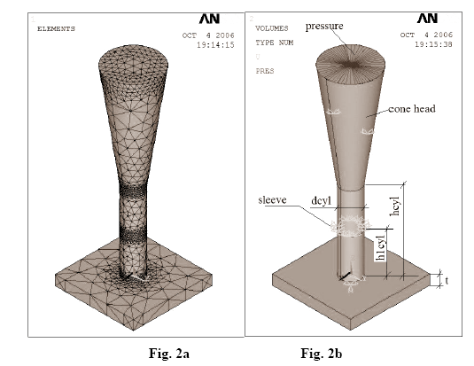

Figure 2: Model of the active element of the die and the plate iron
Fig. 2a: Finite Element model
Fig. 2b: Geometry and boundary conditions of the model

2.2. Description of the Finite Element Model (see [1] and [2])

A spatial Finite Element model of a die (inclining supports, active element, sleeve and plate iron) is created. The model uses ANSYS Parametric Design Language (APDL) and thus easy varying of the dimensions, real constant sets, material properties and loads is available. The active element is chosen to be with a cone supporting head.
The inclination of the generant of the cone is 1:7. The form of the active element is a circle, but it can easily be changed. The active element and the plate iron are modeled by 3-D 10-Node Tetrahedral Structural Solid element - SOLID92 (fig. 2a). This element has a quadratic displacement behavior and is well suited to model irregular meshes (such as the form of the cone in the presented model). SOLID92 is a 10-node brick shaped element. Each element is defined by ten nodes having three degrees of freedom at each node: translations in the nodal x, y and z directions. It also has plasticity, creep, swelling, stress stiffening, large deflection, and large strain capabilities.
A special attention is paid to the contact surface between the active element and the plate iron. In studying the contact between two bodies, the surface of one body is conventionally taken as a contact surface and the surface of the other body as a target surface. For rigid-flexible contact, like the one in the model, the contact surface is associated with the deformable body and the target surface must be the rigid surface. The contact and target surfaces form a “Contact Pair”.
The upper side of the plane iron is meshed by 3-D-8-Node Surface-to-Surface Contact element – CONTA174 with triangle geometry. This is an 8-node element that is intended for general rigid-flexible and flexible-flexible contact analysis. In a general contact analysis, the area of contact between two (or more) bodies is generally not known in advance. The same is the situation in this model.
The CONTA174 contact element is associated with the 3-D target segment elements (TARGE170) using a shared real constant set number. TARGE170 is located on the surface of 3-D solid elements (called underlying elements) and meshes the bottom side of the active element of the die. It has the same geometric characteristics as the underlying elements. TARGE170 is used to represent various 3-D “target” surfaces for the associated contact elements (CONTA174 in the discussed case). The contact elements themselves overlay the solid elements describing the boundary of a deformable body and are potentially in contact with the target surface. This target surface is discretized by a set of target segment elements and is paired with its associated contact surface via a shared real constant set. Any translational or rotational displacement, temperature, forces and moments, etc. can be imposed on the target segment.
The contact elements are constrained against penetration into target surface at its integration points. However, the target surface can, in principle, penetrate through into the contact surface. The penetration distance is measured along the normal direction of contact surface located at integration points to the target surface. It is uniquely defined even the geometry of the target surface is not smooth. Such discontinuities may be due to physical corners on the target surface (which is quite possible in a real active element), or may be introduced by a numerical discretization process (e.g. finite elements). Based on the present way of calculating penetration distance there is no restriction on the shape of the rigid target surface.

3. NUMERICAL SIMULATION
3.1. Description of the Numerical Experiment for Obtaining the Buckling Force
3.1.1. Description of the Used Numerical Technique

There two types of techniques, available in software ANSYS Mechanical, for predicting the buckling force Pcr and buckling mode shape of a structure. They are nonlinear buckling analysis and eigenvalue (or linear) buckling analysis. The nonlinear buckling analysis is the more accurate technique and is recommended for evaluation of actual structures. It allows initial imperfections, plastic behaviour, gaps and large-deflection response to be included in the finite element model.
The eigenvalue buckling predicts the theoretical buckling force in an ideal elastic structure and corresponds to the classic textbook approach to elastic buckling analysis. How ever the nonlinearities (imperfections, plastic deformations, etc.) in the real structures prevent from achieving their elastic buckling strength. Because of that the use of this technique is not generally recommended for everyday engineering analysis. As the proposed work is just the first stage of a project for exploring the pre- and post-buckling behavior of an active element of a die an eigenvalue buckling analysis was performed.
The following assumptions and restrictions are available in eigenvalue buckling analysis: it is valid for structural degrees of freedom; the structure fails suddenly, with a horizontal force deflection curve; the structure has constant stiffness and a static solution with prestress effects included is run.
In eigenvalue buckling analysis, the buckling problem is transformed in an eigenvalue problem:
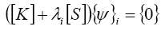

where [K] is stiffness matrix; [S] is stress stiffness matrix; λi is i-th eigen value (used to multiply the loads which generated [S]) and ψi is i-th eigenvector of displacements. For solving the above given equation, the prestress effects must activated for they control the generation of stress stiffness matrix.

3.1.2. Numerical Parameters of the Finite Element Model and Obtained Results
A cylindrical active element of a die with a cone at the top is modeled. The diameter of the resulting in the plate iron perforation, respectively the diameter of the active element of the die is dcyl=0.002m (fig. 2b). The inclination of generant of the cone is 1:7 and its height is calculated as: 7*0.0015=0.0105m. The diameter of the active element and the height of the supported cone are constant during the whole experiment.
As it was said, there two different types of a die that are modeled: with of without a supporting sleeve. The position of the sleeve along the active element of the die is shown by ration: h1cyl/hcyl, where h1cyl is the distance between the plate iron and the lower edge of the sleeve and hcyl is the height of the active element, without the supported cone (fig. 2b). This is the first parameter that was varied and whose influence on the buckling force was investigated (see fig. 3). The ratio h1cyl/hcyl varies from 0.1 - when the sleeve is almost at the bottom of the active element, to 0.9 – when the sleeve is at its top. The case, when there is no sleeve, corresponds to h1cyl/hcyl=1. The numerical experiment was performed for three different sheets of iron, whose thickness varies. It can be seen that the thickness of the plate iron also influences on the buckling force Pcr. This can be explained by the changes of the stiffness of the support at the bottom of the active element, which is regarded in the model.

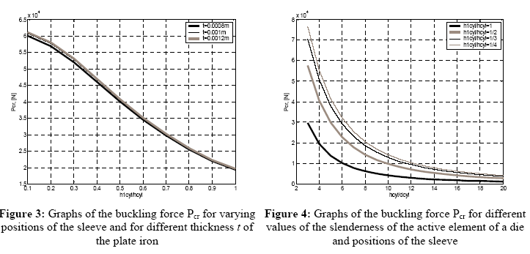

The other numerical experiment explores the influence of the slenderness of the active element of the die, measured by ration hcyl/dcyl, on the buckling force Pcr – see fig. 4. The calculations are performed for three different positions of the sleeve and for an active element without a sleeve. It can be seen that the influence of the slenderness of the active element, which can be controlled by the position of the sleeve, is stronger.

3.2. Description of the Numerical Experiment for Studying the Stresses in an Active Element of a Die
3.2.1. Description of the Used Numerical Approach

The static analysis can be either linear or nonlinear. All types of nonlinearities are allowed - large deformations, plasticity, stress stiffening, contact (gap) elements, and so on. The nonlinear structural behavior can be provoked by different causes, which can be grouped in the following categories: changing status; geometric nonlinearities and material nonlinearities. Many structures exhibit nonlinear behavior that is status-dependent. Situations in which contact occurs are common to many nonlinear applications. Contact conditions form a distinct and important subset to the category of changing-status nonlinearities. Software ANSYS employs the "Newton-Raphson" approach for solving nonlinear problems. Before each solution, the Newton-Raphson method evaluates the out-of-balance load vector, which is the difference between the restoring forces (the loads corresponding to the element stresses) and the applied loads. The program then performs a linear solution, using the out-of-balance loads, and checks for convergence. If convergence criteria are not satisfied, the out-of-balance load vector is reevaluated, the stiffness matrix is updated, and a new solution is obtained. This iterative procedure continues until the problem converges.

3.2.2. Graphs of Some Examined Characteristics of the Finite Element Model

The used finite element model possesses following values of the parameters: diameter of the active element - dcyl=0.002m, height of the active element hcyl=4*dcyl=0.008m; supporting cone at the top of the active element; position of the sleeve – in the middle of the active element h1cyl/hcyl=0.5; thickness of the plate iron – t=0.001m; pressure at the upper side of the cone – approximately 64MPa (corresponding force equals to 26.8 kN, eigenvalue buckling force – 40 kN ). The opening in the supporting structure is with 5% bigger than the diameter of the active element.
The distribution of some stresses in the lower plane of the plate iron, viewed from below, is shown in fig. 5. The edges of the used 3D elements can also be seen. The biggest are the tensile stresses in a very narrow ring at the inner side of the active element. If the force increases a cylinder is perforated from the plate iron just near that ring (fig. 5a and fig. 5d). The black line shows the position of the selected path at z=-0.001m (see fig 6).
The graphs of some of the studied parameters are presented in fig. 6. Five different paths in vertical plane xz are selected thorough the finite element model. The coordinate z marks the position of the path before the deformation. The first and the second paths cross the active element of the die along its diameter at

z=0.001m and at z=0.0005m. The third path is in the upper horizontal plane of the plate iron (z=0.000). The last two paths pass through the plate iron: z=-0.0005m – the path is in the middle of the iron sheet and z=-0.001m – the path lies in the lower horizontal plane of the plate iron. The law of distribution of pressure stress at z=0.001m coincides to the theoretically obtained results (fig. 6b). It can also be seen that in the lower plane of the iron sheet appear tensile stress (z=-0.001m) in the “circle” of cutting the form (fig. 6b). The maximum of the shearing stress also appear in the lower selected path near by the “cutting edges” of the form (z=-0.001m, fig. 6c).

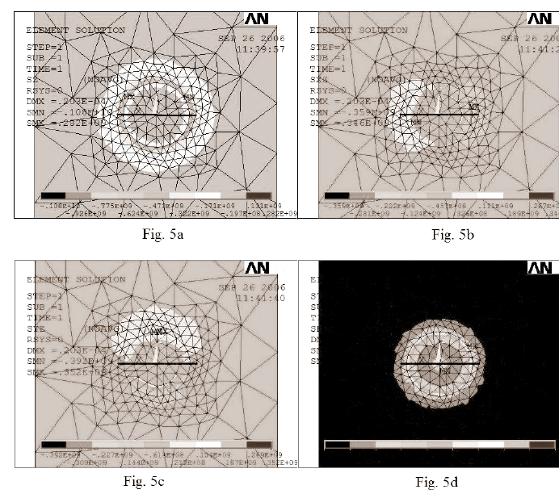

Figure 5: Distribution of stresses in the plate iron – view from below
Fig. 5a: Distribution of pressure stress
Fig. 5b: Distribution of shear stress
Fig. 5c: Distribution of shear stress
Fig. 5d: Distribution of stress von Misses

4. CONCLUSIONS

A methodology for studying the stresses and the eivenvalue buckling force in a typical active element of a die is created. The methodology uses nonlinear static analysis and eigenvalue (linear) buckling analysis. It is base on Finite Element method and is realized by software ANSYS. The examined Finite Element model regards the type of the supporting head of the active element, the exact position of the sleeve (or its absence) and the yielding of the performed plate iron, i.e. the thickness of the iron sheet. The obtained results visualize the distribution and the peaks of the stresses and the eigenvalue buckling form. All results (numerical tables or graphs) can be saved in preferred file formats.

The proposed methodology for examining the distribution of the stresses (especially the position and the value of the maximal stress) and the buckling force in the active element of the die is is demonstrated for a die with two centrally situated leading columns, with or without sleeves and an cylindrical active element with a cone supporting head, but can also be applied to other types of active elemnts.
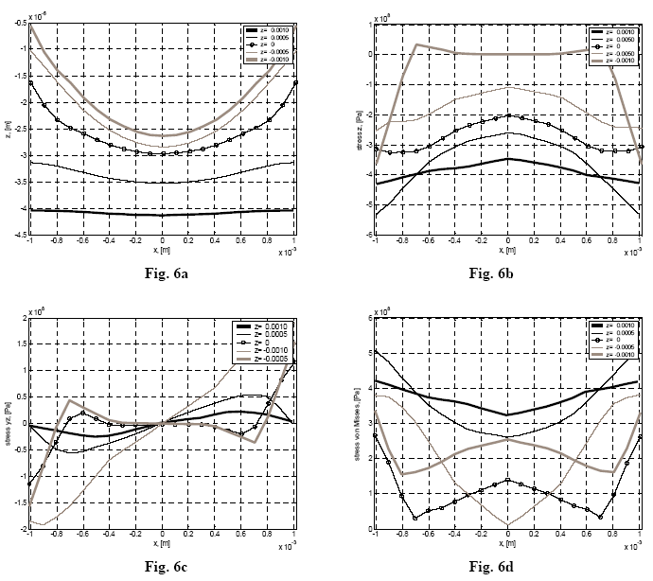

Figure 6: Graphs of some of the studied parameters in pre-selected paths
Fig. 6a: Distribution of vertical displacement z of the points along the selected paths
Fig. 6b: Distribution of pressure stress along the selected paths
Fig. 6c: Distribution of shear stress along the selected paths
Fig. 6d: Distribution of stress von Misses along the selected paths

REFERENCES

[1] ANSYS, Release 10, Help
[2] Bathe, K. J., Finite Element Procedures, Prentice-Hall, Englewood Cliffs (1996)
[3] www.fujifilm.jp

