ON THE BENDING OF CIRCULAR PLATES IN THE PLASTIC DEFORMATIONS FIELD (RIGID-PLASTIC MATERIALS)
PART I: GENERAL THEORETICAL CONSIDERATIONS ON LARGE DEFORMATIONS

Gheorghe N. RADU¹, Ioana COMĂNESCU²
¹TRANSILVANIA University of Brasov, Brasov, ROMANIA, e-mail: rngh@unitbv.ro
²TRANSILVANIA University of Brasov, Brasov, ROMANIA, e-mail:ioanacom@unitbv.ro

Abstract: The present paper deals with the state of stress and deformation at thin circular plates subjected to symmetrical axial loading. The loading is a bending owing to the uniform distributed loads which act perpendicular to the mean surface of the plate, simultaneous with a membrane load (loads acting in the mean plane of the plate). This type of problem is solved by help of equations which result from the equilibrium of a plate’s element and from the boundary and continuity conditions of the mean surface of the plate.
One considers the following two cases:
- the membrane stresses are small comparatively to the bending stresses; in this case the calculus is precise enough if we take into account only the mean plane extensions which will be superposed over the effects given by the transversal bending stress q;
- the membrane stresses are considerable and can not be neglected; in this case, second order calculus is required.
Keywords: deformation, plate, stress, bending, membrane stress

1. GENERAL CONSIDERATIONS

The present paper deals with the state of stress and deformation at thin circular plates under symmetrical axial loading. The loading is a bending owing to the uniform distributed loads, which act perpendicular to the mean surface of the plate, simultaneous with a membrane load (loads which are acting in the mean plane of the plate). This type of problem can be described by equations which result from the equilibrium of an attached plate element and from boundary conditions.

In order to solve these problems, different methods have been suggested and used: Love’s displacement function, the use of the working lengthening tube of Popkowitsch, etc.

Uses of the finite element method and of the finite difference method have shown a great usefulness, leading to very good results. The behavior of the structures is described by help of a stiffness matrix, in the case of the displacements method, by a suppleness matrix, in case of the forces method, or by a stiffness matrix, in the case of the joint method. The above mentioned matrix are established using the finite element method, which is a method of structures division and which requires the similitude of the model’s behavior to the real structure. The displacements method is adequate for the symmetric structures and symmetric loaded structures. The displacements are defined in the interior of an element by polynomials containing a number of parameters equal to the number of the unknown displacements number of the element nodes. One gets the basis equations of this method by help of the energetic method, which is based on the principle of the constant value of the elastic potential.
In calculus one may consider that the material remains in the limits of Hooke’s law validity, when external loads are acting upon it; a linear condition between stresses and deformations is required. At symmetrical axial state of stress correspond symmetrical axial states of deformation and the calculus can be made regarding the mean plane. Under these circumstances, the general 3-D problem can be reduced to a 2-D problem, where the stiffness is expressed by help of a mean section displacements. One divides the continuous structure into a system of symmetrical axial elements, whose unit element is defined as a plane finite element which rotates around the symmetry axis of the structure.

2. GREAT DISPLACEMENTS. EQUATIONS OF EQUILIBRIUM

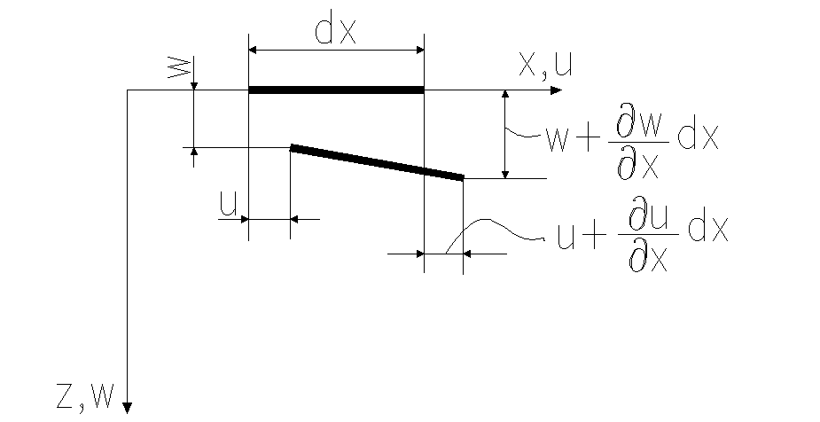
Fig. 1. Displacements | Fig. 2. Displacements

On basis of the notations from Fig. 1, one calculates the length after deformation of an element whose initial length is dx:
$\sqrt{{\left(\text{dx}+\frac{∂u}{∂x}\text{dx}\right)}^{2}+{\left(\frac{∂w}{∂x}\text{dx}\right)}^{2}}≃\text{dx}\left[1+\frac{∂u}{∂x}+\frac{1}{2}{\left(\frac{∂u}{∂x}\right)}^{2}+\frac{1}{2}{\left(\frac{∂w}{∂x}\right)}^{2}\right]$ | (1)
where the approximation of the square root does not influence the calculus or the final results accuracy. One mention the fact that the mean plane deformations allow to neglect the term $\frac{1}{2}{\left(\frac{∂u}{∂x}\right)}^{2}$; equation (1) shows that the element’s length dx is changing with the quantity:
$ε_{x}=\frac{∂u}{∂x}+\frac{1}{2}{\left(\frac{∂w}{∂x}\right)}^{2}$; $ε_{y}=\frac{∂v}{∂y}+\frac{1}{2}{\left(\frac{∂w}{∂y}\right)}^{2}$ (2)

In order to get the angular strain corresponding to the deformation w, normal to the mean plane, one study the case of the perpendicular elements of length dx and dy (∠AOB=π/2), Fig. 2.

The wanted angular strain is given by the subtraction of the final value of the angle ∠AOB (after deformation), ∠A₁OB₁ from the initial angle ∠AOB, plus the share of angular deformation brought by the linear displacements u and v (displacements in the mean plane of the plate).

One writes the cosine of the angle ∠A₁OB₁ as a dot product, getting:
$\text{cos}∠A_{1}{\text{OB}}_{1}=\frac{\frac{∂w}{∂x}\text{dx}⋅\frac{∂w}{∂y}\text{dy}}{\text{dx}⋅\text{dy}},$ or $\text{sin}∠A_{1}{\text{OB}}_{1}=\text{cos}(\text{90}−A_{1}\text{OB})=\frac{∂w}{∂x}⋅\frac{∂w}{∂y}$

One takes into account the share of the linear displacements u and v; one finally get the wanted angular strain:
$γ_{\text{xy}}=\frac{∂u}{∂y}+\frac{∂v}{∂x}+\frac{∂w}{∂x}⋅\frac{∂w}{∂y}$ (3)
From the specific literature (elastic theory), we have the expression of the mean surface curvatures:
$χ_{x}=\frac{∂^{2}w}{∂x^{2}}$; $χ_{y}=\frac{∂^{2}w}{∂z^{2}}$; $χ_{\text{xy}}=\frac{∂^{2}w}{∂x∂y}$. (4)

If one works in plane coordinates, Fig. 3, the equations of the strains and curvatures are easier. Equations (2) and (4) become:
$ε_{r}=\frac{\text{du}}{\text{dr}}+\frac{1}{2}{\left(\frac{\text{dw}}{\text{dr}}\right)}^{2}$; $ε_{θ}=\frac{\left(r+u\right)dθ−\text{rd}θ}{\text{rd}θ}=\frac{u}{r}$ (5)
$χ_{r}=−\frac{d^{2}w}{{\text{dr}}^{2}}$; $χ_{θ}=−\frac{1}{r}⋅\frac{\text{dw}}{\text{dr}}$ (6)

Figure 3: Strains and curvatures in plane coordinate

The load is performed in the field of linear elastic plastic deformations, so that between stresses and deformations following equations are valid (Hooke’s law):
$\text{.}ε_{x}=\frac{1}{E}\left[σ_{x}−{\text{νσ}}_{y}\right];^{}ε_{y}=\frac{1}{E}\left[σ_{y}−{\text{νσ}}_{x}\right];^{}γ_{\text{xy}}=\frac{2\left(1+ν\right)}{E}τ_{\text{xy}}$ (7)

One analyses equations (2) and (3). From these equations we get the deformations from the mean plane, these deformations being membrane deformations.

One calculates the second derivative of the equations (2) and (3) with respect to y and to x and one neglects the high order infinitesimal; one derives equation (4) with respect to x and then with respect to y. We get the following expressions:
$\left\{\frac{∂^{2}ε_{x}}{∂y^{2}}=\frac{∂^{3}u}{∂x∂y^{2}}+{\left(\frac{∂^{2}w}{∂x∂y}\right)}^{2};{}^{}\frac{∂^{2}ε_{y}}{∂x^{2}}=\frac{∂^{3}v}{∂x^{2}∂y};\frac{∂^{2}γ_{\text{xy}}}{∂x∂y}=\frac{∂^{3}u}{∂x∂y^{2}}+\frac{∂^{3}v}{∂x^{2}∂y}+\frac{∂^{2}w}{∂x^{2}}\frac{∂^{2}w}{∂y^{2}}\text{.}\right.$ (8)
One adds the first two equations (8) and one subtract the third one. The compatibility equation (9) yields:
${\left(\frac{∂^{2}w}{∂x∂y}\right)}^{2}−\frac{∂^{2}w}{∂x^{2}}\frac{∂^{2}w}{∂y^{2}}=\frac{∂^{2}ε_{x}}{∂y^{2}}+\frac{∂^{2}ε_{y}}{∂x^{2}}−\frac{∂^{2}γ_{\text{xy}}}{∂x∂y}$ (9)

Substituting equation (7) in relation (9) it results a relation between stresses and deformations corresponding to the membrane state of stress :
$E\left[{\left(\frac{∂^{2}w}{∂x∂y}\right)}^{2}−\frac{∂^{2}w}{∂x^{2}}\frac{∂^{2}w}{∂y^{2}}\right]=\frac{∂σ_{x}}{∂y^{2}}+\frac{∂σ_{y}}{∂x^{2}}−ν\left(\frac{∂^{2}σ_{x}}{∂x^{2}}+\frac{∂^{2}σ_{y}}{∂y^{2}}\right)−2\left(1+ν\right)\frac{∂^{2}τ_{\text{xy}}}{∂x∂y}$ (10)

3. GENERAL EQUATIONS AT BENDING WITH CONSTANT q AND LOADING IN THE MEAN PLANE OF THE PLATE (FIG. 4)

Further on we want to establish a calculus relation between stresses and deformations for the loading of the circular plate, in Fig. 4. In this case, besides the bending due to the constant load q, the plate is subjected to tension because of the loads N_{o} (membrane load).
One specifies the existence of the following two calculus methods [1]:
- the membrane stresses are small in comparison to those due to bending; in this case the calculus is precise enough if we consider only the extensions of the mean plane which are superposed on the effects caused by the transversal load q;
- the membrane stresses due to the loads p are big and can not be neglected. That is the reason why the calculus must be continued.
Figure 4: a. | Figure 4: b.
In order to take into account both the membrane stresses and the state stress caused by the bending loads, normal to the mean plane, one analyses the plate’s element of dimensions dx⋅dy, in deformed state of the mean plane, Fig. 5.

Fig. 5. Equilibrium of the plate’s element

The plate’s element in Fig. 5 is in equilibrium under the action of the shown state of stresses and deformations. On basis of the projections upon axes x and y, taking into account the angles in the deformed state, we get the following two equilibrium equations:
$\left(σ_{x}+\frac{∂σ_{x}}{∂x}\text{dx}\right)⋅\text{cos}\left(α_{x}+\frac{∂α_{x}}{∂x}\text{dx}\right)−σ_{x}⋅\text{cos}α_{x}+\left(τ_{\text{xy}}+\frac{∂τ_{\text{xy}}}{∂y}\text{dy}\right)⋅\text{cos}\begin{aligned}\left(α_{x}+\frac{∂α_{x}}{∂y}\text{dy} | \right) \\ \end{aligned}$ (11)
$\left(σ_{y}+\frac{∂σ_{y}}{∂y}\text{dy}\right)⋅\text{cos}\left(α_{y}+\frac{∂α_{y}}{∂y}\text{dy}\right)−σ_{y}⋅\text{cos}α_{y}+\left(τ_{\text{xy}}+\frac{∂τ_{\text{xy}}}{∂x}\text{dx}\right)⋅\text{cos}\left(α_{y}+\frac{∂α_{y}}{∂x}\text{dx}\right)−τ_{\text{xy}}⋅\text{cos}α_{y}=0$ (12)

Equations (11) and (12) take simple forms, easy to use after the approximations below :
$\left\{\text{cos}α_{x}≃\sqrt{1−{\left(\frac{∂w}{∂x}\right)}^{2}}≃1−\frac{1}{2}{\left(\frac{∂w}{∂x}\right)}^{2};{}^{}\text{cos}\left(α_{x}+\frac{∂α_{x}}{∂x}\text{dx}\right)≃1−\frac{1}{2}{\left(\frac{∂w}{∂x}\right)}^{2}−\frac{∂^{3}w}{∂x^{2}∂y}\right.$ (13)

The plate’s element of dimensions dx⋅dy is at equilibrium, Fig. 6.

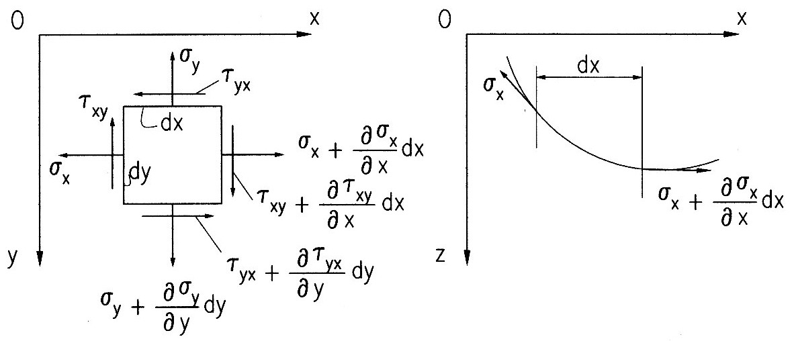

Figure 6: Equilibrium of a plate’s element

In the equations of equilibrium written about the axes of coordinates, besides the loading shown in Fig. 6 one takes also into account the massic forces denoted by R_{x} and R_{y}, of unit [N/mm³]. We get the equations:
$\left\{\frac{∂σ_{x}}{∂x}+\frac{∂τ_{\text{xy}}}{∂y}=R_{x};{}^{}\frac{∂τ_{\text{xy}}}{∂x}+\frac{∂σ_{y}}{∂y}=R_{y}\right.$ (14)

It is important to emphasize the fact that equations (14) are independent and they can be further used in the calculus of plates. One derives them with respect to x and to y ; by adding the yielded relations, we get :
$2\frac{∂^{2}τ_{\text{xy}}}{∂x∂y}=−\frac{∂^{2}σ_{x}}{∂x^{2}}−\frac{∂^{2}σ_{y}}{∂y^{2}}+\frac{∂R_{x}}{∂x}+\frac{∂R_{y}}{∂y}$ (15)

One replaces equation (15) in Equation (10), which was obtained from the relation of compatibility (9). One gets finally :
$E\left[{\left(\frac{∂^{2}w}{∂x∂y}\right)}^{2}−\frac{∂^{2}w}{∂x^{2}}⋅\frac{∂^{2}w}{∂y^{2}}\right]=Δ\left(σ_{x}+σ_{y}\right)−\left(1−ν\right)\left(\frac{∂R_{x}}{∂x}+\frac{∂R_{y}}{∂y}\right)$ (16)
In Equation (17) one takes into account the relations (11) and (12), the projections upon axis z, the curvatures given by relations (4) as well as the independent relations (14) and one yields the equation below [1]:
${DΔ}^{2}w=q\left(x,y\right)+h\left(σ_{x}γ_{x}+2τ_{\text{xy}}γ_{\text{xy}}+σ_{y}γ_{y}\right)−R_{x}\frac{∂w}{∂x}−R_{y}\frac{∂w}{∂y}$ (17)
Equations (16) and (17) show the state of stress and deformation of the plate, under the following circumstances : bending under transversal loading q, taking into account both the membrane stresses and the massic forces (calculated on surface unit of the plate’s mean plane).

The solution yields by help of numerical methods (FEM or FDM), taking into account each effective loading of the plate and the way the plate is supported.
We present further on an example solved by help of FEM (specialized program).

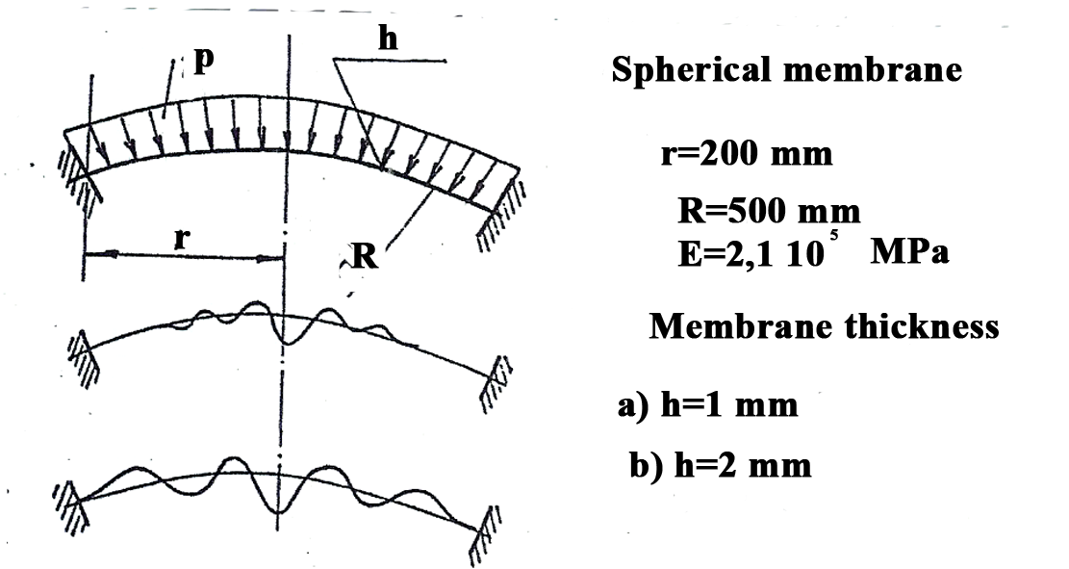
Figure 6’. Spherical membrane

Fig. 6’. presents a fixed spherical membrane subjected to a constant pressure q. One divide in 16 finite elements, using the theory presented in the first part of the paper. We have obtained a critical pressure of 1.047 MPa, for h = 1 mm and 4.359 MPa for h=2 mm, respectively. The yielded values are very precise. They have been compared to the values yielded from the equation given by the differential equation made up by help of Bessel’s functions (Ponomariov). The equation is:
$f_{w}=\frac{{\text{Eh}}^{2}}{R^{2}}⋅\frac{2}{\sqrt{3\left(1−ν^{2}\right)}}$
On basis of the above equation the critical values of the pressure yield: 1.017 MPa and 4.070 MPa, respectively. The eigen ways of loosing stability are shown in the figure above (due to the forking).

REFERNCES

[1] TIMOSHENKO, S.P., WOINOWSKY-KRIEGER, S., Teoria plăcilor plane şi curbe, Editura Tehnică, Bucureşti, 1968.
[2] RADU, Gh. N., Curtu, I., Elastic Stability of the Thin disks due to the Temperature and Rotation Stress, 14th Symposium DANUBIA –ADRIA, Porec, Croatia, 1997.
[3] SHEPLAK, M., Large Deflections of Clamped Circular Plates Under Initial Tension and Transitions to Membrane Behavior, ASME, 1998.
[4] RADU, Gh. N., Contribuţii la studiul discurilor subţiri în mişcare de rotaţie şi în regim termic axial simetric – Teză de doctorat, Braşov, 1992.

