3rd International Conference
″Advanced Composite Materials Engineering ″
COMAT 2010
27- 29 October 2010, Brasov, Romania

PARTICULARITIES CONCERNING THE CHARPY TESTS OF COMPOSITE MATERIALS REINFORCED WITH WOVEN FABRICS

C. Cerbu¹, G. Stan²
Transilvania University, Brasov, ROMANIA
¹cerbu@unitbv.ro, ²gianina.stan@unitbv.ro

Abstract: The paper analyses the effects of the type of reinforcement on the impact characteristics in case of two composite materials reinforced with woven fabrics made of E-glass fibres. Therefore, two kinds of reinforcements were used to manufacture the composite materials: the first composite was reinforced only with glass woven fabrics while the other one composite was additionally reinforced with fir wood flour. The volume ratio of E-glass fibres was the same for each composite analysed. The paper presents and analyses the results of the Charpy tests (failure energy U and resilience K) in case of the composite materials tested. Some important remarks concerning the failure areas of the specimens are presented. Finally, the paper graphically shows the effects of the type of the reinforcement on the dynamical characteristics obtained in Charpy test.
Keywords: composite, Charpy test, failure energy, resilience

1. INTRODUCTION

It is known that composite materials reinforced with glass woven fabrics are increasingly used in case of the application of aerospace industry, automotive industry, naval applications.
On the other hand, during the last years, there were preoccupations [1, 2] concerning to the manufacturing of composite materials by using recycled materials. Therefore, numerous untapped sources of wastes (wood wastes, plastics, pet, aluminium bottle, paper waste, CD/DVD) were used to obtain both filler material and reinforcement material for composite materials.
Charpy test has been used for many years [3, 4] to determine the energy absorption, notch sensitivity, fracture toughness and fracture behaviour of the composite materials through information obtained from standardised type pendulum breaking standardised specimens in a bending mode. For these tests, swinging a weight from a fixed height toward an unnotched or notched specimen, produces an impact load. The failure energy is recorded during the Charpy test [5]. Finally, the resilience denoted by K may also be computed. It represents the ratio between the failure energy U and the area A of the notched cross-section of the specimen [5].
One of the main objectives of this paper is to characterize the effects of the additional reinforcement with wood flour on the impact behaviour in case of the composite materials reinforced with E-glass woven fabrics.
Thus, two kinds of specimens reinforced with glass woven fabric were manufactured: one set of specimens was made of composite material reinforced only with glass woven fabric while the other one set of specimens was made of another composite material reinforced with both glass woven fabric and fir wood flour.

2. MATERIALS AND WORK METHOD

In this paper, seven layers of E-glass woven fabric whose density is equal to ρ =200 g/m², were used to reinforce two kinds of composite materials. Fir wood flour obtained by recycling of the wood wastes, was used to additionaly reinforce one of the composite material tested (Figure 1). It may remark that the length of the wood fibre was less than 500 μm. In the both cases, an epoxy resin called Epolam 2015 was used as matrix material. The weight fibre ratio was 40 % in case of the both composite materials analysed.
The physical and chemical characteristics of the epoxy resin Epolam 2015 are shown in the Table 1 while its mechanical characteristics without reinforcing are given in the Table 2 [6]. The epoxy resin Epolam 2015 is widely used for manufacturing of the laminated composite materials by uding lay-up technology, injection with low pressure and filament wrapping. This kind of resin has a good behaviour for impregnation of timber.
The conditioning time for the plates made of composite materials was two weeks at room temperature. Then, the plates made of composite materials were cut to obtain the specimens whose dimensions are shown in the Figure 2, according to [7]. A total number of 20 specimens were manufactured.
The notch is usually introduced into the material specimen in order to produce a stress concentration and thus promote failure in the case of the ductile materials. Herein, the notch type B [7] is made in case of all specimens tested (Figure 2). Moreover, the notch may be used to align the Charpy specimen with respect to the simple supports of the Charpy pendulum so that the pendulum hammer hits the specimen on the opposite side of the notch.
The dimensions of the cross-section were recorded for each specimen before impact testing. Then, the specimens were subjected to Charpy test.
The impact is produced by swinging the pendulum hummer against the test specimen from a height h. When it is released the hammer swings through an arc, hits the target specimen and after fracturing, it reaches a height h’.

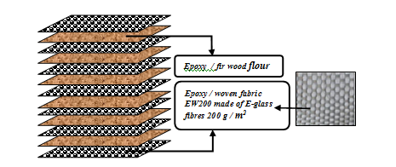
Figure 1: Structure of the laminated composite material reinforced with
both glass woven fabric and fir wood flour

Table 1: Physical and chemical characteristics of the epoxy resin Epolam 2015 [6]
Characteristic | Unit of measure | Value | Method
Density, 25 ºC, in liquid state | g/cm³ | 1.15 | ISO 1675 : 1985
Viscosity, 25 ºC, in liquid state | mPa*s | 1550 | Brookfield LVT
Concentration of hardner Epolam 2014 / 100 g resin | g | 32 | -

Table 2: Mechanical characteristics of the epoxy resin Epolam 2015 without reinforcing [6]
Characteristic | Unit of measure | Value | Method
Glass transition temperature | ºC | 80 | -
Tensile stress in tension | MPa | 70 | ISO 527: 1993
Flexural stress | MPa | 120 | ISO 178: 2001
Modulus of elasticity E | MPa | 3100 | ISO 178: 2001
Impact strength (Charpy) | kJ/m² | 40 | ISO 179: 1994
Elongation in tensile test | % | 5 | ISO 527: 1993
Toughness | Shore D15 | 83 | ISO 868: 2003

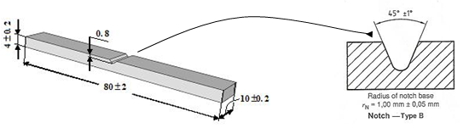
Figure 2: Shape and dimensions of the composite specimen used in Charpy test [7]

The difference between the initial energy and the remaining energy represents a measure of the energy required to fracture the specimen. This quantity is called failure energy in Charpy test and it is denoted by U.
The failure energy U was recorded in case of each specimen tested. Finally, the resilience of each composite specimen was computed by using the following formula:

$K=\frac{U}{A},$ (1)

where A represents the aria of the specimen cross-section where the notch is manufactured.

3. RESULTS

The Table 3 shows the experimental results recorded during Charpy test. To easily analyse the values obtained for the resilience K, the last column of the Table 3 is graphically represented in the Figure 3.

Table 3: Experimental results recorded for all specimen tested in case of the Charpy test
No. | Composite material | Number of specimen | Dimensions of the specimen |  | Remaining thickness at notch | Area of the cross-section | Failure energy | Resilience
 | Composite material | Number of specimen | b  (mm) | h  (mm) | h_{n}  (mm) | A  (mm²) | U  (J) | U / A  (kJ/m²)
1 | EW200-glass / epoxy Epolam 2015 | 1 | 10.00 | 4.00 | 3.20 | 32.00 | 2.25 | 70.31
1 | EW200-glass / epoxy Epolam 2015 | 2 | 9.70 | 3.90 | 3.10 | 30.07 | 1.9 | 63.19
1 | EW200-glass / epoxy Epolam 2015 | 3 | 10.00 | 4.00 | 3.20 | 32.00 | 2.6 | 81.25
1 | EW200-glass / epoxy Epolam 2015 | 4 | 10.00 | 4.00 | 3.20 | 32.00 | 2.6 | 81.25
1 | EW200-glass / epoxy Epolam 2015 | 5 | 9.70 | 3.90 | 3.10 | 30.07 | 1.9 | 63.19
1 | EW200-glass / epoxy Epolam 2015 | 6 | 9.60 | 3.90 | 3.10 | 29.76 | 1.8 | 60.48
1 | EW200-glass / epoxy Epolam 2015 | 7 | 10.00 | 4.00 | 3.20 | 32.00 | 2.4 | 75.00
1 | EW200-glass / epoxy Epolam 2015 | 8 | 10.10 | 4.00 | 3.20 | 32.32 | 2.65 | 81.99
1 | EW200-glass / epoxy Epolam 2015 | 9 | 10.10 | 4.10 | 3.30 | 33.33 | 2.75 | 82.51
1 | EW200-glass / epoxy Epolam 2015 | 10 | 9.80 | 3.90 | 3.10 | 30.38 | 1.9 | 62.54
1 | EW200-glass / epoxy Epolam 2015 | Mean value of resilience |  |  |  |  |  | 72.17
2 | EW200-glass / fir wood flour / epoxy Epolam 2015 | 1 | 16,80 | 6,00 | 5,20 | 87,36 | 10,97 | 125.57
2 | EW200-glass / fir wood flour / epoxy Epolam 2015 | 2 | 16,90 | 6,00 | 5,20 | 87,88 | 9,27 | 105.48
2 | EW200-glass / fir wood flour / epoxy Epolam 2015 | 3 | 16,50 | 5,70 | 4,90 | 80,85 | 9,77 | 120.84
2 | EW200-glass / fir wood flour / epoxy Epolam 2015 | 4 | 16,20 | 6,40 | 5,60 | 90,72 | 10,10 | 111.33
2 | EW200-glass / fir wood flour / epoxy Epolam 2015 | 5 | 17,20 | 6,60 | 5,80 | 99,76 | 12,17 | 121.99
2 | EW200-glass / fir wood flour / epoxy Epolam 2015 | 6 | 18,10 | 6,50 | 5,70 | 103,17 | 10,87 | 105.36
2 | EW200-glass / fir wood flour / epoxy Epolam 2015 | 7 | 16,10 | 5,50 | 4,70 | 75,67 | 10,08 | 133.21
2 | EW200-glass / fir wood flour / epoxy Epolam 2015 | 8 | 17,90 | 6,40 | 5,60 | 100,24 | 12,42 | 123.90
2 | EW200-glass / fir wood flour / epoxy Epolam 2015 | 9 | 15,80 | 5,80 | 5,00 | 79,00 | 8,96 | 113.42
2 | EW200-glass / fir wood flour / epoxy Epolam 2015 | 10 | 15,80 | 5,80 | 5,00 | 79,00 | 9,08 | 114.94
2 | EW200-glass / fir wood flour / epoxy Epolam 2015 | Mean value of resilience |  |  |  |  |  | 117.60

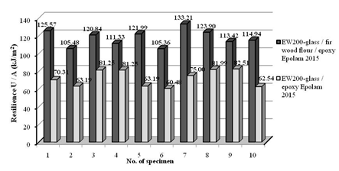
Figure 3: Mean values of the resilience U / A in case of the composite materials tested
Charpy tests showed that an improvement of the resilience K was detected in the case of the composite materials additionally reinforced with fir wood flour. One may remark that the scattering factor of the values of resilience K is quite small in case of each composite material tested.
Finally, the mean values of the resilience K were computed (Table 3). One may observe that in case of the composite material additionaly reinforced with fir wood flour, the resilience K is with 62.94% greater than the corresponding value obtained in case of the composite material reinforced only with glass woven fabric.
A photo of some composite specimens after Charpy test is shown in the Figure 4. All specimens tested were partially broken during the impact test. This happened because the composite specimen was excessively deformed during the impact so that the hummer catched the specimen and dropped it before its complete rupture. This is the reason that only the first layers were completely damaged after impact test.
Expanded image of the failure area (Figure 4) shows that delaminating occurred at the level of the interface of the layers in case of some specimens.

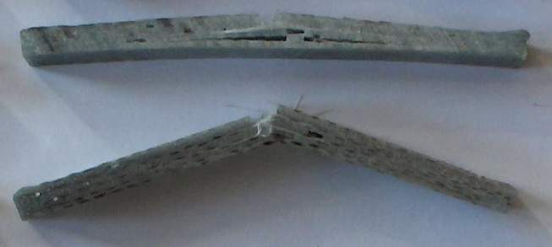 | a. | 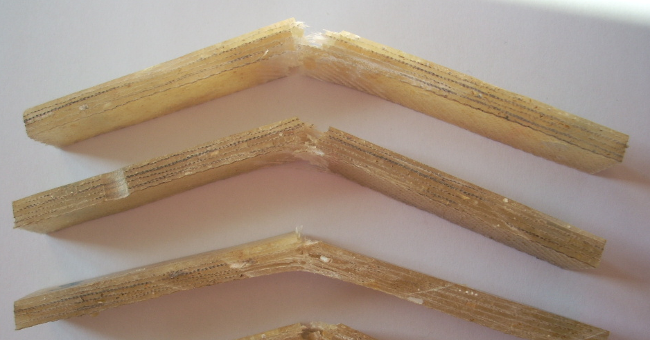 | b.
Figure 4: Photos of some specimens made of:
- EW200-glass / epoxy; b. EW200-glass / fir wood flour / epoxy Epolam 2015

4. CONCLUSIONS AND DISCUSSIONS

To improve dynamical properties (resilience K) of the polymeric composite materials reinforced with glass woven fabrics, wood flour should be used to additionaly reinforce. More exactly, within this paper, it was shown that the using of the fir wood flour as filler material at the interface between two layers made of glass woven fabric, leads to the increasing with 62.94 % of the resilience K.
Improving of the impact behaviour of these kind of composite materials is another advantage of the using of wood flour, in addition to the effects shown within another recent work published [1]. In that article, it was analysed the mechanical properties measured in flexural.

ACKNOWLEDGEMENT

This work is supported by CNCSIS –UEFISCSU, project number PNII – IDEI 733 / 2008.

REFERENCES

- Cerbu C., Curtu I., Ciofoaia V., Rosca I. C., Hanganu, L. C.: Effects of the wood species on the mechanical characteristics in case of some E-glass fibres/wood flour/polyester composite materials, in Rev. Materiale Plastice, MPLAAM 47 (1) 2010, Vol. 47, nr. 1 – martie 2010, Bucuresti Romania, ISSN 0025/5289 – ISI (CNCSIS A), pp.109-114.
- Cerbu C., Luca-Motoc D.: Solutions for Improving of the Mechanical Behaviour of the Composite Materials Filled with Wood Flour, Proceedings of The World Congress on Engineering 2010, Vol II, ISBN 978-988-18210-7-2, WCE 2010, June 30 - July 2, 2010, London, U.K; Publisher: Newswood Limited; Organization: International Association of Engineers; pp. 1097-1100.
- Callister W.: Fundamentals of Materials Science and Engineering, John Wiley&Sons, New York, 2001.
- Abrate, S.: Impact on Composite Structures, Cambridge University Press, ISBN-0-521-47389-6, 1998,
- Sierakowski R.L., Chaturvedi S.K.: Dynamic loading and characterization of fiber reinforced composites, ISBN 0-471-13824-X, 1997, A Wiley-Interscience Publications John Wiley & Sons, Inc., New York,US.
- Certificate of epoxy resin Epolam 2015. Certificate of hardener Epolam 2014 – supplied by the manufacturer: AXON Technologies, the 18th of September 2006.
- SR EN ISO 179-1: Plastic materials, Determination of the properties in Charpy test, the 1st Part: Un-instrumentally dynamic test. Determination of the characteristics of the materials under Charpy test, November 2001.

