3rd International Conference
″Advanced Composite Materials Engineering ″
COMAT 2010
27- 29 October 2010, Brasov, Romania

QUASI-STATIC FINITE ELEMENT ANALYSIS OF CELLULAR STRUCTURES CONSIDERING GEOMETRIC IMPERFECTIONS

Marian N. Velea¹, Simona Lache²
¹ Transilvania University of Brasov, ROMANIA, marian.velea@unitbv.ro
² Transilvania University of Brasov, ROMANIA, slache@unitbv.ro

Abstract: Many types of cellular structures have been proposed to be used as cores in sandwich panels. A validated FE model is often used for analyzing the mechanical properties of such structures. In the case of novel architectures, when an automated manufacturing process has not been fully developed yet, the physical structure is expensive and time consuming to be obtained in a large number of samples necessary for different experimental tests. Instead, few experimental tests are used to validate the FE model of the cellular structure, allowing further on the performance of other FE analyses. Within the correlation process, considering the stiffness response, the theoretical results overestimate the experimental ones, the FE model being difficult to validate. One reason for this is the geometry of the structure which is considered to be ideal in the FE model while in reality it is not. In this paper, geometrical imperfections are considered for developing the FE model of a particular cellular structure, developed at Transilvania University of Braşov. The implementation steps for the geometric imperfections are presented and described. It is studied the influence of the geometric imperfections caused by the manufacturing process, on the out-of-plane stiffness response of the structure. It is proved that more accurate stiffness prediction can be obtained within FE analyses by implementing geometric imperfections.
Keywords: sandwich structure, cellular core, geometric imperfection, FE analysis

1. INTRODUCTION

The sandwich concept has proved to have an important contribution to the increasing performance of mechanical structures for different engineering applications. In a sandwich assembly, the cellular core must accomplish the most important requirements such as: low density, to minimize the weight of the panel and high out-of plane compressive stiffness and strength, to keep the distance between the lateral face sheets constant. In order to respond to these requirements and not only, different cellular architectures have been proposed along the years to be used as cores in sandwich structures.
Within the analysis of cellular cores, it is often important to obtain a validated FE model. The numerical model will allow reducing the costs and time while performing different analyses, instead of running a high number of experimental tests necessary for studying the performance of the structure. Moreover, in the case of novel architectures, when an automated manufacturing process has not been fully developed yet, the physical structure is expensive and time consuming to be obtained in a large number of samples necessary for different experimental tests.
A validated FE model of a structure may be obtained by running few experimental tests and correlate the results with the ones obtained numerically. Experience has showed that it is often difficult to create such a correlation. One reason for this is the degree of simplification when creating the FE model. A simplified model will reduce the calculation costs but the results obtained may give unrealistic results. By considering small details in the FE model it is possible to increase the accuracy of the results but the costs of the analysis increase, at the same time. Another reason is that the theoretical model is considered to be perfect in terms of the geometry and properties of the materials. In reality, the geometry presents some deformations caused by the manufacturing process; the properties of the materials may also be arbitrary modified during the manufacturing process.
In this paper, geometrical imperfections are considered for developing the FE model of a particular cellular structure, developed at Transilvania University of Braşov. The case when the structure is loaded in out-of plane compression is studied. The influence of different degrees of imperfections is analyzed and conclusions are formulated.

2. METHOD

FE analyses give to the engineer the opportunity of making parameterized studies of cellular cores for sandwich structures; when studying the stiffness response, the numerical results most often overestimate the experimental ones. In order to achieve a more realistic solution, geometric imperfections should be introduced in the FE model of the structure. For this, the FE model is created using Abaqus software, Figure 1, where the sandwich structure, formed by two lateral face sheets numbered 2 and 4 and one cellular core numbered 3, is loaded in compression between the element 1 which represents the crosshead of the test machine and the element 5 which represents the fixed part of the machine.

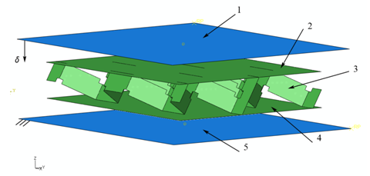
Figure 1: The components of the FE model and boundary conditions

The mesh is created using general purpose elements (S4R). The S4R element is a four-node element; each node has three displacement and three rotation degrees of freedom. The elements numbered 1 and 5 were modelled as analytical rigid shells, having each the motion described by a reference point; for element 1 a displacement has been defined perpendicular to the sandwich assembly while for element 5 all its degrees of freedom have been restricted. The contact between the rigid shells and the face sheets of the sandwich was modelled as a node-to-surface contact, with a friction coefficient of 0.17, corresponding to a general steel to steel contact. The elastic and plastic properties of the materials have been defined according to Table 1 and Table 2. The core shell thickness is 0.2 mm while for the face sheets the thickness is 0.25 mm.

Table 1: Elastic material properties 304 type stainless steel
Young’s Modulus [MPa] | Poisson’s Ratio
187 | 0.29

Table 2: Plastic material properties 304 type stainless steel [1]
Yield Stress  [MPa] | Plastic Strain [%]
181.5 | 0.000
269 | 0.047
343.8 | 0.094
402.5 | 0.138
444 | 0.180
484.4 | 0.220
513.5 | 0.260
546.8 | 0.297
581 | 0.333
645 | 0.402

To introduce the geometric imperfections in the model, the following implementation steps have to be considered:
- compute the buckling modes of the cellular core by performing a linear buckling analysis in Abaqus/Standard;
- write the eigenmodes to the results file as nodal data;
- visualize the buckling modes and chose few of them that better provide the most critical imperfections; the goal is to seed the mesh with a deformation pattern that will allow the postbuckling deformation to proceed correctly [2];
- a scaling factor is applied for each chosen eigenmode
- perform a geometrically non-linear load-displacement analysis of the structure containing the imperfection. The imperfection is introduced by adding these buckling modes to the perfect geometry, and thus creating a perturbed mesh.
The mesh is perturbed using Equation 1, [2]:

$$X^{'}=X+\sum_{i=1}^{m}{α_{i}u_{i}}$$ | (1)

where: X’ – vector containing the new global coordinates; X – vector of original coordinates; m – number of buckling modes; α – imperfection factor; u – eigenvector.
Within the first analysis there have been calculated the first 50 eigenmodes from which number 1 and 41 have been chosen as a deformation pattern, Error: Reference source not found and Error: Reference source not found, corresponding to those observed in the experimental test.

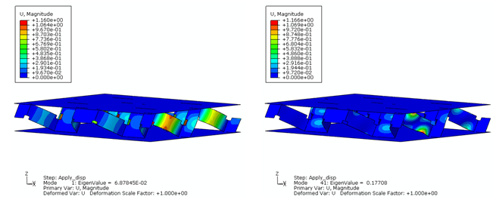
Figure 2: Buckling mode no. 1 Figure 3: Buckling mode no. 41
In order to study the effects of the imperfection geometry five cases have been considered, according to Table 3:

Table 3: Cases studied
 | Eigenmode | Scale factor | Perturbation  %
Case 1 | - | - | -
Case 2 | 1 | 0,1 | 3,43
Case 3 | 1 | 0,5 | 43,75
Case 3 | 41 | 0,3 | 43,75
Case 4 | 1 | 0,8 | 80,63
Case 4 | 41 | 0,6 | 80,63
Case 5 | 1 | 0,9 | 100
Case 5 | 41 | 0,8 | 100

It may be observed in Table 3 that the degrees of perturbation increase with the increase of the scaling factor for the considered eigenmodes.
The perturbation for each of the cases, Table 3, is calculated as a difference between the new global coordinates of the nodes and the original coordinates of the nodes, and expressed in percentage of the shell thickness.
The numerical results are compared with experimental data obtained by testing a sandwich specimen, in the same conditions described above for the FE model. The cellular core and the face sheets are made of stainless steel 304 type metal sheet having a thickness of 0.2 mm and 0.25 respectively. The components of the sandwich assembly are joined together using an epoxy based adhesive. The resulted sandwich dimensions are 40 × 60 × 8.6 mm (length × width × thickness).

3. RESULTS

illustrates the strain-stress curves for each of the cases discussed in the previous paragraph and the experimental results. It may be observed that the stiffness and strength is maxim when no imperfection is added to the FE model (Case 1). Once the geometrical imperfections are introduced gradually, from the Case 2 to 5 with different perturbation degrees, the strength and stiffness response diminishes.

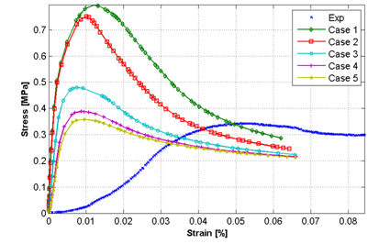
Figure 4: Stiffness and strength response with various initial geometric imperfections

For the Case 5, the strength limit is around 0.35 MPa which is very close to the one obtained from experimental results. Although the stiffness, calculated as the ratio between the stress and strain in the elastic region, is lower for the Case 5 comparing with the Case 1, it is still overestimating the experimental one. This may be an issue of detail modeling. For example, the adhesive has not been taken into account in this model, the contact nodes from the core and the corresponding ones from the face sheets being tied together with restriction for the rotational degrees.

4. CONCLUSIONS

Geometric imperfection may be considered in FE analyses in order to obtain a more realistic solution. The FE package Abaqus allows implementing such imperfections within two analyses: a linear buckling analysis in Abaqus/Standard from which few selected buckling modes are scaled and used to perturb the nodal coordinates of the mesh and a geometrically non-linear load-displacement analysis of the structure containing the imperfection. It is shown that the geometric imperfections have a significant effect on the strength response of the model. For improving the stiffness response a more detailed model may represent a solution.

ACKNOWLEDGMENT

This paper is supported by the Sectoral Operational Programme Human Resources Development (SOP HRD), financed from the European Social Fund and by the Romanian Government under the contract number POSDRU/6/1.5/S/6.

REFERENCES

- Chen, J., Young B.: Stress-strain curves for stainless steel at elevated temperatures, Engineering Structures, Vol. 28, No. 2, p. 229-239, 2006.
- Abaqus, Abaqus Analysis User's Manual, Vol. I, 2007.

