3rd International Conference
″Advanced Composite Materials Engineering ″
COMAT 2010
27- 29 October 2010, Brasov, Romania

HEAT PIPE SCREEN WICK MODELLING

Virgil B. Ungureanu¹
¹ Transilvania University, Brasov, ROMANIA, virbung@unitbv.ro

Abstract: Generally, an optimal wick structure require a small surface pores for large capillary pressure, but large internal pores for minimal liquid flow resistance. Screen wicks are most available, because the possibility of their arrangement in different manner on the heat pipe inner wall. The below discussed properties of the wick are the porosity and the effective pore radius based on a geometric model.
Keywords: heat pipe, screen wick, porosity, capillarity, pore radius.

1. INTRODUCTION

The heat pipe is generally a static device which carries out an efficient heat transfer by joining the vaporization, vapor transport, condensation and condensate return of the working fluid. The condensate return process is accomplished by a special structure of the heat pipe called wick. But also it must to realize the capillary pumping from the condenser zone to the evaporator zone. In the case of space applications, the wick is doubtless necessary. On the other hand, in terrestrial applications gravitational body forces are generally acceptable for the condensate return into the evaporator zone with the condition of the evaporator zone is lower that the condenser zone. However, for a stable operation most cases impose the wick using. For example, wickless heat pipes having liquid metals as working fluids have a discontinuous operation and operating temperature instability. A minimal wick still is needed [1], [2] and [3].
The wick goal is to provide a channel for condensate return to the evaporator zone and capillary pore at the liquid-vapor interface for capillary pumping.
The properties of the wick are the effective pore radius and the permeability. The permeability, the effective pore radius and the cross-section wick area determine how the spacecraft heat pipes can overcame hydrodynamic drops. The effective pore radius is the single parameter that determines the possibility of the heat pipe to overcome the hydrostatic forces in the terrestrial body forces field.
Generally, an effective wick structure requires small surface pores for large capillary pressure, but large internal pore for minimal flow resistance. The composite wicks are provided with separate structures for the capillary pressure development and the liquid flow and lead to high performances of the heat pipes.
The wick can be obtained by grooves cut in the heat pipe wall material, a sintered compound, or many wrapped screen. Screen wicks are most available because the possibility of their arrangement in different manner on the heat pipes inner wall and generally, the lowest cost.
The problem is how can be obtained the interested properties for these composite, therefore non homogeneous structures.

2. THE GEOMETRIC MODEL OF THE SCREEN WICK

The saturated screen wick is a non-homogeneous and sometimes anisotropic material [1]. The wick properties determination is based on a geometric model, [4], [5] and improved [6].
First is measured the wire diameter of the screen $d$, mesh number on length unity $N$, (named the characteristic screen number) and the screen thickness $δ$. By microscopic researches of screens with square mesh, it is observed a different geometry on transversal and longitudinal orientation. Thus it is proposed a geometric model presented in Figure 1, where the filling and warp wires are approximated with circle arches.

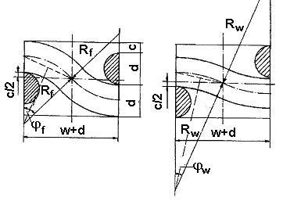
Figure 1: The geometric model of the screen wick

The single layer screen has the thickness defined by the sum:
$δ=2d+c$, (1)
Where $c$ is the clearance due to relative rigidity of the metallic wire (especially in the case of stainless steel materials). So, is to be mentioned that the different geometry is due to the stressed wavy of the filling wires, because there are not stretch similar with the warp wires.
The validation of the screen geometric model has been realized by the comparison of the screen volume and mass obtained by calculus and by direct measuring. However, the cross wires are in direct contact, the clearance proceedings from the screen wires waving. It will be obtained the real length of filling and warp wires.
Then it is obtained the clearance between the filling (weft) and warp wires:
$c=δ−2d$ (2)
and the gap size:
$w=\frac{1}{N}−d$. (3)
From figure 1 it results:

$R_{f}−R_{f}\text{cos}ϕ_{f}=\frac{d+c}{2}$; (4)
$R_{w}−R_{w}\text{cos}ϕ_{w}=\frac{d−c}{2}$, (5)
the filling wires being more stretched then warp wires.
From equations:
$\text{sin}ϕ_{f}=\frac{\frac{w+d}{2}}{R_{f}}$; (6)
$\text{sin}ϕ_{w}=\frac{\frac{w+d}{2}}{R_{w}}$, (7)
can be obtained the curvature radius:
$R_{f}=\frac{w+d}{2\text{sin}ϕ_{f}}$; $R_{w}=\frac{w+d}{2\text{sin}ϕ_{w}}$. (8)
There are expressed the half angle tangent in function of the cosines:
$\text{tg}\frac{ϕ_{f}}{2}=\frac{1−\text{cos}ϕ_{f}}{\text{sin}ϕ_{f}}$; (9)
$\text{tg}\frac{ϕ_{w}}{2}=\frac{1−\text{cos}ϕ_{w}}{\text{sin}ϕ_{w}}$. (10)
By replacing the sinus and cosines from the above equations yields angles $ϕ_{f}$ and $ϕ_{w}$ function of the direct measured screen magnitudes:

$ϕ_{f}=2⋅\text{arctg}\frac{d+c}{w+d}=2⋅\text{arctg}\left[N⋅\left(δ−d\right)\right]$; (11)
$ϕ_{w}=2⋅\text{arctg}\frac{d−c}{w+d}=2⋅\text{arctg}\left[N⋅\left(3d−δ\right)\right]$. (12)
It is defined the waving coefficient by the ratio between the real length of the waved wire and the real length of the screen. So, there are obtained both values for the waving coefficient of the screen with square mesh:
$S_{f}=\frac{2R_{f}ϕ_{f}}{w+d}$; (13)
$S_{w}=\frac{2R_{w}ϕ_{w}}{w+d}$. (14)
Finally it results:
$S_{f}=2\frac{\text{arctg}\left[N\left(δ−d\right)\right]}{\text{sin}\left\{\text{2arctg}\left[N\left(δ−d\right)\right]\right\}}$; (15)
$S_{w}=2\frac{\text{arctg}\left[N\left(3d−δ\right)\right]}{\text{sin}\left\{\text{arctg}\left[N\left(3d−δ\right)\right]\right\}}$. (16)
The real length of the screen wires will be obtained by the product between the screen lengths, number of wires disposed by the cross direction and the corresponding waving coefficient. If it is not known the direction of the screen sampling it can be used successfully for other properties of the screen wicks an average waving coefficient:
$S=\frac{S_{f}+S_{w}}{2}$. (17)
In accordance with the geometric model it is calculated and then measured the volume and mass of a 21 mesh/inch screen sample. It results a good agreement: an error of about 0.9%.

3. THE POROSITY

The average porosity of a materiel is defined by the gap volume to the overall volume:
$ε=\frac{V_{0}}{V}$. (18)
Figure 2 shows two screen layer, the clearance $c$ and the unavoidable interstice, $s$.
For a single layer screen wick and a square pitch there are:
$V=\left(2d+c+s\right)⋅{\left(w+d\right)}^{2}=2d\left(1+\frac{c}{2d}+\frac{s}{2d}\right)⋅\frac{1}{N^{2}}=2d\left(1+B_{0}+B\right)⋅\frac{1}{N^{2}}$; (19)
$V_{0}=V−2\frac{{πd}^{2}}{4}S\left(w+d\right)=V−\frac{{πd}^{2}S}{2N}$, (20)
in which are defined two compaction coefficients:$B_{0}$ - typical of the screen and $B$ - typical of the wrapping operation.

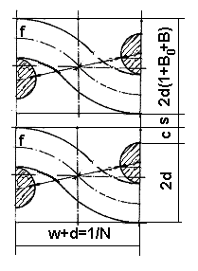
Figure 2: Two superposed screen layers

For a single layer screen wick it results:
$ε=1−\frac{π\text{dSN}}{4\left(1+B_{0}+B\right)}$. (21)
For a plane multilayer screen wick the equation is the same.

4. THE EFFECTIVE PORE RADIUS OF THE SCREEN WICK

The capillary pressure ${Δp}_{c}$ can be determined by the Laplace-Young equation function of the main curvature radius of the liquid/vapor interface:
${Δp}_{c}=σ⋅\left(\frac{1}{R_{1}}+\frac{1}{R_{2}}\right)$. (22)
For the above presented geometric model of the screen the distances measured in radial direction between the filling and warp wires are:
$2r_{f}=\frac{w+d}{\text{cos}θ_{f}}−d$; (23)
$2r_{w}=\frac{w+d}{\text{cos}θ_{w}}−d$, (24)
in which $θ_{f}$ and $θ_{w}$ are angles shown in figure 3.
These angles can be obtained in this manner:
$θ_{f}=\text{arctg}\frac{\frac{δ_{1}}{2}−a_{f}}{\frac{w+d}{2}}$; (25)
$θ_{w}=\text{arctg}\frac{a_{w}−\frac{δ_{1}}{2}}{\frac{w+d}{2}}$, (26)
in which lengths $a_{f}$ and $a_{w}$ are marked in figures. 3. and 4.
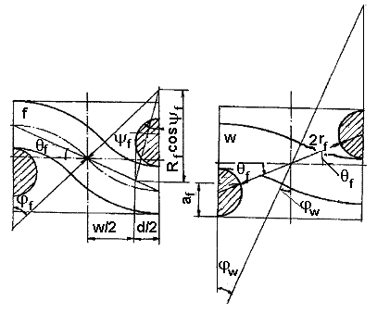
Figure 3: The screen wick geometric model in order to determinate the gap between
filling wires measured in the vapor-liquid interface direction

By corresponding sections from perpendicular planes it can obtain:
$a_{f}=\frac{d}{2}+R_{f}−R_{f}\text{cos}ψ_{f}$; (27)
$a_{w}=d+\frac{d}{2}+R_{w}+R_{w}\text{cos}ψ_{w}$, (28)
where angles $ψ_{f}$ and $ψ_{w}$ can be obtained from relations:
$ψ_{f}≃\text{arcsin}\frac{d}{2R_{f}}$; (29)
$ψ_{w}≃\text{arcsin}\frac{d}{2R_{w}}$. (30)
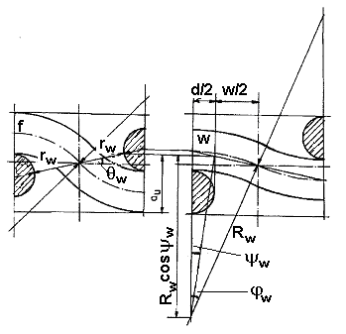
Figure 4: The screen geometric model in order to determinate the gap between
warp wires measured in the vapor-liquid interface direction

For a square mesh having the longitudinal pitch equal with the transversal one, angles $θ_{f}$ and $θ_{w}$ can be easily obtained from the helping constructions from Figure 3 and 4:
$θ_{f}=\frac{ϕ_{f}}{2}$; (31)
$θ_{w}=\frac{ϕ_{w}}{2}$. (32)
The liquid-solid contact angle is measured between the tangent to the liquid surface and the tangent to the solid surface, measured towards the liquid part. The main curvature radius $R_{1}$ and $R_{2}$ can be obtained with the liquid-solid contact angle:
$R_{1}=\frac{R_{f}}{\text{cos}θ}$; (33)

$R_{2}=\frac{R_{w}}{\text{cos}θ}$. (34)
The capillary pressure can be expressed now:
${Δp}_{c}=σ⋅\left(\frac{\text{cos}θ}{r_{f}}+\frac{\text{cos}θ}{r_{w}}\right)=\frac{2σ\text{cos}θ}{r_{c}}$. (35)
Thus it results the equivalent pore radius:
$r_{c}=\frac{2}{\frac{1}{r_{f}}+\frac{1}{r_{w}}}=\frac{2r_{f}r_{w}}{r_{f}r_{w}}$. (36)
The research on capillary height for various screen wick structures, [4] observed the importance of the screen materials, working fluid and cleaning method quality. Thus, for R113, benzene, acetone it can considerate $θ=0°$, for methyl or ethyl alcohol $θ=\text{17}°$ and for water $θ=\text{24}\text{.}2°$. Also, it is observed a greater angle for stainless steel than the phosphor bronze. These experiments are realized for metallic surfaces cleaned by degreasing, scaling with acid and oxidization in presence of air.

5. CONCLUSION

The performance of heat pipes depend on several factors, one of which being the nature of the wick. Numerical methods, physical and mathematical models are effective tools to significantly reduce the number of experimental trials. Validation of the proposed geometric model is being carried out and results a good agreement.

REFERENCES

- Reay D., Kew P. Heat Pipes. Theory and Applications. Elsevier Science and Technology, 2006.
- Ungureanu, V.B. Unele consideraţii privind proiectarea tuburilor termice folosite în domeniul turnării şi injecţiei materialelor calde. Sesiunea de comunicări ştiinţifice, Editura Universităţii "Petru Maior", Tîrgu Mureş, vol. 1, 2000.
- Ungureanu, V.B., Fetcu, D. Fenomene de transfer de căldură şi masă în tuburile termice gravitaţionale fără structură capilară. Conferinţa Naţională de Termotehnică, Craiova, vol. II, 1999.
- Imura H., Kozai H., Ikeda F. The effective Pore Radius of Screen Wicks. Proc. of the 8th International Heat Pipe Conference, Bejing, 1992.
- Kozai H. Transfer Characteristics in Composite Screen Wick Heat Pipes. NDSKR, vol 36, no. 3, 1999.
- Ungureanu, V.B. Structuri capilare compozite pentru tuburile termice gravitaţionale. Conferinta Nationala de Termotehnica, Sibiu, vol.2, 2000.

