FLUID-STRUCTURE INTERACTION, THEORETICAL ASPECTS AND APPLICATIONS FOR AERONAUTICAL STRUCTURES
BULLETIN OF THE TRANSILVANIA UNIVERSITY OF BRAŞOV

D. BARAN* H. PAUN** S. PETRISOR**

Abstract: Numerical simulations have been used for quite some time in aeronautics, but the fluid structure interaction is a rather recent domain. The total annual expenditure for flow simulations in mechanical engineering is still much smaller than for structural analysis, but the number of applications in fluid-flow analysis is growing. This is largely due to valuable analysis capabilities that are now available for many practical cases of fluid flow in mechanical engineering—and the trend will undoubtedly grow stronger, thanks to a newly emerging field of analysis. The main purpose of this paper is implementing and verifying the technology of obtaining fluid-structure analysis in aerospace products.

Keywords: Finite element analysis, fluid-structure interaction, stress analysis

- Introduction

The finite element methods are widely used in the analysis of solids and structures, and provide great benefits in product design. Various commercial finite-element programs are used and have proven to be indispensable in designing safer, more economical products. In the analysis of fluids significant advances have been developed more recent. The mechanical principles governing fluids and solids are the same. It is said that only in the human mind fluids are separated from the solids largely because the response characteristics are quite different for the two media. These different characteristics result in different solution difficulties in numerical simulations of fluids and structures. These difficulties can be overcome and the complex response of various combined fluid and solid media can be analyzed efectively. The main purpose of this paper is note the complex behaviour of a problem of fluid structure interaction and to perform a coupled analysis using the finite element method in order to implement this technology in stress analysis of aerospace products.

- Panel flutter, an exemple of fluid-solid interaction

The flutter of a buckled plate is a problem characterized by a complex dynamic behavior: strong dependence of the initial conditions, existence of attractors with complicated structures, existence of periodic unstable motions with very long periods (sometime infinite periods), etc. Several authors, including Holmes, Holmes and Marsden, Thompson, and Dowell have analyzed this system from different points of view. The equations of motion are those obtained by Dowell [1] using the linear quasi steady aerodynamic hypotheses, including the non linear effects produced by the in plane loads. The boundary value problem is in non dimensional variables:
$\begin{aligned}w\text{''''}−α6(1−υ^{2})[\int_{0}^{1}{(w')^{2}dξ)]w\text{''}−R_{x}w^{''}}+\frac{∂^{2}w}{∂τ^{2}}+ \\ λ\left\{w'+\left(\frac{M^{2}−2}{M^{2}−1}\right){\left(\frac{μ}{λ(M^{2}−1)^{1/2}}\right)}^{1/2}\frac{∂w}{∂τ}\right\}=P\end{aligned}$ (1)
where the principal notations are those used by Dowell and the boundary conditions are those of a simply supported plate.
Using the Galerkin method (for P=0, α=1) one obtains from equation (1) the following system of ordinary differential equations:
The diagram of the maximum Lyapunov exponent and the phase plane representations illustrates the fact that the solution of the stated problem has a certain degree of complexity.
a)Maximum Lyapunov exponent
b) $R_{x}$=54.7 ` c) $R_{x}$=57.18

Figure1. Maximum Lyapunov exponent and phase plane representations

3. Numerical simulations of fluid-solid interaction

In order to develop a coupled fluid structure analysis for a sailplane a complex model of a rear fuselage elaborated (fig. 2):

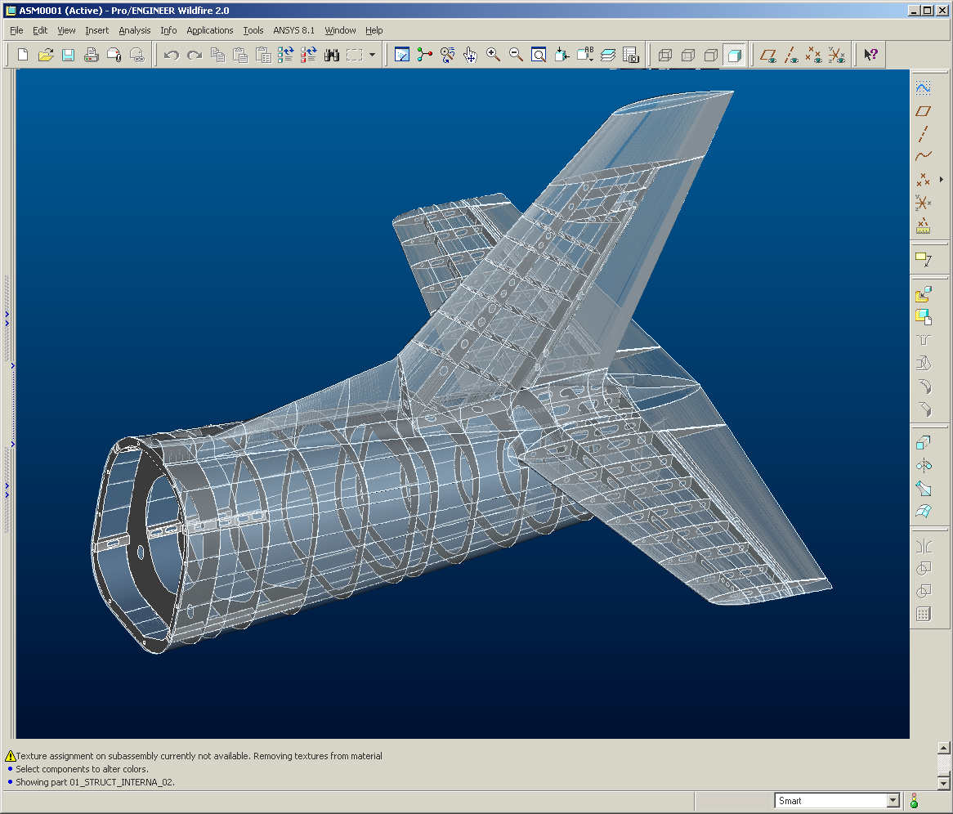

Figure 2. Rear fuselage model

The Multi-field-Solver process is presented in figure 3. The ANSYS Solver for the structural domain leads the whole analysis: reads the MFX commands, elaborates the transfer between the physical characteristics (pressure, temperature) and decides the time steps for the CFX solver.

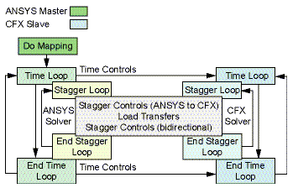

Figure 3. The Multi-field Solver process

The most important problem for a fluid-structure analysis is the interface between the two domains. The mesh of the fluid domain based on tetraeders and the mesh for the structural domain is composed basically on four-sided shells. A transfer scheme was necessary. In figure 4 one can see the transfer scheme.

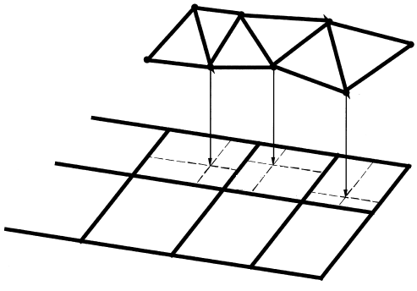
Figure 4. The transfer scheme between the two domains.

In figure 5 is presented the structural domain and in figure 6 is presented the fluid domain.

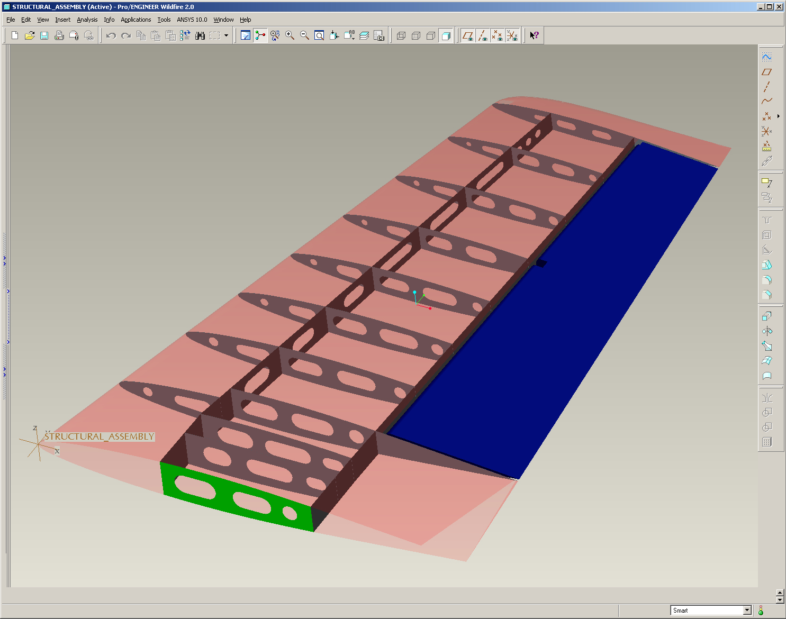

Figure 5 The structural domain

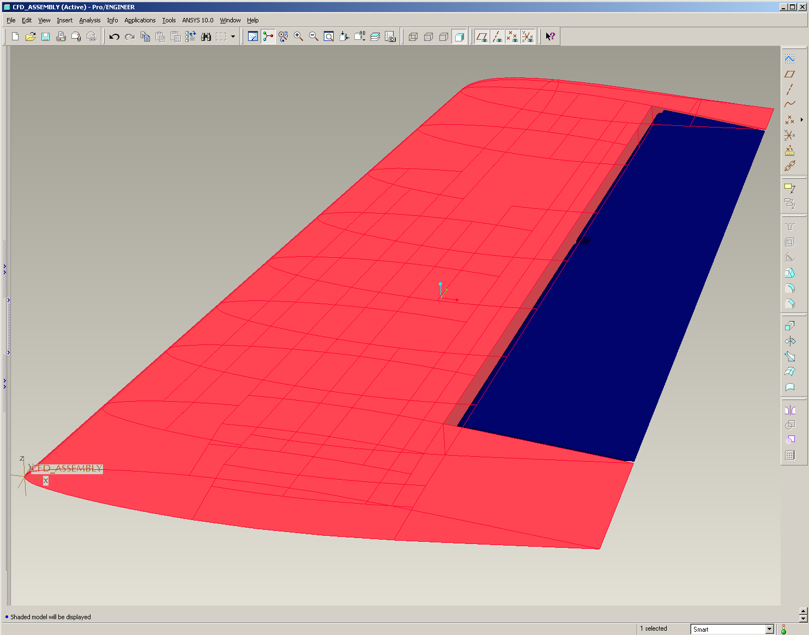

Figure 6 The fluid domain

The structural domain was imported in ANSYS CFX-Mesh in order to be discretizate with finite elements. After a first verification one defines the control regions, the methods and the discretization parameters. The next stage is the discretization of the surfaces and the whole volume is meshed defining a file for ANSYS CFX-Pre. In figure 7 is presented the pressure distribution at the fluid solid interface for 0.8 Mach.

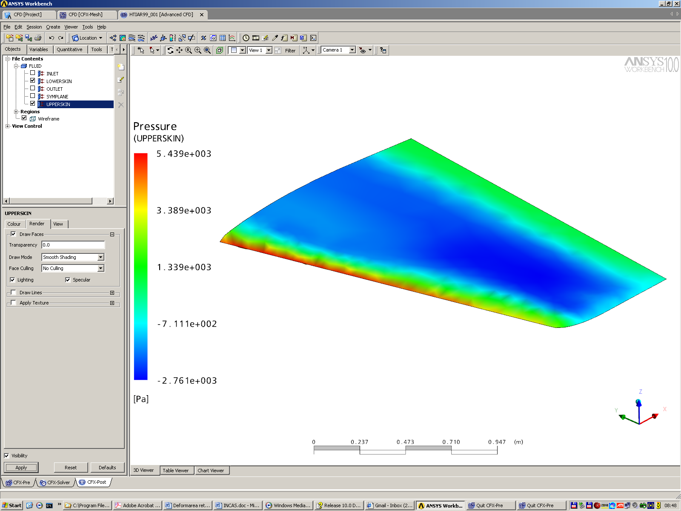

Figure 7. The pressure distribution for 0.8 Mach.

Using this pressure distribution a structural analysis was performed in ANSYS Simulation. In figure 8 one can see the structural discretization with Shell elements.

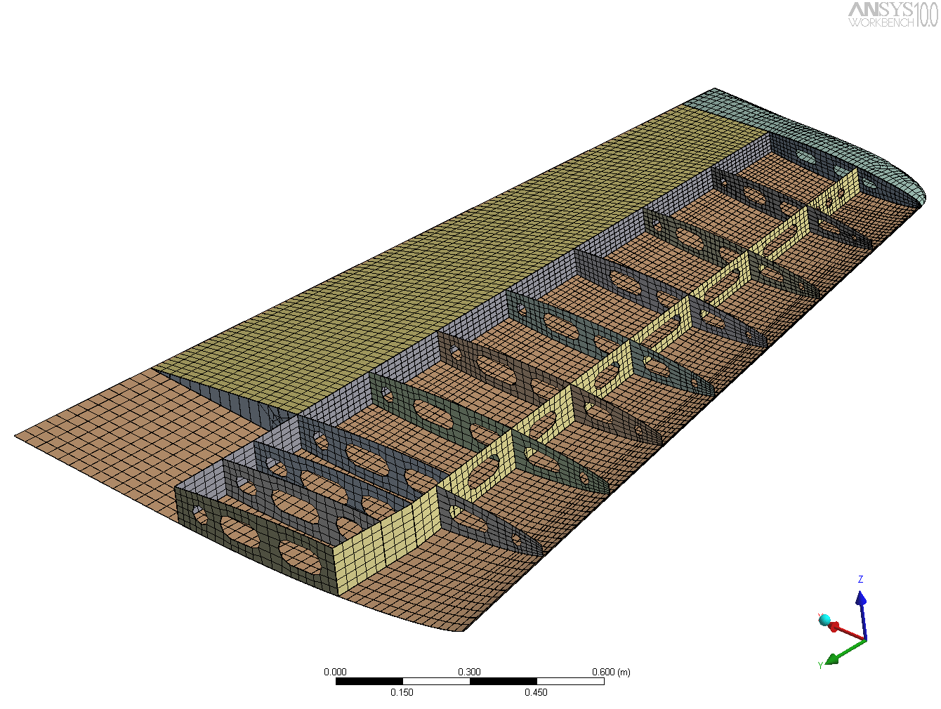

Figure 8. The discretization of the structural domain with SHELL elements.

Three natural frequency are computed for this model:

Order | Frequency [Hz] | Natural modes
First natural frequency | 29.6155 | Bending
Second natural frequency | 110.101 | Torsion
Third natural frequency | 131.108 | Bending and torsion

The torsion mode is presented in figure 9.

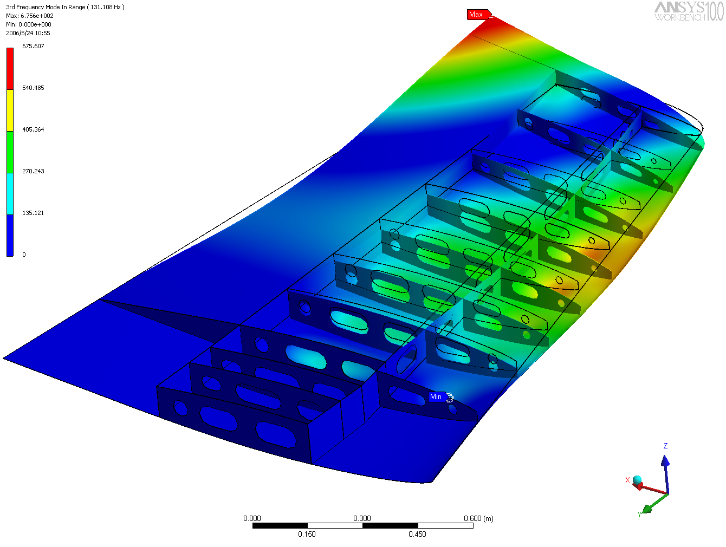

Figure 9. The third natural mode- a torsion mode.

To study aeroelastic problems we consider the first natural mode and define some control nodes to see the time dependence of the tailplane. For a node situated at the end of the structure we obtain the following amplitude, frequency (figure 10 and 11).

Figure 10

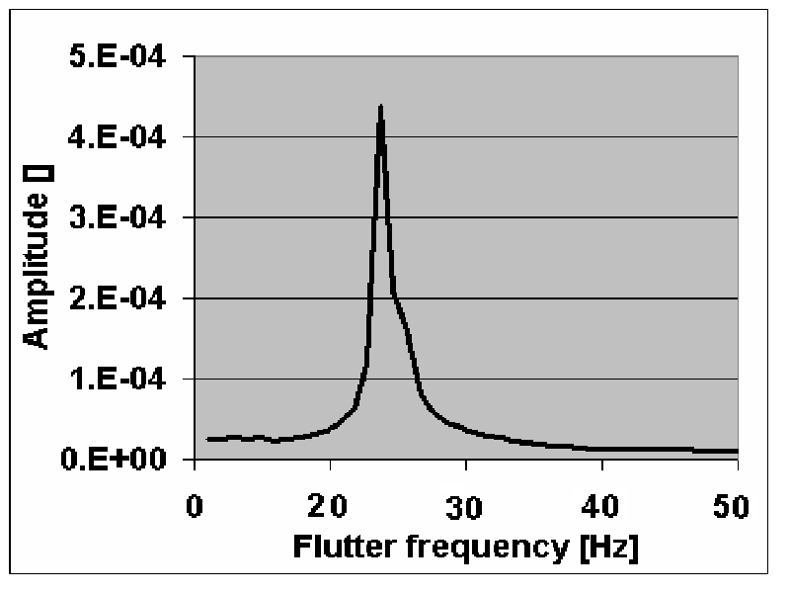

Figure 11

A flutter frequency is presented in figure 12.

Figure 12 Flutter frequency.

The obtained results are useful for further development, the error between 10-15% can be reduced by refining both the fluid and the structural model, but this implies growing computational costs.

References

- Baran, D., Vibratii aleatoare si haotice ale structurilor mecanice cu aplicatii in aviatie si energetica nucleara, Teza de doctorat, Bucuresti,1995.
- Postelnicu, A., Contributii la studiul interactiunii intre fluide si structurile compliante, Brasov,1996.
3.Bathe, K., J, Fluid-structure interactions, The American Society of Mechanical Engineers, 1998.

* INCAS-Bucuresti
**INAS-Bucuresti.

