3rd International Conference
″Advanced Composite Materials Engineering ″
COMAT 2010
27- 29 October 2010, Brasov, Romania

PREDICTION OF ELASTIC PROPERTIES OF MULTIPHASE PREPREGS WITH MULTIPLE APPLICATIONS

H. Teodorescu-Draghicescu¹, S. Vlase¹
¹ Transilvania University, Brasov, ROMANIA, e-mail: draghicescu.teodorescu@unitbv.ro

Abstract: The paper presents a homogenization method and three original averaging methods to predict the elastic properties of commonly used multiphase pre-impregnated composite materials like Sheet Molding Compounds (SMCs) and Bulk Molding Compounds (BMCs). The upper and lower limits of the homogenized coefficients for a 27% fibres volume fraction SMC have been computed. The upper and lower limits of Young’s moduli as well as shear moduli have also been determined. A comparison between these limits of the homogenized elastic coefficients for a 27% fibres volume fraction SMC and the experimental data is presented. The estimation model used as a homogenization method of these heterogeneous composite materials, gave emphasis to a good agreement between this theoretical approach and experimental data. Due to their high mechanical properties and fire performance, these materials are used in aerospace and automotive applications.
Keywords: homogenization, averaging, multiphase, prepreg, heterogeneity

1. INTRODUCTION

In the wide range of prepregs the most common used are Sheet and Bulk Molding Compounds. A Sheet Molding Compound (SMC) is a pre-impregnated material, chemically thickened, manufactured as a continuous mat of chopped glass fibres, resin known as matrix, filler and additives, from which blanks can be cut and placed into a press for hot press molding. The result of this combination of chemical compounds is a heterogeneous, anisotropic composite material (fig. 1), reinforced with discontinuous fibres [1], [2]. A typical SMC material is composed of the following chemical compounds: calcium carbonate, chopped glass fibres roving, unsaturated polyester resin, low-shrink additive, styrene, different additives, pigmented paste, release agent, magnesium oxide paste, organic peroxide and inhibitors in various volume fractions. The matrix system plays a significant role within a SMC, acting as compounds binder and being “embedded material” for the reinforcement. To decrease the shrinkage during the cure of a SMC prepreg, filler have to be added in order to improve the flow capabilities and the uniform fibres transport in the mold. For materials that contain many compounds, an authentic, general method of dimensioning is difficult to find [3], [4], [5], [6], [7], [8].
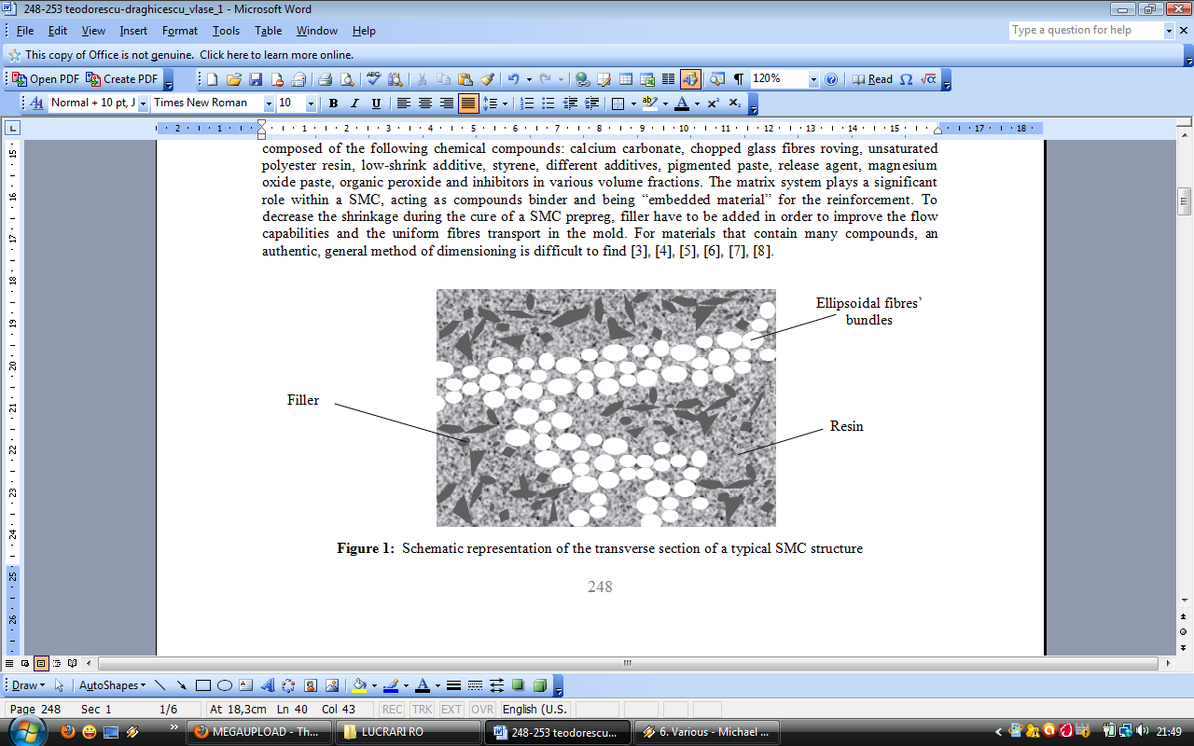
Figure 1: Schematic representation of the transverse section of a typical SMC structure
2. A HOMOGENIZATION METHOD SUITABLE FOR A SHEET MOLDING COMPOUND STRUCTURE

Let us consider a domain Ω from R³ space, in x_{i} coordinates, domain seen as a SMC composite material, in which a so-called replacement matrix (resin and filler) represents the field Y₁ and the reinforcement occupies the field Y₂ seen as a bundle of glass fibres. Let us consider the following equation [9]:
$f(x)=−\frac{∂}{∂x_{i}}\left[a_{\text{ij}}(x)⋅\frac{∂u}{∂x_{j}}\right]; a_{\text{ij}}=a_{\text{ji}}$. (1)
In the case of SMC materials that present a periodic structure containing inclusions, a_{ij}(x) is a function of x. If the period’s dimensions are small in comparison with the dimensions of the whole domain then the solution u of the equation (1) can be equal with the solution suitable for a homogenized material, where the coefficients a_{ij} are constants. In the R³ space of y_{i} coordinates, a parallelepiped with $y_{i}^{0}$ sides is considered, as well as parallelepipeds obtained by translation $n_{i}y_{i}^{0}$ (n_{i} integer) in axes directions. The functions [9]:
$a_{\text{ij}}^{η}(x)=a_{\text{ij}}\left(\frac{x}{η}\right)$, (2)
can be defined, where η is a real, positive parameter. Notice that the functions a_{ij}(x) are ηY-periodical in variable x (ηY being the parallelepiped with ${ηy}_{i}^{0}$ sides). If the function f(x) is in Ω defined, the problem at limit is [12]:
$f(x)=−\frac{∂}{∂x_{i}}\left[a_{\text{ij}}^{η}(x)⋅\frac{∂u^{η}}{∂x_{j}}\right], u^{η}|_{∂Ω}=0\text{.}$ (3)
Similar with equation (2), the vector ${\vec{p}}^{η}$ defines the following elements [9]:
$p_{i}^{η}(x)=a_{\text{ij}}^{η}(x)⋅\frac{∂u^{η}}{∂x_{j}}$. (4)
For the function$u^{η}(x)$, an asymptotic development will be looking for, under the form [9]:
$u^{η}(x)=u^{0}(x,y)+η^{1}u^{1}(x,y)+η^{2}u^{2}(x,y)+\text{.}\text{.}\text{.}; y=\frac{x}{η},$ (5)
where u^{i}(x,y) are elements, Y-periodical in y variable. The derivatives of the functions u^{i}(x,y) behave in the following manner [9]:
$\frac{d}{{\text{dx}}_{i}}→\frac{∂}{∂x_{i}}+\frac{1}{η}⋅\frac{∂}{∂y_{i}}\text{.}$ (6)
The development (6) is valid at the inner of the boundary $∂Ω$, where the periodic phenomena are prevalent. Using the development (6), the expressions $\frac{∂u^{η}}{∂x_{i}}$ and $p^{η}$ are [9]:
$\frac{∂u^{η}}{∂x_{i}}=\left(\frac{∂}{∂x_{i}}+\frac{1}{η}⋅\frac{∂}{∂y_{i}}\right)⋅\left( u^{0}+η⋅u^{1}+\text{.}\text{.}\text{.}\right) = \frac{∂u^{0}}{∂x_{i}}+\frac{∂u^{1}}{∂y_{i}}+η⋅\left(\frac{∂u^{1}}{∂x_{i}}+\frac{∂u^{2}}{∂y_{i}}\right)+\text{.}\text{.}\text{.},$ (7)
$p_{i}^{η}(x)=p_{i}^{0}(x,y)+η⋅p_{i}^{1}(x,y)+η⋅p_{i}^{2}(x,y)+\text{.}\text{.}\text{.},$ (8)
where represent the homogenized coefficients:
$p_{i}^{0}(x,y)=a_{\text{ij}}(y)⋅\left(\frac{∂u^{0}}{∂x_{j}}+\frac{∂u^{1}}{∂y_{j}}\right), p_{i}^{1}(x,y)=a_{\text{ij}}(y)⋅\left(\frac{∂u^{1}}{∂x_{j}}+\frac{∂u^{2}}{∂y_{j}}\right), \text{.}\text{.}\text{.}$ (9)

3. THEORETICAL APPROACH FOR A 27% FIBRES VOLUME FRACTION SHEET MOLDING COMPOUND

In the case of a SMC composite material which behaves macroscopically as a homogeneous elastic environment, is important the knowledge of the elastic coefficients. Unfortunately, a precise calculus of the homogenized coefficients can be achieved only in two cases: the one-dimensional case and the case in which the matrix and inclusion coefficients are functions of only one variable. For a SMC material is preferable to estimate these homogenized coefficients between an upper and a lower limit. Since the fibres volume fraction of common SMCs is 27%, to lighten the calculus, an ellipsoidal inclusion of area 0.27 situated in a square of side 1 is considered. The plane problem will be considered and the homogenized coefficients will be 1 in matrix and 10 in the ellipsoidal inclusion. In fig. 2, the structure’s periodicity cell of a SMC composite material is presented, where the fibres bundle is seen as an ellipsoidal inclusion.
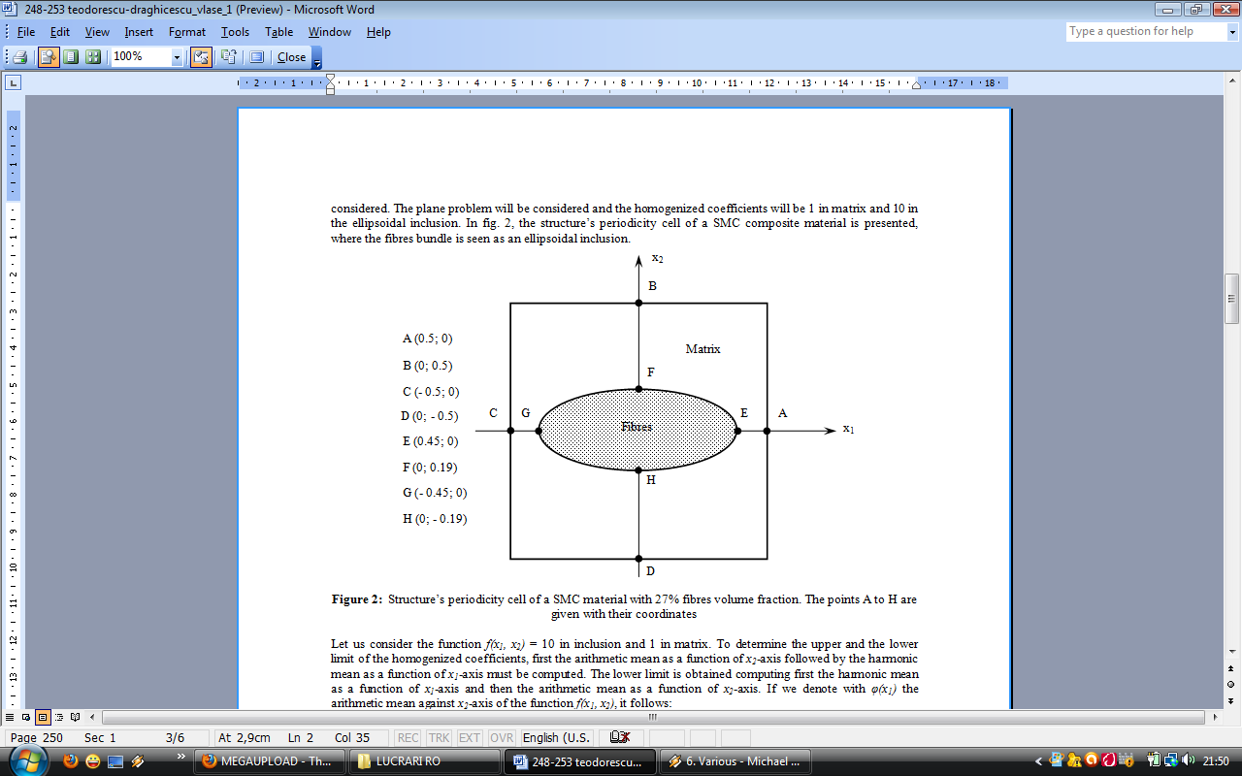
Figure 2: Structure’s periodicity cell of a SMC material with 27% fibres volume fraction. The points A to H are given with their coordinates

Let us consider the function f(x₁, x₂) = 10 in inclusion and 1 in matrix. To determine the upper and the lower limit of the homogenized coefficients, first the arithmetic mean as a function of x₂-axis followed by the harmonic mean as a function of x₁-axis must be computed. The lower limit is obtained computing first the harmonic mean as a function of x₁-axis and then the arithmetic mean as a function of x₂-axis. If we denote with φ(x₁) the arithmetic mean against x₂-axis of the function f(x₁, x₂), it follows:
$ϕ(x_{1})=\int_{−0\text{.}5}^{0\text{.}5}{f(x_{1},x_{2}){\text{dx}}_{2}=1}, \text{for} x_{1} ∈ \left(−0\text{.}5; −0\text{.}\text{45}\right)∪ \left(0\text{.}\text{45}; 0\text{.}5\right),$ (10)
$ϕ(x_{1})=\int_{−0\text{.}5}^{0\text{.}5}{f(x_{1},x_{2}){\text{dx}}_{2}=1+9\text{.}\text{45}\sqrt{0\text{.}\text{2025}−x_{1}^{2}}}, \text{for} x_{1} ∈ \left(−0\text{.}\text{45}; 0\text{.}\text{45}\right) \text{.}$ (11)
The upper limit is obtained computing the harmonic mean of the function φ(x₁):
$a^{+}=\frac{1}{\int_{−0\text{.}5}^{0\text{.}5}{\frac{1}{ϕ(x_{1})}{\text{dx}}_{1}}}=\frac{1}{\int_{−0\text{.}5}^{−0\text{.}\text{45}}{{\text{dx}}_{1}+\int_{−0\text{.}\text{45}}^{0\text{.}\text{45}}{\frac{{\text{dx}}_{1}}{1+9\text{.}\text{45}\sqrt{0\text{.}\text{2025}−x_{1}^{2}}}+\int_{0\text{.}\text{45}}^{0\text{.}5}{{\text{dx}}_{1}}}}}\text{.}$ (12)
To compute the lower limit, we consider ψ(x₂) the harmonic mean of the function f(x₁, x₂) against x₁:
$ψ(x_{2})=\frac{1}{\int_{−0\text{.}5}^{0\text{.}5}{\frac{1}{f(x_{1},x_{2})}{\text{dx}}_{1}}}=1, \text{for} x_{2} ∈ \left(−0\text{.}5; −0\text{.}\text{19}\right) ∪ \left(0\text{.}\text{19}; 0\text{.}5\right) ,$ (13)
$ψ(x_{2})=\frac{1}{\int_{−0\text{.}5}^{0\text{.}5}{\frac{1}{f(x_{1},x_{2})}{\text{dx}}_{1}}}=\frac{1}{1−3\text{.}\text{42}\sqrt{0\text{.}\text{0361}−x_{2}^{2}}}, \text{for} x_{2}∈ \left(−0\text{.}\text{19}; 0\text{.}\text{19}\right) \text{.}$ (14)
The lower limit will be given by the arithmetic mean of the function ψ(x₂):
$a_{−}=\int_{−0\text{.}5}^{0\text{.}5}{ψ(x_{2}){\text{dx}}_{2}=\int_{−0\text{.}5}^{−0\text{.}\text{19}}{{\text{dx}}_{2}+}}\int_{−0\text{.}\text{19}}^{0\text{.}\text{19}}{\frac{{\text{dx}}_{2}}{1−3\text{.}\text{42}\sqrt{0\text{.}\text{0361}−x_{2}^{2}}}+\int_{0\text{.}\text{19}}^{0\text{.}5}{{\text{dx}}_{2}\text{.}}}$ (15)
Since the ellipsoidal inclusion of the SMC structure may vary angular up to ± 30° against the axes’ centre, the upper and lower limits of the homogenized coefficients will vary as a function of the intersection points coordinates of the ellipses, with the axes x₁ and x₂ of the periodicity cell. If we denote P_{M}, the basic elastic property of the matrix, P_{F} and P_{f} the basic elastic property of the fibres respective the filler, then the upper limit of the homogenized coefficients can be estimated computing the arithmetic mean of these basic elastic properties taking into account the compounds volume fractions:
$A_{a}=\frac{P_{M}⋅ϕ_{M}+P_{F}⋅ϕ_{F}+P_{f}⋅ϕ_{f}}{3}\text{.}$ (16)
The lower limit of the homogenized elastic coefficients can be estimated computing the harmonic mean of the basic elasticity properties of the isotropic compounds:
$A_{h}=\frac{3}{\frac{1}{P_{M}⋅ϕ_{M}}+\frac{1}{P_{F}⋅ϕ_{F}}+\frac{1}{P_{f}⋅ϕ_{f}}}\text{.}$ (17)
An intermediate limit between the arithmetic and harmonic mean is given by the geometric mean written below:
$A_{g}= \sqrt[3]{P_{M}⋅ϕ_{M}⋅P_{F}⋅ϕ_{F}⋅P_{f}⋅ϕ_{f}},$ (18)
where P and A can be the Young’s modulus respective the shear modulus.

4. RESULTS

Typical elasticity properties of the SMC isotropic compounds and the composite structural features for a 27% fibres volume fraction SMC are used as input data in the theoretical approach. According to equations (12) and (15), the upper and lower limits of the homogenized coefficients for a 27% fibres volume fraction SMC material have been computed and presented as follows. For 0° angular variation of the ellipsoidal inclusion, the upper limit of the homogenized coefficients is 2.52 and the lower limit of the homogenized coefficients is 0.83. For ± 15° angular variation of the ellipsoidal inclusion, the upper limit of the homogenized coefficients is 2.37 and the lower limit of the homogenized coefficients is 0.851. For ± 30° angular variation of the ellipsoidal inclusion, the upper limit of the homogenized coefficients is 2.17 and the lower limit of the homogenized coefficients is 0.886. Fig. 3 shows the Young’s moduli of the isotropic SMC compounds, the upper and lower limits of the homogenized elastic coefficients as well as a comparison with the experimental value. Fig. 4 presents the shear moduli of the isotropic SMC compounds, the upper and lower limits of the homogenized elastic coefficients and a comparison with the experimental value.
Figure 3: The Young’s moduli of the isotropic SMC compounds, the upper (E+) and lower limits (E-) of the homogenized elastic coefficients
Figure 4: The shear moduli of the isotropic SMC compounds, the upper (G+) and lower limits (G-) of the homogenized elastic coefficients

According to equations (16) – (18), the averaging methods of Young’s and shear moduli of various SMCs with different fibres volume fractions present following distributions in figs. 5 and 6. By increasing the fibres volume fraction, the difference has been equally divided between matrix and filler volume fraction. The averaging methods to compute the Young’s and shear moduli of various SMCs with different fibres volume fractions show that for a 27% fibres volume fraction SMC, the arithmetic means between matrix, fibres and filler Young’s moduli respective shear moduli give close values to those determined experimentally.

Figure 5: Arithmetic, geometric and harmonic averaging methods to compute the Young’s moduli of various SMCs with different fibres volume fractions
Figure 6: Arithmetic, geometric and harmonic averaging methods to compute the shear moduli of various SMCs with different fibres volume fractions

5. CONCLUSIONS

The presented results suggest that the environmental geometry given through the angular variation of the ellipsoidal domains can lead to different results for same fibres volume fraction. This fact is due to the extreme heterogeneity and anisotropy of these materials. The upper limits of the homogenized elastic coefficients are very close to experimental data, showing that this homogenization method give better results than the computed composite’s Young’s modulus determined by help of the rule of mixtures. The proposed estimation of the homogenized elastic coefficients of pre-impregnated composite materials can be extended to determine elastic properties of any multiphase, heterogeneous and anisotropic composite material. The Young’s modulus for the entire composite is closer to the experimental value unlike the Young’s modulus for the replacement matrix. This means that the rule of mixtures give better results than the inverse rule of mixtures in which the filler’s basic elastic property and the filler volume fraction can be replaced with fibres Young’s modulus and fibres volume fraction, appropriate for a good comparison.

REFERENCES

[1] Miracle, D.B. and Donaldson, R.L.: ASM Handbook Volume 21: Composites, ASM International, 2001.
[2] Daniel, I.M. and Ishai, O.: Engineering of Composite Materials, Oxford University Press, 2nd ed., 2005.
[3] Miehe, C., Schröder, J. and Becker, M.: Computational homogenization analysis in finite elasticity: material and structural instabilities on the micro- and macro-scales of periodic composites and their interaction, Comput. Methods Appl. Mech. Eng. 191 (2002) 4971-5005.
[4] Zohdi, T.I. and Wriggers, P.: Introduction to Computational Micromechanics, Springer, 2005.
[5] Whitney, J.M. and McCullough, R.L.: Delaware Composite Design Encyclopedia: Micromechanical Materials Modelling, Vol. 2, University of Delaware, L.A., 1990.
[6] Barth, T.J., Chan, T. and Haimes, R.: Multiscale and Multiresolution Methods: Theory and Applications, Springer, 2001.
[7] Pavliotis, A. and Stuart, A.: Multiscale Methods: Averaging and Homogenization, Springer, 2008.
[8] Allaire, G.: Shape Optimization by the Homogenization Method, Springer, 2001.
[9] Ene, H.I. and Pasa, G.I.: The Homogenization Method. Applications at Composite Materials Theory, Romanian Academy Publishing House, Bucharest, 1987 (in Romanian).

