A GENERALIZED SOLUTION IN ORBITAL RELATIVE MOTION IN A CENTRAL FORCE FIELD
BULLETIN OF THE TRANSILVANIA UNIVERSITY OF BRAŞOV

D.CONDURACHE* V. MARTINUSI**

Abstract: The paper presents a generalized solution in orbital relative motion under the influence of a central force field. This solution generalizes those of Clohessy-Wiltshire and Lawden for keplerian trajectories. The results are given in a vectorial closed form, so they do not depend on a particular coordinate system.
Keywords: relative spacecraft motion, central force field.

1. Introduction

The paper presents a tensorial solution to the relative orbital motion in a central force field problem. The problem refers to the motion of a body (named Deputy) with respect to a reference frame associated to another body (Chief), both moving under the influence of the same central force field.
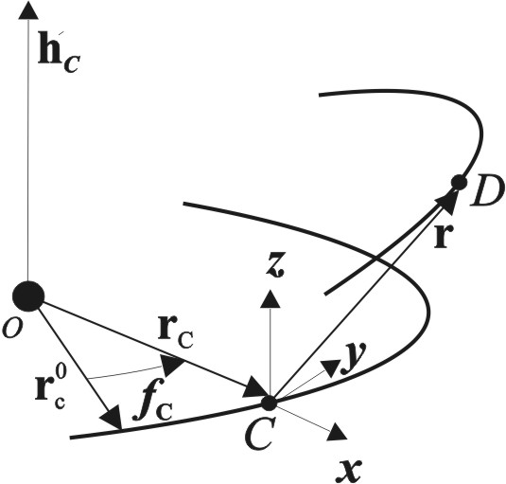
The motion of the Deputy is related to a reference frame that has one axis with the same orientation as the position vector of the Chief with respect to the attraction center, another axis with the same direction as the Chief angular momentum and the third axis completes a positive oriented Cartesian reference frame (see Fig. 1). This non-inertial reference frame will be named LVLH (Local Vertical Local Horizontal).

Figure 1
The problem of the relative orbital motion in a central force field applies in relative orbital dynamics under the influence of the gravity, and all that is implied by this: relative satellite motion, satellite constellations and satellite formation flight. It also models the relative motion of satellites under the influence of some perturbation factors, like the Earth non-sphericity harmonics.
The mathematical model of the relative orbital motion in a central force field is the initial value problem:
(1)
where g is a continuous real valued function that models the central force field, is the angular velocity of the LVLH reference frame (it is supposed to be a differentiable vectorial function), is the position vector of the Chief with respect to an inertial frame originated in the attraction center, are the initial relative position respectively the initial relative velocity of the Deputy with respect to LVLH and is the initial moment of time.
In Cartesian coordinates, eq (1) is written as:
(2)
where is the angle between (the position vector of the Chief at ) and , and is the constant angular momentum of the Chief.

2. Tensorial Considerations

We will introduce the main instrument that helps solve the initial value problem (1). The key is the Darboux equation: determining the orthogonal proper tensorial function that models the rotation with a given continuous instantaneous angular velocity . The skew-symmetric tensorial function associated to will be denoted .

Theorem 1 (Darboux) The solution to the initial value problem:
(3)
has a unique solution Q that is an orthogonal proper tensor.

The solution to the initial value problem (3) will be denoted . This tensorial function models the rotation with angular velocity . a proof to Theorem 1 may be found in [1].

Remark 1 The Darboux equation (3) has explicit solution in some particular cases. When the tensorial function has a constant direction, for example, the explicit solution to eq (3) is:
(4)
In our case, represents the instantaneous angular velocity of LVLH frame, and since the motion is done in a central force field, its direction remains constant.

The main result of this paper offers the solution to the motion in a central force field problem with respect to a rotating reference frame.

Theorem 2 The solution to the initial value problem:
(5)
is obtained by applying the tensorial function to the solution to the initial value problem:
(6)

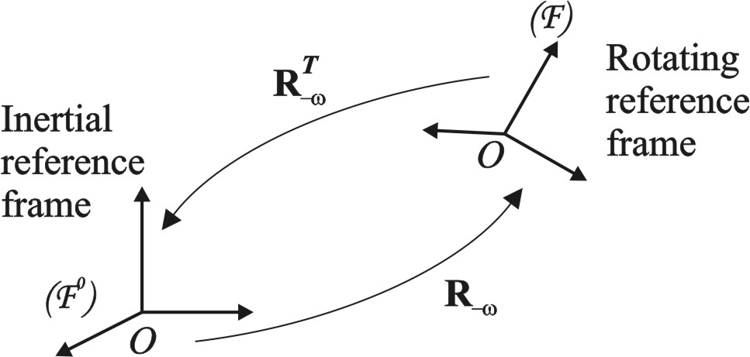
The previous result is a representation theorem for the motion in a central force field with respect to an arbitrary rotating reference frame. It also offers a method for solving the non-linear initial value problem that models such motion: with the help of the inverse of tensor , eq (5) is “transported” in an inertial reference frame, where it becomes exactly eq (6). After solving eq (6), the solution is “transported” back into the rotating reference frame, with the help of tensor . The final result is expressed with respect to the rotating non-inertial reference frame. The inertial frame that appears and then vanishes in this approach plays only a catalyst role. This procedure is similar to the Laplace and Fourier transforms in the case of the scalar differential equations.
Figure 2
We are now ready to give the solution to the relative motion in a central force field problem. One may remark that this is in fact a motion of a particle with respect to a non-inertial reference frame that has a motion composed by:
- a translation along a plane trajectory (that represents the trajectory of the Chief with respect to an inertial reference frame originated in the attraction center);
- a rotation with a fixed direction instantaneous angular velocity (its direction is the same as the Chief angular momentum).

- Relative Orbital Motion in a Central Force Field

3.1. Exact Closed Form Solution

With the help of Theorems 1 and 2, we will offer the solution to the relative motion in a central force field.

Theorem 3 The solution to the initial value problem:
(*)
is:
(7)
where is the solution to the initial value problem:
(8)
and
The proof to Theorem 3 may be done by direct computations.

Remark 2 The solution (7) to eq (*) represents the relative law of motion of a particle with respect to a non-inertial reference frame originated in another particle, both of them moving under the influence of the same central force field that is described by the force law:
(9)
with m representing the mass of the particle, g a continuous real function and r the position vector of the particle.

Remark 3 The solution (7) generalizes the solution to the relative orbital motion in a gravitational field (such as the relative motion of two satellites). In this case, the function g has the particular expression: , where is the gravitational parameter of the attraction center.

3.2. Prime Integrals

By using Theorem 2, we are able to determine the prime integrals of the motion in a central force field with respect to a rotating reference frame. This motion is described by eq (5).

Theorem 4 The prime integrals of eq (5) are:
(10)
(similar to angular momentum conservation);
(11)
(similar to the energy conservation), where
(12)

Proof
One may remark by direct computation that . By using the properties of the tensorial function (see [1]), it follows that the vectorial function may be expressed as the rotation with angular velocity of a constant vector, that is .
Eq (11) results by direct computation.

Remark 4 The vectorial function introduced in eq (10) is similar to the (constant) angular momentum of the motion in a central force field with respect to an inertial reference frame. In case the reference frame has a rotation with an arbitrary instantaneous angular velocity , this clone of the angular momentum is a vector that is obtained by rotating a constant vector with angular velocity .

Remark 5 The function:
represents the generalized specific potential energy. In case is constant, V represents the classic potential energy (see [1]).

3.3. Geometric Visualization of the Relative Orbital Motion
in a Central Force Field

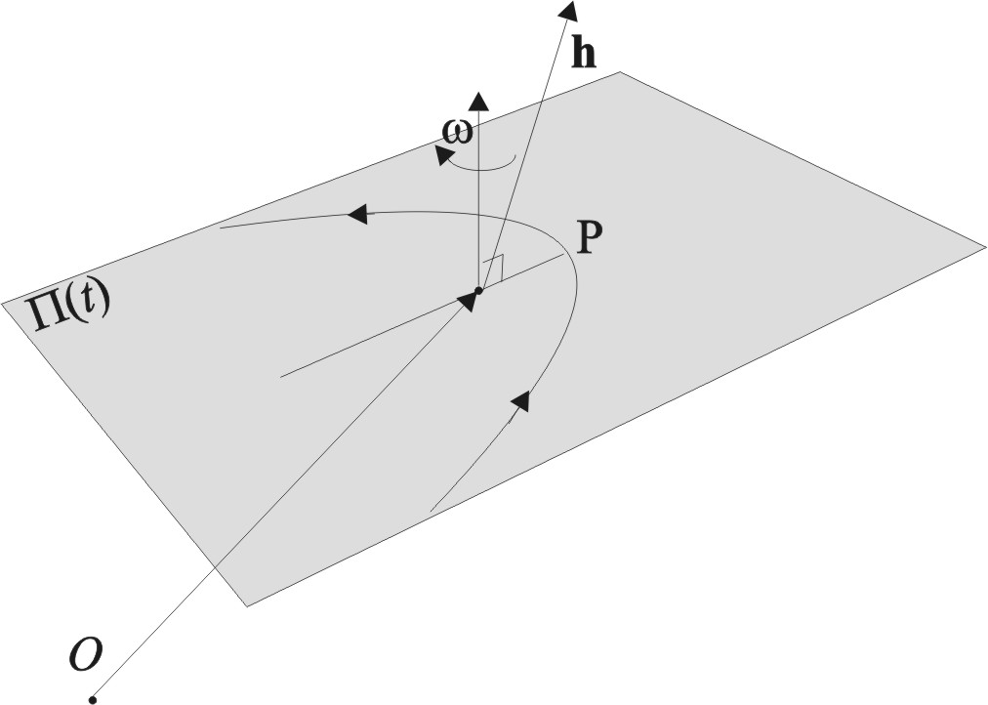
The solution (7) of the initial value problem (1) allows offering a very suggestive geometric visualization of the relative orbital motion in a central force field. The motion may be seen as:
- a planar motion (similar to the inertial motion in a central force field) in a variable plane ;
- a rotation with instantaneous angular velocity of plane ;
Figure 3
- a rectilinear translation of plane ; this translation is described by , the magnitude of the position vector of the Chief with respect to an inertial reference frame originated in the attraction center.

- Keplerian Relative Orbital Motion

This Section particularizes the results from the previous sections: the central force field is the gravitational field of an attraction center, described by a gravitational parameter. The next Theorem offers the exact closed form solution to the Keplerian relative motion. It is a particularization of Theorem 3.

Theorem 5 The solution to the Keplerian relative motion, described by the initial value problem:
(13)
is:
(**)
where is the solution to the initial value problem:
(14)
and

Remark 6 The vectorial function represents, in this particular case, the derivative of true anomaly of the inertial Chief trajectory with respect to time. Considering the true anomaly of the Chief at the initial moment of time being , then it follows that:
(15)
Also, the explicit expression of the tensorial function becomes:
(16)

Remark 7 The vectorial function , expressed with respect to the LVLH frame, is:
(17)
where is the semilatus rectum of the Chief trajectory and its eccentricity. It follows that the solution to the Keplerian relative motion may be written as:
(18)

- Conclusions

The paper offered a complete solution to the orbital relative motion in a central force field. The main instrument that allowed obtaining this solution consists in proper orthogonal and skew-symmetric tensors. The explicit solution to the Darboux equation in case the instantaneous angular velocity has constant direction was also essential.
The applications to these results are immediate: relative motion of satellites. The paper offered the solution to the Keplerian relative orbital motion in a vectorial closed form. This solution generalizes previous approaches to the relative orbital motion problem.

References

Condurache, D., and Martinuşi, V., “Kepler’s Problem in Rotating Reference Frames. Part I: Prime Integrals, Vectorial Regularization,” Journal of Guidance, Control, and Dynamics (accepted for publication), 2006

Condurache, D., and Martinuşi, V., “Kepler’s Problem in Rotating Reference Frames. Part II: Relative Orbital Motion ,” Journal of Guidance, Control, and Dynamics (accepted for publication), 2006

Condurache, D., Martinuşi, V., Relative Spacecraft Motion in a Central Force Field, submitted to AIAA Journal of Guidance, Control and Dynamics, (jul. 2006)

Gill, E., “Description of Keplerian Relative Satellite Motion in an Orbital Reference Frame,” Deutsches Zentrum für Luft- und Raumfahrt, Oberpfaffenhofen, DLR-GSOC TN 02-02, 2002

Inalhan, G., Tillerson, M., and How, P., “Relative Dynamics and Control of Spacecraft Formations in Eccentric Orbits,” Journal of Guidance, Control, and Dynamics, Vol. 25, No. 1, Jan.–Feb. 2002, pp. 48–59.

Gill, E., “Description of Keplerian Relative Satellite Motion in an Orbital Reference Frame,” Deutsches Zentrum für Luft- und Raumfahrt, Oberpfaffenhofen, DLR-GSOC TN 02-02, 2002

Gim, Dong-Woo; Alfriend, Kyle T., Satellite Relative Motion Using Differential Equinoctial Elements, Celestial Mechanics and Dynamical Astronomy, Volume 92, Issue 4, pp.295-336

Gurfil, P., and Kasdin, N. J., “Nonlinear Modeling of Spacecraft Relative Motion in the Configuration Space,” Journal of Guidance, Control, and Dynamics, Vol. 27, No. 1, 2004, pp. 154–157.

Gurfil, P., and Kholshevnikov, K. V., “Distances on the Relative Spacecraft Motion Manifold,” AIAA Guidance, Navigation, and Control Conference and Exhibit, San Francisco, Aug. 2005.

Humi, M., and Carter, T., “Rendezvous Equations in a Central-Force Field with Linear Drag,” Journal of Guidance, Control, and Dynamics, Vol. 25, No. 1, Jan.–Feb. 2002, pp. 74–79.

Pengji Wang, Di Yang, The study of relative dynamics for spacecraft formation flying in eccentric orbits, Aircraft Engineering and Aerospace Technology, Jun 2003 Volume: 75 Issue: 3 Page: 256 – 261

Prasenjit Sengupta; Rajnish Sharma; Srinivas Rao Vadali , Periodic Relative Motion Near a Keplerian Elliptic Orbit with Nonlinear Differential Gravity, Journal of Guidance, Control, and Dynamics, 2006 0731-5090 vol.29 no.5 (1110-1121).

Battin, H.R., An Introduction to the Mathematics and Methods of Astrodynamics, Revised Edition, AIAA, 1999.

Beletsky, V.V., Levin, E.M., Dynamics of Space Tether Systems, American Astronautical Society, 1993.

Beutler, G., Mervart, L., Verdun, A., Methods of Celestial Mechanics: Volume II: Application to Planetary System, Geodynamics and Satellite Geodesy, Springer, 2004.

Bond, V.R., Modern Astrodynamics, Princeton University Press, 1996.

Bonnard, B., Faubourg, L., Trélat, E., Mécanique céleste et contrôle des véhicules spatiaux, Springer;, 2005.

Chobotov, A.V., Orbital Mechanics, The Aerospace Corporation, 2002 (AIAA Education Series).

Curtis, H., Orbital Mechanics: For Engineering Students, Butterworth-Heinemann, 2004.

Fortescue, P., Stark, J., Swinerd, G., Spacecraft Systems Engineering, John Wiley & Sons, 2003.

Kaula, L.M., Theory of Satellite Geodesy: Applications of Satellites to Geodesy, Dover Publications, 2000.

Larson, W.J., Wertz, J.R., Space Mission Analysis and Design, 3rd edition, Microcosm Press; 1999.

Montenbruck, O., Gill, E., Satellite Orbits: Models, Methods and Applications, Springer, 2005.

Moulton, F.R., An Introduction to Celestial Mechanics, Dover Publications; 2nd Rev edition, 1984.

Murray, C., Dermott, S.F., Solar System Dynamics, Cambridge University Press, 2001.

Prussing., J.E., Conway, B.A., Orbital Mechanics, Oxford University Press, 1993.

Roy, A.E., Orbital Motion, Institute of Physics Publishing, Bristol and Philadelphia, 2005.

Vallado, D.A., Fundamentals of Astrodynamics and Applications, 2nd. ed., Microcosm, Inc, 2001.
- 2006
Rezumat: Lucrarea prezintă o soluţie generalizată a mişcării orbitale relative în câmp central. Această soluţie generalizează soluţiile oferite de Clohessy-Wiltshire şi Lawden în cazul traiectoriilor kepleriene. Rezultatele sunt date în formă vectorială închisă, deci nu depind de alegerea în particular a unui sistem de coordonate

Cuvinte cheie: mişcare orbitală relativă, câmp de forţe centrale.

*, ** Dept. of Theoretical Mechanics, Technical University “Gh. Asachi” Iasi, ROMANIA.

