3rd International Conference
″Advanced Composite Materials Engineering ″
COMAT 2010
27- 29 October 2010, Brasov, Romania

EXPERIMENTAL ANALYSIS OF AN ADVANCED COMPOSITE U200x60x10 PULTRUDED PROFILE

H. Teodorescu-Draghicescu¹, A. Chiru¹, S. Vlase¹, L. Paun², D. Rosu³, L. Scutaru¹
¹ Transilvania University, Brasov, ROMANIA, e-mail: draghicescu.teodorescu@unitbv.ro
² S.C. ICTCM S.A. Bucharest, ROMANIA, e-mail: lpaun@ictcm.ro
³ Compozite Ltd., Brasov, ROMANIA, e-mail: compozitebv@yahoo.com

Abstract: The paper presents an experimental analysis of an advanced composite U-beam pultruded profile. Tensile as well three-point bend tests have been accomplished on specimens cut from the pultruded profile along and transverse to the fibres direction. Over thirty mechanical properties including Young’s moduli, flexural rigidities, load-expansion as well as stress-strain distributions have been determined on a Lloyd Instruments LS-100KPlus materials testing machine. The tests show that this kind of pultruded profile is suitable for a large range of applications including automotive and aerospace industry.
Keywords: Stiffness, Glass fibres, Pultrusion, Young modulus, U-beam

1. INTRODUCTION

The pultrusion process is used at the manufacture of any continuous profile. In this process, fibres are pulled out from a beam creel, passed through a resin bath and pulled at constant speed through a heated drawing die. In this heated drawing die, the uniform impregnation is accomplished and the curing process begins. The curing temperature is situated between 120°C and 150°C. The curing speed depends on the hardeners’ quantity from the resin mixture as well as on the disposal of the heating and cooling zones within the drawing die. The cured profile is then cut at the desired length (fig. 1). Except the fibres with orientation at 0°, in the drawing die can be introduced fabrics also [1-8].

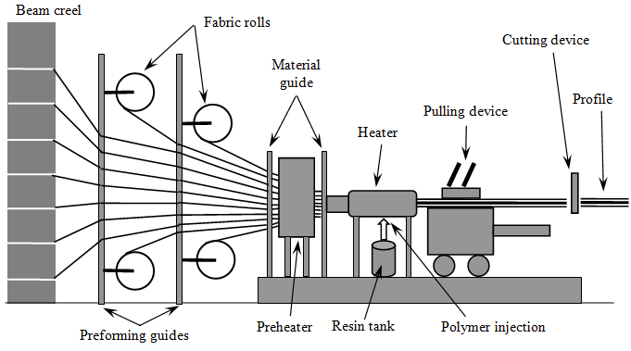
Figure 1: The principle of the pultrusion process [1]
While the pultrusion process is a continuous one obtaining profiles with constant cross sections, nowadays a variant of this process known as “pulforming” allows the introduction of a certain variation in the profile’s cross section. The pulforming process allows materials’ pulling through a drawing die to be impregnated, the resulted profiles being then clamped into a mould for the curing process. Typical application for the pultruded profiles are beams and struts used in bearing structures like roofs, bridges, decks as well as profiled panels. The advantages of the pultruded profiles are:
- Very fast and economic method to impregnate and cure a polymer matrix composite material;
- The resin content required for impregnation can be controled very accurate;
- The mechanical properties of the laminates are very good since the profiles present straight unidirectional oriented fibres and high fibres volume fractions can be obtained;
- The impregnation with resin can be accomplished into a closed zone so that volatile emissions can be limited.
Two main disadvantages of the pultrusion process may be mentioned as following:
- The process is limited at the manufacturing of profiles with constant or almost constant cross sections;
- The costs involved in the heating of the drawing die may increase the overall products’ costs.

2. MATERIAL AND METHOD

The composite material’s characterization is accomplished on an U200x60x10-beam pultruded profile made from unidirectional glass fibres-reinforced isophtalic polyester resin, with overlay veil, having an overall 60% fibres weight fraction. From this pultruded profile, specimens along the fibres direction and transverse to this direction have been cut (fig. 2).

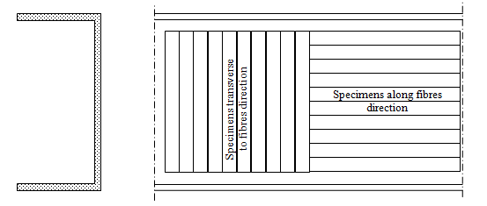
Figure 2: Specimens’ cutting scheme from an U 200x60x10-beam pultruded profile

The tensile as well as three-point bend tests have been accomplished on a testing machine type LS-100KPlus produced by Lloyd Instruments with following characteristics:
- Force range: up to 100 kN;
- Speed accuracy: <0.2%;
- Travel: 840 mm
- Load resolution: <0.01% from the load cell used;
- Displacement resolution: <0.1 microns;
- Type of load cell: XLC-100K-A1;
- Type of extensometer used: EPSILON;
- Analysis software: NEXYGEN Plus.
The tensile tests and specimens’ main features are:
- Specimens’ width: 5 ± 0.5 mm;
- Specimen’s length: 150 ± 0.5 mm;
- Specimens’ thickness: 10 ± 0.5 mm;
- Test speed: 1 mm/min;
- Gauge length: 50 mm.
The three-point bend tests and specimens’ main features are:
- Specimens’ width: 15 ± 0.5 mm;
- Specimen’s length: 150 ± 0.5 mm;
- Specimens’ thickness: 10 ± 0.5 mm;
- Test speed: 2 mm/min;
- Span: 135 mm.
For tensile tests, the specimens have been cut according to ISO 527-5:2009 (Plastics – Determination of tensile properties – Part 5: Test conditions for unidirectional fibre-reinforced plastic composites). For three-point bend tests, the specimens have been cut according to ISO 14125:1998 (Fibre-reinforced plastic composites – Determination of flexural properties).
To avoid the specimens’ degradation during the cutting process, a diamond cutting disc has been used at high speed rotation using a water cooling system. For tensile tests, ten specimens have been cut (five along the fibres direction and five transverse to the fibres direction). For three-point bend tests, ten specimens have been cut (five along the fibres direction and five transverse to the fibres direction).

3. RESULTS

In tensile tests, the specimen have been subjected to a test speed of 1 mm/min and the length between extensometer’s lamellae is 50 mm. Following main features have been determined:
- Stiffness;
- Young’s modulus;
- Load at Maximum Load;
- Stress at Maximum Load;
- Strain at Maximum Load;
- Tensile Strength;
- Extension at Maximum Load;
- Load at Break;
- Stress at Break.
In three-point bend tests following main features have been determined:
- Stiffness;
- Young’s modulus of bending;
- Flexural rigidity;
- Load at Maximum Load;
- Maximum bending stress at Maximum Load;
- Maximum bending strain at Maximum Load;
- Extension at Maximum Load;
- Load at Break;
- Maximum bending stress at Break.
The tensile tests as well as the three-point bend results are presented figs. 3-10. Young’s moduli, Young’s moduli of bending and flexural rigidities have been also determined.

Figure 3: Tensile tests. Load-extension distributions of five specimens cut along the fibres direction
Figure 4: Tensile tests. Load-extension distributions of five specimens cut transverse to fibres direction

Figure 5: Tensile tests. Young’s moduli determined along and transverse to fibres direction

Figure 6: Tensile tests. Tensile strengths of five specimens determined along and transverse to fibres direction
Figure 7: Three-point bend tests. Load-extension distributions of five specimens cut along the fibres direction

Figure 8: Three-point bend tests. Load-extension distributions of five specimens cut transverse to fibres direction

Figure 9: Three-point bend tests. Young’s moduli determined along and transverse to fibres direction

Figure 10: Three-point bend tests. Flexural rigidities determined along and transverse to fibres direction

4. CONCLUSIONS

The pultruded profiles are used in many interesting applications due to their constant cross-section, stiffness, high weather and corrosion resistance as well as high tensile strength. The tensile and three-point bend tests accomplished on specimens cut from a U200x60x10 glass fibres-reinforced pultruded profile along and transverse to the fibres direction put in evidence some of the main advantages of this kind of composite material:
- Young’s moduli up to 52000 MPa determined along the fibres direction;
- Tensile strengths up to 350 MPa determined along the fibres direction;
- Young’s moduli of bending up to 28000 MPa determined along the fibres direction;
- Flexural rigidities up to 34 Nm² determined along the fibres direction.
The mechanical properties determined transverse to the fibres direction show a significant decrease from that determined along the fibres direction, so that the unidirectional reinforced pultruded profiles present a strong anisotropy.

ACKNOWLEDGEMENT

This paper is partially supported by the Sectoral Operational Programme Human Resources Development (SOP HRD), financed from the European Social Fund and by the Romanian Government under the contract number POSDRU/89/1.5/S/59323

REFERENCES

[1] Miracle, D.B. and Donaldson, R.L.: ASM Handbook Volume 21: Composites, ASM International, 2001.
[2] Daniel, I.M. and Ishai, O.: Engineering of Composite Materials, Oxford University Press, 2nd ed., 2005.
[3] Vinson, J.R.: Plate and Panel Structures of Isotropic, Composite and Piezoelectric Materials, Including Sandwich Construction, Springer, 1st ed., 2005.
[4] Bank, L.C.: Composites for Construction: Structural Design with FRP Materials, Wiley, 2006.
[5] Lee, D.G. and Suh, N.P.: Axiomatic Design and Fabrication of Composite Structures: Applications in Robots, Machine Tools, and Automobiles, Oxford University Press, 2005.
[6] Strong, A.B.: Fundamentals of Composites Manufacturing: Materials, Methods and Applications, Society of Manufacturing Engineers, 2nd ed., 2007.
[7] Backman, B.F.: Composite Structures, Design, Safety and Innovation, Elsevier Science, 2005.
[8] Vinson, J.R. and Sierakovski, R.L.: The Behavior of Structures Composed of Composite Materials, Springer, 2008.

