A QUATERNIONIC PROCEDURE IN THE STUDY OF THE KEPLERIAN RELATIVE ORBITAL MOTION
BULLETIN OF THE TRANSILVANIA UNIVERSITY OF BRAŞOV

D.CONDURACHE* V. MARTINUSI**

Abstract: The Keplerian relative orbital motion is studied by using quaternions, and a closed form solution is offered. This solution is based on a representation theorem given for the first time in 1995 in a tensorial form. The equations of relative motion with respect to an adequately chosen reference frame are obtained in a closed form.
Keywords: relative spacecraft motion, Keplerian trajectory, quaternionic approach.

- Introduction

The paper offers a closed form solution to the Keplerian relative orbital motion by using quaternions. Relative orbital motion is of great importance for formation flying satellites – a concept for future space missions. Starting with the work of Clohessy – Wiltshire (see [1]) and Lawden (see [2]) in the early 60’s, the relative orbital motion knew many approaches: when the reference trajectory is circular or elliptic, when gravitational perturbations (Earth non-sphericity), solar pressure, thrust or atmospheric drag are taken into consideration.
The solutions offered by most authors are given by linearizing the equation of motion and by supposing that the relative distance remains small by comparison to the distance to the attraction center. We offer an exact solution to the relative orbital motion without any approximate methods.
This work is based on a result published for the first time in 1995 (see [4]). It relates the motion with respect to a rotating reference frame to the motion in an inertial reference frame by means of proper orthogonal tensorial functions. We give a similar quaternionic result in order to offer the solution to the Keplerian motion with respect to a non-inertial reference frame adequately chosen that has rotation and translation.

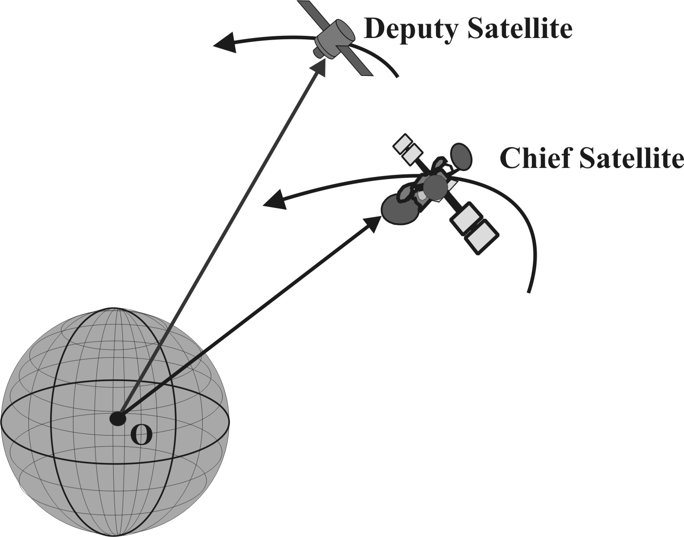
- Problem Formulation

Two spacecrafts are orbiting around the same Keplerian attraction center, with the gravitational parameter. One of them is the reference body, named Chief, and the other one is the targeted body, named Deputy. Consider a reference frame originated in the mass center of the Chief, defined as:
- Ox axis has the direction of the position vector of the Chief;
- Oz axis has the direction of the angular momentum of the Chief;
- Oy axis completes a positive oriented base.

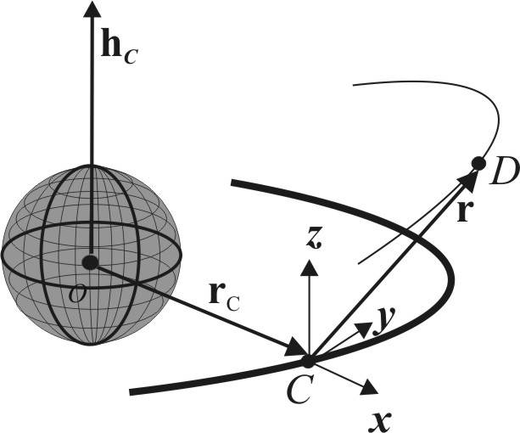
This reference frame is known as LVLH (local vertical local horizontal)
The goal of this paper is to determine the law of motion of the Deputy spacecraft with respect to the LVLH reference frame. This motion is described by the initial value problem:
(1)
where denotes the instantaneous angular velocity of LVLH (it is supposed to be a differentiable function), represent the relative position and the relative velocity of the Deputy with respect to LVLH.

- Quaternionic Considerations

The key of the quaternionic approach to Keplerian relative orbital motion is the Darboux equation expressed with quaternions: finding the unit quaternion that describes the rotation with a given arbitrary instantaneous angular velocity.

Theorem 1 Let be a continuous vectorial function. The quaternionic initial value problem:
(2)
has a unique solution , which is a unit quaternion.

The proof to this theorem may be found in [3], for example.

Remark 1 The unit quaternion which is solution to eq (2) models the rotation with angular velocity . In case vector has constant direction, then the solution to eq (1) may be found explicitly as:
(3)

- A Quaternionic Solution to Keplerian Relative Dynamics

We are now ready to offer the solution to eq (1). First, we will relate the motion with respect to a rotating reference frame to the motion with respect to an inertial reference frame. The next theorem is the quaternionic equivalent of the result from [4].

Theorem 2 The solution to the initial value problem:
(4)
is obtained by applying the quaternion operator:
(5)
to the solution to the initial value problem:
(6)
where is the solution to the Darboux equation (2).

Remark 2 The method offered by the previous theorem helps studying the Keplerian motion in a rotating reference frame: with the help of the inverse quaternion operator:
(7)
the non-linear initial value problem (4) is transformed into a simpler one, that is eq (6). the classic inertial Kepler problem. The solution to eq (6) is transferred back in the rotating reference frame by the quaternionic operator defined in eq (5). Finally, the solution is expressed with respect to the rotating reference frame.

The proof to Theorem 2 may be done by direct computations.
The vectorial equivalent of Theorem 2 is:

Corollary 2 The solution to the initial value problem:
(8)
is obtained by applying the tensorial proper orthogonal function to the solution to the initial value problem:
(9)
where is given by:
(10)

We are now ready to offer the exact solution to the initial value problem (1). Its quaternionic equivalent is:
(11)

Theorem 3 The solution to the initial value problem (11) is:
(12)
where:
- is the solution to eq (2);
- ;
- is the Chief semilatus rectum and its trajectory eccentricity;
- is the position vector of the Chief with respect to an inertial reference frame originated in the attraction center at the initial moment of time ;
- is the solution to the initial value problem:
(13)
- is the absolute (inertial) velocity of the Chief.

The vectorial equivalent to Theorem 3 may be formulated as:

Corollary 3 The solution to the initial value problem (1) is:
(14)
where , has the explicit expression:
(15)
(denotes the Chief true anomaly) and is the solution to the initial value problem:
(16)

By writing explicitly the vectorial solution (14) to the initial value problem (1) and taking into account eq (15), it follows that the closed form vectorial solution to the relative Keplerian orbital motion is:
(17)

- Conclusions

The paper offered a quaternionic solution to Keplerian orbital relative dynamics. By using a quaternionic operator resulted from the Darboux equation, a closed form vectorial solution to the strong non-linear differential equation that models the relative motion was deduced. This solution generalizes the approximate approaches to relative spacecraft dynamics that are presented in the scientific specific literature. Direct applications to this solution are in relative spacecraft motion, orbital rendezvous and satellite formations.

References

Clohessy, W.H., Wiltshire, R.S., "Terminal Guidance System for Satellite Rendezvous", Journal of the Aerospace Sciences, Vol. 27, No. 9, Sept. 1960, pp. 653-658.

Lawden, D. F., "Optimal Trajectories for Space Navigation", Butterworths, London, 1963, pp. 79--86.

Condurache, D., Martinuşi, V., A Tensorial Explicit Solution to Darboux Equation, “The 2nd International Conference << Advanced Concepts in Mechanical Engineering>>", Iasi , 2006.

Condurache, D., "New Symbolic Methods into the Study of Dynamic Systems" (in Romanian), PhD thesis, Technical University "Gh Asachi" Iaşi, 1995.

Condurache, D., Martinuşi, V., Kepler's Problem in Rotating Reference Frames. Part I: Prime Integrals.Vectorial Regularization, accepted to AIAA Journal of Guidance, Control and Dynamics (2006)

Condurache, D., Martinuşi, V., Kepler's Problem in Rotating Reference Frames. Part II: Application to Relative Orbital Motion, accepted to AIAA Journal of Guidance, Control and Dynamics (2006)

Condurache, D., Martinuşi, V., Vectorial Closed Form Solutions to Foucault Pendulum Like Problems, submitted to International Journal of Nonlinear Mechanics (2006)

Condurache, D., Martinuşi, V., A Complete Closed Form Vectorial Solution to Kepler’s Problem, submitted to Meccanica (apr. 2006)

Condurache, D., Martinuşi, V., Relative Spacecraft Motion in a Central Force Field, submitted to AIAA Journal of Guidance, Control and Dynamics, (jul. 2006)

Condurache, D., Martinuşi, V., Relative Keplerian Dynamics by Using Universal Variables, submitted to AIAA Journal of Guidance, Control and Dynamics, (aug. 2006)

Condurache, D., Martinuşi, V.,. The Solution to Kepler's Problem in Non-Inertial Reference Frames, Bul. Inst. Polit. Iaşi, LI(LV), l-2, Sect. Mathematics, Theoretical Mechanics, Physics, pp. 43-55 (2005).

Condurache, D., Martinuşi, V., Kepler's Problem in Non-Inertial Reference Frames: A Vectorial Regularization, Bul. Inst. Polit. Iaşi, LI(LIV), l-2, Sect Mathematics, Theoretical Mechanics, Physics, 45-61 (2005).

Condurache, D., The Two Body Problem in Non-Inertial Reference Frames, Plenary Session, The 2nd International Symposium of Theoretical and Applied Mechanics "D.I.Mangeron", Iaşi, Romania (2005).

Condurache, D., Martinuşi, V.,. An Exact Solution to Satellite Relative Orbital Motion, 1st International Conference ″Computational Mechanics and Virtual Engineering ″ COMEC 2005, October 2005, Braşov, Romania (2005).

Condurache, D., Martinuşi, V., A Closed Form Vectorial Solution To the Relative Orbital Motion, CMDA 2006 — International Workshop on Actual Problems in Celestial Mechanics and Dynamical Astronomy, Babeş-Bolyai University Cluj-Napoca, Romania, May 25—27, 2006

Gurfil, P., “Relative Motion Between Elliptic Orbits: Generalized Boundedness Conditions and Optimal Formationkeeping,” Journal of Guidance, Control, and Dynamics, Vol. 28, No. 4, July–Aug. 2005, pp. 761–767.

Gurfil, P., and Kasdin, N. J., “Nonlinear Modeling of Spacecraft Relative Motion in the Configuration Space,” Journal of Guidance, Control, and Dynamics, Vol. 27, No. 1, 2004, pp. 154–157.

Gurfil, P., and Kholshevnikov, K. V., “Distances on the Relative Spacecraft Motion Manifold,” AIAA Guidance, Navigation, and Control Conference and Exhibit, San Francisco, Aug. 2005.

Humi, M., and Carter, T., “Rendezvous Equations in a Central-Force Field with Linear Drag,” Journal of Guidance, Control, and Dynamics, Vol. 25, No. 1, Jan.–Feb. 2002, pp. 74–79.

Inalhan, G., Tillerson, M., and How, P., “Relative Dynamics and Control of Spacecraft Formations in Eccentric Orbits,” Journal of Guidance, Control, and Dynamics, Vol. 25, No. 1, Jan.–Feb. 2002, pp. 48–59.

Irvin, D. J., Jr., “Linear vs Nonlinear Control Techniques for the Reconfiguration of Satellite Formations,” AIAA Guidance, Navigation and Control Conference and Exhibit, Montreal, Aug. 2001.

José F. Cariñena, Manuel F. Rañada, and Mariano Santander, Central potentials on spaces of constant curvature: The Kepler problem on the two-dimensional sphere S2 and the hyperbolic plane H2, Journal of Mathematical Physics, 2005, Vol. 46,

Prasenjit Sengupta; Rajnish Sharma; Srinivas Rao Vadali , Periodic Relative Motion Near a Keplerian Elliptic Orbit with Nonlinear Differential Gravity, Journal of Guidance, Control, and Dynamics, 2006 0731-5090 vol.29 no.5 (1110-1121).

Scheeres, D. J., and Guibout, V. M., “Spacecraft Formation Dynamics and Design,” Journal of Guidance, Control, and Dynamics, Vol. 29, No. 1, Jan.–Feb. 2006, pp. 121–133.

Alfriend, K. T., Yan, H., and Vadali, S. R., “Nonlinear Considerations in Satellite Formation Flying,” AIAA/AAS Astrodynamics Specialist Conference and Exhibit, Monterey, CA, Aug. 2002.

Breger, L., and How., J., “J2-Modified GVE-Based MPC for Formation Flying Spacecraft,” AIAA Paper 2005-5833, Aug. 2005.

Broucke, R. A., “A Solution of the Elliptic Rendezvous Problem with the Time as Independent Variable,” AAS/AIAA Space Flight Mechanics Meeting, San Antonio, TX, Jan. 2002.

Rezumat: Mişcarea orbitală relativă kepleriană este studiată folosind quaternioni, o soluţie în formă închisă fiind obţinută. Această soluţie se bazează pe o teoremă de reprezentare dată pentru prima dată în 1995, în formă tensorială. Ecuaţiile mişcării relative în raport cu un reper ales în mod adecvat sunt date în formă închisă.

Cuvinte cheie: mişcare relativă a sateliţilor, traiectorie kepleriană, abordare quaternionică.

*, ** Dept. of Theoretical Mechanics, Technical University “Gh. Asachi” Iasi, ROMANIA.

