BULLETIN OF THE TRANSILVANIA UNIVERSITY OF BRAŞOV

Determination of switching times

M. IONESCU*

Abstract: In the present paper the author wants to determine the performances of the LSMs, the basic elements of sequential pneumatic commands. To achieve this goal the author uses originally developed optical sensors connected to a computer that, using appropriate software, measures the response times. These times are compared to those obtained by simulation of a pneumatic circuit with an electronic circuit, using the SPICE program.
Conclusion. It is remarked that the experimental research results obtained using inductive transducers, optical transducers and simulation with an electric circui*t coincide.

Keywords: logical sequence module, sensors

1. Determination of the switching (setting) time

This determination was carried out by means of the circuit presented in figure 3.

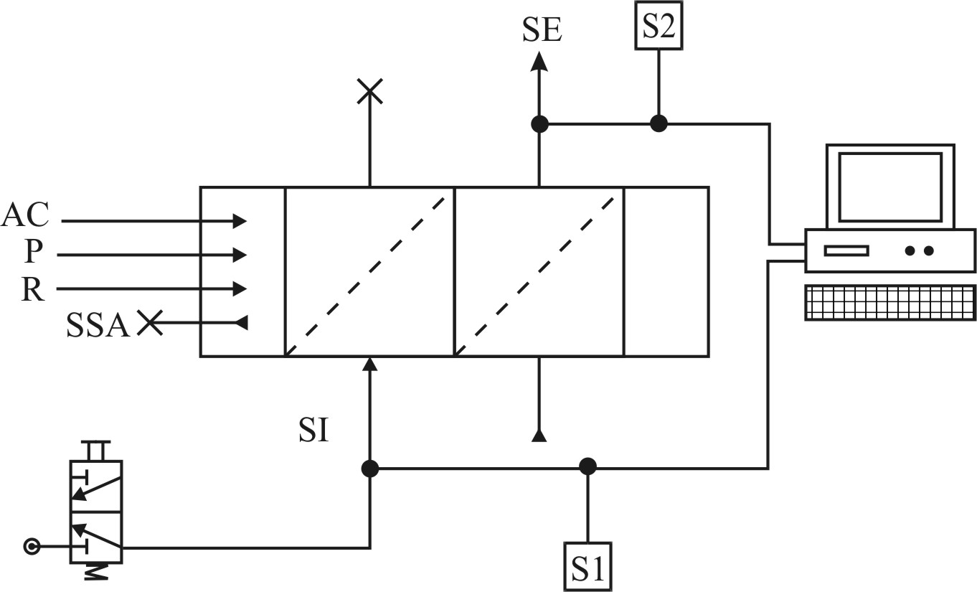

Fig. 1 Principle of measurement

This includes two LSMs [1], [2], [3] fixed by means of end plates. The 3/2 distributor launches an input signal that is converted by sensor S1 into a digital one and is then transmitted to the computer. The effect is the obtaining of an output signal SE detected by sensor S2, then converted into a digital signal and transmitted to the computer with a lag Δt [ms].
Twenty measurements were carried out, presented in table 1.

Table 1.
15 | 13 | 11 | 11 | 11
10 | 10 | 10 | 10 | 10
9 | 9 | 9 | 9 | 9
9 | 9 | 9 | 9 | 9

The statistical processing of the results from table 1 is achieved by means of the Lilliefors test for validation of test result normality, the statistical quantities and normality validation being shown in centralized table 2.

2. Electrical simulation of pneumatic circuits

2.1. The pneumatic circuit for switching (setting)

This is an excerpt of the total circuit of the LSMs, that is the active part which contributes to the achievement of the setting function.
The equivalent electric circuit of the module is presented in figure 2.

  - The simulation results

The evolution of the system was monitored in points V13 (output of the logical OR module, thin line on the graph) and V 18 (output of the universal logical module, medium thick line on the graph) for a signal variation (voltage between 0V and 1.5 V equivalent to a pressure interval of 0 – 1.5 atm) in form of an impulse of 200ms duration, with 50ms increase and 100ms decrease time (bold line), respectively, applied to the circuit input.

  - Interpretation of simulation results

The pressure threshold at which it can be assumed that logical state 1 was achieved is 0.9 of the maximum value (of 1.5 atm), that is 1.35 atm. The graph shows (fig. 3) the lag of the output signal in relation to the input one, of Δx = 11 ms. It can be noticed that at a decrease of the input pressure, the value of the output pressure is self-maintained.

Table 2
No. | Sample | Statistical sampling parameters |  |  | Level of significance  α (%) | Test statistics  d_{max} | Critical value of test d_{n,α} | Statistical decision H₀ is accepted, H₁ is rejected
No. | Sample | Arithmetic mean (m) | Dispersion (S²) | Square deviation (s)
1 | See table 1 | 10,05 | 2,471 | 1,572 | 1 | 0,228 | 0,231 | H₀
Fig. 2. Equivalent electric circuit

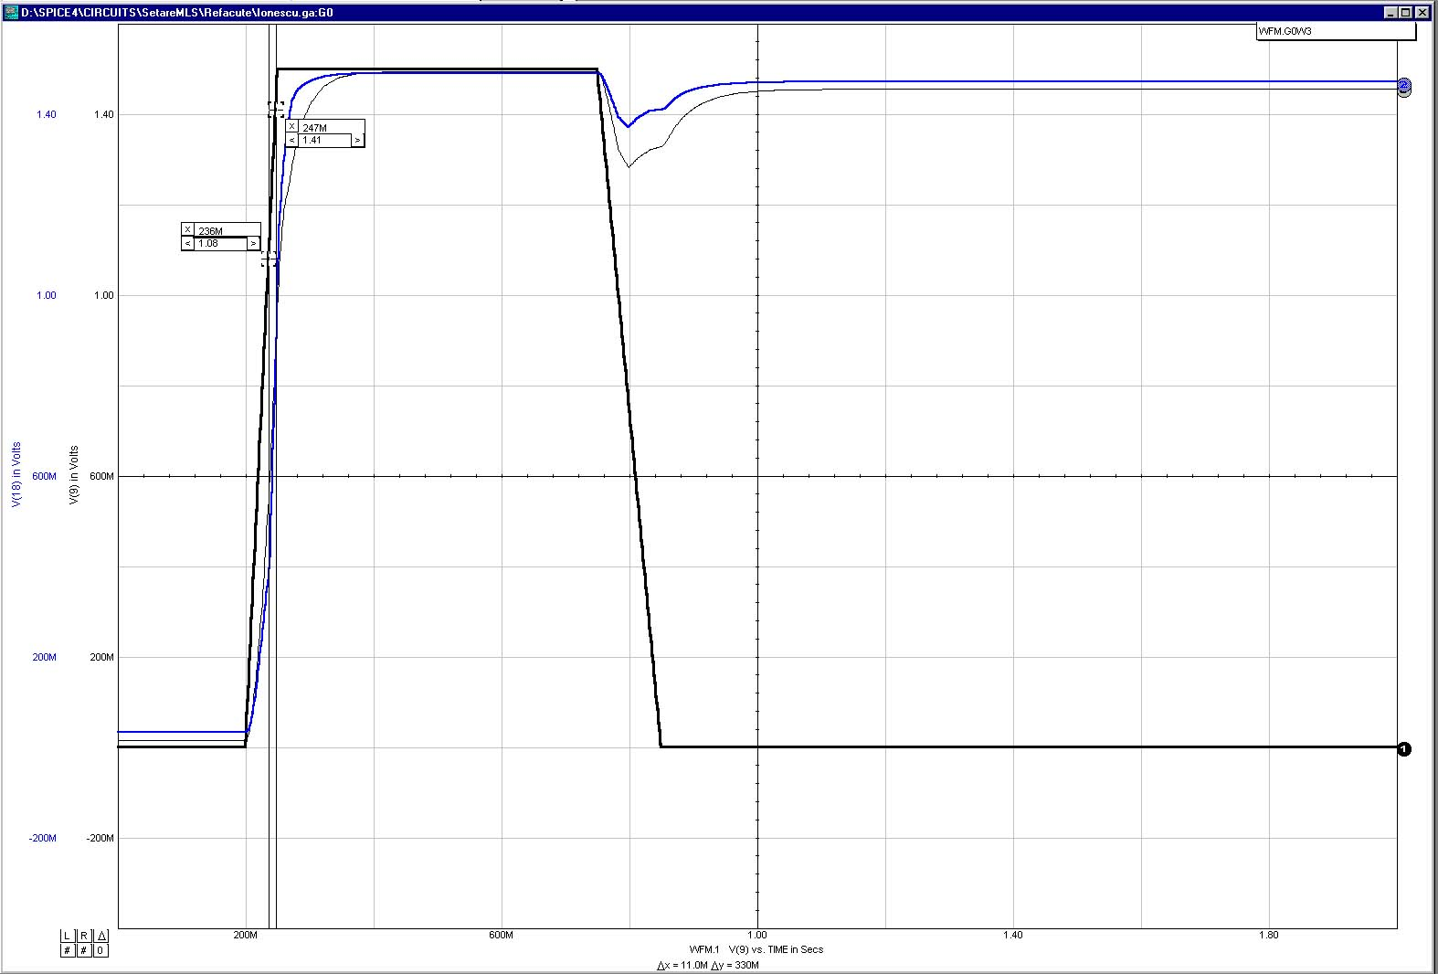

Fig. 3. Signal diagram

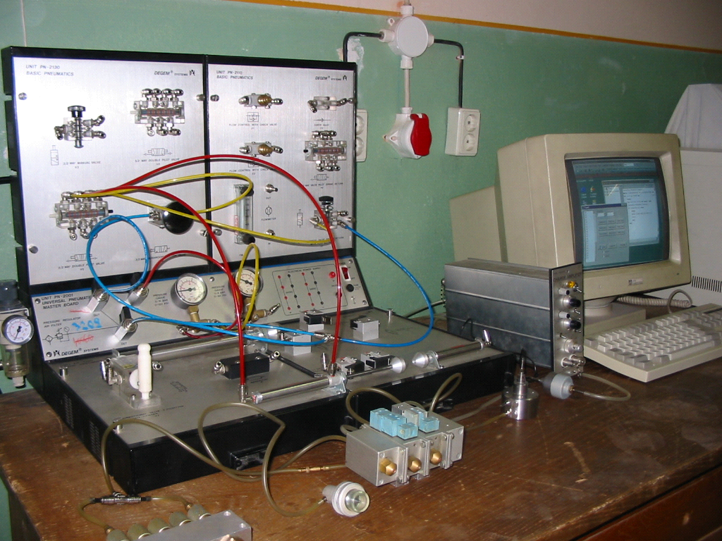
Fig. 4. Logical modules with SEFRO elements

3. Conclusion

It can be noticed that the results of the experimental research carried out alternatively with an inductive transducer [2], [4], an optic transducer and by electric circuit simulation are in concordance.

References

1. Ionescu, E., Ionescu, M.: Module logice de secvenţă pentru cicluri secvenţiale pneumatice. [Sequential Logic Modules for Sequential Pneumatic Cycles]. Brevet de invenţie nr. 76754 din 28.01.1981 [Invention Patent], Romania.
2. Ionescu, M.: Sisteme pneumatice utilizate în comanda maşinilor-unelte.[Pneumatic Systems Used in the Drives of Machine-Tools]. Teză de doctorat. [PhD Dissertation]. Universitatea “Transilvania” din Braşov, 2003.
3. Ionescu, M.: Sisteme pneumatice utilizate în comanda maşinilor-unelte.[Pneumatic Systems Used in the Drives of Machine-Tools]. “Transilvania” University of Brasov Publishing House, 2004, ISBN-973-635-313-3.
4. Ionescu, M.: Automatizări pneumatice destinate maşinilor-unelte. [Pneumatic Automation for Machine-Tools], “Transilvania” University of Brasov Publishing House, 2004, ISBN-973-635-335-4.
5. Radcenco, Vs., Alexandrescu N., Ionescu, E., Ionescu, M.: Calculul şi proiectarea elementelor şi schemelor pneumatice de automatizare.[Computation and Design of Pneumatic Automation Elements and Diagrams] , Editura Tehnică, Bucureşti, 1985.

Determinarea timpilor de comutare

Rezumat: Prezenta lucrare îşi propune să determine performanţele Modulului Logic de Secvenţă, elementul de bază al comenzii pneumatice secvenţiale. Autorul ajunge la rezultate folosind o metodă originală cu ajutorul senzorilor optici conectaţi la calculatorul electronic utilizând un program adecvat şi măsurând timpul de răspuns. Acest timp măsurat este comparat cu cel obţinut prin similitudinea circuitului pneumatic cu un circuit electric echivalent, folosind programul SPICE. Concluzie:se remarcă faptul că datele obţinute pe cale experimentală folosind traductori inductivi, traductori optici şi simulare cu circuite electrice, coincid. Aşadar, metoda este validă.

Cuvinte cheie: modul logic de secvenţă, senzori

* Department of Economical Engineering and Manufacturing Systems, Transilvania University of Brasov

