BULLETIN OF THE TRANSILVANIA UNIVERSITY OF BRAŞOV

PNEUMATIC STEPPER

M. IONESCU*

Abstract. The paper presents the structure of a pneumatic programmer with 10 sequences designed for the control of machine-tools, industrial robots or automated machines with sequential unfolding of the working cycle. The programmer is easily connected to any automated machine its performance being determined by the system of elements included (in this case SEFRO system). The device is noteworthy for its easy working cycle reprogramming and applicability as a control system in other automated machines.

Keywords: automation, pneumatic drives, programming matrices

1. Introductory notions

Frequently sequential cycles of automated machines are not variable with regard to the sequence of phases. In the case of sequential automatic machines with multiple destinations (polyvalent machines) the possibility of programming the sequence of cycle phases becomes essential for the solving of the control circuit. The modular sequential block [3], [5] of register type lends itself for programming of the sequence of phases, thus achieving aim-specific flexible sequential cycles.

2. Diagram of principle

Matrix programmers achieve the working programme by establishing connections between a set of input and a set of output signals, that is xi (i = 1 ... n) and yj (j = 1 ... m), respectively. In the pneumatic variant they consist of a lattice of channels with n rows and m columns located in different planes (fig.1, a); manually controlled 2/2 micro-distributors are integrated in the points of intersection, driven by means of programming jacks (fig.1, b).

3. Basic construction

The construction of the matrix programmer is based on the patented [3] logical sequential module (LSM) which can be modularly assembled such as to include n identical components, thus resulting the modular sequential block (MSB) [1].

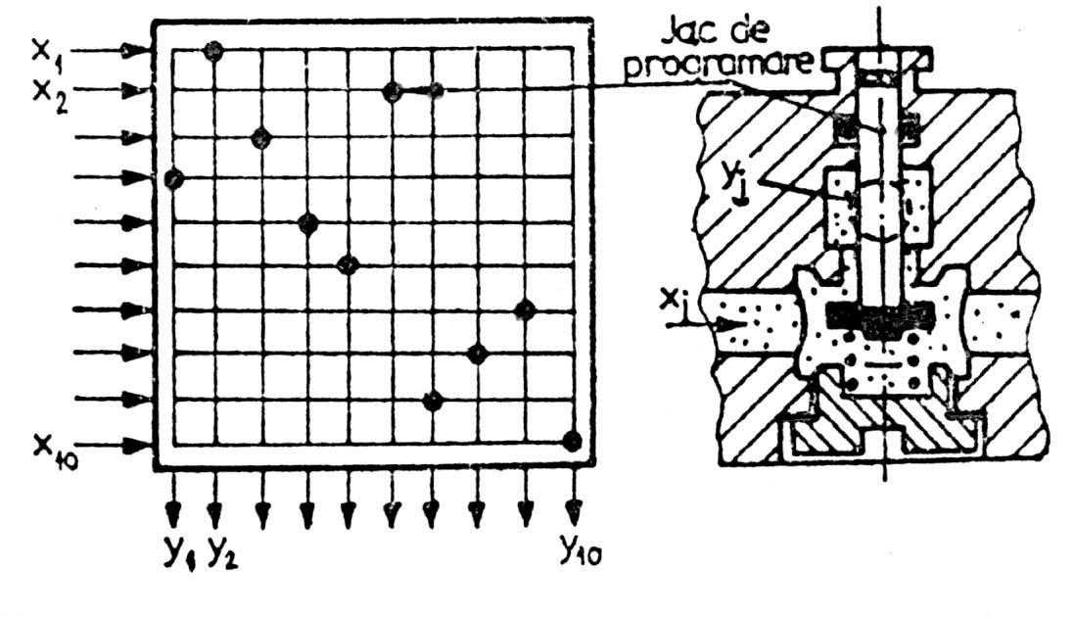
- b)
Fig. 1 Matrix sequential programmer

In a simplified manner, the MSB (fig. 2) is conceived modularly, including n logical sequential modules and two end plates, with the following outlets for external cabling: RC – resume cycle; R – general deletion; SSA – delete previous sequence; P – feed pressure; SE – output signals; SI – input signals. Of these, outlets P and R cross the modular block from one end to the other.

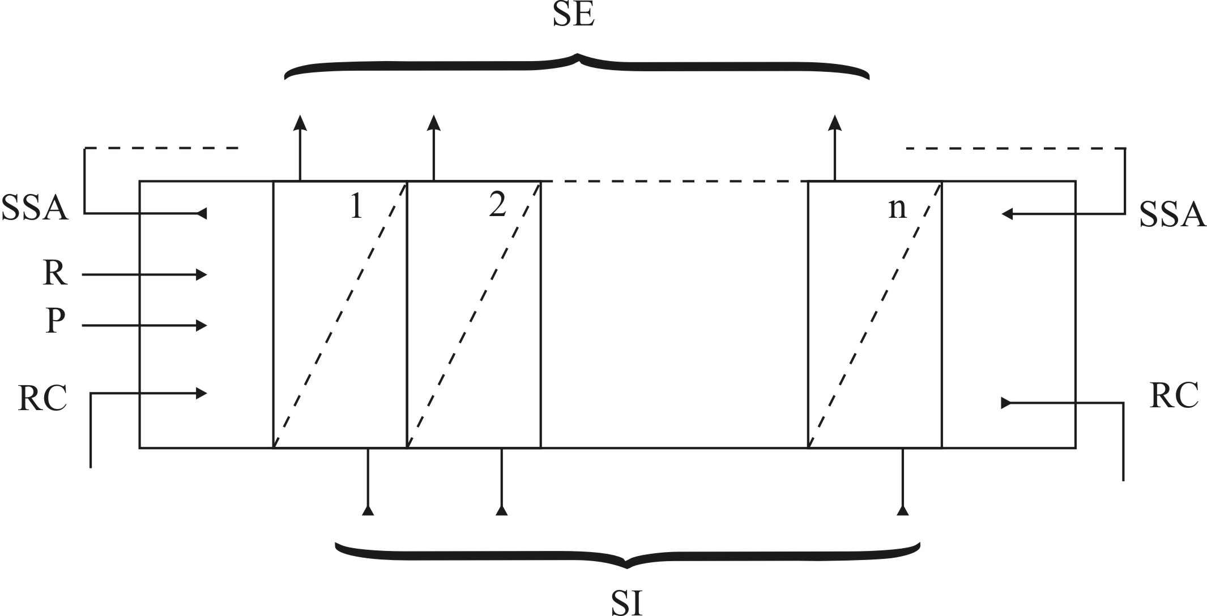

Fig. 2 Modular sequential block (MSB)
The logical diagram of the MSB (fig. 3) includes three logical modules: a memory with prioritised deletion, an AND logical cell, an OR logical cell and a pneumatic indicator, auxiliary element for visualising the active phase.
The operation of the MSB can be observed in figure 3, starting from the fact that the memory of a sequential module is actuated (logical state „1”) by a signal supplied by the AND logical cell of the previous module. The output signal SE of this memory generates five actions:
- ensures an SE signal towards the exterior, for the command of the respective phase;
- auto-maintaining of logical state "1" of the memory, by the OR logical cell;

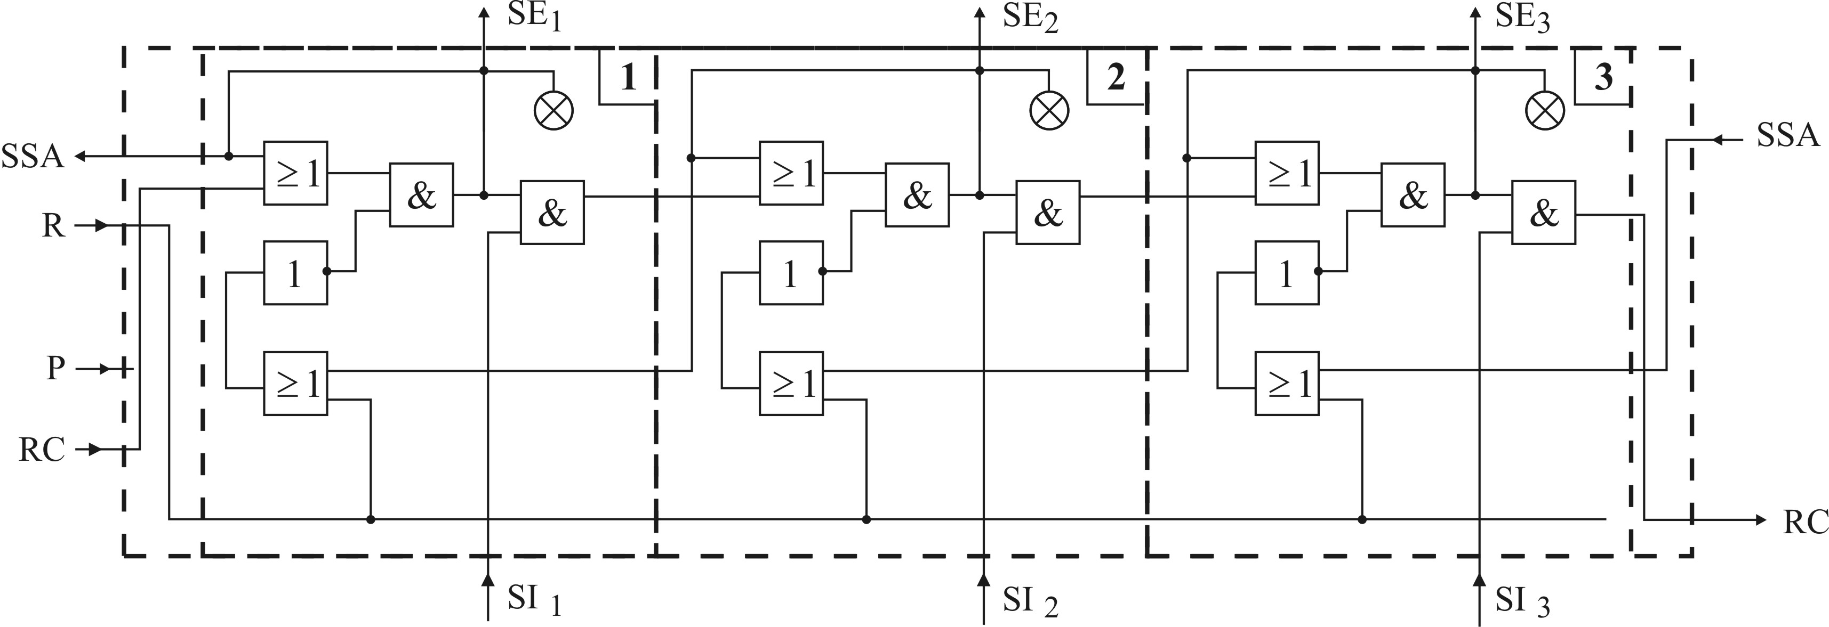

Fig. 3 MSB logical diagram
- deletes the memory of the previous sequential module (logical state „O”), by crossing an OR logical cell;
- feeds the input of the AND logical cell;
- drives/actuates the pneumatic indicator.
Upon completion of the commanded motion, the input signal SI originating from the sensor mounted on the machine-tool , activates the other input of logical cell AND, which transmits an activation signal to the memory of the next sequential module.
Output signal SE are used by coupling these to the control of a pressure-pressure piloted pneumatic distributor, employing its own memory function. In practice not all elements are endowed with a memory function, in which case a logical cell with such a will be function series coupled . The input signals SI originating from the stroke sensors, confirming the completion of the commanded function, are fed to the SI external cabling outlet of the respective module.
Remark: by its logical circuit the MSB ensures the unfolding of the working cycle with high level security, because it is ONLY the input signal of the active phase that can trigger the next phase.
The “Transilvania” University laboratories have studied, conceived, developed and operated a programmer (fig. 4) with i = 10 inputs and j = 10 outputs (which services five operational elements – rotating pneumatic cylinders or motors).
The main characteristics of the matrix pneumatic programmer developed with SEFRO elements are:
- maximum number of output channels nmax = 10;
- nominal (rated) working pressure pn = 1,4 ⋅ 105 Pa;
- minimum control/command pressure pc min = 0,8 ⋅ 105 Pa;
- maximum control/command pressure p c max = 3,2 ⋅ 105 Pa;
- switching time between two modules tc = 15 ms;
- maximum working frequency fmax = 10 Hz;
- minimum number of switchings nmin = 109 cycles;
- working temperature - 20 ... + 60° C;
- air filtering accuracy 40 μm.
The main applications of the programmer include the control of machine-tools, industrial robots, automated industrial processes with a sequential unfolding of the working cycle [4], [5].
Figure 4 illustrates a matrix programmer with 10 channels.

Fig.4. Matrix pneumatic programmer

References

1. Ionescu, M.: Sisteme pneumatice utilizate în comanda maşinilor-unelte.[Pneumatic Systems Used in the Drives of Machine-Tools]. Teză de doctorat. [PhD Dissertation]. Universitatea “Transilvania” din Braşov, 2003.
2. Radcenco, Vs., Alexandrescu N., Ionescu, E., Ionescu, M.: Calculul şi proiectarea elementelor şi schemelor pneumatice de automatizare.[Computation and Design of Pneumatic Automation Elements and Diagrams] , Editura Tehnică, Bucureşti, 1985.
3. Ionescu, E., Ionescu, M.: Module logice de secvenţă pentru cicluri secvenţiale pneumatice. [Sequential Logic Modules for Sequential Pneumatic Cycles]. Brevet de invenţie nr. 76754 din 28.01.1981 [Invention Patent], Romania.
4. Ionescu, M.: Sisteme pneumatice utilizate în comanda maşinilor-unelte.[Pneumatic Systems Used in the Drives of Machine-Tools]. “Transilvania” University of Brasov Publishing House, 2004, ISBN-973-635-313-3.
5. Ionescu, M.: Automatizări pneumatice destinate maşinilor-unelte. [Pneumatic Automation for Machine-Tools], “Transilvania” University of Brasov Publishing House, 2004, ISBN-973-635-335-4.

Automat pneumatic secvenţial

Rezumat: Lucrarea prezintă structura unui programator pneumatic cu 10 secvenţe destinat comenzii maşinilor-unelte, roboţilor industriali şi a maşinilor automate cu ciclu de lucru secvenţial. Programatorul pneumatic se poate conecta cu uşurinţă la orice maşină automată, performanţele fiind determinate de elementele pneumatice cu care se modelează funcţiile logice(în acest caz, sistemul SEFRO). Aparatul se caracterizează prin uşurinţa reprogramării ciclurilor de lucru şi are aplicabilitate în comanda maşinilor automate.

Cuvinte cheie: automatizare, comenzi pneumatice, programator matricial

