THE PROPAGATION TIME IN PIPES
BULLETIN OF THE TRANSILVANIA UNIVERSITY OF BRAŞOV

M. IONESCU*

Abstract: In this paper the author wants to determine the pressure wave propagation times through the pipe-lines necessary for the pneumatic driving and/or actuating. To achieve this goal he uses optical sensors, made by the author, an electronic computer, an appropriate computer programme that is capable to record these times. The experimental data are processed using the Lillfors statistic test.
Conclusion. The propagation time of the pressure wave depends on the working pressure value, on the pipe/line diameter and length.

Keywords: time propagation, sensors, data processing

Experimental research was carried out by means of the installation of figure 1, which includes pipes of constant diameters (d2mm, d2,5mm, d4mm), the sensors S1, S2 being located at distances L<10⁴mm, and coupled to a computer.

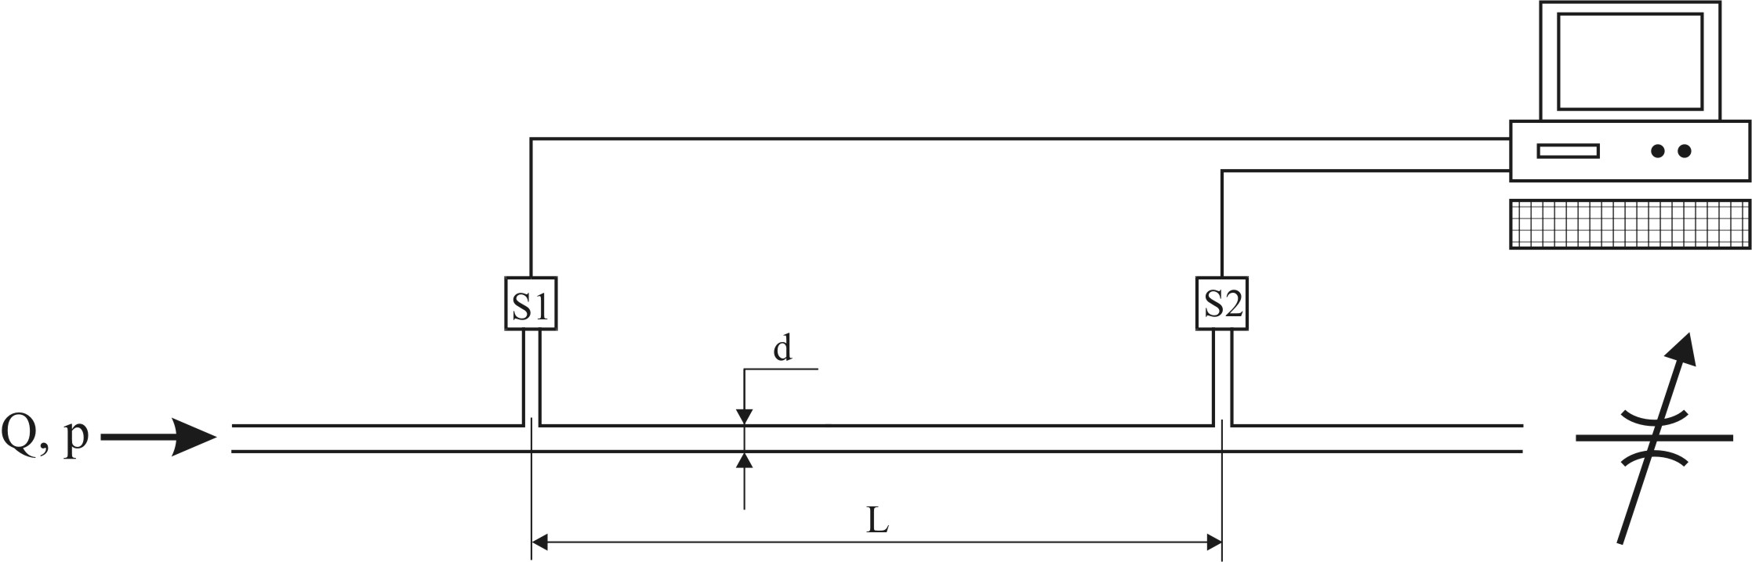

Fig. 1. Principle of measurement

The measured times [ms] are presented in table 1 for 9 distinctive length and 3 pipes of various diameters.

Table1
No. | Diameters  [mm] | Lengths  [mm] | Lag times  [ms]
No. | Diameters  [mm] | Lengths  [mm] | 1 | 2 | 3 | 4 | 5 | 6 | 7 | 8 | 9 | 10 | 11 | 12 | 13 | 14 | 15 | 16 | 17 | 18
1 | 2 mm | 400 | 5 | 5 | 3 | 3 | 4 | 4 | 4 | 4 | 4 | 3 | - | - | - | - | - | - | - | -
2 | 2 mm | 630 | 5 | 7 | 6 | 6 | 6 | 6 | 6 | 6 | 5 | 7 | - | - | - | - | - | - | - | -
3 | 2 mm | 1000 | 9 | 9 | 10 | 10 | 11 | 9 | 10 | 9 | 9 | 9 | - | - | - | - | - | - | - | -
4 | 2 mm | 1150 | 10 | 11 | 10 | 11 | 11 | 11 | 12 | 11 | 11 | 12 | - | - | - | - | - | - | - | -
5 | 2 mm | 1500 | 16 | 16 | 15 | 16 | 16 | 15 | 17 | 17 | 16 | 16 | - | - | - | - | - | - | - | -
6 | 2 mm | 2500 | 38 | 37 | 38 | 38 | 38 | 38 | 37 | 38 | 39 | 39 | - | - | - | - | - | - | - | -
7 | 2 mm | 6500 | 146 | 145 | 147 | 147 | 146 | 146 | 146 | 146 | 145 | 146 | - | - | - | - | - | - | - | -
8 | 2 mm | 8500 | 22 | 218 | 218 | 220 | 220 | 223 | 220 | 223 | 220 | 218 | - | - | - | - | - | - | - | -
9 | 2 mm | 10000 | 326 | 329 | 326 | 329 | 327 | 328 | 327 | 324 | 326 | 326 | - | - | - | - | - | - | - | -
10 | 2,5 mm | 630 | 8 | 6 | 6 | 5 | 7 | 7 | 7 | 8 | 7 | 5 | - | - | - | - | - | - | - | -
11 | 2,5 mm | 2500 | 7 | 7 | 6 | 6 | 7 | 7 | 7 | 7 | 8 | 8 | - | - | - | - | - | - | - | -
12 | 4 mm | 4500 | 176 | 177 | 144 | 164 | 182 | 196 | 222 | 305 | 268 | 271 | 403 | 597 | 330 | 343 | 680 | 612 | 498 | 560

The statistical processing of the data of table 1 followed the Lilliefors normality test. The resulted average values presented in table 2 allowed the plotting of the graph of figure 2, which highlights the correlation of the pressure wave propagation times versus the length of pipes of various diameters.

Table 2
No. | Sample  (see  Table 1) | Statistical sampling parameters |  |  | Level of significance  α (%) | Test statistics d_{max} | Critical value of test d_{n,α} | Statistical decision H₀ is accepted, H₁ is rejected
No. | Sample  (see  Table 1) | Arithmetic mean (m) | Dispersion (S²) | Square deviation (s)
1 | Line (L) 1 | 3,9 | 0,544 | 0,738 | 5 | 0,2077 | 0,258 | H₀
2 | L2 | 6 | 0,444 | 0,667 | 5 | 0,25 | 0,258 | H₀
3 | L3 | 9,7 | 0,678 | 0,823 | 5 | 0,2447 | 0,258 | H₀
4 | L4 | 11 | 0,444 | 0,667 | 5 | 0,25 | 0,258 | H₀
5 | L5 | 16 | 0,444 | 0,667 | 5 | 0,25 | 0,258 | H₀
6 | L6 | 38 | 0,444 | 0,667 | 5 | 0,25 | 0,258 | H₀
7 | L7 | 146 | 0,444 | 0,667 | 10 | 0,25 | 0,294 | H₀
8 | L8 | 220,1 | 3,433 | 1,853 | 5 | 0,156 | 0,258 | H₀
9 | L9 | 326,8 | 2,4 | 1,549 | 5 | 0,149 | 0,258 | H₀
10 | L10 | 6,5 | 0,944 | 0,972 | 5 | 0,254 | 0,258 | H₀
11 | L11 | 7 | 0,444 | 0,667 | 5 | 0,25 | 0,258 | H₀
12 | L12 | 340,444 | 3,098. 10⁴ | 176,022 | 10 | 0,124 | 0,184 | H₀

Table 3 is obtained by centralising the data concerning the arithmetic mean of table 2. The data in table 3 allow the plotting of pressure wave propagation time versus pipe length (figure 2 and figure 3).

Table 3
No. | Pipe length [mm] | Diameter  d = 2 mm | Diameter  d = 2,5 mm | Diameter  d = 4 mm
1 | 2 | 3 | 4 | 5
1. | 400 | 3,9 | 1,25 | 1,01
2. | 630 | 6 | 3,54 | 1,75
3. | 1000 | 9,7 | 5,3 | 2,58
4. | 1150 | 11 | 7,4 | 4,56
5. | 1500 | 16 | 9,2 | 7,26
6. | 2500 | 38 | 27 | 23
7. | 6500 | 146 | 101,2 | 85
8. | 8500 | 220,1 | 175 | 147,25
9. | 10000 | 326,8 | 270 | 210

Fig. 2 Propagation time vs. pipe length graph

3rd degree Polynomial Fit: y=a+bx+cx^2+dx^3...
Coefficient Data:
a = -6.7138921
b = 0.018364823
c = -9.3295337e-007
d = 2.3954967e-010
3rd degree Polynomial Fit: y=a+bx+cx^2+dx^3...
Standard Error: 5.9601919
Correlation Coefficient: 0.9992022

Power Fit: y=ax^b
Coefficient Data:
a = 8.4092987e-005
b = 1.6418524
Power Fit: y=ax^b
Standard Error: 9.9603830
Correlation Coefficient: 0.9968769
Fig. 3 Aproximation fit

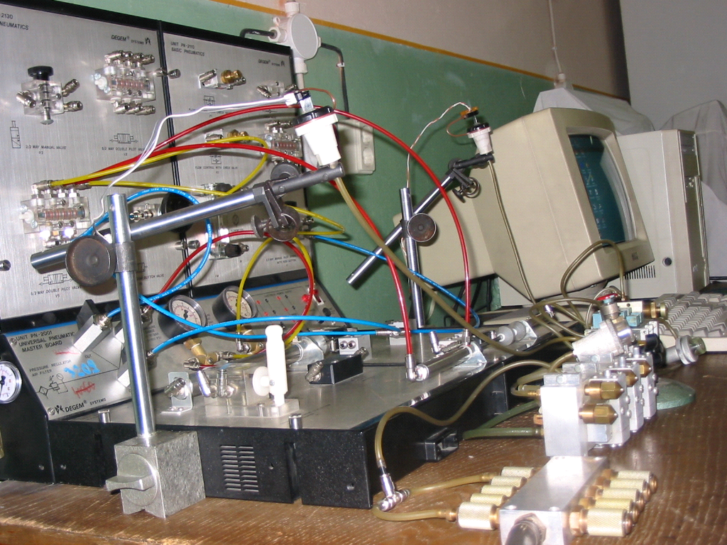

Fig. 4. Utilisation of optic sensors (side view test stand)

Conclusion
The propagation time of the pressure wave depends on the value of the working pressure and on the pipe diameter and length.

References

1. Ionescu, E., Ionescu, M.: Module logice de secvenţă pentru cicluri secvenţiale pneumatice. [Sequential Logic Modules for Sequential Pneumatic Cycles]. Brevet de invenţie nr. 76754 din 28.01.1981 [Invention Patent], Romania.
2. Ionescu, M.: Sisteme pneumatice utilizate în comanda maşinilor-unelte.[Pneumatic Systems Used in the Drives of Machine-Tools]. Teză de doctorat. [PhD Dissertation]. Universitatea “Transilvania” din Braşov, 2003.
3. Ionescu, M.: Sisteme pneumatice utilizate în comanda maşinilor-unelte.[Pneumatic Systems Used in the Drives of Machine-Tools]. “Transilvania” University of Brasov Publishing House, 2004, ISBN-973-635-313-3.
4. Ionescu, M.: Automatizări pneumatice destinate maşinilor-unelte. [Pneumatic Automation for Machine-Tools], “Transilvania” University of Brasov Publishing House, 2004, ISBN-973-635-335-4.
5. Radcenco, Vs., Alexandrescu N., Ionescu, E., Ionescu, M.: Calculul şi proiectarea elementelor şi schemelor pneumatice de automatizare.[Computation and Design of Pneumatic Automation Elements and Diagrams] , Editura Tehnică, Bucureşti, 1985.

Timpul de propagare în conducte

Rezumat: Autorul îşi propune să valideze o metodă prin care să determine timpul de propagare al semnalului pneumatic prin conducte, rezultatul fiind necesar în tehnica comenzilor şi acţionărilor pneumatice. Se utilizează senzori optici, calculatorul electronic şi un program capabil să înregistreze aceşti timpi. Datele experimentale au fost prelucrate statistic prin testul Lilliefors. Concluzie: timpul de propagare al semnalului de presiune pneumatic depinde de valoarea presiunii de lucru, de diametru şi lungimea conductei.

Cuvinte cheie: timp de propagare, senzori, prelucrare de date

