NUMERICAL SOLUTIONS OF SOME HAMMERSTEN-TYPE EQUATIONS WHICH APPEAR IN THE THEORY OF CAVITATIONS
BULLETIN OF THE TRANSILVANIA UNIVERSITY OF BRAŞOV

M. IUGA* A. CARABINEANU**

Abstract: In order to calculate the free streamlines and the drag coefficient for the flow with wake of an ideal fluid past an obstacle we have to solve a Hammerstein – type integral equation. To this aim we employ the successive approximations method.

Keywords: flow past an obstacle, wake, cavitations, Hammerstein equation, successive approximations.

- Introduction

We shall present briefly the mathematical theory (Helmholtz’s model) of the ideal flow with cavitations in the presence of an obstacle, according to the papers [2] and [4]. For studying the free-streamline flow past an obstacle in the complex z - plane (fig. 1 or fig.4), we have to find the conformal mapping of a canonical domain (the plane with a cut along the real axis in the f-plane (fig. 2), or the unit half – disk in the ζ – plane (fig. 3)) onto the flow domain (bounded by the free lines and the obstacle ) . The conformal mapping of the unit half-disk onto the flow domain is
(1)
Where
(2)
(3)
and T(t) is the solution of the nonlinear Hammerstein integral equation
$$T\left(t\right)=\frac{λ}{π}\int_{0}^{π}{e^{−T\left(σ\right)}\text{ln}\left|\frac{\text{sin}\frac{t+σ}{2}}{\text{sin}\frac{t−σ}{2}}\right|\left(1+\text{sin}σ\right)r\left(σ\right)\text{sin}σdσ}$$ | (4)
where h is the curvature of the obstacle, is the affix of the point from the ζ – plane corespunding to the angular point on the obstacle, c is the angle between the semi-tangents in the angular point. We consider symmetrical obstacles and therefor we have . We also mention the formulawhich expresses the length of the arc on the obstacle from the point to the point.

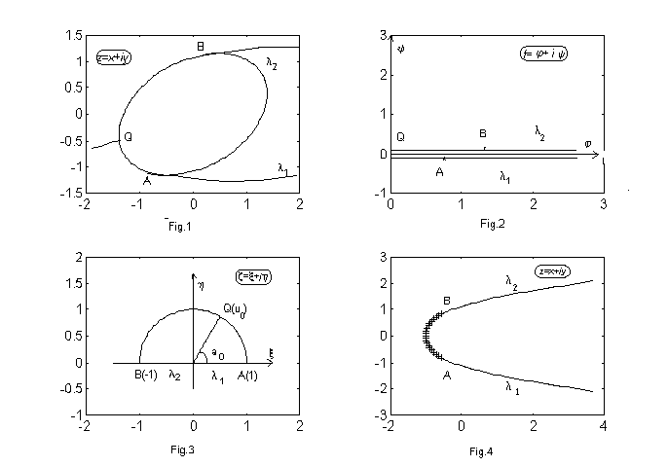
In [2] and [4] one shows that the nonlinear integral equation has a unique solution. The aim of the paper is to calculate numerically, by means of the successive approximations method the solution of the integral equation, and then to calculate the free – lines detaching from the obstacle and the drag coefficient.

- Numerical results

In order to solve the Hammerstein equation (4)
$$T\left(t\right)=\frac{λ}{π}\int_{0}^{π}{e^{−T\left(σ\right)}\text{ln}\left|\frac{\text{sin}\frac{t+σ}{2}}{\text{sin}\frac{t−σ}{2}}\right|\left(1+\text{sin}σ\right)r\left(σ\right)\text{sin}σdσ}$$
we shall employ Nyström’s method.
Before providing an approximation formula for the integral from the right hand
part we notice that the function we have to integrate has an integrable logarithmic singula-
rity. We shall write the integral equation as follows:
$$\begin{aligned}T\left(t\right)=\frac{λ}{π}\int_{0}^{π}{e^{−T\left(σ\right)}\text{ln}\left|\frac{\left(t−σ\right)\text{sin}\frac{t+σ}{2}}{\text{sin}\frac{t−σ}{2}}\right|\left(1+\text{sin}σ\right)r\left(σ\right)\text{sin}σdσ}− \\ −\frac{λ}{π}\int_{0}^{π}{\left[e^{−T\left(σ\right)}\left(1+\text{sin}σ\right)r\left(σ\right)\text{sin}σ−e^{−T\left(t\right)}\left(1+\text{sin}t\right)r\left(t\right)\text{sin}t\right]\text{ln}\left|t−σ\right|dσ}− \\ −\frac{λ}{π}e^{−T\left(t\right)}\left(1+\text{sin}t\right)r\left(t\right)\text{sin}t\int_{0}^{π}{\text{ln}\left|t−σ\right|dσ}\end{aligned}$$
The first two integrals are the definite integrals of two continuos functions
and the third integral, where the logarithmic singularity has been transferred may be
calculated analytically.
We consider on the segment $\left[0,π\right]$ a grid consisting of the nodes $\left\{t_{0},t_{1},…,t_{n}\right\}$
with $t_{i}=\frac{i}{n}π , i=0,…,n$.
Employing the trapeziums formula
$$\int_{0}^{π}{f\left(σ\right)dσ}=\frac{π}{2n}\left[f\left(t_{0}\right)+2\sum_{i=1}^{n−1}{f\left(t_{i}\right)+f\left(t_{n}\right)}\right]$$
and taking into account that $\text{sin}t_{0}=\text{sin}t_{n}=0$, we obtain:

that is equivalent to (for $j=1,…,n−1$) to:
$$n−1$$
Hence we have to solve the system of algebraic equations:
$$T_{j}=λ\sum_{i=1}^{n−1}{w_{\text{ji}}e^{−T_{i}}}$$ | (5)
with and
respectively
Further we shall give an estimation for the differences:
Taking into account the definition of we have:
$$\begin{aligned}=\frac{λ}{π}\int_{0}^{π}{\sum_{m≥1}{\frac{1}{m}\text{sin}{\text{mt}}_{j}\text{sin}mσ\left(2\text{sin}σ+1−\text{cos}2σ\right)}dσ}= \\ \frac{λ}{π}\text{sin}t_{j}\int_{0}^{π}{2\text{sin}σdσ}+\frac{λ}{π}\int_{0}^{π}{\sum_{m≥1}{\frac{1}{m}\text{sin}{\text{mt}}_{j}\text{sin}mσdσ}=}\end{aligned}$$
$$=λ\text{sin}t_{j}+\frac{λ}{π}\sum_{m≥1}{\frac{1}{m^{2}}\text{sin}{\text{mt}}_{j}\text{cos}mσ}|_{π}^{0}=$$
$$=λ\text{sin}t_{j}+\frac{λ}{π}\sum_{m≥1}{\frac{1}{m^{2}}}\text{sin}{\text{mt}}_{j}⋅\left(1−{\left(−1\right)}^{m}\right)≤$$
$$λ+\frac{λ}{π}\sum_{n≥0}{\frac{2}{{\left(2n+L\right)}^{2}}}≤λ+\frac{λ}{π}\left(2+\sum_{n≥1}{\frac{2}{\left(2n+1\right)\left(2n−1\right)}}\right)=$$
$$=λ+\frac{λ}{π}\left(2+\sum_{n≥1}{\left(\frac{1}{2n−1}−\frac{1}{2n+1}\right)}\right)=\frac{λ\left(3+π\right)}{π}$$
Hence we according to the theorem 11.2.3 from [5], page 159, we deduce that the system (5) has for $0<λ<\frac{π}{3+π}$ a unique solution which may be calculated by means of the successive approximations method. In the sequel we shall prove that in fact the system (5) has a unique solution for all $λ>0$. To this aim we consider the application:
$$L:R^{n−1}→R^{n−1} L=\left(L_{1},…,L_{n−1}\right)$$
$L_{j}:R^{n}→R, j=1,…,n−1$
with
$L_{j}\left(x_{1},…,x_{n−1}\right)=λ\sum_{i=1}^{n−1}{w_{\text{ji}}e^{−x_{i}}} w_{\text{ji}}0 ; i,j=1,…,n−1$.
We consider the compact convex set $D⊂R^{n−1}$
$D=\left\{\left(x_{1},…,x_{n−1}\right)∈R^{n−1}|x_{1}≥0,…,x_{n−1}≥0; {\left\|x\right\|}_{2}=\sqrt{x_{1}^{2}+…+x_{n−1}^{2}}≤\sqrt{n−1}\right\}$.
Let us prove that $L\left(D\right)⊂D$. Realy, for $x=\left(x_{1},…,x_{n−1}\right)∈D$ we have:
$$0≤L_{j}\left(x\right)=λ\sum_{i=1}^{n−1}{w_{\text{ji}}e^{−x_{i}}≤λ}$$
whence :
${\left\|L\left(x\right)\right\|}_{2}=\sqrt{L_{1}^{2}\left(x\right)+…+L_{n−1}^{2}\left(x\right)}≤\sqrt{n−1}λ$.
Employing Brouwer’s theorem [5] we deduce that there exists a fixed point of the application $L$, i.e. the system:
$$\begin{aligned}\left\{T_{1}=λ\sum_{i=1}^{n−1}{w_{1i}e^{−T_{i}}} | \right.\left\{⋮ | \right.\end{aligned}$$ | (6)
has at least one solution for every $λ>0$. Let us prove that we may find the solution of
the system (6) by means of the successive approximations method. Let:
${\tilde{T}}^{\left(1\right)}=L\left(0\right)$ i.e. ${\tilde{T}}_{1}^{\left(1\right)}=λ\sum_{i=1}^{n−1}{w_{1i}}>0$
$$⋮$$
$${\tilde{T}}_{n−1}^{\left(1\right)}=λ\sum_{i=1}^{n−1}{w_{\left(n−1\right)i}}>0$$
and ${\tilde{T}}^{\left(n\right)}=L^{\left(n\right)}\left(0\right)=L\left(L^{\left(n−1\right)}\left(0\right)\right) n=1,2,…$
We notice that :
${\tilde{T}}_{j}^{\left(2\right)}=λ\sum_{i=1}^{n−1}{w_{\text{ji}}e^{−{\tilde{T}}_{i}}}{\tilde{T}}_{j}^{\left(1\right)}$
and $0≤{\tilde{T}}_{j}^{\left(k\right)}≤{\tilde{T}}_{j}^{\left(k+1\right)} ∀j=1,…,n−1⇒{\tilde{T}}_{j}^{\left(k+1\right)}≥{\tilde{T}}_{j}^{\left(k+2\right)}$,
$0≤{\tilde{T}}_{j}^{\left(l+1\right)}≤{\tilde{T}}_{j}^{\left(l\right)} ∀j=1,…,n−1⇒{\tilde{T}}_{j}^{\left(l+2\right)}≥{\tilde{T}}_{j}^{\left(l+1\right)}$.
We also deduce that:
$0≤{\tilde{T}}_{j}^{\left(2\right)}≤{\tilde{T}}_{j}^{\left(n\right)}≤…≤{\tilde{T}}_{j}^{\left(2k\right)}≤…≤{\tilde{T}}_{j}^{\left(2l+1\right)}≤…≤{\tilde{T}}_{j}^{\left(2\right)}≤{\tilde{T}}_{j}^{\left(1\right)} ∀j=1,…,n−1$. (7)
The sequence ${\left\{{\tilde{T}}_{j}^{\left(2k\right)}\right\}}_{k≥1}$ is bounded and increasing hence it converges.
Let $T_{j}^{\left(2\right)}=\underset{k→∞}{\text{lim}}{\tilde{T}}_{j}^{\left(2k\right)} j=1,…,n−1$.
We denote
$T^{\left(2\right)}=\left(T_{1}^{\left(2\right)},…,T_{n−1}^{\left(2\right)}\right)$.
The sequence ${\left\{{\tilde{T}}_{j}^{\left(2k+1\right)}\right\}}_{k≥1}$is convergent, since it is bounded and decreasing. Let
$T_{j}^{\left(1\right)}=\underset{k→∞}{\text{lim}}{\tilde{T}}_{j}^{\left(2k+1\right)} j=1,…,n−1$.
From (7) it follows that $T_{j}^{\left(2\right)}≤T_{j}^{\left(1\right)} j=1,…,n−1$.
Moreover, $L\left(T^{\left(1\right)}\right)=T^{\left(2\right)}$ and $L\left(T^{\left(2\right)}\right)=T^{\left(1\right)}$.
In case that $T^{\left(1\right)}=T^{\left(2\right)}$( we can check this by means of a numeric experiment) we have:
In the forthcoming figures we present some numerical experiments for an arc of circle which is symmetrical with respect to the Ox – axis (parralel to the uniform velocity of the fluid at infinity upstream) and for two simmetrical arcs of circle making in the joining point an angle equal to. $\frac{3π}{4}$. 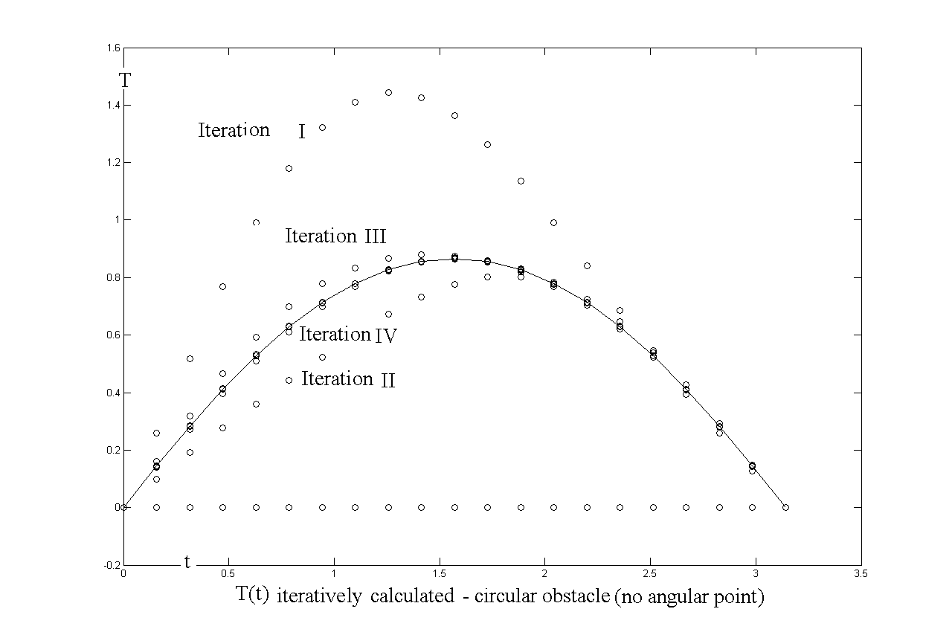
Fig. 5
We consider $λ=1$and we notice that in both cases ${\tilde{T}}^{\left(5\right)}={\tilde{T}}^{\left(6\right)}$ hence the iterative procedure converges very fast and from the sixth iteration the fixed point of the operator is practically calculated.

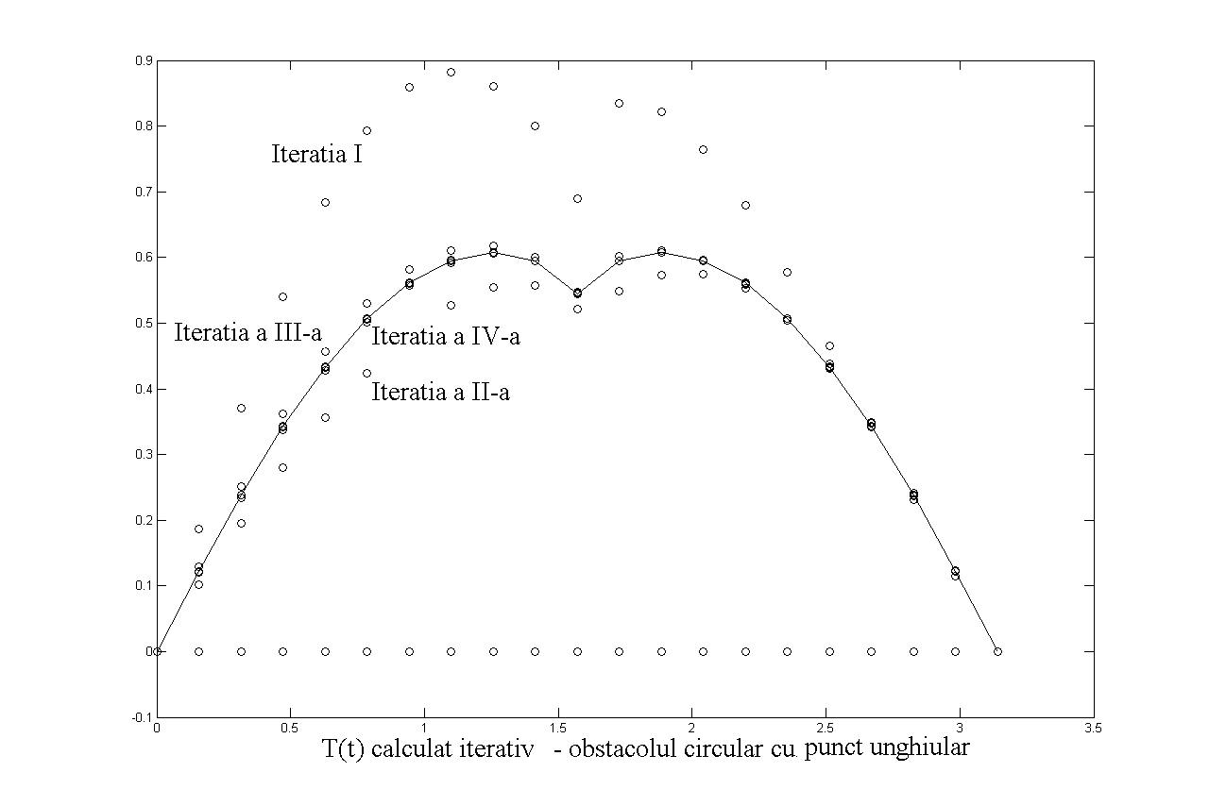
Fig. 6
We consider that the arcs of circle have the curvature $h=1$. The quantity:
$$λ\int_{0}^{π}{e^{−T\left(σ\right)}r\left(σ\right)\left(1+\text{sin}σ\right)\text{sin}σdσ=S_{B}−S_{A}}$$
is the length of the obstacle. Since we know $T_{i}=T\left(t_{i}\right)$ we may employ the trapeziums formula in order to calculate the length of the obstacle $S_{B}−S_{A}$.

- Calculus of the free lines

We have:
.
Since we know the values $T\left(t_{j}\right); t_{j}=\frac{j}{n}π; j=0,1,…,n$, integrating
numerically we may calculate the values of $ω_{c}$ in the points $ξ_{i}^{'}=\frac{i}{m}, i=1,…,m−1$ and $ξ_{i}^{''}=\frac{i}{m}, i=1,…,m−1$ from the real diameter of the unit disk.
We get, taking into account that ,
$$\frac{\text{dz}}{dζ}=\frac{λ}{4}{\left(1−iζ\right)}^{2}\left(ζ−\frac{1}{ζ}\right)⋅\frac{1}{ζ^{2}}⋅{\left(\frac{1+ζi}{1−ζi}\right)}^{c}e^{{iω}_{c}\left(ζ\right)}$$
where $c=0$for the obstacle consisting of an arc of circle and $c=\frac{1}{4}$ for the obstacle consisting of two arcs of circle making in the joining point the angle $\frac{3π}{4}$.
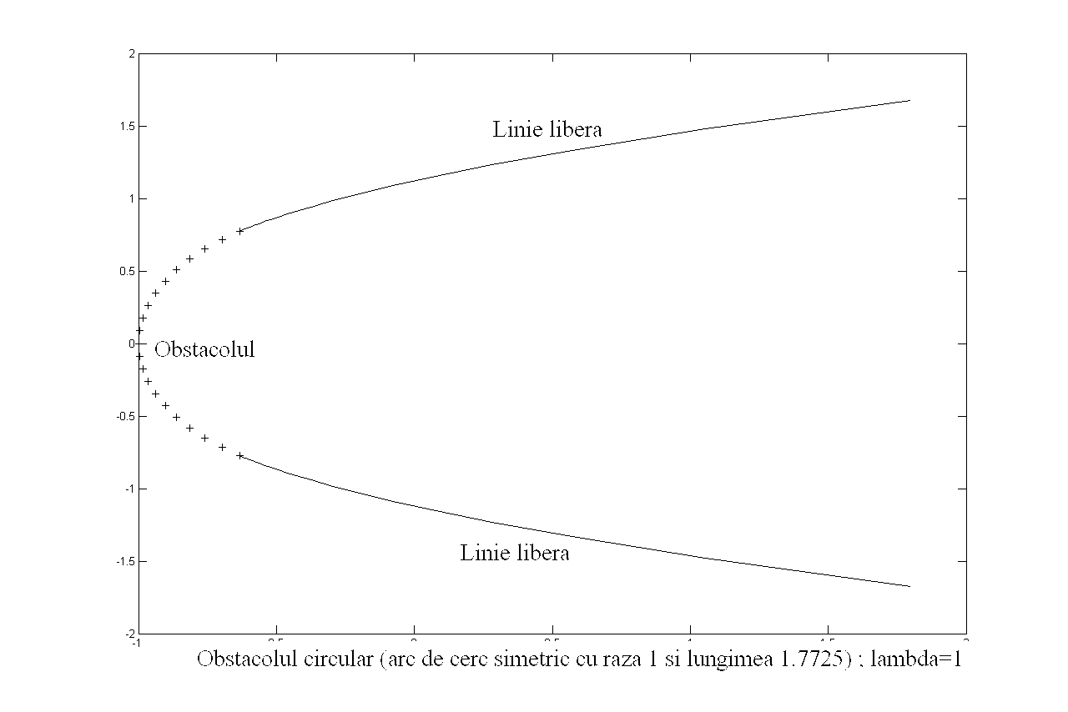
Fig. 7
The points from the free lines, corresponding through the transformation to $ξ_{i}^{'}$and $ξ_{i}^{''} i=1,…,m−1$are calculated numerically. We have
$$Z\left(ξ_{i}^{'}\right)=Z_{A}−\frac{λ}{π}\int_{ξ_{i}^{'}}^{1}{\frac{\text{dz}}{dξ}dξ}$$
for the free – line detaching from the extremity A, respectively
$$Z\left(ξ_{i}^{''}\right)=Z_{B}+\frac{λ}{π}\int_{−1}^{ξ_{i}^{''}}{\frac{\text{dz}}{dξ}dξ}$$
for the free – line detaching from the extremity B. 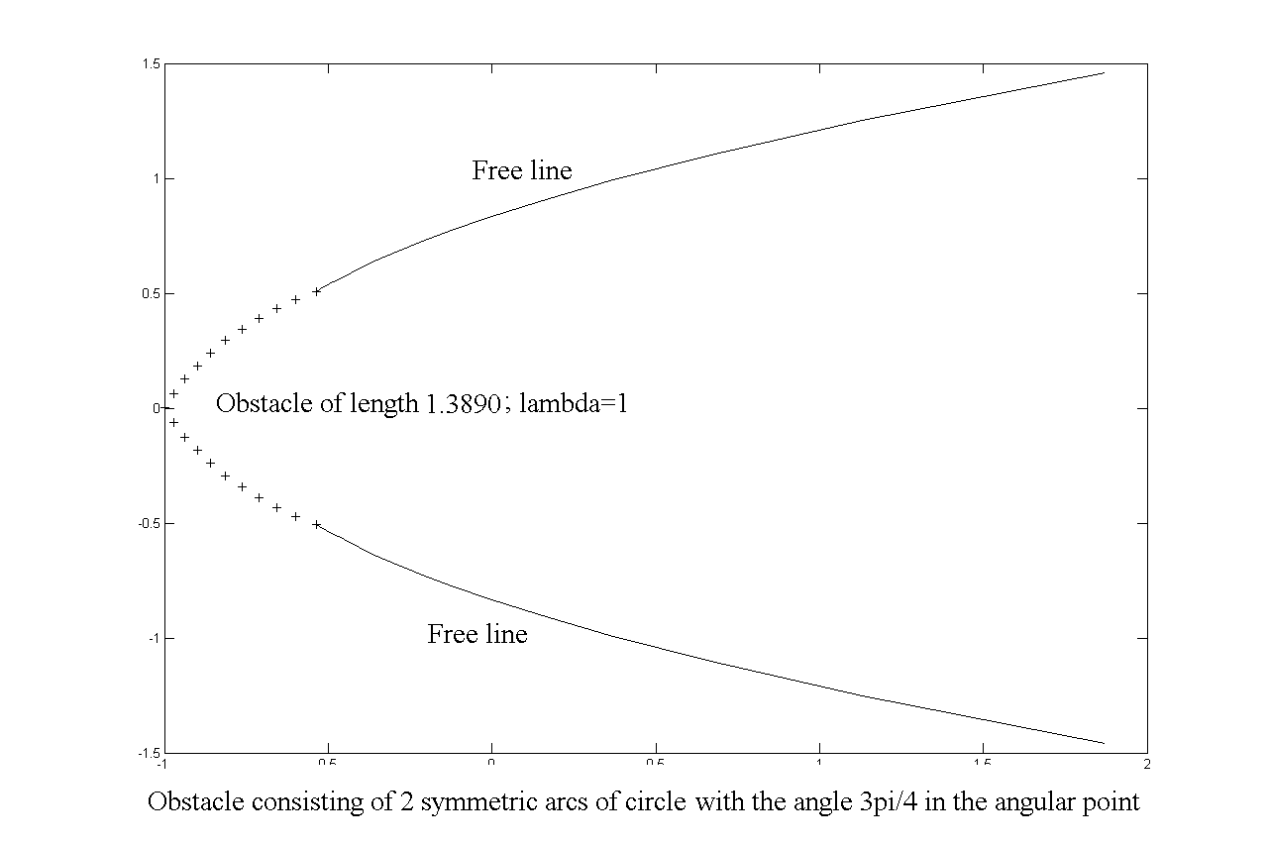
Fig. 8
In figures 7 and 8 we present the free lines detaching from the obstacles that we are studying.

- The drag coefficient for the obstacle consisting of an arc of circle. The bow detachment

The drag coefficien is $C_{D}=\frac{R_{x}}{{ρV}^{2}r}$ where $\left(R_{x},R_{y}\right)$ stands for the hydrodynamic
action and $r$is the radius of the arc of circle.
Taking into account that $λ=8L, r=1$we have:
$$C_{D}=\frac{\text{πλ}{\left(ω^{'}\left(0\right)\right)}^{2}}{8}$$
Derivating the (3), we get:
$$ω_{c}^{ }\left(ζ\right)=\frac{2}{π}\int_{0}^{π}{\frac{T\left(t\right)\text{sin}t}{1−2ζ\text{cos}t+ζ^{2}}\text{dt}−\frac{4ζ}{π}\int_{0}^{π}{\frac{T\left(t\right)\left(ζ−\text{cos}t\right)\text{sin}t}{{\left(1−2ζ\text{cos}t+ζ^{2}\right)}^{2}}\text{dt}}}$$ | (8)
whence:
$ω_{c}^{ }\left(0\right)=\frac{2}{π}\int_{0}^{π}{T\left(t\right)\text{sin}\text{tdt}}$.
Since we know the values $\left\{T\left(t_{i}\right), i=1,…,N+1\right\}$ we may use a quadrature formula in order to calculate $ω_{c}^{ }\left(0\right)$.
We have considered $N+1=\text{41}$equidistant nodes on the interval $\left[0,π\right]$, and we emplyed Simpson’s formula for the approximate calculus of the integrals.
Since the circular obstacle has no singular point, we get
$ω^{ }\left(0\right)=ω_{0}^{ }\left(0\right)+ω_{c}^{ }\left(0\right)=−2+ω_{c}^{ }\left(0\right)$
We have considered $λ=1,\text{1372}$.
It results that for this value the length of the arc of circle of radius 1, is 1.9222, and this corresponds to a detachment angle equal to $\text{55},{\text{04}}^{∘}$.
Some authors, like J. Hureau [3], G. Birkhoff and E. H. Zarantonello [1], Brodetski and Schmieden, have calculated the drag coefficient:
$C_{D}=\frac{\text{πλ}\left(ω^{ }\left(0\right)\right)}{8}$.
They obtained:
$$C_{D}$$ | Hureau | Birkhoff | Brodetski
$$C_{D}$$ | 0,4986 | 0,499 | 0,493

Utilizing the method presented herein, we obtained:
$C_{D}=0,\text{4986}$.
One paid a special attention to the particular case because for this value the curvature of the free – line in the detachment points coincides with the curvature of the obstacle (this is the so called bow detachment) and one considers that in fact for the free lines do not detach in the extremities of the obstacle but they detach upstream such that we should have and the already metioned equality between the curvatures.

References
¶
- Birkhoff, G., Zarantonello, E. H.: Jets, Wakes and Cavities, Academic Press, New York, 1957.
- Jacob, C.: Introduction mathèmatique à la mècanique des fluids, Gauthier-Villars, Paris – Ed. Academiei, Bucuresti, 1959.
- Hureau, J., Bruno, E., Legallais, Ph.: Ideal free streamline flow over a curved obstacle, J. Comp. Appl. Math., vol. 72, 1996, p.193-214.
- Marcov, N., Carabineanu A.: Ecuaţii integrale neliniare în studiul mişcarilor fluide cu linii de discontinuitate, Math. Reports (Stud. Cerc. Mat.), tom 1(51), nr.3, 1999, p.359-377.
- Rus, I. A., : A Principii şi aplicaţii ale teoriei punctului fix: Cluj-Napoca, Editura Dacia, 1978.

Soluţia numerică a unor ecuaţii de tip Hammerstein ce apar în teoria cavitaţiei

Rezumat: Pentru a calcula liniile libere şi coeficienţii de rezistenţă pentru mişcarea cu cavitaţie a unui fluid ideal în prezeţa unu obstacol avem de rezolvat o ecuaţie de tip Hammerstein căreia îi aplicăm metoda aproximaţiilor successive..

Cuvinte cheie: obstacol,, cavitaţie, ecuaţie Hammerstein, aproximaţii succesive .

* Dept. of Mathematics, Valahia University of Targoviste.
** ISMMA, Faculty of Mathematics and Computer Sciences, University of Bucharest.

