MODELING AND NUMERICAL SIMULATION OF CONVERGENT-DIVERGENT NOZZLE BEHAVIOR AT OFF-DESIGN OPERATING CONDITIONS
BULLETIN OF THE TRANSILVANIA UNIVERSITY OF BRAŞOV

- STANCIU* E. MUNTEANU** M. MARINESCU*

Abstract: The numerical simulation of turbulent flows became an indispensable tool for the efficiency analysis of gas dynamics processes. In the case of convergent-divergent nozzles (CDN) operating at off-design conditions, the appearance of shock and expansion waves creates supplemental exergetic losses, whose effect generates a deep damage of expansion process efficiency and reduces the produced trust. This work deal with the numerical simulation and virtual visualization of both, shock waves and volumetric irreversibilities, generated at near design operating conditions of a CDN. The results may be used to identify the turbulence model leading to the best numerical results and to understand the irreversibility structure generated in supersonic turbulent flows by the shock waves and vortexes.

Keywords: numerical.simulation, turbulent flows, entropy generation

- Introduction

The convergent-divergent nozzles (CDN) are frequently used in thermal devices for ground and aerospace applications. At off-design operating conditions, the gas expansion process is characterized by a set of shock and expansion waves, whose interaction with the viscous and turbulence phenomena generates a quite different flow behavior by comparison with the theoretical isentropic one.
The turbulence models for compressible flows are continuously developing. Huang and Bradshaw [1,2] extended the incompressible law of the wall to the compressible flows and Sarkar [3] or Zeman [4] modeled a part of turbulent correlation of density fluctuations in an ingenious and simple manner. These compressibility corrections allowed the extension of classical two equations turbulence models from incompressible to compressible flows. More than that, Spallart and Allmaras [5] have developed a turbulence model with only one partial differential equation which reasonable describes the attached turbulent compressible flows. All these improvements opened the possibility for obtaining reasonable numerical simulation accuracy for a wide range of turbulent supersonic flows, including here the gas expansion process through a CDN operating at off-design conditions.
In the last two decades, the second law analysis became an indispensable method for the exergy loss investigations. Based on the well known Gouy-Stodola theorem, this method was first formulated by Bejan [6], who used the volumetric rate of entropy generation as a measure of laminar boundary layer irreversibility. Sciubba et all [7] were ones of the firsts researchers that connected this method to the numerical simulation techniques. Identifying the peculiar contributions of turbulent fluctuation dissipations at the flow irreversibility, Stanciu et all [8,9] extended the continuum level of second law analysis to the turbulent non reacting and reacting flows.
Using most of the mentioned methods, this work investigates the actual potential of numerical simulation procedures in describing the field of flow properties and flow volumetric irreversibilities for the off design gas expansion process through a CDN.

- The mathematical model of compressible turbulent flow

The mathematical model of turbulent flow consists of Favre averaged continuity, momentum and energy equations:
$$\frac{∂\bar{ρ}}{∂τ}+\frac{∂}{∂x_{i}}\left(\bar{ρ}{\tilde{u}}_{i}\right)=0$$ | (1)
$$\frac{∂\left(\bar{ρ}{\tilde{u}}_{i}\right)}{∂τ}+\frac{∂}{∂x_{j}}\left[\bar{ρ}{\tilde{u}}_{i}{\tilde{u}}_{j}+\bar{p}δ_{\text{ij}}−\left(\overline{τ_{\text{ij}}}+\overline{τ_{\text{ij}}^{(R)}}\right)\right]=0$$ | (2)
$$\frac{∂\left(\overline{ρ}{\tilde{e}}^{}\right)}{∂τ}+\frac{∂}{∂x_{i}}[\overline{ρ}{\tilde{u}}_{i}\left({\tilde{e}}^{}+\overline{p}/\overline{ρ}\right)+\overline{q_{i}}+\overline{q_{i}^{(R)}}−\left({\tilde{τ}}_{\text{ij}}+\overline{τ_{\text{ij}}^{(R)}}\right){\tilde{u}}_{j}]=0$$ | (3)
The mean viscous stress tensor and the mean heat flux vector are expressed by:
${\tilde{τ}}_{\text{ij}}=μ\left[\left(\frac{∂{\tilde{u}}_{i}}{∂x_{j}}+\frac{∂{\tilde{u}}_{j}}{∂x_{i}}\right)−\frac{2}{3}δ_{\text{ij}}\frac{∂{\tilde{u}}_{k}}{∂x_{k}}\right]$ ; $\overline{q_{i}}=−λ\frac{∂\tilde{T}}{∂x_{i}}=\frac{{μc}_{p}}{\text{Pr}}\frac{∂\tilde{T}}{∂x_{i}}$ | (4a,b)
while the homologous Reynolds quantities are:
$\overline{τ_{\text{ij}}^{(R)}}=−\overline{ρu_{i}^{''}u_{j}^{''}}$ ; $q_{i}^{(R)}=−\overline{ρu_{i}^{''}h^{''}}$ | (5a,b)
In the eddy diffusivity concept (EDC), the turbulence closing models rely on the Boussinesq aproximations:
$\overline{τ_{\text{ij}}^{(R)}}=μ_{t}\left[\left(\frac{∂{\tilde{u}}_{i}}{∂x_{j}}+\frac{∂{\tilde{u}}_{j}}{∂x_{i}}\right)−\frac{2}{3}δ_{\text{ij}}\frac{∂{\tilde{u}}_{k}}{∂x_{k}}\right]−\frac{2}{3}δ_{\text{ij}}\overline{ρ}K$ ; $\overline{q_{i}^{(R)}}=−λ_{t}\frac{∂\tilde{T}}{∂x_{i}}=−\frac{μ_{t}c_{p}}{{\text{Pr}}_{t}}\frac{∂\tilde{T}}{∂x_{i}}$ | (6a,b)
where μ_{t}, λ_{t} and Pr_{t} represent the turbulent viscosity, turbulent thermal conductivity, and turbulent Prandtl number. Taking into account the turbulent Prandtl number, Pr_{t} = =ν_{t}/α_{t} = μ_{t}c_{p}/λ_{t}=constant, (where α_{t} is the turbulent thermal diffusivity), only the procedures of turbulent viscosity computation are needed. From the available turbulent closure models, we selected for our investigation the following ones:
- The Spalart-Allmaras model [5], according to ν_{t} , which is calculated with the relation:
$$ν_{t}=\tilde{ν}f_{w1}$$ | (7)
is the solution of partial differential equation:
$$\frac{∂\left(ρ\tilde{ν}\right)}{∂τ}+\frac{∂}{∂x_{j}}\left[ρ\tilde{ν}u_{j}−\frac{∂}{∂x_{j}}\left(μ/σ_{\tilde{ν}}+ρ\tilde{ν}/σ_{\tilde{ν}}\right)\frac{∂\tilde{ν}}{∂x_{j}}\right]=C_{b1}ρ\tilde{ν}\tilde{S}−C_{w1}{ρf}_{w}{\left(\frac{\tilde{ν}}{d}\right)}^{2}+C_{b2}ρ\left(\frac{∂\tilde{ν}}{∂x_{j}}\right)\left(\frac{∂\tilde{ν}}{∂x_{j}}\right)$$
(8)
where C_{b1}, C_{b2}, C_{w1} and σ are the models constants, f_{w} and f_{w1} are damping functions and $\tilde{S}$ represents the source term of kinematic viscosity. Because of its single partial differential equation, this model is low time consuming.
- The standard K-ε model adapted for compressible flows, defined by the following equations:
$$μ_{t}=\bar{ρ}C_{μ}\frac{K^{2}}{ε_{s}}$$ | (9)
$$\frac{∂\left(\bar{ρ}K\right)}{∂τ}+\frac{∂}{∂x_{i}}\left[\bar{ρ}{\tilde{u}}_{i}K−\left(μ+\frac{μ_{t}}{σ_{K}}\right)\frac{∂K}{∂x_{i}}\right]=\bar{ρ}P_{K}\left(1−0\text{.}4M_{t}^{2}\right)−\bar{ρ}ε_{s}−\bar{ρ}M_{t}^{2}+0\text{.}2\bar{ρ}ε_{s}M_{t}^{2}$$ | (10)
$$\frac{∂\left({\text{ρε}}_{s}\right)}{∂τ}+\frac{∂}{∂x_{i}}\left[\bar{ρ}{\bar{u}}_{i}ε_{s}−\left(μ+\frac{μ_{t}}{σ_{ε}}\right)\frac{∂ε_{s}}{∂x_{i}}\right]=C_{ε1}ρ\frac{ε_{s}}{K}P_{K}−C_{ε2}ρ\frac{ε_{s}^{2}}{K}$$ | (11)
where ε_{s} represents the solenoidal dissipation rate of turbulent kinetic energy and $M_{t}^{2}=2K/a$ is the turbulent Mach number. It can be seen that in this form the model includes the Sarkar compressibility correction [3].
- The K-ω SST model of Menter [10]. This model is conceived as a combination between Wilcox’s K-ω [11] and standard K-ε models, the last one reformulated in ω variable. The composing equations of this model are:
$μ_{t}=\frac{\bar{ρ}a_{1}K}{\text{max}\left(a_{1}ω,ΩF_{2}\right)}$ ; $ε_{s}=C_{μ}f_{\text{CK}}ω_{s}K$ | (12,13)
$$\frac{∂\left(\bar{ρ}K\right)}{∂τ}+\frac{∂}{∂x_{j}}\left[ρ{\tilde{u}}_{j}K−\left(μ+\frac{μ_{t}}{σ_{K}}\right)\frac{∂K}{∂x_{j}}\right]=\overline{τ_{\text{ij}}^{(R)}}\frac{∂{\tilde{u}}_{i}}{∂x_{j}}−β^{}f_{\text{CK}}\bar{ρ}ω_{s}K$$ | (14)
$\frac{∂\left(\bar{ρ}ω_{s}\right)}{∂τ}+\frac{∂}{∂x_{j}}\left[\bar{ρ}{\tilde{u}}_{j}ω_{s}−\left(μ+\frac{μ_{t}}{σ_{ω1}}\right)\frac{∂ω_{s}}{∂x_{j}}\right]=\frac{α}{ν_{T}}\overline{τ_{\text{ij}}^{(R)}}\frac{∂{\tilde{u}}_{i}}{∂x_{j}}−β\bar{ρ}ω_{s}^{2}+2\bar{ρ}\left(1−F_{1}\right)σ_{ω2}\frac{1}{ω_{s}}\frac{∂K}{∂x_{j}}\frac{∂ω_{s}}{∂x_{j}}$ (15)
where a₁ α, σ_{Κ}, σ_{ω1}, σ_{ω2}, β∗, β are constants, f_{CK} is a compressible corection function [9] depending of M_{t}², while F₁ and F₂ represent the functions which assure the coupling between K-ε and K-ω models. Beyond its numerical robustness, the computational time required by the model is greater, because the solved equations are more complicated than in previous cases.

3. Mathematical model of volumetric irreversibility

The exergy is the mechanizable part of energy. For the open thermodynamic systems, the total flow exergy of the ideal gas can be expressed as:
$${\text{ex}}_{h∗={\text{ex}}_{h}+{\text{ex}}_{w}=c_{p}\left(T−T_{0}\right)−c_{p}T_{0}\text{ln}\left(T/T_{0}\right)+{\text{RT}}_{0}\text{ln}\left(p/p_{0}\right)+\frac{1}{2}u_{j}u_{j}}$$ | (16)
In the above expression, ex_{h} and ex_{w} represent the thermal and the kinetic part of the total exergy and subscript “0” denotes the reference state. In the case of turbulent flows, this expression needs to be averaged. The presence of logarithmic function enhances the difficulties of Favre average operation, which finaly leads to an aproximate result. Let supose that in a moderate supersonic flow $T^{''}/\tilde{T}\text{<<}1$ and $p^{'}/\bar{p}\text{<<}1$. Using the serial decomposition of logarithmic function we obtain in an aproximate manner the following expression:
$$\begin{aligned}\bar{ρ}{\tilde{e}}_{h∗=\bar{ρ}c_{p}\left(\tilde{T}−T_{0}\right)−\bar{ρ}c_{p}T_{0}\text{ln}\left(\tilde{T}/T_{0}\right)+\bar{ρ}{\text{RT}}_{0}\text{ln}\left(\bar{p}/p_{0}\right)+\frac{1}{2}\bar{ρ}{\tilde{u}}_{j}{\tilde{u}}_{j}+\bar{ρ}K+} +\bar{ρ}c_{p}T_{0}\overline{θ^{2}}/{\tilde{T}}^{2}+{\text{RT}}_{0}\overline{ρp^{'}}/\bar{p}+\text{.}\text{.}\text{.}\text{.}\text{.}\end{aligned}$$ | (17)
The Favre averaged expression of total exergy contains not only the thermal and the kinetic exergy of mean flow properties, ${\tilde{e}}_{h}=e_{h}(\tilde{T},\bar{p})$ or ${\tilde{e}}_{w}=\frac{1}{2}{\tilde{u}}_{j}{\tilde{u}}_{j}$, but also the same kind of components existing in the fluctuating field, $\overline{ρe_{h}^{''}}=\bar{ρ}c_{p}T_{0}\left(\overline{θ^{2}}/{\tilde{T}}^{2}\right)+$ $+{\text{RT}}_{0}\left(\overline{ρp^{'}}/\bar{p}\right)+\text{.}\text{.}\text{.}\text{.}$and $\overline{ρe_{w}^{''}}=\bar{ρ}K$.
The turbulent gas expansion through CDN transfers a part of ${\tilde{e}}_{h}$into${\tilde{e}}_{w}$. In order to sustain the turbulent fluctuations, which are continously dissipated, another part of ${\tilde{e}}_{h}$ and a fraction of ${\tilde{e}}_{w}$are also sent to the thermal and kinetic fluctuating fields. Because of the irreversibility, during these transfer processes a piece of the total exergy is lost even if the total enthalpy of the flow remains unchanged. As pointed out Stanciu et all. [9], at the continuum level of the flow, the well known Gouy-Stodola theorem still holds, so the volumetric rate of total exergy destruction is proportional with the volumetric entropy generation rate.
The instantaneous rate expresion of volumetric entropy generation is:
$${\overset{˙}{S}}_{\text{gen}}^{(Ω)}={\left({\overset{˙}{S}}_{\text{gen}}^{(Ω)}\right)}_{V}+{\left({\overset{˙}{S}}_{\text{gen}}^{(Ω)}\right)}_{Q}=\frac{τ_{\text{ij}}}{T}\frac{∂u_{j}}{∂x_{i}}+\frac{λ}{T^{2}}\frac{∂T}{∂x_{j}}\frac{∂T}{∂x_{j}}$$ | (18)
where the subscripts V and Q denote the viscous and the thermal components. This expression must be averaged but, because of its denominators, the resulting relation cannot be closed in the term of EDC. Using the above hypothesis, the serial decomposition of $(1+T^{''}/{\tilde{T})}^{−1}$ and $(1+T^{''}/{\tilde{T})}^{−2}$leads to the following approximation:
$${\tilde{\overset{˙}{S}}}_{\text{gen}}^{(Ω)}={\left({\tilde{\overset{˙}{S}}}_{\text{gen}}^{(Ω)}\right)}_{\text{V,M}}+{\left({\tilde{\overset{˙}{S}}}_{\text{gen}}^{(Ω)}\right)}_{\text{V,T}}+{\left({\tilde{\overset{˙}{S}}}_{\text{gen}}^{(Ω)}\right)}_{\text{Q,M}}+{\left({\tilde{\overset{˙}{S}}}_{\text{gen}}^{(Ω)}\right)}_{\text{Q,T}}$$ | (19)
Eq. (19) reveals that the turbulent flow irreversibilities are of two types: either mean, induced by the viscous and thermal diffusion (subscript M), or turbulent generated by the fluctuating components of those field (subscript T). The expressions of viscous mean and viscous turbulent parts are:
${\left({\tilde{\overset{˙}{S}}}_{\text{gen}}^{(Ω)}\right)}_{\text{V,M}}=\frac{{\tilde{τ}}_{\text{ij}}}{\tilde{T}}\frac{∂{\tilde{u}}_{j}}{∂x_{i}}$; ${\left({\tilde{\overset{˙}{S}}}_{\text{gen}}^{(Ω)}\right)}_{\text{V,T}}=\frac{\bar{ρ}ε_{K}}{\tilde{T}}$ | (20a,b)
which model the mean motion irreversibility, due to the gradients of averaged velocity and the turbulent irreversibility, generated by the volumetric dissipation rate $\bar{ρ}ε_{K}=\overline{τ_{\text{ji}}\left(∂{u_{j}^{''}}/∂x_{i}\right)}$ of turbulent kinetic energy K. The mean and turbulent thermal components of volumetric entropy generation rates are expressed by:
${\left({\tilde{\overset{˙}{S}}}_{\text{gen}}^{(Ω)}\right)}_{\text{QM}}=\frac{λ}{{\tilde{T}}^{2}}\frac{∂\tilde{T}}{∂x_{j}}\frac{∂\tilde{T}}{∂x_{j}}$;${\left({\tilde{\overset{˙}{S}}}_{\text{gen}}^{(Ω)}\right)}_{\text{QT}}=\frac{\bar{ρ}c_{p}}{{\tilde{T}}^{2}}ε_{θ}$ | (21a,b)
where $\bar{ρ}ε_{θ}=α\overline{ρ(∂T/∂x_{j})(∂{T^{''}}/∂x_{j})}$ represents the volumetric dissipation rate of fluctuating temperature variance, $K_{θ}=\frac{1}{2}\overline{ρT^{}}/\bar{ρ}$.
In the terms of EDC, the four components of volumetric entropy generation rate can receive another interesting interpretation. It is well known that the exergy is extracted from the mean flow by the eddies of larger size and, through the vortex stretching mechanisms is continously trransferred to the smaller scale eddies. This process goes on until the exergy is dissipated (transformed into heat) by the viscosity or thermal conductivity of the gas. The vortex stretching transfer of exergy is allwais irrevresible so, once the exergy is extracted from the mean flow and sent to the turbulent field, it cannot be returned back. On the other hand, it is easy to prouve that the volumetric mean irreversibility components are generated at the larger eddy scales, while the turbulent ones are created at the smallest scales of turbulent eddies (Taylor microscales). From this point of view, the mean volumetric components of entropy generation rate model the large scale irreversibilities and the turbulent ones the irreversibilities of the smallest turbulent scales.
When the turbulent heat model rely on the classical algebraic relations Pr_{t}=constant, ε_{θ} is unavailable. Therefore, the turbulent thermal component of entropy source, (21b), cannot be computed. In this case, the equilibrium turbulence feature can be invoked. Consequently, the productions and the dissipation rates of K_{θ} are equals, so that:
$${\left({\tilde{\overset{˙}{S}}}_{\text{gen}}^{(Ω)}\right)}_{\text{QT}}≃\frac{\bar{ρ}c_{p}α_{t}}{{\tilde{T}}^{2}}\frac{∂\tilde{T}}{∂x_{j}}\frac{∂\tilde{T}}{∂x_{j}}=\frac{λ_{t}}{{\tilde{T}}^{2}}\frac{∂\tilde{T}}{∂x_{j}}\frac{∂\tilde{T}}{∂x_{j}}$$ | (22)
The above equation represents another important approximation of volumetric irreversibility field description, which is obvious induced by the choice of turbulence closure models. Of course, if one of the available two equations eddy diffusivity models for turbulent heat fluxes [12]-[13] is used, the approximation (22) can be removed.

4. Results and discussions
For the numerical simulation, we chosed an axisymetric CDN, experimentally tested at transonic cruise conditions by Carlson and Lee [14]. It is known in the literature as Carlson case 4. At design condition, the nozzle pressure ratio is β=6.23 and the external inflow Mach number is 0.9, but the experimantal data were colected at off-design operating value of β=6. The external geometry of the nozzle is a circular arc and straight-line type with a terminal boattail angle of 8.28º. The internal geometry has a circular-arc throat, a straight-line divergent section angle of 4.78º and an expansion ratio of 1.5.
The computation domain is presented in fig. 1. It extends 60d_{m} downstream the nozzle, 6.5d_{m} upstream it and 20d_{m} in the cross-stream direction, where d_{m} is the maximal external diameter of the nozzle. For the external frontier of the flow we used pressure far field boundary condition, numericaly defined by M∞=0.9, p∞= 0.6 bar, T∞ = 277 K, Tu=0.1%. On the inflow nozzle boundary, we imposed the total pressure p*=3.6, total temperature T*=300K and Tu=4%. The value of total pressure coresponds to a nozzle pressure ratio of 6, for which the experimental data are available. For the nozzle external and internal frontiers we used the compressible law of the wall boundary conditions.
The computation was performed with the commercial solver FLUENT v6012. The numerical solution was obtained using the implicit coupled scheme with second order upwind dicretisation of convective fluxes. Around the nozzle walls, the first grid line lay between y⁺=15 and y⁺=50. Moreover, to improve the numerical acuracy in the shock wave regions, the grid was twice adapted with the pressure gradient method.
Fig. 2 shows the Mach number distribution in the supersonic flow regions. On the external part of the nozzle, we meet a supersonic region which ends with a normal shock wave, whose intensity decreases along it. This shock wave, located on the circular-arc of external nozzle wall, reduces the Mach number from a maximal value of 1.138 to a minimum one of 0.883. Of course, the presence of shock wave in the external region of the flow is unwanted because it increases the drag force of the nozzle. However, the intensity of this shock wave is rather weak, so its interaction with the boundary layer does not generate either flow deattachments or recirculations flow areas on its back.
The internal flow and the nozzle exhaust jet region have some peculiar features. For the beginning we must emphasize the shape of sonic line which starts near the walls in front of the nozzle throat and finishes on the axis in its back. As expected, behind the sonic line, a set of oblique shock and expansion waves exists. Its presence alternates the supersonic acceleration and the deceleration flow regions. Generally, the oblique shock waves are weak but theirs intensity is greater near the axis than close to the nozzle walls or mixing jet layer.
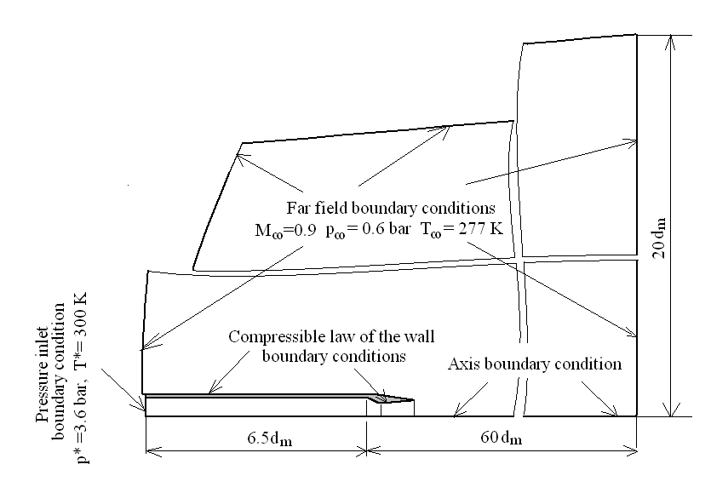
Fig. 1 Geometry and boundary conditions for numerical simulations

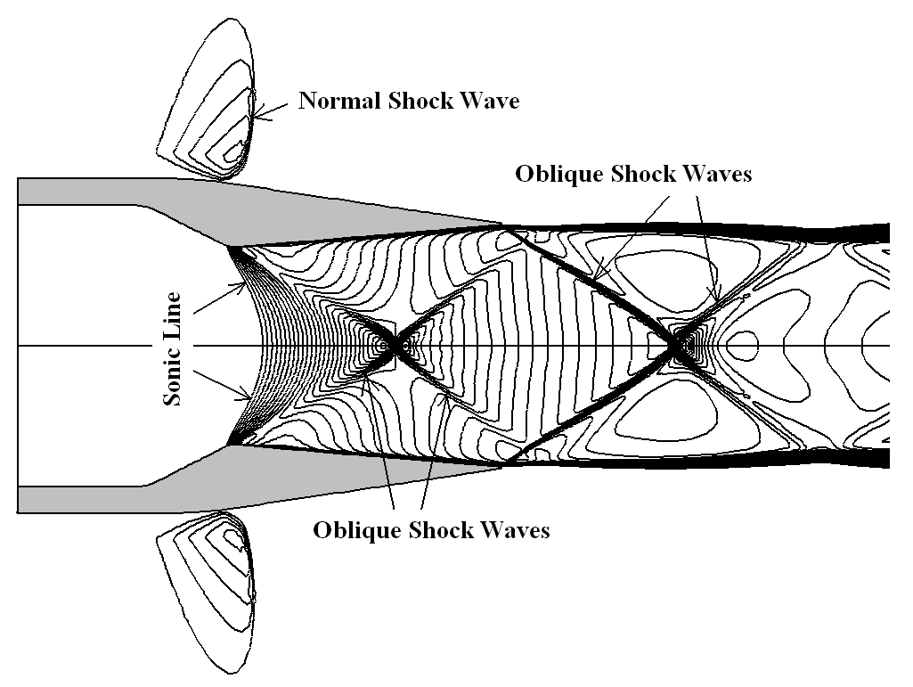
Fig. 2 Mach number distribution in the supersonic part of internal and external flow
The occurrence of shock waves in the internal flow and nozzle jet regions has different physical meanings. Crossing the sonic line, the gas continues to accelerate but the shape of divergent nozzle wall is not optimized to provide an isentropic expansion. In these conditions, near the axis the Mach number becomes too high and an axis reflected oblique shock wave appears. It strongly interacts with the expansion waves created around the nozzle throat, which practically destroy the shock near the divergent wall. Obvious, these shock waves will occur even if the nozzle operates at design conditions and clearly they decrease the nozzle performance. But at off-design conditions (β=6 instead of 6.23), the flow is overexpanded so the static pressure at the nozzle exit section is lower than the external flow pressure. Then, an oblique shock wave appears and lies in the nozzle jet region. It is reflected by the axis or by the mixing jet boundary until the jet and the external flow pressures become equals. As pointed out above, the nozzle operates near the design conditions, so, as in the external flow, theses shock waves are weak and fortunately do not generate recirculation fluid zones.
Figs. 3 present the performances of considered turbulence models in simulating the pressure distribution around the nozzle walls. Fig. 3a compares the computed pressure coefficient distribution along the external nozzle flow with the experimental data of Carlson [14]. Obvious, K-ω SST turbulence model produces the best results for the minim and the recovered after the shock values of pressure coefficient, C_{p}. Unfortunately, it predicts the shock wave location in front of its real position. Even it under estimate the minimum value of C_{p}, the K-ε turbulence model simulates better the shock wave position that the K-ω SST model and quite the same, the recovery pressure value after the shock. The worst results concerning the minimum and the after the shock values of C_{p} are obtained from the Spalart and Allmaras turbulence model, which surprisingly gives the best results for the shock wave position. Note that all the models clearly underpredict in the same way the C_{p} variation in the external gas expansion region. This last behavior is also confirmed in the internal flow area, where all the turbulence models gives the same numerical results, anticipating the air expansion in the convergent part of the nozzle, but modelling in a correct manner the pressure distribution in its divergent region. Unfor-tunately, other experimental datas for the external flow were unavailable. Taking also into account the computational time, it can be considered that the standard K-ε model, completed with the Sakar and law of the wall compressibility corrections, gives the best numerical results in describing the turbulent flow properties around a weak shock wave.
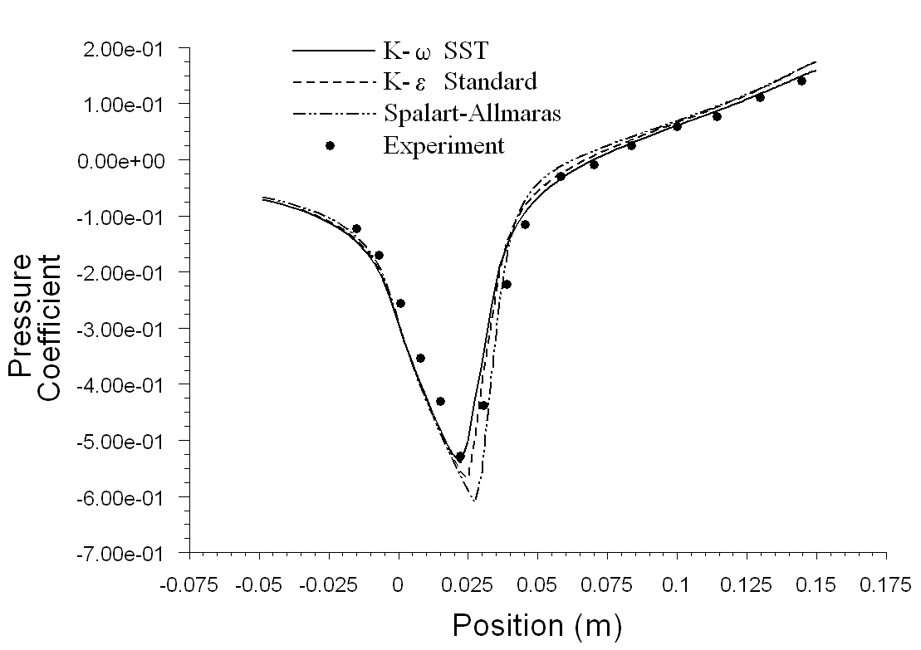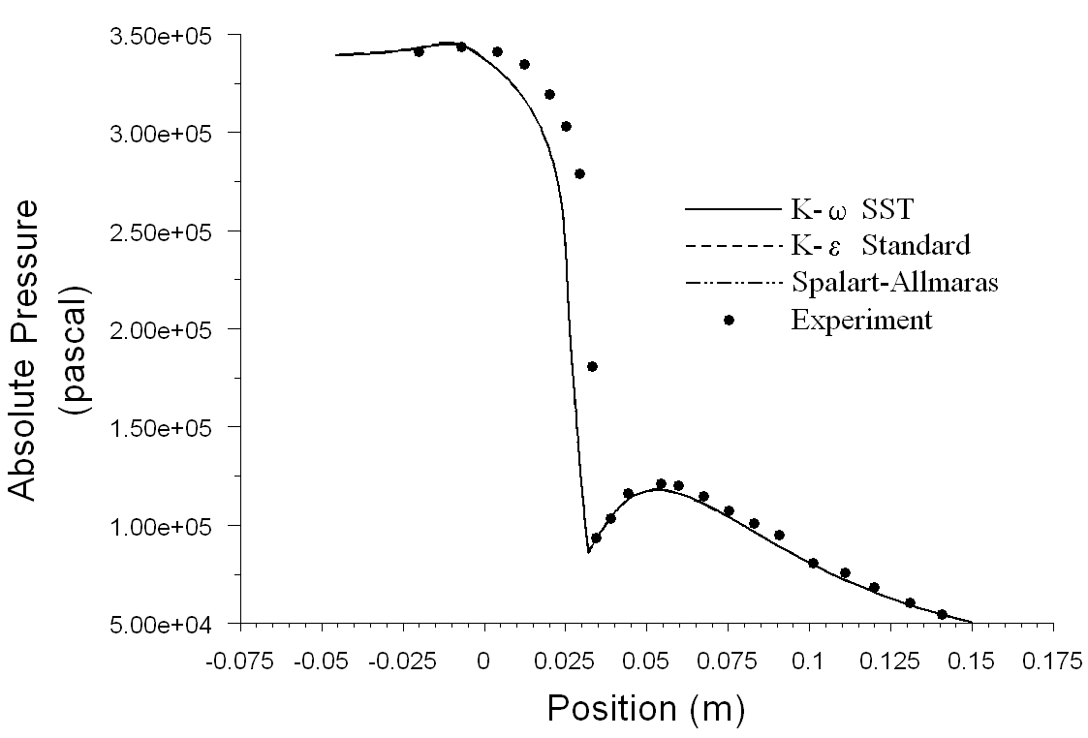
- b)
Fig.3 Computed pressure distributions along the nozzle walls compared with experimental data of Carlson
- Pressure coefficient along the external nozzle wall
- Pressure variation along the internal nozzle wall

Let analyze now the irreversibility field of the turbulent gas expansion process. Of course, the mean and turbulent viscous components always take place, but, because of the heat friction and fluid compressibility, the thermal components also occur, even the nozzle walls are adiabatic. The maps of all the volumetric entropy generation rate compo-nents are presented in figs. 4. For the sake of clarity, the smallest and the greatest values of each component were dropped and the logarithmic scale of 1-200 W/m³-K was chosen for the isoline representation. Using the numerical solution of the K-ε turbulence model, the computation of volumetric irreversibility maps was performed with the relations (20)-(22). Note that the turbulent thermal component was computed with the relation (22), because ε_{θ} was unavailable from the mathematical model of the flow.
The irreversibilities of the gas expansion process take place in all, the boundary layer, shock waves and mixing jets regions of the flow. Uses of the wall’s laws as boundary condition do not allow revealing the entire irreversibility of the boundary layer region, but its basic peculiarities are already known [8].
Even they are weak, the shock waves generate in the flow field important velocity and temperature gradients which produce significant values of mean irreversibility components. Of course, as the shock wave is stronger, as the mean volumetric irreversibilities are greater. Note that the values of mean thermal irreversibility are as important as the mean viscous ones.
Figs. 4 show that the turbulent volumetric irreversibilities are generated not only around the shock waves, but also in theirs downstream direction. Accordingly to the Stokes theorem, the shock waves create large sized eddies which, through the turbulent production mechanisms, extract a part of the kinetic and thermal energy (accompanied with his exergy) form the mean flow and transferred it to the fluctuating field. During the downstream advection, the vortex stretching mechanism transfer theirs energy to the smallest sized eddies, where the accompanied exergy is dissipated by ε_{K} and ε_{θ}.
Another place of irreversibility occurrence is the jets mixing layer. In this region, the mean cross-stream convection of momentum and heat is the same order of magnitude as the mean downstream advection. These high values of mean exchange rates create great values of mean viscous and mean thermal irreversibilities and also, very large rates of turbulent production. As a consequence, the cross-stream turbulent convection becomes also very important in the momentum and heat transfer balance. In these conditions, the rates at which the thermal and kinetic energy (accompanied with his exergy) is extracted from the mean flow and transferred from the larger to the smaller eddy scales of the flow are higher, and finally generate significant values of turbulent irreversibilities. Usually in this kind of flows, the turbulent dissipations exceed the mean ones.
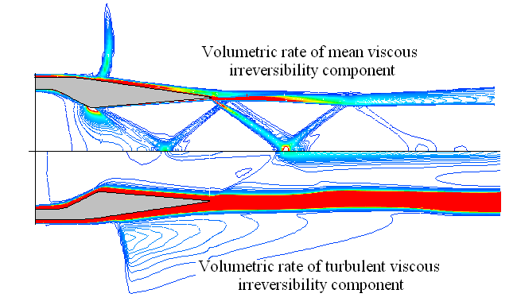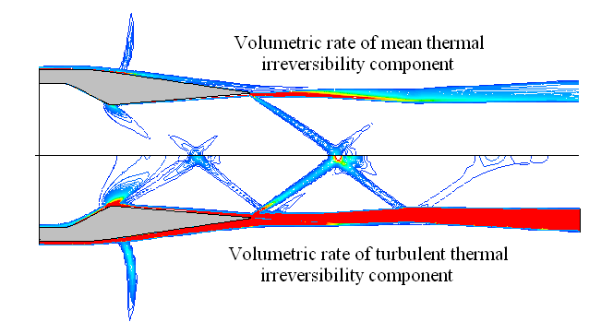

a) viscous irreversibility distributions b) thermal irreversibility disributions
Figs. 4 Irreversibility distributions in external and internal flow.
Let discuss now about the implications of the approximation (22), employed in the numerical simulation for computing the turbulent thermal component of volumetric irreversibility. Clearly in the shock wave and jet mixing regions of the flow the production rates are greater than those of dissipation. But K and θ are always convected in the downstream direction and partially are destroyed in other regions of the flow, where the dissipations rates exceed the production ones. Therefore, in some regions of the flow, the volumetric turbulent parts of thermal irreversibility are overestimated, while in other ones they are under predicted. This behavior can be easily removed if the turbulent thermal field is also described by a two equation model, but for this choice only the low Reynolds number turbulence models must be used.

5. Conclusions

The goal of this paper was to investigate the performance of some classical turbulence models in describing the axisymetric nozzle flow at transonic speed and to reveal the peculiarities of irreversibility maps for this kind of flows. The peculiarities of the flow consist of the presence of the weak intensity shock waves in both, the internal and external field. Our numerical results show that none of the tested models does correctly simulate the entire flow field around the shock waves. Each of them fails in recovering some properties of the mean flow and successful catch other ones. Taking into account the numerical errors of each turbulence model and its computational time, the standard K-ε model seems to have the best behavior.
Accordingly to the local formulation of the second law, the irreversibility field of the flow can be correctly modeled only by the volumetric rate of entropy generation. In the case of turbulent flows, its expression contains four components, which are of two types: either mean, induced by the viscous and thermal diffusion (subscript M), or turbulent generated by the fluctuating components of those field (subscript T). Theirs numerical simulation reveals that the wall boundary layer, the shock wave and the mixing layer represent the most dissipative regions of the flow. Moreover, even the nozzle walls are adiabatic, in theses regions the mean thermal irreversibilities are as important as the mean viscous ones and the turbulent irreversibilities could exceed the mean ones. This new procedure of irreversibility analysis can reveal not only the most dissipative flow areas, but also the true structure of its creation. Clearly the mathematical and numerical model can be improved with the aid of a two equations model for the turbulent heat fluxes.

References

- Huang, P., G., Coleman, G., N., “Van Driest transformation and compressible wall bounded flows”, AIAA Journal, vol. 32, nr. 10, 1994, pag. 2110.
- Huang, P. G., Bradshaw, P., “Law of the wall for turbulent flows in pressure gradients”, AIAA Journal, vol. 33, nr. 4, 1995, pag. 624.
- S. Sarkar and L. Balakrishnan: “Application of a Reynolds-Stress Turbulence Model to the Compressible Shear Layer”, ICASE Report 90-18, NASA CR 182002, 1990.
- Zeman, O.: Dilatational Dissipation: The concept and Aplication in Modeling Compressible Mixing Layer, Physics of Fluid, part A, 1990.
- P. Spalart and S. Allmaras: “A one-equation turbulence model for aerodynamic flows”, Technical Report AIAA-92-0439, American Institute of Aeronautics and Astronautics, 1992.
- Bejan A. (1988) Advanced Engineering Thermodynamics, John Wiley and Sons, New York 1988.
- Sciubba, E.: Optimisation of Gas Turbine Components via Constrained Minimisation of the Local Entropy Production Rates, NATO-ASI Workshop on Thermodyn, and Optimisation of Complex Energy Systems, Constanza, 1998.
- Stanciu, D., Marinescu, M., Isvoranu, D.(2000) Second law analysis of the turbulent flat plate boundary layer. IJAT, 3, 99-104.
- Stanciu, D., Marinescu, M.: Entropy Generation Rates in Swirling Diffusion Flame, ECOS 2006, Agia Pelagia, GRECE, Proceedings vol I, 239-246
- Menter, F., R.: “Two Ecuations Eddy Viscosity Turbulence Models for Engineering Applications”, AIAA Journal, vol 52 nr. 8, 1994, 1598-1605.
- Wilcox, C., D. : “Turbulence Modeling for CFD”, DCW Industries, 1993
- 12.Sommer T. P., So R. M.C., Lay Y. G.: A near-wall two equations model for turbulent heat fluxes, Int. J.Heat Mass Trans, 12, 1997, 3375-3384.
- 13.Abe, K., Kondoh, T., Nagano,Y.: A New Turbulence Model for Predicting Fluid Flow anf Heat Transfer in Separating and Reattaching flows-II. Thermal Field Calculation, Int. J. Heat Mass Transfer, vol 38, 1995, no. 8, 1467-1481.
- Carson, G.,T., Lee, E., E.: Experimental and Analytical Investigation of Axisymmetric Supersonic Cruise Nozzle Geometry at Mach Numbers from 0.6 to 1.3, NASA TP-1953,1981.
- Stanciu, D.: Thermodynamic irreversibilities of turbulent flows (in Romanian), Editura Printech, 2001.

* Dept. of Engineering Thermodynamics, Polytechnic University of Bucharest. ** Dept. of Aerospace Engineering, Military Technical Academy, Bucharest.

