A PREDICTION METHOD FOR AERODYNAMIC NOISE FROM HAWT
BULLETIN OF THE TRANSILVANIA UNIVERSITY OF BRAŞOV

- DUMITRACHE* H. DUMITRESCU*

Abstract: The aim of this paper is to give a new prediction model for the aerodynamical generated noise from horizontal axis wind turbines (HAWT). Aerodynamic noise is generated when the rotor encounters smooth flow. It contains airfoil self-noise and turbulence inflow noise. The present semiempirical model is coupled with CFD and aerodynamic calculation so as to improve the accuracy of the prediction model. The total noise spectrum for a given wind turbine is compared with experiment and encouraging result is obtained..

¶Keywords: airfoil self-noise, wind turbine noise, Lighthill’s acoustic theory

1. Introduction

The future of using wind energy is so exciting that it has many advantages such as: no air pollution, no need of any fossil or nuclear resources during operation. But with the fast increase of wind energy development, it also gives rise to the problems concerning public acceptance of wind energy. Therefore it's necessary to estimate the noise level in the field where the wind turbines are installed. Generally, the noise from wind turbine is composed with mechanical noise and aerodynamic noise. However, the way to reduce aerodynamic noise from wind turbines should be studied together with power efficiency.
A fully established method to predict the wind turbine noise is still limited. For engineering purpose of use, several semi-experimental noise prediction models are available. Some of the models are originally developed for application on helicopter and aircraft wings. One of the first model was carried out by Grosveld [1] in 1985. In 1981, Viterna [2] applied a method to the low-frequency noise estimation from a wind turbine.
Brooks, Pope and Marcolini [3] performed a set of experiments for NACA0012 airfoil sections. Therefore, the boundary layer parameters at trailing edge should be calculated instead of using experimental data from NACA0012 airfoil.
Unweighted, or linear-weighting, was used in the presentation of data, while the standard regulations, typically used in measuring the acoustic emissing from wind turbines, specify A-weighting, which de-emphasizes frequencies below 1000 Hz and correlates extremely well with human subjective response.

- Noise and sound fundamentals

When the fluctuating pressure in fluids is at the level about 10⁻⁴ times the standard atmospherical pressure, the correspond sound pressure level is up to 120 dB in the normal air condition. This sound pressure level is extremely high which is close to the threshold of pain.
The governing equations for the aerodynamic sound generation and propagation are the well-known control equations of fluid dynamics: i) The mass equation; ii) The momentum equation; iii) The energy equation. To express the equation with the dynamic sound pressure, the result is the linear wave equation:
$\frac{∂^{2}p'}{∂x^{2}}+\frac{∂^{2}p'}{∂y^{2}}+\frac{∂^{2}p'}{∂z^{2}}=\frac{1}{c^{2}}\frac{∂^{2}p'}{∂t^{2}}$, | (2.1)
where $p'$ is the acoustic pressure which is defined as the pressure difference between dynamic pressure and the static pressure (the pressure when the fluid is at rest), c is the sound speed at a certain fluid. In perfect gases, c is the function of the adiabatic bulk modulus and the equilibrium density of the medium: $c=\sqrt{K_{s}/ρ}$. For gases, $K_{s}={γp}_{0}$, where $γ$ is the specific heat at constant pressure to that at constant volume and $p_{0}$ is the static atmospheric pressure.
A sinusoidal source will generate a sound field which varies harmonically at all positions with a same frequency from the harmonica sound source. Therefore, at any given position the sound pressure is often expressed with a complex form:
$\hat{p}'={\text{Ae}}^{j\left(ωt+ϕ\right)}$, | (2.2)
where $ω$ is defined as $2π$ times the frequency f, and $ϕ$ is the phase angle. For a plane wave that propagates in the x-direction, the complex form is written as:
$\hat{p}'=p_{1}e^{j\left(ωt−kx\right)}$, | (2.3)
where $p_{1}$ is the amplitude of the wave, k is the wave number which is defined as $k=ω/c$.
The sound field varies with $e^{jωt}$, in eq. (2.1), if we replace $∂/∂t$with $jω$ and replace $∂^{2}/∂t^{2}$ by $−ω^{2}$, the Euler’s equation of motion can be rewritten into:
$j\text{ωρ \{}\hat{u}+∇\hat{p}'=0$, | (2.4)
where $\hat{u}$ is the particle velocity in the plane propagating wave. And the wave equation can be simplified into Helmholtz equation form:
$\frac{∂^{2}\hat{p}'}{∂x^{2}}+\frac{∂^{2}\hat{p}'}{∂y^{2}}+\frac{∂^{2}\hat{p}'}{∂z^{2}}+k^{2}\hat{p}'=0$. | (2.5)
A harmonic spherical sound wave is a solution of the Helmholtz equation:
$\frac{∂^{2}\left(r\hat{p}'\right)}{∂r^{2}}+k^{2}r\hat{p}'=0$. | (2.6)
A sound single can be broadband or narrowband. It is characterized by whether the sound spectrum covers a wide range of frequencies or not. To analysis a sound source, the frequency spectrum of the sound source has to be determined. If the sound source is unsteady, the sound pressure will be a function of time. It is much more convenient to study the frequency domain of the sound source than to look at the dynamic pressure. The frequency domains are different due to different noise mechanisms.
The most common filters in acoustics are narrow band, 1/3-octave band and one-octave band. Narrow band is used when the sound single has strong periodic or tonal signal. Such a spectrum gives the most detailed diagram of the sound single.
To obtain the sound pressure for a frequency band for any stationary sound single, the mean square value identical with the sum of mean square values of their frequency components. This can be obtained by a parallel bank of contiguous filters: $p_{\text{rms}}^{2}=\sum_{i}{p_{\text{rms},i}^{2}}$. Since the human ear does not response linearly to the amplitude of the sound pressure, such a rms pressure can not give sufficient information about the sound. So that the sound pressure level is always given in logarithmic scale and presented with decibels (dB). This is close to the real response of the human hearing.
$L_{p}=\text{10}{\text{log}}_{\text{10}}\left(p_{\text{rms}}^{2}/p_{\text{ref}}^{2}\right)=\text{20}{\text{log}}_{\text{10}}\left(p_{\text{rms}}/p_{\text{ref}}\right)$, | (2.7)
where $p_{\text{ref}}$ is the standard reference sound pressure. This reference pressure corresponds to the lowest audible sound at 1000Hz which is the weakest audible sound or threshold of human hearing. The unit for $L_{p}$ is dB. As weighting filters are often used to correct the human hearing, thus an A-weighted sound pressure is often labelled $L_{\text{pA}}$ with a unit dB(A).
A very important characteristic of sound pressure level is that the mean square sound pressure levels from difference sources are additive which is the basis of the present wind turbine noise prediction model.
$L_{p,\text{total}}=\text{10}{\text{log}}_{\text{10}}\left(\sum_{i}{{\text{10}}^{0\text{.}1L_{p,i}}}\right)$. | (2.8)
Sound power level $L_{W}$ is another acoustic quantity: $L_{W}= \text{10}{\text{log}}_{\text{10}}\left(p_{a}/p_{\text{ref}}\right)$, where $P_{\text{ref}}=1\text{pW}$, is the reference sound power. $P_{a}$ is the sound power from the source. It is calculated by integrating the mean square pressure on a spherical surface which encloses the sound source. $P_{a}=\int_{S}{\left(p_{\text{rms}}^{2}/\left(ρc\right)\right)}\text{dS}$.
Lighthill's equation [4] gives exactly the theoretical solution for the noise emitted by turbulent flows. However, the main limitation of this theory is that it is strictly valid only for an unbounded fluid such as jet flow. Therefore, some extension of Lighthill's theory are carried out. Among these theories, Ffowcs Williams-Hawking [5] equation and Helmholtz [6] integral equation are commonly used.

3 Noise mechanisms of wind turbines

Nowadays, the size of wind turbine and the capacity of wind farms are becoming larger. The noise generated from wind turbines is considerably higher than before. A large amount of effort has to be gone into reducing noise emission from wind turbines to make wind energy the really green energy.
The noise is generated from the wind turbine blades, gearbox and generator. There are two potential types of noise from wind turbines mechanical and aerodynamic noise.
Mechanical noise comes from the metal components moving or knocking against each other. Aerodynamic noise is caused by the blade passing through air.
The noises caused by wind turbine mechanical components are of tonal property, e.g. noise from the meshing gears.

Boundary Conditions

The causes of aerodynamic noise are mainly divided into three types:
- Low-frequency noise
- Turbulent inflow noise
- Airfoil self-noise; Figure3.1: (Turbulent BL - TE noise, Laminar boundary layer vortex shedding noise, Tip vortex formation noise, TE bluntness vortex shedding noise).
Low-frequency noise from wind turbine is originated by the changes of the wind speed experienced by the blades due to the presence of the tower and the wind shear. The wind turbine tower normally has a cylindrical cross section. Most wind turbines are of upwind type which have less effect from the tower and atmospheric wind shear compare with a downwind turbine.
As mentioned before, the human ear is not linearly response for the sound level with the frequencies. If we apply the A-weighting curve, the low frequency noise is really not an important part in the spectrum. However, low-frequency noise may excite vibrations for buildings around the wind turbines.
Turbulent inflow noise. The broadband noise from wind turbines also depends on the turbulent inflow characteristics, especially in the case of large wind turbines. The atmospheric boundary layer is defined in a similar way as every viscous flow over a surface. The velocity on the ground is zero and then increases with the altitude. For wind turbine, the free stream velocity is often defined as the mean wind velocity at the hub height. And in the atmospheric boundary layer, the actual wind velocity is the sum of the mean velocity and the turbulence fluctuating velocities which are in x, y, z directions. The instantaneous wind velocities can be expressed as: $V_{0}+\left(u\text{',}v\text{',}w'\right)$. The correlation of fluctuation components, $u'$, $w'$ in the x and z directions determines the shear stress. Since the products of the two velocities are in general not zero for turbulence case, the rotating and swirling air eddies must exist. The eddy size is therefore the most important parameter for determining the inflow turbulent noise. Due to the stability of the atmosphere and the turbulence structure, the eddy size has a wide range. It creates broadband noise as the blades interact with the eddies. In general, the inflow turbulence creates broadband noise which are perceived by the observers as swishing noise.
Turbulent boundary layer trailing edge (TBL-TE) noise. Trailing edge noise has been long recognized as another major source of airfoil self-noise. It is generated as the blade-attached turbulent boundary layer converts into the wake at the airfoil trailing edge. At certain angle of attack and Reynolds number, the transition from laminar flow to turbulent flow happens at a certain position on the airfoil surface. This turbulence generates a fluctuating pressure on both suction and pressure sided of the trailing edge. The noises on suction side and on pressure side are major noise source at low angle of attacks. However, at high angle of attacks the boundary layer separation occurs which
generates separated-flow-noise. The separation on the suction side have a region that contains rotating eddies which is larger than eddies at low angle of attacks. Noise from this region is caused by the turbulent vortices convert into the wake.
The trailing edge noise is also broadband. And most importantly the peak sound pressure level appears at intermediate frequency domain which is sensitive to human hearing. The boundary layer thickness turns out to be one of the key parameters to determine the noise level. This means different airfoil shape will lead to different noise spectrum.
Laminar boundary layer vortex shedding (LBL-VS) noise. A wind turbine can be operated under a Reynolds range from 10⁵ to 10⁶ because of the changes of relative wind speed and the chord length at different blade radius. Therefore, the flow conditions on each blade sections are differ from each other. If the laminar boundary layer exist on one
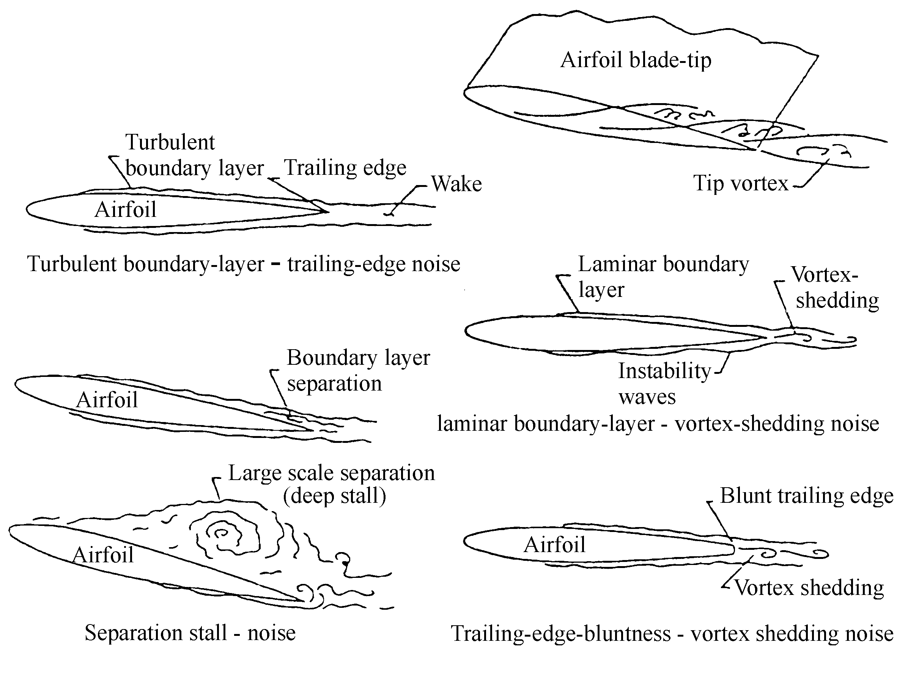
Fig. 3.1 Flow conditions producing airfoil blade self-noise
or both sides of the airfoil and cover the most of the airfoil surface, a resonant interaction between the unsteady laminar-turbulent transition with the trailing-edge noise will occur. This is termed as laminar boundary layer vortex shedding noise.
The boundary layer thickness parameter is used the same as defined in the TBL-TE noise prediction. This tonal noise can be significant at certain operating conditions for modern wind turbines which have low angular speed and large blade radius.
Tip vortex formation noise. Evidence exists that the flow around the tip is three dimensional thus the pressure difference between the suction and the pressure sides result in a rotational flow region over the airfoil. This flow is described as a vortex with a thick viscous turbulent core. The interaction between the tip vortex and the trailing edge has the same manner as the interaction between turbulent boundary layer and the trailing edge.
Tip noise level strongly depends on the geometry details of the blade tip. It was a problem for most of the old wind turbines with a squared and thick blade tip. This noise can be successfully controlled by the well-designed tip shape.
Trailing edge bluntness vortex shedding (TEB-VS) noise. The TEB-VS noise results by the vortex shedding from the blunted trailing edges. The noise level varies with the bluntness thicknesses at each blade sections especially near the tip of the blade. The bluntness thickness is often comparable with the boundary layer thickness at the trailing edge, but it is much larger than the boundary layer displacement thickness. So that it is desirable to make the trailing edge bluntness thickness just likely smaller that the boundary layer thickness.

4 Noise prediction model for wind turbines
Numerical simulation of far-field sound on a large computational domain is expensive and very difficult even for simple flow conditions. Some features of wind turbine noise are of considerable importance in subjective response for wind turbine noise. Therefore available theories require reinterpretation for application to predict wind turbine noise. The well-know Lighthill's acoustic theory is the theoretical basis for most of the prediction models. The self-noise prediction model introduced in this section is based on the experimental work of Brooks, Pope, and Marcolini [3]. The turbulent-inflow noise model is based on Amiet [7].
Turbulence characteristic. Prediction of the turbulence characteristic is crucial to predict the noise. The turbulence intensity and the length scale are depended on the evaluate height above the ground and also the meteorological conditions at the given site. The height of the wind turbine above the ground is fixed, thus the turbulence might be considered isotropic which indicates that the fluctuations are approximately the same in all directions. The mathematical description is given as:
$w=\bar{w}e^{{iω}_{z}\left(t−z/V_{0}\right)}$, | (4.1)
where $w$ is the turbulence velocity, $z$ is the down-stream direction, $ω_{z}$ is the longitudinal frequency and Vo is the mean free stream wind velocity. This simplification is valid for horizontal axis wind turbines. The longitudinal turbulence is the most important component and it is assumed to be a horizontal sinusoidal gust of the form as equation 4.1. The mean square turbulence fluctuation at the height h is given by [8].
A method of computing the intensity is introduced here which is used in the present noise prediction model. The mean wind speed varies with height and it's often described with the power law relationship:
$V_{z}=V_{\text{ref}}{\left(Z/Z_{\text{ref}}\right)}^{γ}$, | (4.2)
where $γ$ is the power law factor which gives the amount of the shear:
$γ=0\text{.}\text{24}+0\text{.}\text{096}{\text{log}}_{\text{10}}z_{0}+0\text{.}\text{016}{\left({\text{log}}_{\text{10}}z_{0}\right)}^{2}$, | (4.3)
Turbulence intensity can be found using the relationship:
$\bar{w}/\bar{V}=γ\left[\text{ln}\left(\text{30}/z_{0}\right)\right]/\left[\text{ln}\left(z/z_{0}\right)\right]$, | (4.4)
To characterize the turbulence of wind, the turbulence length scales also play an important role. The turbulence length scale is the measurement of averaged size of a gust in a certain directions which is used to determine how rapidly the gust properties vary in space. The turbulence length scale, given by ESDU [25], is formulated as following:
$L_{\text{ESDU}}=\text{25}z^{0\text{.}\text{35}}z_{0}^{−0\text{.}\text{063}}$. | (4.5)
Inflow noise prediction. The adopted prediction model for turbulence inflow-noise in this paper is based on the model on Amiet [7]. A semi-empirical model was given which was valid against wind tunnel measurements with a single airfoil section under turbulent inflow. For case of rotating wind turbines, a corrected model was given by Lowson [10]. The model from Amiet can be used for each blade segments along the blade span. For both high and low frequency regions, Lowson shown a model with smooth transition between the two regions:
$L_{p,\text{INF}}=L_{p,\text{INF}}^{H}+\text{10}{\text{log}}_{\text{10}}\left(K_{c}/\left(1+K_{c}\right)\right)$. | (4.6)
where $L_{p,\text{INF}}^{H}$ is the sound pressure level for high frequency region:
$L_{p,\text{INF}}^{H}=\text{10}{\text{log}}_{\text{10}}\left[ρ_{0}^{2}c_{0}^{2}l\left(ΔL/r^{2}\right)M^{3}I^{2}{\hat{k}}^{3}{\left(1+{\hat{k}}^{2}\right)}^{−7/3}\right]+\text{58}\text{.}4$, | (4.7)
with l denotes the turbulence length scale and I denotes the turbulence intensity. $ΔL$ is the blade segment semi-span. The low frequency correction $K_{c}$ in equation 4.11 is given as $K_{c}=\text{10}S^{2}M{\hat{k}}^{2}/β^{2}$, where S is a function which denote the compressibility of the flow. The formula is suggested by Amiet:
$S^{2}={\left(2π\hat{k}/β^{2}+{\left(1+2\text{.}4{\hat{k}}/{β^{2}}\right)}^{−1}\right)}^{−1}$, where $β^{2}=1−M^{2}$. | (4.8)
The wave number is given by Lowson which is corrected from Amiet: $\hat{k}=π\text{fc}/V_{\text{rel}}$.
Prediction model for TBL-TE noise and separation-stall noise. The scaling laws for self-noise mechanisms are based on the results of Ffowcs Williams and Hall [5] which has been mentioned in section 2. The scaling law applied for the TBL-TE noise is basically described by:
$p^{2}∝ρ_{0}^{2}{\bar{w}}^{2}\left(U_{c}^{3}/c_{0}\right)\left(\bar{D}ΔLℓ/r^{2}\right)$, | (4.9)
where $p^{2}$ is the mean square sound pressure at distance r from the trailing edge, $\bar{D}$ is the directivity parameter with the value equals 1 if the observer is normal to the trailing edge surface. $ℓ$ is the correlation factor for the turbulence. It is approximated by [3] that $ℓ∝δ^{}$ or $δ$.
From this scaling law the total TBL-TE noise together with separation/stall noise spectrum in 1/3-octave band is predicted by [3].
Prediction model for LBL-VS noise. The scaling method for LBL-VS noise is similar with that used for TBL-TE noise. The scaling parameters are boundary layer parameters, Mach number, angle of attack and Reynolds number. The boundary layer thickness at trailing edge is used for LBL-VS noise prediction instead of using boundary layer displacement thickness.
Prediction model for tip vortex formation noise. The flow around the tip is highly turbulent and the tip noise is generated due to the passage of this turbulence over the TE edge into the wake. The TIP noise model is developed by Brooks, Pope and Marcolini [3].
${\text{SPL}}_{\text{TIP}}=\text{10}\text{log}\left(M^{2}M_{\text{max}}^{3}l'^{2}{\bar{D}}_{h}/r^{2}\right)−\text{30}\text{.}5$, | (4.10)
where $l'$ is the spanwise extent of tip vortex at trailing edge.
Prediction model for TEB-VS noise. The TEB-VS noise is scaled using the method as TBL-TE noise and LBLVS noise. The sound pressure level frequency and the spectral shapes are modelled as function of angle of attack and the airfoil trailing edge parameters. The model is based on the measurement of airfoil NACA0012.
The noise spectrum are predicted as:
${\text{SPL}}_{\text{BLUNT}}=\text{10}\text{log}\left(M^{5\text{.}5}ΔL{\bar{D}}_{h}/r^{2}\right)+G_{4}\left(h/δ_{\text{arg}}^{},Ψ\right)+G_{5}\left(h/δ_{\text{arg}}^{},Ψ,{\text{St}}^{\text{'''}}/{\text{St}}_{\text{peak}}^{\text{'''}}\right)$, | (4.11)
where h is the bluntness thickness, used for calculating the Strouhal number instead of using boundary layer thickness parameter, ${\text{St}}^{\text{'''}}=\text{fh}/U$. $G_{4}$ is the peak level spectrum and $G_{5}$ is modified as the shape of the spectrum.
Boundary layer thickness calculations. For each airfoil, the boundary layer displacement thicknesses are calculated at both pressure side and suction side for Reynolds number range 0.1e6 ~ 20e6 and for the attack angle range -5⁰ ~ 25⁰, by using the 2D airfoil code XFOIL [11]. To model the transition conditions, the $e^{N}$ method is used in XFOIL. $n_{\text{crit}}$ = 9 corresponds to the standard situation which is assumed to be the untripped case. Calculation of $n_{\text{crit}}$ = 4 is also performed which represent the tripped case. Therefore there is a trigger in the noise prediction code to specify whether the flow is tripped or untripped.
Sound directivity. The sound directivity at both high and low frequencies are based on the research of Amiet [7]. It can be normalized by the trailing edge noise emitted at the position of $Θ={\text{90}}^{0}$ and $Φ={\text{90}}^{0}$. Therefore, at this position the sound directivity reaches the maximum value of 1 (valid at low frequencies). The low frequency directivity is applied in case of separation stall noise. The reason is that the turbulence eddies are comparable in size with the airfoil chord length and the eddy convection speeds are low.

5 Analysis of the CFD Model
In our present work, the aerodynamic code BEM [12] is coupled with the aerodynamic noise prediction model. The induced velocities are computed by BEM code using a new tip correction method [12]. Also for wind turbines operating at certain yaw angle or/and tilt angle, the velocity field is accurately computed using the coordinate transformation matrix.
In this section some results are illustrated using different input parameters (unfortunately, not all figures shown here due to lack of space). Therefore, the model is validated against measurements and also some principle trends are studied.
All the analysis are based on the Bonus Combi 300kW wind turbine since some measurements have already been performed [13] .
The effect by different airfoil contours. The first calculation is based on the original experimental data from NACA0012 airfoil by Brooks, Pope and Marcolini [3]. The result is in general fits the measured curve. In another case, when NACA634xx series airfoils are used instead of the original NACA0012 airfoil, the predicted result agree with measurement data well at low and high frequency range.
The boundary layer parameters at trailing edge play an important role of the total noise radiation level. In general, the prediction for untripped curve has better result at high frequency range and the tripped curve fits well with experiment curve at low frequency
range. The measured overall sound power level at wind speed 8m/s is 99.1 dB(A). The predicted overall sound power level for NACA634xx are: 97.02 dB(A) (untripped boundary layer) and 96.81 dB(A) (tripped boundary layer).
Effect of the tip pitch angle. It should be mentioned here that the pitch angle of Bonus Combi 300kW wind turbine is fixed. The motivation of changing the pitch setting is only from an analysis point of view. The sound power level decreases by increasing the tip pitch angle. The differences between these curves are mainly observed in the intermediate frequency range. The reason is that the effect is only due to the changes of trailing edge noise and the separation-stall noise.
After doing the aerodynamic and noise calculation together, it can be seen in this case that for the present wind turbine the optimized pitch setting is around 0 to -1 degree.
Effect of sound directivity. It is known that sound pressure level changes with the observer positions by effect of the sound directivity. For a single wind turbine case, we can conclude that the noise radiation property behaves like a dipole sound source. Since the blades are twisted, there are also nonsymmetrical properties. Therefore, there is no doubt that the best location for the residents is in tangential direction of the rotor plane.
Trailing edge bluntness. If the trailing edge bluntness thickness is too large, very high tonal noise may occur. The noise due to TE-bluntness vortex shedding can be controlled successfully by changing the TE-bluntness thickness.
Tip shape. The way of reducing the tip formation noise is to choose an optimized tip shape. The lowest noise level was found from the blade tip with small chord length. This trend was also validated by experiments. However, the changes of the total sound power level are not notable since in this case the tip noise is more than 6dB lower than the overall noise level.
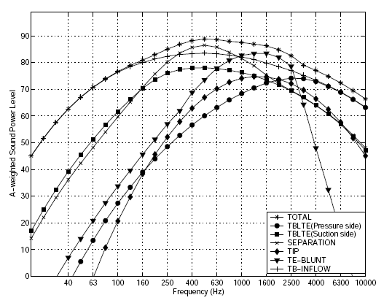
Fig. 5.1. Noise spectrums from all source mechanisms.
Noise from all sources are plotted together in figure 5.1. The result curves are obtained using noise prediction model together with BEM code. In general the larger the Mach number, the louder the noise radiates from wind turbine. Therefore, the noise level is very sensitive with the rotating speed and the size of the wind turbine.

6 Conclusion
In the present prediction model, the mechanical noise from the wind turbine is neglected. The unsteadiness includes turbulence inflow which is time depended, wind shear, pitching and yawing blades and wake dynamics. Boundary layer on every airfoil section is controlled by different Mach number and Reynolds number. The surface roughness of the airfoil could also change the flow condition on the airfoil surface. In general, the laminar boundary layer vortex shedding noise is not included for wind turbines with high tip speed ratio.
In general the larger the Mach number, the louder the noise radiates from wind turbine. The noise level is very sensitive with the rotating speed and the size of the wind turbine. Boundary layer thickness is required as the basic input for all the self-noise prediction laws. For the wind turbine designer, the noise prediction model should be always coupled together with a comprehensive aerodynamic computation to make sure that the electric power efficiency is not change too much. For wind turbines to be sited, the prediction model can be helpful to avoid non-necessary annoyance for the inhabitants.

References

1. Grosveld, F.W.: Prediction of Brodband Noise from Horizontal Axis Wind Turbines, Journal of Propulsion and Power, Vol.1,No.4, 1985, p. 292-299.
2. Viterna, L.A.: The NASA LeRC Wind Turbine Sound Prediction Code, NASA CP-2185, 1981, p.410-418.
3. Brooks, T. F., Pope, D. S.: Marcolini, M. A., Airfoil Self-Noise and Prediction, NASA Reference Publication 1218, 1989.
4. Lighthill, M.J.: On Sound Generated Aerodynamically; I.General Theory. Proceedings of the Royal Society of London. Series A, 211, 1952, p. 564-587.
5. Ffowcs-Williams, J.E, Hawkings, D.L.: Sound Generation by Turbulence and Surfaces in Arbitrary Motion. Philosophical Transactions of the Royal Society of London, 264, A 1151, 1969, p.321-42.
6. Ciskowsky, R.D., Brebbia, C. A.: Boundary Element Methods in Acoustics, Computational Mechanics Publications, Elsevier Applied Science, 1991.
7. Amiet, R.K.: Acoustic Radiation from an Airfoil in a Turbulent Stream, J. Sound Vib., 1975, p.407-420.
8. Ferdinand, W. G.: Prediction of Broadband Noise from Horizontal Axis Wind Turbines, J. Propulsion, 1, 4, 1984, p. 292-299.
9. ESDU-Report: Characteristics of Atmospheric Turbulence Near the Ground, Part II: single point data for strong winds (neutral atmosphere), No. 85020, 1993.
10. Lowson, M.V.: Assessment and Prediction Model for Wind Turbine Noise: 1.Basic Aerodynamic and Acoustic Models, Flow Solution Report 93/06, 1993, p.1-46.
11. http://raphael.mit.edu/XFOIL.
12. Mikkelsen, R., Soerensen, J. N., Shen W. Z.: Modelling and analysis of the flow field around a coned rotor , Wind Energy, 4, 3, 2001, p. 121-135.
13. Jakobsen, J., Andersen, B.: Aerodynamical Noise from Wind Turbine Generators. EFP j.nr.1364/89-5, JOUR-CT 90-0107, 1993.

O metoda de estimare a zgomotului aerodinamic produs
de o turbina de vant cu ax orizontal (HAWT)

Rezumat Scopul acestei lucrari este de a obtine un nou model de estimare a zgomotului aerodinamicgenerat de turbinele de vant cu ax orizontal (HAWT). Zgomotul aerodinamic este generat cand rotorul este traversat de curentul produs de vant. El contine zgomotul autoindus de profil si zgomotul turbulentei curgerii incidente. Prezentul model semiempiric este cuplat cu programe CFD si de calcul aerodinamic pentru a imbunatati precizia de predictie a modelului. Spectrul total al zgomotului unei turbine de vant date este comparat cu rezultatele experimentale, fiind obtinut un rezultat satisfacator.
¶
Cuvinte cheie: zgomotul autoindus de profil, zgomotul turbinei de vant, teoria acustica a lui Lighthill.
¶

* Institute of Mathematical Statistics and Applied Mathematics “Gheorghe Mihoc-Caius Iacob”, Bucharest.

