SINGULAR POINTS FOR THREE-DIMENSIONAL SEPARATION
BULLETIN OF THE TRANSILVANIA UNIVERSITY OF BRAŞOV

H. DUMITRESCU* V. CARDOŞ*

Abstract: The possibility of the occurrence of singularities in three–dimensional boundary layer calculations in direct mode is studied here. For this, the system of the entrainment and global momentum equations is used and it is shown that the system is totally hyperbolic. It is demonstrated that singularities can be formed by focusing of the wall streamlines which are also characteristic lines of the system of equations.

Keywords: 3D Boundary layer; Singularities.

- Introduction

The determination of the separated regions in three–dimensional flows on regular surfaces is linked to the topology of the wall streamlines. In order to determine them, the most convenient theoretical means is to calculate the boundary layer. In a classical way, such a calculation consist of a determining the boundary layer development from a prescribed external flow. However, in the simplest case of a two-dimensional flow, such a technique leads to a singularity at the zero skin–friction point. The practical effect of this singularity is to produce physically unrealistic solutions in which the derivatives of certain boundary-layer characteristics become infinite.
In three-dimensional flow the existing analyses tend to prove that singularities can also occur but their structure is not as well understood as in two-dimensional case. Moreover, several authors have confused numerical breakdowns with real separation lines and a lot of misunderstanding has resulted. Actually a separation line must have properties of regularity and should not be confused with a singularity line [1].
In order to analyze this problem correctly it is important to know the conditions under which singularities can occur in the direct formulation of a boundary-layer calculation procedure. It is also important to define the nature of these singularities.
The analysis of singularities in the direct mode and elaboration of an inverse method will be examined for turbulent flow by means of an integral method. The analysis being performed with global equations is not exactly identical to the solution of the local equations, since method is based on a set of closure relationships. However, the accuracy of the results is good regarding the comparisons with experiment and the mathematical behaviour.

- Analysis of the 3-D boundary-layer equations

The integral method for three-dimensional turbulent boundary layers uses the entrainment and global momentum equations. In Ref [2], the equations are presented in a general coordinate system with arbitrary metric coefficients. However, the properties of these equations are clearer if streamline coordinates are used because the closure relationships have been established in such an axis system. The x axis coincides with the projection on the wall of the external streamlines and the z axis is orthogonal to the streamline in a plan tangent to the wall, the y axis being orthogonal to the wall.
Equations. For an incompressible flow relative to observer coordinates rotating at a steady rate ω_{y} the stream wise and cross wise global equations of momentum and the entrainment equation are [3]
(1)
(2)
(3)
In these equations represent the derivates and where x and z are generalized coordinates defined in the stream wise and cross wise directions, h₁ and h₃ are the associated metric coefficients, K₁ and K₂ the geodesic curvatures of x and z lines are related to the metric coefficients by formulas
If the external absolute flow is free of rotation, we have
In streamline coordinates we get
and thus
Let u and w be the stream wise and cross wise components of the velocity in the boundary layer. We define the following integral thickness which are contained in the above global equations
where δ is the boundary layer thickness, C_{fs} and C_{fn} are the skin-friction coefficient components
.
We also define the angle β₀ between the limiting streamline and the external streamline
.
Closure Relationships. The three global equations (1-3) contain the following ten unknowns: the thicknesses δ, δ₁, δ₂, θ₁₁, θ₂₁, θ₁₂, θ₂₂, the skin –friction coefficient components C_{fs}, C_{fn}, and the entrainment coefficient.
From the definition of θ₁₂, δ₂ and θ₂₁, we have only one additional relationship
.
Therefore, it is necessary to add hypotheses to arrive at a closed system. To this end, we have used similarity solutions [2], the analysis of which leads to a set of closure relationships which depend on the three following parameters
.
An important relation ship expresses the factor as a function of the shape parameter. The above relationships based on similarity solutions show that H* is also a function of the Reynolds number, but this effect is negligible for positive stream wise pressure gradients. The simplified form of this relationship is written as follows:
(4)
Moreover, the relationships between cross wise thickness are expressed by means of a additional unknown C which well be defined later
(5)
Hypotheses (5) are equivalent to assuming that the cross-flow profile is linear with a slope C (Johnston’s assumption)
.
Obviously, the hypothesis of linearity is wrong near the wall because of the non-slip condition but the concerned region is very thin even if the maximum of w corresponds to values of in the range 0.5-0.6.
Then, the resulting error in the estimated thicknesses is negligible and unlikely to affect the analysis.
Nature of the System of Equations. Taking into account the proposed closure relationships, only three main unknowns are present in the global Eqs. (1-3) Their choice is arbitrary and we have adopted δ₁, θ₁₁ and C. With these functions, Eqs. (1-3) become
(6)
(7)
(8)
With and
Equations (6-8) constitute a system of first–order linear partial-differential equations, the nature of which is studied by means of the characteristic equation. The coefficients C_{fs}, C_{fn} and C_{E} do not play any role in the study of properties of the global equations as they do not involve derivatives of boundary-layer parameters and they are included in the right hand side of Eqs. (6-8).
Let 1/λ be the slope of a characteristic line in the earlier defined external streamline axis system So, the angle between a characteristic line and the external streamline is . λ is the solution of the following characteristic equation:
Using the relationship Eq. (4), the coefficients of this equation can be expressed as functions of H alone. We get
(9)
It is easy to see that a root of the Eq.(9) is
(10)
Then the characteristic equation takes the form
The other two roots are
(11)
(12)
where .
The calculation of the roots of the characteristic equation leads to the following conclusion: since the roots are real and distinct, the set of global equations is totally hyperbolic. Of particular importance is the root λ₁, because it defines a line which can be identified with the wall streamline.
Among the set of closure relationship deduced from the similarity solutions, one relationship enables us to calculate β₀. For high enough values of the Clauser parameter G, this relationship can be simplified and is expressed by
(13)
Equations (11) and (13) show that the wall streamline and the λ₁- characteristic line are nearly identical. The other two characteristic directions lie between external streamline and the wall streamline as shown in Fig. 1.
Singularities. Now, we shall specify the conditions under which singularities can occur in a three dimensional boundary-layer calculation in the direct mode. Before dealing with this problem, it is useful to recall briefly the results of the two-dimensional case in order to understand how they constitute a particular or degenerate form of the three-dimensional one.
The two dimensional equations are obtained from Eqs. (6-8) by setting C=0, ω_{y}=0. The crosswise momentum equation becomes trivial and the entrainment and stream wise momentum equations are written as
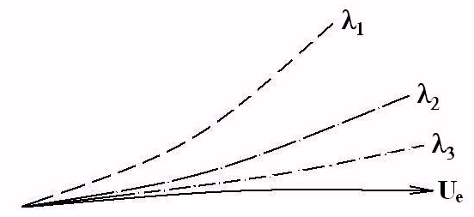
Fig. 1 Configuration of the characteristic lines: U_{e} – external streamline; λ₁ – characteristic or wall streamlines.
(14)
(15)
with
.
Equations (14) and (15) are a system for two unknowns () which enables us to construct locally a solution from initial data.
Generally a solution exists but a difficulty will arise if the determinant of the system Eqs (14) and (15) is zero i.e., if . In this case the derivative () will become infinite unless Eqs (14) and (15) are compatible. The compatibility relation is. In this hypothesis the system is indeterminate but this eventuality is highly improbable if the boundary –layer equations are solved in direct mode. So, at the point the solution is such that () is generally infinite which is not physically possible. Relationship eq. (4) shows that this point correspond to a critical value of the shape parameter around . Among the set of closure relationship of Eqs. (14) and (15), one relationship enables us to calculate . It has been shown that the condition is obtained when . An adjustment of the closure relationships would be sufficient to equalize the two values and of the shape parameter. So, the integral method behaves in a way similar to the Goldstein singularity of the local equations.
In three–dimensional flow, there is no reason for the point H*’=0, to be singular, in general. At such a point, the characteristic equation shows that there always exists three real and distinct characteristic values. The passage through a point H*’=0 implies only the incipient occurrence of an influence from downstream to upstream because the wall streamline becomes orthogonal to the external streamline. Fig. (2)
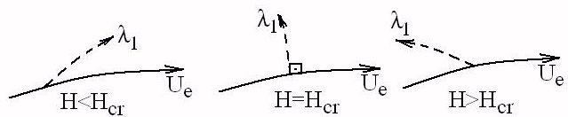

Fig.2 - Passage through a point H*’=0 in three –dimensional flows.
Some results. The objective was to calculate the boundary layer developing on a rotating blade-root. The data consists of the magnitude and direction of the velocity in inviscid flow. Boundary-layer characteristic were given as initial data along a starting line close to the leading edge. The computed wall streamline pattern is shown in Fig.3.This figure also shows the vortex flow above the blade assumed to be of this kind with a strong vortex near blade–root.
Generally, in three–dimensional case, the singularities are not local. They must be sought rather in configurations leading to a focalization of the characteristic lines belonging to the same family. More precisely, they are lines defined by λ₁ i.e., the wall streamlines which are likely to focalize. They may then, possess an envelope that is not a wall streamline and that defines a physically meaningless singular line. This line have not to be confused with an experimental separation line which is one regular. However, the considered case is a purely three–dimensional example in which the point H*’=0 is singular.
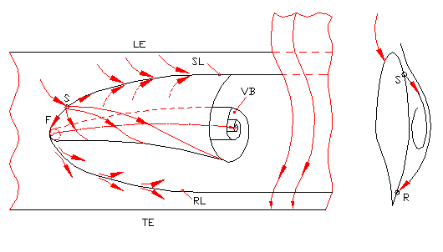
Fig. 3 - Structure of singular points at inboard locations.
- Conclusions

The analyses of the properties of a system of global boundary-layer equations has shown the eventuality of occurrence of singularities in calculations in the direct mode.
In the steady two–dimensional case the singularity is defined by zero skin friction and is reflected by infinite values of the derivates of certain boundary layer parameters. In fact, it is a degenerate form of the singularities that can occur in the steady three dimensional case. In this case, the point is no longer the signal of a singularity; this point simply indicates a change in the orientation of the boundaries of the domains of influence and of dependence. However, the hyperbolicity of the equations and the existence of weak solutions can lead to discontinuous solutions.
On the other hand, it has been shown that the characteristic line which is likely to lead to singularities, is identifiable with a wall streamline.

References

- Legendre, R.: Lignes de courant d’un écoulement permanent. Décollement et séparation. In : La Recherche Aérospatiale, Nov-Dec.1977, p.327-335.
- Cousteix, J.: Analyse théorique et moyens de prévision de la couche limite turbulente tridimensionelle, ONERA Nr. 157, 1974.
- Mager, A.: Generalization of the boundary–layer momentum–integral equations to three-dimensional flows including those of rotating systems, NACA Rep.1067, 1952.

* Institute of Statistics and Applied Mathematics “Gh. Mihoc-C. Iacob” Bucharest.

