Chapter Number ¶(18pt)
¶(22pt)
RFID- APPLICATION IN INFO-DOCUMENTARY SYSTEMS
¶(12pt)
Angela REPANOVICI & Luciana CRISTEA
Transilvania University of Brasov
Romania
¶(20pt)

- Introduction

The automatization process in all industrial and social fields requires large amounts of data processing. Data Acquisition and Control Solutions can be improved by collecting and processing data in real-time without human involvement through Automatic Identification or Auto ID.

Auto-ID technology provides the means to track any object, anytime, anywhere by using low-cost smart tags, readers, and unique object-identification schemes.
These technologies include:
- Electronic Product Code (EPC);
- Barcode (uniform product codes- UPC);
- Optical character recognition (OCR);
- Magnetic ink character recognition (MICR);
- Magnetic strip;
- Biometrics (such as retinal scans, fingerprints, etc);
- Voice recognition.

Modern libraries must provide quality services quickly and efficiently. This requires automation and computerization of libraries specific activities. Auto ID allows automated identification, recording and management books, magazines, CD's, tapes, videos and DVDs.

Until recently, bar code type indicators have great use in libraries, but lately have started to become inadequate in a number of increasingly large applications. The advantage is that bar codes can be purchased at extremely low prices, but their drawback is the limited capacity to store information, data having rescheduled.

Radio Frequency Identification (RFID - Radio Frequency Identification) or proximity is the latest and most advanced method automatic data collection technology, gaining a wide acceptance as people understand and use this technology.
With the advent of RFID technology, RFID has been introduced in the library. The free and efficient use of the newest resources of the information technology is a big step toward to the public free and rapid access to information and to the global documentation with high quality.

- The RFID technology

RFID is a no touch technology, which identifies an object or person automatically by using radio waves through a serial number or an Electronic Product Code (EPC). RFID can be used in authentication, detection of tracking, checking, warehousing, inventory management, surveillance, security, library store, document management, transportation management, cashless payments and computation for objects in various fields of industry such as manufacturing, construction, library and health care.

The simplest applications of RFID can be compared with barcode systems, but the most sophisticated RFID products can be interface with external sensors to measure specific parameters, or even GPS (Global Positioning Satellite system) for tracking the position of objects via satellites.

RFID technology was invented in 1948 by Harry Stockman. Until 1960 RFID was experimented in laboratory and after that the theory was funded. After 1970, tests of RFID were accelerated and began the implementation and the development of RFID. From 1990 commercial applications and Standards are developed. Today, RFID becomes a part of everyday life.

The fundamental components of an RFID system are primarily a transponder (tag), an interrogator (reader), communication networks and host computers (fig. 1)

Figure 1. RFID configuration - Block Chart.
In an RFID system there are two types of antennas: one is in the tag while the other is connected to the reader. The information flow during the RFID system (from simple tag to the host application) begins with host manages reader and issues commands. The reader and tag communicate using a radio-frequency (RF) signal. Reader generate carrier signal on request from the host application and send it out from reader antenna. This signal, hits the tag which receives and modifies it and reflects back the modulated signal. The reader antenna receives the modulated signal and sent them to the reader which decodes the signal into digital data. The digital data is sent to the host application.

  - RFID TAGS

The tag is a device that stores certain unique information. Tags are attached to objects or people and then communicate with a reader when the reader receives radio waves. It consists of an electronic circuit (ASIC) and an antenna integrated into one piece. “RFID tags are used in many applications, depending on the application”(3M, 2011) the purchaser will have different expectations for tag cost, read range and durability.

SHAPE \* MERGEFORMAT
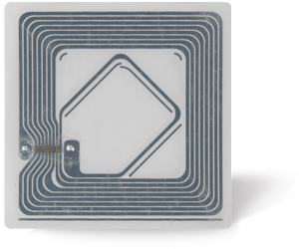

Figure 2. Tag construction

A common HF RFID tag is a lamination of multiple categories of materials that can interact with each other (Create a new library, 2010)

The first layer is made usually of paper or polypropylene and is a protective layer. Under this layer is a layer of adhesive which can be hot melt or pressure sensitive. The integrated circuit or chip (IC) is linked with the antenna through a conductive adhesive which can be an epoxy, a tape or a paste.

The antenna is made of aluminium or copper and she is attached to a substrate of plastic, usually PET. The last layer is the liner which is a silicone-coated paper and this layer is attached to the others by an adhesive layer. The materials used in the tag construction can have a large impact on long-term reliability. In tag design, materials are chosen for each application. Tag designers select the best materials that assure the optimal configuration of cost, performance and durability.

The antenna receives and reflects radio-frequency (RF) waves coming from the reader antenna. The design of the antenna is according with the particular frequency of the application and it determines the size of the tag.

The chip assures the operational functionality of the tag. The main parts of the integrated circuit (IC; chip) are: RF front-end, (Course Hero) some basic signal processing blocks, logic circuitry (algorithm implementation), and memory for storage (Figure 3).

The RF front-end is the core interface between the antenna and signal processing unit. It is responsible of implementing modulators, voltage regulators, resets and connections to the external antenna. (Halayci, 2009)

Figure 3.Chip configuration

Tags can be classified according to: the power source, frequency, functionality and protocols that they belong to.

Depending on the source of the power, tags are classified as:
- Passive;
- Semi-active or semi-passive (also called battery assisted passive tags- BAP or
battery assisted tag - BAT);
- Active.

The passive RFID tag has no internal power source. The passive tag’s read range is limited by the amount of power that can be obtained from the RF waves from the reader. The benefits of passive RFID tags are that they are smaller, cheaper (<0.5$), unlimited in life span because power does not have to be supplied. The reading range, however, is shortened to around 10cm up to a few meters (<6m) (Clampitt, 2010). So, if tags are placed outside of the electromagnetic field, these devices do not work to detect. The disadvantages of passive tags are a lower read range and high power readers. The passive tags are mainly used to: item, box, or case level tracking; low-value assets; identification (passports, badges, etc.); managing DVDs, documents and library checkout, baggage tracking, point of sale, blood supply, drug packages, livestock, pets, etc. (RFID, 2010)

The semi-active tag has a battery on it but no radio transmitter. The battery powers its integrated circuit (IC), which helps it to modulate the reflected signal. The reflected signal is required because the tag does not have a radio transmitter. The advantage of this type of tag is that you do not need to power the tag from the reader. Therefore, one can use low-power readers and store more data on the tag. This type of tag is used to get longer read range (up to 50m) or to couple the tag with environment sensors such as temperature, pressure, relative humidity, Global Positioning System (GPS), etc. Since the sensors require continuous power, the battery is required on the tag. The disadvantages of these tags are higher cost, larger and heavier tag and limited life due to battery. (HALAYCI, 2009)

The active RFID tag has its own power source and transmitters. This tag communicates at a
longer distance because it is not dependent on a reflected signal. Its communication distance ranges from 100m to 225m. It has more memory, up to 128Kbytes. However, the cost is high (>20 $), the size is larger, and the weight is higher (Kinkenzeller, 2003). The active tag’s life is between 2 and 5 years and it depends on the battery. The active tag stops working when the battery dies.
The active tags can be used in various applications like: box, pallet, or container level tracking; people tracking (such as patients); real-time location; long-range monitoring; area monitoring; security, sensor monitoring and others.

Tag characteristics are different according with the frequency bands in which the tag is designed to operate.
In tag design there are used four frequency bands:
- Low Frequency - LF 125 - 135 KHz;
- High Frequency - HF 13.56 MHz;
- Ultra High Frequency - UHF 860-960 MHz;
- Microwave Frequency - 2.45 and 5.8 GHz.
Low Frequency tags- LF 125 to 135 KHz have a very short read range –up to 40 cm with low-read speed. These tags are used in: access control; animal tagging; inventory control and car immobilizer
High Frequency tags - HF 13.553 to 13.567 MHz have a short to medium read range –30cm to 1m with medium-read speed. These tags are used in: Smart Cards and item tagging.
Ultra High Frequency tags - UHF 860 to 960 MHz have a medium read range 60 to 6m with high-read speed. These tags are used in pallet tagging. The tag costs are high.
Microwave frequency tags have a medium read range -60cm to 15m with high read speed. As UHF tags, Microwave tags are very expensive.
The library RFIDs mainly operate in the high-frequency (HF) 13.56 MHz band.

According to the tags read/ write capabilities, memory capacities, power sources and communication capabilities, these are classified in six functionality classes:
- Class 0 – including passive –read only tags (data are written once by manufacturing),
- Class 1 – including passive –read only after initial programming tags (field programmable only once),
- Class 2 – including passive tags with read and write functionality. These tags are rewritable by reprogramming,
- Class 3 – including semi-passive tags with read and write functionality,
- Class 4 –including active and reprogrammable tags,
- Class 5 – including readers and read/write functionality tags which can power class 0, 1 and 2 tags.

  - RFID INTERROGATOR OR READER

The second important part of the RFID system is the Interrogator or Reader (fig.3). The RFID reader sends a pulse of radio energy to the tag and listens for the tag’s response. The tag detects this energy and sends back a response that contains the tag’s serial number and possibly other information as well (Garfinkel, 2005). The reader can be fixed in adequate place or hand –held according to ensure the best conditions to read the tags by passing them through the interrogation zone.

A hand-held reader is a small, lightweight device that is used to receive quickly and accurately information from the tag (fig.4).

A fixed reader is installed on a stationary point like a wall or a ceiling to read movement, location, or internal data of objects in the area (fig.5). The reader collects the information continuously. Depending on the reader size (especially its antenna), the range and accuracy is greater than hand-held readers. (KIM, 2007)
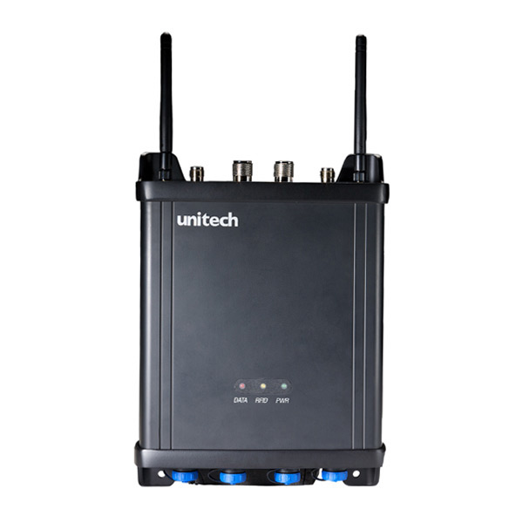
Figure 4. Hand-held reader Figure 5. Fixed Reader (www.us.ute.com)
(www.3M.com/uk/library).
There are two main classes of RFID readers: read-only, an example being those that operate with the purely passive Class 1 tags, and read/write, which can write new information back to a tag that has been equipped with a read/write memory (WARD, 2006). According with the main functionality, the readers must demodulate and decode the information received from the tags, and also these must assure the best conditions to communicate with the tags by supplying the necessary energy.

Table 1 Common ISO Passive RFID Standards
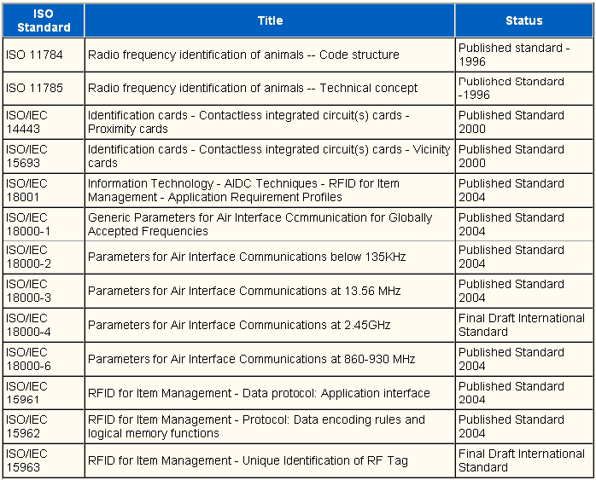

  - RFID STANDARDS

The reader and the tag can communicate with each other through the protocols establish during the manufacturing. To assure communication between readers and tags from different manufacturers there are defined standardized protocols.

Two organizations are most involved in drafting standards for RFID technology: the International Organization for Standardization (ISO) and EPC global. ISO represents global interests and has been involved with different RFID technologies for many years (Table 1). Most of the work has been through various sub-groups of Joint Technical Committee One (JTC12), for drafting standards for information technology.

EPC global's mission started with the vision to identify every item with a unique electronic product code (EPC). The plan is to have a global network implemented making every item visible throughout the supply chain. A great amount of research and development resources have been invested in creating specification and standardization of the EPC tags and the required infrastructure EPC global's efforts are primarily focused on UHF. (Team, 2010).

ISO developed a new series of standards—the ISO 18000 family—that addresses how tags and readers communicate in a number of item identification applications. One of these, ISO 18000 Part 3, identifies 13.56 MHz as the frequency for tag-reader communication in these applications. ISO 18000 Part 3 Mode 1 is the type of tag commonly used in many of these applications, including libraries (3M, 2011)
The ISO has formed an international working group to develop applications standards that will allow global interoperability. At this time ISO developed three different working drafts standards of standards, called ISO/WD 28560 part x.

- Part 1 describes in general the data elements that can be used for libraries.
- Part 2 describes the object based encoding drawn from ISO 15962. The only mandatory data element is the Primary Item Identifier (Barcode). If more optional elements are needed like e.g. owner of library, item set information, shelf location etc. an object index is required that the library system knows the particular elements that can be accessed on the tag. The advantage is the flexible memory size of tag due to the data elements that are stored.
- Part 3 describes the fixed length encoding similar as already used e.g.in Denmark. Five data elements are mandatory (the Danish model includes 8 mandatory elements). (3M, 2011)

- RFID technologies in libraries

RFID application in Library must be able to assure the maximum efficiency in operations, such as:
•loans and refund of materials (assisted by librarian or as self-serving);
•collection inventory;
•identify materials and rapidly finding of material that are wrongly placed on the shelves;
•collection security;
•automatic sorting for putting on the shelves.

In libraries, activities such as making an inventory of the book involves a lot of work and time spent by library staff, so the RFID system is suitable for identification, inventory and management books, magazines, CD's, tapes, videos and DVDs sites. Such a system significantly reduces repetitive operations; the books were quickly counted by scanning simultaneously and directly to the shelves.

Another application of RFID systems is the introduction of direct services offered to users, allowing the loan and return documents in faster and easier way, thanks to self-service workstations and the possibility of booking through the Internet. Based on the entry permit with a RFID chip inserted, readers can use these self-service stations.

Library readers have easier access to traditional library activities (booking, loan return) by using e-mail and by automatically generated SMS messages thus amplifying the degree of communication with the library. Using the library automatisation it is possible to send: automatic warning messages that are intended to remind to the reader the obligation to return the loan documents in time and messages for the extension of the loan (the user can extend his loan period, if there is no other request for the document and this extension is via the Internet and the information are automatically update in the system) Automat documents booking system allows the automat detection of the reserved document by any RFID workstation and the system will deliver a message to protect the reservation.

The most important elements of RFID system for libraries are: door sensor, auto-loan unit and the librarian work-unit. These components are independent of each other, and to implemented computer circulation system. Since the components are "intelligent", there is no need for a server and adding components allow additional elements themselves, with the development system.

Librarian work-unit allows the following functions:
• operating loans / refunds;
• programming (write) labels;
• conversion barcode labels in RFID tags.

Gate sensor –RFID reader (fig.6)
It is designed to detect and read information from RFID tags passing through the area. The gate read the EPC or serial number (given by the library) and can tell if a book was escape or not. The reader consists of two antennas placed in parallel, plus an electronic reader. The distance between the two antennas can be 90 cm, while the three antennas can reach 1.8 m.

Auto-loan unit (fig.7)
After identifying the user, which may be based on an RFID identification card, it can put documents (books, CDs, video discs, etc.) on the reading surface to be recorded on his behalf and scheduled in "loan". The chip will be placed on the "quiet" mode and no alarm output will be active. It is possible that the return of books to be made also in auto-loan unit. The user can check more books to return an average reader can read 25 cm, so that depending on the thickness of the book, you can find out how many books can be returned in a single reading.

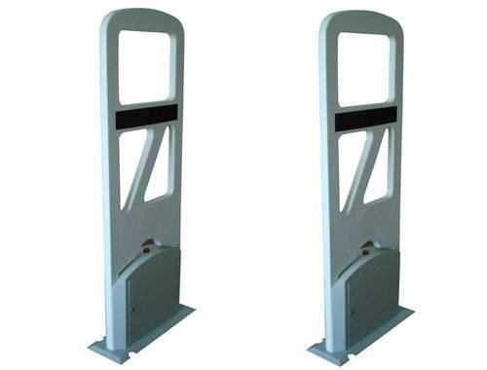

Figure 6. RFID reader – Security gate Figure 7. Sef check unit
(www.cfnewsads.thomasnet.com). (www.blog.library.villanova.edu/news)

RFID systems for info documentary application assure a lot of advantages

• Rapid check-out / check-in;

• Simplified self check-out / check-in;

• High-speed inventorying;

• High reliability;
• Better inter-library facilities, more efficient reservation facilities;
• More staff available for assistance;

• Long tag life;

• Automated materials handling.

RFID systems used in libraries provide the following features:
  - High reliability;
  - Compatibility with other RFID chips;
  - Compatibility between different generations of RFID chips of different manufacturers(ISO 15693);
  - No additional security elements (electro-magnetic tapes, etc..);
  - The system can be extended to access cards, access control in various areas of the library, copying or other payments to national library services, Internet access etc.
  - Components (gateway, readers, etc.) can be exchanged during operation without the need for library RFID system interference.

- Application at Transilvania University of Brasov, Advanced Mechatronics Systems Research Department SIPTEH project
The project SIPTEH (Shared Integrated System for Processing of Technical Content) was approved and funded by the National Centre of Project Management in the summer of 2008, integrated in the National Plan for Research-Development and Innovation II 2007-2013, 4th Programme – Partnerships in major fields, 1st Research Direction – Information technology and communications. The project is to be carried out in the next three years, with July 2011 as deadline, and comprises a partnership between Dunarea de Jos University of Galati (coordinator), Transilvania University of Brasov, Politehnica University of Bucharest and Lucian Blaga University of Sibiu (partners).
The team recommended the use of a pre-indexing, indexing, storage and digital information retrieving system as in the figure 8
The four partners work independently but the results will be found on a common platform and will meet the users’ needs, namely finding information sooner and more easily (Fig 8).
The project activities were:
- the workflows corresponding to harvesting, digitizing, indexing, storing and retrieving information in the institutional repository;
- modelling and simulation of the autonomous partners systems of digital information processing;
- modelling and simulation of the integrated system of digital information processing;
- specific software design of information processing in the integrated system.

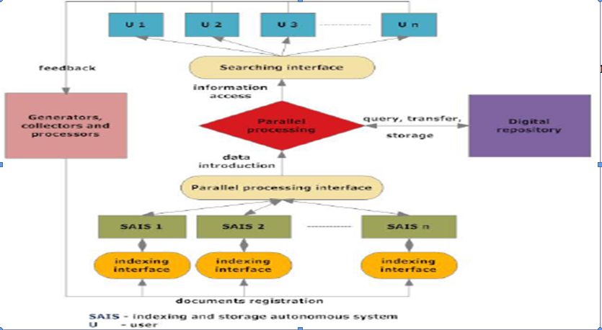

Figure 8. On-line indexing and sharing integrated system
of digital documents (SIPTEH, 2008)

Transilvania University of Brasov has already implemented Dspace as open source repository software.
The scientific research is based on the activity of information and documentation and is finalised by promoting the researches findings of everybody who can use them in order to develop knowledge and innovation. Using open sources and developing new models and systems that are based on them lead to scientific progress.
Transilvania University of Brasov proposed a model of harvesting, digitizing, indexing, storing and retrieving information using the principles of open access to information and the advantages of using open access sources. The model is projected so that it should allow integration within an integrated system by using RFID technology for documents accounts, circulation and periodical inventory, achieving, with a minimum cost price, the computerization of small libraries in universities research departments and visible improvement of the department scientific production by publishing the staff’s papers in open access.
4.1.OPEN SOURCE INITIATIVE IN DIGITAL PRESERVATION: THE NEED FOR AN OPEN SOURCE DIGITAL REPOSITORY AND PRESERVATION SYSTEM
The open source software means sets of programmes which are developed by a community, by a company or by an individual and are offered to be used under the General Public License ; they are characterized by their users’ freedom to utilize, copy, redistribute, study, alter and improve them.
The open source software is free but the one that develops it can offer for a fee certain services, such as system instalment, staff training, technical support, data conversion.
Advantages of the Open source software:
- Ability of being adapted and suited to local needs: The software source code can be altered and improved so that it can meet the own needs of its user.
- There is no restriction in using it: There is no contractual restriction concerning the manner in which the software is used.
- Low costs: The software itself is free; there are costs only for an ulterior development, staff training, data conversion etc.
Disadvantages of the Open source software:
- Big and unexpected efforts: A library will find out that, in order to succeed in getting a good result, the necessary efforts will have to be much bigger than the initially supposed ones in adapting the software to its needs.
- Lack of coordination: The decentralized development of open source software is made rather chaotically and there are delays in solving programming errors.
- Inappropriate technical support: The documentation tends to be limited and destined to the developers especially. There are limitations concerning documentation for the users of this type of software.
- Personalization: The open source software is possible to not offer the desired level of personalization compared to a commercial soft.
The system proposed by Transilvania University is materialized into an integrated system of managing the documents of the research department library with a digital repository consisting of the university scientific production together with a RFID system of documents managing and accounting and a security system as well (Fig.9).
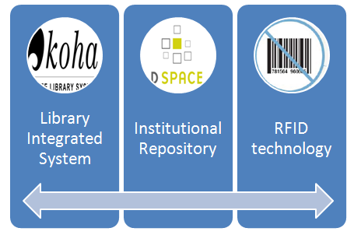
Figure 9. Open source integrated system proposed at Transilvania University of Brasov
4.2. Open source library integrated systems
The library integrated systems that are used in the Romanian university libraries are software products that were acquired from different suppliers. The cheapest is Liberty which is used at Transilvania University Library; Liberty is useful in libraries that possess up to 1 million volumes.
To computerize the department library which is being developed but it is not to exceed 10,000 volumes in the near future; such an investment is useless now when we have at our disposal open sources library integrated systems that are used by libraries worldwide.
In order to choose some open source software dedicated to library I took into consideration the following:
- To exist current active developments of this product.
- To contain modules of cataloguing, circulation, users’ access, acquisitions and serials control.
- To support MARC standards.
- The current source code and its documentation should be used under the General Public License (GPL)
- The product should already be used in libraries.
- Scalability – to support a big volume of data loading and to allow its extension.
- To be able to be adapted and in the same time to be a friendly system for the user.
KOHA
After having studied the market, we chose Koha. It is the first open-source Integrated Library System (ILS). In its use worldwide, its development is steered by a growing community of libraries collaborating to achieve their technology goals. The reasons for which we chose this system are presented below:
- Koha is an Integrated Library System. It is a complete system. Being an open source software product, there is no costs for license. It can be installed and used free of charge, it can be adapted to local needs; it has the same characteristics as a commercial software product has.
- It was initially developed in New Zeeland by Katipo Communications together with Horowhenua Library Trust.
- At present it is maintained by a dedicated team of software suppliers and by the technical staff of some libraries from all over the world.
- By adopting this software, the client becomes a kind of joint owner of this product. He can install the new versions if he likes it or not. Particularly, he can finance an ulterior development of his product or he can do it through his own efforts.
- Koha has been tried and tested and it has proved its stability and scalability, now it is used in hundreds of libraries worldwide.
- It is an economical alternative compared to the commercial software items which are expensive. The costs for commercial software include: the software acquisition with all its modules, ulterior acquisition of license and costs for training and technical assistance. There are no initial costs for Koha.
- Characteristics: Koha has all the characteristics of a complete commercial software product.
- It motivates and encourages the technical staff to be creative!
Requirements of KOHA system are not so expensive and can be easily achieved. There are:
- Koha Free 3.0 stable version (Available on Internet http://www.koha.org/)
- Server Web Apache, Free 2.0.58 (Available on Internet http://www.apache.org)
- MySQL. Relational Database Management System http://www.mysql.com Free
- Module Perl 5.8 http://www.cpan.org Free
- Zebra 2.0 http://www.indexdata.com/zebra Free
- Linux (RHEL 3.0, 4.0, 5.0) or any other variant of LINUX or WINDOWS Server
Requirements for the operator’s skills are:
- Koha interfaces are logically projected and can be used extremely easily.
- Staff and readers need only basic competences in using computer; in order to use the system efficiently these competences are gained quickly.
- Cataloguing module needs understanding cataloguing practice, such as knowing MARC standards, and also using the instruments of finding with the help of Z39.50.
- Administrators must know the operating system (Linux, etc) for maintenance, have some cataloguing knowledge which is useful for the initial settings of preferences system (for setting branches, access rights, types of documents, types of borrowing, categories of readers etc).
Koha have all integrated systems modules. In our model we are focused only on few modules. One of them is OPAC Module with the next characteristics:
- Koha offers a public catalogue (OPAC) with complete functions.
- OPAC users can search on ten fields (topics, authors, titles, publishers, barcodes etc)
- The OPAC users who are authenticated as members can make online reservations for the library documents.
- Biblio basket: the members who are logged can select various registrations which they can send and find in the email afterwards; these can be saved in a usual form, text or in ISO 2709 format, and subsequently read with the help of End Note-type software.
- OPAC users can send suggestions concerning acquisitions; they will automatically be announced through email by any action taken in accordance with their suggestions.
Another very interested module is KOHA – Cataloguing Module, with the next characteristics:
- Cataloguing module is one of Koha main strengths. There can be defined some forms in order to catalogue different types of publications: monographs, electronic resources, periodical magazines, etc.
- Export / Import: it allows the export and import of some registrations in MARC format; they can be found in the catalogues of some other libraries that use Koha and, with the help of Z39.50 protocol, they can be brought in the library own catalogue, thus achieving a quick cataloguing, subsequently only the local data will be filled in.
- Searching: it allows doing various searching, which can be done on any MARC field of the registration.
- Barcode generation- permits developing RFID solutions.
We implemented the Koha system at the research department of Transilvania University of Brasov.
We started to use cataloguing module and add records from our own library. We started with one of the author’s book.
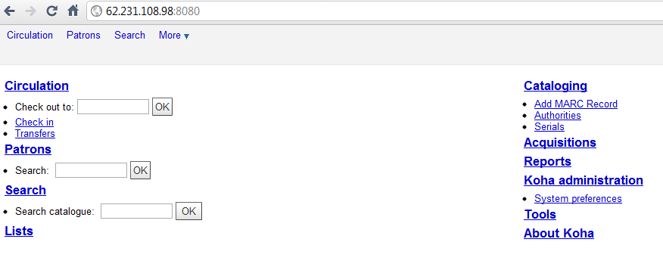
Figure 10 Library integrated system at Transilvania University of Brasov. Koha modules
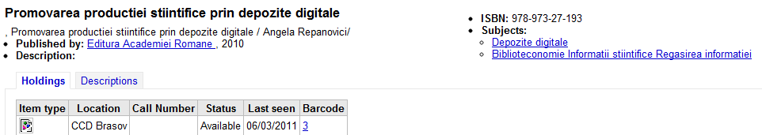
Figure 11. Records in Koha system
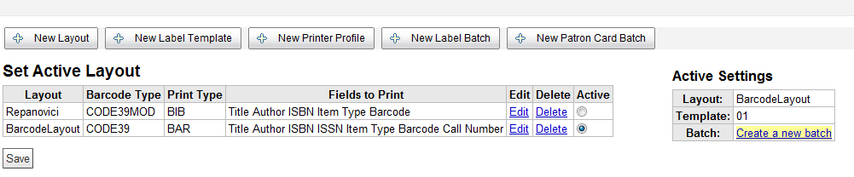
Figure 12. Generating barcode for Koha records
We started to grow Koha collection and we generated barcode for all the registered documents.
4.3. Open source institutional repository technology
Dspace
The universities and the research centers from the whole world are very active in planning and implementing the digital repositories. A help guide has been published for the organizations which plan the implementation of IR by the presentation and selection of the software systems which best satisfy the needs of the institution.
All the presented systems satisfy three criteria:
- They are available free of charge by an Open Source license, namely they are available for free and can be modified, updated and redistributed.
- They are compatible with Open Archives Initiative-OAI and by any implementation participation to the global network of the institutional inter-operable repositories is possible
- They are recently made and available to the public
- The presented systems are Archimede, ARNO, CDSware, Dspace, Eprints, Fedora, i-Tor, MyCoRe and OPUS.
4.3.1. Content of the digital repository
The Dspace software, the open source used by Transilvania University offers the capacity of stocking and saving the following types of documents:
- Articles, pre-prints, e-prints;
- Technical reports;
- Research reports;
- Conference proceedings;
- Video, audio-video materials, images;
- Teaching materials;
- Digitalized materials;
- Bachelor degrees, master’s degree, PhD theses.
The implementation team will be a partnership between:
- Faculty of Economic Sciences;
- Faculty of Mechanical Engineering;
The selection criteria of the implementation team are:
- Friendly departments to the mission of the PILOT DIGITAL REPOSITORY;
- Diversity in the area of disciplines;
- Diversity in content and formats;
- Management examples of the different forms of intellectual property;
- Archiving small-size collections for a start;
- Team with strong bonds and confidence.
The members of the team worked in other projects, too. Each of them has got expertise in their activities.
Technologies for choosing the platform and the software
As a consequence of a technical analysis, it is considered that Dspace is the solution for the open source where the PILOT REPOSITORY was implemented in the Transilvania University.
The basic services that are offered are:
- Archiving management for ensuring a long-term conservation,
- Persistent stocking, for back-ups and recuperation procedures included.
- Attribution of a unique identifier to each document for citing.

We have three research departments involved in development of repository.
Browsing “Books” at Advanced Mechatronics Research Department we choose the same book we generated barcode in Koha system.
In order to exemplify we chose the document for which we generated barcode in Koha library integrated system, fig.15.

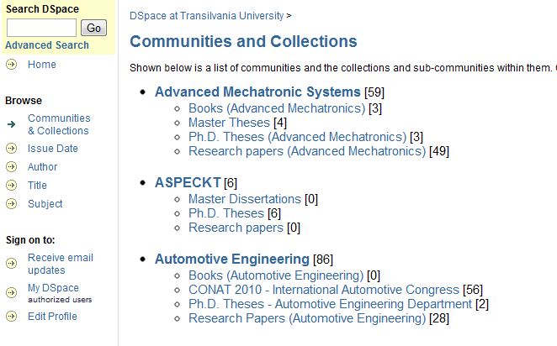
Figure 13. Aspect Dspace institutional repository at Transilvania University of Brasov

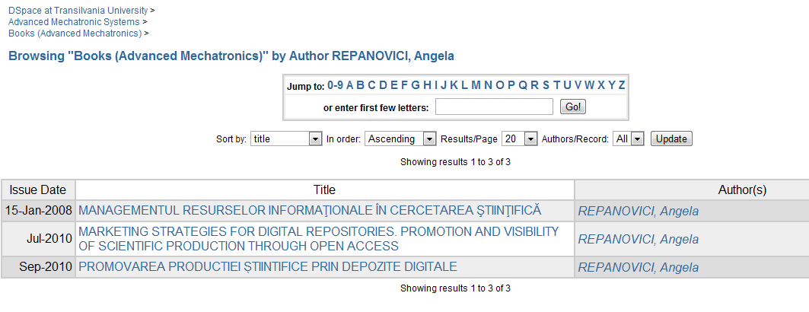
Figure 14. Books at Mechatronic Advanced Department in Aspect Dspace repository

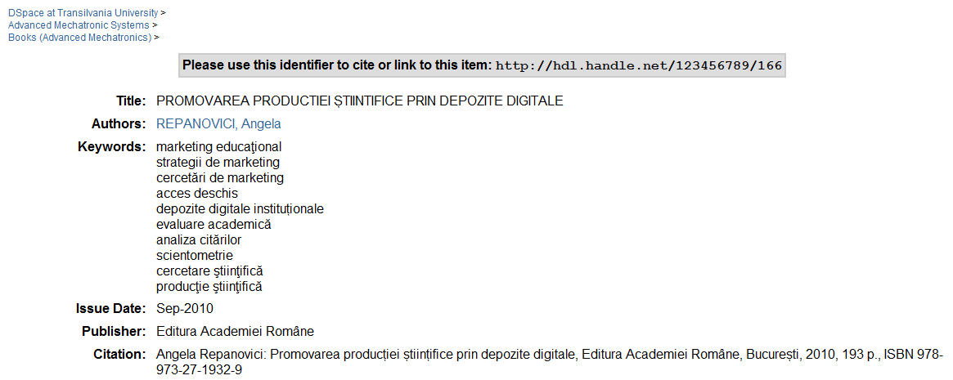
Figure 15. Bibliographic description of the book in Aspect Dspace repository
The implemented digital repository allows us to visualize the resources access. This way we can know the geographical area of interest or how many downloads were initiated. The example in the figure shows the total visits per month, countries and cities that were interested for the book Promovarea productiei stiintifice prin depozite digitale in english Scientific production promotion by institutional repositories. This thing can be noticed in the monthly activity.
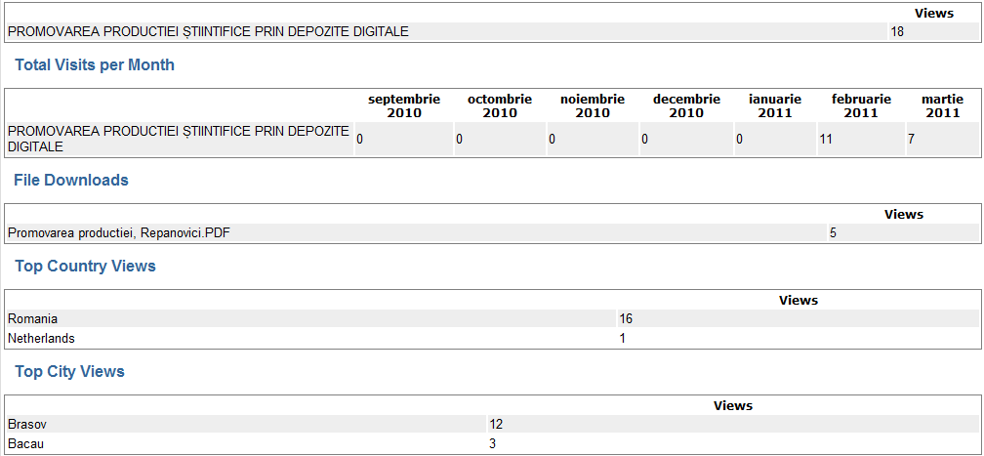

Figure 16. Statistics of download and visibility of the book in Aspect Dspace repository
4.4. RFID System Implementation
Implementing RFID system at the model achieved from combining the two open sources supposes the transformation of the barcode generated by the label that is integrated in RFID technology.
In Romania one of the university libraries which functions in an integrated system and uses RFID technology is the library of the university in Sibiu.
We implemented the system used in this library.
RFID (Radio Frequency ID) tags are the centerpiece of any RFID system. Applied to packages, pallets or individual items, RFID tags store the item data essential to any RFID-based tracking system.
Difference between Barcode and RFID (LIS Links : A Virtual Community of Indian LIS Professionals, 2011):
- Information can be read from RFID tags much faster than from barcodes
- Several items in a stack/counter can be read at the same time using RFID
- Items do not have to be handled one-by-one nor removed from the shelves
- Inventory-taking is no longer a tedious operation (LibBest, 2010)
- RFID can stand more than 10,000 read/write
- RFID can have theft bit which can be in two states “ON/OFF”
- Shelf verification/rectification can be done on daily basis
- More information can be written in the RFID tag on incremental basis
- Need not open/remove books to capture information
- Items are identified on upper and lower shelves more comfortably (Radio-frequency identification (RFID), 2010)

- Transilvania university research department library and RFID system
The components of RFID are:
1. Tag or intelligent label, contains a microchip that is attached to an aerial, they are encapsulated, in accordance with the utility, into different materials, paper or plastic.
Characteristics:
- They are rewritable
- They permit ID material stocking (inventory number, barcode) for protecting the readers’ information having a personal character.
- They permit stocking of the borrowing state directly on the tag
- dimensions: 48mm x 57mm
- price of RFID 1024 bits tags– ( 0.6 – 0.9 Euro / piece)
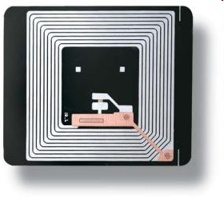
Figure 17. Tag or intelligent label
2. RFID scanner or RFID mobile reader sends a radio impulse and waits for the tags answer. The tag captures the energy sent by the reader and uses it in sending itself its unique identification number and also other pieces of information that have been memorized previously. RFID readers can function in the stand-alone manner (independently) or can be connected to an IT network.
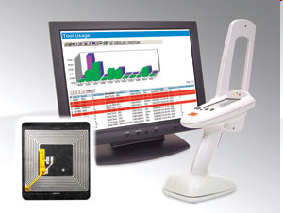
Figure 18. Scanner RFID
3. Librarian - Koha system application work unit allows the following functionalities:
  - operates book borrowings/book returns;
  - programmes (writing) tags;
  - converts barcode tags into RFID tags;
  - allows identification of reader license by using both barcode technology and MIFARE-type cards;
  - ergonomic (reading support placed at the down side).
4. RFID security gate or Gateway–Dual Technology (RF+EM) electronic system, which uses electromagnetic technology in combination with radiofrequency technology, thus allowing the combination of the advantages of both these technologies: flexibility in using and high grade of detecting. On the books in circulation fund there will be used activated/deactivated tags through contact or at distance, by panels set on circulation desk.
All the books with open access at the shelf have both barcodes and RFID tags; they are places as follows: the barcode inside the cover-front, down, and the RFID tag inside the cover-back, in 3 positions: down, medium and up, at a distance of maximum 2 cm from the back;


Figure 19. RFID tag and barcode used on a document
;
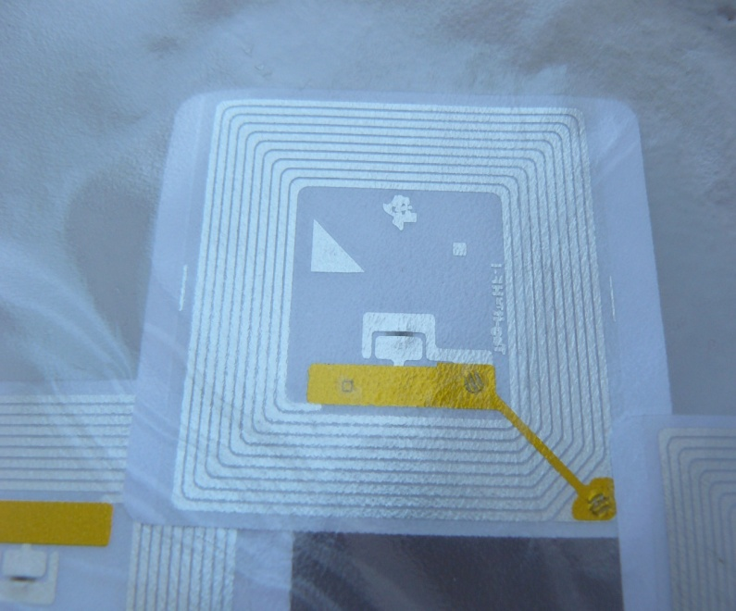
Figure 20. RFID Tag

Initially we will work using barcode in parallel with RFID tag, namely:
- barcode – it is applied at Koha cataloguing module, when barcode is generated.
- then the tag is applied on the book and the barcode is written in the tag memory by the local RFID librarian station;
The tags that will be used are the ones used by the Library of The University of Sibiu, namely RFID 3 M tags with the following dimensions: 57,15 x 49,3 mm, 1000 pieces / box, capacity 1024 bits ( Fig.20)
- Conclusion
Compared to classical systems like Barcode where all the operations are made manually, the biggest benefit brought by RFID to library is rapidity with which information can be read/registered from/in a RFID Tag and possibility of operating with more objects in the same time as well.
Introducing the RFID system does not mean direct elimination, from the first day, of the barcode system. The two systems can exist simultaneously, the RFID readers having the capacity of reading barcodes, which allows library an easy and gradually transition towards the implementation of RFID system.
The system allows flexibility and modularity and thus the library can start introducing simple RFID, permitting ulterior adding of new products or activities according to requirements and necessities. RFID, its application, standardization, and innovation are constantly changing. Its adoption is still relatively new and hence there are many features of the technology that are not well understood by the general populace."RFID is increasing in popularity among libraries, as the early adopters of this technology have shown that it makes good economic sense, both for large and small libraries." (Narayanan A.)
The proposed solution offers the model with a minimum cost using open sources software and it offers a useful instrument for the university researchers opening new opportunities for master students and PhD students.
References
3M. (2011). Library systems. Retrieved January 29, 2011, from http://solutions.3m.co.uk/wps/portal/3M/en_GB/Library_Systems/Library_System/?WT.mc_id=www.3m.com/uk/library
Clampitt, H. (2010). The RFID HandBook 7th Edition . Retrieved March 3, 2011, from http://www.rfidhandbook.blogspot.com/
Course Hero. (2009) Retrieved March 3, 2011, from http://www.coursehero.com/file/2110010/basatsabris200612mast/
Create a new library. (2010). Retrieved March 2, 2011, from RFID 401 Tag quality and reliability:http://multimedia.3m.com/mws/mediawebserver?mwsId=66666UuZjc%20FSLXTtnXMVo8%20T2EVuQEcuZgVs6EVs6E666666--&fn=RFID%20401.pdf
Garfinkel, S. (2005). Understanding RFID Technology. Garfinkel.book.
Halayci, S. (2009). Design of a radio frequency identification (RFID) ANTENNA. Retrieved February 12, 2011, from http://etd.lib.metu.edu.tr/upload/12610554/index.pdf
Kim, G. K. (2007). Locating and tracking assets using RFID. Thesis.
Kinkenzler, K. (2003). RFID Handbook: Fundamentals and Application in Contactless Smart Cards and Identification. New York: John Wiley and Sons.
LibBest. (2010). Library RFID Management System. Retrieved January 15, 2011, from http://www.rfid-library.com/en/default_e.html
LIS Links (2011) : A Virtual Community of Indian LIS Professionals. (2011). Retrieved March 3, 2011, from http://lislinks.com/forum/topics/security-system-for-library
Narayanan A., S. S. (2009). Implementing RFID in Library: Methodologies, Advantage and Disadvantage. Retrieved March 3, 2011, from http://library.igcar.gov.in/readit-2005/conpro/lgw/s5-8.pdf
Radio-frequency identification (RFID). (2010). Retrieved January 11, 2011, from http://rfid-chip.org/
RFID (2010). Retrieved March 5, 2011, from http://www.scribd.com/doc/4098031/radio-frequency-identification-RFID
SIPTEH (2008). Integrated system for indexing and share online for digitized technical documents (SIPTEH). Galati: Dunarea de Jos University ( in Romanian)
Team, G. R. (2010). RFID Asset Tracking. Retrieved December 21, 2010, from Understanding RFID:http://www.gaorfidassettracking.com/RFID_Asset_Tracking_Resources/rfid_understanding/
Ward, M. K. (2006). RFID: Frequency, standards, adoption and innovation. JISC Technology and Standard Watch.

