The 40th International Conference on
Mechanics of Solids, Acoustics and Vibrations &
The 6th International Conference on
“Advanced Composite Materials Engineering”
COMAT2016 & ICMSAV2016
Brasov, ROMANIA, 24-25 November 2016

A Comparative study of THE Tubular Welded Structures DOUBLE Gussets

Gabriel. D. Dima¹, Ion Balcu ²
¹Schaeffler Romania SRL, Brasov, ROMANIA, dimadmi@schaeffler.com
²Transylvania University, Brasov, ROMANIA, balcu@unitbv.ro

Abstract: The tubular structures, known also as hollow structures, are reinforced with side or double gussets. Because of the standardization missing, a big variation is met on the products, in a wide range, from the offshore platforms to the lightweight aerostructures. Having a tubular T joint with usual dimensions as reference, a complex double gusset shapes assessment is made based on the Hot Spot Stress method, taking into account the most common loading condition. The results of the stress, rigidity and weight are discussed, together with design and manufacturing recommendations, and conclusions.
Keywords: Hot Spot Stress, double gusset, tubular structure, welding design, T joint

1. INTRODUCTION

In heavy structures applications, gussets (longitudinal plates) are used to facilitate bracing or other attachments to rectangular tubular structures. References [3] and [5] give design guidelines based on deformation limits for rectangular hollow structures connecting face and non-uniformly stress in the plate.
In civil engineering, the gussets are used in rigid beam to column (seat brackets) and rigid column to base connection [6], [4], [1].
Studies related to strengthen the tubular structures connections by gussets are rarely met. Other methods to increase the strength of the T joint are using base plates (chord doubler) [9], [8], [11], or outer collar [1]. Reference [1] presents also the using of gusset to decrease the stress level in K connections. Reference [8] mentions chord doubler as an economic method to repair the damaged structures.
A study of decreasing the stress level in K joint using a gusset was done by Nazari and Durack [7] showing a von Misses stress decrease of 45% (axial bending), 33% (in plane bending) and 18% (out of plane bending).
After ref. [10], tapered gusset plates should be incorporated in all important welded joints to insure the gradual changes in stress intensity in members; also gussets lessen the danger of fatigue failure by reducing the stress intensity. Reference [2] recommends gusset especially to vibrations subjected and/ or out of plane bending loaded connections.
The objective of the article is to give synthesis over the influence of different type of double gussets over the tubular joints used in tubular structures in general, and aerospace lightweight structures in particular.

2. THE WORKING METHODOLOGY

A usual T joint (90°) between two tubes with external diameter of 25 mm was considered, having the wall thickness of 1.0 mm both for tubes and gusset. The chord (horizontal tube) is 600 mm length and the brace (vertical tube) is 500 mm height. The gusset has the dimensions of 80 × 80 × 1.0 mm. The method is based on the Hot Spot Stress using Finite Element Method to determine the stress level and rigidity for three load cases: axial load (AXL), in plane bending (IPB) and out of plane bending (OPB).
For the FE study a commercial solution was used - Hypermesh / Radioss. There were used shell quad elements specific to thin walled structures; the method excludes the effects related to fabrication such as the configuration of the weld (flat, convex, concave) and the local condition of the weld toe (radius of weld toe, undercut, etc.). The boundary conditions were embedded (all degree of freedom restraint) for chord (corresponding to a welded end) and free for brace. Loads are introduced with a rigid connector (RBE2) from the free end of brace.
The selected material is a low alloyed steel with ultimate tensile strength of 980 – 1080 MPa, Poisson ratio of 0.3 and Yield Modulus E = 2.1E5 MPa
For the study of rigidity, the relative displacement, as the ratio between the gusseted and the unstiffened joint displacements was assessed. Regarding the stress, the values of the gusseted joints was normalized with the stress of the unstiffened joint (U) and the diagonal bracing (DB).

3. THE CONSIDERED DOUBLE GUSSET SHAPES

Along the side gussets, the double gussets are used to increase the stiffness of the high loaded tubular joints. The double gussets in one or two pieces were subjected to a research regarding the stress level, rigidity and mass, relative to the unstiffened joint. The selected gussets are usual in primary and secondary structures form aerospace industry (Table 1).
The gusset M has a triangular shape and it is tangent placed to the joint tubes (often met in aircraft engine supports). The tangent placed double gussets need a specific attachment on the joint, and this also available for the gusset M, being provided with a vertical slot on the symmetry axis to allow the welding seam. The gusset N is similar with gusset M, the weald seams being placed in holes (a costless variant than the gusset M).
The gusset O is radial placed, being inserted in the tubes in the symmetry plane of the joint (the tubes are slotted). This type of gusset is used in the high loaded joints or in hard points to introduce significant loads in the structure (attachments of heavy equipments or of other sub-structures). The gusset P is radial placed, also inserted in the symmetry plane of the joint. In this case, the brace is not in contact with the chord, having the formed end to match with the gusset on the whole contour. This application is mainly used in joints gathering multiple tubes. The gusset R is made of two triangular gussets radial symmetrically placed. The gusset S consists of two triangular gussets tangent placed. The gusset T is a new proposed design to attach both sides of the joint with a single one strap of metal.
For the reference, there were considered the unstiffened joint (U), the tangent side gusseted joint (D) and the braced joint (DB).

Table 1: The assessed double gussets codification
 | 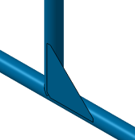 | 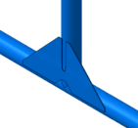 | 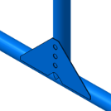 | 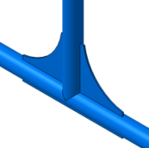
U | D | M | N | O
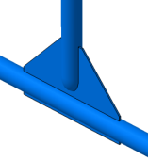 | 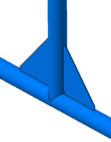 | 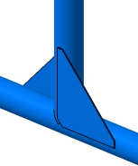 | 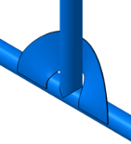 | 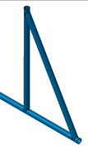
P | R | S | T | DB

4. THE RESULTS OF THE AXIAL LOADING

The stress distribution results are displayed in figure 1. If for the unstiffened joint U the stresses are concentrated in the upper area of the horizontal brace, for all double gusseted joints, the hot spot stress (HSS) migrates to the lower outer sides of the gusset. For all radial placed gussets the hot sport stress occurs in the horizontal brace, while for gussets placed tangent to joint, the HSS occurs in gusset. The gusset D keeps a HSS on the horizontal brace, on the unstiffened side. Gussets M, N and O present a relative homogenous distribution in gusset and brace, while the gusset S presents stresses even in the vertical brace. The most stressed joints are those fitted with gussets R and T.
The normalized stress values are presented in figure 2. All gussets lead to an increase of the normalized stress, the gusset O being the closest to the unstiffened joint U. The braced joint (DB) also lead to an increase of the normalized stress. The poorest behavior was obtained for the gusset R (the normalized stress is more than double relative to the unstiffened joint) and for the gusset T. The gusset S is the one allowing both spread stress gradient and a low normalized stress level.
The gusset R is the single one stressing only the horizontal brace upper side, leading to the highest stress peaks. For the axial load, the gusset D has the same effect as the heavy gussets, like M, N or P. The normalized stress for all gussets are bigger than stresses of the unstiffened joint (with 4 ÷ 100%), therefore for the axial load gussets are not recommended. Gussets O and S are the most suitable because in other load cases these bring a significant stress decrease.
From figure 2 it may be observed that for the majority of gussets, the displacement decrease is significant. The gussets M and N are more elastic, increasing the displacement with about 25%. The gussets O, P and R are more rigid than the bracing DB, decreasing the displacements with 13 – 36%. Even the gussets O and P are the most rigid, the gussets R and T lead to bigger values for stresses. It is noticeable that gussets O and S lead to a better behavior of joint (stress and displacement) than the diagonal bracing.

U  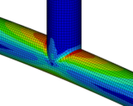 | M  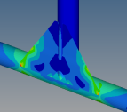 | N  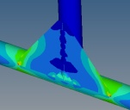
O  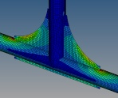 | P  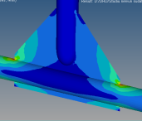 | R  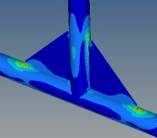
S  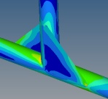 | T  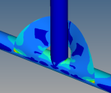 | D  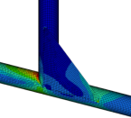

Figure 1: The stress gradient of the unstiffened and gusseted joints for axial loading

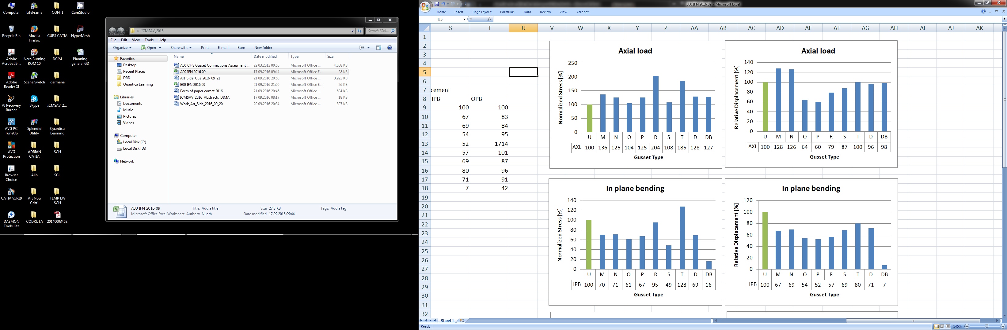
Figure 2: The normalized stress and displacements for the axial load

5. THE RESULTS OF THE IN PLANE BENDING

The stress distribution for the assessed gussets having the reference of the unstiffened joint are shown in figure 3. By adding a gusset, the hot spot stress location is moving from the joining area of the tubes to the upper joining end of the gusset. The stress concentration factor is increasing with the gusset stiffness. The stress distribution for the gusset S is quite particular, leading to maximum stress area extension up to the margins of the gusset, as long as for the other gussets the hot spot stress is precisely localized at the end of the gusset.

U  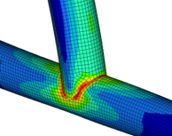 | M  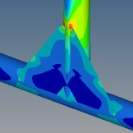 | N  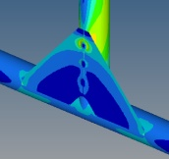
O  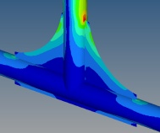 | P  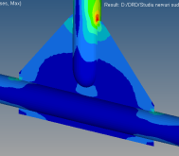 | R  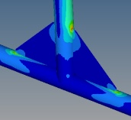
S  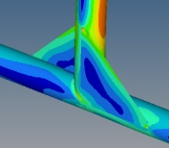 | T  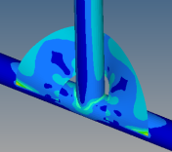 | D  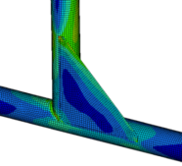

Figure 3: The stress gradient of the unstiffened and gusseted joints for in plane bending

Figure 4: The normalized stress and displacements for the in plane bending

The normalized stresses are similar for the tangent placed gussets and for those inserted in the symmetry plan of the joint; all these lead to a 30 – 52% normalized stress decrease (Fig. 4). The gusset R keeps the same level of the normalized stress, while gusset T has a worse behavior. The gusset S shows the best results, even the normalized stress is three times bigger than the diagonal braced joint (Fig. 4).
All studied gussets produce a decrease of the relative displacements between 20 – 48%, being far from the braced joint, of 93%. The best combination of the decrease of stress and displacements is given by the gussets O, P and S. For both normalized stress and relative displacement, the diagonal bracing (DB) offers a different range relative to the gusseted joints.

6. THE RESULTS OF THE OUT OF PLANE BENDING

The hot spot stress is localized in the lowest point of the vertical arm (Fig. 5). By adding a gusset, the hot spot stress remains in the same position like the unstiffened joint. For the tangent placed gussets (M, N and D), the hot spot stress is placed on the opposite side relative to the gusset. The gusset P is not recommended for the out of plane bending, the normalized stress value being out of the range of the other gussets.

U  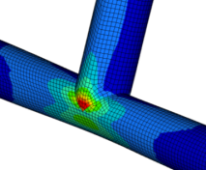 | M  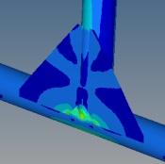 | N  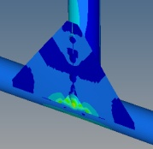
O  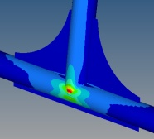 | P  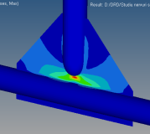 | R  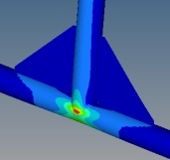
S  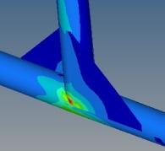 | T  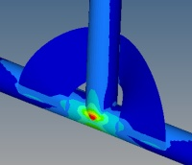 | D  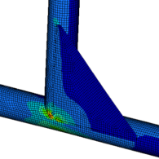
Figure 5: The stress gradient of the unstiffened and gusseted joints for out of plane bending

The gusset R increases the normalized stress relative to the unstiffened joint. The double gussets tangent placed (M, N, and S) present similar results (the normalized stress decreases of about 28% by increasing the inertia momentum of the joint section relative to the loading direction). These joints present also a stress distribution in the gussets, thus reducing the stresses in joint members. The bracing remains the best choice for the out of plane bending, the S gusset being the closest variant according to the stress and displacement values. The gusset S reduces the normalized stress with about 15% relative to the gusset D, for a double mass. The majority of the gussets offer a small improvement of the rigidity – up to 14% (Fig. 6).
The gusset P is out of both stress and displacement ranges of the other gussets. Together with the gusset R, they are not recommended to be used in joints subjected to out of plane bending. The diagonal bracing offers the best normalized stress and rigidity values. The conclusion is the the decision to use a specific gusset has to be made taking into account all three load cases (axial, in plane and out of plane bending).

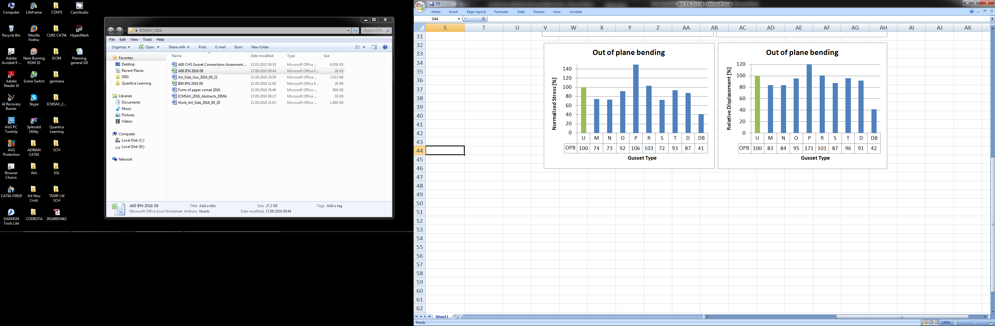
Figure 6: The normalized stress and displacements for the out of plane bending

7. CONCLUSIONS

Within the paper, a research regarding the double gussets shape was presented. After the assessment of the mechanical behavior, the following conclusions may be formulated:
- The double gussets add 6 – 3% to the unstiffened joints mass, while gusset D adds only 3%;
- The bracing adds 49% overweight, meaning that this may be replaced by gussets if the weight is a critical requirement;
- For axial loading, the bracing may be replaced with gussets O and S, for in plane bending with gusset S and for out of plane bending with gussets M, N or S;
- For out of plane bending, the majority of gussets increase the stress, being not recommended;
- For in plane bending, some gussets decrease stress with about 50% and displacement with about 40%;
- Gussets inserted in the symmetry plane of joint are recommended to planar loading;
- Tangent placed gussets are recommended for bending loads.

Future investigations will be done to identify the influence of the combined loading of the triangular tangent placed gusset (D) over the stress, stability and rigidity of the tubular joints.

REFERENCES

[1] Blodgett O. W., Design of Steel Structures, The James F. Lincoln Arc Welding Foundation, 1976
[2] Bruhn E. F., Analysis and design of flight vehicle structures, Tri-State Offset Company, 1973
[3] Cao J. J., et al., Design Guidelines for Longitudinal Plate to HSS Connections, Journal of Structural Engineering, 1998
[4] Eurocode 3, Part 1.8. Design of Joints, CEN, 2002
[5] Kurobane Y., et al., Design guide for structural hollow section column connections – CIDECT/ TUV Verlag, 2004
[6] Martin L. H., Purkiss J. A., Structural Design of Steelwork, Butterworth-Heinemann, 2008
[7] Nazari A, Durack J., Application of The HSS Method to The Fatigue Assessment of HSS Shiploader Boom Connection, 5th Australasian Congress on Applied Mechanics, Brisbane, 2007
[8] Nazari A., et al., Analytical Methods for Better Design and Repair of Mechanical Welded Structures, CRC Mining Technology Conference, Fremantle, 2003
[9] Nazari A., et al., HSS Design with parameters equations for fatigue assessment of tubular welded structure, Australian Mining Technology Conference, 2006
[10] Niu M. C. Y., Airframe Structural Design, Hong Kong Conlimited Press, 1988
[11] Packer J. A., Henderson J. E., Hollow Structural Section – Connections and trusses - Canadian Institute of Steel Corporation, 1997
[12] * * *, Hypermesh 8.0 User’s Manual, Altair Engineering Inc, 2007

