The 40th International Conference on
Mechanics of Solids, Acoustics and Vibrations &
The 6th International Conference on
“Advanced Composite Materials Engineering”
COMAT2016 & ICMSAV2016
Brasov, ROMANIA, 24-25 November 2016

ELASTIC FOUNDATION MODEL OF ROLLING
CONTACT WITH FINITE ELEMENT AND TRANSVERSAL TANGENTIAL FORCES

Ioan Enescu¹
¹ Universitatea Transilvania, Brasov, ROMANIA, enescu@unitbv.ro

Abstract: The difficulties of elastic contact stress theory arise because the displacement at any point in the contact surface depends upon the distribution of pressure throughout the whole contact. To find the pressure at any point in the contact of solids of given profile there fore ,requires the solution of an integral pressure.The difficulty is avoided in the solids, can be modeled by a simple Winkler elastic foundations or “mattress” rather than an elastic half-space ,and the modulations by finite elements. When the plane of a wheel is slightly skewed to the plane of rolling described as ”sideslip” or” yaw”, transverse friction forces and moments brought into play.
Keywords: elastic, mattress, finite element

- INTRODUCTION

When two non-conforming solids are brought into contact they tough initially at a single point or along a line. Under the action of the slightest load they deform in the vicinity of their point of first contact so that they touch over an area which is finite through small compared with the dimensions of the two bodies. A theory of contact is required to predict the shape of this area of contact and how it grows in size with increasing load; the magnitude and distribution of surface tractions, normal and possibly tangential, transmitted across the interface.
Finally it should enable the components of deformation and stress in both bodies to be calculated in the vicinity of the contact region.

2 foundation model

The profile, therefore, requires the solution of an integral equation for the pressure.The difficulty is avoided if the solids can be modeled by a simple Winkler elastic foundation or ‘mattress” tether than an elastic half-space .The model is illustrated in fig.1. The elastic foundation, of depth h, rests on a rigid base and is compressed by a rigid indenter. The profile of the indenter, z(x, y), is taken as the sum of the profiles of the two bodies being modeled:
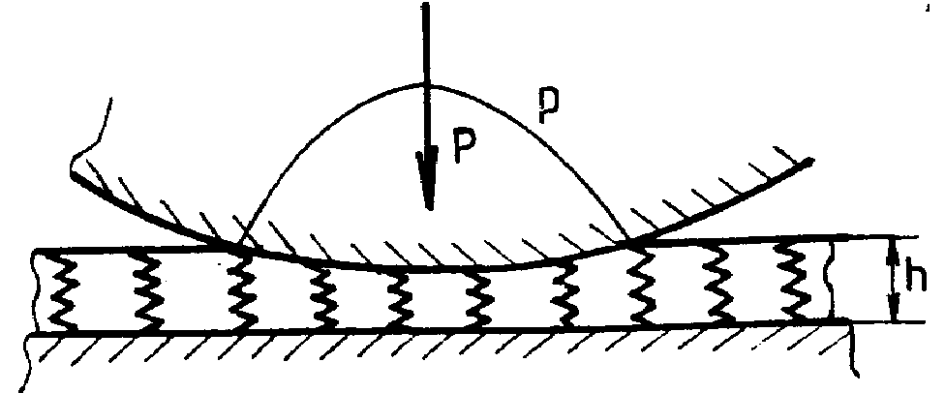

Figure.1.The elastic foundation model

z (x ,y) =z₁(x ,y)+z₂(x ,y) (1)

There the difficulty of elastic contact stress theory arise because the displacement at any point in the contact surface depends upon the distribution of pressure throughout the whole contact. To find the pressure at any point in the contact of solids of given is no interaction between the stings of the model, shear between adjacent elements of the foundation is ignored. If the penetration at the origin is denoted by δ , then the normal elastic displacements of the foundation are given by:

${\bar{u}}_{z}(x,y)=$δ - z (x, y), δ>z (2)
${\bar{u}}_{z}(x,y)=$0 δ≤ z

The contact pressure at any point depends only on the displacement at that point, thus

p (x ,y)= (K/h)${\bar{u}}_{z}(x,y)$ (3)

where K is the elastic modulus of the foundation.
For two bodies of curved profile having relative radii of curvature R’ and R’’, z(x ,y) we can write

${\bar{u}}_{z}=δ−({x^{2}}/2R^{'})−({y^{2}}/2R^{\text{''}})$ (4)
Inside the contact area. Since ${\bar{u}}_{z}=0$ outside the contact, the boundary is an ellipse of semi-axes a=(2δR’)^{1/2} and b=(2δR’’)^{1/2}.
The contact pressure by (3), is:

P(x ,y)= (Kδ/h){1-(x²/a²)-(y²/b²)} (5)

Which is paraboloidal rather ellipsoidal as given by Hertz theory. By integration the total load is:

P=Kπ a b δ/2h (6)

In the axi-symetic case a=b= (2δR) ^{1/2} and

$P=\frac{π}{4}(\frac{\text{Ka}}{h})\frac{a^{3}}{R}$ (7)

For the two-dimensional contact of long cylinders:

${\bar{u}}_{z}=δ−{x^{2}}/2R=(a^{2}−x^{2})/2R$ (8)

so that

p (x)=(K/2Rh)(a²-x²) (9)

and the load
$P=\frac{2}{3}(\frac{\text{Ka}}{h})\frac{a^{2}}{R}$ (10)

In the bidimensional case (cylinder), K/h=1.8E*/a, and in the axes-symmetric case K/h=1.7E*/a where E* is:

$\frac{1}{E^{}}=\frac{1−ν_{1}^{2}}{E_{1}}+\frac{1−ν^{2}}{E_{2}}$ (11)

Equations (7) and (10) express the relationship between the load and the contact width. Comparing them with the corresponding Hertz equations, agreement can be obtained, if in the axi-symmetric case we chose K/h=1.70E*/a and in the two-dimensional case we choose K/h=1.18E*/a. For K to be material constant it is necessary to maintain geometrical similarity by increasing the depth of foundation h in proportion to the contact width a. Alternatively, thinking of h as fixed requires K to be reduced in inverse proportion to a. It is consequence of the approximate nature of the model that the value of K, required to match the Hertz equation are different for the two configurations. However, if we take K/h=1.35E*/a, the value of a under a given load will nod be in error by more than 7% for either line or point contact.
The compliance of a point contact is not so well modeled. Due to the neglect of surface displacements outside the contact, the foundation model gives $δ={a^{2}}/2R$which is half of that given by Hertz. If it were more important in a particular application to model the compliance accurately we should take K/h=0.60E*/a; the contact size a would then be too large by a factor of$\sqrt{2}$.

3. Pneumatic tyres. Transverse tangential forces from sideslip and spin

The lateral deformation of the tyre is characterized by the lateral displacement u of its equatorial line, which is divided into the displacement of the carcass us and that of the tread a_{t}. Q wing to the internal pressure the carcass is assumed to carry a uniform tension T. This tension resists lateral deflexion in the manner of a stretched string. Lateral deflexion is also restrained by the walls, which act as a spring foundation of stiffness K per unit length. The tyre is deflected by a transverse surface traction q(x) exerted in contact region a≤x≤a .The equilibrium equation is

K_{c}u_{c} - T∂²/∂x²=q(x)-K_{t}u_{t} (12)

where K_{t} is the tread stiffness. The ground is considered rigid (u₂=0) and the motion one dimensional, so that we can drop the suffixes. Equation (12) can then be solved directly throughout in contact region for any assumed pressure distribution. The carcass deflexion are clearly not negligible however and it is more realistic to follow
von Schilippe (1941) and Temple (1952) who neglected the tread deflexion compared with the carcass deflexion (u_{t}=0, u=u_{c}) as show in fig. 3. Equation (12) then becomes

u - λ²d²/dx²=q(x)/K_{c} (13)

where the relaxation length λ=(T/K_{c})^{1/2}.Tafing the case of side slip first, the displacement within the contact region is given by

u=u_{t}-ξx (14)

where u_{t} is the displacement at the leading edge (x=-a) . Outside the contact region q(x)=0 so that the complementary solution to (13) gives

u=u₁ exp {(a+x)/λ}
u=u₂ exp {(a-x)/λ} (15)

at the back of the contact.
The foundation model is easily adapted for tangential loading also to viscoelastic solids.
A one-dimensional model of the resistance of a tyre to lateral displacement is shown in fig.2.

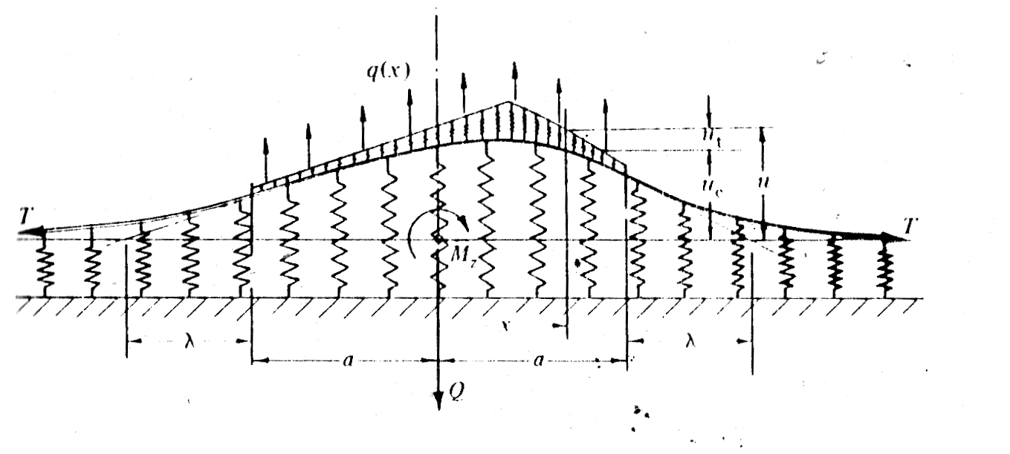
Figure.2. A dimensional model of the resistance of a tyre to lateral displacement

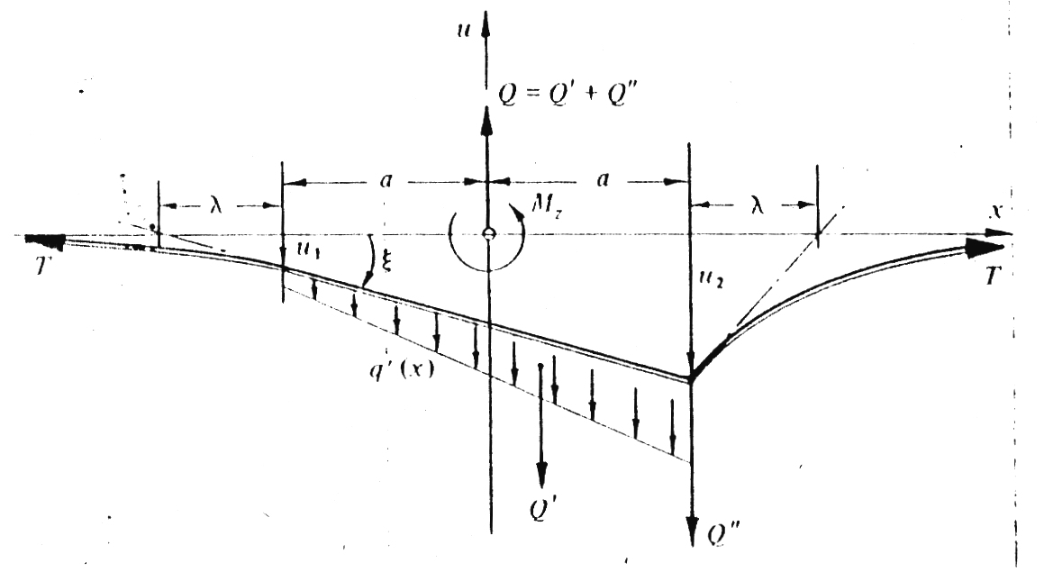

Figure.3. The deflected shape of the equatorial line together with the traction distribution

The deflected shape of the equatorial line is shown in fig.3 together with the traction distribution.is with solid bodies, the infinite traction at the trailing edge necessitates slip such that deflected shape u(x) has no discontinuity in gradient and satisfies the conditions q(x)=$μ$p(x) within the slip region. Calculations of the cornering force Q and self-aligning torque M_{x} by Pacejka assiming a parabolic presure distribution and taking $λ$=3a are show in fig. 4
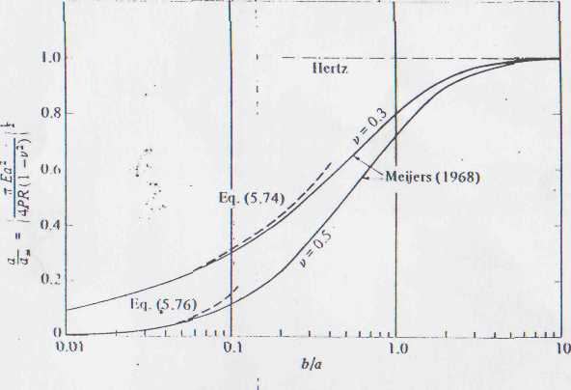
Figure.4. Calculations of the cornering force Q and self-aligning torque M_{x}

4. Elastic foundation model by finite element

The model is presented in fig.5, the finite plane rectangular elements. In fig.5 is presented the variation of contact pressure between the role and the rule .The process is iterative and every date when a node by the possible zone of contact is make in contact, the matrix of stiffness it is modified corresponding.
For the 19-27 nodes it was introduced the stiffness (springs) of one constant size for beginning about of Ox, Oy, directions, determinated by the measure of pressure of the 19-27 nodes.
If the pressure is changed the direction and it is negative and in the anterior node, it is positive, than the limited of the contact zone it’s in those case two nodes which interacted.
If the process is repeated from the intermediate nodes, we find the place where the pressure is changing the sign P>0.
In this way the x coordinate of the respective node represent the semi-breth of contact zone. If every nodes where is in contact, the stiffness matrix is differenced and the maximum stiffness of the elements by who we works carrying o
The dates are:
R=150 mm, D=300 mm, b=40 mm, ν=0.3, E=2.12*10⁵ Mpa, K=3*10⁸ Mpa – the maxim stiffness in this node If the pressure is changed the direction and it is negative and in the anterior node, it is positive, than the limited of the contact zone it’s in those case two nodes witch interacted.
If the process is repeated from the intermediate nodes, we find the place where the pressure is changing the sign P>0.
In this way the x coordinate of the respective node represent the semi-breath of contact zone. If every nodes where is in contact, the stiffness matrix is difference and the maximum stiffness of the elements by who we works carrying oel case and from this case of loads the semi-breath is a=63 mm.

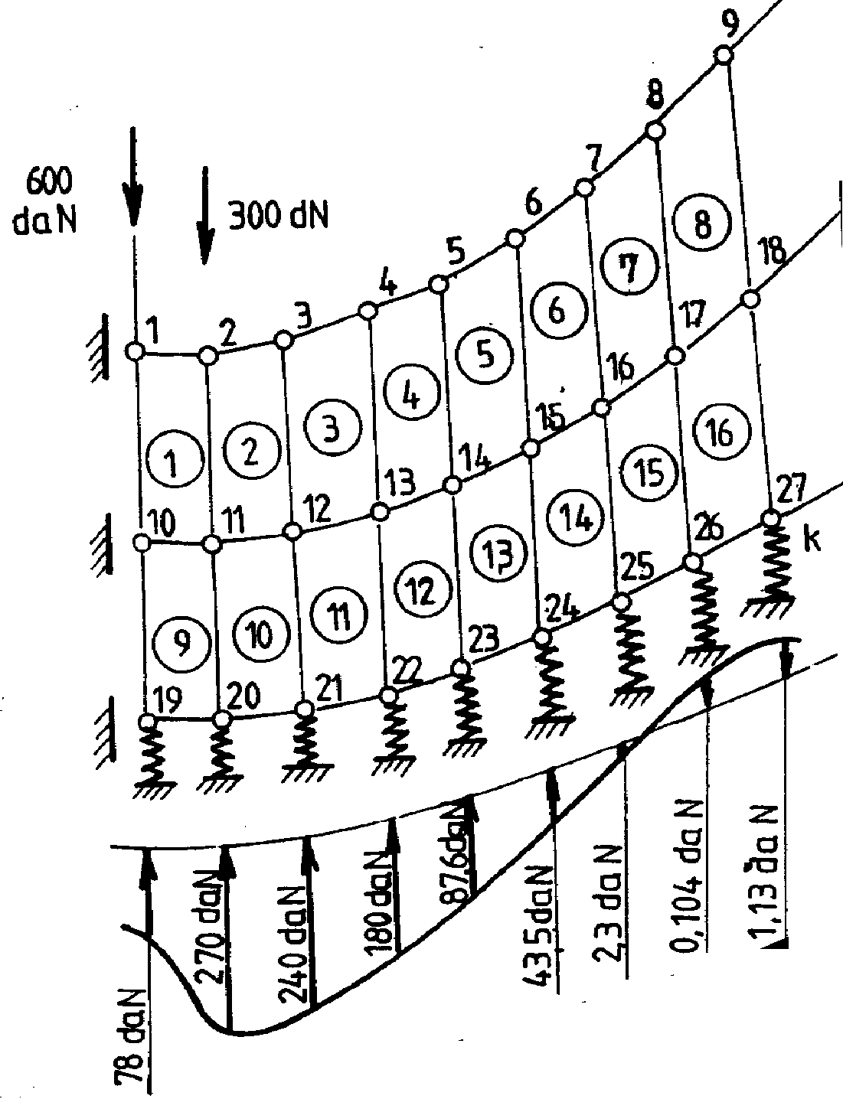
Figure.5 Elastic foundation by finite element

4. CONCLUSIONS

The normal elastic contact could be greatly simplified by modeling the elastic bodies by a simple Winkler elastic foundation rather than by elastic half space. The finite element method are one of the best methods to determinations the pressure of contact

References

[1] Enescu, I.: Aspecte ale mecanicii contactului la rulmenti, Editura Lux Libris, Brasov,2000
[2] Johnson,K.L.: Contact Mechanics ,Cambridge Universit Press Cambridge ,1985
[3] Enescu I. Tofan M.: Modelarea elastică a fenomenului contactului dintre solide Buletinul celei de-a XXI –a Conferințe Naționale de MECANICA SOLIDELOR Brașov, 1998
[4] Raoo, S.,S.,: The finite Element Method in Engeneering, Pergamon Press 1982
[5] ChangT.,Y.:Finite element solution of two-dimensional contact problems, Computer&Structures,nr.4,1987

