The 40th International Conference on
Mechanics of Solids, Acoustics and Vibrations &
The 6th International Conference on
“Advanced Composite Materials Engineering”
ICMSAV2016& COMAT2016
Brasov, ROMANIA, 24-25 November 2016

IMAGE PROCESSING USED FOR thermographic RESPONSE ASSESSMENT from THE HAND-FINGERS COMPOSITE STRUCTURE

Mihaela Ioana Baritz¹
¹ Transilvania University Brasov, Brasov, ROMANIA, e-mail: mbaritz@unitbv.ro

Abstract: This paper analyzed thermo-graphic images of the hand-finger complex structure by image processing methods. Thermo-graphic images of the system are taken by a FLIR infrared camera type. Thermo-graphic images are taken in different situations of induced effort in the fingers and hand and they are processed to highlight more dimensional features and especially those related to temperature distribution on the surface of the hand-fingers structure. Basic procedures for image processing to find the edges or contour mapping highlighted the more obvious areas where temperature variations in thermo-graphic images were assimilated with the same level of “false color”. Such analysis can punctual and zonal analyses these variations in relation to the entire outer surface of the assembly hand-fingers.
Keywords: image processing, thermic, hand-fingers,

1. INTRODUCTION

In vivo analysis from thermally point of view of fingers-hand-arm system is a challenge with considering all aspects of fluid flow blood epithelial tissue structure and the whole anatomy of the human body. [1]
As shown by the author in his work [2] “heat transfer in living tissues is a complicated process because it involves a combination of thermal conduction in tissues, convection and perfusion of blood, and metabolic heat production”.
For a better understanding of the mechanisms that occur within these structures it has developed a series of mathematical models to describe morphological changes under the influence of variations in the temperature. Also in his works the author [2] shows that “the most widely used bio-heat model was introduced by Pennes in 1948. Pennes proposed a new simplified bio-heat model to describe the effect of blood perfusion and metabolic heat generation on heat transfer within a living tissue. And, also a large number of bio-heat transfer models have been proposed to overcome the shortcomings of Pennes’ equation. [2,3]
These models include the continuum models which consider the thermal impact of all blood vessels as a global parameter and the vascular models which consider the thermal impact of each vessel individually”.
Throughout time were made other models based on mathematical and computational power configurations to determine with maximum precision and highlight these events unfolded in living tissues. These are composed of biological tissue like: the layers of skin, fat, muscle and bone.
Moreover, the skin is composed of two stratified layers: epidermis and dermis. An important parameter is the thermal conductivity of biological tissues having values between 0.21 – 0.64 W/mK (minimum for fat and respective maximum for blood).[4]

2. TEorethical aspects

Based on some important assumptions and as evidenced by his researches [2] “(blood is assumed to reach the arterioles supplying the capillary beds at the body core temperature, larger blood vessels in the vicinity of capillary beds play no role in the energy exchange between tissue and capillary blood, the flow of blood in the small capillaries is assumed to be isotropic), Pennes (1948) modeled blood effect as an isotropic heat source or sink which is proportional to blood flow rate and the difference between the body core temperature and local tissue temperature.
Therefore, Pennes (1948) proposed a model to describe the effects of metabolism and blood perfusion on the energy balance within tissue. These two effects were incorporated into the standard thermal diffusion equation, which is written in its simplified form as:
(1)
where ρ_{ti}, C_{ti}, T_{ti} and k_{ti} are, respectively, the density, specific heat, temperature and thermal conductivity of tissue. Also, T_{art} is the temperature of arterial blood, q_{m} is the metabolic heat generation and ρ_{bl}, C_{bl} and W_{bl} are, respectively, the density, specific heat and perfusion rate of blood.” [2]
Another model used by researchers is continuum model Wulff. He said in 1974 “that the heat transfer between flowing blood and tissue should be modeled to be proportional to the temperature difference between these two media rather than between the two bloodstream temperatures (i.e., the temperature of the blood entering and leaving the tissue). Thus, the energy flux at any point in the tissue should be expressed by follow equation:
(2)
where v_{h} is the local mean blood velocity.” [5]
Other study models were developed and tested in various applications in the form of complex continuum models (Klinger, Chen-Holmes, Weinbaum, Jiji, Lemons) but simplified (Weinbaum-Jiji). Another aspect analyzed in various studies has exemplified thermoregulatory control mechanisms of the human body. Thus defined “the cold and warm signals of human body for skin and core compartments as follows (Doherty & Arens, 1988):
(3)
(4)
(5)
(6)
where CSIG and WSIG, respectively, represent cold and warm signals of the human body, T_{sk,n} is neutral skin temperature (≈ 33.7ºC), and T_{cr,n} is neutral core temperature (≈ 36.8ºC).”[2]
Weinbaum and Jiji model is a mathematical model too complex and difficult to solve for the boundary conditions proposed for the three layers of the skin thermoregulatory mechanism.
As the author mentions in his research [5] “the WJ equation provides a simple expression for determining the effect of the Reynolds number on heat transfer.
Weinbaum and Jiji found that the heat exchange of the countercurrent vessels in diameter less than 0.05 mm is negligible and the only significant countercurrent vessels have a significant enhancement due to directed perfusion.”
In other research paper, Shih et al. [7] “proposed that heat transfer in living tissues, including blood flow in micro-vascular bed, could be modeled by solving a conjugate problem with the porous medium concept. This model contains a solid sub-domain for the tissue and a liquid subdomain for the blood that couple throughout their common boundary conditions. For the tumor tissue, neglecting the metabolic heat production term, it is possible to simplify the Pennes bio-heat transfer equation”.
Another application that uses the Pennes model is the model proposed by the authors D. Ratovoson et al. like “bi-dimensional multi-layer model in which the veins are considered as fluid continuous media. The epidermis, the dermis and the hypodermis are considered as solid continuous media in which the evolution of heat is controlled by the Pennes equation.” [3]
The two-dimensional numerical approach is then developed and applied based on the Pennes equation in two extreme cases of heating / cooling of a tissue in vivo, positioned horizontally and vertically to highlight the importance of blood fluid flow and its effects on thermoregulation process. [5,6,10]

3. EXPERIMENTAL SETUP

a specific experimental structure for thermo-graphic imaging and analysis in order to highlight the characteristics of temperature variation on the surface epidermis-hand fingers was designed and developed. In the experimental setup was used: a sample of subjects, an assembly of devices and a computer system required to apply on high performance image processing procedures. Thus, through infrared video-camera was acquired a full set of images for hand (right and left) of some subjects who made the same activity of inducing controlled effort. This set of pictures has used to image processing and analysis in order to establish the best and accurate information about the variation of the temperature of the hand-fingers.
Induction effort level was controlled via a vibratory plates and system to develop the vibrations in the hand and fingers (Figure 1) systems that have been used in the same way for all subjects in the sample. [7]

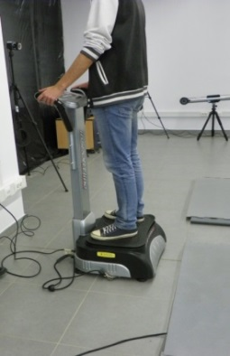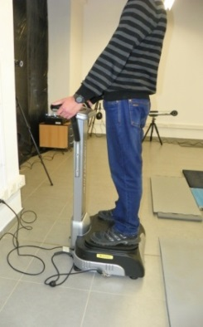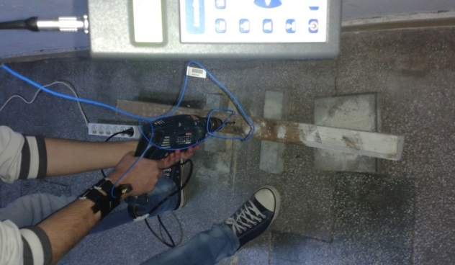
Vibration plate to transmit the vibration through hands and feet
Accelerometer
HVM
wood
Figure 1: Systems to induce controlled effort into hands and feet [9]

Before and after the induction level of controlled effort, the thermo-graphic images of the hand and fingers were taken (with FLIR thermo-graphic video-cam) and introduced in procedure of image processing using software package QuickReport ver.1.0 (Fig.2). The software package is used to transfer images from the video-cam and creating database.
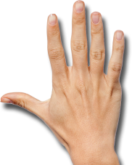
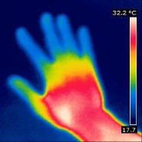
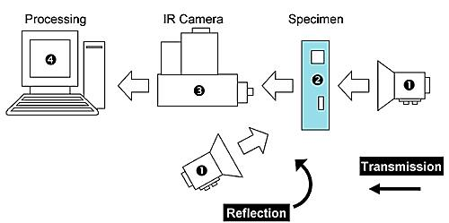

Figure 2: Experimental setup [8,9]

Start
ROI
Segmentation
Trace contour
Layer
T⁰ measure
Figure 3: Image processing flux (ROI = range of interest) [9]

Operating flow applied to the images is represented in Figure 3 and is based on segmentation procedure, find edges and trace contour to separate areas of hand-fingers uniform temperature. [10]

4. RESULTS

In the initial phase of images acquisition by the thermal video-cam, the software package allows a preprocessing step which can carry several forms of image that will choose those images with content most suitable procedures for tracing contour or finding edges.
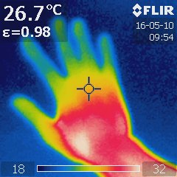 a) 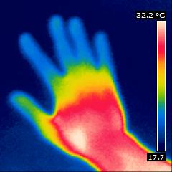 b) 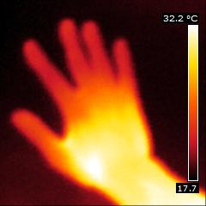 c)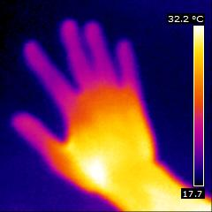 d)
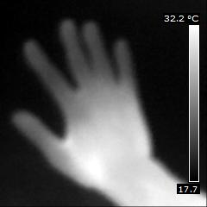 e) 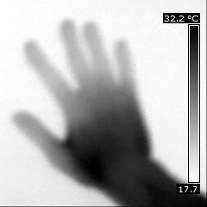 f) 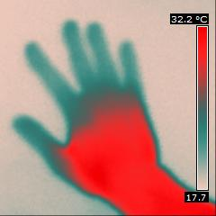 g) 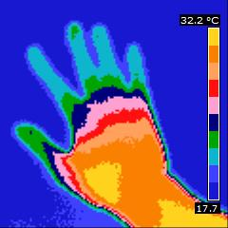 h)
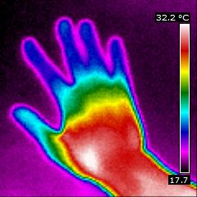 i) 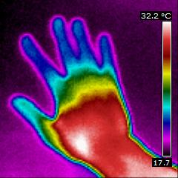 j) 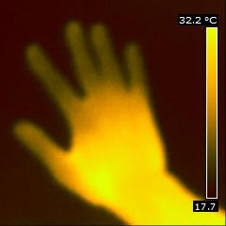 k)
Figure 4: Sample of the same picture of hand in different pallets:
a) initial image from FLIR thermo-vision camera, b) image without spot point, c) glowbow image, d) iron image, e) grey image, f) invert grey image, g) greyred image, h) medical image, i) iron image, j) ironHi image, k) yellow image [9]
a) 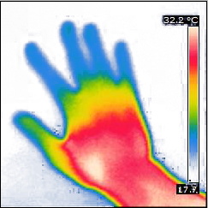 b)
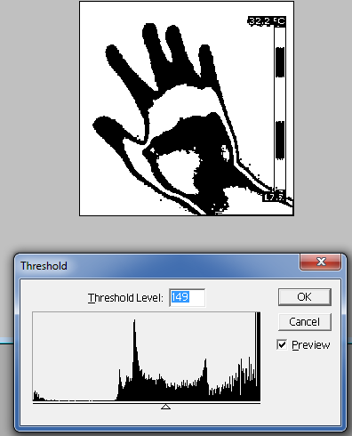 c) 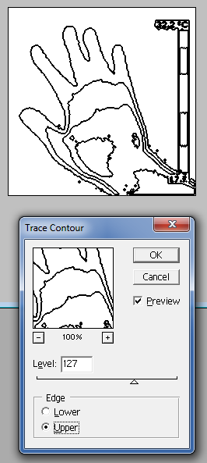 d) 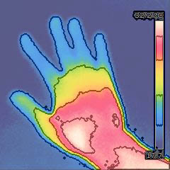 e)
Figure 5: Initial image (a), segmentation operation (b), threshold level for segmented image (c), trace contour at 127 level (d), transform in layer and superimposition on the initial image (e) [9]

Applying this sequence of image processing operations on the image b) from Fig.4 was obtained representation from Fig.5, which were able to isolate areas with the same temperature variation on the surface of the hand. Temperature measurement in segmented areas and outlined by previous operations are determined with greater accuracy compared to the initial measurement of thermo-graphic images, the temperature zones are defined in terms of the variation intervals of about 10⁰C and is 3D graphical representation (fig.6).

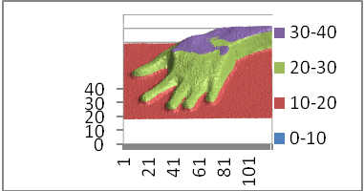
Figure 6: Initial temperature measured by QuickReport ver.1.0. software [9]

For another maneuver for determining the temperature variation areas were used variants presented in Fig. 4 that were applied find edges filters and then overlay the layers on the original image. These maneuvers have led contour errors - incorrect or incomplete - and in some cases even whole areas with substantial variation of temperature were not detected (fig.7).

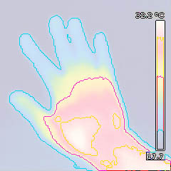xx 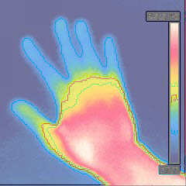xx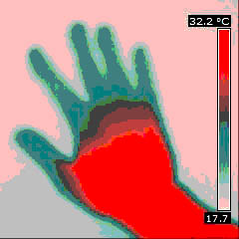
Incorrect contour
Incomplete contour
Missing contour
Figure 7: Other variants of image processing of initial image to establish the temperature variation areas [9]

Another example of image processing for highlighting areas of temperature variation was performed using imaging variant type "medical" which has been compared with the image shown in Fig. 5 resulted from the procedure. This comparison highlights areas clearly defined gradients of temperature and can also determine the degree of mediation of these areas (fig.8).

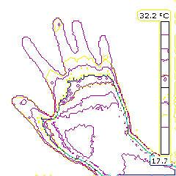xx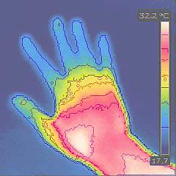xx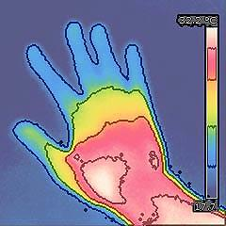
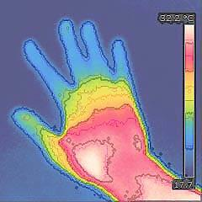
Average area
Average area
Figure 8: Comparing medical type image with initial image to establish the average temperature areas [9]

Temperature variation measured on fingers and hand surface using thermo-graphic images show temperature decreases in the fingers due of "white fingers" syndrome in the same time with the temperature gradient increases at the posterior surface of the hand up to the wrist (fig.9).
Fingertips
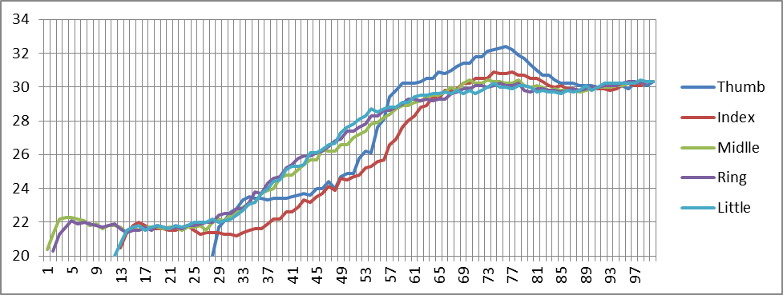xx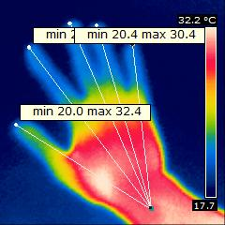
Figure 9: Temperature variation from fingers to wrist [9]
Wrist
This gradient are between the limits of 20⁰-32.4⁰C which represents an average increase of temperature from fingertips to wrist about 62%. Where subjects were exposed to controlled effort may increase this percentage up to 71.3% which change hand dexterity, wrist flexibility and determine a structural change in the fingers.

5. CONCLUSION

The procedure to analyze the temperature gradient variation using image processing strategy has allowed highlighting areas with uniform or varying temperatures, allowed the establishment of the zones and also allowed getting a quick response in determining the areas most exposed to the cold hands syndrome.
As future applications of this research identifies the need to analyze the influence of thermal changes of the entire arm-hand-fingers complex on the level of energy consumption necessary for carrying out activities or malfunctions on the evolution of the entire human body (like loco-motor system). [8,11]

REFERENCES

- Callister W., Fundamentals of Materials Science and Engineering, John Wiley&Sons, New York, 2001;
- Zolfaghari A. and Maerefat M., Bioheat Transfer, Ch.9 Developments in Heat Transfer, Edited by Dr. Marco Aurelio Dos Santos Bernardes, www.intechopen.com, 2011;
- Ratovoson D., Jourdana F., Huon V., A study of heat distribution in human skin: use of Infrared Thermography, E P J Web of Conferences 6, 21008, http://www.epj-conferences.org, 2010
- Mihir Sen Bioheat Equations Heat transfer in blood vessels and tissues, presentation March, 2013;
- Tzu-Ching Shih, Hong-Sen Kou, Win-Li Lin: Effect of effective tissue conductivity on thermal dose distributions of living tissue with directional blood flow during thermal therapy. Int. Comm. Heat Mass Transfer 2002;29: 115-126.
- Shahnazari M., Aghanajafi C., Azimifar M., Jamali H., Investigation Of Bioheat Transfer Equation Of Pennes Via A New Method Based On Wrm & Homotopy Perturbation, www.arpapress.com/Volumes /Vol17Issue3/ 2013;
- Braun B., Non contact displacement transducers implementation as stage in the development of a flexible low cost coordinate measuring machine, Applied Mechanics and Materials, vol 772, 2015;
- Barbu, D.M. The Effects of Radiation on the Eye in Industrial Environments, Annals of the Oradea University, Volume XIV, Issue 2, pp.7-12, 2015;
- Personal archive
- http://theses.ulaval.ca/archimede/fichiers/23016/ch02.html
- Braun, B., Roşca, I., Locomotory Diseases Influence on Body Equilibrium and Balance, OPTIROB, Applied Mechanics and Materials, Vol. 555, 2014;

