The 40th International Conference on
Mechanics of Solids, Acoustics and Vibrations &
The 6th International Conference on
“Advanced Composite Materials Engineering”
ICMSAV2016& COMAT2016
Brasov, ROMANIA, 24-25 November 2016

STRUCTURAL ANALYSIS OF sportive goggles BEHAVIOR

Mihaela Ioana Baritz¹
¹ Transilvania University Brasov, Brasov, ROMANIA, e-mail: mbaritz@unitbv.ro

Abstract: This paper analyzed the complex structures used in sports eyewear. Samples of the type intended for ski and swimming goggles were analyzed in terms of mechanical behavior. The samples were analyzed also by digital microscopy in terms of the influence of various substances or variations of temperature on material quality. The captured images are taken by digital microscopy software for highlighting the structural changes. Samples of glasses were chosen based on use age and also as different variations in form, material and design. In the final part of the paper are presented the conclusions and future research directions.
Keywords: sportive goggles, microscopy, composite structure, mechanical behavior

1. INTRODUCTION

In the current phase it is estimated that two thirds of the population practice sports and of these about 60% are in need of visual correction. It requires a sporting spectacle meet aesthetic requirements of customers without compromising their optical quality. [1]
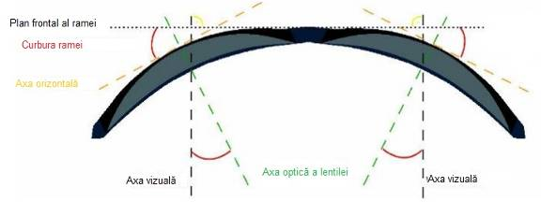xx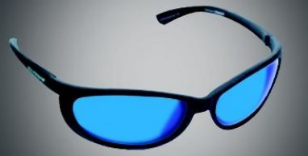
Figure 1: Shape of sportive spectacles [1]

The main brands of sport goggles have optimized optical properties of the lens so as to minimize aberrations and to increase wearer comfort, producing also lens with correction for sports spectacles.
The characteristic shape of glasses is greater curvature of the frame (fig.1), which produces some optical defects such as prismatic effects, oblique astigmatism, refractive errors, but increases the field of view by 30%. Some dimensions of the frame can be adapted individually like pantoscopic angle, vertex distance, inter-pupillary distance, even the curvature of the frame (fig. 2). [1]
For example, the material of the spectacles frame made for skiing can be: Polycarbonate; Grilamid TR-90; Polymethylpentene PMP; TPEE - thermoplastic elastomer; TPU - thermoplastic polyurethane; Cellulose acetate.
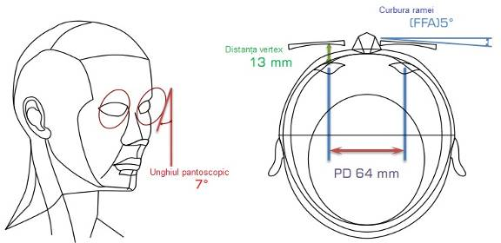
Figure 2: Spectacles personalized dimensions [1]

These materials have a number of qualities specified by the manufacturer such as hardness, impact and scratch resistance, flexibility, light weight, soft, comfortable, non-allergic, durable etc. [2]
The lenses used for the construction of ski goggles presents a series of specific features such as: Polycarbonate lenses are lightweight, thin, durable and impact and scratch resistant, naturally absorb UV radiations; Polarized lenses reduce glare and brightness irritating. The contrast is much better, the view is clear, the objects are easily identified. They allow the wearer to quickly notice changes in texture of snow or appearance of ice areas to react in time. They are suitable for all outdoor activities, including driving cars and also for hypersensitive people to light. [2]
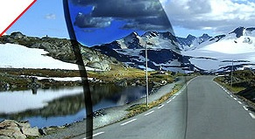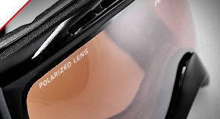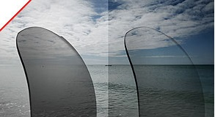
Figure 3: Lenses with polarization, photo-chrome and with yellow filter [2]

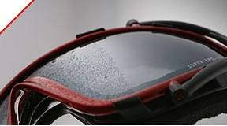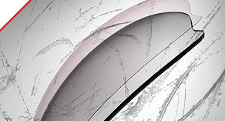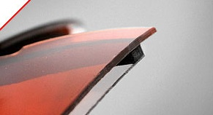
Figure 4: Anti fog protection, UV protection, anti-scratch protection and double lens system [2]

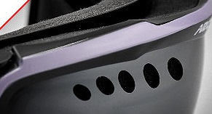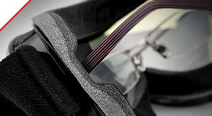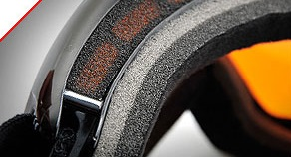
Figure 5: Ventilation system, anti-impact foam layer and rigid layer for ski spectacles [2]

For ski goggles are necessary other features to ensure comfort, adaptability and flexibility in use by the human factor. Thus, mounts, accessories and glasses constructive elements must be non-allergic and provide air ventilation on the face, sweat absorption, proper positioning without sliding or blocking and impact protection (fig.5).
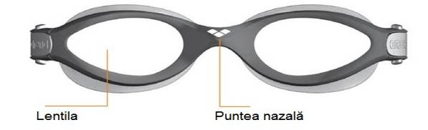xx 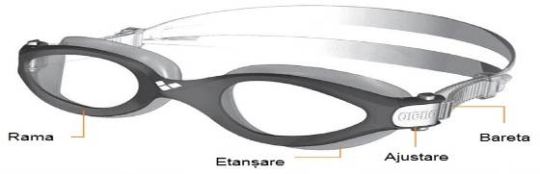
Figure 6: Swimming spectacles and accessories [3]

The glasses used in aquatic sports (swimming, water polo, kayaking) are different because they have to face the aggression of water quality and action speed. Lenses for these glasses have to be tough, durable, resistance at impact and superior clarity. The lens can be made of polycarbonate or cellulose polymer for more flexibility. Depending on the width, height and curvature of the lens, it can provide a side view and front above the normal. The lens may have a mirror or polarized to protect against glare and harmful UV radiation or an anti-fog coating. [3] Nasal bridge can be manually or automatically adjustable in width, taking the form of facial or unusual facial shapes, you can use the additional attached decks (fig. 6). The frame should fit perfectly on facial shape and be sealed with a hydrodynamic design, very light and not leave traces after wear. The sealing system can be made of hypoallergenic silicone or a TPR layer for spectacles without fittings. Also it can apply a layer of silver over neoprene seals to make them hypoallergenic. The manual adjustment of the strap is simple and effective, with the possibility of adjusting during wear, and the bar is made of liquid silicone and is flexible and durable. [3]

2. experimental setup

To start behavior analysis of used skiing and swimming goggles have chosen three variants of wear glasses for a long time and a new pair each having similar characteristics.
These types of glasses were subjected to a series of tests (compressive deformation, immersion in solutions, aggression by scratching with different material, temperature variation) to track behavior of lens, mount and accessories that provide rigidity and impact resistance.
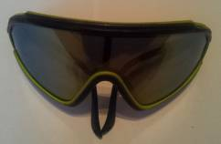x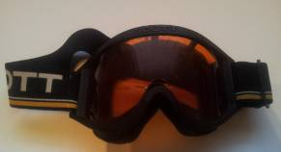x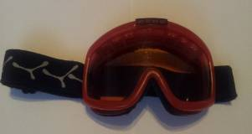
Figure 7: Ski spectacles [4]

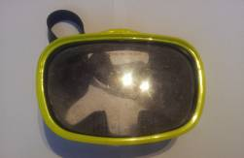x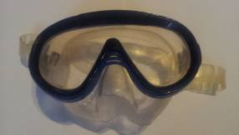x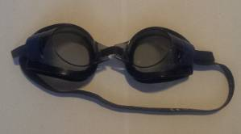
Figure 8: Swimming spectacles [4]

The first attempt at having undergone constructive elements of ski goggles was compression request of the area, namely active glasses lens.
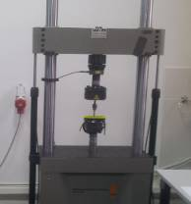x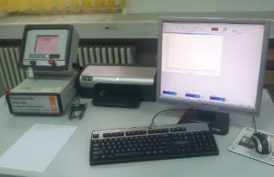x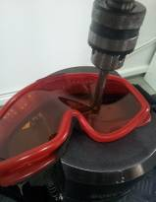x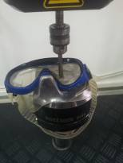
Figure 9: Compression testing machine and ski/swimming spectacles samples [4]

This test was done on a hydraulic machine type Walter + Bai AG with a 60 kN load cell (fig.9).
Upload speed was set at 10 mm/min and performed a quasi-static compression test of 6 pairs of ski goggles.
The test results are influenced by many factors, such as indenter shape (cylindrical and flat head), the material and the length of glasses, frames elasticity.
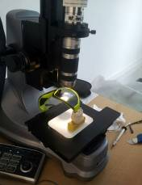x 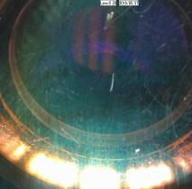x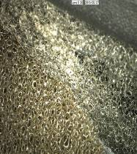 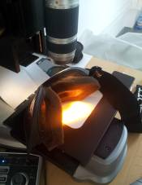
Figure 10: Digital microscope type Keyence and image samples [4]

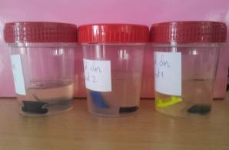 x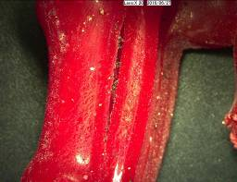x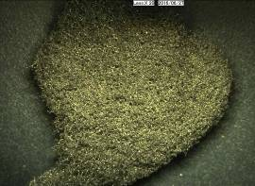x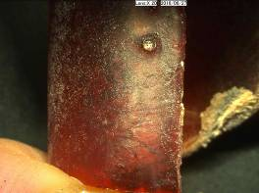
Figure 11: Spectacles samples in temperature variations [4]

To view the effects of substances on glasses lens surfaces has been used digital microscope type Keyence, having a magnification of 20x-200x and 1688x1248 pixels for sensitive surface (fig.10).
The immersion of samples of lenses, frames, flaps or other construction materials glasses for 168 hours in different solutions and at different temperatures (-18⁰C and + 100⁰C) took into account the environment in which these glasses variants are used (fig.11).

3. RESULTS

The results of experiments were accomplished by determining strain curves of the lens material, in all variants of glasses. Also were recorded the materials transformations images, materials that were “mechanic assaulted” (scratching with metal, wood and stone) or with different chemical solutions (chlorine, 50% saline, hard water).
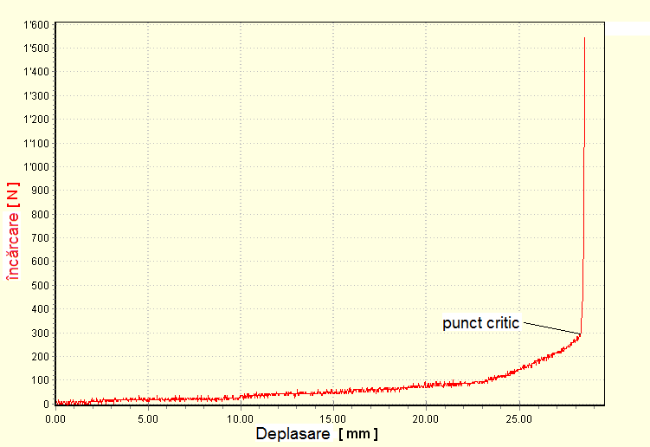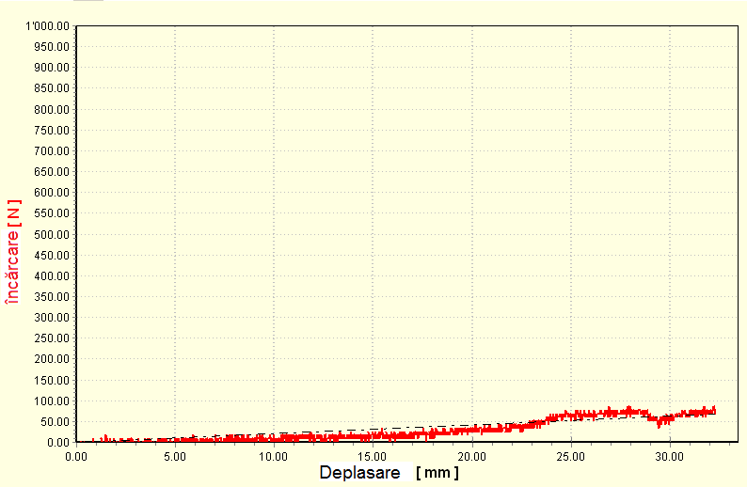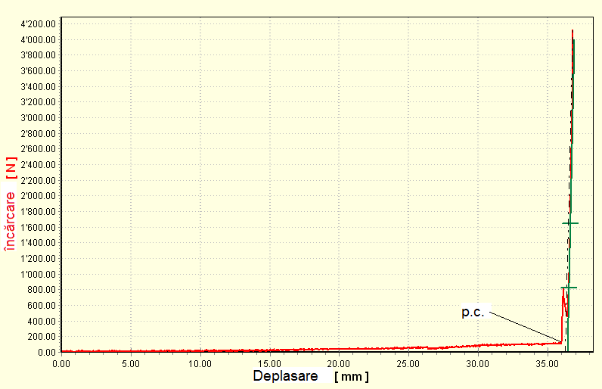
Figure 12: The graph deformations of different variants of ski goggles [4]

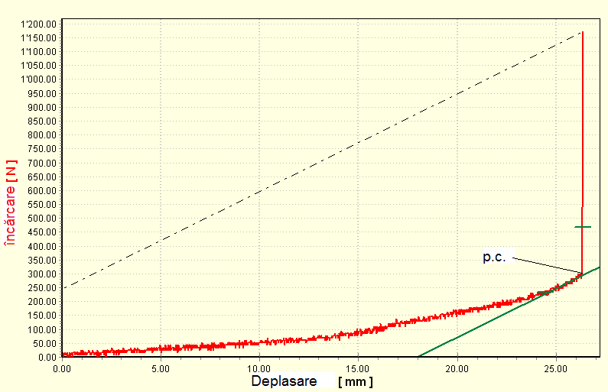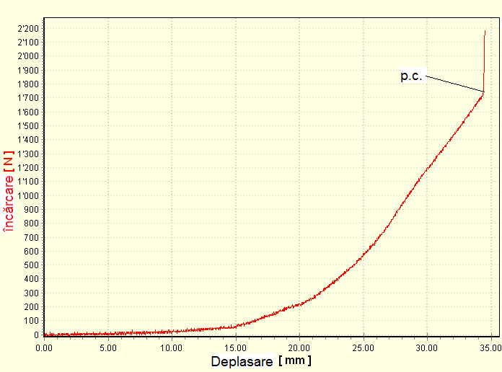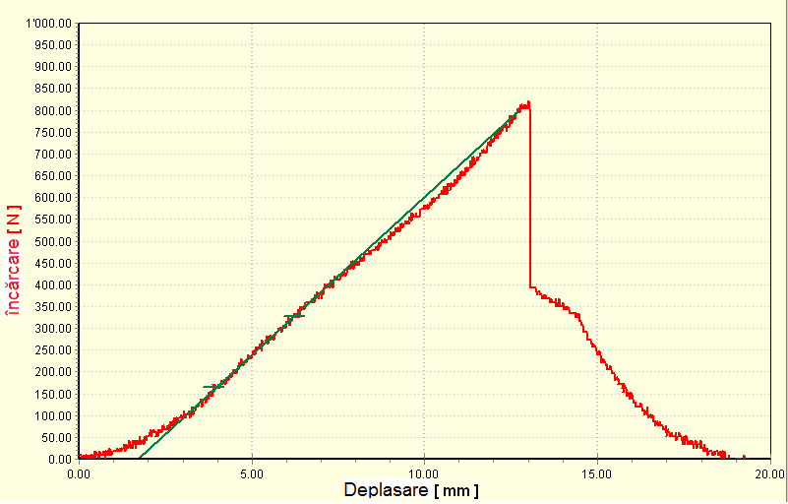
Figure 13: The graph deformations of different variants of swimming goggles [4]
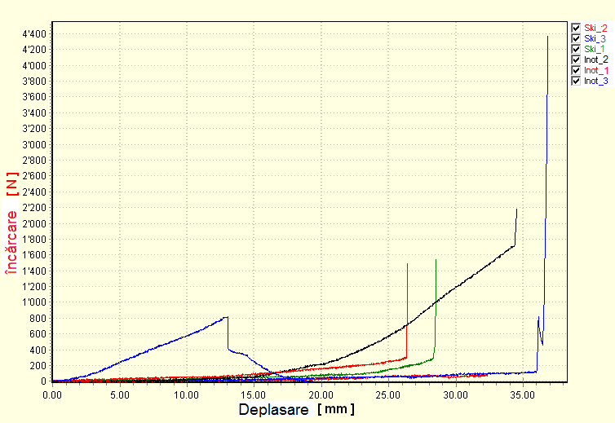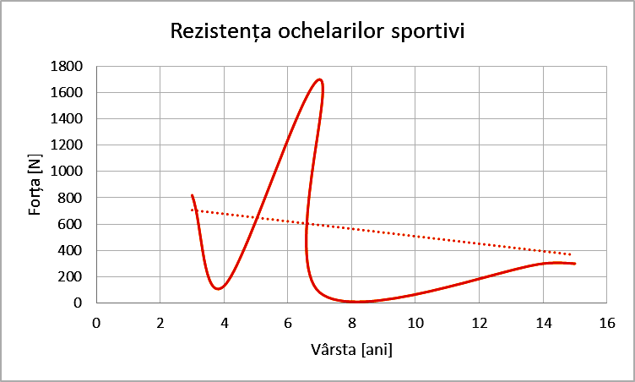
Figure 14: Variants of goggles deformations graph and force variation in accordance with used goggles age [4]

The glasses used for this experiment had over 4 years to 15 years of use age, causing an "aging" of the material and a possible change in their optical and mechanical characteristics. This aspect is evidenced by the different level of force that yielded lens materials and the average change indicates a decrease in compressive forces with increasing of glasses age (fig.14).
In terms of lens surfaces damage for ski or swim glasses by scratching with hard materials (wood, stone, metal) can observe different behaviors, shapes and sizes scratches according with material used in the conditions of applying the same scratching force (fig.15).
These scratches became in time stress concentrations that can cause damage to glasses during its activity (resulting in personal injury) or when stored.
Aggression of substances with which these glasses come in contact while using increase faster the risk of damage possible occurrence of accidents.
In addition, temperature variations that are undergoing goggles in incorrect way can cause an accelerated "aging" of the lens or material they are made of mounts and accessories.
These events were highlighted in this experiment by immersing for 168 hours of sample lens in saline 50%, chlorine, hard water and viewing changes occurred in this period, using a digital microscope. If case of swimming goggles, they were introduced in the mentioned solutions and behaved differently, especially for materials mounts and accessories glasses.

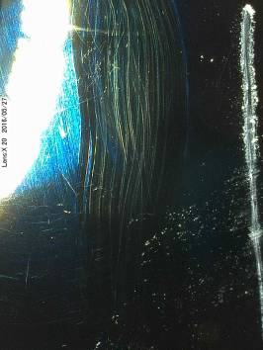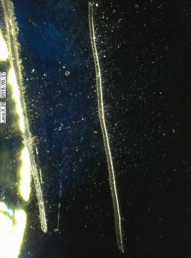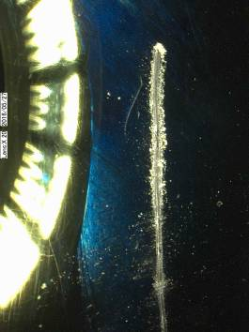
Figure 15: Ski goggles lens surface scratched with wood, metal and stone [4]
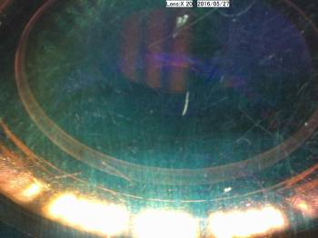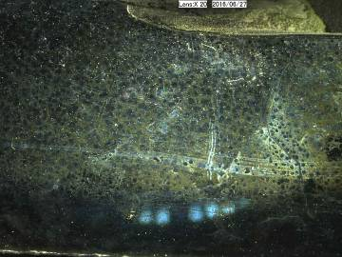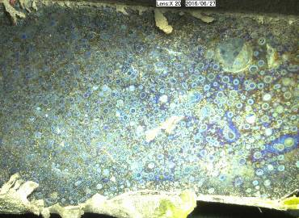
Figure 16: Ski goggles lens surface before and after (front and back) high temperature exposure [4]
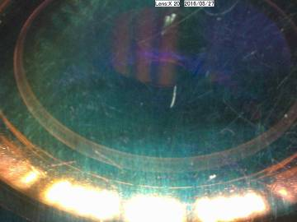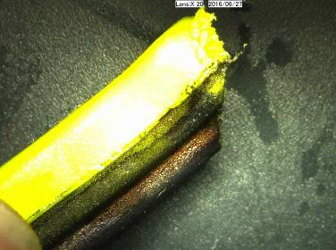
Figure 17: Ski goggles lens surface before and after (lens and frame) low temperature exposure [4]
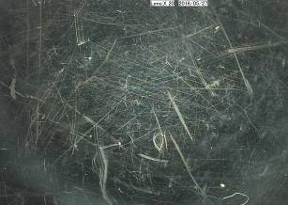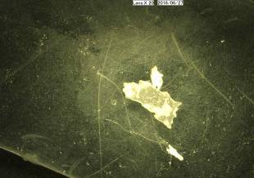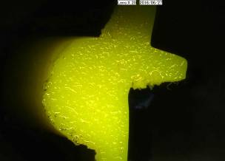
Figure 18: Swimming goggles lens surface and frame before and after immersion in hard water [4]
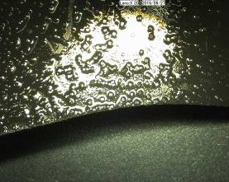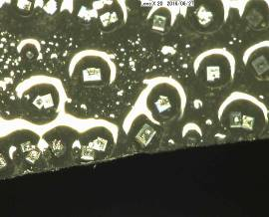
Figure 19: Swimming goggles lens surface and frame after saline immersion (magnification 20x and 100x)[4]
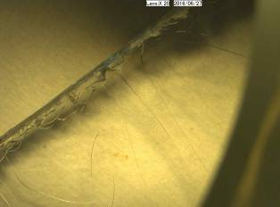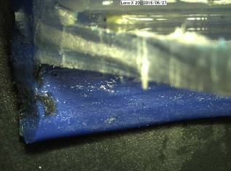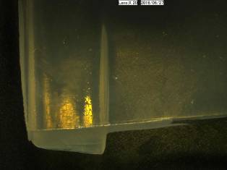
Figure 20: Swimming goggles lens surface and frame after chlorine immersion [4]

For a detailed and comparative analysis of the effects of "mechanical and chemical aggression" on surfaces of lenses and spectacle frames it was used image processing procedure applied to the sample images taken from digital microscope. A case presented in fig.21 indicates the development of cracks in composite layers of swimming goggles lens after immersion in chlorine solution for 168 hours. These cracks are analyzed by the image processing procedure (trace contour, layer, filter threshold and composition) with the aim of marking and measuring the affected areas.
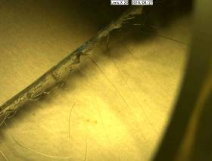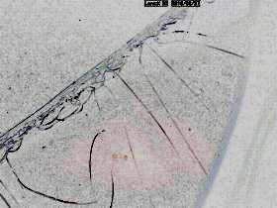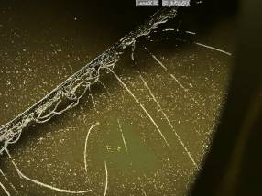
Figure 21: Swimming goggles lens surface visualization by image processing

Thus, we applied a series of filters, contour tracing procedures and dimensional measurements of cracks, scratches or deformities highlighted in skiing and swimming lenses samples exposed to the mechanical, thermal or chemical effects. [5]

4. CONCLUSIONS

Through these procedures, we obtained some conclusions summarized as follows: scratches controlled made with different material on the lens surface caused the occurrence of stress concentrations, changes in transparency, micro abrasions that can accumulate waste; in case of exposure to the temperature variation, the lens will be opacifed, anti-reflex layer will be destroyed (though not visible to the naked eye), the frame channel and even lens was deformed, and the sponge will no longer provide adequate ventilation, deteriorating skin around eye; lens anti-reflex layer destroyed by the cold and stress concentration points from the lens will create cracks; hard water contributes to the dulling lens and deposition of minerals on the materials surface. [6]
Over time, these deposits accumulate damage and diminish clarity of vision.
In time, from saline, the salt particles are deposited on the lens and the frame to destroy silicone surface, blurred vision and may cause irritation to the wearer.
Exposure to chlorine solution shows destruction gloss surfaces, silicon becomes rough and causing possible skin irritation and the lens becomes opaque and crack faster, with a higher impact hazard.
Therefore, using of old glasses, may occur hazards for visual system and is recommended to be replaced in time to not unleash visual dysfunction or discomfort in visual behavior.
In future research are provided to perform detailed analyzes of shapes, sizes and formation directions of cracks which can affect the lens glasses in several sports branch. Also, some performance improvement solutions in use of sports glasses are provided to be analyzed. [7]

Acknowledgements

In these experiments we’ve developed the investigations with equipments from ”Advanced Mechatronic Systems Research Center - C04” and optometric laboratory at University Transylvania of Brasov. We want to express gratitude to the students from Optometry study program for their help in this research.

REFERENCES

- Broșura de prezentare Nova Sport WLCLENS; http://www.wlclens.co.uk/downloads/nova-sport/Brochure/nova-sport-product-presentation.pdf ;
- Technology. Arctica sports eyewear, http://www.arctica.eu/t30/technology.html;
- https://www.arenaswimwearstore.com;
- Personal archive
- User manual of digital microscope type Keyence, 2010;
- Braun B., Non contact displacement transducers implementation as stage in the development of a flexible low cost coordinate measuring machine, Applied Mechanics and Materials, vol 772, 2015, p.312-317.
- Barbu, D.M. The Effects of Radiation on the Eye in Industrial Environments, Annals of the Oradea University, Volume XIV, Issue 2, pp.7-12, 2015;

