MATHEMATICAL MODEL OF THE MONOMASS PEDESTRIAN IN INTERACTION WITH THE VEHICLE

Dr.eng Adrian ŞOICA
Transilvania University of Braşov

Abstract: The hereby paper advances the single mass generalized analytical model of the touring car- pedestrian interaction in case of collision. The aim of the paper is to reconstruct the pedestrian kinematics at touring car-pedestrian primary impact by considering anatomic data and touring car geometry and impact force.

1. Introduction

Ever since the vehicle was created at the beginning of the XX-th century and throughout its development, the first victims of the „high-powered cars” of the time were recorded. Their number increased year by year, and as a result, together with the development of the car industry in the fifties – sixties new fields of study have immerged: technical-oriented vehicle passive safety and technical and juridical-oriented road accidents technical evaluation.

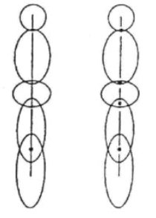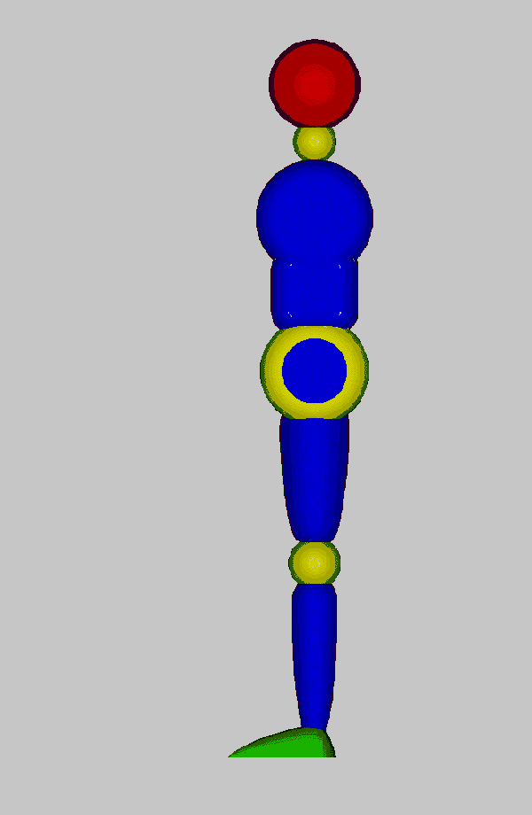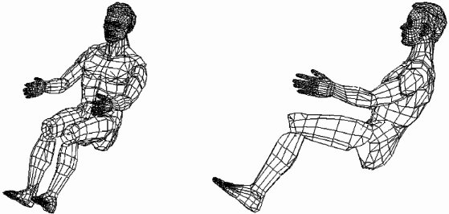
Figure 1 Human models used when investigating accidents

In order to investigate these undesirable events there have developed a series of mathematical models aiming at determining the pedestrians trajectories after the impact with the vehicle.
In the end, the computerized mathematical models, based on the dynamics of the rigid bodies, were used in order to simulate the vehicle-pedestrians impact. Other researchers examined the efficacy of a bidimensional model with various complexity degrees. The commercial programme MADYMO was used in order to create bidimensional models of the pedestrian having two, five or seven rigid body regions as well as a tridimensional model whose body is made up of fifteen segments. The tests results were compared with the ones obtained following the tests on dummies.
Unfortunately, most of the pedestrian models are based on the dummies characteristics to a great extent and as a consequence the simulations results are still limited as regards the accuracy required. One exception is reflected by the works belonging to Hoyt and Chu that used a bidimensional version of the MADYMO in order to develop a nine-segment model for the adult pedestrian. Consequently, it is considered that for road accidents investigation implying pedestrians, from the point of view of the road technical expert the less sophisticated mathematical models are sufficient. The present paper aims at developing a mathematical model for a mono-mass pedestrian.

2. Single-mass pedestrian model

In figure 2 there is drawn up the process through which a solid body is hit in a point O₁ = O₂ that is eccentric towards the O₂y₂ axes. The xOyz axes system is fixed, when connected to the ground, the x₁O₁y₁z₁ system is mobile when in translation movement towards the fixed system, and the x₂O₂y₂z₂ system is connected to the body whose centre of mass is to be found in the C_{g} point. The point O₁ = O₂ stands for the instantaneous rotation center and the body rotates around it with the ψ, θ şi ϕ angles. The xOyz system is connected to the mobile system x₁O₁y₁z₁ through the position vector r₀ and to the x₂O₂y₂z₂ system through the position vector of the centre of mass r_{c}. O₁ stands for the instantaneous rotation centre of the pedestrian during the impact with the vehicle. Through the rotation of the above mentioned angles, around the system’s axes there are determined the vectors of the new positions axes have on the mobile system, connected to the body, x₂O₂y₂z₂.
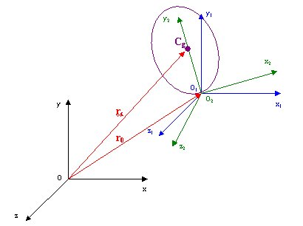
Figure 2 Coordinates of the single-mass pedestrian during the impact process
It is considered that the body rotation will cover three phases, as follows:
- Rotation with angle ψ around the axe y (y₁ = y₁')
- Rotation with angle θ around the axe z (z₁' = z₁'')
- Rotation with angle ϕ around the axe x (x₁'' = x₂)
Once the calculations completed there are going to be obtained the relations for the vectors of the x₂O₂y₂z₂ coordinates system.
There is noticed that the vector of the axe y₂ stands for j_{2,} and it has the following position towards the xOyz system:
$\vec{j_{2}}=\vec{u_{\text{cg}}}=\left\{\begin{matrix}u_{x} \\ u_{y} \\ u_{z}\end{matrix}\right\}=\left\{\begin{matrix}\text{sin}(Ψ)⋅\text{sin}(ϕ)−\text{cos}(Ψ)⋅\text{sin}(θ)⋅\text{cos}(ϕ) \\ \text{cos}(θ)⋅\text{cos}(ϕ) \\ \text{cos}(Ψ)⋅\text{sin}(ϕ)+\text{sin}(Ψ)⋅\text{sin}(θ)⋅\text{cos}(ϕ)\end{matrix}\right\}$ (1)
Due to the fact that the movement in the tridimensional space is more difficult to be studied for bodies, there is going to be analysed only the movement in yOx plan. It will result only one rotation around Oz axe with angle θ, see figure 3, and the relation (4) becomes:
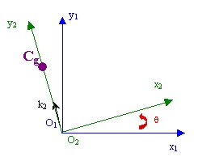
Figure 3 Diagram determining the vectors in case of model’s plan rotation
$\vec{j_{2}}=\vec{u_{\text{cg}}}=\left\{\begin{matrix}u_{x} \\ u_{y} \\ u_{z}\end{matrix}\right\}=\left\{\begin{matrix}−\text{sin}(θ) \\ \text{cos}(θ) \\ 0\end{matrix}\right\}$ (2)
The position vector of the body centre of mass r_{c} will be:
$\vec{r_{c}}=\vec{r_{0}}+O_{2}C⋅\vec{u_{\text{cg}}}$ (3)
it results the equations of the body centre of mass coordinates on x and y axes:
$\left\{\begin{matrix}x_{c}=x_{O}−O_{2}C⋅\text{sin}(θ) \\ y_{c}=y_{O}+O_{2}C⋅\text{cos}(θ)\end{matrix}\right.$ (4)
For the position vector of the impact point that is also instantaneous centre of rotation (r_{O}) in the first phase, there can be chosen a variation law in case the vehicle is running at the moment of impact or it can be null if the vehicle’s brakes are applied at the moment of impact.
Assuming the lack of a law of motion for vector r₀, by adapting the notations according to figure 4 and by derivating the former relation there will be successively obtained the velocities and accelerations of the body centre of mass.
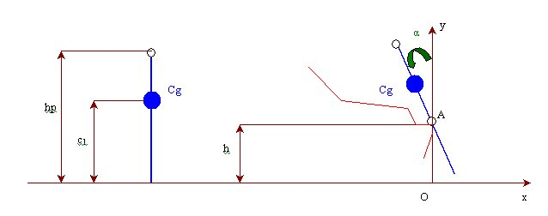Figure 4 Model of the vehicle-single-mass pedestrian impact
(5)
In order to simplify the calculations there will be drawn up a system of the following form:
(6)
that can be written under the form:
$\left\{a\right\}=\left[A\right]⋅$ (7)
where [A] stands for the pedestrian’s angular acceleration coefficients matrix;
[B] stands for the pedestrian’s square angular acceleration coefficients matrix;
{a} stands for the vector of the body translation and rotation accelerations.
According to figure 5 for the case of the single-mass pedestrian the equations of equilibrium are as follows:
$\left[\begin{matrix}m1 & 0 & 0 \\ 0 & m1 & 0 \\ 0 & 0 & J1\end{matrix}\right]⋅$ (8)
that may be written under a simplified form as follows:
$\left[M\right]⋅\left\{a\right\}=\left\{Q\right\}$ (9)
where: [M] stands for the matrix of both the mass and pedestrian’s inertia moment;
[Q] stands for the matrix of the forces actuating upon the pedestrian;
{a} stands for the vector of the body translation and rotation accelerations.
Aiming at finding out the unknown out of the equations (7) and (9) by multiplying on the left with [A]^{T} there will be obtained:
${\left[A\right]}^{T}⋅\left[M\right]⋅\left[A\right]⋅$ (10)
where:
$\left\{Q_{\text{ext}}\right\}={\left[A\right]}^{T}⋅\left\{Q\right\}$ (11)
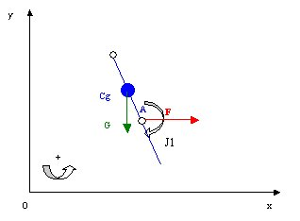
Figure 5 The diagram of the forces actuating upon the monomass pedestrian

The relation (10) may be written under the form:
$\left[A1\right]⋅$ (12)
The relation (12) represents the simplified form of the differential equation in the unknown α = α(t). By replacing it in the relation (4) there can be found out the coordinates of the pedestrian’s body centre of mass.
For a pedestrian whose height is of 1,80 m, and the mass of 73 kg and the height of the impact point at 0,51 m from the ground, the graphical representation of the differential equation solution of grade two led to a regression curve whose equation may be approximated through a polynomial function of grade two the expression of which is as follows:
$α=0\text{.}\text{0011}⋅t^{2}+0\text{.}\text{1363}⋅t$ (13)
The graphic of the function described through the relation (13) is presented in figure 6.
The relations (4) and (12) will help draw the trajectory of the pedestrian at the moment of his impact with the vehicle. Therefore the contact point “O1” = “O2” between the vehicle and the pedestrian will be attributed a law of motion.

3. Conclusions

The use of simplified models reduces the time and the calculation expenses. The analysis of both theoretical and experimental results outlines the fact that the model submitted to research lends itself to the study of technical experts; that is why a great importance is given not so much to the determination of the curve described by the pedestrian after the impact but to the determination of the vehicle’s impact velocity. The present model proposed as such helps us determine also the times at which the pedestrian hit the hood or the vehicle’s windshield that hit him.

Figure 6

Bibliography

[1] Asandei C., Cercetări asupra dinamicii evenimentelor rutiere pieton automobil, teza de doctorat, 2001
[2] Şoica, A., Cercetări privind impactul autoturism – pieton, teza de doctorat, 2002.
[3] Şoica, A., Florea, D., Aspects of human body modelling with application on car crash tests, Symposium "Prevention of traffic accidents on roads 2000", Novi Sad, Yugoslavia.

