CAR20111210

Research about influence of vehicle’s bumper position upon adult pedestrian head injuries

¹Adrian Soica*, ¹Nicolae Ispas
¹Department of Vehicles and Mechanical Engineer, Faculty of Mechanical Engineering, Transilvania University of Brasov, Romania

KEYWORDS - bumper, bonnet, pedestrian injuries, vehicle.

ABSTRACT - The aim of the research is to emphasize the possibilities to study the impact between the motor vehicle and the participants in road traffic, by assessing the design parameter of the car body. The impact velocity and motor vehicle frontal structures, including geometry and rigidity, have proved to be important factors that produce trauma. In the presented paper the parameters of the vehicle’s bumper assembly were modified and experimental researches and simulations were carried out, for the bumper position influence over the adult pedestrian head injuries.

Bumper generalities

The bumper is part of a system which includes shock absorbers on which the bumper is fixed, frontal frames and consolidation and fixing elements of the radiator, as well as the headlight system whose protection must be assured.
Some paper has demonstrated that an adaptive bumper, based on an anisotropic material, could contribute significantly to the ‘pedestrian friendliness’ of a vehicle’s front end, while retaining high levels of durability. However, before such a concept is ready for full size trials, development of the necessary mechanics is required. [20]

Multibody model of pedestrian

Motor vehicles are generally regarded as rigid bodies for the simulation of traffic accident collisions with kinetic 3D simulation programs. For collisions with pedestrians, occupants or small objects with multiple components, this simplification does not allow the motion to be accurately modeled. In order to obtain realistic results it is necessary to model pedestrians and many other objects as multibody systems. [7]

With the use of multibody systems it is also possible to correlate pedestrian and occupant injuries to vehicle damage areas. The geometry of the vehicle can have a large effect on the pedestrian dynamics, so the model allows the use of different vehicles shapes.
The multibody pedestrian body elements (head, torso, pelvis, etc.) are interconnected with pivoting joints. For each body there are different properties such as geometry, mass, contact stiffness and coefficients of friction. [8]

Figure 1. The pedestrian multibody model

Vehicle classification upon the front end design

The motor vehicle’s front end is determined, from geometrical point of view, by a series of parameters. Modifying these parameters dictates the framing of specific classes of motor vehicles within geometrical corridors. Likewise, these parameters influence the impact dynamics with the other participants in traffic, such as pedestrians or cyclists.
For some vehicle geometrical parameters identification, that influences the pedestrian’s impact, it is presented in figure 2 the vehicle general profile that includes elements with variable parameters. However, the current vehicle design has evolved comparing to the presented figure, and for these cases some of the presented parameters will have particular values.

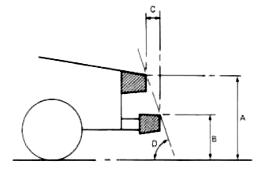
Figure 2. Vehicle front end design and specific parameters
E

Table 1. Parameters defining the motor vehicle’s front end design
Symbol | Name
A | Height of bonnet front edge
B | Height of the bumper upper edge
C | Front edge advance of bumper
D | Angle determined by the bumper upper edge and the bonnet front edge
E | Bonnet inclination angle

First classification version, accomplished following some DEKRA researches for EEVC-WG17 working group, contain the most usual 6 vehicle frontal profiles. Geometrical parameters are presented in the following table. [13]

Table 2. Initial proposal regarding the geometric frontal profile accomplishment
 | Height of bonnet front edge  [m] | Bonnet inclination angle  [°] | Angle determined by the bumper upper edge and the bonnet front edge [°]
Key profile | < 0.7 | < 20
Trapezoidal profile
Superficial bonnet inclination |  | < 20 | < 70
Pronounced bonnet inclination |  | > 20 | < 70
Ellipsoidal profile | Bonnet front edge have a radius of curvature >0.25 m
Pontoon profile |  |  | > 70
Vertical profile (BOX) | Vertically contact plan

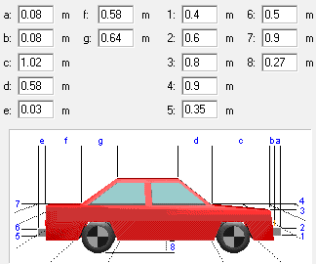
Figure 3. Vehicle geometrical parameters sample

Using PC-Crash application there ware modified vehicle’s frontal geometry parameters with shock absorbent bumper advance variation and through bumper assemblage height variation. Trough modifying these parameters that define the frontal vehicle geometry several vehicle profiles can be obtained, according to previous classification. The link of these parameters to the figure 3 is table 3.

Table 3 Correspondance between PC-Crash and VGV (Variable geometry vehicle)
No. Param. | PC-Crash/ vehicle’s profile | Variable Geometry vehicle | Parameter description
P1 | 1 |  | Height of the bumper lower edge
P2 | 2 | B | Height of the bumper upper edge
P3 | 3 | A | Height of the bonnet front edge
P4 | 4 |  | Height of the bonnet rear edge
P5 | a | C | Bumper advance
P6 | b |  | Front edge advance of bonnet
Modeling the motor vehicle – pedestrian impact

The method used to analyze the simulations data was structured throughout the following stages:
- Carrying out an overall analysis of accelerations during the specific time interval;
- Determining time sub-intervals of high interest. These are characterized by the head acceleration values;
- Determining the values regarding the injury criteria;
- Carrying out a comparative analysis of these values in order to determine the influence of front end design parameters upon the impact with the pedestrian as well as the injury degree.
It is possible to set the initial conditions such as position, initial speed, and inclination angle towards the main axis of movement for both motor vehicles and pedestrians.
The simulations undertook vehicle speeds of 30 and 50 km/h and respectively stable stance for the pedestrian, figure 4. Following the synthesizing of vehicles’ profile from table 2, the researchers calculated the bonnet’s inclination angles as well as the angle determined by the bumper upper edge and the bonnet front edge, “D” parameter as in figure 2.

$D=a\text{tan}\left(\frac{P3−P2}{P5}\right)$ (1)

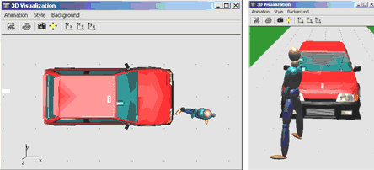
Figure 4. Sample test Pedestrian initial position

$\text{HIC}=\frac{\text{max}}{t_{1},t_{2}}\left\{\left(t_{2}−t_{1}\right){\left[\frac{1}{t_{2}−t_{1}}\int_{t_{1}}^{t_{2}}{a(t)\text{dt}}\right]}^{2\text{.}5}\right\}$ (2)

The simulations allowed the authors to determine the accelerations and impact speeds of the pedestrian’s head with the vehicle’s surface. The acceleration curves subsequently enabled the determination of the head injury criterion HIC, these values being synthesized in table 4. The HIC is the maximum value over the critical time period t1 to t2 for the expression. The representations of the injury criteria were made according to the values of “D” angle. The results obtained following the simulations for accelerations and head injury criteria are presented in figures 5, 6 and 7.

Figure 5. Pedestrian head acceleration signals at 30 km/h
Figure 6. Pedestrian head acceleration signals at 50 km/h

Figure 7. HIC variation in function of several impact parameters and vehicle velocities

Experimental study on the motor vehicle – pedestrian impact

In order to define the tests, a particular situation was considered as representative:
- Pedestrian crossing the street running - was impacted on its right side. A side impact was chosen because this position is representative of real accidents as a majority of pedestrians are hit laterally by a vehicle. Both feet of the dummy are in contact with the ground and support the body’s weight. The width between both feet was chosen to have a stable stance.
- The motor vehicle runs at a constant speed before the moment of impact.
The dummy designed and constructed for this type of tests in the Laboratories of the Department of Vehicles and Engines was instrumented with 6 monoaxial accelerometers mounted on two triaxial systems.

Table 4. Calibrating the dummy’s masses
Body segment | Mass obtained after calibration [kg]
Head | 4.50 | 6.05
Neck | 1.55 | 6.05
Upper and lower thorax | 29.65 | 37.95
Forearms | 4.00 | 37.95
Arms and palms | 4.30 | 37.95
Torso | 11.55 | 29.00
Hip | 9.05 | 29.00
Calf and foot | 8.40 | 29.00
Total weight | 73.00 | 73.00

The measurement chain made up of the previously described equipment is schematically represented in the figure below.
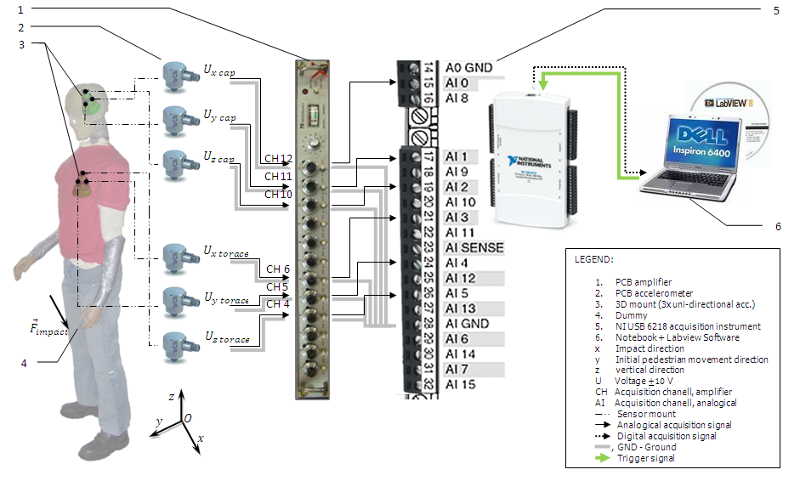
Figure 8. Diagram of the measurement chain for data acquisition from sensors applied to the dummy

The vehicles were prepared for tests as follows:
- The fuel tank was empty for safety reasons;
- During the tests, the 5th wheel device was mounted to determine the traveling speed;
- The frontal surface of the car body was painted in different colors to mark the areas with different potential injury degrees for the pedestrian;
- The surfaces were marked with linear grid and the rims were marked in order to facilitate the image and film analysis;
- The Datalogger OMEGA SHOCK101 and the DSD Pocket DAQ device were mounted according to the axes of the general orthogonal reference system chosen.

Experiment development

The pedestrian was placed in front of the motor vehicle, the position of crossing the street, with right leg towards the vehicle. The impact occurred at tibia level, just under the knee. The vehicle’s speed at the moment of impact was 29.18 km/h, the motor vehicle hitting the pedestrian between the first third and the median area of the bumper.
The diagrams analysis shows that for impact speeds of 29.18 km/h, the duration of the vehicle/pedestrian primary collision is almost 190 ms.
The pedestrian hit the vehicle’s windshield with the head. The first lower limb that came in contact with the vehicle was fractured in the region of the knee joint. The experiment shows that the damages caused by the pedestrian occur mainly at windshield level. There were noticed only some traces on the bonnet. The front edge of the bonnet presented a slight imprint of the hip and the upper part of the thigh.
The analysis of data, diagrams and photo-video recordings shows the three typical phases of a motor vehicle-pedestrian impact:
- Phase 1. The contact with the motor vehicle, which lasts from the moment of impact until the moment the pedestrian falls down.
- Phase 2. Throwing phase, which lasts from the moment that pedestrian is thrown until his contact with the ground.
- Phase 3. The contact with the ground, which lasts from the moment that pedestrian reaches the soil until the final position.

Phase 1. Contact with the motor vehicle
The contact between the vehicle and pedestrian is graphically detailed in the figure 9. First contact is at the passenger right knee, passenger that is positioned for simulating the running in front of the vehicle. It was observed that in the moment next to the bumper/leg contact appears the stricken point “drawing” under the vehicle phenomenon. This phenomenon appears because of the knee articulation break after the impact. After that, the passenger is bearing with the right thigh on the front edge of bonnet, and the impact will be transferred on the left foot.
Following this, the pedestrian is rotated on the bonnet and hits the wind shield with the head. The photo-video analysis shows the following sub-phases of the impact dynamics and the pedestrian trajectory.
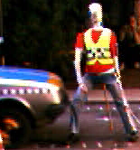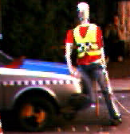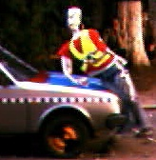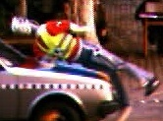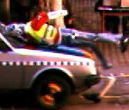

Figure 9. Sub-phases of the primary impact at 0, 50, 100, 150 and 200 ms

Phase 2. Throwing phase
In the next following moment of the head/wind screen impact it was observed a pedestrian rotation around the axe generated by the intersection of sagittal and coronal planes. This movement implies a pedestrian sliding from the vehicle’s bonnet (figure 10). Due to the low speed the throwing phase consisted of sliding down the bonnet, the right wing.

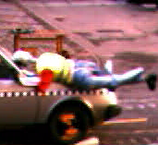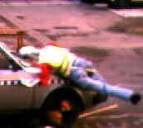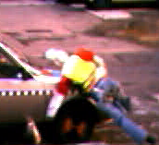

Figure 10. Throwing phase

Phase 3. Contact with the ground

The final stage of the impact takes place from the pedestrian detachment (sliding) from the bonnet moment until his final position on the ground. It was noticed that in this phase exist a roll up and sliding movement of the pedestrian on the ground, existing the possibility of another head/ground impact (example: frame stones).
The pedestrian falls on his legs, the first contact with the ground occurring at the level of lower limbs. The rotational movement of the body is continued, supporting the upper thorax on the wing, the body slides down on the wing and it is then dragged under the vehicle; it is likely that the head is dragged under the vehicle unless the vehicle stops (figure 11).
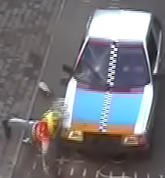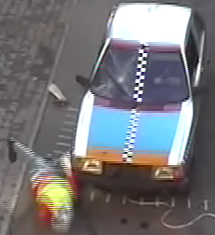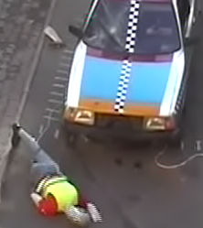

Figure 11. Contact with the ground

Results and discussion

As the vehicle speed increases at the impact with the pedestrian’s leg, one can notice a decrease in the duration of the impact between the pedestrian’s head and the bonnet or the windshield. The duration of this impact decreases as the vehicle’s speed increases (Figures 5 and 6).
The level of head accelerations increases with a non-linear variation according to the vehicle’s speed. This is better underscored by determining the variation tendency of the HIC criterion according to speed and bumper advance, figure 7.
Thus, the regression curve defining the tendency of the HIC variation is much more accentuated at the speed of 50 km/h than at the speed of 30 km/h.
Likewise, the dispersion of HIC values around the regression curves is more accentuated in case of the impact speed of 50 km/h.

References

[1] Jonsén, P., Isaksson, E., Sundin, K., and Oldenburg, M., (2009) “Identification of lumped parameter automotive crash models for bumper system development”, International Journal of Crashworthiness, 14: 6, 533 - 541.
[2] OJALVO, I. U., WEBER, B. E., and EVENSEN, D. A., “Low speed car impacts with different bumper systems: correlation of analytical model with tests”, SAE Technical Paper Series, Paper 980365, 1998.
[3] FMVSS 572, Subpart E: “Hybrid III test dummy”, 51FR26701 (Standard), 25 July, USA, 1986.
[4] BRUNNER, A., „Vorlesung: Unfallanalyse und - Rekonstruktion an der FH Konstanz 2005“, DVD, 2005;
[5] HARTMUT, R., DIETMAR, O., BURKHARD, S., “Pkw-Fussgangerkollisionen im hohen Geschwindigkeitsbereich Ergebnisse von Dummyversuchen mit Kollisionsgeschwindigkeiten zwischen 70 und 90 km/h”, Journal Umfall und Fahrzeug technik, Dec. 2000, page 341-346
[6] MIEDREICH, M., „Fussgängerschutzsystem mit faseroptischem Sensor“, ATZ nr.3/2005;
[7] MOSER, A., s.a. „Validation of the PC - Crash Pedestrian Model”, SAE 2000 World Congress, March 2000, Detroit, MI, USA, Session: Accident Reconstruction: Simulation & Animination, mar. 2000
[8] MOSER, A., STEFFAN, H., Kasanicky, G., - The Pedestrian Model in PC-Crash – The Introduction of a Multi Body System and its Validation, SAE 1999-01-0445, Accident Reconstruction: Technology and Animation IX
[9] NAHUM, A.M., MELVIN, J.W., Accidental Injury, Ed. Springer Verlag, 1996.
[10] OVERKOTT, H. şi col.“Inteligenter Aktor für universelle Fahrzeuganwendungen“, ATZ nr.7-8/2006;
[11] RUŞITORU, F., Soica, A., „Aspects Regarding the Vehicle Pedestrian Collisions“, The 4th European Academy of Forensic Science Conference, EAFS2006, Helsinki, Finland, 2006;
[12] Document, UNECE, INF-GR-PS, 49 / IHRA/PS/118R6, „Child Head Test Method“, references\2\INF-GR-PS\ps-49.pdf;
[13] DETTINGER, J., „Beitrag zur Verfeinerung der Rekonstruktion von Fussgangerunfallen“, part.1, part.2, Verkehrs Unfall und Fahrzeug Technik. 12/96, 1/97;
[14] DEPRIESTER, J.P., “Comparison of several methods for real pedestrian accident reconstruction”, Criminal Research Institute of the French National Gendarmerie, France, Paper 05-0333, 2005;
[15] SIMMS, C.K., WOOD, D.P., WALSH, D.G., “Conﬁdence limits for impact speed estimation from pedestrian projection distance” International Journal of Crashworthiness, 9(2):219–228, 2004;
[16] MASSON, C., SERRE, T., “Pedestrian-vehicle accident: analysis of 4 full scale tests with PMHS”, Laboratory of Applied Biomechanics. French National Institute for Transport and Safety Research-Faculty of Medicine of Marseille, Marseille, France, Paper 07-0428, 2007;
[17] SCHUSTER, P., “Current Trends in Bumper Design for Pedestrian Impact - A Review of Design Concepts from Literature and Patents”, Mechanical Engineering Department California Polytechnic State University, San Luis Obispo, California, 805-756-2976;
[18] POHLAK, M., MAJAK, J. and EERME, M., “Optimization of car frontal protection system”, Int. J. Simulation Multidisciplinary Design Optim., 2007, 1, 31–37.
[19] Soica, A., “Siguranta pasivă a autovehiculelor”, Editura Universităţii Transilvania din Braşov, Braşov 2010, ISBN 978-973-598-739-8.
[20] SMITH, A., ASHMEAD, M., GAY, P., SIEVER, N., - “Pedestrian protection potential of an adaptive bumper”, Cellbond Composites Ltd., Huntingdon, UK.

