5th International Conference
″Advanced Composite Materials Engineering ″
COMAT 2014
16 – 17 October 2014, Brașov, Romania

NAVIGATION SYSTEM OPTIMIZATION FOR MOBILE ROBOT
PRO BOT 128

Ţârulescu Radu¹, Olteanu Ciprian²
¹ Transilvania University, Braşov, Romania, radu.tarulescu@unitbv.ro
¹ Transilvania University, Braşov, Romania, oltcip@unitbv.ro

Abstract: This paper develops another optimization model of the mobile robots sensorial system, in order to improve navigation behavior in a close environment. Tests were performed with Pro Bot 128 mobile robot in a maze type of working space. In order to reduce the distance traveled by the vehicle between a starting point and a destination, Pro Bot 128 was equipped with a Parallax ultrasonic sensor. The ultrasonic sensor has been implemented with a rotating platform, which allows rotation at an angle of 180 degrees.
Keywords: ultrasonic, sensor, mobile robot, environment.

1. INTRODUCTION

Avoiding obstacles is one of the most important problems which are focuses at the mobile robot navigation in a working environment. Avoiding objects on the proximity is a consequence at the obstacle detection and stopping or changing direction of movement for mobile robots, with purpose at collision avoiding [1]. To notice the mobile robots behavior in a maze type of working environment, it was tested the Pro Bot 128 robot. The Pro Bot 128 robot has a high level of autonomy, having the possibility to sense and avoid obstacles with infrared sensors detection system, without the intervention of the human operator. For the navigation in the working environment the robot was programmed to use its anti collision infrared sensorial system.

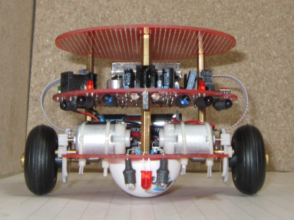
Figure 1: Mobile robot Pro Bot 128

2. THEORETICAL COSIDERATIONS

Mobile robot Bot Pro 128 uses a differential locomotion system. A differential system is composed of two wheels mounted on a common shaft controlled by two separate motors. In a differential locomotion system, the vehicle must rotate around a point which is the common axis of the two wheels [2]. By changing the speeds of the two wheels, the path of rotation can be changed.
The speeds of the two wheels must comply with the following relationship:

(1)

Where v_{s} is the speed of the wheel on the left side, v_{d} is the right side wheel speed, R is the distance between the center axis of the second wheel and the center of curvature CC, ω is the angular velocity, and l the distance between the two wheels [3]. The rotation angle is represented by θ.

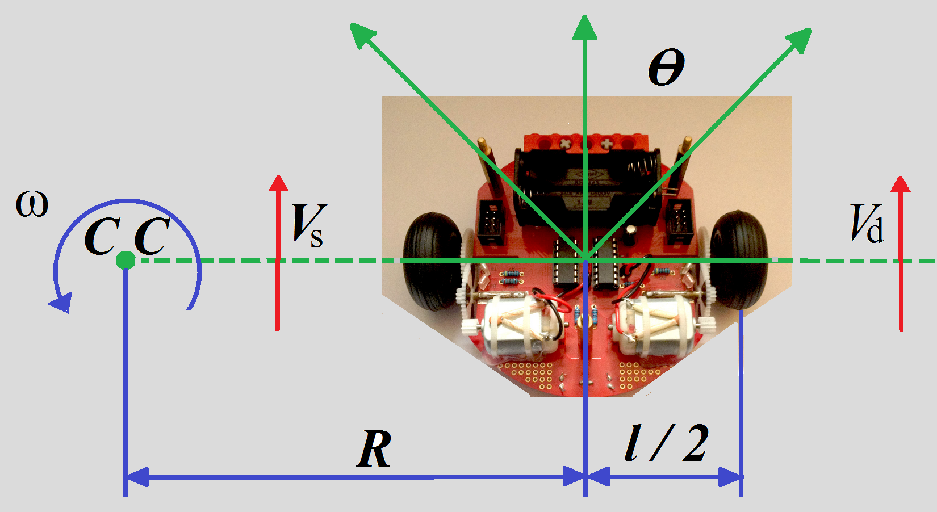
Figure 2: Differential locomotion system

Solving the system of equations above leads to the following solutions:

(2)

(3)

A variety of different points of the starting point can be achieved by choosing speeds v_{s} and v_{d}. Determination of a point can be achieved by vehicle through manipulation of control parameters, called direct kinematics equations of the vehicle. A special case is when v_{s} = v_{d}. Distance in this case R is infinite, so the vehicle will move in a straight line. If v_{s} = -v_{d}, distance R becomes 0 and the vehicle moves instantly around the middle axis. For any other values of v_{s} and v_{d}, the vehicle will rotate on a circle of radius R from the center of curvature.
Determining of control parameters (speed v_{s} and v_{d}) to reach a certain point already established, is called inverse kinematics equations of the vehicle. Because solving the system of equations above is difficult, it is proposed two special cases of motion of the vehicle with differential locomotion system [4].
In the first case, if the equates v_{s} with v_{d} = v, the above equation becomes:

(4)

In the second case, if we choose v_{s} = -v_{d} = v, the equation becomes:
(5)
Therefore, in order to move the vehicle from (x_{s}, y_{s}, θ_{s}) to (x_{g}, y_{g}, θ_{g}), with θ_{g} ≠ θ_{s}, can be used for the second control law (v_{s} = -v_{d} ) until θ_{g} = θ_{s}, then moving the vehicle using the first control law (v_{s} = v_{d} ).

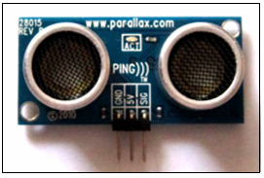
Figure 3: The ultrasonic sensor Parallax PING

For optimization it was used an ultrasonic sensor Parallax Ping. Ultrasonic sensors are useful under poor lighting conditions or when there are many transparent objects such as windows or glass doorways, as this is where infrared or vision-based sensors fail. The sensor operation uses the principle of echo location. Ultrasonic sensors transmitter sends out a short pulse within a specific direction. When the pulse hits an object, which does not absorb the pulse, it bounces back, after which the echo can be picked up by a receiver [5]. Some sensors have separate transmitter and receiver components, while another sensor combines both in a single piezoelectric transceiver. Most ultrasonic sensors use a single transducer to both transmit the sound pulse and receive the reflected echo, typically operating at frequencies between 40 kHz and 250 kHz. However, the basic operation is the same in both devices.
The distance to the object can be determined by measuring the time between sending the pulse and detecting the echo.
By multiplying the time between pulse and echo t (in seconds) with speed of sound c, you will get twice the distance d to the object in meters (since the sound traveled the distance twice to get to the object and bounce back).

(6)

The accuracy of the distance measurement is directly proportional to the accuracy of the speed of sound used in the calculation [6]. The speed of sound in air varies as a function of temperature T by the relation:

(7)

3. EXPERIMENTAL RESEARCH ON THE PRO BOT 128 NAVIGATION

Through the robot testing is aimed its behavior in terms of distance traveled from a start point to a goal and at obstacles avoiding manner. For those tests it was equipped a working environment of maze type.
For establishing with precision the path traveled by the robot, it was endowed with a system of tracking marking. That system uses a marker which will draw a line while driving the robot. In Figure 4 it is presented the place where it is located the tracking marking system for highlighting the route. For precise tracking, the tracking marking system was placed in the wheels axle center of symmetry.

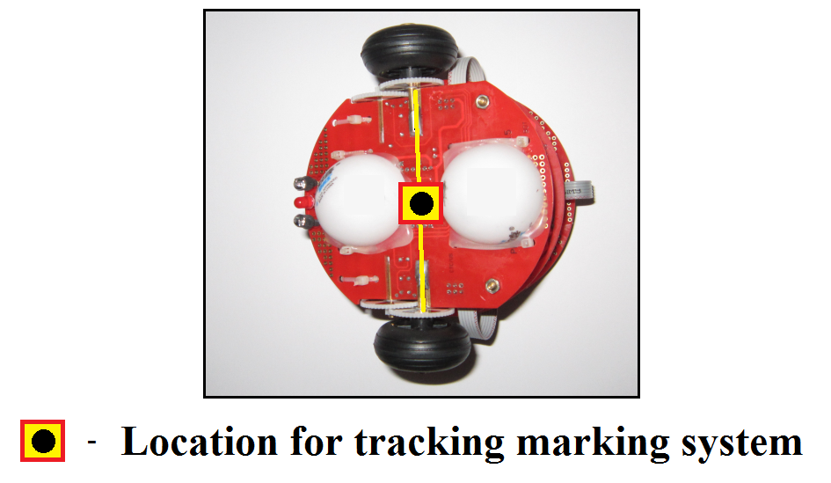
Figure 4: The tracking marking system for Pro Bot 128
At the construction of working environment there were used wood boards with same texture, having a thickness of 2 cm, height of 0.3 m and lengths between 0.2 and 1.2 m. During selection of these it was considered as the height to be greater than the height of which is placed the sensorial system of each robot, like in Figure 5. The red line, representing the level of the sensorial system, must be between yellow lines which are delimiting the wooden board used.

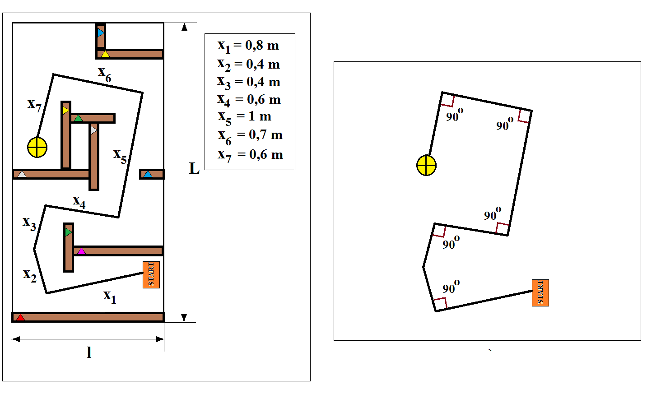
Figure 5: The maze type of environment

Before the mobile robots testing, it was proposed an ideal trajectory taking into account the dimensions of the larger robot [7]. In Figure 5 it is presented the proposed trajectory, being calculated by adding the seven segments:

(8)

Taking into account that the mobile robots usually not performed each time turning at angles of 90 degrees, the proposed path has been shaped, replacing angles with arcs noted with y₁. Therefore was chosen five square of 0.2 m in which are inscribed circles with radius of 0.1 m.

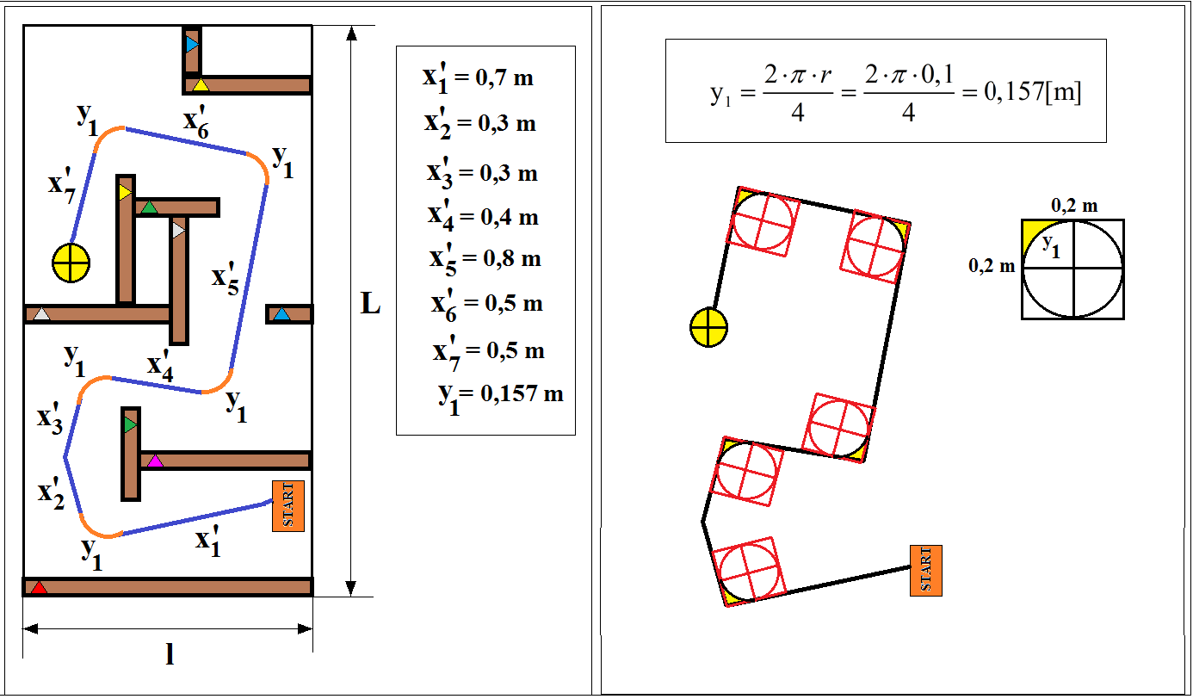
Figure 6: Ideal trajectory for the maze environment

In this case, the ideal trajectory will be:

(9)
In Figure 7 it is presented the trajectory of the Pro Bot 128 robot in the working environment. Line drawn has been divided into 57 segments. It is noted that this robot has performed and movements back (marked with red) for the obstacles avoiding. Distance traveled was determined by adding the values ​​of segments, having the value d = 9.739 m, in which 2.338 m were driven backwards. The robot has traveled a distance of 5.439 m higher than the ideal trajectory.
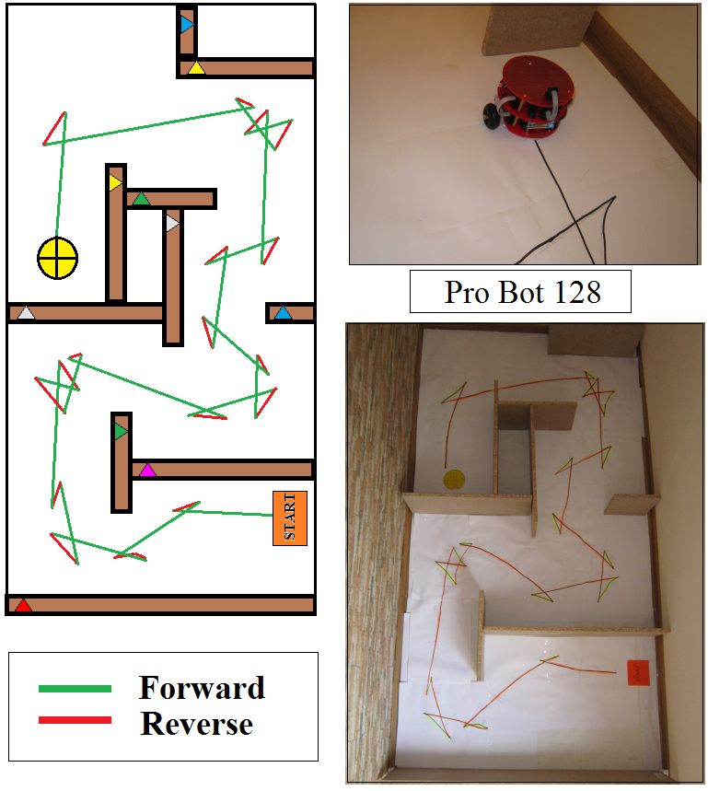
Figure 7: Movement of Pro Bot 128 before optimization

4. SENSORIAL SYSTEM OPTIMIZATION

To optimize the sensorial system is proposed addition of one or more Parallax Ping ultrasonic sensors and a Propeller Activity Board processing unit [8]. The ideal solution in this case is to mount a sensor on a platform, operated by an actuator which has the possibility of rotating 180 degrees like in Figure 8.

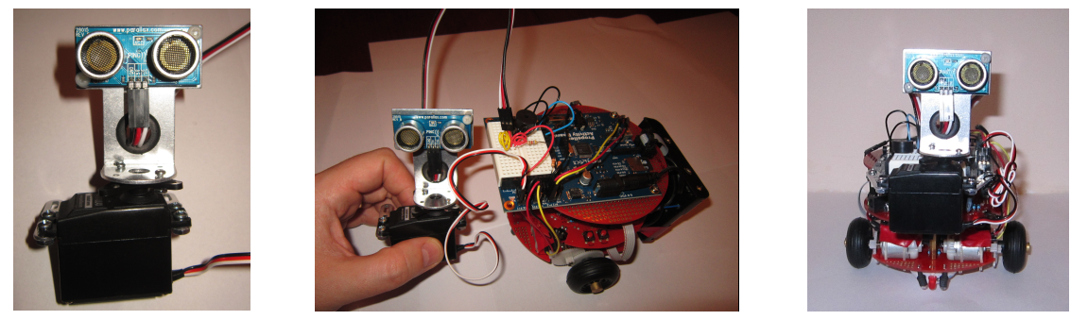
Figure 8: Implementation of the rotating platform with ultrasonic sensor on the robot

The Figure 9 presents the trajectory of the vehicle with the new sensorial system with ultrasonic sensor mounted on the rotary platform. The trace was divided into 66 straight segments. Distance traveled was determined by adding the values ​​of the segments, with d = 7.053 m, in which 1.054 m were driven in reverse. The vehicle has traveled a distance of 2.753 m higher than the ideal trajectory.

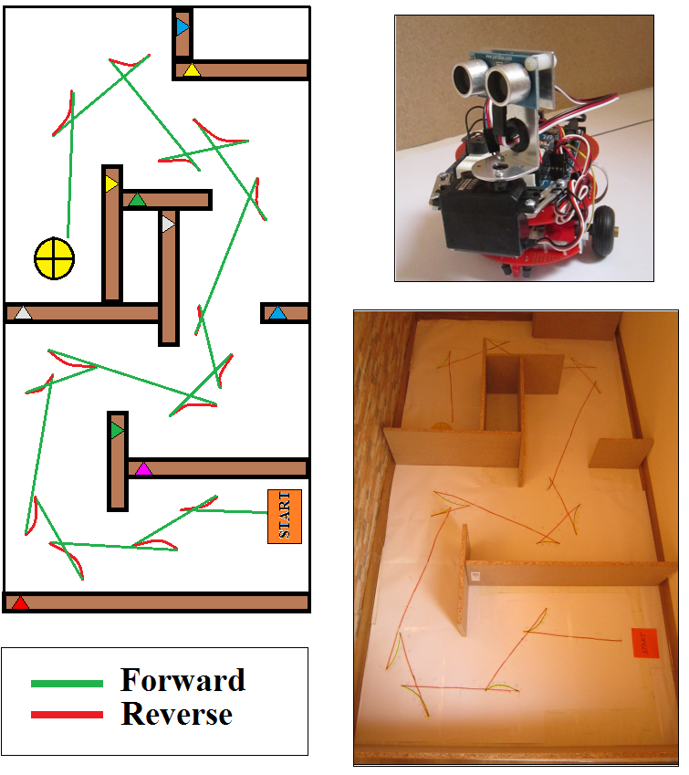
Figure 9: Movement of Pro Bot 128 after optimization
Table 1 show the distance traveled by vehicle Pro Bot 128 before and after optimization compared to the ideal trajectory proposed.

Table 1: Distance traveled by mobile robot Pro Bot 128
Vehicle status | Total distance traveled | Distance traveled forward | Distance traveled in reverse | Gap from ideal distance
Vehicle status | [m] | [m] | [m] | [m]
Before optimization | 9.739 | 7.401 | 2.338 | 5.439
After optimization | 7.053 | 5.999 | 1.054 | 2.753

After the mobile robot optimization with the ultrasonic detection system, the distance traveled from start point to the destination in the maze environment it was reduced with 2.686 meters. There also reduced the number of moves made from optimized robot to travel the proposed distance.

5. CONCLUSION

Experimental study on the behavior of mobile robots in the perception of obstacles requires choosing an enclosed space environment which can be controlled atmospheric parameters, such as temperature, humidity and noise level. In the presented study, optimizing sensorial system with ultrasonic sensors has improved vehicle behavior in terms of distance traveled, reducing the number of moves made ​​to avoid obstacles.
The ultrasonic sensor Parallax PING can be successfully used for mobile robots orientation in the working space. Sonar sensing is adequate due to its low cost, the simplicity of the required processing, and the rapidity with which it can return results reflecting range measurements over a large region of space.

ACKNOWLEDGMENT

This paper is supported by the Sectoral Operational Programme Human Resources Development (SOP HRD), ID134378 financed from the European Social Fund and by the Romanian Government.

REFERENCES

- Buiu C., Sisteme avansate pentru conducerea roboților autonomi, Editura Electra (ICPE), 2003.
- Niţulescu M., Sisteme robotice cu capacitate de navigaţie, Editura Universitaria Craiova, 2002.
- Lovasz, E. C., Robotică avansată, Editura Politehnica Timișoara, 2013.
- Nehmzow U., Mobile Robotics: A Practical Introduction, June 11, 2003.
- Călinoiu, C., Senzori și Traductoare, Volumul 1, Editura Tehnică, 2009.
- Dolga, V., Senzori şi traductoare, Editura Eurobit, Timişoara, 1999.
- Hahnel, D., Map building with mobile robots in dynamic environments, Robotics and Automation, Proceedings. ICRA '03. IEEE International Conference, Pages: 1557 - 1563 vol.2, 2003.
- Ţârulescu R., Usage of Parallax ultrasonic sensors in distance measuremnts, Editura Universitatii din Oradea, ISSN 1583-0691, ANNALS of the ORADEA UNIVERSITY, 2013.

