5th International Conference
″Advanced Composite Materials Engineering ″
COMAT 2014
16-17 October 2014, Braşov, Romania

RESEARCH ON LIQUID METAL HEAT PIPE STARTUP AND
OPERATION

Virgil B. Ungureanu¹
¹ Transilvania University, Braşov, ROMANIA, virbung@unitbv.ro

Abstract: The paper presents experimental investigations on liquid metal (sodium and potassium) heat pipe operating and startup. Thus, is studied the wickless gravity assisted heat pipes, that presents a high non-uniformity of the temperature profile along the entire pipe. Because the temperature increasing of the evaporator lower end, it is compulsory to provide wick in the liquid metal heat pipes. There are recommended composite wicks with grooves and screen, or some screen layers.
Keywords: heat pipe, gravity assisted heat pipe, wickless heat pipe, screen wick, heat pipe startup.

1. INTRODUCTION

Because of the diversity of field utilization, the heat pipes there are very extended ranges of the operating temperature. The heat pipes that operate in the middle and low temperature ranges and also the effects of working fluid and wick configuration on the startup characteristics of heat pipes have studied by many authors. Thus, it was demonstrated that in the case of the gravity assisted wickless heat pipes, the startup is suddenly, by reaching a quasi-metastable state. Further on, it is establish an accurate operating, with pulsatory liquid boiling that assure the constant temperature within the entire heat pipe [1].
El-Genk, Huang and Tournier [2], [3] investigate the operation and design constrains pertinent to uses of water and liquid metal heat pipes in space reactor systems, and the modelling capabilities of the startup from a frozen state. A free molecular, transition and continuum vapor flow model based on the dusty gas model is developed and a two dimensional heat pipe transient analysis model, to analyses the startup of a radiatively-cooled sodium heat pipe from a frozen state.
Chang [4] studied the feasibility of employing heat pipes to cool the hot sections of the Army’s ground-to-ground missile fins.
Faghri [5] studied the heat pipe startup from the frozen state. For a safe startup Ponnapan [6] studied a diffusion controlled startup of a liquid metal heat pipe.
Gravity assisted wickless heat pipes have studied by Fetcu, [7], in a view to utilize for heat pipe heat recovery systems.
Dickinson [8] analyses the performance of liquid metal heat pipes and characterize the frozen startup and restart behavior of liquid metal heat pipes in a microgravity environment.
This paper investigates the startup of sodium and potassium heat pipes.

2. TYPICAL TRANSIENT PHENOMENA OF METAL LIQUID HEAT PIPES

The startup behavior of heat pipes is difficult to provide because it depends of many factors. In the startup period, the vapor flows with a high speed from the evaporator to the condenser zone because the low density of vapor [5]. Thus, the pressure drop and implicit of temperature along the heat pipe is great. Because the axial temperature gradient in a heat pipe is determined by the vapor pressure drop, the initial evaporator temperature shall be greater than the evaporator one. The temperature level realized in the evaporator zone is dependent by the working fluid. If the heat flow rate transferred by the heat pipe is great, it is observed a temperature front that moves towards the condenser section. During a normal startup of a heat pipe, the evaporator temperature increase with some degrees until the heat pipe becomes quasi-isothermal. If the vapor speed is high during the liquid metal startup, the liquid returning towards evaporator zone can be braked.
3. EXPERIMENTAL RESULTS

3.1. The experimental stand

Figure 1 presents the schematic stand having the main components: a radiation oven (1) composed by a stainless steel covered by an insulation (2); the electric installation of the radiation oven composed by a voltage control device, a transformer (4), two flexible cables (5 and 6) coupled to the radiation oven by two clamps (7 and 8) cooled by an water circuit; the oven temperature measuring installation composed by two K thermocouples (9 and 10) connected successively to the measuring apparatus; the temperature measuring installation along the heat pipe composed by a K thermocouple connected to the correspondent measuring apparatus; chassis for the oven-heat pipe assembly, having the possibility to be oriented at various tilt inclination angles towards the horizontal between 0 to 90º.
Figure 1 presents a section through heat pipes too. Thus, for an accurate temperature measuring in the heat pipe it is introduced a pipe Φ6×1.2 from stainless steel fixed by welding at both caps of the heat pipe.
The evaporator zone cooling is realized by radiation in the ambient.
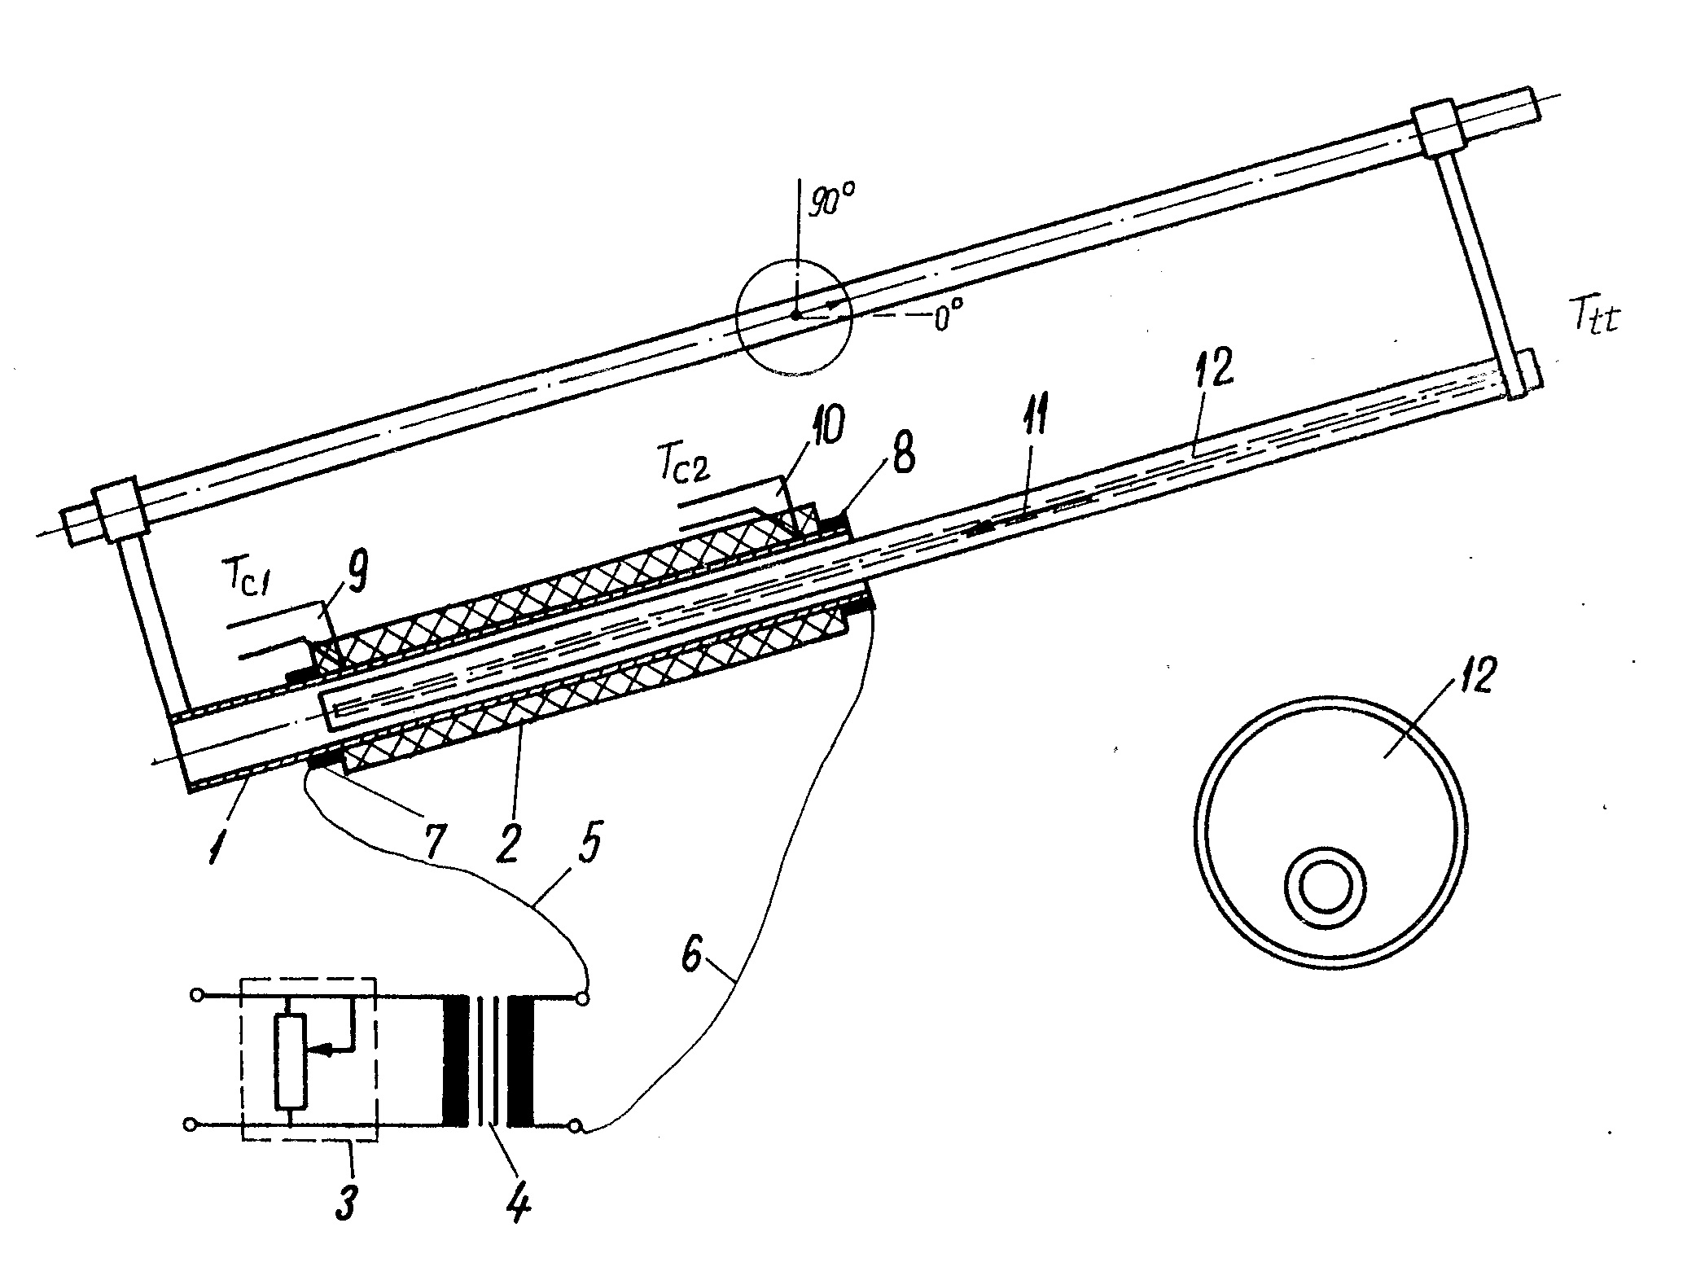
Figure 1: The experimental stand

There are manufactured three wickless gravity assisted heat pipes having the dimensions: outer diameter 28 mm, wall thickness 2.4 mm, overall length of the pipe 1000 mm. Volumes of working fluid are: 1st heat pipe with sodium: 90 cm³ (the filling coefficient 0.228); the 2nd heat pipe with sodium, too: 53 cm³ (the filling coefficient: 0.134); and respectively the 3rd heat pipe with potassium: 102 cm³ (the filling coefficient 0.259). The filling coefficient is the working fluid volume (liquid) to the entire void of the heat pipe ratio.
However, there are manufactured two heat pipes: 1st heat pipe with sodium: outer diameter: 32 mm, wall thickness: 2.5mm, overall length of the pipe 1480 mm, and two wrapping screens: the first composed by three layers of 50 mesh per inch and the second adjoined at the wall, composed by 1.25 layers of 25 mesh per inch to create a channel with high permeability for liquid flow, both being spot welded, overall volume of working fluid being 61.6 cm³, (corresponding to a filling coefficient 0.072); the 2nd heat pipe with sodium, too: outer diameter 27.5 mm, wall thickness 2.55 mm, overall length 980 mm, inner diameter of the wick: 20 mm, the wick being composed by three layers with 50 mesh per inch.

3.2. The gravity assisted wickless heat pipe testing

First, it was tested the 1st heat pipe for an evaporator length of 480mm and condenser zone of 530mm, at the oven temperature of about 700ºC. It is observed that the heat pipe operates very instable. The next tests are realized by using a cylindrical insulation of 250mm length over the condenser zone of the heat pipes.
Figure 2 presents the temperature profile along the wickless heat pipe in this configuration.
Figure 2: The longitudinal temperature profile of the 1st wickless heat pipe

The 2nd heat pipe was tested in the configuration: evaporator zone: 630 mm; condenser zone: 370 mm; insulated zone: 180mm. The oven temperature was about 760ºC, experimental results being presented in figure 3.
Figure 3: The longitudinal temperature profile of the 2nd wickless heat pipe

It is observed a quasi-isothermal operation on a greater length of the condenser zone, due, probably the higher filling coefficient and/or an accurately manufacturing of the heat pipe (higher degasing of the container and working fluid).
The potassium heat pipe was tested with the geometry: evaporator zone length: 640mm; condenser zone length placed in the ambient: 360mm. There are no used the insulation on the condenser zone. Like the sodium heat pipes this one has an instable operation. Figure 4 presents temperature profiles. However, there are remarked a lower overheating of the evaporator zone, probably because of the higher filling coefficient.

Figure 4: The longitudinal temperature profile of the 3rd wickless heat pipe

3.3. The gravity assisted wicked heat pipe testing

The 1st heat pipe was tested with the geometry: evaporator zone length: 680mm; condenser zone length 800mm; insulated zone: 600 mm. Test results are presented in figure 5.
Figure 5: The longitudinal temperature profile of the 1st wicked heat pipe

It is remarked that the insulation was used because the source hasn’t sufficient power. The heat pipe was a stable operation. By using a high power oven, the heat pipe was a uniform temperature on the overall condenser zone (about 600 mm).
The 2nd heat pipe was tested by using the geometry: evaporator zone length: 630 mm, condenser zone length, free in ambient: 350 mm. The oven temperature was between 775 to 800ºC and there wasn’t utilizing thermal insulation on the condenser zone.
Figure 6 presents the temperature profile. It is remarked that the startup is very good like the 1st heat pipe, the operation is proper and the temperature profile is very good.

Figure 6: The longitudinal temperature profile of the 2nd wicked heat pipe

It is remarked that the operation, startup and stability are not influenced by the tilt angle.

4. CONCLUSION

While the startup and operation of the wickless heat pipes that operates in the middle and low temperature ranges is very accurate, the liquid metal gravity assisted wickless heat pipes operates very faulty, with overheating of the lower end caps of the evaporator zone and pulsating temperature. Thus, it is necessitating a wick, even a summary wick having a high permeability for providing the liquid return. There are recommended composite wick, with grooves and screen, or some screen layers.

REFERENCES

- Fetcu D. Hoffmann V., Ungureanu V.B., Theoretic and experimental researches on the gravity assisted wickless heat pipes operation. Heat transfer and optimization of thermal energy utilization, Brasov, Oct. 30-31. 1986, pp I-55.
- El-Genk M.S., Huang L., Experimental investigation of low temperature heat pipe response to transient heating. Proc. of the 8 th International Heat Pipe Conference, Beijing, Sept. 14-18, 1992.
- El-Genk M.S., Tournier J.M.P. Uses of liquid-metal and water heat pipes in space reactor power systems. Frontier in Heat Pipes (FHP), 2, 2011.
- Chang W.S., Startup of the liquid-metal heat pipe in aerodynamic heating environments Final report. Aero Propulsion and Power Directorate, Wright Laboratory, Ohio.. Feb. 1996.
- Faghri A., Bean J., Heat pipe startup from the frozen state, Proc. of the 8-th International Heat Pipe Conference, Beijing, Sept. 14-18, 1992.
- Ponnapan R., Boehman L.I., Mahefkey E.T., Diffusion controlled start-up of a bas-loaded liquid metal heat pipe. Journal of Thermophysics and Heat Transfer, vol. 4. No. 3, 1990, pp 332-340.
- Fetcu D., Ungureanu V.B. Bacanu G., Gravity assisted wickless heat pipe heat exchangers. Proc. of the 8-th International Heat Pipe Conference, Beijing, Sept. 14-18, 1992.
- Dickinson T.J., Performance analysis of a liquid metal heat pipe space shuttle experiment. Thesis. Air Force Institute of Technology. Wright-Patterson Air Force Base, Ohio, Dec. 1996.

