5th International Conference
″Advanced Composite Materials Engineering ″
COMAT 2014
16-17 October 2014, Braşov, Romania

THERMAL PROPERTIES OF SOLID WASTE MATERIALS

Liviu Costiuc¹
¹ Transilvania University of Braşov, Braşov, Romania, lcostiuc@unitbv.ro

Abstract: This paper presents the results obtained in measurements on heat of combustion of solid waste materials coming from municipal waste to evaluate this as fuel candidate. There are analyzed especially samples of plastic wastes coming from Braşov, Romania. Measurements for the heat of combustion of solid waste were done using the Parr bomb calorimeter. There are presented the sample preparation, the testing procedure, the comparative results on the mixed wastes and usual fuels and also the conclusions of the experiment. That proves the solid waste could be effectively used for energy recovery, by incineration.
Keywords: solid waste; heat of combustion; calorimeter.

1. INTRODUCTION

Since 1999, Romania adopted the Waste Management Evidence and The Waste European Catalogue. At the end of 2005, the 1281 Rule (1281/16.12.2005) of the Environment and Water Management Ministry concerning the waste containers colors was adopted.
Concerning the management of plastics waste, landfilling is the last option, more and more avoided. Other options are: energy recovery by waste incineration, power station and cement kiln, or feedstock recovery by synthesis production and finally mechanical recycling.
A Romanian citizen generates around 5 kilos of household waste per week, half of it is biodegradable, a half of a kilo is glass and another half of a kilo is paper and cardboard. The rest is shared between other types of waste, 250 grams textiles and 200 grams polymers [1].
The reason of this study is to determine the effectiveness of municipal solid waste plastic wastes use as fuel.

2. MATERIALS AND METHODS

The tested plastic wastes come from Urban Enterprise source, Brasov County, Romania. The municipal solid waste was sorted to separate the plastic waste (see Figure 1). Second step was the washing procedure to eliminate organic waste, and after that the waste was dried and cut (see Figure 2). The sample average size after the cutting is about 10-20mm. The average sample size required for heat of combustion measurement with calorimeter is about 0.5-1.0mm. For that reason the plastic waste sample has been frozen in liquid nitrogen and after that was cut in the frozen state with a Retsch ZM200 centrifugal mill.
The resulted average sample size was approximately 0.5 mm. After drying, the samples were weighed using precision analytical balance. Each sample weight was approximately 1 gram with 0.1 mg precision. The resulted samples are a mixture of plastic materials, and there are prepared for measurements about 10 samples of municipal plastic waste to find out an averaged value for the heat of combustion.
The equipment used for the heat of combustion tests were: XRY-1C Oxygen bomb calorimeter, XRY-1C software and Kern & Sohn ABJ 220-4M analytical balance.
The heat of combustion is the energy released as heat when a compound undergoes complete combustion with oxygen in an enclosure of constant volume.
The gross heat of combustion, or calorific value, at constant volume (higher heating value or gross energy or upper heating value or higher calorific value) is the absolute value of the specific energy of combustion, in Joules, for the unit mass of a solid recovered fuel burned in oxygen in a calorimetric bomb under the conditions specified. The products of combustion are assumed to consist of gaseous oxygen and nitrogen coming from the gaseous atmosphere of burning, of carbon dioxide and sulphur dioxide, of liquid water (in equilibrium with its vapor) saturated with carbon dioxide under the conditions of the bomb reaction, and of solid ash, all at the reference temperature [7].

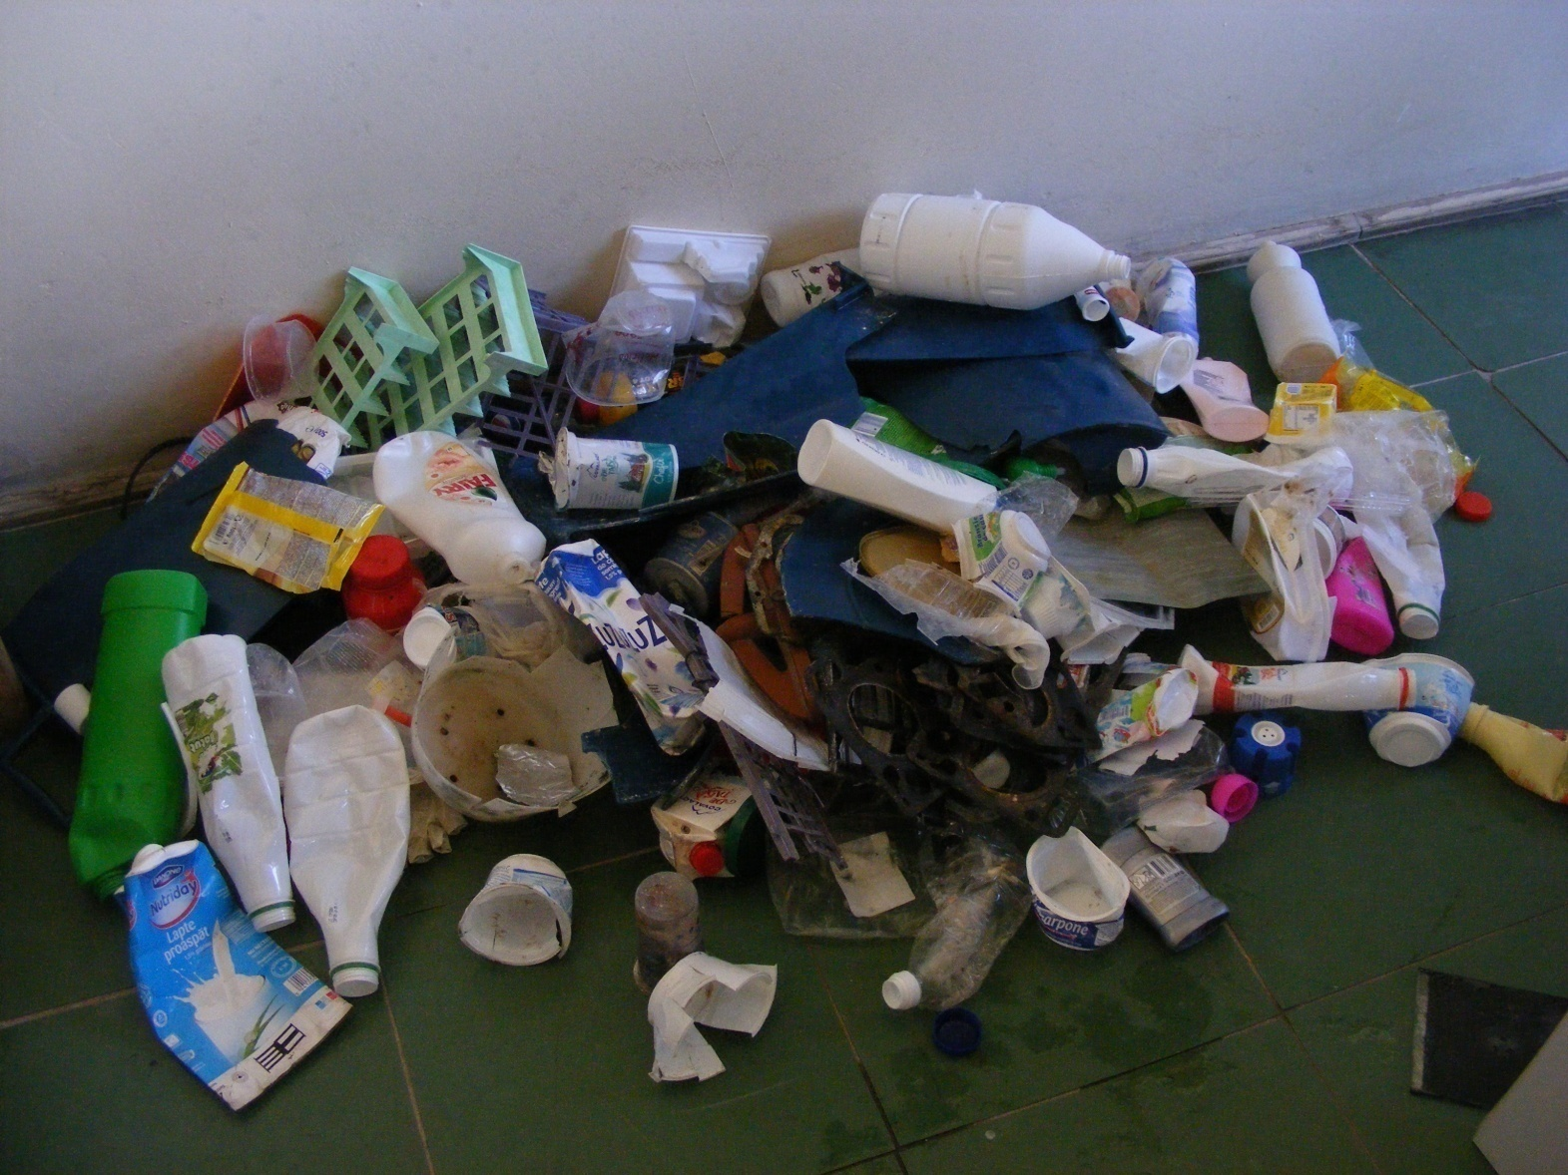
Figure 1. Sorted plastic waste from municipal Urban waste, Romania

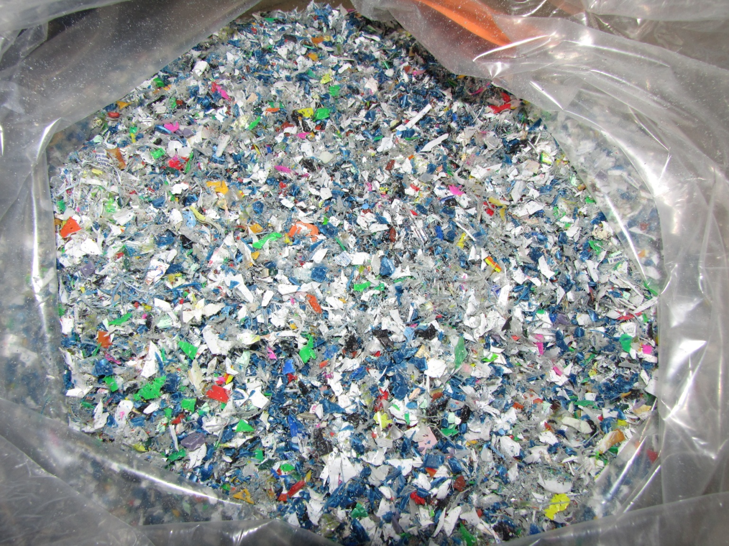
Figure 2. Cut and dried prepared plastic waste.

The net heat of combustion, or calorific value, at constant volume (lower calorific value) is the absolute value of the specific energy of combustion, in Joules, for the unit mass of a solid recovered fuel burned in oxygen under conditions of constant volume and such that all the water of the reaction products remains as water vapor in a hypothetical state at 0.1 MPa, and the other products being all at the reference temperature [7]. With the bomb calorimeter is measured the gross calorific value. The testing procedure is presented in [2, 3, 7].

3. RESULTS

Before determinations of the heat of combustion value of samples, it is necessary to do the calibration of oxygen bomb calorimeter. This consists in a reverse procedure of testing. Having the value of the heat of combustion of benzoic acid standardized sample about 26435 J/g, it is determined by the same kind of test the thermal capacitance of the calorimeter, W, burning in crucible the benzoic acid and knowing its mass. The thermal capacitance of the calorimeter determined as average of 3 calibrations was W=12875 J/K.
For each waste plastic sample, in the XRY-1C software panel there were introduced the following input data: the mass of ignition wire in grams; the mass of cotton fuse in grams; the calorific value of wire [J/g]; the calorific value of cotton [J/g] and the mass of test sample in grams. After burning process the software has plotted the output graph containing temperature-time evolution(figure 3) and finally calculates the gross heat of combustion value as output using Regnault-Pfaudler method.

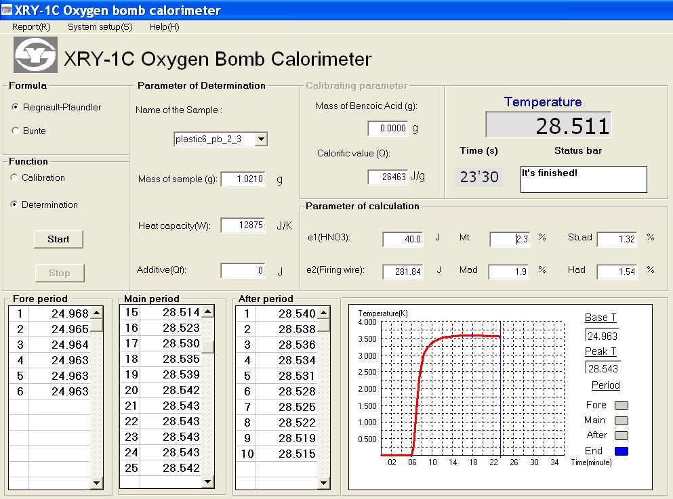
Figure 3. The XRY-1C software result panel of the plastic waste sample

The results obtained for mixed plastic waste are presented in Table 1. The Q_{gr,ad} column is the gross heat of combustion value in adiabatic conditions, and Q_{net,ad} is the net heat of combustion value, adiabatic. In Table 2 are presented the values for the heat of combustion of usual polymers and fuels as reported in literature.

Table 1. Results of calorimetric analysis of plastic waste mixture from Romania
Sample no. | Sample mass [g] | Gross  heat of combustion  Q_{gr,ad} [MJ/kg] | Net  heat of combustion  Q_{net,ad} [MJ/kg]
1 | 1.0654 | 45.135 | 44.582
2 | 0.8243 | 45.269 | 44.716
3 | 0.8204 | 44.441 | 43.891
4 | 0.8232 | 44.499 | 43.948
5 | 0.8350 | 44.496 | 43.946
6 | 0.8778 | 44.498 | 43.947
7 | 0.9211 | 44.151 | 43.602
8 | 0.8720 | 42.757 | 42.214
9 | 0.8418 | 43.151 | 42.606
10 | 0.8563 | 42.528 | 41.986

Table 2. Heat of combustion of some polymers and fuels [4]
Material type | Heat of combustion  [MJ/kg]
Polyethylene (PP) | 46.40
Polypropylene (PE) | 46.30
Polystyrene (PS) | 41.40
Polyvinyl Chloride (PVC) | 18.00
Poly Ethylene Terephtalate (PET) | 24.13
Poly carbonate bisphenol A (PC) | 31.53
Unsaturated Polyester | 26.00
Coal, Anthracite | 32.80
Lignite | 28.00
Gasoline | 46.80
Jet Fuel, JP-4 | 46.60
Paper, Newsprint | 19.70
Wood, Dry, Average | 20.00

Comparing the results for heat of combustion for solid waste with the heat of combustion of usual polymers and fuels as reported in literature (Figure 4) can be observed that the all samples have high heat of combustion with an average value of 43.544 MJ/kg which is about 33% higher than anthracite coal, 55% higher than lignite, 7% smaller than gasoline and 6.6% smaller than jet fuel.

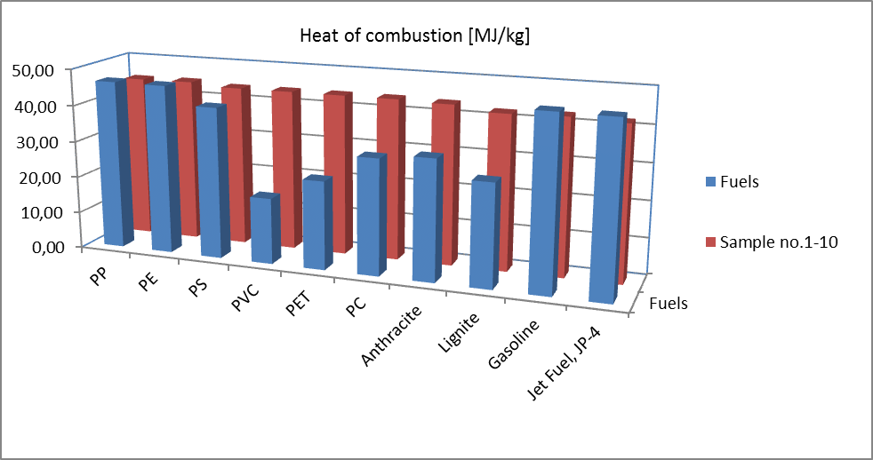
Figure 4. The comparative values for heat of combustion for fuels and solid waste samples.

4. CONCLUSIONS

The calorimetric analysis reveals a high capacity of the mixed plastic wastes to be used as fuel. The heat of combustion of those materials has a high level compared to solid fuels and comparable with petroleum products.
Generally the polymers having higher density are characterized by lower calorific power. As the PE and PP were found in plastic wastes as composites, the heat of combustion of these mixtures will be higher, due to the higher polyolefinic calorific power of the PE and PP.
Even after considering the mixture of plastic waste in different concentrations the calorific power of these residues is still greater than those of different sorts of coals and these waste materials could be burned to obtain a useful amount of energy. That proves the solid waste could be effectively used for energy recovery, by incineration.

Acknowledgements: This research was funded by FP7 Grant 212782, „Magnetic Sorting and Ultrasound Sensor Technologies for Production of High Purity Secondary Polyolefins from Waste”, acronym W2Plastics.

REFERENCES

- Baltes, L., Draghici, C., Manea, C., Ceausescu, D., Tierean, M., Trends in Selective Collection of the Household Waste, Environmental Engineering and Management Journal, July/August 2009, Vol.8, No. 4, pag. 985-991.
- Costiuc, L., Popa, V., Serban, A., Lunguleasa, A., Tierean, M.H., Investigation on heat of combustion of waste materials, Proceedings of the International Conference on Urban Sustainability, Cultural Sustainability, Green Development Green Structures and Clean Cars, Malta, September 15-17, 2010, Published by WSEAS Press, ISSN: 1792-4781, ISBN: 978-960-474-227-1, pag. 165-168.
- Costiuc, L., Lunguleasa, A., Improving measurement accuracy of biomass heat of combustion using an oxigen bomb calorimeter, Bulletin of the Transilvania University of Brasov, vol.2(51)-2009, ISSN 2065-2119(print), ISBN- 978-973-598-521-9, pag. 467-474.
- Kittle, P.A., 1993, Alternate daily cover materials and subtitle D-the selection technique, Rusmar Incorporated West Chester, PA, http://www.aquafoam.com/papers/selection.pdf.
- Walters, R.N., Hackett, S.M., Lyon, R.E., Heats of combustion of high temperature polymers, http://large.stanford.edu/publications/coal/references/docs/hoc.pdf.
- European Commission DG ENV, Plastic Waste in the Environment, Specific contract 07.0307/2009/545281/ETU/G2 under Framework contract ENV.G.4/FRA/2008/0112, Final report, November 2010.
- European Committee for Standardization, Solid recovered fuels - Methods for the determination of calorific value, DD CEN/TS 15400:2006, 2006.

