The 2nd International Conference
″Computational Mechanics
and
Virtual Engineering″
COMEC 2007
11 – 13 OCTOBER 2007, Brasov, Romania

THE INFLUENCE OF THE PROBES BRIGHTNESS SURFACES ABOUT THE DIMENSIONAL CONTROL PRECISION IN CASE OF THE USE OF NON CONTACT DISPLACEMENT TRANSDUCERS

BRAUN, B¹; OLTEANU, C¹; DRUGĂ, C¹
¹ TRANSILVANIA University of Brasov, ROMANIA, e-mail: braun@unitbv.ro

Abstract: This paper presents a study regarding the high influence of the probes brightness surfaces about the linear characteristics displacement of an optical non contact transducer, produced by OMRON Company (Japan). Being known the functional and technical characteristics in the product guide, we took the problem by the point of view of the evaluation of the transducer functioning behavior in other conditions as microelectronics. It is known that the device can be successfully used for the small probes in ceramics, used in micro-electronics, which properties are that their reflexive surfaces are frosted. So, we purpose to observe the linear transducer characteristics varies in case of small probes having different properties (color, reflexivity of surfaces), in order decide in which domains ranges the transducer could be used for the dimensional control process and also to establish in which cases its use should be required.
Keywords: non contact transducer, measuring range, precision

1. THE MAIN ADVANTAGES OF THE USE OF THE NON CONTACT DISLACEMENT TRANSDUCERS

For the modern technical domains like microelectronics, the precision in manufacturing, manipulation and placing to the integrated circuits boards is extremely required. For this reason, just in time of manufacturing process of the micro – electronic components, is important to have a strictly control of them. But, due to the fact that frequently, this operation must be without contact, because of their dimensions and sensibility, for example in dimensional control, the use of some non contact displacement transducer is required. The best results in dimensional control using this kind of devices are obtained in case of small ceramic probes for micro-electronics, having frosted surfaces.

2. DESCRIPTION OF THE USED NON CONTACT DISPLACEMENT TRANSDUCER

For our study we used an optic non contact displacement transducer, produced by OMRON Company of Japan, series Z4W-V.
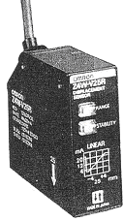

Figure 1: The optic non contact displacement transducer series Z4W-V photography [1]
The main functional characteristics are presented below:

Table 1: The main functional characteristics of the Z4W-V optic non contact displacement transducer
Light source | Measuring resolution | Output signal | Stability indicator | Response time | Sensing distance
Visible LED light source | 10 μm | analog output,  4 ÷ 20 mA  1 ÷ 5 V DC | Stability indicator | 5 ms | 25 mm

The technical characteristics are presented in the table 2:

Table 2: The mai technical characteristics of the optic transducer
Power supply voltage | 12 ÷ 24 V DC
Current consumption | max. 80 mA
Vibration resistance | until 30 g for 15 minutes, each in X, Y and Z directions
Chock resistance | until 50 g for 3 times, each in X, Y and Z directions
Ambient temperature | -10°C ÷ 55°C
Humidity | 35% ÷ 85%
Weight | 150 g, with 5-m cable  50 g without cable
Accessories supplied | Mounting bracket, mounting screws, resistor (250 Ω, 0,5 W)

3. ESTABLISHING OF THE LINEAR DISPLACEMENT CHARACTERISTIC OF THE TRANSDUCER, IN CASE OF HIGH REFLXIVE SURFACES PROBES

Having in the technical documentation of the device the linearity domain range, this information being valid only for frosted surfaces probes, used in microelectronics, we proposed to make a study regarding the evolution of the linear characteristic in case of probes having different properties.

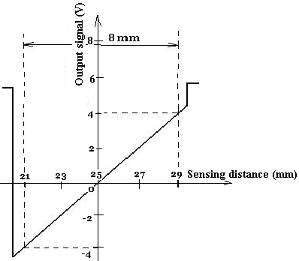

Figure 2: The displacement linear characteristic of the Z4W-V optic transducer [1]

So, for our determinations, we used a set of 10 gauges block having the following dimensions: 0.5 mm; 1mm; 1.5 mm; 2 mm; 2.5 mm; 3 mm; 3.5 mm; 4 mm; 4.5 mm and 5 mm.
In order to determine the linear displacement characteristic for the gauges, we repeated the determinations for three distinct cases: a) The measuring placing the averaged dimension gauge (3 mm) at the measuring range lower limit (21 mm distance), b) The measuring placing the averaged dimension gauge (3 mm) at the middle of the measuring range (25 mm distance) and c) The measuring placing the averaged dimension gauge (3 mm) at the measuring range higher limit (29 mm distance).
For all the cases, for the measurements we followed two steps: The calibration of the transducer for the 3mm dimension gauge block and the comparative measuring for all the others block gauges. As a result, we obtained the following tables for each of the three cases:
Table 3: The measuring results in case of the placing on the measuring range lower limit (21 mm distance)
Block gauge dimension [mm] | Comparative measured value with the transducer [mm]
0.5 | 0.3
1 | 0.78
1.5 | 1.23
2 | 1.83
2.5 | 2.36
3 | 3.09
3.5 | 3.46
4 | 4.04
4.5 | 4.63
5 | 4.97

Table 4: The measuring results in case of the placing on the middle of the measuring range (25 mm distance)
Block gauge dimension [mm] | Comparative measured value with the transducer [mm]
0.5 | 0.31
1 | 0.83
1.5 | 1.41
2 | 1.95
2.5 | 2.46
3 | 2.99
3.5 | 3.61
4 | 4.05
4.5 | 4.52
5 | 5.18

Table 5: The measuring results in case of the placing on the measuring range higher limit (29 mm distance)
Block gauge dimension [mm] | Comparative measured value with the transducer [mm]
0.5 | 0.27
1 | 0.99
1.5 | 1.51
2 | 2.29
2.5 | 2.88
3 | 3.51
3.5 | 4.23
4 | 4.73
4.5 | 5.34
5 | 6.09

It was find that for the placing of the transducer on the middle of the measuring range, it was obtained the highest precision, in time that for the placing on the lower limit it was the lowest. Due to this result we could establish the linearity diagram in case of high reflexive surface probes (see figure 3). [2]

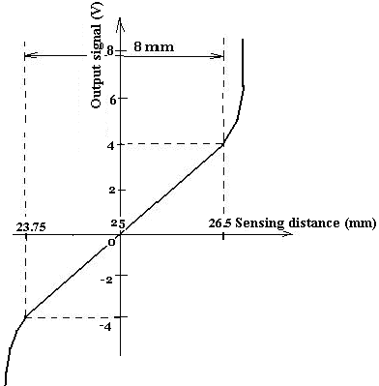

Figure 3: The obtained linearity characteristic of the transducer in case of high reflexive surfaces probes
3. CONCLUSION

Having the results regarding the evolution of the linear characteristic of the transducer in case of high reflexive surfaces probes, means that for some manufactured metallic probes, having very reflexive surfaces, the dimensional control with this type of transducers is not required. But in case of any kind of metallic or plastic probes with frosted surfaces, the measuring precision could be satisfactory. Even in case of metallic reflexive surface probes, if the form deviations are inside of the established linearity domain, this type of transducers could be successfully used.

REFERENCES

- LED Displacement Sensor Z4W-V - OMRON user guide documentation, 2006;
[2] Braun, B; Olteanu, C - The modeling of the radial deviations measuring process for the revolution probes, using the type and characteristic of the displacement inductive transducers - 8th International Conference of Mechatronics and Precision Engineering, COMEFIM ‘8, June 8-10, 2006 – CLUJ-NAPOCA, ROMANIA, Acta Technica Napocensis, Series Applied Mathematics and Mechanics 49 vol. III 2006, ISSN 1221 – 5872, pp. 563 – 568.

