The 2nd International Conference
″Computational Mechanics
and
Virtual Engineering″
COMEC 2007
11 – 13 OCTOBER 2007, Brasov, Romania

THE STATISTICAL EVALUATION OF THE AIDED BY PC MEASURING RESULTS, VIA Lab VIEW

BRAUN B¹; DRUGĂ C¹; OLTEANU C¹
¹ TRANSILVANIA University of Brasov, ROMANIA, e-mail: braun@unitbv.ro

Abstract: Our paper presents a virtual application, developed in Lab VIEW, for the simulation a dimensional control technological process, aided by PC. We presented the all the type of information obtained in this way, referring especially to the statistical evaluation aspects. That means that our application allowed to have a lot of information not only about the dimensional control process, but also about the metrological statistic of the obtained results. Due to this information, the program permitted also to make a virtual simulation about the post control process, thus being very useful for example, for the machine operator, in case of automatic industrial manufacturing. In this paper we pointed out the main advantages of the aided by PC processes simulation, meaning the reporting of the information quantity and quality to the very short time necessary for their obtaining.
Keywords (TNR 9 pt Bold): statistical evaluation, simulation, transducers, Lab VIEW

1. THE AIDED BY PC PROCESS SIMULATION IMPORTANCE

In order to optimize some processes, the statistical evaluation of the results is required. It allows to obtain many information about many events of the process. It permits, especially to evaluate with high accuracy the evolution of some representative steps which define the entire process. For example, in case of a technological process, to reduce drastically its costs, it is very important to realize a simulation before its implementation in practice. In order to have a lot of information about some process tendency parameters, just in the simulation phase, an events statistical analysis is important.

2. THE STATISTICAL EVALUATION AIDED BY PC CONCEPT

Nowadays a very easy method for all the processes simulation is to use the computer. In this order some special software, like Matlab, Lab VIEW, RoboLab are required. Beside, the simulation of the process events includes successfully the statistical aspects, which are synthetized into graphics, data tables, diagrams and so on. But one of the main advantages is about the drastically times reducing, who are necessary to obtain this kind of information.
An other major advantage is that due to the statistical results, just in the simulation processes phase, not only to obtain important information about the process optimization, but even to simulate aided by PC of some improved processes, via establishing of some decisions, taking into account the statistical information. To establish decisions, aided by PC means to interleave the generated statistical information, with some virtual modifications in the events, due to the programming software.

3. EXEMPLE OF STATISTICAL EVALUATION AIDED BY PC

In this paper we present a simple example in which a technological dimensional measurement process can be successfully statistically evaluated using the computer. The software used is Lab VIEW 7.1, developed by National Instruments.
As an example, to simulate the dimensional measurement process, we used measuring gauge for the flywheels behavior. In fact, it was analyzed the radial deviation of the probe, in equidistant measuring points reported to its circumference.
Regarding the statistical results, we compared, via Lab VIEW, the radial deviation measured values, using different displacement transducers coupled to the PC. For this reason, preliminary, we determined the radial deviations, successively with the following four displacement transducers: an incremental displacement sensor, produced by the HEIDENHAIN company (Germany) , two inductive displacement transducers, produced by the HOTTINGER and MARPOSS companies and a non contact laser displacement transducer, developed by OMRON company (Japan).
Being known the fact that the incremental sensor ensures the highest resolution (0.2 μm), we considered the measuring obtained with this sensor as reference. So all the measuring results, obtained with the others transducers were compared with the specified reference. Having this information, in Lab VIEW we could easily to program the determination of the measuring errors reported to the reference values. In this way, in the panel window, we obtained a complex table in which we have all the specified data (see table 1). Besides, the program allowed to calculate to averaged and maximum values for each of determined errors matrix.
In order to have the table of results in the panel, with other Lab VIEW measuring applications, we generated different ASCII files of the measured values for each displacement transducer, meaning four distinct files. Running our application, the program can acquire successively the information, from all the specified files, to generate the presented table. For the reading, we used four distinct Read from spreadsheet file functions, for the generation of 1-D matrix of measured values providing from each displacement transducer (see figure. 2). Using two mathematical operators, we programmed the determination of the errors of the measured values, in case of each displacement transducer.

Table 1: The statistical results, regarding the precision with different measuring systems – panel window
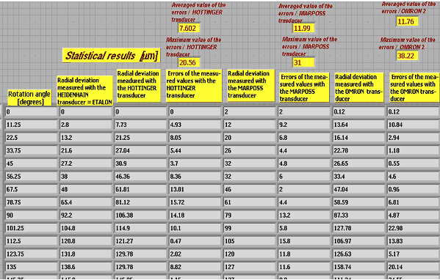

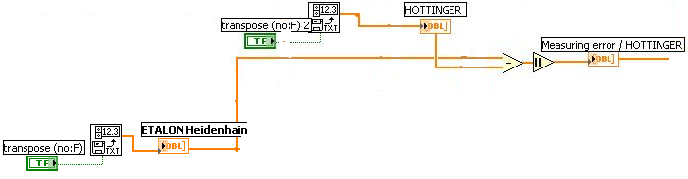

Figure 2: The programming part for the acquiring from files and processing of the measured values

The virtual instrument created in Lab VIEW offers many information about the probe‘ s geometry, synthetized in a graphic chart about the flywheel profile, a diagram representing the radial deviation distribution reporting to the probe’s circumference and two 1 – D matrix, showing the where is positioned the minimum and maximum radial deviation, reporting to the measuring points (see fig. 3) [1,4]. It could be found that the maximum radial deviation corresponds to the 157,5° measuring point and the minimum corresponds to the 326,25° measuring point [5]. This graphical information were obtained in Lab VIEW, due to the measured radial deviations with the incremental transducer, this being the reference regarding the precision.
For this reason, in the diagram window, we used an Array Min / Max function, to extract the minimum and maximum values of the measured values. The minimum and maximum values were compared with each measured value corresponding to each measuring point, using two FOR structures. Inside we programmed a Boolean TRUE / FALSE structure to specify if the current measured value is equal or not with the minimum or maximum measured value. As output signal thee were obtained two 1-D led matrix in which the corresponding to minimum / maximum value led is ON. To obtain the number of iterations of the FOR structures we reported the established number of readings from transducer to the number of readings from transducer between two successive measuring points. To compare each current measured value from the generated 1-D array, we used inside the FOR structures an Index array function, related to the iteration index of the FOR structures.

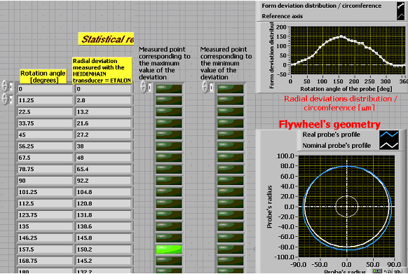

Figure 3: The graphical information about the probe’s geometry

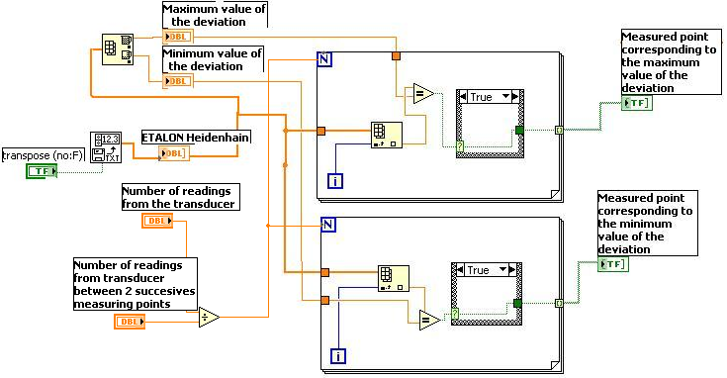

Figure 4: The programming sequence for the displaying of the maximum and minimum values of the radial deviation corresponding to the measuring points (diagram window)
Corresponding to the determined measuring errors resulted using the other three displacement transducers, displayed into the table 1, our application allowed to generate chart containing three distribution diagrams for each determined errors 1-D array. It can be find that the determined errors in case of the measuring using the inductive HOTTINGER displacement transducer, reported to the radial deviation values measured with the incremental transducer (as reference), were graphically represented in red, so that in each measuring point is very easy to find the corresponding determined measuring error. Similarly, in green, there are represented the measuring errors for corresponding to the use of the inductive MARPOSS displacement transducer and also, in blue are shown the measuring errors issued in case of the use of the OMRON non contact laser displacement transducer.

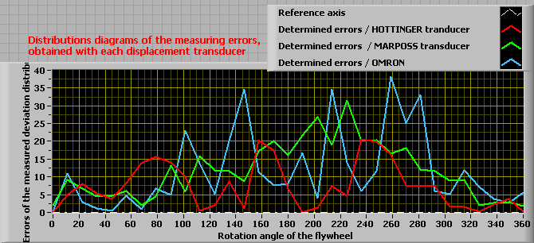

Figure 5: The generated distribution diagrams for the measuring errors issued in case of the use of each displacement transducer, excepting the referenced incremental displacement transducer

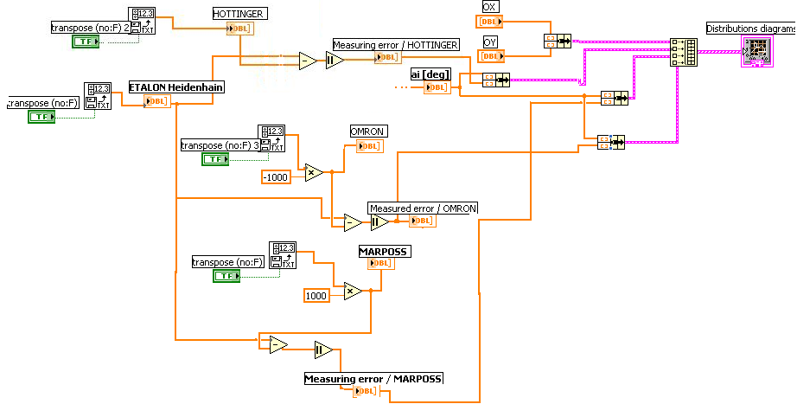

Figure 6: Programming sequences for the displaying of the measuring errors distribution diagrams

Each 1 – D array of measured values with different displacement transducers was related by the 1 – D array of reference measured values with the incremental transducer. In this way it were determined the measuring errors for each case. Each 1 – D array of measuring errors was coupled to the 1 – D array of the measuring points (ai [deg] ), being obtained three pairs of values: measuring point / measuring error. Beside, we created a pair meaning two 1 – D arrays of values for the OX – OY axis coordinate system, in order to obtain a reference axis to which the errors distribution could be displayed [2].
All the four pairs of values were coupled into a complex matrix, via a function Build Array, so that its output could be related to the diagram indicator. Both the obtained table of values and the errors distribution diagrams permits to the user to have a statistical determination via PC in case of a dimensional measuring technological process.
Besides, our application refers also to a post – process control simulation regarding the dimensional control. So, for our example about the flywheel, the Lab VIEW virtual simulation allows the signal of the cases regarding the appointment of the measured values into the established dimensional control tolerances. So, for each case, on of the three led turns ON. For example, if the dimension of the flywheel corresponds, le green led turns ON. Thus means that both the maximum and the minimum form deviation values must be inside of the maximum and minimum tolerance limits. Thus can be modified by the used, depending by the measurement application required. In this case, the simulation allows also to establish in which class of precision the manufactured probe is situated. If the maximum measured form deviation is higher than the established maximum tolerance, le yellow led turns ON. In this case, our application allows some information for machine operator about the part of the probe which must be adjusted, during the manufacturing process. In the last case, if the minimum measured form deviation of the probe is lower than the established minimum tolerance, the red led turns ON, meaning that the probe’s dimension is to low, so that it will be rejected. All this information were obtained being reported by the reference measured form deviation values [3].

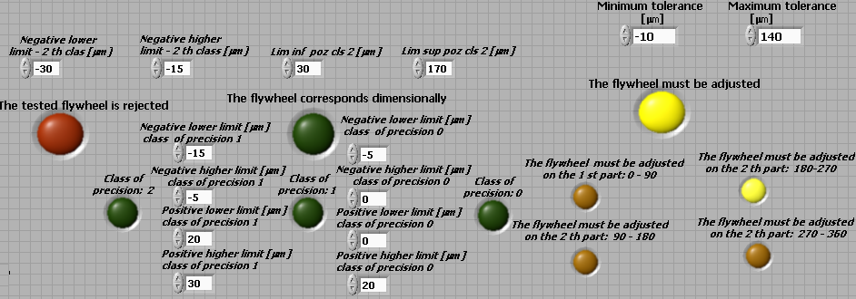

Figure 7: The virtual simulation of the post control process, via Lab VIEW

The programming sequences necessary to have the simulation, is shown in the figure 8.

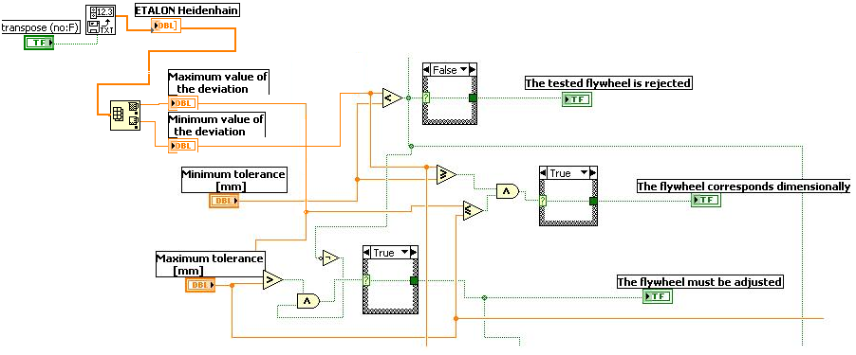

Figure 8: Sequences of programming referring to the dimensional post control simulation
In order to simulate the three cases, we used three Boolean structures, in which it were compared the maximum / minimum measured form deviations with the maximum / minimum established tolerances.

4. CONCLUSIONS

In our paper we demonstrated that via Lab VIEW it was possible to make a completely simulation of a technological process and also to have a statistical evaluation, via PC.
The main advantage is that the used could obtain all the necessary information in a very short time, so that this type of applications could successfully developed associated with industrial automatic manufacturing applications, but not only.
Beside, our research can be continued, regarding the measured values acquisition. For example it will be possible to eliminate the first step, meaning the measuring process and the data storage into ASCII files. A method is to develop some virtual instruments in Lab VIEW, which permits to transfer automatically the measured data into our aided by PC simulation application.

REFERENCES

[1] Ursuţiu, D – Iniţiere în LabVIEW. Programarea grafică în fizică şi electronică – Editura LUX LIBRIS, Braşov, 2001, pag. 106, ISBN 973 – 9428 – 60 6;
[2] Barbu BRAUN, Corneliu DRUGĂ, Cătălina TURCU, Ciprian OLTEANU - The surface quality inspection, aided by computer, 11th International Research Conference “Trends in the development of machinery and associated technology”, TMT 2007, 5 – 9 september, 2007, Hammamet, Tunisia, ISBN 978 – 9958 – 617 – 34 – 8, pp 703 – 706;
[3] Barbu BRAUN, Ciprian OLTEANU, Corneliu DRUGĂ - The active control technical process optimization, 11th International Research Conference “Trends in the development of machinery and associated technology”, TMT 2007, 5 – 9 september, 2007, Hammamet, Tunisia, ISBN 978 – 9958 – 617 – 34 – 8, pp 695 – 698;
[4] Braun, B; Turcu, C; Drugă, C - The verifying of the measuring precision of the inductive displacement transducers, via the virtual instrumentation - First National Conference COPTOMIM, 9-11 June 2006 BRAŞOV - Optometry and Medical Engineering;
[5] Braun, B - The virtual instrumentation in the dimensional control - Buletin of TRANSILVANIA University of Brasov, 2006, vol. 13(48), New Series, Series A, ISSN 1223 - 9631.

