1st International Conference
″Computational Mechanics and Virtual Engineering ″
COMEC 2005
20 – 22 October 2005, Brasov, Romania

OPTICAL CONCENTRATION TRANSDUCERS FOR TURBIDITY MEASUREMENT

Ioan Ardelean,
Technical University of Cluj-Napoca,Cluj-Napoca, ROUMANIA,
e-mail: ioan_ardelean@yahoo.com

Abstract. Turbidity instrumentation is used in many industries to measure the presence or concentration of particles should be thought of as undissolved solids, liquids, or gases having a different refractive index than that of the carrier liquid streams. Other terms used besides turbidity are clarity, haze and transparency. They are all nontechnical descriptors and they describe the effect a sample, including suspended particles, has on light passing through it. Turbidity is most often used to describe the measurement of low concentrations of particles (< 1% v/v) that should not be in the process stream, like particles in drinking water or filtrate. Turbidimeters measure the scattering of light by particles at these concentrations and correlate it to particle concentration. A basic understanding of the principles of light scattering and the methods used to measure it will help in selecting and specifying the instrument needed for the required measurement.
Keywords : optical, concentration, transducers, turbidity, measurement.

1. INTRODUCTION

Since turbidity is a visual phenomenon, it deals with the scattering of visible light, that is, electromagnetic radiation with wavelengths between 380 and 780 nms. When a focused beam of light is transmitted through a clear nonabsorbing liquid containing no particles, it passes through undisturbed in intensity and direction. However, these conditions rarely, if ever, exist. Even pure water will attenuate and scatter a beam of light, albeit at very low levels. If the beam of light encounters a particle, the intensity of the transmitted beam of light is decreased, see Figure 1. Some of the light lost from the incident beam is absorbed, while the rest of the lost light is redirected or scattered by particles. Further discussion of scattered light theory can be found in the literature [1]. In a turbidity measurement, the intensity and direction of scattered light are determined by the properties of the particles suspended in the liquid and the properties of the liquid itself. Particle properties affecting scatter are the refractive index, size and shape, color, and concentration.
Light
Source
l _{s}
l _{s}
l _{s}
l ₀
l _{t}
l _{t} < l ₀
l _{s}
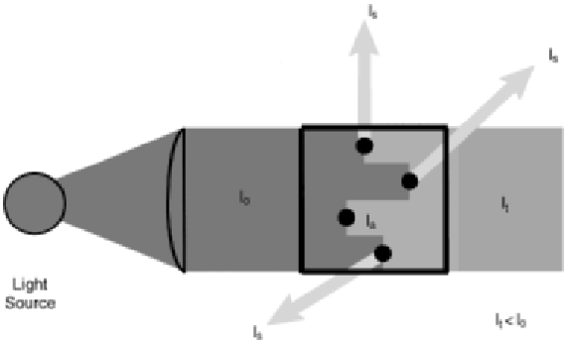

Figure 1. Basic Turbinimeter and Particle Influence on Light.

The particle must have a different refractive index (RI) than that of the carrier liquid. This is usually not a problem with inorganic substances. The RI of organic substances can approach or equal that of the carrier liquid, making detection by light scattering difficult or impossible. The greater the difference
in RI, the greater the intensity of the scattered light. Light scattered by a particle is not just in one direction as implied in Figure 1. The direction of light scattered depends on a particle’s size relative to the wavelength of the incident light and the particle’s shape. When the size of a particle is less than one-tenth of the incident light
a, ()((9
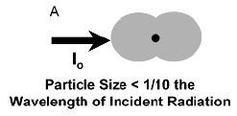
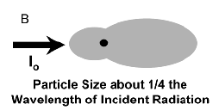
a,
b,

l ₀
l ₀

Particle Size about 1/4 the wavelength
of Incident Radiation

Particle Size < 1/10 the wavelength
of Incident Radiation

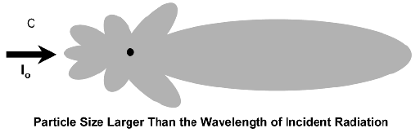
c,
c,

l ₀
l ₀

Particle Siye Larger Than the walvelenght of Incident Radiation

Figure 2. Angular patterns of intensity Radiation.

wavelength, light is symmetrically scattered, Figure 2a. More light is scattered in the forward direction as the size of the particle approaches the wavelength of the incident radiation Figure 2b. Two scattering characteristics are shown in Figure 2c. When the size of the particle exceeds the wavelength of light, the forwardscattered light greatly intensifies. However, if the particle has an irregular shape, that is, it is not a sphere, light is again scattered in all directions, although not symmetrically as with small spherical particles. If a particle is colored, especially if it is black, part of the incident radiation interacting with the particle will be absorbed and not scattered. The absorbed light intensity, ( Ia) in Figure 1, decreases the intensity of light transmitted through the sample (It) and the intensity of scattered light (Is). Ratioing the scattered light intensity to the transmitted light intensity (Is/It) factors out the effect of absorbed light.
As mentioned earlier, light scattering is used to measure low particle concentration levels. The upper limit of light scatter detection is reached when insufficient light is transmitted through the sample as a result of high levels of light absorption by the particles. At some concentration, dependent on particle color, the absorption of light exceeds the intensity of the scattered light, see Figure 3. The measurement of particles by light scattering is then no longer possible. Analyzers based on light absorption are

l _{s} > l _{a}
l _{a} > l _{s}
Absorption
Scatter
Particle concentration
Intensity
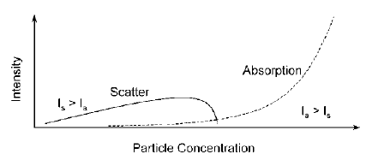

Figure 3. Relationship between scatter intensity and particle concentration

used to measure these higher concentrations. However, the relationship between concentration and absorption (the loss of transmitted light) is nonlinear, and special compensation must be used to correlate particle concentration to absorbed light. Properties of the liquid affecting light scattering are color, refractive index, and optical path length. A colored solution will also absorb part of the visible incident light, thus reducing the amount of light available for scattering. The intensity of the transmitted light will also be attenuated. Some of the scattered light will be absorbed by a colored solution and reduce the sensitivity of the method. Highly colored or dark solutions may reduce the amount of incident visible light to a level where turbidity measurement is not feasible.
As mentioned before, the greater the difference between the RI of the particle and that of the carrier liquid, the greater the intensity of light scattering. If the carrier liquid is composed of two miscible liquids or if there is a dissolved compound in the carrier liquid, changes in the concentrations of any of these will change the RI of the carrier liquid. This will affect the angles at which light is scattered from the particles. Particle concentration would then appear to change under these special optical conditions, even though the actual concentration may be constant.
Optical Path Length can be adjusted to compensate for highly colored solutions and/or high particle concentrations. Reducing the path length reduces the amount of sample between the light source and detector. This reduces the amount of absorbed incident light, allowing more light for scattering and transmission. However, very small path lengths may cause sample-plugging problems or not provide the required sensitivity. Long path lengths increase the amount of sample between the source and detector, increasing the intensity of scattered light. This aids in measuring very low particle concentrations.

2. METHODS OF MEASUREMENT

Turbidimeters consist basically of three components: a light source, one or more detectors, and a sample cell, see Figure 4. Variations in the arrangement of these components account for the many types of turbidity instrumentation on the market. Forward scatter, 90. scatter, and backscatter are the main methods of scattered light measurement. Turbidity values between these methods should not be compared because there are no simple correlations relating the values between the methods. Figure 5 illustrates the difference between the methods.
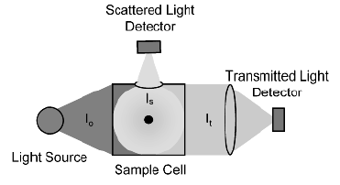
Scattered Light
Detector
Transmitted Light
Detector
Light Source
Sample Cell
l ₀
l _{s}
l _{t}

Figure 4. Basic turbimeter.

- 90. scatter or nephelometry is the method by which light scattered at right angles to the incident light
beam is measured. Since smaller particles scatter more light at right angles to the incident beam, nephelometry
is better suited to detect small particles [2]. Anaspect of this method making it particularly suited for low concentrations is that the detector looks at a dark background, as opposed to the forward-scatter method, which has the detector looking at a background lighted from the incident beam. The advantage of this is analogous to the number of stars one can see at night in rural areas versus how many can be seen in a city. The light of the
city makes it difficult to see the fainter stars in the sky, whereas they are visible in the absence of city lights. Sensitivity down to 0.001 nephelometric turbidity units (NTU) is achieved with this method.
b) Forward Scatter. As its name implies, this measures light scattered in the forward direction. Detectors are placed at angles, typically 10.–25., to the incident light beam. This method is better suited to the measurement of larger particles since they preferentially scatter light in the forward direction. This method may not be sensitive enough at very low particle concentrations because the small amount of forward-scattered
light may be indistinguishable from the transmitted light. Sensitivity between 0.001 and 0.005 NTU
is achieved with this method.
c) Backscatter. This places the light source and detector close to each other. Light scattered back near the source location is measured. This method is best suited for measuring high particle concentrations. The advantage of the method is that it can be performed with a single probe design. Most turbidity instruments require either all or part of the process stream to flow through the instrument. A probe can
be inserted through a nozzle into a vessel or process line. The disadvantage to the probe is that there is
no compensation for coatings on the probe lens or for changing color hue of the carrier liquid. Some
manufacturers offer mechanical in-line cleaning apparatus to solve coating problems. This method
90⁰ – Scatter Ratio
Forward – Scatter Ratio

Backscatter
Surface Scatter
Absorption
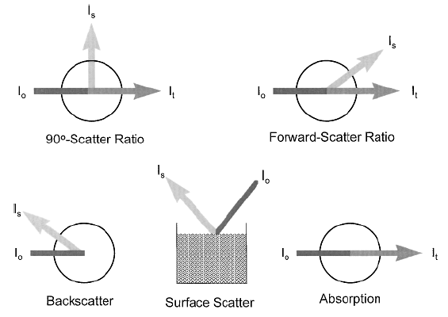
Figure 5. Methods of Light Scatter Measurement.

has a sensitivity of 0.1 NTU.
d) Surface Scatter. A method used less frequently is surface scatter [3]. As shown in Figure 5, a beam of light is focused on the surface of a sample, and light scattered above the sample is measured. The method requires the sample to be at atmospheric pressure.
e) Absorption method. The absorption method, Figure 5, is not a true turbidimeter because transmitted light, not scattered light, is measured. Attenuation of the incident radiation may be caused by scatter, carrier liquid absorption, color, particle absorption, and fouled optics. Use of this method may be required for high particle concentrations in which light scatter methods are not suited. In some cases particle concentrations of 60% (v/v) have been be measured. Other variations in the arrangement of light sources and detectors improve the accuracy and reproducibility of the turbidimeter. The most common variation is the addition of a second detector
to measure the transmitted light in addition to the scattered light. The scattered light intensity is compared to the intensity of the transmitted light. This compensates for changes in the incident light intensity, carrier liquid color, and some fouling of the optics. Some manufacturers narrow the wavelength range of incident light to improve the reproducibility of the measurement due to the particle size–wavelength relationship. Descriptions of other light source–detector arrangements as well as additional methods of scattered light measurement can be found in the literature [4], [5].

3.UNITS OF MEASURE and APLICATIONS

There are many units of measure associated with the measurement of scattered light. Several of the units depend on the calibration standard used. Some are simply defined differently by various organizations. Some conversion factors between units are different for various manufacturers. This exists because the correlation between different methods of scattered light measurement is usually not consistent.
Two of the most common standards used are diatomaceous (Fuller’s) earth and formazin. The original turbidity unit of JTU, Jackson turbidity units, represents the turbidity caused by suspending specified diatomaceous earth in distilled water. Forward-scattering turbidimeters correlate well to this unit. The formazin standard is a polymeric suspension prepared by reacting hydrazine sulfate with examethylenetetramine [7]. Formazin standards are often used to calibrate instruments using the 90⁰ scatter method.
Turbidimeter applications number in the hundreds because the measurement is relatively simple and
versatile. Turbidimeters are usually used to measure one of the following:
1. Particles that should not be in the process stream, such as water in a petroleum product or catalyst
in filter effluent.
2. Concentration, of which examples are tomato juice concentration and the concentration of particles
in a filter feed line.
3. The detection of changes, such as the onset of crystallization and immiscible interface zones.
4. Blending, such as adding the appropriate amount of filteraid to a filter feed stream.

Flow
Block Valves
Sight Glass
Sample/Flush
Nozzel
Turbidity Meter
Drain/flush
Nozzel
Flow
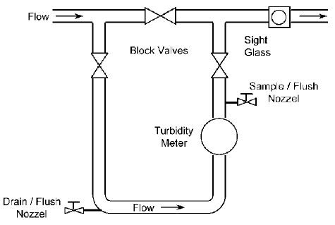

Figure 6. Turbinimeter installation.

4. SPECIFICATION, DESIGN AND CALIBRATION

Turbidimeter selection is very application dependent, and not all models of turbidity instrumentation willwork successfully on every application. Characteristics of the particles and carrier liquid influence which method to use, as was discussed. Most manufacturers require that an application data sheet be completed to help them specify the correct instrument.
A good installation design will also help ensure a successful application. The manufacturer’s manual usually contains design and installation recommendations. General “rules of thumb” in turbidity instrument design are listed below and shown in Figure 6.
1. Ensure the measuring sensor will stay liquid full at all times. Mount the sensor so the flow is in an
upward vertical direction if possible.
2. Avoid the formation of bubbles in the sensor by keeping pressure on the sample. Locate the sensor
before pressure letdown points such as a control valve to prevent degassing.
3. Avoid introducing stray light into the sensor. At low particle concentrations, very little stray light
is needed to cause erroneous readings. Locate sight glasses away from the sensor by placing them several feet from the sensor or after pipe elbows.
4. Design for the ability to calibrate the instrument. A turbidimeter installed in a bypass stream with isolation valves allows for flushing the instrument with water for a close to zero calibration check. This also facilitates removal of the instrument for bench calibration or isolation of the instrument during maintenance without disrupting the process. Sample taps located downstream of the instrument provide a way to collect grab samples for lab analysis comparison.
Manufacturers are very careful in making sure the instrument is calibrated before it leaves the factory.
However, it is a good idea to verify calibration once the instrument has been installed. If a comparative method is used, make sure it uses the same method as that of the on-line meter. Measurements from forward-scatter instruments will not match nephelometric readings. Some of the ways to check calibration are as follows.
1. Compare the turbidity of a grab sample as measured with a lab meter to that of the on-line meter at the time of the sample. If this method is used it is also important that the integrity of the sample does not change. Changes in temperature and pressure may cause precipitation or formation of bubbles.
2. Flush the meter with water and compare the meter reading to that of the water as analyzed by a lab meter. Demineralized water will usually give low ppm readings.
3. Swap with a spare in shop. This method is more work and requires two on-line turbidimeters if continuous operation is required. However, calibration standards can be used with this method. Calibration checks should be done as often as the user feels is required. Control charts go a long way in determining when the instrument is “out of control.” Installation of a bypass loop around the meter will aid in performing the last two methods of calibration checks, Figure 6. A manufacturer’s representative should be consulted before adjusting the calibration.

5. MAINTENANCE

Examine the output of the instrument daily to verify that the measured values make sense. The signal
should be somewhat noisy and not “flat lined.” The source light bulb will eventually burn out. Most instruments can sense when this happens, and it should be suspected if the reading suddenly drops to zero for no apparent process reason. Other common problems are listed below.
1. Bubbles are usually caused by the degassing of pressurized liquids. Most turbidimeter electronics
can filter the noise caused by bubbles. If the signal noise from severe bubble formation cannot be filtered out, relocation of the instrument or the installation of a bubble trap may be required. The sample must be at atmospheric pressure to use a bubble trap.
2. Stray light is usually caused by a sight glass located too close to the instrument. This will show up as high readings. Covering up the sight glass may help, but relocation of the sight glass farther away from the instrument and preferably past a pipe elbow will solve the problem.
3. Window fouling by the process is compensated to some extent by turbidity instruments ratioing the scattered light to the transmitted light. However, accumulation of material on the process side of the optical window will attenuate the signal to the point where insufficient light is available to perform the measurement. This can be anticipated based on experience with the condition of the pipe wall for existing process lines. Ensuring a fast sample flow will usually prevent solids from building up on the optical windows. Abrasion and chemical attack will interfere with the measured signal by changing the light refraction and transmission characteristics of the optical windows.
4. Moisture condensation on the nonprocess side of the optical windows in high-humidity environments
and cold sample temperatures is the most common cause of significant measurement error. Even small amounts of moisture can cause an interference error of over 50% of the signal. Purging the optics with dry instrument air prevents condensation by removing the moisture from the optical components.
5. Low readings will occur if the particle concentration is too high for the method. As shown in Figure 3, absorption by too many particles causes the scattering of light to decrease even though the concentration of particles is increasing. Continuous operation in this range may require using the absorption method. Turbidimeters using the ratio measurement method compensate for this. However, if the liquid is too dark, there may be too little light available to reach the detectors.

REFERENCES

[1]. McMillan, G. K.,Douglas M. Considine,D.M., PROCESS/INDUSTRIAL INSTRUMENTS AND CONTROLS HANDBOOK, McGRAW-HILL, 1999.
[2]. Clevett, K. J., Process Analyzer Technology, J. Wiley, New York, pp. 558–561, 1986.
[3]. Byrnes, J., and A. Valentine, The Effect of Measurement Angle and Particle Size on Scattered Light in the
Beer Line, McNab Inc., Mount Vernon, New York 10550.
[4]. Sadar,M. J., Turbidity Science Technical Information Series, Booklet No. 11, Hach Company, Loveland, Col.,p. 25, 1998.
[5]. Liptak, B. G., Instrument Engineers’ Handbook, Process Measurement and Analysis, 3rd ed., Chilton, Radnor, Pa., pp. 1230–1235, 1995.
[6]. Lex, D., “Turbidimeter Technology Turns On the High Beam,” Intech, pp. 36–38, June 1994.
[7]. HSB Instruction Manual, McNab, Incorporated, 20 North MacQuesten Parkway, Mount Vernon, New York
10550, pp. 2–4, copyright 1992.
[8]. ASTM Method D 1889–94, Section 10.
[9]. M. A. Betts, “Turbidimeters Solve Suspended Solids Monitoring Problems,” I&CS, pp. 75–78, May 1998.
[10]. Model 725, Process Refractometer Instruction Manual, p. 2, Liquid Solids Control, Inc., P.O. Box 259, Upton, Mass. 01568, 1998.
[11]. Instruction Manual for PR–01–S, p. 5, K-Patents, Inc., 1804 Centre Point Circle, Suite 106, Naperville, Ill.,
1996.

