The 2nd International Conference
″Computational Mechanics
and
Virtual Engineering″
COMEC 2007
11 – 13 OCTOBER 2007, Brasov, Romania

DEVELOPMENT OF 3D SOLID MODELER FOR DESCRIPTIVE GEOMETRY EDUCATION

Yasushi NIITSU¹ , Takashi KOHAMA²
School of Information Environment, Tokyo Denki Univ., Inzai-City, Chiba, 270-1382, JAPAN
yniitsu@sie.dendai.ac.jp¹
kohama@sie.dendai.ac.jp²

Abstract: An 3D solid modeling software has been developed for the education of the descriptive geometry and computer graphics. The boundary representation and the winged-edges method have been adopted as a description method of solid model. The developed solid modeler can create a 3D solid model by executing the command lines of text format. Combining the 13 kinds of primitive models, the solid model is constructed. The developed software has several kinds of display modes more than 140, such as the edge-type, the surface-type, the perspective and parallel views, three faces and so on. The practice of descriptive geometry with the software had been carried out in Tokyo Denki Univ. The students were interested in the geometry and their geometric ability was improved.
Keywords: Solid Modeler, Descriptive Geometry, Education.

1. INTRODUCTION

In the mechanical engineering, civil engineering and architecture school, the drawing and descriptive geometry educations are carried out. There is an individual difference in the three-dimensional consciousness ability and understanding of the three-dimensional modeling is difficult for the many students. The computer can be efficiently utilized for the descriptive geometry education. However, there is no software of the educational use of the descriptive geometry used in the university educational programs.
Author has been developing the 3D solid modeler (Solid Interpreter) for the education of descriptive geometry and computer graphics. “Solid Interpreter” adopted the boundary representation and the winged-edges method as a description method of solid model. “Solid Interpreter” can create a 3D solid model by executing the command scripts of text format. By combining the thirteen kinds of primitive solid models, the complex solid model can be constructed. The developed software has several kinds of display modes such as the edge-type and the surface-type display modes. It is possible to advance the production of the solid model by confirming the graphic display. This software was applied to the education of the descriptive geometry for the students of Tokyo Denki University in 1999, 2000 and 2001.[1]

2. DEVELOPED SOLID MODELER

Function of Command
Three-dimensional solid modeling software (Solid Interpreter) takes the method for carrying out the generation and deformation of the solid models with the command of the text format. Generation and display of the solid models are carried out by 37 kinds of command scripts classified as the basic model generation command, the model operation command and other command. The objects (structural data in memory) are named in character strings. Table 1 shows the named objects used in the solid modeler. Functions and name of major commands are shown in Table 2. Since all operations are described in the text form, it is possible to create the solid model of the purpose by correcting the text file.

Table 1: Objects described with name.

Object | The properties in Object
Eye information | Name, Eye position, Reference, Display effect, Display mode.
Axis object | Name, Association, Vectors
Group object | Name, Parent group, Color, Associating Axis.
Solid object | Name, Color, Parent group, Face, Edge, Vertex, Loop.

Table 2: List of major commands

Command | Function
Cone | Create cone object
Cube | Create rectangular
Cylinder | Create column
Ellipse | Create spheroid
Helix | Create helix object
Prism | Create prism
Pyramid | Create Pyramid
Revolve | Create revolve object
Sphere | Create sphere and polyhedron
Torus | Create torus
= | Duplicate Solid object
=,+,-,* | Set operations
Affine | Affine transfer
Move | Parallel translation of Object
Rotate | Rotational transfer of Object
Xcolor | Set color (RGB) of Object
Eye | Create Eye object
Display | Display solid models
Group | Group operations
Axis | Set Axis and moving operations

Basic Solid Models (Primitive Models)
It is possible to create 13 kinds of basic models (straight line, prism, pyramid, two kinds of revolve, cube, cylinder, cone, sphere, ellipse, torus, spiral, helix) according to the command. Some kind basic models are generated with another model generation code as shown in Fig. 1. The arrow of Fig. 1 shows that the basic models at the bottom can be created by same generation process of the basic models at the upper. The other models like polyhedrons are created by the optional commands.

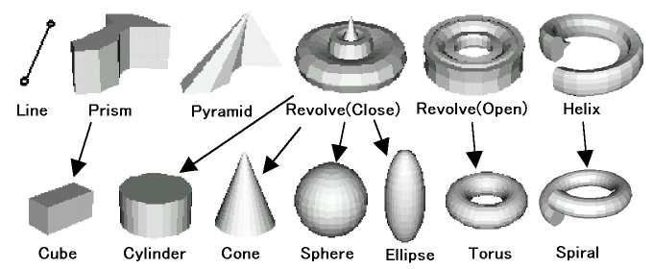

Figure 1: Thirteen kinds of basic models (Primitive models) of “Solid Interpreter”

Tool Windows
Solid Interpreter has many kind of tool windows to support the 3D programming. The major tool is “Primitive creation window” to create the command of the primitive models visually. Figure 2 shows this window. User can easily make the command lines of primitive models without the key input with this window.

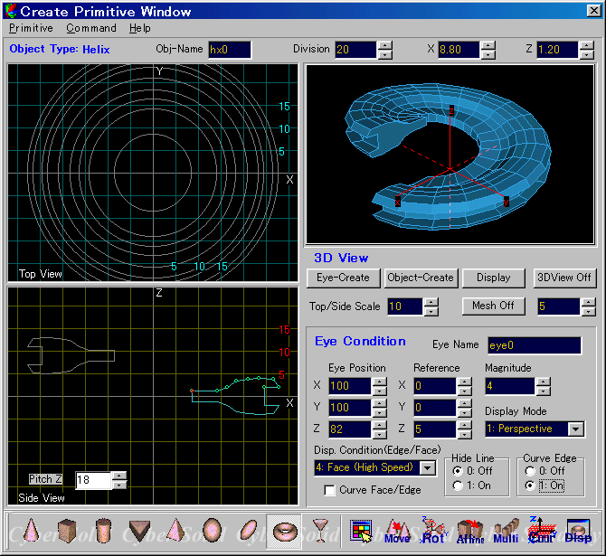

Figure 2: Creation of primitive model by Tool window.

Set Operations (Boolean Operations)
Three kinds of set operations of addition, subtraction and overlapping are available as shown in Fig. 3. These set operations are carried out by simple expression like algebraic equation, as followings,

Solid3 = Solid1 + Solid2
Solid3 = Solid1 - Solid2
Solid3 = Solid1 * Solid2.

Here, operation code of ‘+’ means the synthesis (union of set) of models, ‘-‘ means the subtraction and ‘*’ means the intersection of solid models. Figure 3 shows the examples of set operations between a sphere and a cylinder.

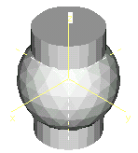
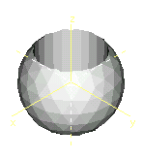
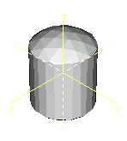

Solid1+Solid2 Solid1-Solid2 Solid1*Solid2

Figure 3: Sample of Boolean (set) operations.

3D Modeling by “Solid Interpreter”
“Solid Interpreter” is consisted with the modeling engine, display engine, text editor, command generation GUI tools and data structure analyzing tools. Usually, user can create a simple model by only mouse operations. The modeling and display engines can execute the command lines of text format. Figures 4, 5 show the models by the following 13 lines program of boolean operations (set operations), and 20 lines program with the group command.

### Figure 4
### Program 1 (example of Boolean operations)
###
Eye eye0 100,100,82 0,0,0,4.5,1,4,0,0
Sphere -q s0 20.4
Sphere -p s1 20
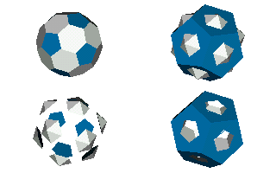
Xcolor s1 255, 255, 255
Xcolor s0 192, 128, 0
Xobj0 = s0 * s1
Xobj1 = s1 + s0
Xobj2 = s1 - s0
Xobj3 = s0 - s1
Window 0,0.5,0.5; Display Xobj0
Window 0.5,0.5,0.5; Display Xobj1
Window 0,0,0.5; Display Xobj2
Window 0.5,0,0.5; Display Xobj3

### Figure 5
### Program 2 (example of Variable & Group operation)
###
Eye eye0 100,100,82, 0,0,0, 3, 1,4,0,0 Figure 4: Samples of Boolean operations.
N=5 # Variable N is the number of wings
R=360/N # Variable R is the angle of wings
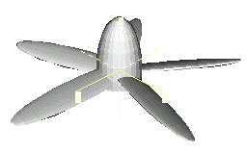
Group Propeller {
Ellipse e0 12, 8, 20
Cube q0 30, 20, 20
Move q0 -15.00, -10.00, -24.0
e0 = e0 - q0
delete q0
Ellipse e1 12, 5, 25
Affine e1 0,0,0; 0.20,0.00,0.00;
0.00,1.00,0.00; 0.00,0.00,1.00
Move e1 0, 0, 20 Figure 5: Solid model of Propeller with five wings.
Rotate e1 0, 0, 0, 0, 1, 0, 90 (example of variable and parametric expression)
Rotate e1 0, 0, 0, 1, 0, 0, -15
Ncopy -s e1 0,0,0, 0,0,1, R,0,N
delete e1
}
clear
display eye0 Propeller
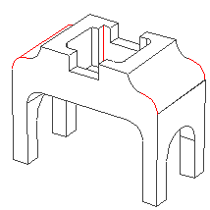

Figure 6: Example of the hidden-line removal mode

3. PRACTICE AT THE CLASS OF UNIVERSITY

The practice of descriptive geometry with the software had been carried out in Tokyo Denki Univ. The class was for the fresh man of first grade. The practice was spent five weeks, and three hours in each week, as following table.

Table 3: Schedule of Lecture and Practice.

Week | Contents of Lecture and Practice
First | Lecture of introduction of 3D-CAD, vector, top-front-side views, parallel and perspective views, exercise
Second | Lecture and practice of software, primitive model, exercise, home work
Third | Practice of software, modification of models, exercise, home work
Fourth | Practice of software, leaning of grouping and animations, exercise, home work
Fifth | Presentation of student’s works

Numbers of the students were about 140 in 1999 and 120 in 2000. The teaching staff were a professor, a lecturer, an assistant and three teaching assistant of graduate course students.
The practices of the first week were mainly carried out to write on papers because this class was the first course of the descriptive geometry in University. The last week was used for the presentation of the student’s works of their solid modeling. Figure 7 shows the excellent models made by students. These models were programmed to have the moving actions with “Axis” command.
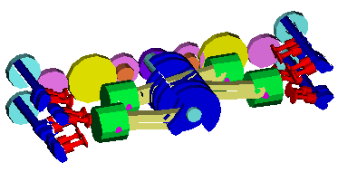
After this class, The questionnaire on the class and the effect of the practice was done. More than 60% of students thought the practice with this software was effective for the development of their 3D object grasp ability (geometric ability).

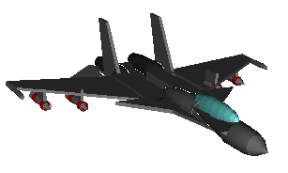

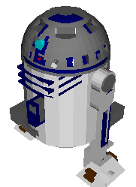

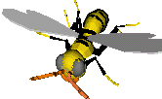

Figure 7: Excellent solid models made by students.

4. RECENT SOFTWARE DEVELOPMENT

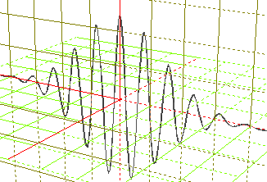
Recently, we have developed new version of “Solid Interpreter” which can create the model by mathematical functions like “Mathematica”.[2] Figure 8 shows the solid models made with new version software. These models are not surface model but solid, therefore these models requires the value of thickness and Boolean operations are available.

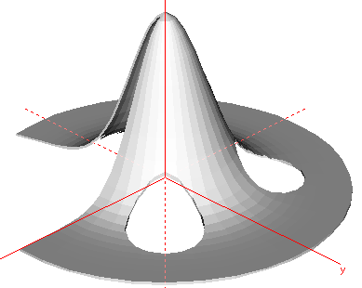

Figure 8: Linear and sheet type solid models made with new versions of “Solid Interpreter”.

5. CONCLUSIONS

The students could establish their original solid model by using the developed software only in five weeks. All teaching staff were surprised in the abilities of the students. We thought sure that this software was effective for the geometry, drawing and graphics education. If you have interesting on this software, download from “http://www.n-plus.co.jp/” and use it please.

REFERENCES

[1] Y. Niitsu, "Development of 3D Solid Modeling Software for Education of Descriptive Geometry and Computer Graphics" (Japanese), Journal of EAIT (Journal of the Educational Application of Info. Tech.), Vol.2, No.1, pp.7-12, (1999 November)
[2] Y. Niitsu, “Solid Modeling with Polygon Data of Mathematica”, Proc. of 4th Int. Mathematica Symp. (Symbolic Computation) , pp.369-374, (2001 June).

[Application and Manual are downloadable from “http://www.n-plus.co.jp/”.]

